Towards a consensus on mode II adhesive fracture testing and data reduction methods.

M. Pérez-Galmés¹, J. Renart¹, C. Sarrado¹, A. Rodríguez-Bellido²

¹AMADE, Polytechnic School, University of Girona. Carrer Universitat de Girona, 4.
Campus de Montilivi. 17003-Girona. magdalena.perez@udg.edu, jordi.renart@udg.edu, carlos.sarrado@udg.edu. http://amade.udg.edu/
²Composite Technology, Materials and Processes, AIRBUS Operations S.L.
Paseo John Lennon s/n.28906-Getafe. ana.rodriguez@airbus.com

Keywords: Mode II fracture toughness, Bonded joints, J-integral, FRP, Mechanical testing.

Abstract

Mode II fracture toughness is crucial in the design of structural bonded joints between fibre reinforced polymers (FRP). However, one of the main problems encountered in mode II experimental testing is the poor reproducibility between the most common test methodologies: End-Notched Flexure (ENF), End-Load Split (ELS), 4-point End-Notched Flexure (4ENF), and the Mixed Mode Bending (MMB) test at 100% of mode II.

The objective of this work is to define reliable test methodologies and data reduction methods to obtain comparable results among mode II tests. For this reason, an experimental test campaign consisting of the abovementioned four mode II test methods was carried out. The J-integral was implemented in all the tests as data reduction method, and it was compared to the existing data reduction methods based on Linear Elastic Fracture Mechanics (LEFM).
The results obtained from the J-integral based methods were independent from the test methodology and the adherend used. Very good agreement vas obtained among all the tests.

1. Introduction

Nowadays, adhesive bonding is widely used in industrial applications as an alternative to traditional mechanical fasteners, especially in lightweight structures. Bonded joints are designed such that the adhesive is loaded in the direction of its maximum strength (i.e. shear), whereas tension or peel stresses are minimized. For this reason, determining mode II fracture toughness is extremely important.

There are various standardized test methodologies available to determine the mode II fracture toughness of fibre-reinforced polymer composites, named the End-Notched Flexure (ENF) test [1], the End-Loaded Split (ELS) test [2] and, alternatively, the Mixed Mode Bending (MMB) test [3] used at 100% mode II ratio. Although not standardized, the Four End-Notched Flexure (4ENF) test also widespread within the scientific community [4].

One of the main problems in mode II testing is the poor comparability among the existing test methods [5- 9]. The causes of such discrepancies in results are diverse, ranging from the friction and large deflections involved, to the complex damage mechanisms occurring at the crack tip [5, 10-14].
Besides, in the case of adhesive bonded joints, they have been reported to entail a large Fracture Process Zone (FPZ) at the crack front, instead of a sharp crack tip, due to the plasticity of the adhesive layer [15, 16]. Therefore, analysing situations involving large FPZ may fall outside the scope of the mode II delamination standards data reduction methods because they are based on Linear Elastic Fracture Mechanics (LEFM).

The interest in bonded joints failure has led to new data reduction methods being developed to determine fracture toughness in a non-linear framework. One that has enjoyed particular success is the J-integral developed by Rice [17] from which simple closed form solutions have been used to obtain fracture toughness in tests such as ENF [18], ELS [19] and MMB [20].

The objective of this work is to obtain a reliable mode II fracture toughness test for structural adhesives. Four mode II test methodologies were compared (ENF, ELS, 4ENF and MMB at 100% mode II ratio) in an experimental test campaign of bonded joints between Carbon Fibre Reinforced Polymers (CFRP). Different data reduction methods based on both LEFM and the J-integral were applied to each test methodology. A J-integral closed form solution for the 4ENF test is presented, as it is the only one from the tests studied for which a J-integral closed form does not exist in the literature.

2. Experimental test campaign

The tests were performed in AMADE research group testing laboratory, at the University of Girona. The specimens tested were 25 mm wide, 210 mm long, 4.8 mm thick with a 60 mm long artificial crack in the bonding line. Two different specimen types (M1 and M2) were manufactured with the same adhesive but each with a different CFRP adherend, differing in the type of fibres and resin used.

With the aim of avoiding unstable crack initiation from the insert a pre-crack in mode I of at least 5 mm was made in all the specimens following the ISO25217 [21] standard before the mode II tests.

After the pre-crack tests, the edge was marked every millimetre with a vertical line from the initial crack tip, a₀, to the final propagation length, a_{f} (c.f. Fig. 1).
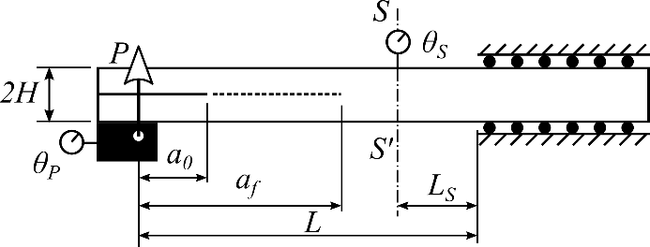 | 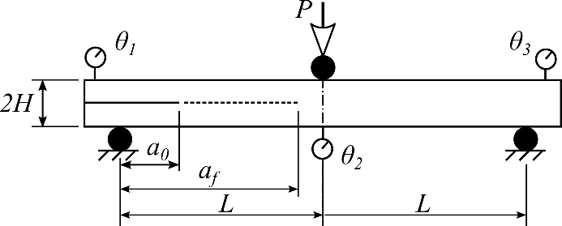
- ELS | - ENF
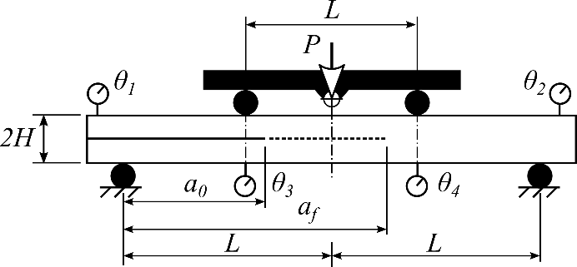 | 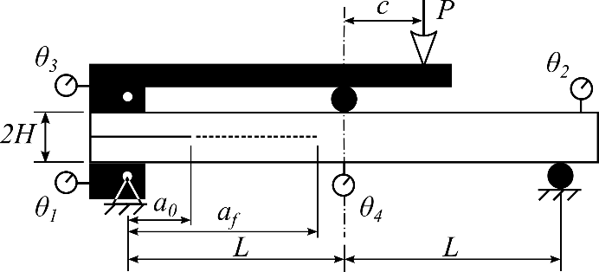
- 4ENF | - MMB

Figure 1. Tests geometries and instrumentation. In black, the supports and the loading applicators, white circles represent the inclinometers. Dimensions used in ENF, 4ENF and MMB were: L = 60 mm, a₀ = 35 mm, a_{f} = 60 mm and roller radius = 5 mm. Dimensions used in ELS were: L = 100 mm, a₀ = 55, a_{f} = 95 mm and L_{S} = 10 mm
The tests were carried out under displacement control in a universal test machine and different methods were used for the data reduction: LEFM-based and J-integral based. In that account, during the mode II tests, the load, the displacement, the crack length, and the rotations at the loading application points and at the supports were recorded.

In the ELS test the data reduction methods used to obtain the fracture toughness were: the Simple Beam Theory (SBT), the Experimental Compliance Method (ECM) and the Corrected Beam Theory using Effective crack length (CBTE) from ISO15114 [2], the area method (AREA) [22] and the J-integral [19].

In the ENF test the data reduction methods used to obtain the fracture toughness were: the Simple Beam Theory (BT) [10, 23], the Corrected Beam Theory (CBT) [10, 24, 25], the Compliance Calibration Method (CCM) [25, 26], the area method (AREA) [22] and the J-integral [18].

Four data reduction methods were considered for the 4ENF test: the Simple Beam Theory (SBT) [4], the Experimental Compliance Method (ECM) [5], the Compliance Calibration Method (CCM) [5], and additionally, a J-integral data reduction method, was developed for this test [27]:
$$J_{II}= \frac{P}{2W}\left(-\tan{θ_{1}}-\tan{θ_{2}}+\tan{θ_{3}}+\tan{θ_{4}-\frac{3P\cos{θ_{1}}μL}{2WH^{2}E}}\right)$$ | (1)
where P is the applied load, W is the specimen width, H is the half thickness of the specimen, L is the half span length, E is the adherend longitudinal young modulus, µ is the friction coefficient between cracked surfaces and θ₁, θ₂, θ₃ and θ₄ are the rotations of the specimen at the roller application edges (c.f. Fig. 1). The last therm in equation (1) takes into account the frictional effects. According to Davidson et al. [5] a friction coefficient of µ = 0.345 was used in calculations.

In MMB test the data reduction method proposed in the standard [3] was used in addition to the J-integral [20].

3. Results and discussion

No results were obtained for M2 specimens of 4ENF and MMB test configurations, since a premature failure occurred in the adherend, invalidating the tests.

The fracture toughness was measured when the R-curve reached a plateau. All results are normalized with respect to the averaged value of J_{IIc} obtained from M1 specimens tested with the ELS, which had a fracture toughness of J_{ELS} (M1) = 4.64 KJ/m².

In Tables 1 to 4 the averaged values of each batch tested with their corresponding standard deviation (SD) are summarized.

Table 1. ELS tests summary of results. All values are normalized with respect to the averaged value of J_{IIc} from the M1 ELS batch.
Batch |  | J_{IIc} | G_{IIc}(CBTE) | G_{IIc}(ECM) | G_{IIc}(SBT) | G_{IIc}(AREA)
M1 | Average | 1.00 | 0.94 | 0.68 | 1.22 | 0.92
M1 | SD | 0.17 | 0.11 | 0.11 | 0.20 | 0.15
M2* | Average | 1.06 | 1.10 | 1.12 | 1.15 | -
M2* | SD | 0.07 | 0.09 | 0.35 | 0.29 | -
*Final unstable crack growth invalidate G_{IIc} (AREA) data reduction method.

Table 2. ENF tests summary of results. All values normalized with respect to averaged value of J_{IIc}
from the M1 ELS batch.
Batch |  | J_{IIc} | G_{IIc}(CCM) |  | G_{IIc}(BT) |  | G_{IIc}(CBT) |  | G_{IIc}(AREA)
M1 | Average | 0.99 | 1.00 | 1.23 |  | 0.87 |  | 1.02
M1 | SD | 0.17 | 0.15 | 0.21 |  | 0.18 |  | 0.11
M2 | Average | 0.98 | 1.01 | 1.41 |  | 1.04 |  | 0.98
M2 | SD | 0.22 | 0.18 | 0.31 |  | 0.16 |  | 0.28

Table 3. 4ENF summary of results. All values normalized with respect to the averaged value of J_{IIc} from the M1 ELS batch.
Batch |  | J_{IIc} | G_{IIc} (CCM) | G_{IIc} (ECM) | G_{IIc} (BT) | G_{IIc} (AREA)
M1 | Average | 0.96 | 1.08 | 0.93 | 1.54 | 1.28
M1 | SD | 0.18 | 0.15 | 0.10 | 0.24 | 0.44

Table 4. MMB tests summary of results. All values normalized with respect to the averaged value of J_{IIc} from the M1 ELS batch.
Batch |  | J_{IIc} | G_{IIc}
M1 | Average | 0.93 | 1.33
M1 | SD | 0.11 | 0.24

In the ELS test some of the data reduction methods present large differences with respect to the reference value and between them (i.e G_{IIc} (ECM) and G_{IIc} (SBT), having differences of more than a 20% in the average value). Furthermore, the average fracture toughness of each batch results in large SD for all test methods, probably due to the fact that each batch contains specimens from different panels. However, the discrepancies between the data reduction methods are too large to be considered as material heterogeneity. Therefore, to a large extent, they must be attributed to the data reduction method used.

From the comparison between M1 and M2, the authors expected no changes in the fracture toughness, because the adhesive layer was the same, and the properties between adherends are similar. In this sense, the J-integral and the CBTE are the data reduction methods that provide fewer differences between both materials, with J_{IIc} giving the smallest difference. The relative error between both methodologies is less than 6%.
A discrepancy of G_{IIc} (ECM) and G_{IIc} (SBT) results compared to those obtained with the CBTE method was expected, as this has been stated in a round-robin study on carbon-fibre epoxy material [28].

Similarly to what it is observed in the ELS results, in the ENF test there are significant differences between some of the methods (of more than 20%).
Only the J-integral and CCM provide values of G_{IIc} closer to those obtained from the ELS test. Besides this, both methods are independent of the adherend used, having small differences, of less than 2%, in the fracture toughness measurement between M1 and M2.

In the 4ENF test none of the data reduction methods takes into account the friction effects, albeit except for the J-integral, in which the friction coefficient is defined as µ = 0.345 [5]. The J-integral offers similar results to those obtained from the ENF and ELS tests. Results from the CCM are also in fairly good agreement with those obtained from the other tests. On the other hand, large differences are encountered in the methods that directly depend on the crack length measurement, i.e. BT and AREA. Despite also depending on the crack length measurements, like the CCM, the ECM provides acceptable results of G_{IIc} (less than 10% difference). The discrepancies between the J-integral and the other methods can be explained by the friction effects and the difficulties in the crack length measurement.

For the MMB specimens, the results obtained following the MMB test standard [3] (G_{IIc}) are higher than those obtained in the ENF, ELS or 4ENF tests, similar to what occurred in the previous test methodologies that depend on crack length measurements. Again the the J-integral offers close values to the previous tests.
To graphically observe the deviation between the methods, Fig. 2 shows the average results, with their corresponding standard deviation, for the J_{IIc} and compliance calibration based methods.

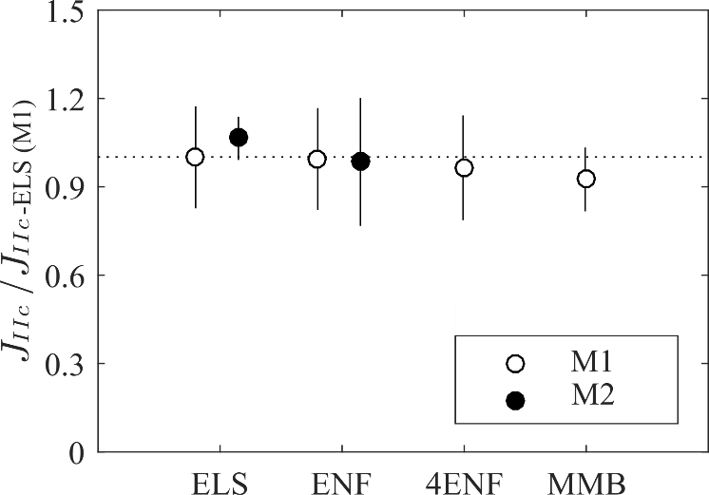

Figure 2. Summary of J_{IIc} results. Batch average and standard deviation of each batch normalized with respect to the J_{IIc} average value from the M1 ELS batch.

A very good agreement between J-integral-based results is observed for all test typologies (differences between them below 10%) and materials (differences below 6%). On the other hand, the CC-based data reduction methods are also providing similar results of fracture toughness regardless of the test used (CBTE in ELS, CCM in ENF and CCM in 4ENF). Although they are less accurate than the J-integral-based methods, they can serve as a good alternative to the J-integral.

4. Conclusions

With the aim of obtaining a reliable mode II fracture toughness test procedure for structural adhesives, four delamination-based mode II test methods (ELS, ENF, 4ENF and MMB) have been compared through an experimental test campaign with bonded joints between CFRP. Additionally, two specimen typologies (M1 and M2) were tested, with the same adhesive but each with a different adherend.

For each test, different data reduction methods were used to obtain the fracture toughness, LEFM and J-integral. For this purpose, a data reduction method based on the J-integral was developed for the 4ENF test.

From the analysis of the results, in determining the fracture toughness there were some discrepancies between the tests and the data reduction methods. The methods based on the visual crack length monitoring show differences in the determination of the fracture toughness because they mainly depend on the measurement of the crack length, and a neat crack tip does not exist when testing adhesives under mode II loadings because of the large FPZ involved. Therefore they are not reliable for measuring fracture toughness. On the contrary, methods that are not based on a direct measurement of the crack length, such as CC-based (CBTE in ELS, and CCM in ENF and 4ENF) and the J-integral, result in small differences between the different test typologies and materials.
Even though the CBTE and CCM methods are based on LEFM, they rely on calculating an equivalent crack length that somehow takes into account the FPZ length. This is why their results show better agreement with the J-integral approach, based entirely on a non-linear fracture mechanics framework.

In all the tests, the J-integral was proven to be independent of the test typology and material, but the CC-based methods are also in acceptable agreement with those obtained with the J-integral.

Acknowledgments

The authors would like to acknowledge the support of the Spanish Government through the Ministerio de Economía y Competitividad under the contracts TRA2015-71491-R and MAT2015-69491-C3-1-R and the University of Girona for the grant ‘Ajuts per a l’asistència a congressos internacionals de recerca per estudiants de màster i doctorat de la Universitat de Girona’.

References

[1] ASTM D7905M-14 . Standard Test Method for Determination of the Mode II Interlaminar Fracture Toughness of Unidirectional Fiber-Reinforced Polymer. American Society for Testing and Materials 2014;.
[2] ISO 15114:2014 . Fibre-reinforced plastic composites - Determination of the mode II fracture resistance for unidirectionally reinforced materials using the calibrated end-loaded split (C-ELS) test and an effective crack length approach. International Standard Organization, Geneva, Switzerland 2014;(1):1{26.
[3] ASTM D6671/D6671M . Standard Test Method for Mixed Mode I-Mode II Interlaminar Fracture Toughness of Unidirectional Fiber Reinforced Polymer Matrix Composites. American 397 Society for Testing and Materials 2013;.
[4] Martin R, Davidson B. Mode II fracture toughness evaluation using four point bend, end notched
flexure test. Plastics, Rubber and Composites 1999;28(8):401{6.
[5] Davidson B, Sun X, Vinciquerra A. Influences of Friction, Geometric Nonlinearities, and Fixture Compliance on Experimentally Observed Toughnesses from Three and Four-point Bend End-notched Flexure Tests. Journal of Composite Materials 2007;41(10):1177{96.
[6] Davidson B, Sun X. Effects of friction, geometry, and fixture compliance on the perceived toughness from three- and four-point bend end-notched fixure tests. Journal of Reinforced Plastics and Composites 2005;24(15):1611{28.
[7] Blackman BRK, Kinloch AJ, Rodriguez-Sanchez FS, Teo WS. The fracture behaviour of adhesively-bonded composite joints: Effects of rate of test and mode of loading. International Journal of Solids and Structures 2012;49(13):1434{52.
[8] Davies P, Blackman BRK, Brunner A. Standard test methods for delamination resistance of composite materials: current status. Applied Composite Materials 1998;5(Iso 4585):345{64.
[9] Davies P, Kausch H, Williams J, Kinloch AJ, Charalambides M, Pavan A, et al. Round-robin interlaminar fracture testing of carbon-fibre-reinforced epoxy and PEEK composites.Composites Science and Technology 1992;43(2):129{36.
[10] Davies P, Sims G, Blackman BRK, Brunner A, Kageyama K, Hojo M, et al. Comparison of test configurarions for the determination of GIIC: results from an international round robin. Plastics, Rubber and Composites 1999;28(September):432{7.
[11] Davies P. Summary of results from the second VAMAS mode II round robin test exercise using the 4ENF specimen. IFREMER Report TMSI/RED/MS 9982 1999;.
[12] Davies P. Review of standard procedures for delamination resistance testing. In: Delamination Behaviour of Composites. 2008, p. 65{86.
[13] Carlsson L, Gillespie J. Mode-II Interlaminar Fracture of Composites. In: Friedrich K, editor. Application of Fracture Mechanics to Composite Materials; chap. 4. 1989, p. 113{57.
[14] Vassilopoulos AP. Fatigue and Fracture of Adhesively-bonded Composite Joints Behaviour, Simulation and Modelling. 2015. ISBN 9780857092700.
[15] Blackman BRK, Kinloch A, Paraschi M. The determination of the mode II adhesive fracture resistance, GIIC, of structural adhesive joints: an effective crack length approach. Engineering Fracture Mechanics 2005;72(6):877{97.
[16] Hogberg J, Sorensen B, Stigh U. Constitutive behaviour of mixed mode loaded adhesive layer. International Journal of Solids and Structures 2007;44(25-26):8335{54.
[17] Rice J. A Path Independent Integral and the Approximate Analysis of Strain Concentration by Notches and Cracks. Journal of Applied Mechanics 1968;35:379{86.
[18] Stigh U, Alfredsson KS, Biel A. Measurement of cohesive laws and related problems. IMECE2009: Proceedings of the ASME International Mechanical Engineering Congress and Exposition 2009;(11):293{8.
[19] Pérez-Galmés M, Renart J, Sarrado C, Rodríguez-Bellido A, Costa J. A data reduction method based on the J-integral to obtain the interlaminar fracture toughness in a mode II end-loaded split (ELS) test. Composites Part A: Applied Science and Manufacturing 2016;90:670{7.
[20] Sarrado C, Turon A, Renart J, Costa J. An experimental data reduction method for the Mixed Mode Bending test based on the J-integral approach. Composites Science and Technology 2015;117(117):85{91.
[21] ISO 25217:2014 . Adhesives - Determination of the mode 1 adhesive fracture energy of structural adhesive joints using double cantilever beam and tapered double cantilever beam specimens. International Organization for Standardization, Geneva, Switzerland 2009;.
[22] Hashemi S, Kinloch A, Williams J. The analysis of interlaminar fracture in uniaxial fiber-polymer composites. Proceedings of the Royal Society A 1990;427:173{99.
[23] AITM 1.0006:1994 . Carbon Fibre Reinforced Plastics Determination of interlaminar fracture toughness energy (Mode II GIIC-TEST). Airbus Industries Test Method 1994;(2):1{8.
[24] Russell A, Street K. Moisture and Temperature Effects on the Mode I and Mode II Interlaminar Fracture of Graphite/Epoxy Composites. Key Engineering Materials 1989;37:199{208.
[25] Carlsson LA, Gillespie JW, Trethewey BR. Mode II Interlaminar Fracture of Graphite/Epoxy and Graphite/PEEK. Journal of Reinforced Plastics and Composites 1986;5(3):170{87.
[26] de Moura M, Campilho RDSG, Goncalves JPM. Pure mode II fracture characterization of composite bonded joints. International Journal of Solids and Structures 2009;46(6):1589{95.
[27] Pérez-Galmés M, Renart J, Sarrado C, Brunner A J, Rodríguez-Bellido A. Towards a consensus on mode II adhesive fracture testing: experimental study. Submitted to Theoretical and Applied Fracture Mechanics, 2018.
[28] Blackman BRK, Brunner A, Williams J. Mode II fracture testing of composites: a new look at an old problem. Engineering Fracture Mechanics 2006;73(16):2443{55.

