EuroSun2026
MONITORING-BASED PERFORMANCE ASSESSMENT AND IMPACT ASSESSMENT OF SOLAR THERMAL AND PVT SYSTEMS IN SOUTHERN AFRICA
Baumann Rene, Moschik Rudolf
Affiliation: AEE – Institute for Sustainable Technologies
Emails: r.baumann@aee.at, r.moschik@aee.at
Summary
Southern Africa combines exceptional solar resources with rapidly growing demand for reliable and affordable heat, yet solar thermal technologies remain underutilised. This paper evaluates monitoring data from three large domestic-hot-water demonstration systems in Botswana, Namibia and South Africa, covering conventional solar thermal, solar thermal coupled with a heat pump, and PVT integrated with heat pumps. Combined with operational experience from more than 1,000 SOLTRAIN installations, the findings support a representative planning yield of approximately 750 kWh/(m²·a) for well-designed and properly commissioned systems in Southern Africa. At this yield, solar heat can substantially reduce electricity consumption for water heating, lower peak demand and improve energy resilience in hospitals, hostels and other high-demand facilities. Where it replaces electric resistance heating supplied by carbon-intensive grids, avoided emissions can approach 0.75 t CO₂-eq/(m²·a). Rigorous commissioning and continuous monitoring are therefore essential to convert the region’s excellent solar resource into reliable long-term energy, climate and socioeconomic benefits.
Keywords: Solar thermal monitoring, Southern Africa, solar resource assessment, PVT systems, performance and impact assessment
Field of application for the findings: Sustainable Heating and Cooling Systems for Buildings; Energy Efficient Buildings: Solar and Efficient Buildings
Addressed audience: Researchers, system designers, consultants, policymakers, and development cooperation stakeholders
- Introduction
Southern Africa has an exceptional solar resource. The International Energy Agency estimates that Africa contains 60% of the world's best solar resources, yet hosting only little of overall installed solar thermal capacity [1]. Satellite-based resource mapping indicates annual global horizontal irradiation of roughly 1,800-2,400 kWh/m² across much of the Southern African Development Community (SADC) region [2]. The cumulative 2023 profiles in Figure 1 reach approximately 2,300 kWh/m² in Windhoek and 2,000 kWh/m² in Johannesburg, compared with little over 1200 kWh/m² in Vienna. Their slope also shows how the resource accumulates over the year. Although irradiation alone does not determine delivered heat, it provides a strong physical basis for low- and medium-temperature solar-thermal applications.
Despite South Africa’s exceptional solar resource, with average daily solar irradiation ranging from approximately 4.5 to 6.5 kWh/m², solar-thermal deployment remains modest relative to the available potential. Because technology-specific market statistics remain incomplete or inconsistent for many other SADC countries, South Africa is used here as an indicative case for regional market development.
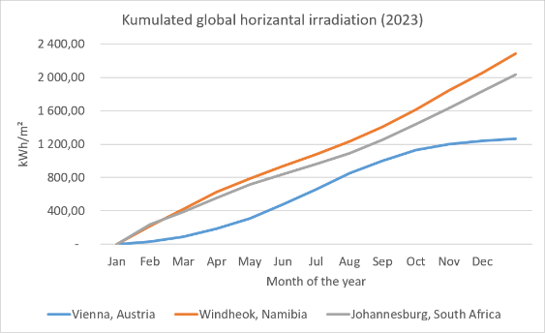
Figure 1 Cumulative global horizontal irradiation in Vienna, Windhoek and Johannesburg in 2023 (project data).
At the end of 2023, conventional solar-thermal installations in South Africa comprised 2,070 MWth, approximately 2.96 million m² of collector area and a calculated equivalent of 741,442 systems. Their estimated annual collector yield was 2,221 GWhth, while 120 MWth of new capacity was installed during 2023, corresponding to approximately 5.8% of the year-end stock [3]. PVT remains a niche technology in South Africa: at the end of 2024, only 878 m² of PVT collector area was reported, corresponding to 0.491 MWth and 0.108 MWp, while neither a national system count nor annual PVT energy production was available [3]. Its limited uptake can plausibly be attributed partly to higher initial costs and greater design and system-integration complexity compared with PV-only or conventional solar-thermal solutions.
Resulting from the SOLTRAIN-training initiative, 1,024 solar-thermal demonstration systems with 8,926 m² of thermal collector area have been installed, achieving an estimated annual thermal yield of 6,200 MWh_{th} and 2,471 t of avoided CO2 [4]. These totals shall demonstrate the significance of avoided greenhouse gases through defossilization with solar thermal. Yet these numbers are very little compared to the needed measures for the energy system in southern Africa. To further deepen the potential for solar thermal application in southern Africa this paper presents monitored thermal performance from three large domestic-hot-water demonstrations using different solar-heat configurations.
Solar thermal systems can deliver a high useful-heat yield per unit of aperture area when load and temperature levels allow efficient operation. Yet newly installed solely solar thermal system degrade on a wider market statistic. Where solar thermal once dominated the market, PV is taking over singlehandedly or in combination with heat pumps. As PV has a poor area utilization, in recent years PVT collectors emerged on the solar market. Combining electricity and heat generation on a temperature level suitable for domestic households, it is a promising solution for the future. Hence the Mediclinic PVT case is included for a specific comparative purpose: to evaluate, from measured data, how a hybrid PVT-plus-heat-pump system performs against solar-thermal-only and solar-thermal-plus-heat-pump configurations. The comparison will consider thermal yield, PV generation, heat-pump electricity and seasonal performance, thereby identifying advantages and disadvantages where roof area is limited.
- Monitoring Concept and Methodology
2.1 Measurement architecture
A monitoring system should make the energy path observable from the collector to the final load. Figure 2 shows a representative architecture comprising the primary collector loop, an external heat exchanger, the secondary loop (also the storage-charging circuit), stratified storage and the domestic-hot-water (DHW) circuit. Heat meters should be placed at the boundary required by each indicator: on both sides of the heat exchanger when a transfer ratio is evaluated, and in the DHW/load circuit for delivered useful heat. Each meter measures volume flow and a matched supply/return temperature pair, its integrator accumulates thermal energy. Irradiance measurement is required to calculate collector efficiency, while separately metered auxiliary thermal or electrical energy is required for an unambiguous solar fraction.
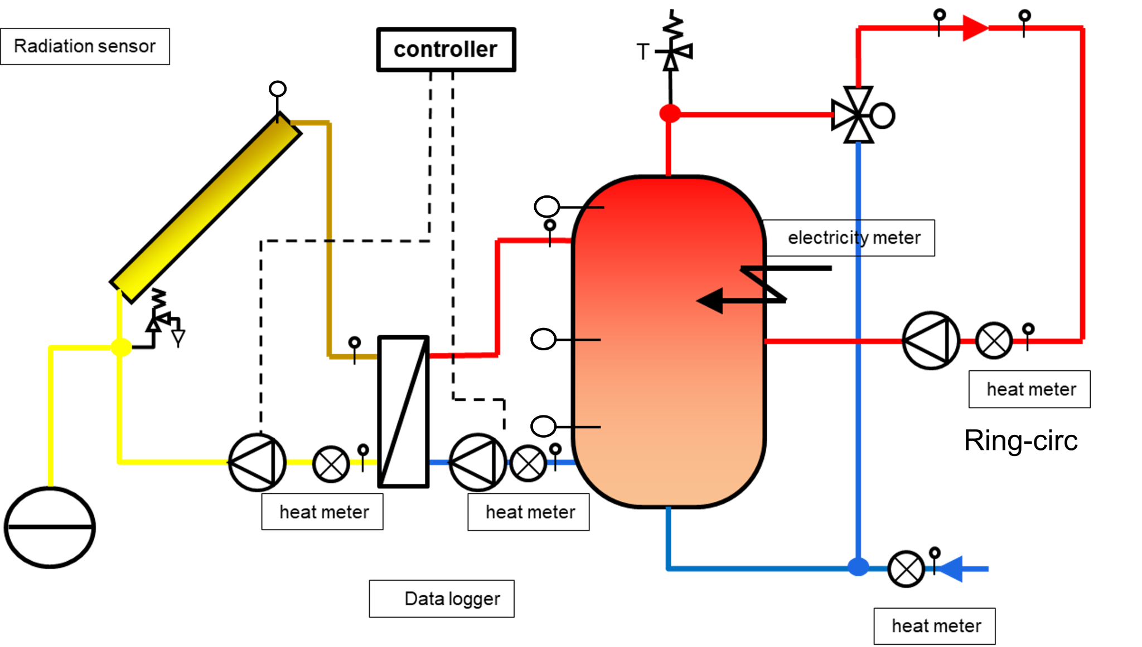
Figure 2 Representative monitoring concept with collector loop, external HX, stratified storage and DHW circuit [4]
A data logger time-stamps controller states and analogue values, stores them locally and optionally transfers them to an online platform. Online access shortens fault-response time and enables comparable key performance indicators across sites. A local circular buffer or SD card should bridge communication outages, and periodic exports should be archived independently. Raw data at one- to five-minute resolution are retained for troubleshooting, while daily and monthly aggregates support performance assessment. Clock synchronisation, units, sensor identifiers, calibration metadata and explicit missing-data flags are essential. The logger's aggregation mode must also be documented: instantaneous samples and interval means can produce different peak values. Figure 3 shows typical SOLTRAIN monitoring components.
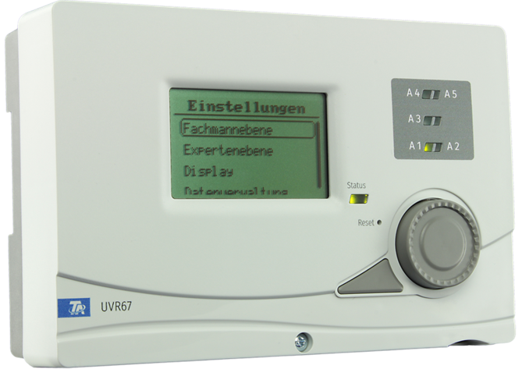  Controller  Source: Technische Alternative^{[5]} | 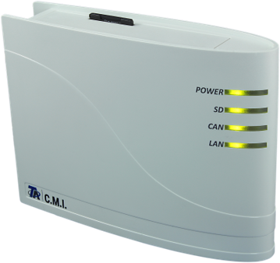  Data logger  Source: Technische Alternative^{[5]} | 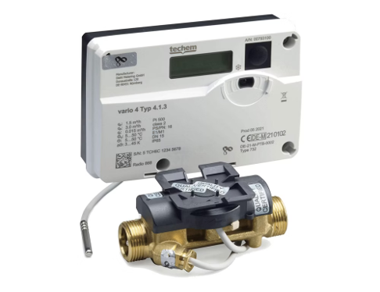  Heat meter  Source: Techem^{[6]} |   Temperature sensor  Source: Technische Alternative^{[5]}
Figure 3 Examples of the four core monitoring components used in solar thermal systems (project material).
2.2 Heat meters, temperature sensors and performance indicators
A thermal energy meter combines a volume-flow sensor, a matched temperature-sensor pair and an integrator. The installed Techem vario 4 units use either mechanical multi-jet/impeller or ultrasonic volume measurement. Mechanical meters are comparatively inexpensive but introduce moving parts, pressure loss and sensitivity to particles and wear, ultrasonic meters have no moving parts and typically lower pressure loss but remain sensitive to bubbles, deposits, minimum flow and the configured fluid properties. Meter selection must cover the expected flow range, temperature, pressure and water-glycol concentration. Installation and verification should follow the EN 1434 thermal-energy-meter series [7].
PT1000 resistance temperature detectors are used predominantly in the monitored systems. The temperature sensors data sheet from “Technische Alternative” specifies DIN Class B accuracy from 0 to 100 °C, corresponding to tolerances of ±0.30 K at 0 °C, ±0.55 K at 50 °C and ±0.80 K at 100 °C. The collector probe is rated for continuous operation up to 240 °C [8]. PT1000 sensors are preferred because their near-linear characteristic and tolerance curve are standardised in EN 60751, which supports interchangeability and plausibility checks, while the 1,000 Ω nominal resistance reduces the relative influence of lead resistance compared with a PT100. For heat metering, matched pairs, adequate immersion depth, thermal contact and insulation remain essential because the useful signal is the difference between two absolute temperatures.
For transparency, the physical basis used by the meter integrator is retained. For a finite fluid volume V, the sensible heat Q is calculated as
Q = V · ρ · cₚ · ΔT (1)
where ρ is density, cₚ is specific heat capacity and ΔT is the temperature change. For a flowing circuit, instantaneous thermal power and accumulated energy are
Q̇ = V̇ · ρ · cₚ · ΔT; Q = ∫ Q̇ dt (2)
To compare systems with one and another different indicators need to be calculated. The calculation is outlined in Table 1. For the specific yield the aperture is used to avoid different results due to physical differences of different collector brands. Additionally to the solar fraction a “proxy” solar fraction is introduced as some systems do not have measurements installed covering the auxiliary heating. Due to that, the solar fraction cannot be calculated and an approximation needs to be used. With the “proxy” calculation a first estimate can be calculated, but as the storage losses are not included in these calculations and as this remaining energy “demand” is supplied by the axillary heating, the total solar fraction is going to be slightly less.
Table 1 Solar thermal performance indicator formulas
Quantity | Equation | Description and unit
Specific collector yield | $$y_{spec} = \frac{Q_{sol}}{A_{ap}}$$ | Solar yield per collector aperture area; reported in kWh/m² for the measurement period or kWh/(m²·a) for a complete year.
Solar fraction | $$f_{sol} = \frac{Q_{sol,useful}}{Q_{load}}$$  $$= \frac{Q_{sol,useful}}{Q_{sol,useful} + Q_{aux,useful}}$$ | Share of the useful load supplied by solar heat; dimensionless or expressed as a percentage.
Proxy solar fraction | $$f_{sol,proxy} = \frac{Q_{sol,sec}}{Q_{DHW}}$$ | Applied when auxiliary heat is not measured separately. It is only an approximation because energy balance is not complete.
Heat-exchanger transfer ratio | $$r_{HX} = \frac{Q_{sol,sec}}{Q_{sol,prim}}$$ | Ratio between heat measured in the secondary charging loop and collector heat measured in the primary loop.
- Selected Demonstration Systems and Monitoring Results
To compare monitored solar-heat performance across different system configurations, three large DHW demonstrations are considered. Glenn Valley in Botswana uses flat-plate solar thermal collectors with installed electrical resistance backup; Katutura Hospital in Namibia couples flat-plate solar thermal collectors with a heat pump as the active auxiliary source; and Mediclinic in South Africa combines PVT collectors with two heat pumps. The comparison focuses on thermal output, aperture-normalised yield, solar fraction or a transparently labelled proxy, heat-exchanger transfer and if available auxiliary heat. The Mediclinic results remain pending until its final dataset is validated.
3.1 Glenn Valley Hostel, Botswana
Glenn Valley Hostel is a high-throughput DHW application with an external heat exchanger and two separately measured collector banks, shown in Figure 4. Owing to the roof geometry, the banks are physically separated but both face north. One bank has a 4 × 4 collector layout, elevated at 40° and 29.3 m² aperture area, while the other has a 4 × 5 layout, installed roof parallel around 20° and 36.6 m²; in each bank, two sub-arrays are connected in series. Each bank has its own pump with pulse-width modulation (PWM), and separate commands, flow, temperature, power and energy signals are recorded. From January to July, the bank meters accumulated 16.143 and 17.003 kWh, respectively, or 33.146 kWh in total. The corresponding seven-month yields are 551 and 465kWh/m². The external heat exchanger was dimensioned with a large heat transfer area, resulting in an heat transfer deltaT of only 3K. The external unit additionally separates the glycol collector circuit from the water-filled secondary circuit. Two storage tanks were used because they were easier to acquire and transport. Their serial connection supports a cooler return and a hotter delivery zone, although two vessels have more external surface area than one equivalent tank.
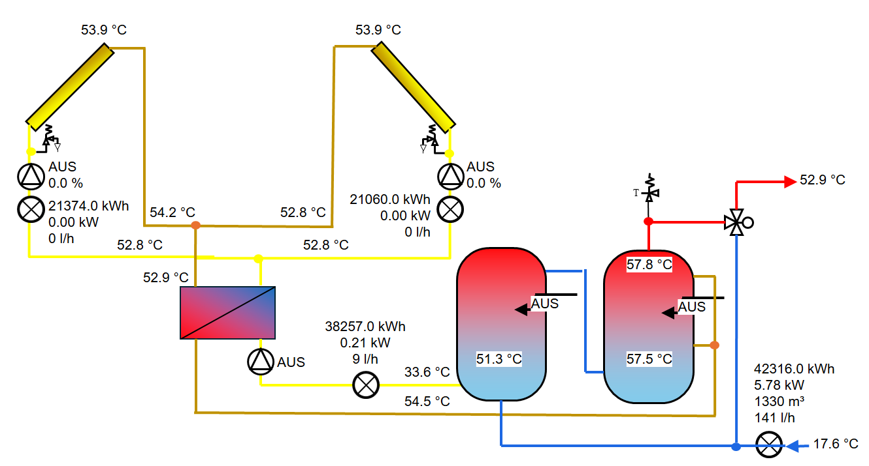
Q_{DHW}
Q_{sol,sec}
Q_{sol,prim,1}
Q_{sol,prim,2}
Figure 4 Graphical overview of the Glenn Valley system [4]
From January to July 2026, the two collector circuits produced 33.146 kWh in total and 29.400 kWh was measured on the secondary side of the heat exchanger, giving r_HX = Q_sol,sec/Q_sol,prim = 88.7%. Delivered DHW heat was 33.959 kWh. Electrical resistance heaters provide backup, but their electricity use and useful heat were not separately measured. The available proxy is therefore f_sol,proxy = Q_sol,sec/Q_DHW = 86.6%. This is not a 100% accurate solar fraction: solar heat is metered before storage, whereas DHW is metered after storage and auxiliary heating. Therefore, as not all of the storage losses are included in these calculations and as this remaining energy “demand” is supplied by the axillary heating, the total solar fraction is going to be slightly less. Across the full 65.9 m² aperture area, the measured seven-month specific yield was 503 kWh/m², providing a yearly expectation of 900 to 1000 kWh/m². DHW volume ranged from 103 to 183 m³/month, averaged 153.3 m³/month and totalled 1,073 m³ in only 7 months. This is respective to an average daily consumption of 4 to 7 m³. As the electrical grid in Botswana is also quite fragile, the hot water supply reliability has been increased. Because no irradiance sensor is installed, collector efficiency cannot be calculated from these data. Figure 5 summarises the measured boundaries.
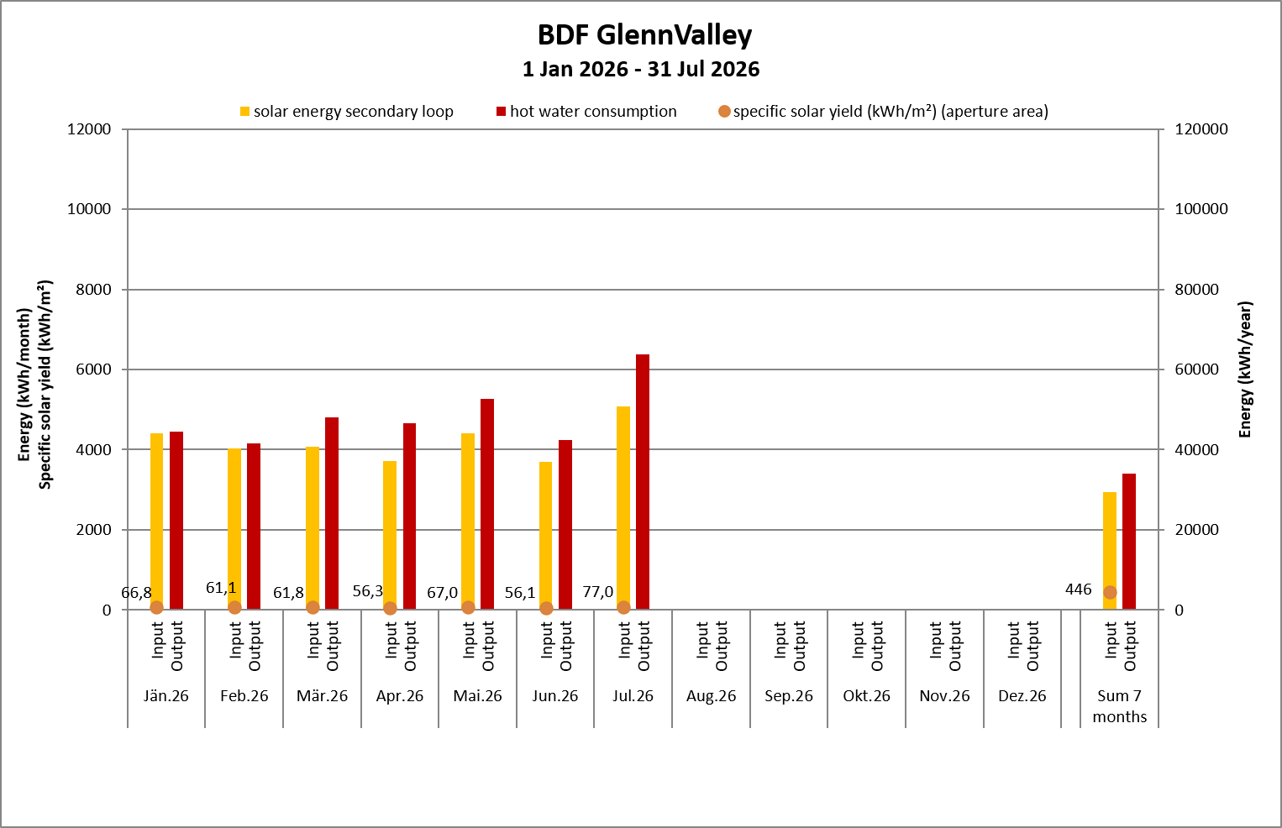
Figure 5 Measured monthly Glenn Valley energy balance and heat-exchanger transfer ratio, January–July 2026 [4]
3.2 Katutura Hospital, Windhoek
The Katutura Hospital combines large area (10 m² each) flat pate collectors with an air to water heat pump covering the residual demand through heating up the most left buffer tank. Additional heating elements are installed for backup but have not been used in this monitoring period. The system layout shown in Figure 6 lists two 1000-liter hot water tanks, which are supplied via the freshwater units. The internal coil implementation serves as a backup, as these coil-tanks were already existing. The serial designed buffer tank system totaling at 6000 liters, is based on a stratified principle where the solar system is charging the hottest buffer until the storage temperature is close to the secondary loop temperature, including a designated deltaT. Reaching this threshold a controlled valve switches the supply to the other buffer tanks, as indicated in the graphic below. This system layout ensures high yields through the use of freshwater units and using a separate buffer system for energy storage and stratification to ensure high solar yields through low supply temperatures to the solar collectors.
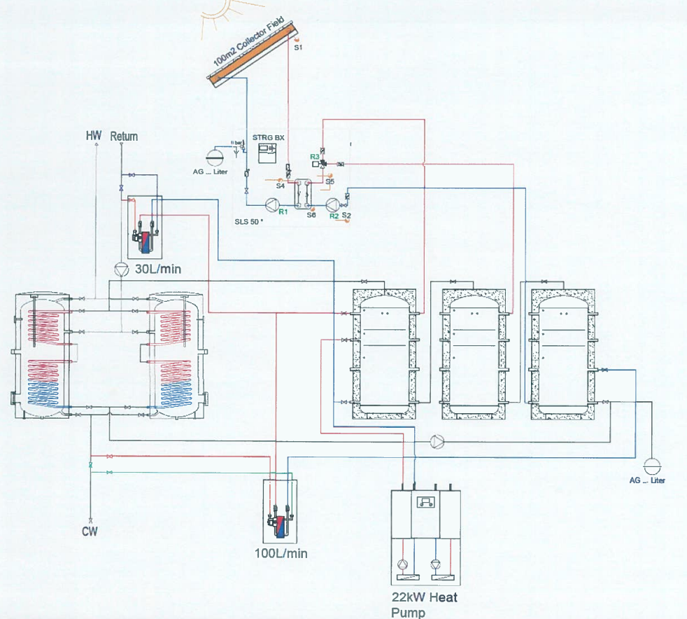
Figure 6 Katutura Hospital hydraulic scheme [9]
The Katutura Hospital balance covers January-December 2025 and uses 100 m² of collector aperture area. Measured solar heat (secondary loop) was 79.686 kWh and the thermal contribution from the heat pump was 15.160 kWh. The installed electric backup heaters were not used. On the output side, 50.110 kWh was measured for DHW draw-off and 44.846 kWh for the circulation loop losses. At the thermal-input boundary, f_sol = Q_sol/(Q_sol + Q_HP) = 84.0%, and the specific solar yield was 796.9 kWh/(m²·a). The heat pump COP averages a high 3.8 by providing >55 °C from June to Dezember where electricity measurement is available. Because no irradiance sensor is installed, collector efficiency cannot be calculated from these data.
Figure 7 shows that solar heat dominated every month, including winter, while the heat pump supplied a comparatively stable auxiliary contribution. The circulation loop losses accounted for 44.846 kWh, nearly half of the measured output.
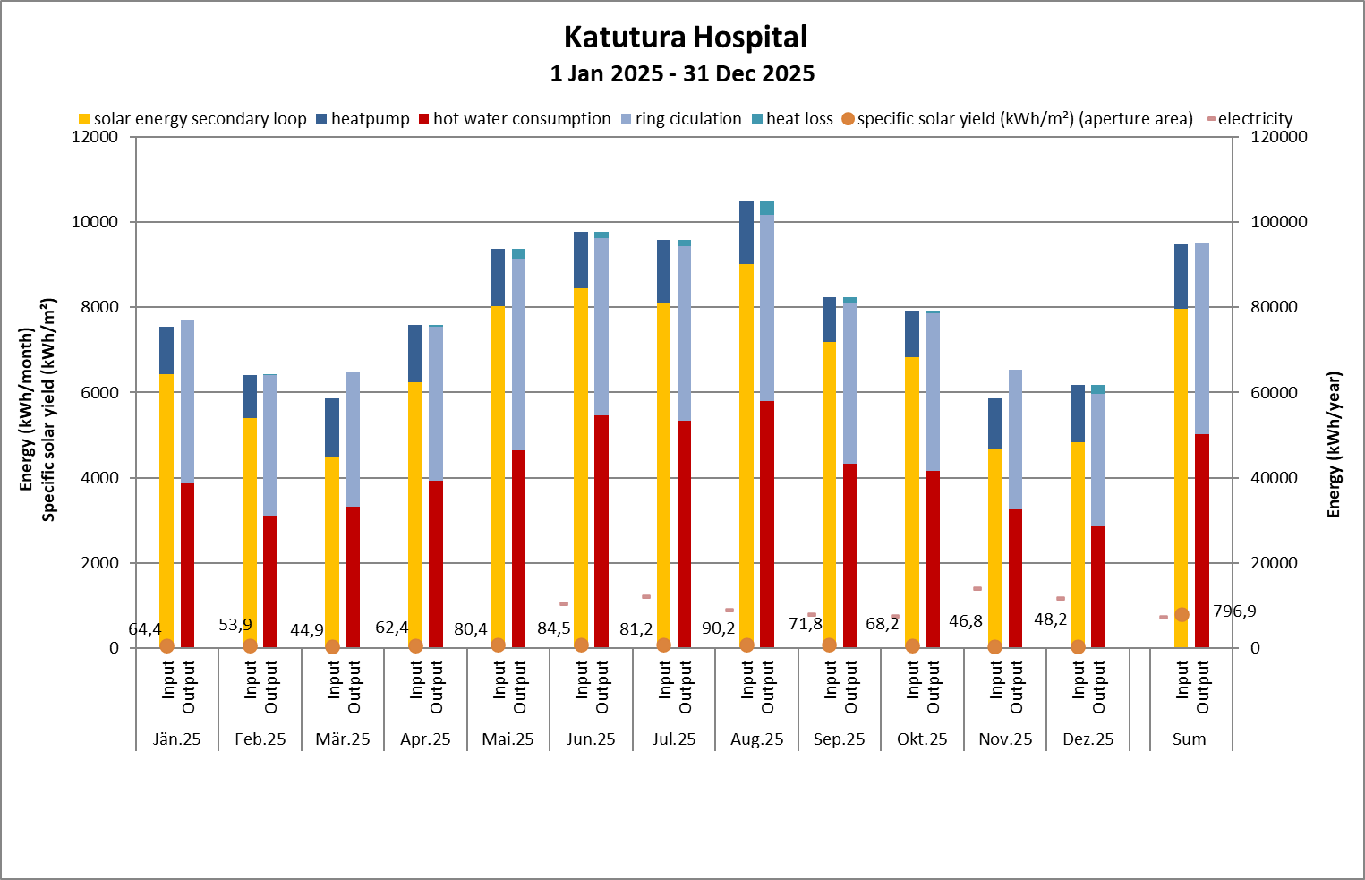
Figure 7 Measured thermal inputs and outputs of Katutura Hospital over 12 months in 2025 [4]
3.3 Mediclinic Hospital, Cape Town (PVT + Heat Pump Integration)
Mediclinic Hospital follows a hybrid approach based on PVT collectors rather than conventional solar-thermal collectors. The field consists of 100 Abora modules divided between north-western and south-eastern roof arrays, each installed at a 10° tilt. Based on the projects data, the field provides 188 m² aperture area (196 m² gross area) and 35 kWp electrical capacity. The modules can therefore generate electricity and low-temperature heat from the same roof area.
On the thermal side, the PVT circuit is hydraulically separated from an 8,8 m³ stratified solar buffer by a plate heat exchanger. A separate 4.5 m³ DHW storage tank supplies the hospital load. Cold-water make-up and demand-dependent charging of the DHW tank extract heat from the solar buffer and are intended to preserve a comparatively cold lower buffer zone and thus a low collector inlet temperature.
Auxiliary heat is supplied by 2 parallel water-to-water compression heat pumps using waste heat from one of the hospital's chiller circuits as its source. The hydraulic connection is partly serial: solar preheating is prioritised, while the heat pump provides the final lift to the required DHW temperature and serves as the back-up. The design intent is to reduce the required heat-pump temperature lift and avoid a hydraulic short circuit. The PV electricity can in principle offset part of the heat-pump electricity demand, subject to temporal coincidence and the electrical balance. Low PVT operating temperatures also support electrical output. The module data sheet specifies a maximum-power temperature coefficient of −0.36%/K [11]. Control therefore limits the thermal operating temperature to approximately 60 °C to avoid additional PV temperature losses.
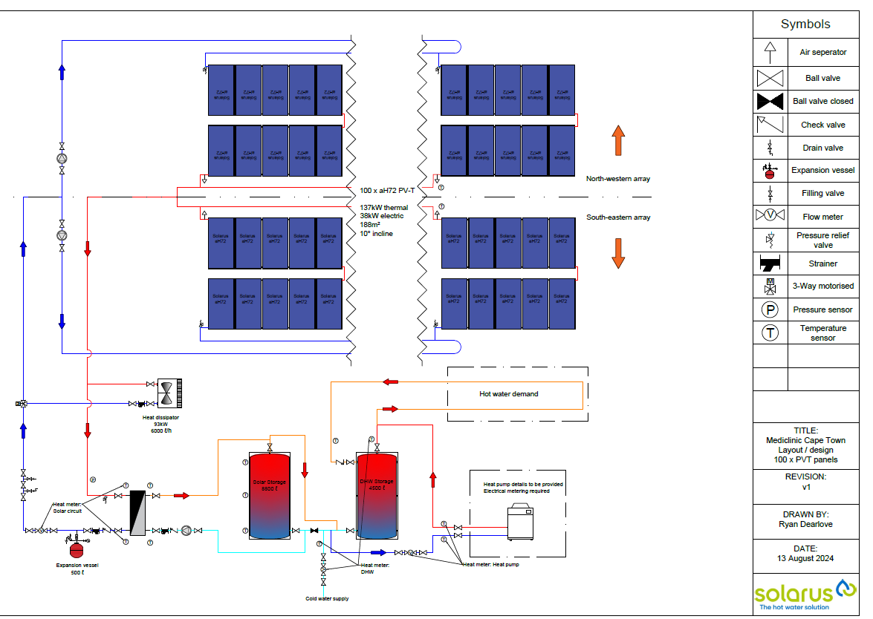
Figure 8 Hydraulic scheme of mediclinic hospital [10]
Monitoring data are available for January–August 2026 and provided in Figure 9. During these eight months, 24,577 kWh of solar heat were measured in the secondary charging loop downstream of the heat exchanger, corresponding to 130.7 kWh/(m²*8 months) of aperture area. The heat pump supplied a further 8,703 kWh of heat, while the PVT field generated 27,229 kWh of electricity. On the load side, 107,161 kWh were recorded for DHW draw-off and 122,354 kWh for the circulation losses. Thus, the measured solar and heat-pump inputs account for only 33,280 kWh of the 229,515 kWh output-side total. The residual 196,237 kWh, or 85.5% of the load-side balance, indicates unmetered auxiliary heat and/or poor system behavior. The solar fraction calculated as Q_sol,sec/(Q_DHW + Q_circ) is 10.7%, showing yet again the underperforming system behavior or measurement issues. Nevertheless, optimization measures have been discussed and performed, which are described in the following paragraphs.
The low thermal yield is consistent with the observed operating temperatures. Primary-loop flow frequently exceeded 2,000 l/h, equivalent to more than 21,3 L/(h·m²) (due to partly serial connection of the collectors) over the aperture area and therefore representative of low-flow operation. Under useful solar input it should produce a measurable collector temperature rise, but it has to be acknowledged that the system is east/west oriented and therefore prone to achieve lower total yields. Additionally according to the measurement the return temperature to the collector banks was elevated in the measurement period. Error control has shown that the ring circulation line has returned to the solar tank and not the DHW tank, resulting in an elevated tank and return temperature. Solving this issue has resulted in an increase of solar yield from average 50 kWh/day to 129 kWh/day, providing a positive outlook for increasing the solar performance. This increase has now to be validated through to coming monitoring period.
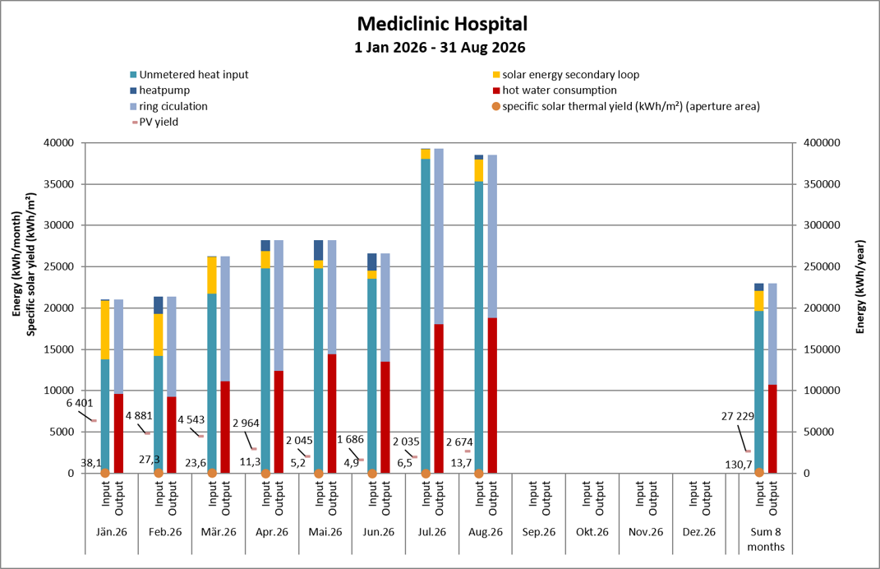
Figure 9 Measured monthly thermal and electrical energy balance of Mediclinic Hospital, January–August 2026 [4].
Electrical production was substantially less anomalous than the thermal output. The 35 kWp PVT field generated 27,229 kWh, corresponding to 778 kWh/kWp over the eight measured months. Taking into account the cape town is now drifting into high radiation season 1,200 to 1,300 kWh/kWp can be expected. The value remains below the approximately 1,500–1,700 kWh/(kWp·a) long-term potential indicated for Cape Town by the Global Solar Atlas [12]. Elevated cell temperature is a plausible contributor, consistent with the −0.36%/K coefficient, but orientation, shading, soiling, inverter availability and curtailment can also reduce yield.
Heat-pump performance requires a distinction between conversion efficiency while operating and total contribution over the monitoring period. The units supplied only 8,703 kWh of heat in eight months despite an installed rated thermal capacity of 27,31 kW_{th} and 67,10 kW_{th}, respectively. Nevertheless, the monthly coefficients of performance range from 3.18 to 4.12, with an average of 3.82, indicating reasonable conversion efficiency during measured operation. The low heat contribution is instead consistent with limited source availability. When the heat pump cools the return of the connected chiller below its permissible range, that chiller switches off and the heat pump loses its source, while three other chillers continue to satisfy the hospital's cooling demand.
No permanent correction had been implemented by the end of the evaluated period. Two options are under investigation: limiting heat extraction to maintain a minimum chiller return temperature or connecting the heat pump directly to the primary chiller-water circuit to obtain a more stable source flow. Before either measure is implemented, the required source temperatures and flow rates, the chillers' permissible operating envelope, the heat pump's evaporator limits and the resulting COP must be evaluated.

- Conclusion
The three demonstrations show that system architecture and system functionality matter more than technology labels alone. On a fully measured annual thermal basis, Katutura Hospital delivered the strongest result: 79,686 kWh of solar heat, 796.9 kWh/(m²·a) and an 84.0% solar input fraction. Glenn Valley reached 503 kWh/m² in only seven months and transferred 88.7% of collector-loop heat across the external heat exchanger. Mediclinic provides the broadest service: heat, electricity and waste-heat upgrading, but currently has the weakest thermal result. Its 130.7 kWh/m² over eight months is not yet usable for comparison as this system is currently undergoing fault analysis and improvement measures. Table 2 reports period, boundary and potential impact generated together.
Table 2 Comparison of evaluated systems
System | Destination | Configuration | Spec. solar yield | Solar Fraction | CO₂ Impact  _{(1 kg CO2-eq/kWhe)}
Glenn Valley, Hostel | Gaberone, Botsuana | Flat Plate | 503 kWh/  (m²*7 months) | 87 % | 29 tons  58 tons potential
Katutura Hospital | Windhoek, Namibia | Flat Plate + Heat Pump | 797 kWh/(m²*a) | 84 % | 91 tons  95 tons potential¹
MediClinic Hospital | Cape Town, South Africa | PVT +  Heat Pump | 131 kWh/  (m²*8 months) &  778 kWh/  (kWp*8months) | 11 % | 33 tons  344 tons potential¹

The impact extends beyond annual energy. Solar heat, thermal storage and efficient auxiliary heat pumps can reduce electric-water-heating demand during daytime and peak periods, lower distribution losses and tariff exposure, and improve hot-water resilience in hospitals and residential facilities. These benefits are especially valuable in South Africa: Eskom reports that stationary combustion emitted almost 1.00 kg CO_{2-eq} per kWh sent out in 2023 [13].
Africa is becoming the new emerging market for solar thermal and other solar technologies. With an increase of population from 1.6 to 2.5 billion and an increase of thermal energy demand by the factor 2, the potential and need for renewable technologies, especially solar technologies, become determined. Not only can these technologies provide clean energy but especially in this developing society, solar technologies can bring cheap energy to already struggling societies. Furthermore, the climatical impact, especially in South Africa with 1.00 kg CO_{2-eq} per kWh electricity, is significant in Africa, where these fossil neutral technologies can provide very high impacts.
Future demonstration plants should therefore be commissioned as measured energy systems: irradiance, collector and charging-loop heat, delivered DHW, circulation, auxiliary heat and electricity must share synchronised intervals and explicit boundaries. The evidence from Katutura and Glenn Valley already confirms that high solar fractions and high area-specific heat yields are achievable. Mediclinic shows the additional impact available from PVT and waste-heat recovery once hydraulic and control faults are resolved. The most scalable pathway is consequently not a single technology winner, but solar thermal as the low-marginal-cost heat source, heat pumps for efficient lifting and resilience, and PVT where roof competition justifies co-generation. After capital and maintenance are accounted for, the solar resource itself carries no fuel cost:
-----------------------The sun sends no invoice. -----------------------

- Literature
[1] International Energy Agency, Africa Energy Outlook 2022. Paris, France: IEA, 2022. [Online]. Available: https://www.iea.org/reports/africa-energy-outlook-2022. Accessed: Aug. 6, 2026.
[2] Energy Sector Management Assistance Program and Solargis, Global Solar Atlas 2.0 Technical Report, Rep. 170-14/2019. Washington, DC, USA: World Bank, 2019. [Online]. Available: https://documents1.worldbank.org/curated/en/529431592893043403/pdf/Global-Solar-Atlas-2-0-Technical-Report.pdf. Accessed: Aug. 6, 2026.
[3] M. Spörk-Dür, Solar Heat Worldwide 2025: Global Market Development and Trends 2024, Detailed Market Figures 2023. Gleisdorf, Austria: AEE INTEC and IEA SHC, 2025, doi: 10.18777/ieashc-shww-2025-0001.
[4] AEE INTEC, SOLTRAIN system documentation and monitoring datasets, unpublished project material, 2025-2026.
[5] Technische Alternative RT GmbH, ‘Temperature Sensors,’ Version 1.5, Amaliendorf, Austria, 2017. [Online]. Available: https://www.ta.co.at/en/downloads/file/1128. Accessed: Aug. 31, 2026.
[6] Techem Energy Services GmbH, ‘Messkapsel-Wärmezähler Typ 4.1.1’ and ‘Ultraschallzähler 4.1.3,’ product data sheets, 2026. [Online]. Available: https://www.techem.com/content/dam/techem-ch/documents/geräte/wärmezähler/d_6.1.1_Funk%20Messkapsel-
[7] Thermal Energy Meters - Part 1: General Requirements, EN 1434-1:2022, European Committee for Standardization, Brussels, Belgium, 2022.
[8] Temperature Sensors Data Sheet, Technische Alternative, Vers. 1.5EN, „KTY and PT1000 acuracy“, Available: https://www.ta.co.at/download/datei/1128
[9] Werner Sebastian, “Hydraulic Scheme Katutura, Solarenergy South Africa, unpublished project material, Website: https://solarenergy.co.za
[10] https://solarus.com/en/solutions/
[11] Abora Solar, ‘aH72SK Hybrid Solar Panel Data Sheet,’ ver. 5, Zaragoza, Spain, Nov. 30, 2022. [Online]. Available: https://abora-solar.com/. Accessed: Sep. 3, 2026.
[12] Energy Sector Management Assistance Program and Solargis, ‘Global Solar Atlas: Site data for Cape Town, South Africa,’ World Bank Group. [Online]. Available: https://globalsolaratlas.info/map?r=ZAF&c=-33.928830,18.417220,11&s=-33.928830,18.417220&m=site. Accessed: Sep. 3, 2026.
[13] Eskom Holdings SOC Ltd., 2023 Carbon Footprint Report, document 240-164779414, rev. 4, Johannesburg, South Africa, May 2025. [Online]. Available: https://www.eskom.co.za/wp-content/uploads/2025/07/Carbon_Footprint_Report_2023.pdf. Accessed: Sep. 3, 2026.

„potential“ is meant as if 100 % of the DHW demand is supplied renewably for 1 whole year (linear interpolated except Katutura)

