EuroSun2026
FAÇADE AS HEAT SOURCE IN HEAT PUMP SYSTEMS FOR MULTIFAMILY HOUSES: POTENTIAL ANALYSIS AND IMPLEMENTATION OF TWO DEMONSTRATION BUILDINGS

Federico Giovannetti¹ (corresponding author), Edward Frick¹, Christoph Buettner¹,
Michael Eberl², Herbert Sinnesbichler²
¹Institute for Solar Energy Research Hamelin (ISFH), Emmerthal (Germany)
²Fraunhofer Institute for Building Physics IBP, Holzkirchen (Germany)
E-Mail: giovannetti@isfh.de
Summary
Heat pumps are expected to almost completely replace fossil-fired boilers in the European building sector in the next two decades. The targeted transformation represents a huge challenge, especially for densely populated urban areas with space, geological or other kinds of constraints (noise, regulations, general acceptance issues). The energetic use of the building envelope offers a promising alternative to conventional heat sources with untapped potential. The work discusses the use of thermally activated, rear-ventilated façades as additional heat source in heat pump systems for multifamily houses. Our simulation study with the software TRNSYS based on validated models shows, that these new façades can reduce the size of borehole fields up to 36% in small buildings with 8 residential units. After this first theoretical analysis we present heat supply concepts, practical experiences and monitoring results of two demonstration buildings with different active façades, which were implemented in 2023 und 2025 respectively.
Keywords: solar façade, ground-coupled heat pumps, multifamily houses, solar regeneration
Field of application for the findings: energy-efficient building design and renovation
Addressed audience: façade and heat pumps manufacturers, housing companies, architects, building system engineers, energy consultants, researchers
- Introduction
Heat pumps are expected to progressively replace fossil-fuel-fired boilers as the primary heat generator in the European building sector. Energy scenarios for achieving Germany’s climate goals project an increase in the number of heat pumps from 2 million today to as many as 15 million by 2045 (Fraunhofer ISI et al., 2024). The targeted market growth represents an enormous challenge, particularly in urban areas (Fraga et al., 2018). A key issue here is accessing the heat source of heat pump systems, as installation conditions are often unfavorable (lack of space, noise emissions, distance regulations as well as general acceptance issues).
Solar thermal collectors can mitigate this challenge by both serving as a direct heat source for the heat pump or regenerating other heat sources like geothermal systems or ice storages. While traditional rooftop installations have long been established for this purpose (Hadorn, 2015; Carbonell et al., 2015), the use of the building envelope remains an unconventional alternative that has been tested exclusively in research works or rare pilot projects (Giovannetti et al., 2016; Tanzer et al., 2018; Koch et al., 2020). A key benefit here is the synergy resulting from the combined renovation of the building envelope and the building system engineering, which can lead to cost savings.
In an ongoing research project, a team of facade manufacturers, housing companies, and research institutes is systematically investigating the potential of solar-thermally activated, rear-ventilated façades as heat pump sources in apartment buildings. What makes the project approach particularly remarkable is, on the one hand, the use of standard façade claddings as solar absorbers and, on the other hand, the invisible integration of heat exchangers into the ventilation gap, ensuring that the resulting appearance is not distinguishable from that of conventional façades. Following the successful development of different façade and heat supply concepts, the project has moved 2023 into the demonstration phase, aiming at the construction and scientific monitoring of two pilot buildings. In both cases the façade is implemented as an additional heat source and for the regeneration of borehole heat exchangers (BHE).
After a theoretical analysis of the potential of the façades for this specific application based on system simulations, the paper presents and discusses the heat supply concepts of the buildings, focusing on the practical aspects of the implementation, as well as first monitoring results.
- Potential analysis
To analyze the energy potential of the façade as an additional source in geothermal heat pump systems, we performed coupled simulations using the programs TRNSYS and EED (Earth Energy Designer) on a reference building. Our study examined the influence of the solar façade on thermal regeneration and, consequently, on the sizing of the ground-source heat exchanger, using TRNSYS to model the building and its associated systems and EED for the long-term analysis of the geothermal boreholes field.
The reference building is a detached multifamily house consisting of 4 stories, each comprising 2 apartments with 84 m² of living space (see Figure 1). The building’s heat demand is 23.3 MWh/year for space heating and 10.5 MWh/year for domestic hot water preparation (DHW). The building envelope meets the German energy Standard “Effizienzhaus 55”, with rear-ventilated façade featuring 18 cm of mineral wool insulation. The domestic hot water profiles for the 8 residential units were generated using the established DHWCalc program (Jordan et al., 2019) assuming an average consumption of 89 l/d (65 l/d to 119 l/d) at 45 °C.
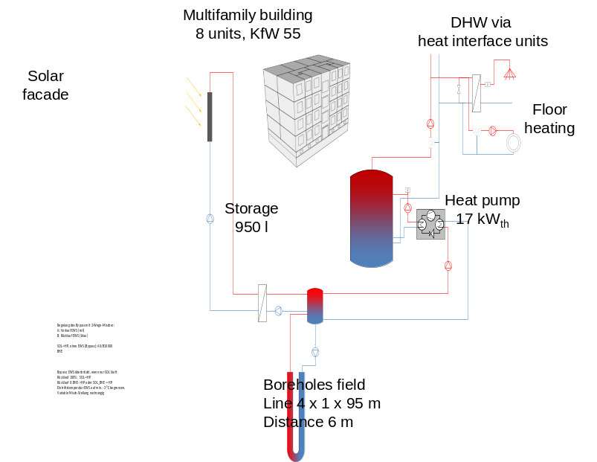
Fig. 1: Schematic representation of the investigated heat supply concept
Heat is generated by a modulating brine-to-water heat pump with a maximum power of 17 kW_{th}. A buffer storage tank with a volume of 0.95 m³ supplies the heat interface units installed in the individual apartments via a 2-pipe loop system. Heating is provided by underfloor heating (35/30 °C). When outdoor temperatures exceed 15 °C (moving 24-hour average), the space heating is deactivated. Depending on the hydraulic configuration, the heat pump can use either the BHE or the solar façade - or a combination of both - as heat sources. The two sources are connected to the heat pump’s evaporator via a hydraulic separator. The selected control strategy is crucial for system evaluation: If the façade temperature is above the temperature of the BHE (3 K < ΔT < 5 K), both sources can be operated simultaneously. If the façade temperature is significantly above the temperature of the BHE (ΔT ≥ 5 K), the façade can also serve as the sole heat source. When the facade temperature is higher than the temperature of the BHE, and there is no heat demand in the buffer tank, the ground can be actively recharged by the solar façade. In its standard configuration, the field consists of 4 boreholes arranged in a line, each at a depth of 95 m and spaced 6 m apart. The array geometry was determined in accordance with the German Guideline VDI 4640 for systems with a heating power of less than 30 kW (VDI, 2019). The BHE length is defined considering the German Federal Mining Act, which requires additional permitting procedures for drillings exceeding 100 m (Bundestag, 1980). The criterion for designing the BHE field is to maintain a monthly average inlet temperature of 0 °C in the field over 50 years of plant operation. The simulations are performed using this reference system as an example, with the understanding that regeneration effects become more significant and the savings in BHE length are higher as the field size increases.
Based on performance data measured at the ISFH for a large-scale metal façade (Frick, 2022; Frick, 2025), the reduction of BHE length was determined as a function of the façade area, orientation, and color. To contextualize the results, the thermal performance of the façade is compared to that of a commercially available, roof-mounted, uncovered collector (south-facing, 45° tilt), which can be used for the solar regeneration of ground-sources or ice storage systems. The area was varied up to 200 m² to analyze the trends in the curves, with the maximum available opaque areas of the reference building being 145 m² for the south and north facades and 131 m² for the east and west facades. The flat roof has an area of 183 m². The corresponding performance coefficients according to ISO 9806 (ISO 9806, 2018) are shown in Table 1. The collector characteristics are also derived from ISFH measurements (Rockendorf, 2001).
Tab. 1: Performance coefficients according to ISO 9806 for façade module and roof absorber (swimming pool absorber)
used in the simulation study
Parameter | Unit | Metal façade | Rooftop collector
η_{0b} | - | 0.590 | 0.892
b₀ | - | 0.055 | 0.055
K_{d} | - | 0.98 | 1.00
a₁ | W/m²K | 10.96 | 13.92
a₂ | W/m²K² | 0.00 | 0.00
a₃ | J/m²K | 1.22 | 3.64
a₄ | - | 0.212 | 0.782
a₅ | J/m²K | 22755 | 18900
a₆ | s/m | 0.039 | 0.017

The change in façade color (dark, medium, and light gray) was implemented by adjusting the conversion factor η_{0b} (0.59 > 0.44 > 0.24) and by a parallel shift of the power curve.
The results of the simulations are shown in Figures 2 and Figure 3 and can be summarized as follows:
- The rooftop collector achieves maximum reduction of 43% starting at 145 m², with a regeneration efficiency of 95%. Larger collector field and higher yields do not provide any additional benefits. Significant savings of 30% - enough to eliminate one of the four BHE and save 36 m² ground area - are already achieved with 45 m² collector;
- The south-facing reference façade (dark gray, η_{0b} = 0.59) achieves a 30% reduction with a regeneration efficiency of over 60% when the active area is 85 m² or greater (approximately 40% of the total façade area). The total length of the BHE can be reduced by up to approximately 36%;
- The use of façades with other orientations yields lower reduction; however, due to the low operating temperature and the additional function as an environmental heat exchanger, the influence of orientation (i.e. solar radiation) is less significant than in traditional solar thermal applications: With 85 m², the east and west facades enable savings of approximately 20% and 25%, respectively; even the north facade can achieve savings of up to 15%;
- The change in color is also not as significant as it is with typical solar collectors, as it can be deduced from the relationship between the conversion factors and the correspondent savings achieved. Even light-colored, north-facing solar thermal facades can make a valuable contribution and enable reductions in BHE meters of over 10%.
Based on the simulation results and considering market prices for BHE in recent years, Figure 2 also shows exemplary values for the specific economic savings related to the reduction of the BHE length for the south-oriented façade, which have to be taken into consideration for the design and cost assessment of the system.

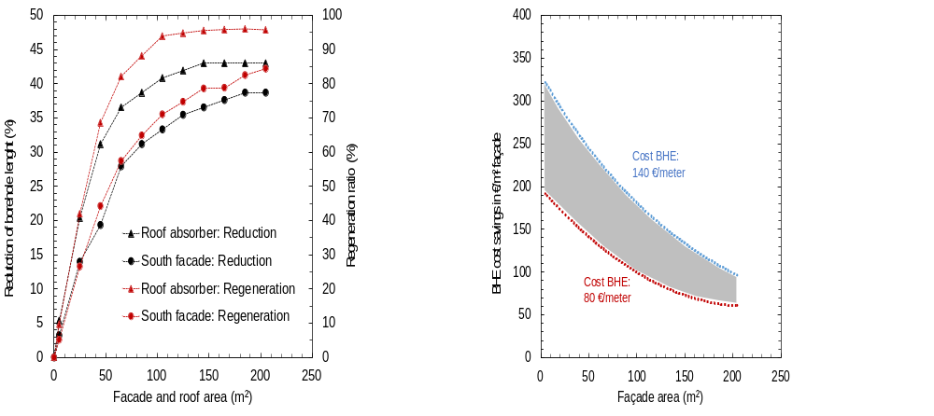Fig. 2: Regeneration ratio and savings in BHE meters for the reference system as a function of the area of the supporting heat source for a dark gray south-facing façade and a roof-mounted collector (left) as well as specific cost savings related to the reduction of BHE for the dark gray façade as a function of façade area and BHE costs (right)
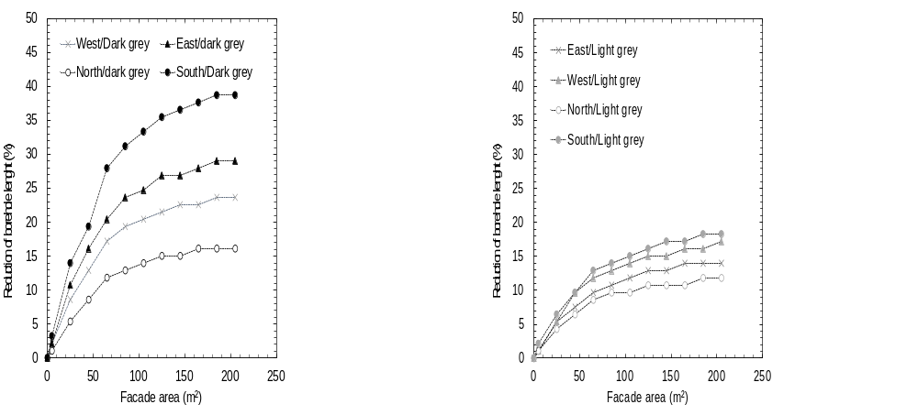
Fig. 3: Savings of BHE meters for the reference system under consideration, as a function of color (dark and light gray, with η₀=0.6 on the left and η₀=0.2 on the right) and the orientation of the solar-activated façade
Overall, the study shows that solar-thermally activated rear-ventilated façades in multifamily buildings are well-suited and sufficiently large for the regeneration of BHE fields. Combinations of differently oriented façades with varying colors offer both high potential and a high degree of flexibility and design freedom. In ongoing research, the simulations are being extended to include larger buildings or building complexes and correspondingly larger BHE fields. Based on the results of the extended study, the project is developing a practical design tool to assess the suitability and perform rough sizing of solar-thermal façades in multifamily buildings, taking into account general information like building’s heat demand, façade design, and façade’s properties.
- Demonstration buildings
The construction of the two demonstration buildings is intended to validate the results of the theoretical study and the experimental investigations of components and subsystems in a practical setting. Key aspects of the demonstration include analyzing the planning and installation processes, evaluating the effort and costs compared to conventional solutions, and identifying critical steps and potential optimizations.
3.1 Multifamily building in Pforzheim
3.1.1 Overall system
The first pilot project is a newly constructed multi-story residential building in Pforzheim (Germany) consisting of 19 residential units, each with 2–3 rooms, which was completed in 2023 (see Figure 4). The building was constructed on the site of a former watch factory from the 1950s. Its urban design is modeled after the former structure but allows for significantly better use of the lot and a high-quality residential layout. Innovative concepts according to the Germany Energy Standard “Effizienzhaus 55” were implemented for both the façade design and the system technology. For the heating system, the housing company Pforzheimer Bau und Grund opted for a highly efficient, single-energy solution featuring two brine-to-water heat pumps.
A preliminary study in the planning phase showed that the lot area was insufficient for installing the necessary BHE, but that the project offered an ideal opportunity to test the facade as a supplementary heat source. The system concept was developed in close collaboration between the housing company, its technical planners, the research partner (ISFH and Fraunhofer IBP), and GASAG Solution + GmbH. Heating loads and useful energy requirements for space heating and domestic hot water (52 MWh/a and 20 MWh/a, respectively) were determined by the housing company. The focus of the system simulation conducted at ISFH was on the design of the innovative heat sources and the overall system. To this end, based on the reference multifamily building used for the simulation study presented in Section 1, the components, the heat distribution, and the weather data were adjusted, and the energy demands were subsequently scaled without exactly modeling the building geometry.
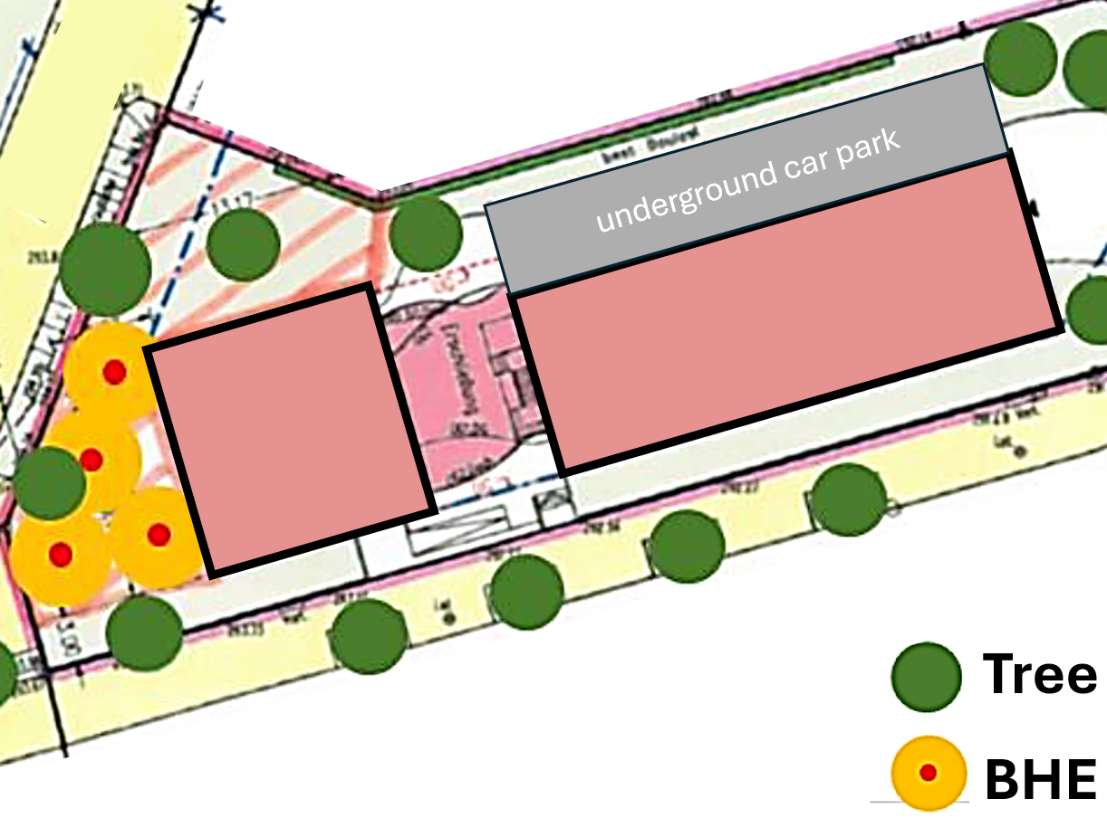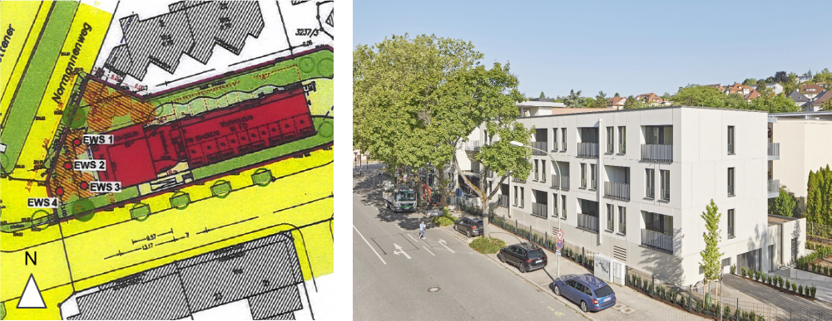
Figure 4: Location of the four installed BHE (left) and the completed apartment building with a solar-thermal concrete facade in Pforzheim (right)
For the BHE field, two different configurations with double-U probes were investigated, at depths of 100 m and 150 m, respectively. For both variants, the coupled simulations using TRNSYS and EED show that 100 m² of solar-thermally activated modules of the planned concrete façade (13% of the total opaque façade area) enable a 25% reduction in the total length or number of BHE, thereby facilitating easier integration into the property: From 8 to 6 BHE at a depth of 100 m, and from 4 to 3 BHE at a depth of 150 m. In total, the façade supplies 24 MWh/a through the activation of 75 m² of the east facade (34% of the corresponding opaque area) and 25 m² of the west facade (10% of the corresponding opaque area). The system efficiency remains unchanged: The seasonal performance factor (SPF) is 4.5 for the heat pump (SPF_{HP}) and 3.2 for the entire system up to the heat output (SPF_{SYS}).
For space-saving and economic reasons, on the actual building the smaller array of 4 BHE was installed at a spacing of approximately 6 m. The experimental setup was designed so that one BHE can be shut off, allowing the system behavior to be investigated and compared with both 4 and 3 BHE over two consecutive operating years. The heating system consists of two non-modulating heat pumps (power = 19.6 kWth, COP = 4.54 at B0/W35), which can be operated individually or in parallel, and three thermal storage tanks, each with a volume of 0.95 m³. A hydraulic separator was installed to ensure optimal management of the various heat sources (ground, west and east facades). For heat distribution, the storage tanks are connected to the heat interface units in each apartment via a 2-pipe system. The central flow temperature is 42 °C to preheat the domestic hot water (post-heating via electric instantaneous water heaters).
The complete system, including measurement and data acquisition technology, was commissioned in the summer of 2024 and has since then been scientifically monitored by the Fraunhofer Institute for Building Physics IBP. Figure 5 shows the average monthly seasonal performance factors (MPF) for the heat pump (MPF_{HP}) and the entire system up to heat distribution (MPF_{SYS}), as well as the contributions of the facades during the second operation year with 4 BHE (second year with 3 BHE started in August 2026). The SPF_{HP} of 4.5 is nearly identical with the simulation expectations. The increase of MPF_{HP} in November and December was achieved by optimization of volume flows at the hydraulic separator. The low MPF_{SYS} and its pronounced progression are particularly striking. The lower efficiency is attributable, on the one hand, to the decentralized electric DHW heating and, on the other hand, to distribution and storage losses in the system, which are currently being investigated. Over the entire measurement period, the seasonal performance factor SPF_{SYS} is 2.6.
The solar façade has generated around 23.3 MWh over its operational period (east facade: 18.9 MWh, west facade: 4.4 MWh). Of this, 15.7 MWh is used for ground-source regeneration and 7.6 MWh for directly powering the heat pump. The specific yields of the solar façades are in good agreement with the expected values based on the simulation study. According to the latest analysis, the slightly lower production is attributable to the system being oversized in its configuration with four BHE, which requires less regeneration, as well as to suboptimal control algorithms, which differ from those used for the simulations. Once the errors have been corrected and the optimizations implemented, the system is to be operated and monitored in the target configuration with a reduced BHE field.
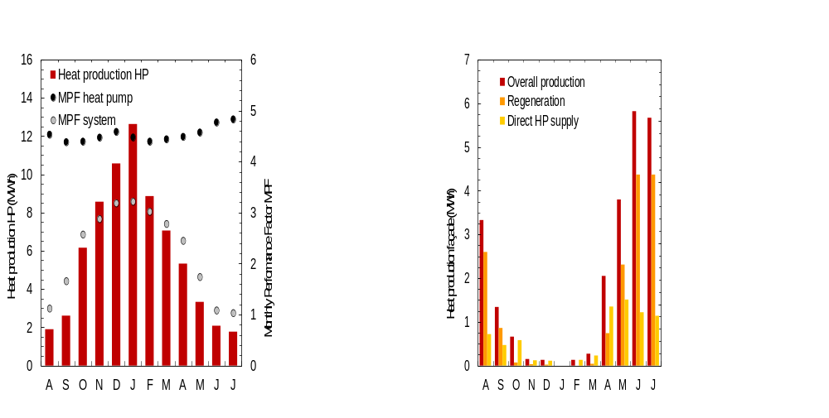Figure 5: Thermal output of the heat pumps and monthly performance factors for the heat pump and the entire system (left), as well as facade yields (right). Results of the monitoring by Fraunhofer IBP (August 2025 to July 2026)
In addition to the monitoring results, the following general findings from the planning, implementation, and operation are to be highlighted:
- In multi-source heat pump systems such as this one, source management represents the main challenge for the system engineering. In this regard, building façades do not differ significantly from other heat pump or regeneration sources. During the considered monitoring period, typical errors occurred: incorrectly sized pumps, incorrect positioning of sensors for the control system, or imprecise settings for control and regulation criteria. The effort required and the risk of errors increase with the growing number of sources - in this case, the thermally activated facades of a building (here, the west and east facades);
- Due to the novelty and complexity of these systems, clear communication and efficient collaboration throughout the entire planning and construction process between housing companies, technical planners, contractors, and manufacturers are significantly more critical than in standard practice. To ensure that systems of this kind can enter the market after the scientifically supervised monitoring period, a pragmatic reduction in complexity and the development of a practical guideline for planning, installation, and operation—based on project experience - are essential and have been planned for in the project;
- The ongoing cost analysis shows that, despite synergy effects and savings on borehole meters (€130/m), the new system in its prototype stage is significantly more expensive than conventional solutions. However, it is not the façade modules themselves but rather the peripheral components and the additional efforts for planning and installation (personnel costs) that play the decisive role. It is expected that simplifying and standardizing concepts and processes can significantly improve the cost-effectiveness of the system. The aforementioned guideline will also make an important contribution in this regard.
3.1.2 Solar-active concrete façade
The rear-ventilated facade consists of load-bearing limestone masonry (20 cm), thermal insulation (18 cm mineral wool), ventilation gap (4 to 5 cm), and precast concrete cladding panels (12 cm thickness). Thermal activation is achieved by integrating polypropylene capillary tube mats during the manufacture of the concrete elements (see Figure 6).
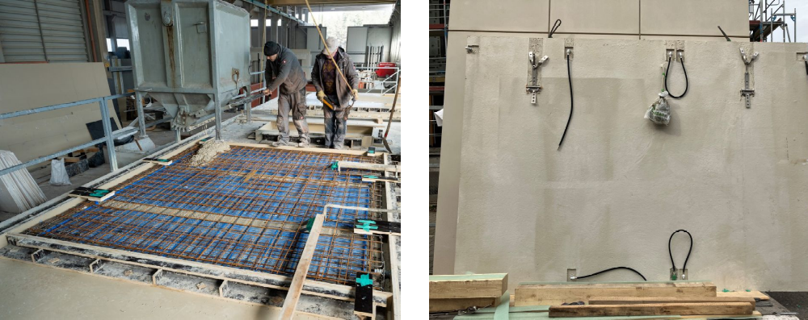
Figure 6: Manufacture of a solar-active concrete element for the façade of the building in Pforzheim (left) and the back of a finished module with hydraulic connections (right)
Solar-active façade modules with different properties were developed and investigated during the first phase of the project, as the material composition, structure, and surface color, as well as the arrangement of the capillary tubes within the panels, have a significant impact on their energy performance. Double-reinforced beige modules with heat exchangers embedded close to the outer surface were used for the building. On the east side, 9 concrete modules with a total area of 89 m² have been installed and fixed to the floor slabs using facade anchors. The west side features 3 modules with a total area of 30 m². All active façade elements are connected to the supply and return lines via flexible hoses with plug-in fittings, following the Tichelmann principle. From the various phases leading up to the commissioning of the façade, the following key insights and differences from conventional processes can be identified:
- Planning: Due to the different skills required for the task, the façade design called for close collaboration among manufacturers (concrete façade and heat exchanger), the housing company’s technical planners, and researchers. For future applications, the mentioned guidelines and planning tool are aimed at empowering façade manufacturers to independently design projects using their innovative solar-active products;
- Manufacturing: Production at Hemmerlein Company proceeded as planned. In addition to integrating the capillary tube mats by fixing them to the reinforcement, another important step is to perform an air pressure test on the mats before embedding them in concrete. This process allowed the project team to detect damage to individual capillary tubes that would otherwise have resulted in leaks. The damaged mats were simply replaced, although repair options on-site are also conceivable and can be taken into consideration in future projects;
- Transport: Compared to standard concrete elements, special care must be taken during the transport of active modules to protect the connection supports protruding from the concrete. In the project, the connections on two modules were damaged and had to be repaired on-site at considerable time and expense. Optimization approaches should be developed in the future to both protect the connection fittings of the capillary tube mats and facilitate repairs;
- Installation: Due to the shallow ventilation gap of 4 to 5 cm, the hydraulic design and pipe layout - while complying with the minimum building physics requirements for rear-ventilated facades (cavity depth > 2 cm) - proved to be major challenges during both planning and installation. In this project, horizontal pipe installation was avoided if feasible; for future applications, a larger gap and the use of not-insulated pipes are recommended. Prior to installation and hydraulic connection, additional air pressure tests were conducted to identify potential leaks, which could have occurred during transport, followed by the deairing of the modules. Thermographic images of the façade have proven to be a practical means of verifying the correct flow through the individual elements;
- Operation: An inherent advantage of rear-ventilated façades with regard to maintenance, repair, and potential replacement of modules is the ease with which the façade can be inspected. However, in the case of the unique façade of the building in Pforzheim, removing the concrete elements - which weigh several metric tons - would be possible only with considerable effort.
3.2. Multifamily building in Hannover
3.2.1. Overall system
The second pilot plant is located in a residential district in Hanover (Germany) and consists of 4-story building wings with 11 apartment buildings and over 100 residential units, as well as 12 additional commercial units that are currently undergoing energy-efficiency renovations (see Figure 7). The renovated buildings are being gradually connected to a new 2-pipe local heating network. The original heat supply solution via gas-fired individual heating systems is being replaced by a centralized, trivalent system comprising a brine-to-water heat pump, a cogeneration unit (CHP) partially powered by biogas, and a gas-fired peak-load boiler also partially powered by biogas. Domestic hot water is provided via heat interface units. The heat pump (power = 38 kW_{th} and COP = 4.8 at B0/W35, 2-stage) handles the preheating to 50 °C, while the power-controlled CHP unit (power 33 to 51 kW_{th}) provides the final heating to the supply temperature of the local heating network. This ambitious renovation is expected to reduce the heating load by 70%, resulting in a total annual heat demand of 384 MWh.
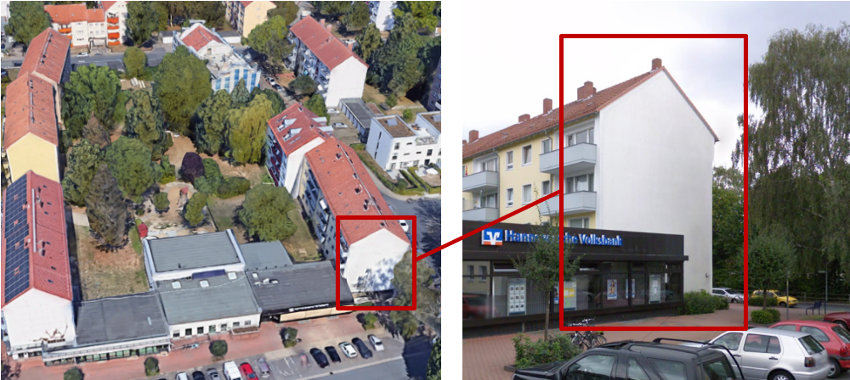
Figure 7: Building complex (left, Foto: Google Maps) and south façade of the demonstration building (right) before the energetic renovation
As with the demonstration building in Pforzheim, a preliminary analysis in the planning phase revealed that the available space in the inner courtyard was a critical factor for the necessary size of the BHE field to supply the heat pump system, and that the property was ideally suited for testing alternative heat and regeneration sources. Here, too, the design was the result of a collaboration between the housing company Gundlach GmbH, its technical planners, and the ISFH, with the ISFH focusing on the detailed design of the building services engineering using system simulations with TRNSYS.
After conducting comparative studies of various solutions, the housing company selected a combination of a thermally activated metal façade and a solar air absorber field from the company Viessmann as supplementary heat sources for the heat pump system. Our simulations show that 85 m² of south-facing façade and 43 m² of solar air absorbers, by directly reducing the load on the ground source and regenerating it, can reduce the number of BHE by 42% - from 24 to 14 (BHE length 66 m) - thereby enabling the system to be installed in the inner courtyard of the building complex. The design is conservative, taking into account significant shading of the facade and roof. The sensitivity analysis conducted shows that the metal facade can deliver in average 25 MWh/a, and the solar air absorber 42 MWh/a.
Based on the simulation results, the system was implemented and completed in December 2024. Differently from the original design, 17 BHE were installed because the planned depth could not be reached in all boreholes. The size of the solar façade was also reduced to 60 m² for constructive reasons. The ISFH conducted an additional simulation-based assessment of the sustainable operation of the final configuration. Commissioning, including measurement and data acquisition technology, took place in March 2025. Due to technical problems with the hydraulics of both additional heat sources and the overall system controlling as well as to the failure of the heat interface units in several apartments, the heat pump system hasn’t operated long enough to enable a feasible performance assessment so far. The scientific monitoring has nevertheless proved to be a valuable means to verify the correct functionality of the components and will carry on till the summer of 2027, with the aim of evaluating the system and specifically the two regeneration sources as well as to identify optimization potential.
As with the demonstration building in Pforzheim, the planning and construction phases nevertheless provide valuable insights, particularly regarding the complexity of the system and source management, as well as costs and optimization strategies.
3.2.2. Solar-active metal façade
The rear-ventilated façade on the south side of the renovated building consists of limestone masonry (24 cm), insulation (18 cm mineral wool), ventilation gap (7 cm), and of powder-coated aluminum panels (3 mm). Of the total 120 m², 60 m² have been equipped with solar active modules, with heat transfer achieved via a mechanically fastened metal heat exchanger mounted on the back of the modules. Here, too, various façade configurations - particularly heat exchangers and corresponding mounting systems - were examined during the first phase of the project (Frick, 2022). The implemented anthracite-gray variant corresponds to the façade that has been exposed to long-term testing at ISFH. The energy performance data correspond to the performance values used in the simulation study from Section 2. The active modules are hydraulically connected to the manifold pipes via flexible hoses with plug-in fittings. The façade layout and hydraulic schema are shown in Figure 8.
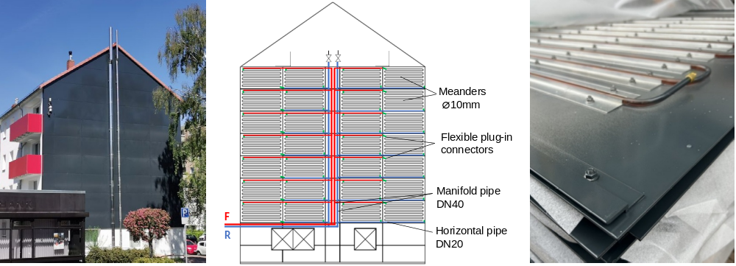
Figure 8: Renovated south façade of the demonstration building (left), hydraulic system (center), and a close-up of the solar-thermal façade modules (right)
In addition to the aspects already mentioned for the demonstration building in Pforzheim, the following findings should be noted regarding the façade in Hanover:
- Planning: Compared to conventional projects, the planning process proved to be more complex for the facade manufacturer. A critical factor here was the high degree of detail in the facade, which was primarily due to the building’s structural characteristics (front gable and chimney) but also to the need to ensure that selected cladding elements could be inspected. The solar-thermal activation of the façade elements resulted in only a slight increase in system complexity;
- Manufacturing: The production of the active modules proceeded without any problems. The heat exchangers of the prototypes were attached manually; for larger-scale production, streamlining of processes and automation of individual steps are feasible;
- Transport: No particularly complex measures were required during transport compared to conventional façades, and no damage or other issues were reported;
- Installation: By ensuring sufficient depth for the ventilation gap (7 cm) and omitting pipe insulation, the building physics requirements for rear-ventilated façades could be met without any problems. Due to the small diameters of the prototype heat exchanger pipes, all modules were connected in parallel to minimize pressure loss, which resulted in a higher complexity of the hydraulic system. However, the use of larger pipe diameters is possible for future productions;
- Operation: Compared to the project in Pforzheim, the construction in Hanover more closely resembles a traditional rear-ventilated facade, featuring a standard substructure and lighter, more manageable cladding elements. At critical points, accessible modules were integrated to facilitate easy maintenance during operation. While all modules can be made accessible using commercially available mounting elements, this is not always intended in practice and was also not implemented in this project.
- Summary
Accessing heat sources for retrofitting multifamily buildings with heat pump systems poses a major challenge, especially in densely built-up urban areas. Solar thermal energy offers an alternative to conventional solutions such as air or geothermal energy, both as a standalone and as a supplementary source. This paper analyzes the potential of solar-active façades in combination with BHE systems based on a theoretical simulation study and two completed demonstration buildings.
The following findings can be summarized from the theoretical analysis:
- Façades offer enough area to sustainably regenerate BHE fields and can reduce the size required to supply a building of 8 residential units by up to 36%. This approach increases the implementation potential of these highly efficient heat pump systems;
- Since this kind of facades primarily operate at low temperatures (< 30 °C) and largely utilize ambient heat, shading, orientation, and color play a less significant role than in common solar thermal applications;
- This greater flexibility meets the aesthetic and design demands of architects and building owners, thus providing a convincing argument for the energy retrofitting of façades in multifamily houses.
Based on practical experience with the two completed buildings in Pforzheim and Hanover, the following conclusions can be drawn:
- Lack of space is a real problem when implementing geothermal heat pump systems in urban areas. Even a 25% reduction in the required space for the heat sources can increase the chances of implementation;
- Innovative systems such as those investigated in this work require cross-trade collaboration, for which no trade is currently prepared. This results in significantly more time and higher costs compared to standard solutions. This problem is not new, but has long been reported in the context of building-integrated solar technologies (solar thermal as well as photovoltaics, s. Cappel et al., 2014);
- A first key challenge is the planning and installation of the solar-active façade, since neither manufacturers nor specialized designers currently possess the necessary expertise for this task;
- A second critical point is the overall system control, since commercially available solutions from system providers are generally not flexible and allow only limited extensions;
- For these systems to gain a foothold in the market, detailed information is needed for all trades involved in the process regarding the sizing of components and systems (façade area, hydraulic connections, interfaces, etc.) as well as the installation procedures and specific responsibilities. For this purpose, we are preparing a guideline with detailed instructions for each construction phase, and developing a practical, freely available design tool - based on the results of our coupled simulations with TRNSYS/EED-.
The results to date for use of solar-active façades in combination with BHE systems are promising. However, future operational experience and the analysis of effort and costs - taking into account feasible optimizations - will be decisive for the final evaluation. Other heat supply concepts with active façades are possible and being investigated in the project. In particular, their use as the sole heat pump source offers significant economic potential and could represent a very attractive solution for the market.
- Acknowledgment
The work is based on the results of the project "Solar-VHF”, funded by the Lower Saxony Ministry of Science and Culture and by the German Federal Ministry of Economy and Energy (BMWE, reference number 03ETW013A-I), following a decision of the German Parliament. The investigations are carried out in cooperation with the Fraunhofer-Institut für Bauphysik IBP and the German companies Konvortec GmbH & Co. KG, Systea GmbH, Gundlach GmbH & Co. KG Wohnungsunternehmen, Pforzheimer Bau und Grund GmbH and Clina Heiz- und Kühlelemente GmbH. The authors are grateful for the support and responsible for the content of the publication.
- References
Bundestag, 1980. Bundesberggesetz (BBergG).
Cappel, C., Streicher W., Lichtblau, F., Maurer, C., 2014. Barriers to the Market Penetration of Façade-integrated Solar Thermal Systems, Energy Procedia 48. Internet: https://doi.org/10.1016/j.egypro.2014.02.151.
Carbonell, D., Schubert, M., Neugebauer, M., 2021. Assessment of solar ice systems for multifamily and tertiary buildings. Schlussbericht zum BFE-Projekt „Big Ice“ (SI/501726-01).
ISO 9806:2018-04, Solar energy - Solar thermal collectors - Test methods.
F. Weiland, M. Kirchner, V. Rensinghoff, F. Giovannetti, O. Kastner, D. Ridder, Y. Tekinbas, H. Hachul, Performance assessment of solar thermally activated steel sandwich panels with mineral wool core for industrial and commercial buildings, J. Phys. Conf. Ser. 1343 (2019) 12098, https://doi.org/10.1088/1742-6596/1343/ 1/012098.
Fraga, C., Hollmuller, P., Schneider, L., Lachal, B., 2018. Heat pump systems for multifamily buildings: Potential and constraints of several heat sources for diverse building demands, Applied Energy https://doi.org/10.1016/j.apenergy.2018.05.004.
Fraunhofer ISI, Consentec, Ifeu, TU Berlin, 2024. Long-term Scenarios 3, Presentation of the new BMWK long-term scenarios – Orientation scenarios, Webinar 02.07.2024 (German language). Internet: https://langfristszenarien.de (last access: 20.08.2026).
Frick, E., Buettner, C., Kirchner, M., Giovannetti, F., 2022. Solar thermal, rear-ventilated façades as heat pump sources in multi-storey buildings. Proceedings EuroSun 2021. DOI: 10.18086/swc.2021.43.01.
Frick, E., Kirchner, M., Kabelac, S., Giovannetti, F., 2025. Thermally active rear-ventilated façades: Numerical modelling and experimental validation. Energy and Buildings, Volume 347, Part A, 116293, ISSN 0378-7788, https://doi.org/10.1016/j.enbuild.2025.116293.
Giovannetti F., Kirchner M., Sass R., Rockendorf G., 2016. Enameled glass panels for solar thermal building envelopes. Energy Procedia 91, 49 – 55.
Hadorn, J.-C. (Hrsg.), 2015. Solar Heat Pumps, IEA SHC TASK 44.
Jordan, U., Braas, H., Best, I., Orozaliev, J., Vajen, K. and Kassel, U., 2019. DHWcalc Update 2.02: Programm zur Generierung von Trinkwasser-Zapfprofilen auf statistischer Basis, Kloster Banz, Bad Staffelstein, Conexio GmbH.
L.M. Koch, Energy performance and ecological potential of solar thermal collectors made of ultra-high performance concrete (UHPC) for a CO2 neutral heat supply. Dissertation, TUM School of Engineering and Design.
Rockendorf, G., Sillman, R., Bethe, T., Köln, H., 2001. Solare Freibadheizung - Absorberprüfung und Testergebnisse. ist Energieplan GmbH, Kanden.
Tanzer, B., Schweigler, C., 2016. Façade-integrated massive solar-thermal collectors combined with long-term underground heat storage for space heating, Energy Procedia 91, 505–516, https://doi.org/10.1016/j.egypro.2016.06.188.
VDI, 2019. VDI 4640 – Blatt 2, Thermal use of the underground - Ground source heat pump systems.

