The effects of polypropylene film on springbacked carbon fiber reinforced thermoplastics

Daiki Kobayashi*¹, Yi Wan¹, Jun Takahashi¹ and Isamu Ohsawa¹

¹Department of Systems Innovation, School of Engineering, The University of Tokyo, 7-3-1 Hongo, Bunkyo-ku, Tokyo 113-8656, Japan;
*Email: kobayashi-daiki@cfrtp.t.u-tokyo.ac.jp

Keywords: CFRTP, springback, light weight, polypropylene, maleic anhydride

ABSTRSCT

Carbon fiber reinforced thermoplastics (CFRTP) have increasingly attracted attention with their outstanding advantages of short molding cycle time, energy absorption capacity and formability for multiple times. In relation to fabrication of CFRTP, there is a characteristic phenomenon, called springback. Springback is the deformation of randomly oriented short fiber reinforcement thermoplastic resulting from deconsolidation. Springback phenomenon decreases the density of CFRTP and expected for weight reduction of component design. However, after springback, there are some problems (degradation of mechanical properties, interlayer bonding properties, and so on) for practical application. In this paper, we approached to solve these problems by applying springbacked CFRTP to sandwich structure with several combinations of polypropylene (PP) film. Finally, we summarized that the effects of matrix combination on sandwich springbacked composites in specific mechanical properties.

- INTRODUCTION
As the ideal material for lightweight products, CFRTP (carbon fiber reinforced thermoplastics) have recently been paid attention to, because of its advantage in suitability for lightweight applications. CFRTP application leads to reduction of energy use and solution of some environmental issue such as global warming. Moreover, CFRTP is useful not only for lightweight products, but also for multiple times formability. Regarding the formability, there is a characteristic phenomenon, called springback. This is a deformation of randomly oriented short fiber reinforcement thermoplastic resulting from deconsolidation [1]. After the springback, the density becomes lower, which gives an advantage in weight reduction. Nevertheless, springback material has many problems for practical application due to the degradation of mechanical properties and its porous structure as shown in Figure 1. Therefore, to take an advantage of the weight reduction of springback material, it was usually applied core material in sandwich structure like as honeycomb and foam core. Sandwich structure is expected to achieve a stiff and simultaneously lightweight component [2]. However, as we applied springback material to core in sandwich panel, some problems were occurred. The main problem was concerned with interlayer bonding property in each layer. After springback, CFRTP induced the degradation of interlayer bonding property between the layers which are fabricated by stacking short fiber reinforced sheets. Moreover, springbacked CFRTP had poor adhesion with adhesives because of its porous structure (Figure 2, [3]), hence springback composites was expected to be made without adhesives. Then, we considered that deficiency of a resin in each layer caused the weakness of its adhesion. Therefore, in this study, polypropylene (PP) film was used to supply its deficiency in order to enhance the interlayer bonding property. We introduced several PP film conditions (concentration of maleic anhydride and PP film insertion patterns) in making process, and then we examined the effect of PP film in terms of specific mechanical properties by four point bending test and impact test.
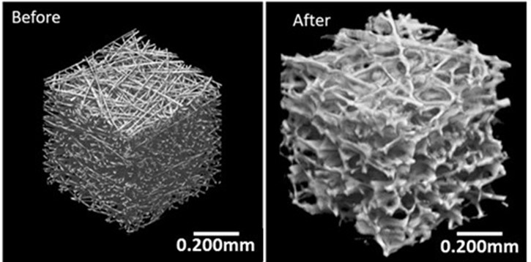

Figure 1: The 3D structural models of CFRTP
(Left: before springback, Right: after springback) [1].

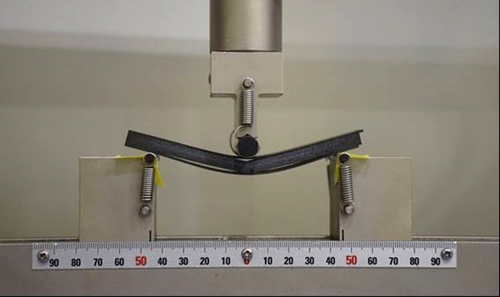

Figure 2: A typical hybrid specimen with springbacked core material
after three point bending test [3].

- MATERIALS
In this study, the materials which consisted of sandwich panels with springbacked core were as follows.

  - UD
In this study, we used polyamide-6 matrix carbon fiber UD (uni-direction) prepreg as skin material. The CF/PA6 UD sheet (Figure 3) was made by Industrial Technology Center of Fukui Prefecture [4]. The thickness of sheet is 132µm and V_{f} (volume fraction of fiber) is 54%.

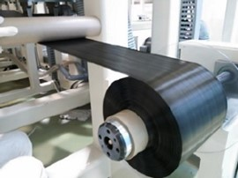

Figure 3: The images of UD prepreg sheet.

  - CPT
As springback material, CPT (carbon fiber paper reinforced thermoplastics: Figure 4) were introduced. CPT are made from the recycled carbon fibers (RCF) and PP fibers [5]. RCF originally provided by Toray Industries Co. was recycled by means of depolymerisation technique of Hitachi Chemical Co., Ltd. CPT can be made by RCF without degradation of the mechanical properties [6]. The average length of RCF and PP fiber are closed to 6 mm. The V_{f} of CF is about 30%. These fibers are carefully dispersed by a continuous paper-making process. In this study, we selected CPT with polypropylene matrix as springback material. That’s because the melting point of polypropylenes is lower than PA6. Therefore, we can induce core materials which made of carbon fibers and polypropylenes to springback without influencing except for CPT.

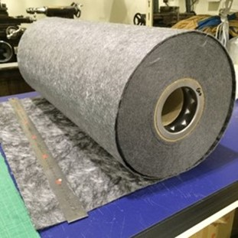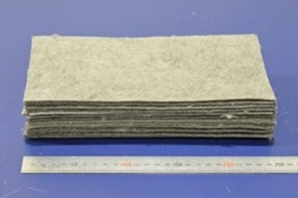

Figure 4: The images of CPT sheet (Left: roll state, Right: sheet state).

  - PP film
In this study, PP film was made of polypropylene pellet by hot press machine (0.76 MPa, 190℃) as shown in Figure5, and the thickness of film was about 50 µm. As a characteristics of polypropylene, maleic anhydride grafted polypropylene is generally employed as compatibilizer to improve the interfacial adhesion between carbon fiber and polypropylene. Therefore, to compare the effect of the concentration of maleic anhydride (MA concentration) in polypropylene pellet, we adopted three types of its concentration (0%, 0.5% and 2%).

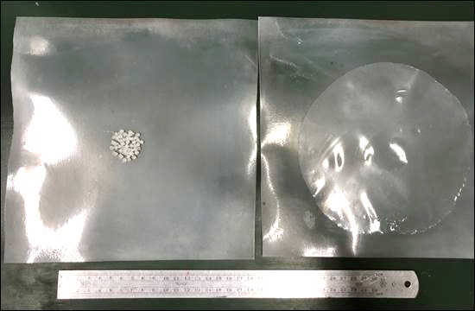

Figure 5: The image of the polypropylene pellet (left) and sheet (right).

- EXPERIMENTS
  - Making process
Making process of specimens is as shown in Figure 6. To make sandwich panel with springbacked CPT, we firstly piled CPT and PP film alternately, and then put them between UD sheets. Next, pressed them by hot press machine. The molding temperature was constant 260℃ for 5 min under the pressure. Finally, we cut it into 6 pieces, and reheated them for inducing springback. Springback ratio (SB ratio) was adopted 2.5 considering previous studies [7-9] and it was calculated by below equation.

$$SB ratio= \frac{the thickness of CPT after springabck}{the thickess of CPT before springback}$$

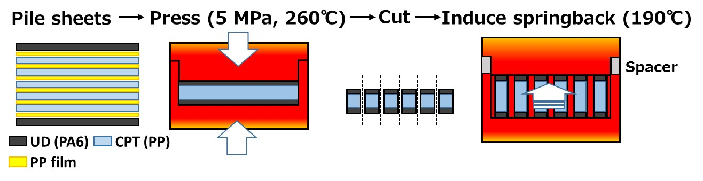

Figure 6: The schematic images of making process of specimen.

  - Four point bending test
In order to examine the effects of PP film in terms of the specific flexural properties of sandwich panel with springback CPT, we conducted four point bending test in several core conditions. The details about the conditions are as below (reference: ASTM C393), and span length was 100 mm.

3.2.1 Concentration of maleic anhydride
As mentioned above, maleic anhydride could improve the interfacial adhesion between carbon fiber and polypropylene. In this study, we made specimens with three types of MA concentration (0%, 0.5% and 2%) and conducted four point bending test to compare the specific flexural properties with sandwich panel without PP films. Information about specimens is as shown in Table 1 and the failure mode was observed by high speed camera. The number of PP film which was inserted between each layer was one.

Table 1: Specimen information of four point bending test (Concentration of maleic anhydride).

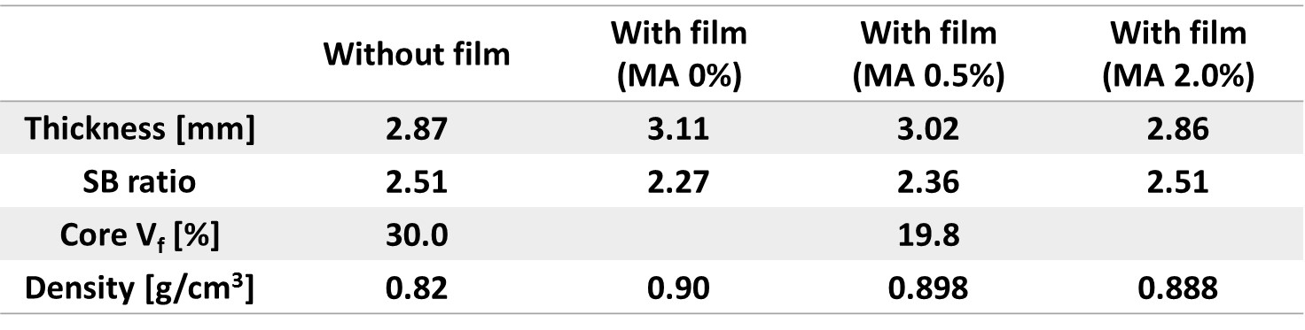

3.2.2 Amount of PP film
We also investigated the effects of amount of PP film. Making process was almost same as section 3.1. In subsection 3.2.1, we inserted a PP film between each layer. In this subsection, we called it “Standard reinforced” (same as “With film (MA 0%)”). Furthermore, we made two different specimens (Figure 7). First is “Skin-core reinforced”. It also had a PP film between each CPT layer, however had three PP films between skin and core layer. Second is “Layer reinforced”. It had two PP films between each layer. Information about specimens is as shown in Table 2.

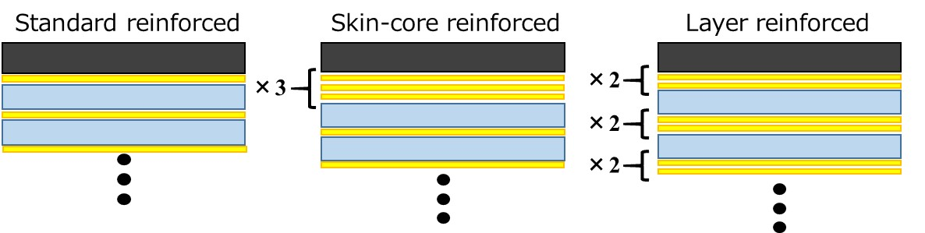

Figure 7: The schematic images of specimens
(From the left side: Standard reinforced, Skin-core reinforced, Layer reinforced)

Table 2: Specimen information of four point bending test (the amount of PP film).

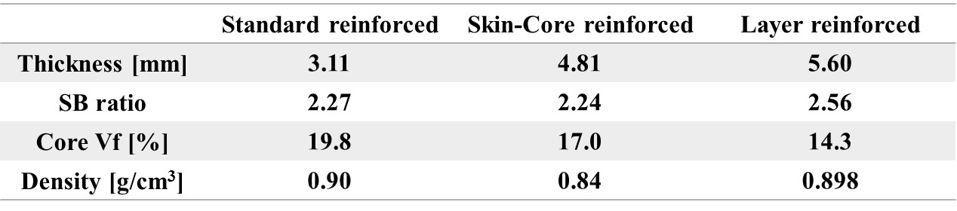

  - Impact test
Considering the results of four point bending test, we conducted impact test in three conditions, “Without film”, “With film (MA 0%) and “Not springback”. Making process was same as four point bending test. The specimen of “Not springback” wasn’t induced springback in making process. Information of specimens are shown in Table 3. We referred to “JIS K7084” and the span length was 80 mm. The failure mode was observed by high speed camera.

Table 3: Specimen information of impact test.

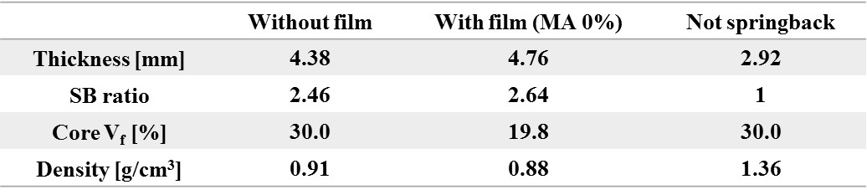

- RESULTS
  - Results of four point bending test (Concentration of maleic anhydride)
The results of four point bending test are shown in Figure 8. Based on specific flexural stiffness and strength, PP film was useful to imprive these properties. As the MA concentration in PP film increased, the specific flexural properties decreased and the scatters were restraind. Therefore, we considered that proper MA concentrain for springbacked CFRTP is lower than CFRTP which isn’t springbacked. Surely, maleic anhydride helps to improve the interfacial bonding property between carbon fiber and polypropylene, but it made polypropylene matrix brittle. Consequently, PP film (MA 0%) remarked the highest mechanical properties. Moreover, from the observation of initial failure process by high speed camera (Figure 9), PP film changed failure mode. The initial failure happened between core layers in “Without film”, but it happened between skin and core layer in “With film (MA 0%)”. From this observation, PP film is expected to be improve interlayer bonding properties in springback core and V_{f} 30% seemed to be too high as springback core.

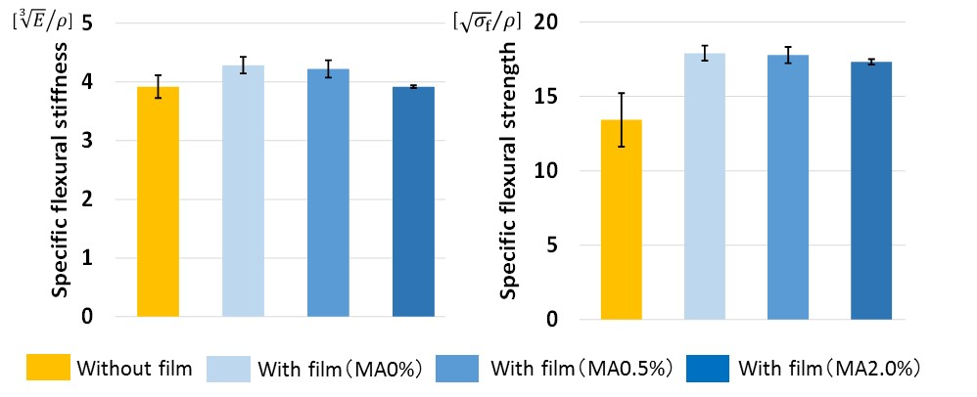

Figure 8 : The results of specific flexural stiffness and strength
(Concentration of maleic anhydride).
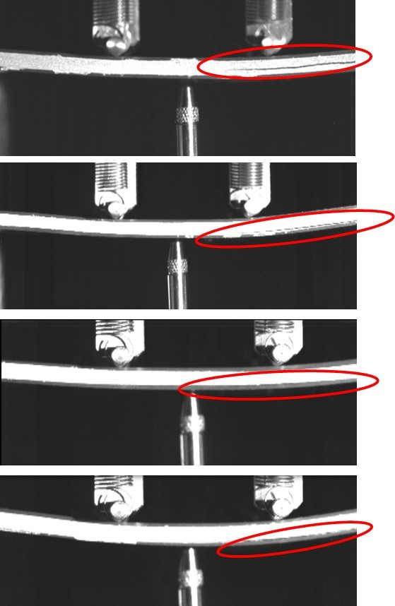

Figure 9: Observation of initial failure process by high speed camera in four point bending test (Left: “Without film”, Right: “With film (MA 0%)”).

  - Results of four point bending test (Amount of PP film)
The results of four point bending test are shown in Figure 10. The resluts showed that the mechanical properties were decreased as V_{f} dicreased. It suggested that the proper V_{f} is around 20%. Failure mode of three was almost same as “With film (MA 0%)” in the section 4.1.

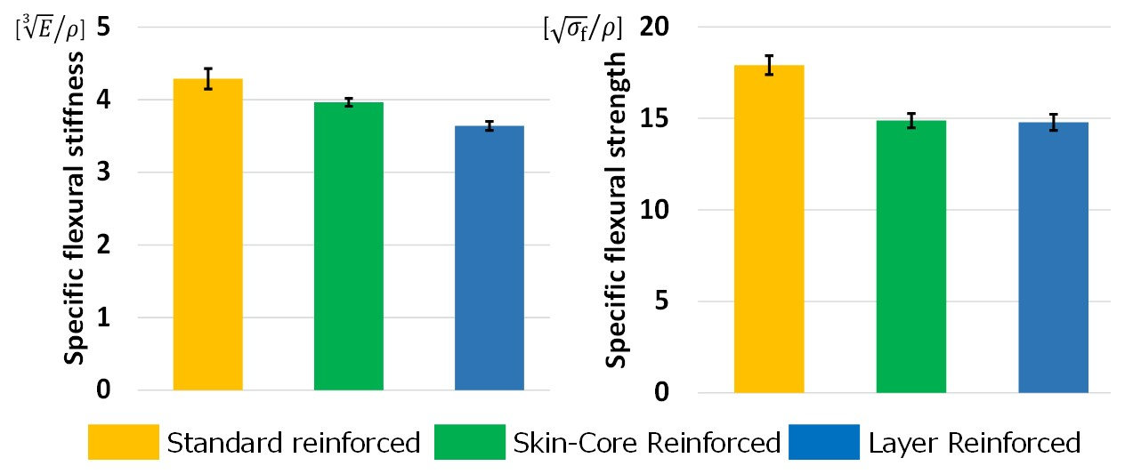

Figure 10 : The results of specific flexural stiffness and strengh (amout of PP film).

  - Results of impact test
The results of impact test are shown in Figure 11-13. From the stress-strain curve (Figure 11), maximum load of springbacked sandwich panels was lower than “Not springback”. However, springbacked panels didn’t break at once and the fracture process lasted longer since the soft core absorbed much energy. Therefore springbacked panels remarked higher specific energy absorption than “Not springback” (Figure 12). The scatter of specific energy absorption in springbacked panels was restrained. That’s because springbacked panels were restrained the scatter of displacement in stress-strain curve. Moreover, from the observation (Figure 13), PP film changed initial failure mode and helped to improve the interlayer bonding property.

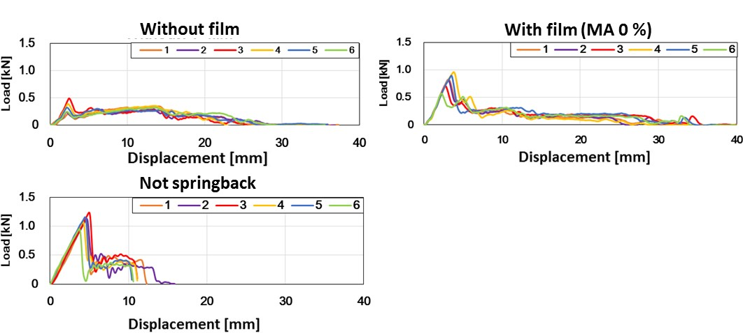

Figure 11: Load-displacement curve (Impact test).

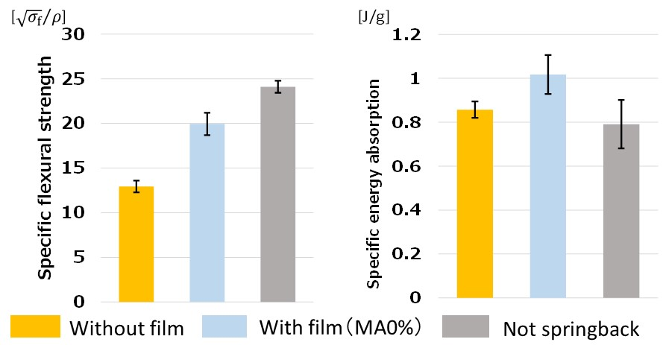

Figure 12: The results of specific flexural strength and specific energy absorption.

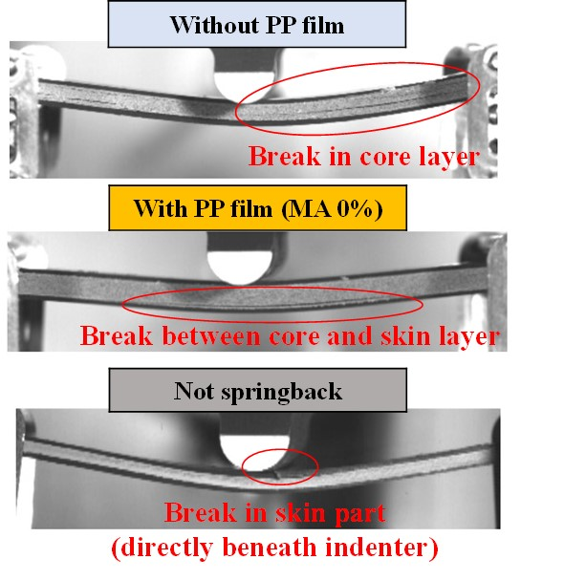

Figure 13: Observation of initial failure process by high speed camera (impact test).
- CONCLUSION
In this study, we investigated that polypropylene (PP) film as adhesive could help to enhance the interlayer bonding properties and improve the specific mechanical properties. The conclusion of this study is summarized below.
- PP film which was inserted between each layer in sandwich panel with springback core was effective to improve specific mechanical properties in four point bending test and impact test.
- Appropriate V_{f} as springback core in sandwich panel is expected around 20 %.
- From the result of impact test, sandwich panel which was reinforced by PP film was improved not only the interlayer bonding properties but also specific energy absorption thanks to its ductile failure.

ACKOWLEDGEMENTS
Part of this study was conducted as Japanese METI project “the Future Pioneering Projects / Innovative Structural Materials Project” since 2013fy. Authors would like to express sincerely appreciation to the project members who have provided valuable information and useful discussions.
REFERENCES
- Y. Wan and J. Takahashi, “Deconsolidation behavior of carbon fiber reinforced thermoplastics”, Reinforced plastics & composites, vol. 13, no. 17, pp. 1613-1624, 2014.
- R. F. Gibson, “Principles of composite material mechanics”, Ohio, CRC PRESS, 2012.
- T. Nakamura, Y. wan, H. Wei, I. Ohsawa and J. Takahashi, “Investigation of sandwich panel made by CFRTS and CFRTP”, 13th Japan International SAMPE Symposium and Exhibition, Kanazawa, 2015.
- S. Sihn, R.Y. Kim, K. Kawabe, and S. W. Tsai, “Experimental studies of thin-ply laminated composites”, Composites Science and Technology 67, 2007, 996-1008.
- CARMIX, Awa Paper Mfg. Co., Ltd., http://www.awapaper.co.jp/e/eproducts/carmix.html
- S. Pimenta, S. T. Pinho, “The effect of recycling on the mechanical response of carbon fibres and their composites”, Composite Structures 94, 2012, 3669-3684.
- D. Kobayashi, T, Nakamura, Y. Wan, I. Ohsawa and J. Takahashi, “A study on hybridization of springbacked carbon fiber reinforced thermoplastics” 21st International Conference on Composite Materials, Xian, China, Aug. 2017.
- Y. Zhang, Y. Wan, T. Nakamura, J. Takahashi, “Effect of springback ratio on bending and impact property of carbon fiber reinforced thermoplastics sandwich structures”, 21st International Conference on Composite Materials, Xian, China, Aug. 2017.
- B. Xiao, Y. Wan, I. Ohsawa and J. Takahashi, “Needle punching effect on carbon fiber reinforced thermoplastic sandwich panels”, 21st International Conference on Composite Materials, Xian, China, Aug. 2017.

