EuroSun2026
ASSESSING FLEXIBILITY IN SOLAR BASED DISTRICT HEATING AND COOLING SYSTEMS: A SIMULATION-ASSISTED CASE STUDY

Authors: Emmanuel Hosea Mposola*, Jon Iturralde Iñarga
Affiliation: TECNALIA, Basque Research and Technology Alliance (BRTA)
Área Anardi 5,20730 Azpeitia, Gipuzkoa, Spain
Emails: emmanuel.mposola@tecnalia.com, jon.iturralde@tecnalia.com
Summary
The performance of a complex multi-energy district heating and cooling (DHC) system was assessed and optimized. This system is based on locally produced solar energy and comprises multiple thermal conversion technologies, whose operational strategy was optimized to enhance overall energy efficiency. Dynamic simulations were conducted for improvement assessment across three categories: advanced control optimization implementation, thermal energy storage integration and increase of solar capacity. These scenarios were assessed to quantify gains in energy flexibility and system performance. Results demonstrate enhanced solar energy utilization, effectively leveraging favorable climatic conditions to maximize local generation. The proposed optimization measures showed a potential to increase renewable energy share in the DHC from 18 % to 25.6 % and boost electrical self-sufficiency from 24.6 % to 30 %. Collectively, these improvements enhanced the system’s energy flexibility, efficiency and operational independence, reducing annual equivalent CO₂ emissions by up to 27.3 % and lowering yearly operational costs by up to 15.9 %.
Keywords: District heating and cooling, solar energy, decarbonization, resilience, energy efficiency
Field of application for the findings: Sustainable and Efficient District heating and cooling
Addressed audience: district heating and cooling facility management, energy service companies, planners
1. Introduction
The building sector covers a good share of overall global energy consumption both for cooling and heating. As a result of the transition toward low carbon centralized heating and cooling infrastructures, there is an increasing demand for heating and cooling networks that can actively adapt to fluctuating renewable energy supplies and varying thermal loads to take advantage of the renewable energy (Kim, et al., 2026). Recently, the integration of diversified energy sources to cover thermal demand for residential and public buildings and district heating and cooling (DHC) networks has been proved to stabilize the system while following variable electricity prices. This paves a direction towards optimal solutions from energy, environmental and economic point of view (Jacopo, et al., 2022).
To achieve diversified energy sources in centralized heating and cooling the use of large-scale heat pumps, solar thermal plants, waste heat recovery and utilization and thermal energy storage tanks both for cold and hot water demonstrated a positive impact, significantly reducing or even completely phasing-out the use of fossil fuels (Kalina, et al., 2025). Additionally, since new-generation DHC systems consume a significant amount of electricity due to the implementation of heat pumps and chillers, they can be further supported by solar photovoltaic (PV) panels, which could (partly) cover the base energy load. This reduces the electricity imported from the grid and thus its corresponding energy cost, resulting in overall savings in the operation of centralized heating and cooling networks (Delle, et al., 2019).
Within this overall framework, the present study aims at the same optimization goals, but in a particularly complex case, due to the various production technologies available onsite.
2. Methodology
2.1. Case study description
This study presents a detailed, simulation-assisted case study analyzing the operational flexibility of a solar based DHC system supplying the thermal demand of a large hospital complex located in Southern Europe. The local climate is hot summer continental mediterranean (Csa in Köppen classification) (Beck, et al., 2018), characterized by summer temperatures surging up to 40 °C and mild winters. For this reason, the cooling demand is dominant. Also, there is a good availability of solar resources and thus a considerable amount of locally produced solar energy. Increasing its share is crucial, not only to decarbonize the installation and reduce its costs, but to ensure its energy security. Reducing dependence on the power grid and other external energy sources is of vital importance for critical infrastructure, such as hospitals, as it prevents disruptions caused by blackouts or similar incidents that could have catastrophic consequences for their operations.
This DHC installation is characterized by being a complex multi-energy system, comprising various energy sources (solar, electricity, natural gas) and multiple generation technologies and units (PV, solar thermal, heat pumps, chillers, dry coolers, cooling towers and boilers). Due to the nature of the activity of the building, there are simultaneous thermal demands for different services: heating, cooling, domestic hot water (DHW) and steam. These demands vary depending on weather conditions, occupancy, use of installations, etc.
The objective of this study is to propose technical measures applicable to DHC systems to enhance their energy efficiency, sustainability and resilience. To this end, modifications were proposed for both the physical equipment and the operational control logic. All of them have the aim to maximize renewable self-consumption, contributing to decarbonization and savings. Specifically, the following improvements are assessed:
- Optimization of temperature setpoint control strategies
- Integration of a thermal energy storage (TES) in the cooling circuit
- Increment of the installed PV generation capacity
These scenarios were evaluated through a series of dynamic simulations, where key parameters (such as equipment sizing and control settings) were optimized to determine the optimal implementation specifications
2.2. Model description
For the assessment of improvements through simulations, a model of installation was developed in Dymola, a dynamic modelling tool based on Modelica language. This software is well‑suited for modelling multi‑energy systems because of its Multiphysics capabilities and the availability of dedicated libraries that include thermal and electrical components (Brück, et al., 2002). The resulting model can be observed in fig.1.
The dynamic model followed the operational sequence of the existing DHC system. In this configuration, the solar thermal field is prioritized as the primary heat source, complemented by a water-to-water heat pump that recovers heat from the cooling loop and transfers it to the heating loop, thereby satisfying the base loads for both heating and cooling. When the combined output of the solar field and heat pump is insufficient to meet peak heating demand, a gas boiler is activated as a fast-response backup.
The cooling plant comprises four compression chillers of varying sizes and efficiencies configured in a cascade to dynamically adjust to the demand exceeding the baseload provided by the heat pump. When ambient temperatures are below 25 °C, dry coolers function as condensing units, while cooling towers serve that purpose with temperatures exceeding that reference. Finally, a PV system (>2 MW) supplies a portion of the facility's total electrical demand.
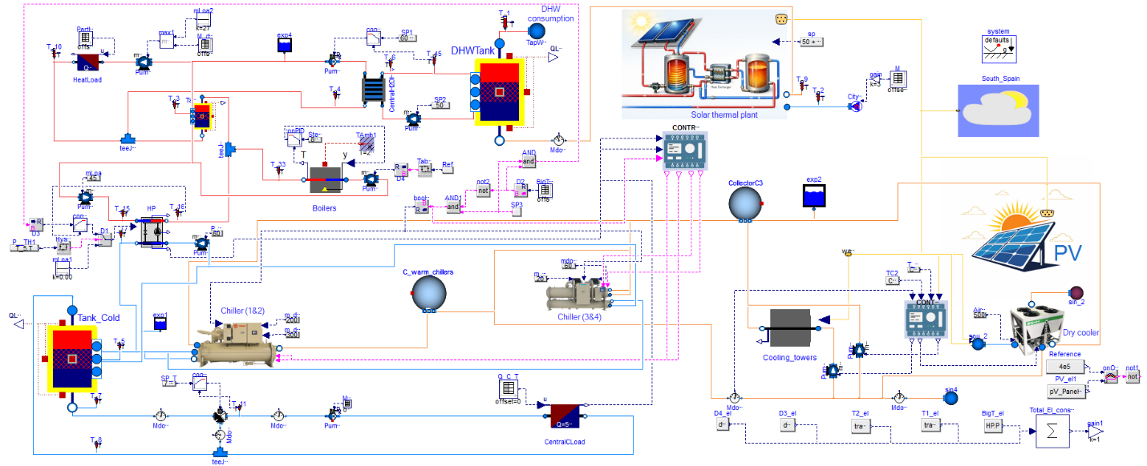
Fig. 1: Model of the multi-energy DHC installation
2.3. Model Calibration and Validation
The model calibration process was conducted through the following procedure:
- Equipment sizing: Dimensions and capacities were obtained from P&IDs, datasheets, and other documentation provided for the installation. Where this information was unavailable, component capacities were estimated based on monitored operational data.
- Validation using monitored data: Actual demand and consumption data were input into the simulation model to verify that the predicted performance patterns aligned with the records obtained from the physical circuits.
- Model calibration: The remaining system parameters were adjusted, specifically auxiliary components, to ensure that the simulation results matched the actual performance records.
The simulation results are compared against measured data for key parameters in fig.2 to fig.5 below.
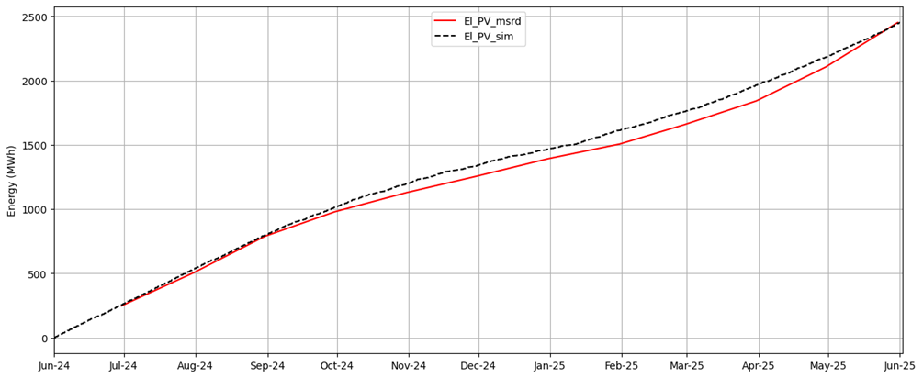
Fig. 2. Cummulative PV production simulation (EL_PV_msrd) vs monitored (El_PV_sim)
In Fig. 2 El_PV_msrd and El_PV_sim represent accumulated electricity generation in the measured and simulation data, respectively. The monitored data vs simulated data had a maximum instantaneous deviation of 122.9 MWh but a final deviation in the accumulated energy of only -0.005 %.
As for the heating, cooling, solar thermal and electricity consumption are shown in Fig. 3, following the same nomenclature (cold = cooling, el = electricity, heat = heating and sol = solar thermal).
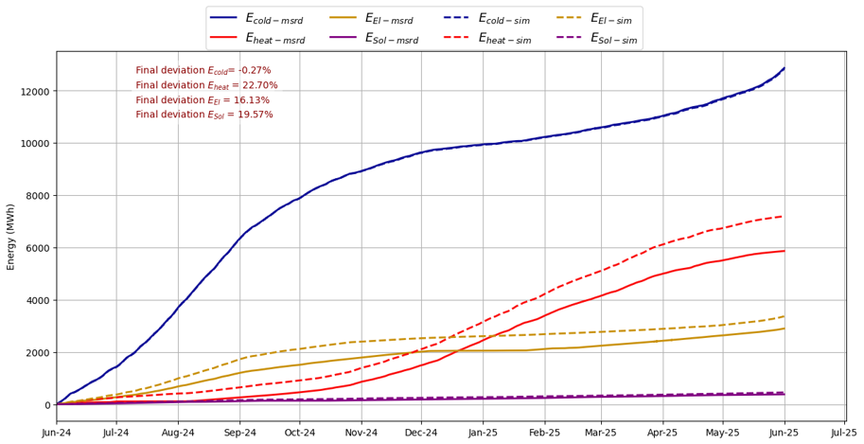
Fig. 3.Overall performance of the model vs monitored data.
Finally, the model of the DHC system was validated against the measured data and subsequently used as the baseline with a maximum deviation of ± 22.70 % in the accumulated heating energy over a period of whole year based on the formula in eq.1.
$$deviation=\frac{Model estimation-measured value}{measured value}*100\%$$ | (eq. 1)
These high deviations are attributed to the inexisting automatic operational strategy, as the actual installation is controlled in a very manual way by switching components ON/OFF and adjusting their performance based on demands from the users. These arbitrary manual interventions cannot be reproduced in the model due to their random nature. However, during periods where the system operated under logical control, the model was able to replicate the measured performance patterns as shown in Fig. 4 and Fig. 5.
In Fig. 4, calibration results for the main heat pump are showed, following the same nomenclature (H = heating capacity, C = cooling capacity and El = electricity consumed by the compressor). A high correlation can be observed between simulated and measured dynamic data.
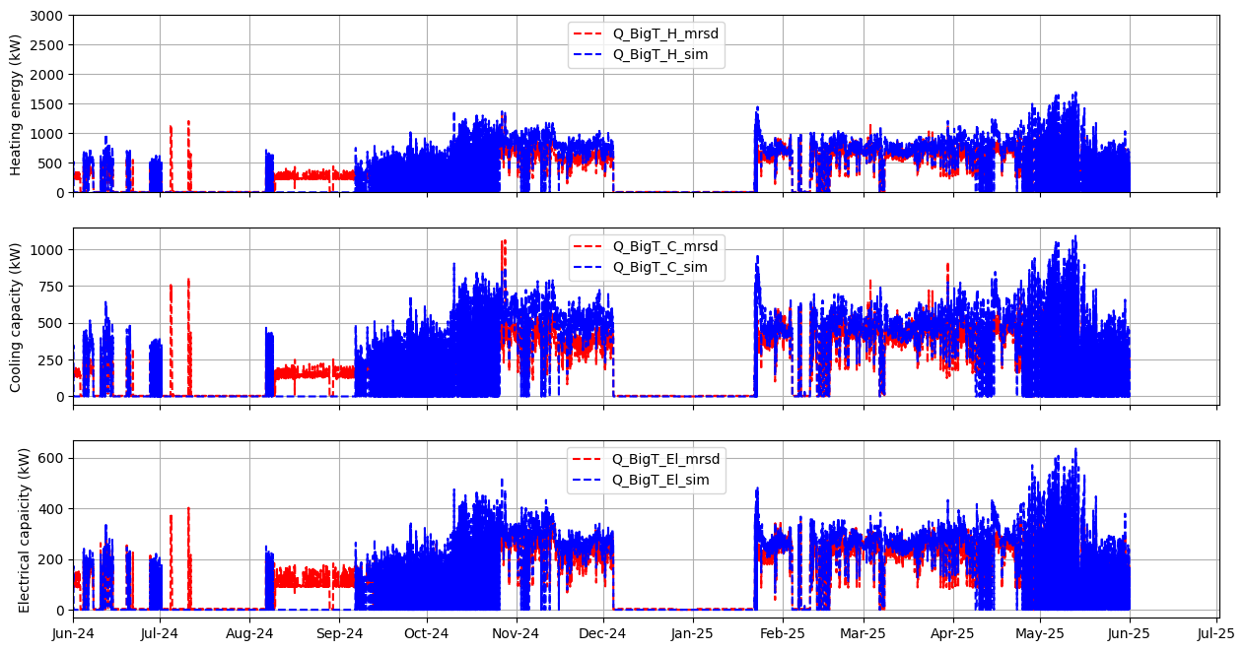
Fig. 4. Performance of Heat Pump; (measured vs simulation).
In Fig. 5, E_B_H_mrsd and E_B_H_sim denote to accumulated heat energy generated by boilers for the measured data and simulation data respectively. Q_B_H_mrsd and Q_B_H_sim represent to instantaneous boilers heat output for the measured data and simulation data respectively. The discrepancy in boilers performance (between measured data and the simulation data) can be primarily attributed to the manual boilers operation in the actual installation vs the automated one in the simulation.
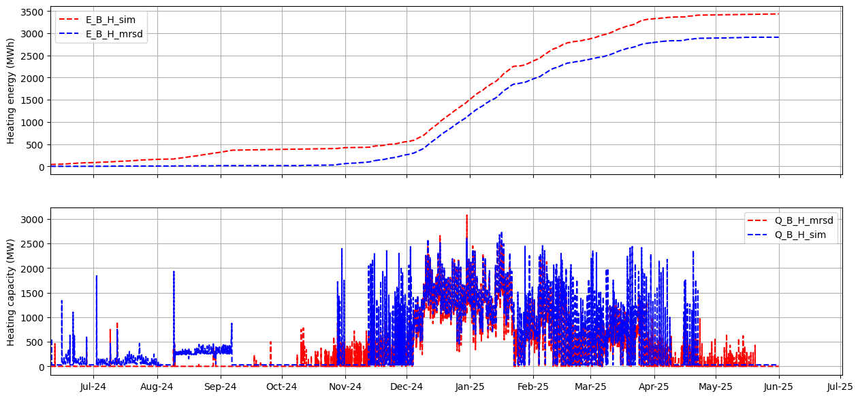
Fig. 5.Performance of boilers (Measured data vs simulation).
2.4. Scenarios description
Flexibility studies were conducted using the validated model to evaluate eight distinct cases in several categories, as defined by the following nomenclature:
- Temperature optimization (T-Optimization)
In this scenario, the DHC operation was optimized solely through the adjustment of temperature setpoints based on the availability of excess on-site PV electricity. During the cooling season, the chilled water supply temperature was reduced from 7 °C to 3 °C when excess PV generation was available. This increase in chiller electrical load enhances self-consumed renewable energy share. Similarly, during the heating season, the supply temperature of the heat pump serving the heating loop was increased from 70 °C to 80 °C during periods of electricity surplus.
- Temperature optimization + cooling TES (T–opt + TES-(200, 500, 800))
Building upon the optimized temperature strategy, a TES was introduced into the cooling network. This measure addresses the fact that cooling constitutes the hospital's largest energy demand, while the existing district cooling network currently lacks any storage capacity.Three storage capacities were evaluated: 200 m³, 500 m³, and 800 m³.
- Temperature optimization + PV capacity increase (T-opt+PV-(10,20))
In addition to temperature optimization, the expansion of installed PV capacity was assessed. Two expansion scenarios were evaluated: a 10 % and a 20 % increase in the current PV capacity.
- Temperature optimization + PV capacity increase + cooling TES (T-opt+PV-10+TES (200, 500))
In these scenarios, the three previously described measures were combined: temperature optimization, a 10 % increase in PV capacity, and two sizes of cold thermal storage (200 m³ and 500 m³). These specific capacities were selected to evaluate the incremental impact of storage volume on the overall system performance.
2.5. KPI Quantification methods
By comparing the results of simulations for each measure against the baseline the impacts of each improvement were quantified for different KPIs. These KPIs include gas consumption, CO₂ emissions, renewable energy share (Ren_share) calculated using eq.4 and self-sufficiency flexibility calculated using eq.3
$$Ren=gas_{cons}*{gas}_{{ren}_{factor}}+El_{grid}*Grid_{ren_{factor}}+PV_{{El}_{{ren}_{factor}}}$$ | (eq. 2)
$$NRen=gas_{cons}*{gas}_{{nren}_{factor}}+El_{grid}*Grid_{nren_{factor}}+PV_{{El}_{{nren}_{factor}}}$$ | (eq. 3)
$$Ren_share=\frac{Ren}{Ren+NRen}*100 \%$$ | (eq. 4)
$$self_sufficiency=\frac{El_{from PV}}{El_{total consumption}}*100 \%$$ | (eq. 5)
Where: Ren and NRen are the renewable and non-renewable energy (MWh/year); ${gas}_{ren}$ $and {gas}_{nren}$are the natural gas renewable and non-renewable fraction; $Grid_{ren} and Grid_{nren}$ are renewable and non-renewable fraction from grid electricity respectively; $El_{grid}$ is electricity from grid; and $gas_{cons}$is natural gas consumption.
As for the calculation of renewable and non-renewable fractions of primary energy and equivalent CO₂ emissions, the following conversion factors were used for the three primary energy sources available in the DHC installation:
Tab. 1. Primary energy and CO₂ equivalent conversion factors.
Reference | Primary energy, renewable (kWhₚᵣᵢₘ,ren/kWhfinal) | Primary energy, non-renewable (kWhₚᵣᵢₘ,nren/kWhfinal) | CO₂ emission factor (kgCO₂/kWhfinal)
Natural gas  (MITECO, 2026) | 0.005 | 1.19 | 0.252
Spain mainland grid electricity (REE, 2026) | 0.51 | 1.51 | 0.258
Local PV production | 1 | 0 | 0

3. Results and Discussion
In T-Optimization scenario, natural gas consumption in boilers decreased significantly from 4960 MWh/year to 3581 MWh/year due to increased use of HP rather than switching off during winter (existing mode of operation) due to excess cooling production which was solved by switching off or reducing the operation of other chillers, prioritizing the HP. Also, CO₂ emission decreased from 1905 kg CO₂eq/year to 1656 kg CO₂eq/year and renewable share increased from 18 % to 21.6 %. On the other hand, self-sufficiency decreased from 24.6 % to 23.2 %, this is due to an increase in electricity consumption in HP as shown in Fig. 7.
In Fig. 7, Pel_Baseline and Pel_Optimized refer to electrical power consumption in baseline and temperature optimized scenario respectively, Q_Baseline and Q_optimized represent condenser capacity in the baseline and temperature optimized scenarios respectively. It is vivid that the COP of the HP in the temperature optimized scenario decreases compared to baseline in the time of excess PV as set points changed resulting in higher temperature lift between the source and supply in the HP, thus, electricity consumption and condenser heat in optimized scenario increased compared to baseline.
The addition of cold thermal storage tanks decreased the natural gas consumption in the boilers with increase in storage volume shown in scenarios; T-opt+TES-200, T-opt+TES-500, and T-opt+TES-800 from 4960 MWh/year in baseline to 3014 MWh/year in the largest storage volume scenario, thus CO₂ emissions decreased with increase in storage volume. Renewable energy share significantly increased compared to baseline with increase in storage volume from 18 % to 22.5 % but slightly increased by changing from smaller volume (200 m³ to 800 m³). Self-sufficiency decreased from 25 % in baseline to 23 % in T-opt+TES-200, this decrease is due to higher volume of chilled water while same installed PV capacity compared to baseline scenario. The self-sufficiency remained nearly constant with increase in volume to T-opt+TES-800, because the increase in electricity consumption was during the period of excess PV and the stored cold energy was further used in night or periods without excess PV production.
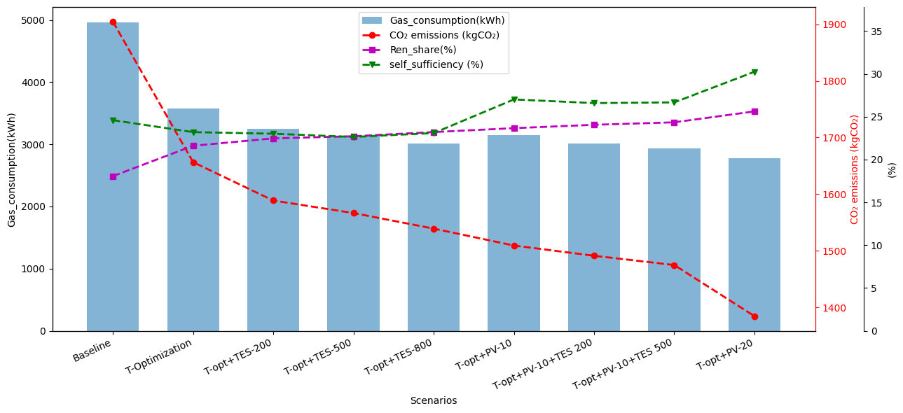
Fig. 6. KPIs comparison across all scenarios.
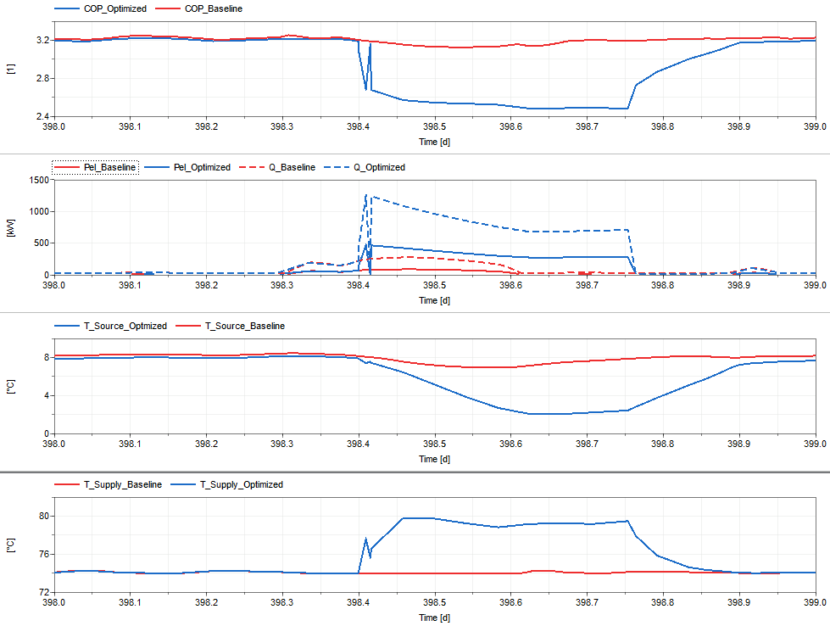
Fig. 7. Performance of the HP in Temperature optimized vs Baseline scenario (COP(1st), Capacities (2nd), sink temperature (3rd), source temperature (4th) graph naming from top).
The addition of installed PV capacity led to decrease in natural gas consumption, from 4960 MWh/year in baseline to 2776 MWh/year in the scenario with 20 % increase in PV capacity as shown in T-opt+PV-10 and T-opt+PV-20. Similarly, there was increase in renewable energy share up to 25.6 % and self-sufficiency up to 30 % with significant decrease in CO₂ emission from 1905 kg CO₂eq/year in the baseline to 1385 kg CO₂eq/year in T-opt+PV-20, which is equal to a reduction of 27.3 % CO₂ emissions related to operation of the facility.
The combination of all measures: temperature optimization, increase in cold storage volume, and installed PV capacity implied reduction in natural gas consumption and CO₂ emissions, increase in self-sufficiency and RES compared to baseline as seen in T-opt+PV-10+TES 200 and T-opt+PV-10+TES 500 scenarios. The increase of storage volume from 200 m³ to 500 m³ in the combined scenarios resulted to reduction in natural gas consumption, CO₂ emissions, increased RES and self-sufficiency.
For further comparison of the measures, a simple economic analysis was conducted using daily spot market price of electricity and natural gas prices for non-household consumers in Spain were used shown in Fig. 8. The price of natural gas for second semester of 2024 and first semester for 2025 was 0.0507 €/kWh and 0.0513 €/kWh respectively.
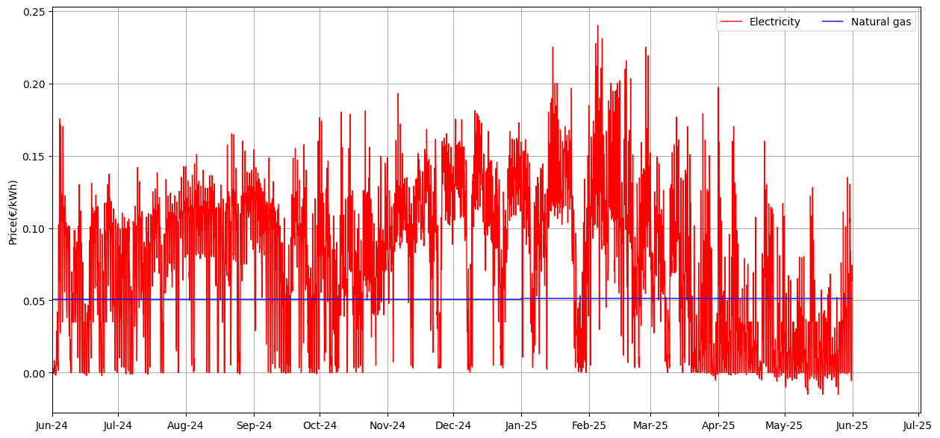
Fig. 8. Electricity price (REE, 2026)and Natural gas price (Eurostat, 2026).
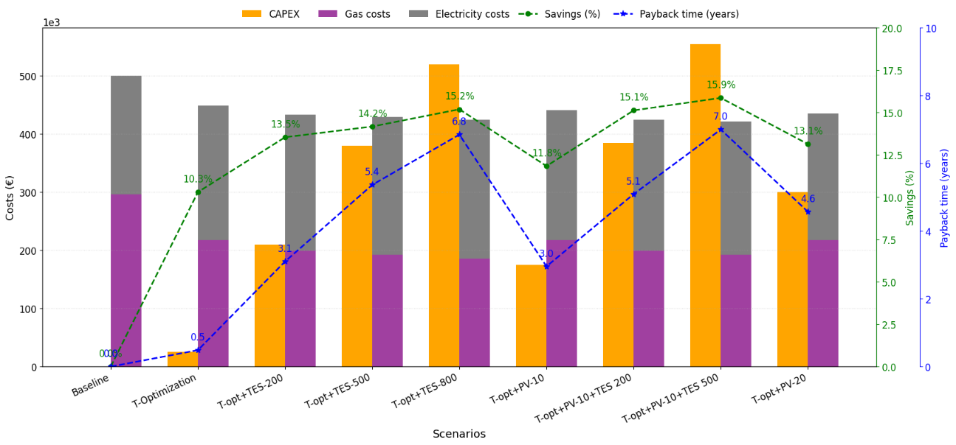
Fig. 9. Operational costs and payback time comparison across scenarios
In Fig. 9, El costs refers to costs due electricity consumption from the grid, Gas costs refers to cost related to natural gas consumption, while CAPEX is the estimated investment costs and savings is the reduction in total operation costs compared to baseline scenario, and Payback time is calculated using eq.6.
$$Payback (yrs) =\frac{CAPEX(€)}{Annual savings (€)}$$ | (eq. 6)
The CAPEX estimates were derived through benchmarking and comparison with published cost data, industry guidance, and relevant project references, including ( (ASHRAE, 2020), (Bhatkar, et al., 2025), (Diputació de Barcelona, 2023), (Euskadi.eus, 2024), (Lüchinger, et al., 2025) and (Público, 2024)).
Temperature optimization scenario reduced gas costs and total costs, while increased costs related to electricity due to more operation of the HP. At the end, the scenario showed a 10.3 % savings with a payback time of 0.5 year. T-opt+TES-200 resulted in a reduction in gas costs and total costs, while increased electricity costs due to more operation of the HP compared to baseline, with final savings of 13.5 % and a payback period of 3.1 years. T-opt+TES-500 showed a reduction in total costs and gas costs while increased electricity costs due to more operation of the HP, with final savings of 14.2 % and a payback period of 5.4 years.
T-opt+TES-800 showed a reduction in total costs and gas costs while increased electricity costs due to more operation of the HP, with final savings of 15.2 % and a payback period of 6.8 years. The gradual increase in savings with increasing TES volume is primarily attributed to the corresponding reduction in natural gas consumption. During periods of excess PV generation, the heat delivered by the HP condenser is the highest in the T-opt+TES-800 scenario, owing to its highest source temperature. Increasing the TES volume reduced temperature fluctuations, thereby maintaining a higher average source temperature compared with the smaller storage capacity in T-opt+TES-200 as shown in Fig. 10.
T-opt+PV-10 showed a reduction in total costs and gas costs; however, increased electricity costs due to higher operation of HP compared to baseline. This resulted in a net reduction in total costs of 11.8 % with a payback period of 3.0 years. T-opt+PV-20 reduced total costs and gas costs; however, this increased electricity costs due to higher operation of HP compared to baseline. This resulted in a net reduction of total costs of 13.1 % and a payback period of 4.6 years. The increase in savings with higher installed PV capacity is primarily attributed to the reduction in grid electricity costs resulting from increased on-site electricity generation.
Combining all measures resulted in the highest savings, although with the longest payback periods. Most notably, scenario T-opt+PV-10+TES 500 achieved a 15.9 % savings with a payback period of 7 years.
The economic cross comparison of the scenarios was based on the normalized KPIs to rank their performance as shown in eq.7-eq.9.
$${Savings}_{norm} =\frac{Savings}{\max\left(Savings\right)}$$ | (eq. 7)
$${Payback}_{norm} =1-\frac{Payback time}{\max\left(Payback time\right)}$$ | (eq. 8)
$$Score =W1*{Savings}_{norm}+W2*{Payback}_{norm}$$ | (eq. 9)
Where: W1, W2 are weight factors for savings and payback times respectively.
Tab. 2 Cross-scenario comparison of economic KPIs
Scenario | Score
Scenario | W1=0.5,W2=0.5 | W1=0.8,W2=0.2 | W1=0.2,W2=0.8
Baseline | 0.5 | 0.2* | 0.8
T-Optimization | 0.79* | 0.71 | 0.87*
T-opt+TES-200 | 0.71 | 0.79 | 0.62
T-opt+TES-500 | 0.56 | 0.76 | 0.37
T-opt+TES-800 | 0.49* | 0.77 | 0.21
T-opt+PV-10 | 0.66 | 0.71 | 0.61
T-opt+PV-20 | 0.59 | 0.73 | 0.44
T-opt+PV-10+TES 200 | 0.61 | 0.82* | 0.41
T-opt+PV-10+TES 500 | 0.5 | 0.8 | 0.2*
(*): best, (*): worst.

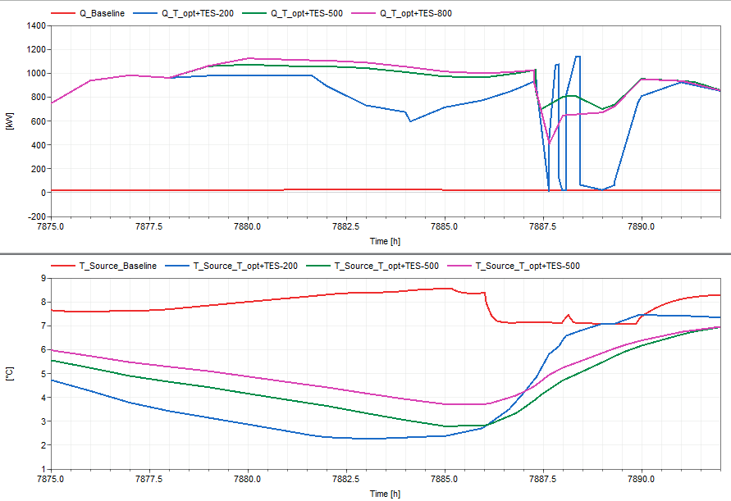
Fig. 10.Comparison of performance of the HP across scenarios (Capacities (top), Source temperature (below)).
4. Conclusion
From the results discussed above, it is clear that any applied measure would lead to better performance in the analyzed KPIs. In terms of lowest natural gas consumption, lowest CO₂ emissions, highest self-sufficiency and highest renewable share, the scenario combining temperature optimization and PV expansion by 20 % (T-opt+PV-20) offers the best results followed by the scenario which combines temperature optimization, PV capacity expansion by 10 % and thermal energy storage of 500 m³ (T-opt+PV-10+TES 500), with baseline as the worst scenario due zero savings, highest CO₂ emissions and lowest renewable energy share. Therefore, there is a potential of reducing CO2 emission related to operation by up 27.3 % annually.
Considering economic analysis based on operational costs and investment costs, the highest savings were obtained in the scenario which combines temperature optimization, PV capacity expansion by 10 % and thermal energy storage of 500m³ (T-opt+PV-10+TES 500) with 15.9 %; however, with longest payback period of 7 years. T-Optimization scenario offers the shortest payback period of 0.5 years with lowest savings of 10.3 % among other scenarios apart from baseline and it is the measure which should be implemented first, because all other scenarios are built upon it. If savings and payback time are given same weight, then T-Optimization is the best in terms of savings and shortest payback period followed by the scenario which combines temperature optimization and thermal energy storage of 200 m³ (T-opt+TES-200) with 13.5 % savings and a payback period of 3.1 years. If annual savings are given more weight (i.e. 0.8) then scenario which combines temperature optimization, PV expansion by 10 % and thermal energy storage of 200 m³ (T-opt+PV-10+TES 200) performs best, while the baseline shows the lowest performance. On the contrary, if payback time weighs more (i.e. 0.8) then scenario T-Optimization ranks highest followed by baseline, while T-opt+PV-10+TES 500 shows the lowest performance.
It is evident that prioritizing the heat pump operation over the boilers during periods of excess PV generation yields superior results, while the integration of thermal energy storage enhances the operational dispatchability of the heat pumps and chillers. The magnitudes of savings, CO₂ emissions and payback times are subject to the conversion factors used in Tab. 2Error! Reference source not found. and Fig. 8.
5. Acknowledgements
This work has been developed under the project of “SENERGY NETS” funded by the Horizon Europe framework of the European Union, Project No. 101075731.
The views and opinions expressed are those of the author(s) only and do not necessarily reflect those of the European Union. The European Union can not be held responsible for them.
6. References
ASHRAE, 2020. Chapter 50: Thermal Storage. In: In ASHRAE Handbook: HVAC Systems and Equipment. Atlanta: ASHRAE.
Beck, H. E., Zimmermann, N.E., McVikar, T.R., Vergopolan, N., Berg, A., Wood, E.F., 2018. Present and future Köppen-Geiger climate classification maps at 1-km resolution. Scientific Data, Volume 5, p. 180214.
Bhatkar, V. W., Shastri, D.S., Kaithari, D.K., Bhambare, P.S., Allampllewar, G.L., Meherkar, A.A., 2025. Heat Transfer Analysis of Stratified Chilled Water Storage Tank for District Cooling Systems. International Journal of Heat and Technology, Volume 43, pp. 39-46.
Brück, D., Elmqvist, H., Mattsson, S. E., Olsson, H., 2002. Dymola for Multi-Engineering Modeling and Simulation. The Modelica Asssociation.
Delle, M., Civcisa, I., Vitolins, V., Lauka, D., Blumberga, D., 2019. Integration of Sun PV Electricity in Centralized Heating Systems. Environmental and Climate Technologies, Volume 23, pp. 245-259.
Diputació de Barcelona, C., 2023. Obres del dipòsit d'acumulació d'aigua freda de la xarxa del Tub Verd, a la carretera de Barcelona de Mataró, s.l.: CIDO (Cercador d'Informació i Documentació Oficials).
Eurostat, 2026. Natural gas prices for non-household consumers. [Online, accessed 08 2026]. Available at: https://ec.europa.eu/eurostat/statistics-explained/index.php?title=Natural_gas_price_statistics#Source_data_for_tables_and_figures_(MS_Excel)
Euskadi.eus, 2024. Kontratazio Publikoa Euskadin Plataforma. [Online, accessed 08 2026]. Available at: Available at: https://www.contratacion.euskadi.eus/webkpe00-kpesimpc/es/contenidos/anuncio_contratacion/expjaso483502/es_doc/index.html
Jacopo, V., Mattia, C., Angelo, Z., Michele, D. C., 2022. Investigation on Individual and Collective PV Self-Consumption for a Fifth Generation District Heating Network. Energies, p. 1022.
Kalina, J., Tańczuk, M., Jendryasek, Ł., 2025. Planning energy transition and decarbonisation of district heating systems in Poland. Energy, Volume 328, p. 136578.
Kim, D., Kim, H. J., Tak, H., Lee, J. Y., 2026. Field evaluation of a soft actor–critic-based control strategy for a centralized geothermal heat pump system. Energy Conversion and Management, p. 121248.
Lüchinger, R., Hendry, R., Walter, H., Worlitschek, J., Schuetz, P., 2025. Cost Analysis for Large Thermal Energy Storage Systems. ASME Journal of Engineering for Sustainable Buildings and Cities, Volume 6, pp. 1-49.
Maitanova, N., Schlüters, S., Hanke, B., von Maydell, K., 2024. An analytical method for quantifying the flexibility potential of decentralised energy systems. Applied Energy, Volume 364, p. 123150.
MITECO, 2026. Factores de emisión 2025. [Online, accessed 08 2026]. Available at: https://www.miteco.gob.es/content/dam/miteco/es/cambio-climatico/temas/mitigacion-politicas-y-medidas/factoresemision_tcm30-542746.xlsx
Público, P. d. c. d. s., 2024. Anuncio de adjudicación. [Online, accessed 08 2026]. Available at: https://contrataciondelestado.es/FileSystem/servlet/GetDocumentByIdServlet?DocumentIdParam=24u1F%2BRvDxHsHE0zZG0dc0CQU0v2SZovsjQc5ZE%2BbMFyUt9FbNPxH%2BHfn6kw2ZwD6LE%2BJKJgz7qYWGbMgOrpiTKmejhNTgkoJSs%2Ba%2FtaWFv3GVhXrFFqN7yFncy7YfRK&cifrado=QUC1GjXXSiLkydR
REE, 2026. Informe del sistema Eléctrico 2025, s.l.: s.n. [Online, accessed 08 2026]. Available at: https://www.sistemaelectrico-ree.es/sites/default/files/informes/2026/ise-2025.pdf
REE, 2026. Mercados Y Precios. [Online, accessed 08 2026]. Available at: https://www.esios.ree.es/es/analisis/612?vis=1&start_date=01-06-2024T00%3A00&end_date=31-05-2025T23%3A55&compare_start_date=31-05-2024T00%3A00&groupby=hour&geoids=3
Zhou, E., Hale, E., Present, E., 2022. Building flexibility revenue in modeled future bulk power systems with varying levels of renewable energy. Heliyon, Volume 8, p. e09865.

