EuroSun2026
AI-Driven Adaptive Optimisation of Solar-Assisted Industrial Heat Networks Using LSTM System Identification and MPC

Summary
Solar-assisted industrial heat systems are characterised by nonlinear dynamics and long thermal time constants, making conventional modelling and control approaches inadequate. This study proposes a data-driven control framework that relies solely on temperature measurements and pump status, eliminating the need for weather and flow sensors. A Long Short-Term Memory (LSTM) network is developed to model the thermal behaviour of a stratified buffer tank and predict temperatures over a 10-minute horizon. The model is trained using high-resolution operational data from a solar thermal system at the University of Botswana. It achieves an RMSE of 3.36 °C and an R² of 0.928 for top-layer temperature prediction. The LSTM model is integrated into a Model Predictive Control (MPC) framework to optimise binary pump operation. Compared with a tuned hysteresis controller, the proposed approach increases pump utilisation (26% to 43%) and ensures smoother operation, while resulting in 12% lower cumulative heat output due to short prediction horizon limitations. The framework is computationally efficient, requires minimal instrumentation, and is suitable for retrofit applications. Future work will focus on longer prediction horizons and reinforcement learning to improve thermal performance.
Keywords: Long Short-Term Memory, Solar Thermal Systems, Model Predictive Control
Field of application for the findings: Smart energy districts, solar thermal heating, digitalised energy networks
Addressed audience: Energy system researchers, district heating operators, smart city planners
- Introduction
The large-scale deployment of solar-assisted industrial heat (SAIH) systems is hindered by the associated technical and economic challenges (Sharma et al., 2026). The commonly employed control strategies, such as the hysteresis controller, often lead to either unnecessary pumping or missed solar gains (Koparde et al., 2026). Equally, the physics-based models require extensive knowledge about collector properties, storage stratification, piping losses, and sometimes even weather forecasts. Calibration of these models is a tedious and site-specific process. Moreover, using physics-based models in real-time optimization is also computationally intensive, making it difficult to implement in cost-effective controllers. In contrast, data-driven modelling using techniques like neural networks provides an opportunity to model complex systems like solar thermal systems more effectively. Neural networks approximate complex nonlinear system behaviour using empirical data (Talib et al., 2025). They can learn and adjust to new system behaviours with new training data. However, there is little work on using data-driven modelling techniques in solar thermal system control, except for using feed-forward neural networks for one-step ahead prediction (Platis, 2026) and reinforcement learning for policy optimisation (Koparde et al., 2026).
In this paper, we address a realistic, sensor-constrained SAIH system, namely: measured variable which comprises the collector outlet temperature, three buffer tank temperatures (bottom, centre, top), and pump status; no direct irradiance, ambient temperature, or flow measurements; the control action, which is the binary pump on/off.
- System Description and Dataset
The solar-assisted industrial heat system under examination is in operation at the University of Botswana Hostels and functions during the summer season from October to March, where the solar irradiance is at its peak, and the ambient temperature varies from 25 °C to 35 °C.
2.1. Data Acquisition and Variables
The data were logged by a Siemens PLC at a fixed sampling interval of 120 seconds from 2025-03-20 12:36:43 to 2025-04-03 22:36:12, resulting in approximately 10,080 samples over 14 days.
2.2. Data Preprocessing
The data were split chronologically to avoid look-ahead bias:
  - Training: 2025-03-20 to 2025-03-27 (first 8 days)
  - Validation: 2025-03-28 to 2025-03-30 (next 3 days)
  - Test: 2025-03-31 to 2025-04-03 (remaining 3 days)
To provide a performance benchmark, we implemented a hysteresis (differential) controller that is typical in existing solar thermal systems. The control rule is:
$$u(t)=\left\{\begin{matrix}1 & \text{if }T_{\text{col}}(t)-T_{\text{top}}(t)>Δ_{\text{on}} \\ 0 & \text{if }T_{\text{col}}(t)-T_{\text{top}}(t)<Δ_{\text{off}} \\ u(t-1) & \text{otherwise}\end{matrix}\right.$$
- Methodology
3.1 Input and Output Formulation
At each discrete time step $t$ (with $Δt=2$ minutes), the input vector is:
$$x(t)={\left[T_{\text{col}}(t), T_{\text{bottom}}(t), T_{\text{centre}}(t), T_{\text{top}}(t), sin⁡\left(\frac{2πh(t)}{24}\right), cos⁡\left(\frac{2πh(t)}{24}\right), u(t)\right]}^{⊤}∈R^{7}$$
The output vector is the three buffer temperatures at a future time $t+H_{p}$:
$$y(t)={\left[T_{\text{bottom}}(t+H_{p}), T_{\text{centre}}(t+H_{p}), T_{\text{top}}(t+H_{p})\right]}^{⊤}∈R^{3}$$
3.2. LSTM Architecture
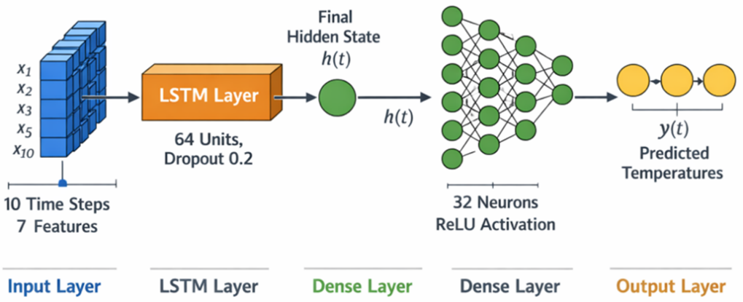
Figure 1: Architecture of the LSTM Framework
3.3 Objective Function
The objective for a candidate control sequence $u=[u(t),u(t+1),…,u(t+H_{c}-1)]$ is:
$$J(u)=α\sum_{k=0}^{H_{c}-1}{max⁡}\left(0, {\hat{T}}_{\text{top}}(t+k+1)-{\hat{T}}_{\text{top}}(t+k)\right)-β\sum_{k=1}^{H_{c}-1}{∣u(t+k)-u(t+k-1)∣}$$where ${\hat{T}}_{\text{top}}(⋅)$ are the recursively predicted top temperatures, $α=1.0$ is the weight for heat delivery, $β=0.1$ is the penalty per pump switch.
- Results and Discussion
4.1 Prediction Accuracy
Tab. 1: Prediction errors on the test set (10-minute horizon).
Variable | RMSE (°C) | MAE (°C) | $$R^{2}$$
$$T_{\text{bottom}}$$ | 4.44 | 3.29 | 0.958
$$T_{\text{centre}}$$ | 4.01 | 3.11 | 0.906
$$T_{\text{top}}$$ | 3.36 | 2.22 | 0.928
4.2. Prediction Visualisation
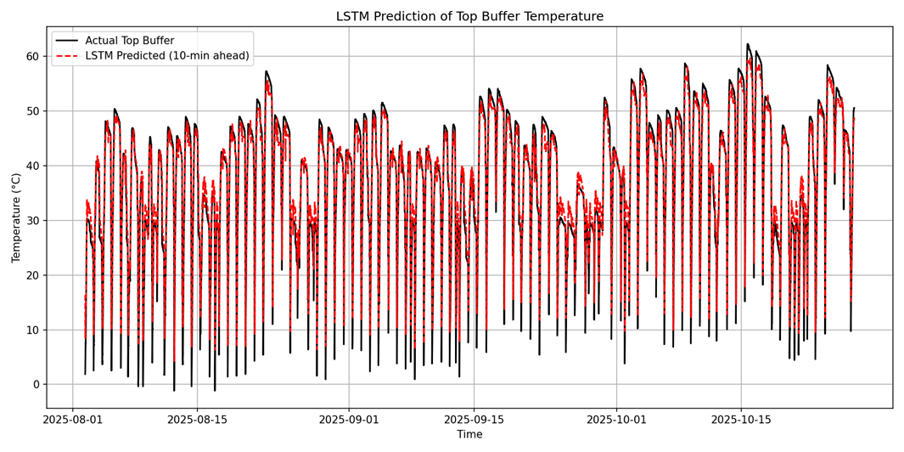
Figure 2: LSTM Prediction of Top Buffer Temperature
4.3. Overall Performance
Tab. 2: Control performance comparison (500 sample test, ≈16.7 h)
Metric | Hysteresis | LSTM-MPC | Difference (MPC – Hyst)
Heat delivered (cumulative Δ$T_{\text{top}}$) [°C] | 32.8 | 28.9 | –3.9
Pump cycles | 10 | 12 | +2
Pump on-time fraction | 0.26 | 0.43 | +0.17
Stagnation events (>95 °C) | 0 | 0 | 0
- Conclusion
This paper proposed a data-driven framework for system identification and control of the SAIH system using only temperature information and pump status. The LSTM network achieved good accuracy in predicting buffer tank temperatures at a horizon of 10 minutes. The proposed LSTM network is then used to improve the binary pump on/off control using MPC. In a 500-sample simulation, the proposed LSTM MPC controller increased the proportion of time the pump is on from 26% to 43%, albeit with 12% less heat produced than the tuned hysteresis controller. This shows the difficulties with discrete control with short prediction horizons. Despite the negative results, the proposed framework shows that it is possible to achieve good surrogate modelling with few sensors, and the proposed method can be used for retrofits.
- References
Koparde, S., Nandgaonkar, A., Deshpande, P., & Iyer, B. (2026). Energy and Spectral Efficiency Optimization with Security in Massive MIMO–5G Using Integrated Machine Learning. International Journal of Computer Networks and Applications, 13(1), 17–37. https://doi.org/10.22247/ijcna/2026/02
Platis, I. D. (2026). Geometries (1st ed. 2026). Springer Nature Switzerland. https://doi.org/10.1007/978-3-032-08016-5
Sharma, G., Khurana, S., Sharma, B., & Sharma, G. (2026). A Self-Tuning Reinforcement Learning–Driven Isolation Forest Framework for Scalable and Efficient Anomaly Detection in Solar Power Plants. International Journal of Computational Intelligence Systems, 19(1), 133. https://doi.org/10.1007/s44196-026-01210-5
Talib, Z., Abdul Rahaim, Dr. L. A., & S. Aljuboury, Dr. A. (2025). Modified CNN Learning Model for Tetouan City Energy Consumption Prediction. Journal of Internet Services and Information Security, 15(3), 465–479. https://doi.org/10.58346/JISIS.2025.I3.032

