Surface MOdification of carbon fibres for interface improvement in textile composites

Jiawen Qiu¹, Jiashen Li¹, Zishun Yuan¹, Haoxian Zeng^{1,2} and Xiaogang Chen¹
¹School of Materials, University of Manchester, Manchester M13 9PL, United Kingdom
²School of Science, Zhongyuan University of Technology, Zhengzhou, China
Email: jiawen.qiu@manchester.ac.uk; jiashen.li@manchester.ac.uk; xiaogang.chen@manchester.ac.uk; zishun.yuan@manchester.ac.uk; haoxian.zeng@mancheseter.ac.uk

Keywords: carbon fibre modification, graphene, composites, interface, characterization, micro-bond

Abstract
The performance of carbon fibre-reinforced composites is dependent to a great extent on the properties of the fibre-matrix interface. In this research, based on the reviewed surface modification technique and inspired by the in situ growth of three-dimensional graphene coatings on nanomaterials, a new method of in situ growth of a graphene-related structure on the surface of carbon fibres is to be applied, for which it is intended to use a mixed solution of Ferrous Sulfate Heptahydrate (FeSO₄∙ 7H₂O) and D-Glucose monohydrate (C₆H₁₂O₆ · H₂O) to treat the carbon fibres under specific conditions to in-situ growth of a graphene-related coatings on the surface of carbon fibres. Firstly, the method was carried out by heating the mixed solution under specific temperature on the silicon substrate and followed with characterisation experiments such as Raman, Scanning Electron Microscopy (SEM). Then, the mixed solution was applied on the carbon fibres and treated under the same condition. The characterisation results indicated successfully growth of the porous carbon coatings on the surface of carbon fibres, which contained with graphene-related structures and the interfacial shear strength (IFSS) was increased by 38% compared with the raw carbon fibre composite.

1. Introduction

Carbon fibres reinforced composites have the superior stiffness to weight and strength-to-weight ratios, which have been used in a large number of high-performance structural applications such as the automotive, aerospace, military defence and new energy. While the bulk composite properties of carbon fibres reinforced composites will be affected by the interface between fibres and matrix . Fibre-matrix interfacial adhesion is extremely important since carbon fibres have chemical inertness and poor wettability with most of the polymeric matrices .

The interface between the fibre and the matrix of composites materials is a very important aspect of the mechanism, which can affect the load transfer characteristic and mechanical behaviour under external loading. The wetting, dispersion and interface adhesion between fibre and matrix are very important factors in designing fibre reinforced composites . Studies focused on the effect of Chemical Vapor Deposition (CVD) applied grafting on the mechanical properties of carbon fibre-reinforced epoxy composites have been carried out decades ago. In continuous fibre-reinforced composites, the load is transferred from the matrix to the fibre through shear. With poor interfacial strength, less shear stress is capable of being transferred to the fibre, creating a weaker, less efficient composite . The synthesising of 3D graphene layers on non-metal substrates by using the CVD method also has been accomplished .

In this research, inspired by the in situ growth of three-dimensional graphene coatings on nanomaterials , the method of in-situ growth of graphene-related structure on the surface of carbon fibres was proposed, which intended to use a mixed solution of Ferrous Sulfate Heptahydrate (FeSO₄∙ 7H₂O) and D-Glucose monohydrate (C₆H₁₂O₆ · H₂O) to treat the carbon fibres, then transfer the treated carbon fibres into a tube-furnace under specific conditions to in-situ grow a graphene-related coating on the surface of carbon fibres. The in-situ growth of graphene-related coating is believed to be able to improve the interface adhesion between carbon fibre and composite resin to develop the mechanical properties of the carbon fibres reinforced composites.

2. Experimental Section

2.1. Materials

The carbon fibres used in this research were type 12K A-42 DowAksa (Turkey). The Ferrous Sulfate Heptahydrate (FeSO₄∙ 7H₂O) and D-Glucose monohydrate (C₆H₁₂O₆ · H₂O) were purchased from the Fisher Scientific and Sigma-Aldrich® (UK) respectively. And the Nitric Acid (HNO₃) and Acetone (CH₃COCH₃) were also purchased from Sigma-Aldrich® (UK).

2.2. Methodology

In the research of Qian et al. carbon nanotubes were grown on carbon fibres using the chemical vapour deposition (CVD) method. Iron was selected as the catalyst and pre-deposited on carbon fibres directly for the formation of carbon nanotubes (CNT). Iron particles with diameters of between 20 and 55 nm were uniformly coated onto the fibre surface . These particles acted as the catalyst for CNT growth, giving rise to a homogeneous layer of grafted CNTs. However, small holes were observed on some fracture surfaces of the CNT-grafted fibre composites. The formation of the pits can be attributed to “the dissolution of iron into the carbon fibres” at the reaction temperature . It leads to a seriously negative influence on the tensile strength of carbon fibres and the carbon fibre-dominated mechanical properties of the composites. Zhang et al. have constructed, in-situ, a nanometer-thick catalytic interface on the micro/nano particle surface by introducing a trace amount of transition metal salts and solid carbon sources with strictly controlled content and ratio, which is inspired by the CVD growth mechanism of 2D graphene sheets on the bulk metal substrates .

In the experiment, iron and extra carbon source material are coated to carbon fibres, so that the extra carbon source can help to restrict the iron particles to a small size. Iron particles near the carbon source can help to keep the iron particles small in size. Then, iron particles near the carbon fibre dissolve carbon atoms both from the carbon fibre and the extra carbon source at high temperature. When the temperature decreases, carbon atoms are released from the iron particles and they form graphene-related layers. Thus, these graphene-related layers are really grown in-situ and have primary contact with the carbon fibres as shown in Figure 1. There should be C-C bonds between the graphene-related structure and the carbon fibres, and not any other chemically grafted GO with covalent bonds because this cannot survive at high temperature during the following CVD process. Therefore, the interface strength between the carbon fibre and the GO are weakened.

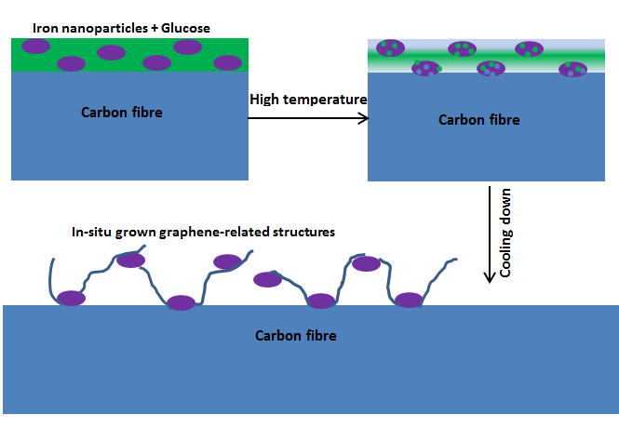

Figure 1. The methodology of in-situ growth of graphene-related coatings on the surface of carbon fibres

3. The growth of graphene-related coatings

In order to exclude the possible effects of commercial sizing from the interfacial shear strength improvement in the system, the size needs to be removed. Two different methods have been used to remove the size, which include immersing the carbon fibre in 65% heavy HNO₃ for 1 hour, immersing the carbon fibre in acetone for 24 hours and heating the carbon fibre under high temperature. Then, the ferrous and glucose solution can be used to treat the desized carbon fibre to produce pretreated samples. Then, the pretreated carbon fibre was dried in an oven at 80 ̊C for 12 hours. After that, the completed sample was transferred to the tube furnace with the protection of Ar/H₂ in a (95:5) ratio atmosphere. The temperature was set up at 950 ̊C at a rate of 5 ̊C/min and maintained the temperature for 6 hours according to the analysis of result from different studies. Finally, the sample was cooled down to room temperature at 5 ̊C/min; the process is illustrated in Figure 2.

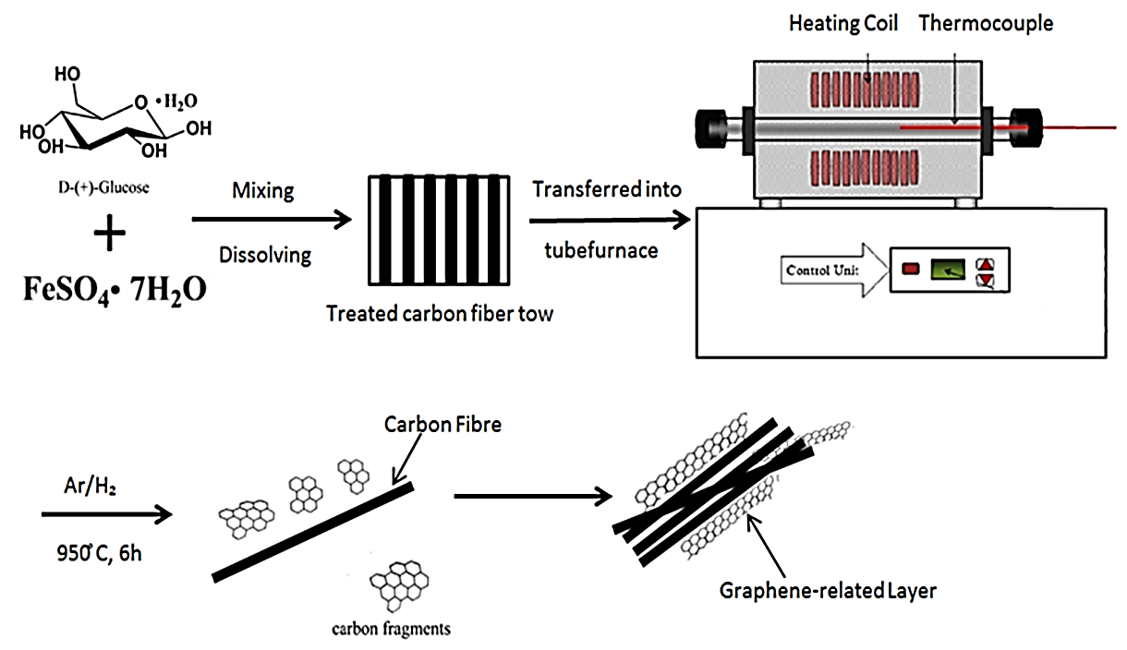

Figure 2. The experiment of in-situ growth of graphene-related coatings on the surface of carbon fibres

4. Characterisation results and discussion

4.1. Characterisation of the modified method on the silicon substrate

The solution on the silicon substrates was heated in the tube furnace under high temperature and an Argon/H₂ atmosphere to verify the modified method. Then the residues of the reacted solution were characterised by using scanning electron microscopy (SEM/Ultra 55) and Raman spectroscopy (Renishaw 1000 514nm Argon-ion laser). The SEM results demonstrated that a porous carbon structure has been generated from the residues of the solution as shown in Figure 3(a) and (b).
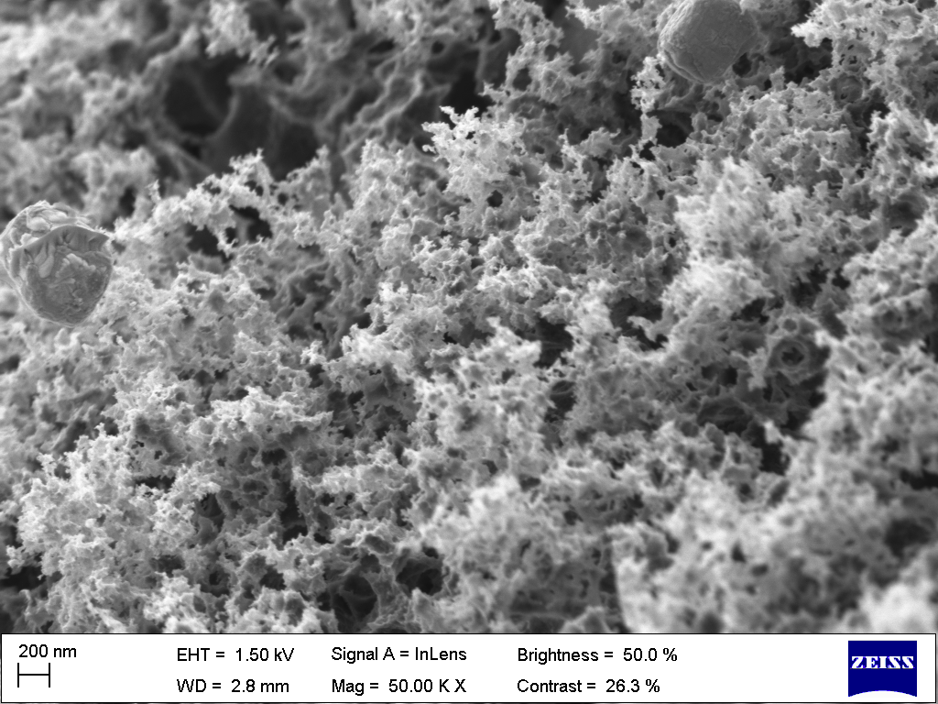  (a) | 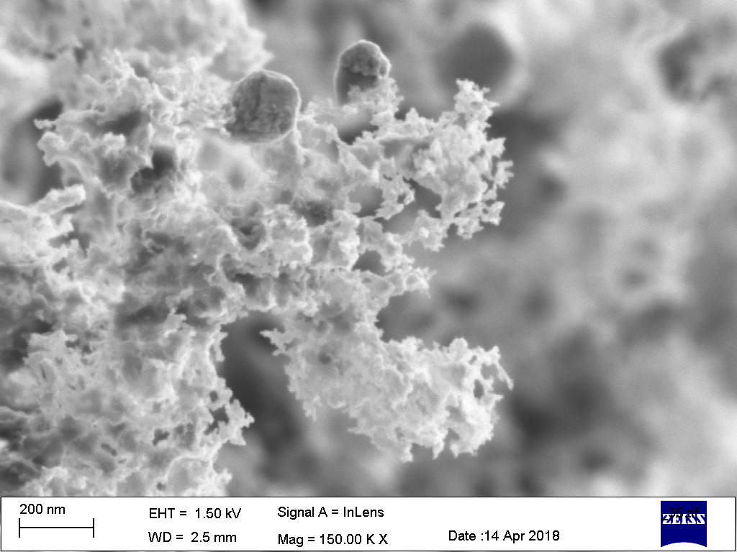  (b)
Figure 3(a) and (b). The porous carbon structure generated from the reacted Ferrous Sulfate Heptahydrate and D-glucose monohydrate mixed solutions

The dotted structure distributed in the porous carbon structure was shown by SEM to be iron and the rest of the material is carbon under the Energy-dispersive X-ray Analysis (EDS) mode shown in Figure 4(b) and (c). There should be graphene-related structures generated in the porous carbon structures according to the achieved Raman spectrum results.
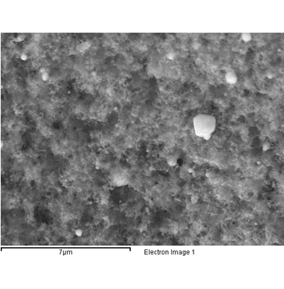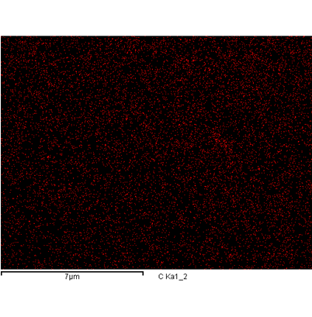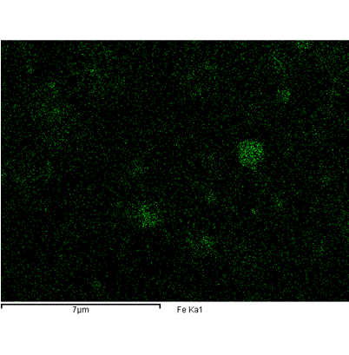
(a) (b) (c)

Figure 4. (a) The SEM image of the porous carbon structure (b) The C element in the porous carbon structure under the EDS mode of the SEM (c) The Fe element distribution in the porous carbon structure under the EDS mode of the SEM

The Raman spectrum Figure 5 indicated that it consists of two prominent peaks at around ~1330 and ~1600 cmˉ¹ along with a wide band extending from about 2600-3200 cmˉ¹. The peaks at ~1330 and ~1600 cmˉ¹ are the D and G bands respectively . The G band is a characteristic of all graphitic structures. The D band is attributed to the presence of defects, wrinkle formation and the presence of functional groups . The wide band at the high-frequency end of the spectrum contains three peaks around 2650cmˉ¹, 2930 cmˉ¹ and 3190 cmˉ¹, respectively. The peak at ~2650 is known as the 2D band since it is an overtone of the D band. While unlike the 2D peak of the perfect monolayer graphene which has high intensity and a Lorentzian shape, the 2D peak indicated a few layered graphene depositions, and is complex in shape and evolves with the number of layers

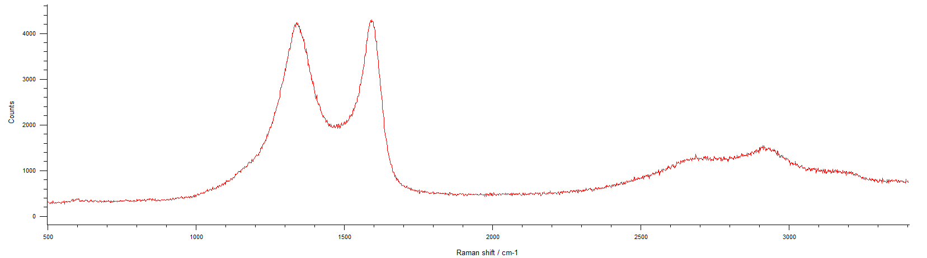

Figure 5. Characterisation results of the residues of the reacted Ferrous Sulfate Heptahydrate and D-glucose monohydrate mixed solutions analysed by using Raman spectroscopy

4.2. In-situ growth of graphene on sized and desized carbon fibres

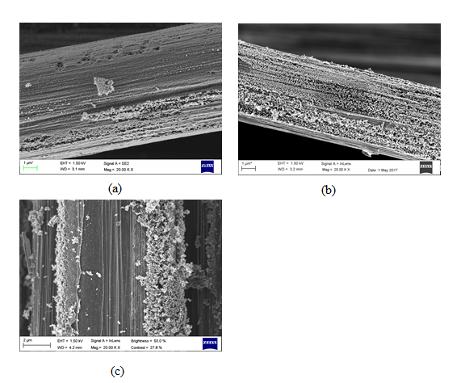

Figure 6. (a) Raw carbon fibre treated with Ferrous/glucose solution (b) Desized carbon fibre (with Acetone) and treated with Ferrous/glucose solution (c) Desized carbon fibre (with HNO₃) and treated with Ferrous/glucose solution

The raw carbon fibre treated with solution and then heated in the tube-furnace are shown in Figure 6(a) and indicated that there are only small amount of bumps on the surface of the solution-modified carbon fibres compared with the desized carbon fibres. This is caused by the sizing on the surface of the carbon fibres that lead to the uneven of the solution on the surface of the carbon fibres. The longitudinal grooves on the surface of the carbon fibre after treating by HNO₃ and Acetone can help to load the solution better compared with the raw carbon fibre . The porous carbon structure coatings were captured on the surface of the desized carbon fibres and treated with the solution as shown in Figure 6(b) and (c).

4.3. Mechanical test

The micro-bond test was carried out by using a designed rig fixed on the tensile testing machine as shown in Figure 7(a) and (b). The fibre was pulled between the blade to identify the micr-bond shearing force between the carbon fibre and the resin droplet.
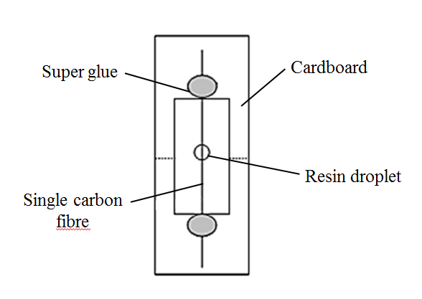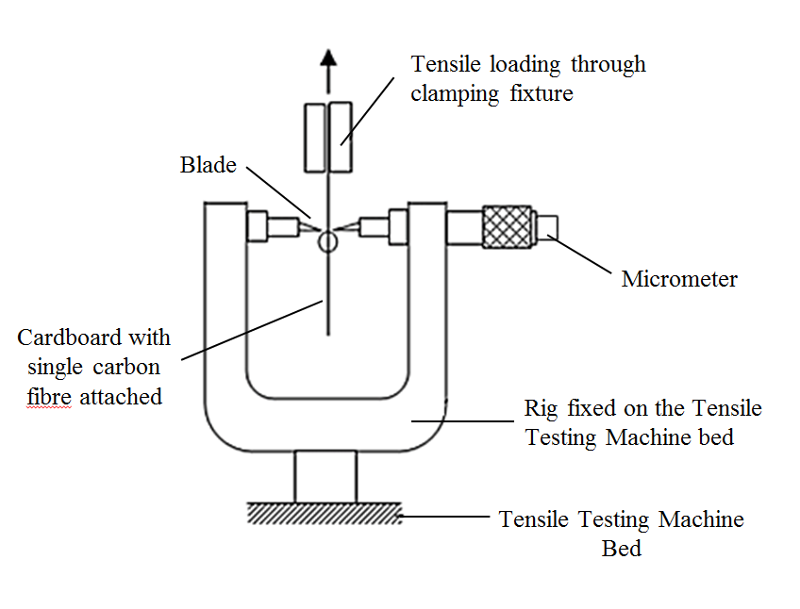
(a) (b)

Figure 7. (a) Illustration of the specimen for the mico-bond test (b) Microbond test machine setting

The interfacial shear strength (IFSS) was determined using the equation below, assuming that the interfacial shear stress keeps constant along the fibre:
IFSS=F/(πDl) | (1)
Where F is the maximum pull put force, D is the fibre diameter, l is the embedded length, which is in a range of 40-60 μm. 20 valid data were collected for each different type of carbon fibres.

4.3.1. Interfacial shear strength test result and analysis

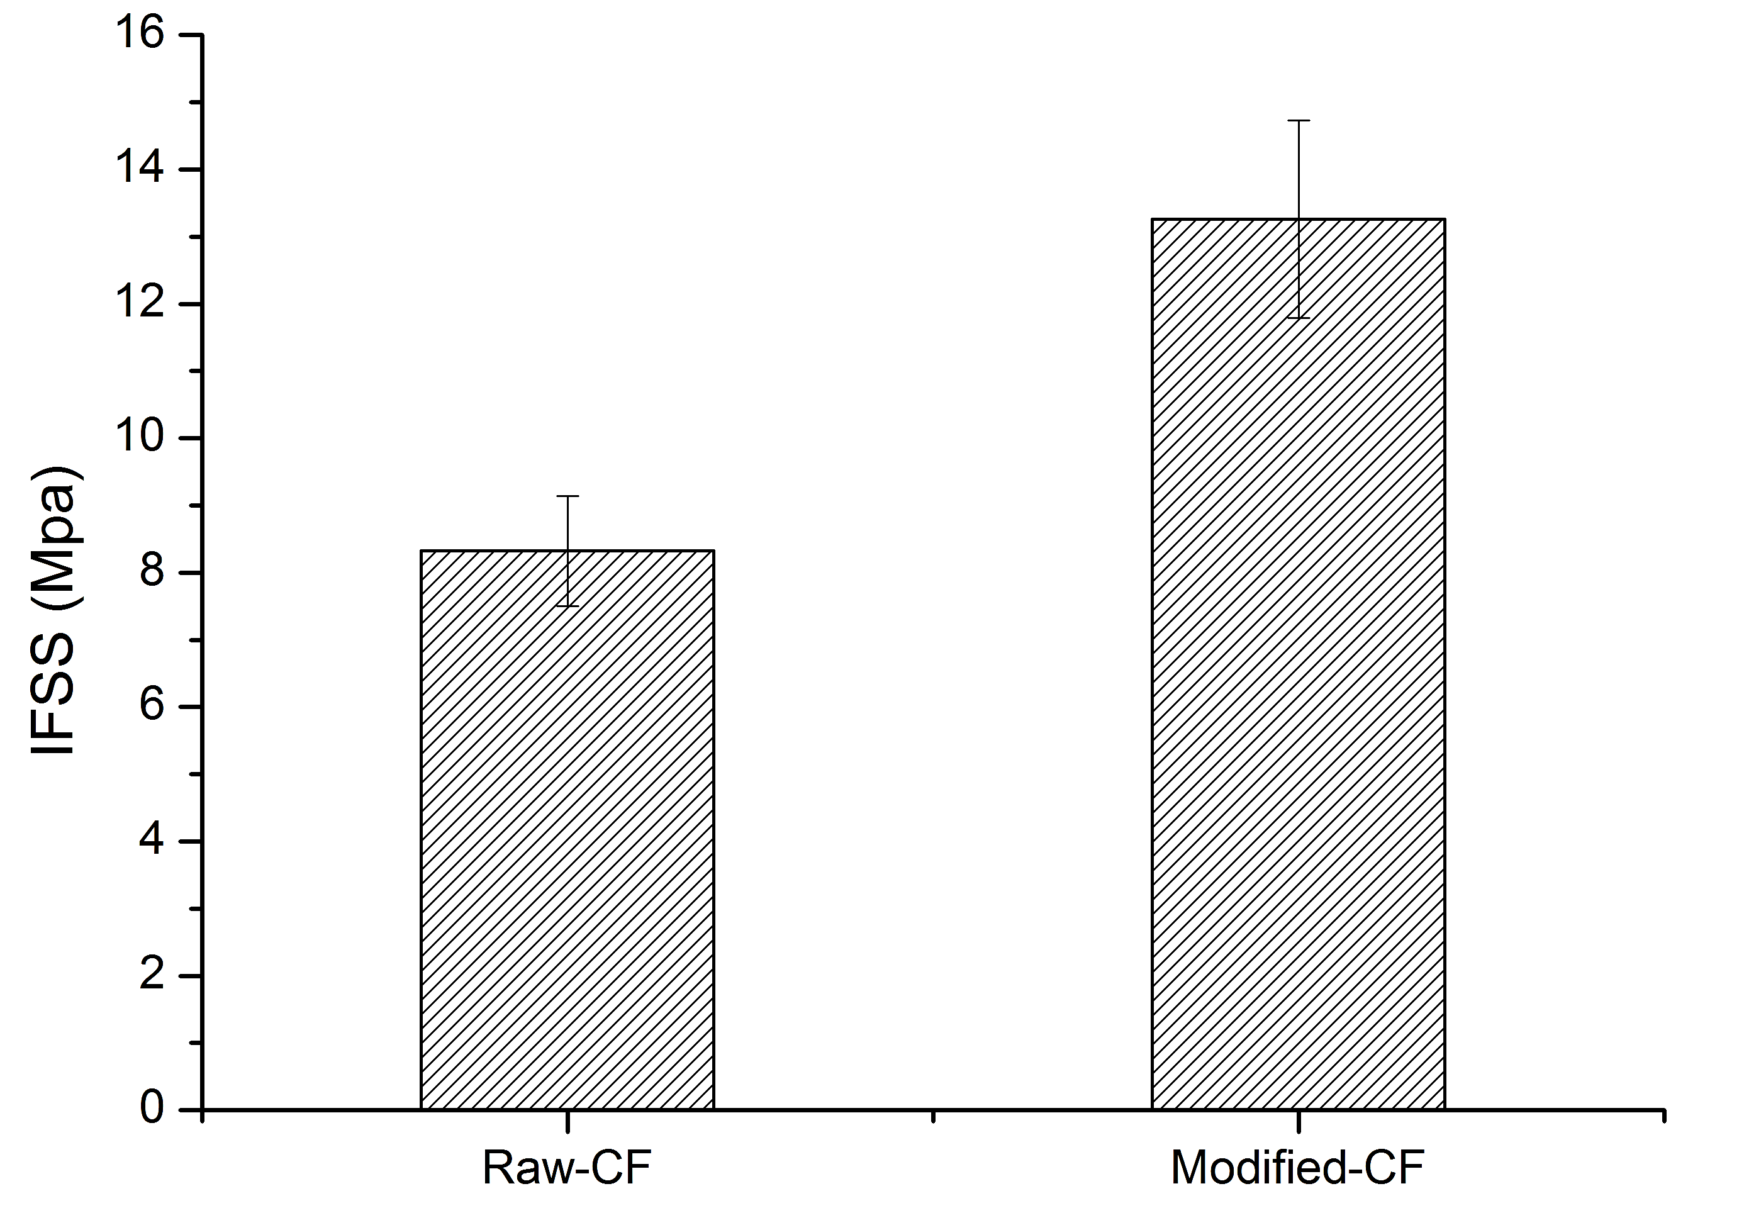

Figure 8. The interfacial shear strength between single carbon fibre and resin droplet

The result of the interfacial shear strength between the different types of carbon fibre composites was shown in Figure 8. It indicated that the interfacial shear strength of the raw carbon fibre composite and surface modified carbon fibre composite is 8.3 Mpa and 13.3 Mpa respectively. Thus, the IFSS of the surface modified carbon fibre composite is around 38% higher compared with the raw carbon fibre composite which can be explained by the SEM result. The in-situ grown porous carbon structure on the surface of the carbon fibre has not only built an original bonding with the carbon fibre but also increased the surface area of the carbon fibre. Therefore, the adhesion between the carbon fibre and the resin was increased greatly.

Conclusion

The residues of the reacted solutions were characterised by Raman spectroscopy and the three peaks at around ~1330 cmˉ¹ and ~1600 cmˉ¹ along with a wide band extending from about 2600-3200 cmˉ¹ indicated that there should be graphene-related structures in the coating. The porous carbon structure has been in-situ grown on the surface of carbon fibres and the result indicated that the IFSS was increased by 38% compared with the raw carbon fibre composite.

Then the mixed solutions are used to treat the carbon fibre to promote the in-situ growth of graphene-related structures on the surface of the carbon fibres, before applying the solution to the surface of the carbon fibres. The commercial sizing needs to be removed to reduce the effect on the growth of the graphene-related layer on the surface of the fibres and also help to introduce some carboxyl groups on to the carbon fibres. The SEM image demonstrated that the raw carbon fibres treated with solution samples have the worst coating compared with the desized samples, which indicated that the commercial sizing does affect the uniformity of the graphene-related coatings.

References

[1] H. Yao, X. Sui, Z. Zhao, Z. Xu, L. Chen, H. Deng, Y. Liu, X. Qian. Optimization of interfacial microstructure and mechanical properties of carbon fiber/epoxy composites via carbon nanotube sizing. Applied Surface Science, 347:583-590, 2015.
[2] X. Zhang, X. Fan, C. Yan, H. Li, Y. Zhu, X. Li, L. Yu. Interfacial microstructure and properties of carbon fiber composites modified with graphene oxide. ACS applied materials & interfaces, 4:1543-1552, 2012.
[3] R. Sager, P. Klein, D. Lagoudas, Q. Zhang, J. Liu, L. Dai, J. Baur. Effect of carbon nanotubes on the interfacial shear strength of T650 carbon fiber in an epoxy matrix. Composites Science and Technology, 69:898-904, 2009.
[4] L.W. Xu, Y. Huang, L. Liu. Advanced Materials Research. Trans Tech Publ, pp. 2221-2226, 2011.
[5] M. Shazed, A. Suraya, S. Rahmanian, M.M. Salleh. Effect of fibre coating and geometry on the tensile properties of hybrid carbon nanotube coated carbon fibre reinforced composite. Materials & Design, 54:660-669, 2014.
[6] F. Li, Y. Liu, C.-B. Qu, H.-M. Xiao, Y. Hua, G.-X. Sui, S.-Y. Fu. Enhanced mechanical properties of short carbon fiber reinforced polyethersulfone composites by graphene oxide coating. Polymer, 59:155-165, 2015.
[7] L. Zhang, L. Zhang, J. Zhang, P. Xue, W. Hao, M. Shen, H. Zheng. In situ growth of three-dimensional graphene coatings on arbitrary-shaped micro/nano materials and its mechanism studies. Carbon, 92:84-95, 2015.
[8] J. Pang, A. Bachmatiuk, I. Ibrahim, L. Fu, D. Placha, G.S. Martynkova, B. Trzebicka, T. Gemming, J. Eckert, M.H. Rümmeli. CVD growth of 1D and 2D sp2 carbon nanomaterials. Journal of Materials Science, 51:640-667, 2016.
[9] D.C. Marcano, D.V. Kosynkin, J.M. Berlin, A. Sinitskii, Z. Sun, A. Slesarev, L.B. Alemany, W. Lu, J.M. Tour. Improved synthesis of graphene oxide. ACS nano, 4:4806-4814, 2010.
[10] J.A. Rodríguez-Manzo, C. Pham-Huu, F. Banhart. Graphene growth by a metal-catalyzed solid-state transformation of amorphous carbon. ACS nano, 5:1529-1534, 2011.
[11] J. Li, L. Zhang, L. Zhang, W. Hao, H. Wang, Q. Qu, H. Zheng. In-situ growth of graphene decorations for high-performance LiFePO 4 cathode through solid-state reaction. Journal of Power Sources, 249:311-319, 2014.
[12] M. Sevilla, A.B. Fuertes. Catalytic graphitization of templated mesoporous carbons. Carbon, 44:468-474, 2006.
[13] G. Wu, K.L. More, C.M. Johnston, P. Zelenay. High-performance electrocatalysts for oxygen reduction derived from polyaniline, iron, and cobalt. science, 332:443-447, 2011.
[14] H. Qian, A. Bismarck, E.S. Greenhalgh, G. Kalinka, M.S. Shaffer. Hierarchical composites reinforced with carbon nanotube grafted fibers: the potential assessed at the single fiber level. Chemistry of Materials, 20:1862-1869, 2008.
[15] Y. Li, L.j. Guo, Y.w. Wang, H.j. Li, Q. Song. A novel multiscale reinforcement by in-situ growing carbon nanotubes on graphene oxide grafted carbon fibers and its reinforced carbon/carbon composites with improved tensile properties. Journal of Materials Science & Technology, 32:419-424, 2016.
[16] R. Bajpai, S. Roy, J. Rafiee, N. Koratkar, D. Misra. Graphene supported nickel nanoparticle as a viable replacement for platinum in dye sensitized solar cells. Nanoscale, 4:926-930, 2012.
[17] A. Eckmann, A. Felten, A. Mishchenko, L. Britnell, R. Krupke, K.S. Novoselov, C. Casiraghi. Probing the nature of defects in graphene by Raman spectroscopy. Nano letters, 12:3925-3930, 2012.
[18] A.C. Ferrari, J. Meyer, V. Scardaci, C. Casiraghi, M. Lazzeri, F. Mauri, S. Piscanec, D. Jiang, K. Novoselov, S. Roth. Raman spectrum of graphene and graphene layers. Physical review letters, 97:187401, 2006.
[19] A.C. Ferrari. Raman spectroscopy of graphene and graphite: disorder, electron–phonon coupling, doping and nonadiabatic effects. Solid state communications, 143:47-57, 2007.
[20] A. Gupta, G. Chen, P. Joshi, S. Tadigadapa, P. Eklund. Raman scattering from high-frequency phonons in supported n-graphene layer films. Nano letters, 6:2667-2673, 2006.
[21] J. Zhao, L. Liu, Q. Guo, J. Shi, G. Zhai, J. Song, Z. Liu. Growth of carbon nanotubes on the surface of carbon fibers. Carbon, 46:380-383, 2008.

