EuroSun2026
CYCLICAL OPERATION OF HORIZONTAL GROUND-SOURCE HEAT EXCHANGER IN A DUAL-SOURCE HEAT PUMP SYSTEM

Phillip Breidenbach (corresponding author), Tobias Reum, Elijah Flisar, David Schmitt, Tobias Schrag
Institute of new Energy Systems, Technische Hochschule Ingolstadt
phillip.breidenbach@thi.de
Summary
This paper presents an experimental investigation of a laboratory-scale shallow ground-source heat exchanger (GSHX) operated by a dual-source heat pump (DSHP) system. The GSHX investigation is based on a novel system integration of plate-type heat exchanger for peak-load coverage. The study focuses on the thermal behavior of a compact and densely packed shallow GSHX operated under cyclic heat extraction and regeneration at different soil moisture conditions. The results demonstrate a significant influence of moisture on the collector’s performance. Increased soil moisture led to heat extraction rates that were up to 20% higher and affected regeneration behavior, indicating improved thermal performance. Furthermore, increased moisture leads to slower cooling of the surrounding soil and the collector’s surface during heat extraction. Temperature plateaus observed in the measurements suggest freezing processes and the release of latent heat, which provides even more energy during heat extraction. Meanwhile, higher moisture levels ensure that the collector stabilizes at higher temperatures within a limited extraction time, thereby reducing ice formation despite a larger volume of freezable pore water and the need for regeneration. Overall, moisture was identified as a key parameter affecting heat extraction, regeneration behavior, thermal storage and phase change processes. The thermal behavior of the densely packed shallow GSHX is explainable. However, moisture must be considered both during operation and modelling.
Keywords: dual-source heat pumps, ground-source heat exchangers, soil moisture, thermal regeneration, phase change processes
Field of application for the findings: Thermal behavior of compact horizontal ground-source heat exchangers for dual-source heat pump systems.
Addressed audience: Researchers and engineers in shallow geothermal energy, heat pump systems, thermal energy storage and building energy systems.
- Introduction
The decarbonization of the heating sector in densely populated urban areas remains a challenge. In Germany, for example, about 18 % of the living area falls into terraced buildings (Loga et al., 2015). In these areas, central and decentral heating systems are in competition for the most energetic and economic solution.
While district heating networks require extensive planning and high initial investment, decentralized solutions such as heat pumps are not exactly easy to install and operate. Air-source heat pumps (ASHPs) suffer from poor efficiency during winter months due to low ambient air temperatures (Dongellini et al., 2015) and increased sound emissions when delivering high heating powers (Gindre et al., 2021). Ground-source heat pumps (GSHPs) require either specific geological conditions and extended planning phases when utilizing vertical ground-source heat exchangers (GSHXs), like boreholes, or large areas for horizontal GSHXs (Verein Deutscher Ingenieure (VDI), 2019) – often not available in densely populated urban areas like terraced buildings.
As reviewed by Cao et al. (2023), dual-source heat pumps (DSHPs) offer a solution for decentralized heat pump systems in these densely populated urban areas. DSHPs combine multiple heat sources, thus reducing the individual disadvantages. DSHPs combining an air-source and a ground-source have shown comparable seasonal performance factors to GSHPs while reducing the required GSHX dimensions by about 50 % (Allaerts et al., 2015; Grossi et al., 2018; Reum et al., 2023). In this context, horizontal GSHXs have not been investigated thoroughly, as the behavior is heavily impacted by soil conditions, moisture and freezing (Ramming, 2007).
Horizontal GSHXs can be dimensioned independently for energy content and heating power. Suggested distances between pipes and / or collectors usually refer to annual extraction of heat, which builds up ice packages over the heating season. These ice packages are not supposed to fuse into blocks, hindering water drainage. If a horizontal GSHX is included in a DSHP, only peak loads need to be covered by the GSHX: When the ambient air temperature is low, the benefit of using the GSHX instead of the ambient air as the heat source is maximized. The regeneration of the GSHX reduces both total energy consumption in the winter and the amount of energy drawn from the system. (Reum et al., 2026a)
Additionally, regeneration is mostly studied by including solar thermal collectors (Cao et al., 2023). Only few studies investigated DSHPs including regeneration of the GSHXs. Allaerts et al. (2015) have investigated an office building with borehole fields supported by air-based drycoolers. The system was investigated in the scope of a mostly balanced heating and cooling load. In their system, seasonal regeneration with drycoolers allowed a reduction of the borehole field size by about 50 % without affecting the long-term performance. Integrating air-based regeneration of horizontal GSHXs in single-family houses is not researched thoroughly.
In this work, a DSHP system with a peak load GSHX is introduced. The system limits the net extracted energy from the GSHX by a) using two heat sources alternatively, and b) introducing an active regeneration (AR) mode to regenerate the GSHX in relatively warm periods using the air-source heat exchanger (ASHX) as the heat source. In contrast to conventional horizontal pipe-loop collectors, the investigated GSHX concept is designed as a compact horizontal peak load GSHX consisting of plate-type heat exchangers. The long-term objective is the development of a design and simulation model as well as design guidelines for such systems in combination with DSHPs. For this purpose, a detailed understanding of the thermal processes is required.
Besides thermal conductivity and heat capacity, moisture dependent effects, regeneration processes and phase change phenomena may affect collectors’ performance and need to be investigated. Therefore, the key question is which processes influence the performance of compact peak-load GSHXs and need to be considered in future design and simulation models.
The effects of the heat extraction-injection application principle on horizontal collectors are to be researched in this paper. In an experimental setup, small-scale collectors are buried in sand inside a collector box. Heat is first extracted and then injected into the setup using different moistures in the soil, demonstrating the effect of rainfall and draining of water into the soil on the GSHX performance. Attention is given to latent heat utilization, the heat conductivity within the soil in heat extraction and regeneration as well as the heating power of the collectors over the extraction-regeneration cycle and the total energy extracted. This allows the dominant processes governing the performance of peak-load GSHX to be identified.
- Methodology
In the following sections, the methodology of the experimental investigation is described.
  - System Setup
The DSHP system connected to the peak load GSHX is using both the GSHX during ground-source operation (GSO) and an ASHX during air-source operation (ASO) as potential heat sources. This allows benefiting from high ambient air temperatures even during winter periods, while still having the (small) peak load GSHX for cold periods available. The GSHX does not require to deliver heat for extended periods of time.
Additionally, a novel operation mode is introduced: Active Regeneration (AR) allows heat injection into the peak load GSHX. In this process, controlled subcooling of the refrigerant in the plate heat exchanger (HX) of the GSHX allows heat rejection of the refrigerant at low temperatures. This can increase the total delivered heat during this operation mode. The working principle of active regeneration has been described by Reum et al. (2026b). Fig. 1 shows an exemplary operating strategy of the described DSHP.
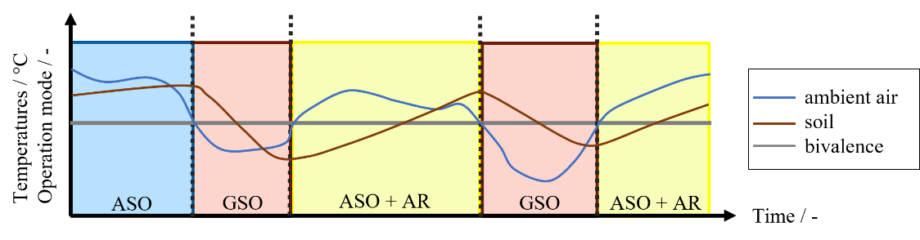
Fig. 1: Schematic annual operating strategy of the DSHP system
During mild periods (e.g. spring or summer) the system operates in ASO, whereas GSO is primarily used during cold phases (e.g. winter). Between extraction periods AR enables heat injection into the GSHX, thereby replenishing the thermal energy extracted during previous operation cycles. As illustrated in Fig. 1, the collector is therefore operated in repeated extraction and regeneration cycles throughout the year rather than providing heat continuously over an entire heating season.
This operating strategy reduces the thermal energy capacity of the GSHX and allows the collector to be dimensioned primarily for peak-load coverage. Consequently, smaller collector systems with reduced spacing requirements may become feasible while maintaining the required heat extraction capacity.
Fig. 1 illustrates the intended operation of the DSHP over the course of a year. The laboratory investigation presented in this paper focuses on the underlying cyclic processes of heat extraction and regeneration. For this purpose, a small-scale experimental setup consisting of a heat pump and a collector box - representing the GSHX - was constructed. The setup allows the influence of different moisture conditions on the thermal behavior of the collector to be investigated under reproducible boundary conditions.
  - Materials and experimental setup
The experimental setup consisted of a hydraulic test bench with a DSHP and an experimental collector box. The test bench and the DSHP are described in more detail in Reum et al. (2025). The box, measuring 1200 mm x 1000 mm x 800 mm (L x W x H), contained four small vertical collectors and was filled with sand. Brine with 25 % glycol was used as the heat transfer fluid with a specific heat capacity of 3100 J kg⁻¹ K⁻¹ and density of 1065 kg m⁻³. The collectors were connected in parallel and hydraulically balanced to ensure uniform flow distribution. In addition, temperature and moisture sensors were installed at different locations within the collector box. Fig. 2 shows the filled collector box with the installed sensors.
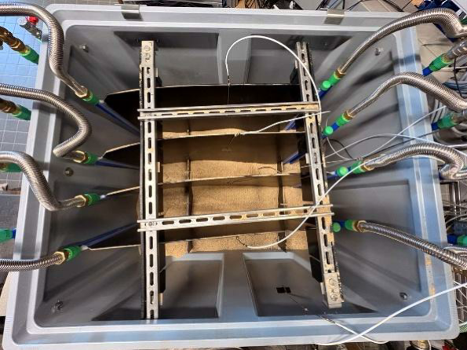  (a) | 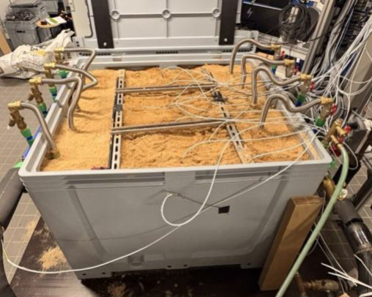  (b)
Fig. 2: Collector box (experimental GSHX) in the laboratory environment with (a) and without (b) sand and sensors
For the analysis of the experiment, measurement results from seven sensors were considered. These include two temperature sensors inside the box, one of which was placed on one of the collectors (K3) and one between the collectors (Z3). Two more temperature sensors were used to measure the temperature at the inlet and outlet of the box. The other three sensors were humidity sensors, which were installed in the center of the box at three different heights (top, middle and bottom). Fig. 3 shows the placement of the different sensors and the testbench hydraulics including the DSHP evaporator as well as the testbench pump and heat exchanger, which can provide additional heat as needed.
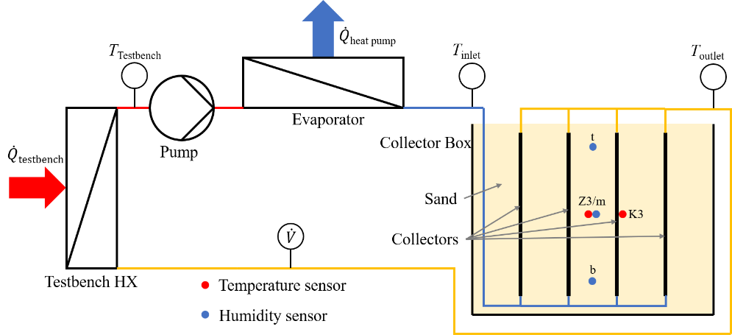
Fig. 3: Sketch of the sensor placement and the testbench hydraulics. The line colors indicate relative temperatures of the brine from cold (blue) over medium (yellow) to warm (red) at ground source operating mode.
  - Calculations
The temperature measurements $T_{inlet} and T_{outlet}$ (see Fig. 2) as well as the volume flow provided by the testbench were used to calculate the thermal power ${\dot{Q}}_{GSHX}$and the energy $Q_{GSHX}$provided by the collectors. The thermal power of the GSHX was calculated using
 | $${\dot{Q}}_{GSHX}= \dot{V}⋅ ρ⋅ c_{p}⋅\left( T_{outlet}- T_{inlet} \right).$$ | (eq. 1)
The total heat extracted from the GSHX over the set test duration of heat extraction was calculated by integrating the thermal power from the start of the experiment $t_{0}$ until the end of the extraction $t_{extract}$ phase using
 | $$Q_{Extract}=\int_{t_{0}}^{t_{extract}}{{\dot{Q}}_{GSHX}}⋅dt.$$ | (eq. 2)
Similarly, the cumulative regeneration energy was calculated by integrating the thermal power over the regeneration period, i.e. from the beginning of regeneration until the end of the experiment $t_{end}$:
 | $$Q_{Reg}=\int_{t_{extract}}^{t_{end}}{{\dot{Q}}_{GSHX}}⋅dt$$ | (eq. 3)
The sensors used to measure the supply and return temperatures ($T_{inlet} and T_{outlet}$) of the collector box are clamp-on sensors attached to the outside of the pipework. Although the sensors were thermally insulated during the experiments, their readings are still affected by ambient conditions and transient heat transfer effects. As the collector power is calculated based on these temperatures, the resulting measurement deviations must be considered. Therefore, a dedicated uncertainty analysis was conducted, as described in the following section.
  - Uncertainties
The clamp-on sensors at the collector $T_{inlet} and T_{outlet}$ exhibited systematic deviations from the in-situ sensors of the hydraulic test bench and the heat pump. These deviations are caused not only by the sensor characteristics themselves but also by installation-related effects, such as thermal contact resistance and heat exchange with the surrounding environment. To account for these effects, brine temperature dependent correction functions were derived from comparisons at approximately 0 °C, 10 °C and 22 °C. These correction functions were applied to the collector’s inlet and outlet temperature. This improves the accuracy of the calculated collector power and reduces systematic errors.
After applying the correction functions, the remaining temperature uncertainty was estimated based on the accuracy class A (1/10) specified in DIN EN IEC 60751 (Europäisches Komitee für Elektrotechnische Normung, 2022). Within the investigated temperature range (-2 °C to 22 °C) the resulting uncertainty $u$ of a single measurement remained below ±0.019 K. The resulting uncertainty of the calculated collector power was determined using Gaussian error propagation based on the corrected inlet and outlet temperatures. The uncertainty of the temperature differences $u_{ΔT}$is derived from eq.1 based on the uncertainty of the inlet and outlet sensor $u_{T_{inlet}}$ and $u_{T_{outlet}}$.
 | $$u_{ΔT}=\sqrt{u_{T_{inlet}}^{2} +u_{T_{outlet}}^{2}}$$ | (eq. 4)
Applying eq. 4 and the stated uncertainty of a single sensor results in a temperature difference uncertainty $u_{ΔT}$ of 0.027 K, which corresponds to a negligible uncertainty compared with the systematic error.
Strictly speaking, the uncertainty in the volume flow rate should also be considered. However, the systematic error of the measurement method (clamp-on sensors) has the greatest impact on the calculated collector power and is assumed to be the dominant factor. Since the temperature uncertainty has already been identified to be relatively small compared with the systematic error, it can be assumed that the uncertainty of the volumetric flow is also negligible small.
  - Description of the tests conducted
As already mentioned, sand is used as backfill material for the collectors, which is also common practice to protect the collectors from mechanical damage. In practical installations, water drainage from the sand backfill may be limited by the surrounding soil. Consequently, water can accumulate within the collector trench after rainfall events and dissipate during drying periods. Therefore, the moisture content of the sand is subject to significant variation.
To observe the effect of moisture on thermal processes in the sand, five experiments were conducted for this series of measurements. The first experiment was carried out using dry sand. The sand was then increasingly saturated by pouring a total of 240 liters of water into it in 60 l increments, which was uniformly distributed over the collector box surface. The measurement procedure was repeated during each increment. The increments are intended to reflect different stages of water accumulation within the collector backfill. The resulting moisture conditions are summarized in Tab. 1.
Tab. 1: Water content of the measurement series
measurement | water content [l]
m0 | 0
m60 | 60
m120 | 120
m180 | 180
m240 | 240

Based on previous test runs, the test duration was set at a total of 7 h and consisted of a 5 h heat extraction phase and a 2 h regeneration phase. During the heat extraction, the heat pump cools the brine before it is reheated in the collector box. Due to the limited thermal capacity of the laboratory-scale GSHX, the test bench maintained a constant brine inlet temperature of -2 °C at the heat pump by supplying additional heat. After the heat extraction phase, regeneration was performed by circulating brine at a flow temperature of 10 °C through the collector box provided by the test bench.

- Results and Discussion
  - Moisture Conditions
The moisture conditions prevailing at each measurement are shown in Fig. 4. The resulting moisture $θ$ in each layer (b = bottom, m = middle, t = top) represents the volumetric water content in percent.
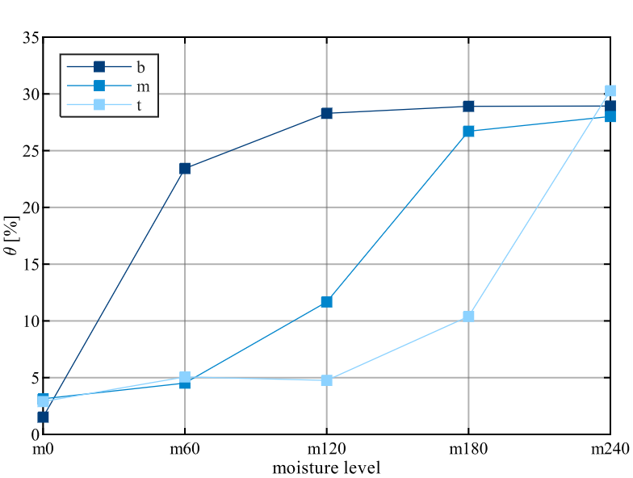
Fig. 4: Moisture distribution in the layers of the collector box during the experiments (b = bottom; m = middle; t = top)
Fig. 4 reveals that volumetric moisture increases in all layers as the water content rises. The greatest increase is observed in the lowest sand layer (b). This suggests that the added water initially seeps into the lower regions of the collector box and accumulates there before the overlying layers become significantly moistened. Once the amount of water added reaches approximately 120 l, the bottom layer (b) is largely saturated. This is reflected in a significantly lower increase in moisture content. As soon as this saturation level is reached, the moisture content in the middle (m) and top layers (t) increase, since additional water can no longer be stored in the lower regions and seeps into higher layers. After adding 240 l (m240), the collector box appears to be largely saturated at approximately 30 %.
The moisture distribution is representative of the conditions expected in practical installations. The observed accumulation of water in the lower part of the collector is consistent with practical installations, where downward seepage is limited by the surrounding compacted saturated soil. In the laboratory setup this effect is represented by the box walls. The following section examines how the observed moisture conditions affect the temperature development at the collector surface and within the surrounding soil during heat pump operation.
  - Temperature behavior and phase change processes during heat extraction and regeneration
Fig. 5 shows the temperature curves resulting from the power extraction and regeneration during the conducted tests. The figure shows the temperatures on one middle collector (K3) and the temperatures in the sand between it and the adjacent collector (Z3, see Fig. 3).
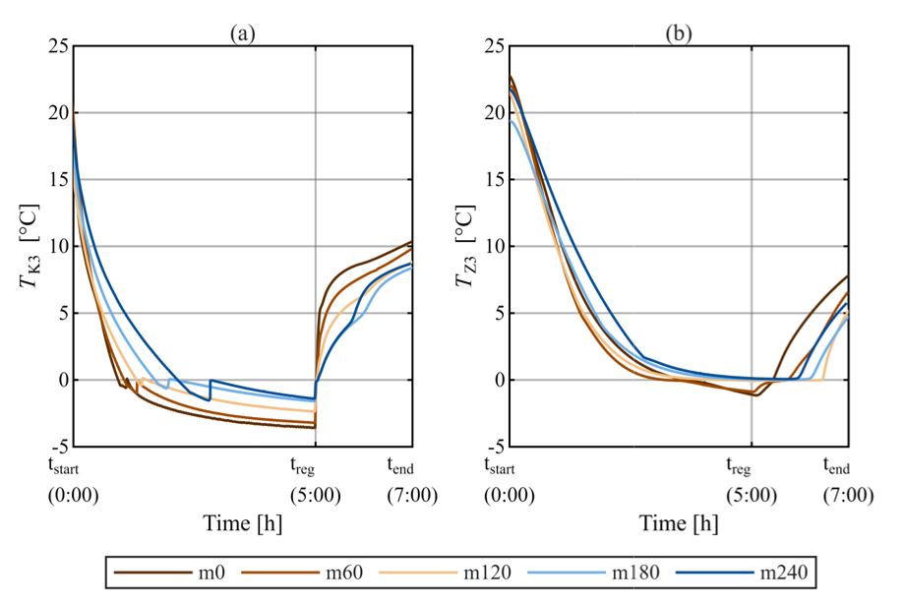
Fig. 5: Temperature on the center collector (a) and between (b) during constant power extraction and regeneration at different moisture levels
The temperature curves of both measurement points, Z3 and K3, are increasingly delayed during the power extraction with rising moisture content. When considering the temperatures on the collector’s surface (K3) reached in steady state of heat extraction the following aspects become apparent. The drier the soil, the lower the temperatures reached at the surface of the collector. Thus, the temperature in moist sand (m240) is about 2 K higher than the dry reference state. The higher temperatures observed at the collector’s surface indicate an improved thermal capacity. As a result, the collector temperatures remain at a higher temperature level during heat extraction. The delayed temperature response under moist conditions is also consistent with the increased volumetric heat capacity of the substrate, which was also reported by Abu-Hamdeh (2003). Wet soils store more thermal energy, thus changes in temperature occur delayed. The upward jumps in the signals from the collector’s surface during cooling indicate ice formation, as examined by Farina et al. (2024).
As regeneration begins, temperatures on the collector surface (K3) rise sharply. Dry sand reaches the highest temperature levels, while under moist conditions, a delayed rise can be observed. The sand between the collectors (Z3) exhibits the same effect. The dry references show the fastest temperature recovery, while the wet conditions once again show a significant delayed response. This aligns well with the increased heat capacity as described above.
The temperature differences during heat extraction within the soil (Z3) are significantly lower than on the collector’s surface. As moisture increases, the temperature during the extraction phase remains closer to the freezing point or falls only slightly below it. This is most evident in measurement m120-m240. This suggests that additional heat becomes available to the surrounding soil, potentially including latent heat released during pore water freezing. The enthalpy of solidification released during the phase transition from water to ice counteracts a further drop in temperature and stabilizes the soil temperature around 0 °C. As a result, more thermal energy can be extracted without causing a further temperature drop. The corresponding effects on collector performance are discussed in section 3.3.
The released latent heat contributes to the extracted energy in addition to the effect of increased total heat capacity. The temperature plateaus in the area between the collectors can therefore be used as an indicator of ongoing phasechange processes. Furthermore, the measurements suggest that the contribution of sensible and latent heat depends on the moisture content. While dry conditions are dominated by sensible heat, intermediate moisture levels (m120) maximize latent heat utilization under the present conditions. At higher moisture levels sensible heat dominates the observed thermal behavior again because the increased thermal capacity maintains higher temperatures and may increase the relative contribution of sensible heat again during fixed extraction time.
When considering regeneration, it is evident that regeneration periods vary both within the soil (Z3) and on the collector’s surface. The m120 measurement reacts the slowest on the temperature change while m180 and m240 measurements warm up and regenerate more quickly. This is likely since regeneration must first melt the ice that has formed potentially during heat extraction. Slow temperature increases indicate the presence of more frozen pore water. The longest thawing period is observed for m120. This suggests that the amount of frozen pore water reaches a maximum at intermediate moisture levels under the present conditions. Although higher moisture contents provide more freezable pore water, the fixed extraction time (5h) appears insufficient to freeze the additional water completely.
This interpretation is further supported by the temperatures measured within the soil at the end of heat extraction, shown in Fig. 6. Temperatures below 0 °C indicate phase change processes, whereas temperatures above 0 °C no phase changes occur. The temperature closest below the freezing point is observed for m120, whereas higher moisture contents result in higher temperatures despite the larger amount of potentially freezable pore water. This behavior suggests that the fixed extraction period is insufficient to freeze the additional water available at higher moisture levels. Consequently, intermediate moisture levels appear to maximize the amount of frozen pore water under the investigated conditions. The results further indicate that the experiments are limited by extraction duration rather than by the amount of water available for freezing. In addition, the higher temperature levels for m180 and m240 at the end of extraction phase indicate that the collector environment remains in a thermally more favorable state under moist conditions. Consequently, the soil is less thermally depleted at the beginning of regeneration.
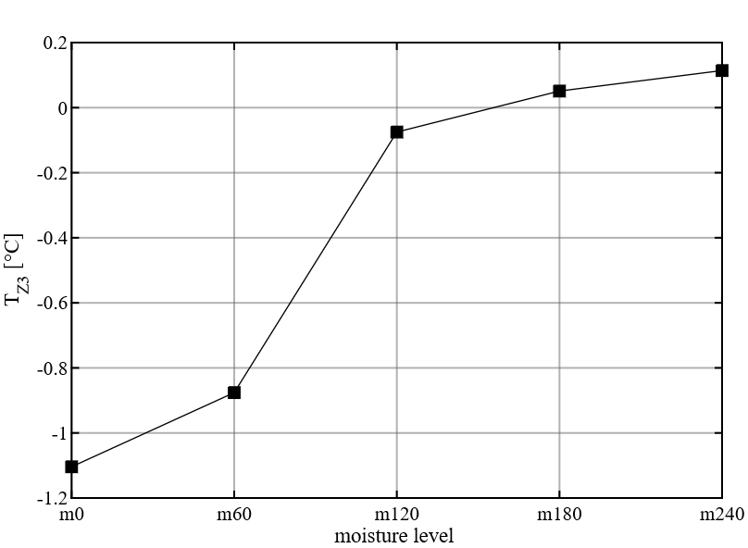
Fig. 6: Temperature within the soil (Z3) at the end of heat extraction (5h)
Furthermore, the temperature measurements indicate that soil moisture influences not only thermal capacity but also the amount of pore water participating in phase change influence as well as providing latent heat. The following section investigates how these effects affect the collector’s performance during heat extraction and regeneration.
  - Collector performance
The previously discussed temperature and phase change processes are directly reflected in the collector’s thermal power. Fig. 7 shows the resulting thermal performance profiles during heat extraction and regeneration which are corrected by the affected uncertainties shown in the sections above. Eq. 1 was used to calculate the extracted and supplied thermal power.
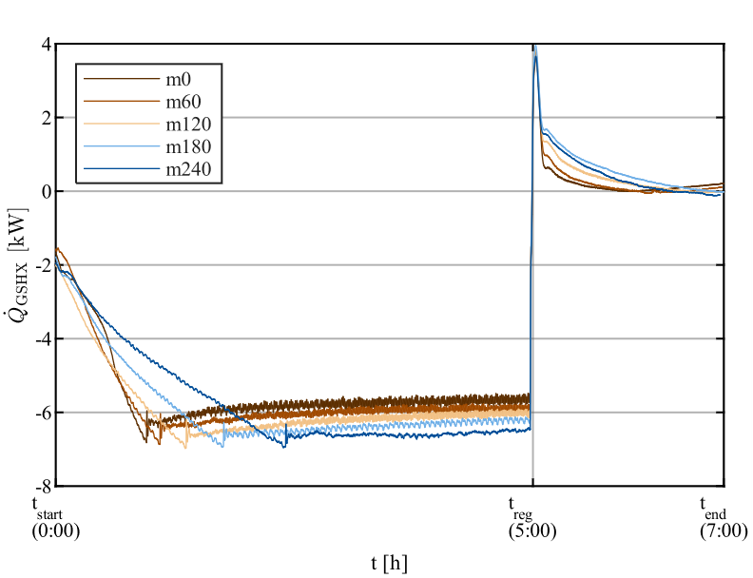
Fig. 7: Extracted and supplied power at different moisture conditions – the transient behavior at the start of measurement (${\dot{Q}}_{GSHX}=0$) lies outside the visualization range
However, the absolute performance curves must be evaluated considering the limitations of the experimental setup. These include passive heat exchange from the laboratory environment to the collector box and the laboratory as well as the use of clamp on sensors for the collector inlet and outlet temperature. In this context heat transfer occurs not only between the sand and the collectors but also between the experimental setup and the laboratory environment. Based on the applied correction functions, which have the greatest impact on the measurement series, the uncertainty of the calculated collector power was estimated to be ±0.014 kW. However, the dominant source of uncertainties comes from installation-related effects and temperature dependent offsets of the clamp on sensors rather than from the sensor accuracy itself. Despite these limitations, the observed trends are considered reliable because of constant setup, operating procedure and boundary conditions. While the absolute values of collector power may be fraught with uncertainty, the relative differences of thermal powers between the several moisture conditions can be interpreted with greater confidence.
The performance curves in Fig. 7 illustrate two effects. First, higher moisture levels lead to increased power extraction rates, resulting in power increases of up to 20 %. Second, the decrease of power during first period of extraction phase becomes less pronounced with increasing moisture content. The delayed decline in power is consistent with a higher thermal capacity of the soil at higher moisture content. As a result, the soil reacts more slowly under continuous heat extraction. In addition, the higher steady-state power extraction rates might also be due to higher storage capacity (leading to higher temperatures in the soil) and possibly improved heat transfer between the collector and the surrounding soil. Consequently, the collector’s performance is strongly influenced by the water content of the soil.
The correlation between higher moisture and increased collector performance is further reflected in the cumulative extracted and regenerated amount of heat, shown in Tab. 2. The calculation was performed using eq. 2 and eq. 3.
Tab. 2: Summary of heat extraction and supply during heat pump operation
Moisture Level | $$Q_{Extract} [kWh]$$ | $$Q_{Reg} [kWh]$$
m0 | -27.43 | 0.84
m60 | -28.30 | 0.59
m120 | -29.39 | 0.88
m180 | -29.09 | 1.27
m240 | -28.56 | 0.98

While the data shown in Fig. 7 confirms a clear increase in power extraction at steady state with increasing soil moisture, the influence on the cumulative extracted and regenerated energy shown in Tab. 2 does not exhibit a strictly monotonic trend. At first sight, this appears inconsistent with the previously discussed increasing collector performance observed for higher moisture content. However, extraction time was limited to 5 h for all experiments. Consequently, the thermal state at the end of the extraction varies depending on moisture content. This is consistent with the temperature measurement discussed in the previous section. Although less regeneration energy is observed at the highest moisture level, the temperature measurements indicate higher soil temperatures at the end of the extraction phase. This suggests that the regeneration demand may be lower because the collector environment remains at a higher thermal state following the extraction phase, while lower temperature gradients reduce the amount of energy transferred during regeneration. Therefore, a reduced amount of regeneration energy should not necessarily be interpreted as a reduced regeneration potential or lower performance. Instead, this suggests that the increased soil moisture maintains the collector at a higher temperature level and may reduce the regeneration demand.
Furthermore, the temperature measurements suggest that intermediate moisture levels (m120) contain the largest amount of ice. Higher moisture levels provide additional pore water. However, the fixed extraction time appears insufficient to freeze this additional water completely. As a result, higher moisture contents remain at higher temperature levels despite the larger thermal capacity. This observation is also reflected in the temperature trends shown in Fig. 5, which indicated a maximum ice formation at intermediate moisture levels (m120). A higher amount of frozen pore water increases both the extracted energy and energy absorbed during regeneration, which explains the trend shown in Tab. 2. Therefore, the observed trend is likely not caused by lower thermal potential at higher moisture. Instead, the fixed extraction time limits the development of freezing processes and prevents the additional thermal storage potential from being fully utilized.
- Conclusion and Outlook
The present study demonstrates that soil moisture is a key factor governing the thermal performance of densely packed shallow GSHXs during both heat extraction and regeneration. The performance of the investigated system increases significantly with increased soil moisture. This can result in an increase of power up to 20% depending on the moisture level, which is consistent with the improved thermal capacity of moist soils. Consequently, soil moisture directly affects the feasibility of compact peak-load GSHXs in DSHP systems. The resulting improvement in thermal coupling facilitates heat transfer from the surrounding substrate to the collector. A greater amount of energy that can be supplied and stored within the ground indicates a higher effective thermal storage capacity under increased moist conditions. This effect is particularly important for cyclic operation, as higher moisture conditions improve not only heat extraction but also the ability of the ground to absorb and store regenerative energy between operating cycles. Beside the effect of thermal capacity, temperature measurements revealed that under moist conditions soil temperatures remain closer to the freezing point. A particularly relevant finding is that latent heat released during pore water freezing appears to contribute to heat extraction under moist conditions. The mechanism provides additional energy while limiting the temperature reduction around the collector. This may represent a previously underestimated contribution to the thermal potential of GSHXs and enables improved operating conditions during peak extraction periods.
The present measurements suggest that the amount of frozen pore water does not automatically increase with higher moisture. Under the selected conditions, most ice formation appears to occur at intermediate moisture levels. Although higher moisture contents provide more freezable pore water, the limited test duration restricts the development of freezing processes. For this reason, the thermal potential associated with increased moisture cannot be fully exploited.
In practice, the energy input and increased storage capacity while regeneration may allow higher specific extraction rates during cyclic operation with higher moisture levels. While the collector size may potentially be reduced due to higher extraction rates, adequate moisture levels and regeneration cycles are required to compensate for the reduced thermal energy content of the smaller ground volume. This is particularly relevant for peak-load GSHXs, where the collector size is intentionally reduced and the available ground energy becomes a limiting factor.
Additionally, adequate soil moisture may represent an effective strategy for improving seasonal performance of ground source collectors. The results indicate that soil moisture should be treated as a key operational parameter rather than a fixed boundary condition. Maintaining favorable moisture conditions may significantly improve both heat extraction and regeneration performance. On the other hand, the findings indicate that long-term soil drying has a major impact on the collector’s efficiency and can lead to performance losses as well as reduced regeneration potential. For soil simulations it appears that assuming constant soil parameters (e.g. heat transfer coefficient, heat capacity) may underestimate the thermal potential of the soil. Therefore, these should consider moisture dependent thermal properties and potential phase change processes.
Further work should focus on long-term effects and the quantification of the latent heat effect. In this context longer energy extraction cycles and full heating periods should be run to determine the decline in collectors’ performance after several cycles of extraction and regeneration. In addition, longer extraction times allow full utilization of the collector’s potential. Regarding the latent heat effect, the study of the spatial and temporal spread of freezing fronts in the collector environment should be investigated. Further investigations should also evaluate whether active moisture management of GSHX is beneficial from energetic and economic perspective. Additionally, the test bench should be upgraded to allow for in-situ measurement of the inlet and outlet temperature at the collector box and to ensure adequate insulation to minimize heat losses during operation.
Overall, the results demonstrate that the performance of GSHXs is not only influenced by operating temperature levels. Rather, it is strongly governed by moisture and the associated heat transfer, storage and phase change processes. The mechanism should therefore be considered in the design, operation and modelling of future GSHX systems.
- References
Abu-Hamdeh, N.H., 2003. Thermal Properties of Soils as affected by Density and Water Content. Biosystems Engineering 86 (1), 97–102.
Allaerts, K., Coomans, M., Salenbien, R., 2015. Hybrid ground-source heat pump system with active air source regeneration. Energy Conversion and Management 90, 230–237.
Cao, J., Zheng, L., Peng, J., Wang, W., Leung, M.K., Zheng, Z., Hu, M., Wang, Q., Cai, J., Pei, G., Ji, J., 2023. Advances in coupled use of renewable energy sources for performance enhancement of vapour compression heat pump: A systematic review of applications to buildings. Applied Energy 332, 120571.
Dongellini, M., Naldi, C., Morini, G.L., 2015. Seasonal performance evaluation of electric air-to-water heat pump systems. Applied Thermal Engineering 90, 1072–1081.
Europäisches Komitee für Elektrotechnische Normung, 2022. Industrielle Platin­Widerstandsthermometer und Platin­Temperatursensoren (IEC 60751:2022), 2022nd ed., 28 pp.
Farina, D., Machrafi, H., Queeckers, P., Dongo, P.D., Iorio, C.S., 2024. Innovative AI-Enhanced Ice Detection System Using Graphene-Based Sensors for Enhanced Aviation Safety and Efficiency. Nanomaterials (Basel, Switzerland) 14 (13).
Gindre, T., Oltersdorf, T., Vering, C., Emhofer, J., Reichl, C., Arumugam, K., 2021. Report on Task 4: Analysis of the Effect of Operating Conditions of Heat Pumps on Acoustic Behaviour. System modelling, including acoustics for control, and studies on time dependent behaviour as well as influence of external conditions.
Grossi, I., Dongellini, M., Piazzi, A., Morini, G.L., 2018. Dynamic modelling and energy performance analysis of an innovative dual-source heat pump system. Applied Thermal Engineering 142, 745–759.
Loga, T., Stein, B., Diefenbach, N., Born, R., 2015. Deutsche Wohngebäudetypologie Beispielhafte Maßnahmen zur Verbesserung der Energieeffizienz von typischen Wohngebäuden. erarbeitet im Rahmen der EU‐Projekte, 2nd ed., Darmstadt.
Ramming, K., 2007. Bewertung und Optimierung oberflächennaher Erdwärmekollektoren für verschiedene Lastfälle. Dissertation, Dresden.
Reum, T., Natale, C., Schmitt, D., Dongellini, M., Naldi, C., Summ, T., Morini, G.L., Schrag, T., 2026a. Control Strategies for Active Regeneration in a Dual-Source Heat Pump, in: Zilio, C., Busato, F., Mazzarella, L., Noro, M. (Eds.), Proceedings of the 15th REHVA HVAC World Congress - CLIMA 2025, vo. 762. Springer Nature Switzerland, Cham, pp. 564–574.
Reum, T., Schmitt, D., Schrag, T., 2026b. Simulation-based investigation of active regeneration in a novel dual-source heat pump refrigerant cycle. 15th IEA Heat Pump Conference. IEA HPT Conference Proceedings Paper.
Reum, T., Schmitt, D., Summ, T., Schrag, T., 2023. Investigation of a Novel Hybrid Heat Pump Concept. 14th IEA Heat Pump Conference. IEA HPT Conference Proceedings Paper.
Reum, T., Schmitt, D., Summ, T., Trinkl, C., Ochs, F., Schrag, T., 2025. Experimental analysis of parallel operation of two heat sources in a dual-source heat pump incorporating two compressors. International Journal of Refrigeration 171, 124–138.
Verein Deutscher Ingenieure (VDI), 2019. VDI 4640 Blatt 2 - Thermische Nutzung des Untergrunds - Erdgekoppelte Wärmepumpenanlagen, 139pp.

