EuroSun2026
Wood–Solar Hybridization for Swiss District Heating
Pauletta S*, Duret A, Baillifard MA, Monti M & Eicher S
​Institute of Energies, School of Engineering and Management Vaud, HES-SO
*corresponding author: stefano.pauletta@heig-vd.ch
Summary
The integration of solar thermal energy with wood-fired district heating networks offers an opportunity to reduce biomass consumption and pollutant emissions while maintaining renewable heat supply. Four hydraulic configurations combining solar thermal collectors, thermal energy storage (TES), and biomass boilers were modelled dynamically in TRNSYS and compared with a biomass-only reference system. Technical, economic, and environmental performances were evaluated for different solar field areas and TES volumes to provide an insight on the best layout to adopt. Once characterized, the production cost of the solar-biomass hybrid configurations was further compared with solutions based on heat pumps (HP) to position this type of installations on the Swiss market. Overall, hydraulic configuration, TES sizing, and boiler operating conditions are identified as key factors governing the technical, environmental, and economic performance of wood–solar DHN systems.
Keywords: Solar thermal collectors, thermal energy storage, biomass boiler, TRNSYS
Field of application for the findings: Solar thermal energy, energy system modeling
Addressed audience: district heating network operators & planners, developers & engineering companies
- Introduction
District heating networks (DHNs) play a central role in the decarbonization of the heat supply in Switzerland, particularly in urban and peri-urban areas. Accounting in 2022 for 11% of the domestic heat supply, they enable the aggregation of heat production and facilitate the utilization of local renewable energy resources [1]. Thanks to its availability, storage capacity, and compatibility with high-temperature heating networks [2], biomass, and more specifically wood energy, already constitutes a cornerstone of this transition, with 30% of the DHN supply covered by woody biomass. However, the rapid expansion of DHNs raises new challenges related to resource availability, fuel logistics, plant sizing, and long-term cost stability [3].
In this context, solar thermal energy emerges as a natural complement to biomass-based systems. Unlike electrical solutions, solar thermal energy supplies heat directly at temperatures suitable for the network during periods that partially coincide with a drop in heating demand, thereby offering the opportunity to reduce boiler operation without compromising security of supply. Previous studies have demonstrated the technical feasibility and fuel-saving potential of coupling solar thermal energy and biomass in DHNs [4][5][6][7]. Several studies have focused mainly on evaluating the impact of solar thermal installations on the techno-economic performance of the hybrid systems. Solar systems have been found beneficial in increasing the overall system efficiency and in reducing the number of on/off cycles of pellet boilers [8], or in allowing covering the summer load of the hot water production, while assuring the downtime needed to maintain the boilers [9]. The investigation of the environmental impact of decentralized hybrid systems provided an insight into the effect of combining solar thermal energy and biomass on the reduction of the pollutant emissions by the overall system [10] or which optimization methods can be adopted for combining the two [11]. But while the integration aspects are discussed, a lack of quantitative comparison of the different possible layouts doesn't provide clear guidance on the best way to couple a solar thermal field equipped with a Thermal Energy Storage (TES) to an automatic pellet boiler installation. For DHN applications, in particular, there is a need to assess the overall system efficiency, its economic performance and the final impact on the annual emissions of pollutants from the combined plant (CO, NOx and particulate). By modeling and comparing several layout alternatives, the project OptiCADSol, funded by the Swiss Federal Office of Energy (SFOE), has addressed such aspects by providing clear guidance regarding operationally realistic hydraulic configurations and regulation strategies for solar-biomass hybridization, analyzing current guidelines
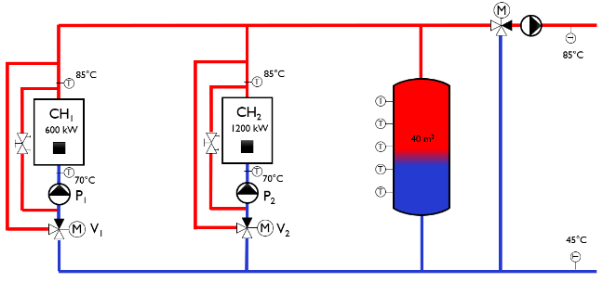 | 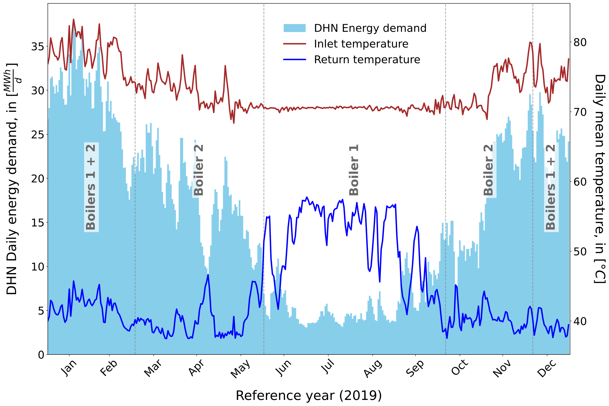
Figure 1: Schematic of the reference heating plant (left) and DHN daily energy demand with typical temperatures and boiler cascade schedule (right) for the DHN located in Ponts-Les-Martels (CH₁ & CH₂: boiler 1 and boiler 2)
from industry associations [2] and proposing the adoption of both technical and financial performance indicators (see Acknowledgements). The project aimed to identify robust integration principles and evaluate the competitiveness of solar hybridization within the current Swiss market context, identify the most effective wood–solar thermal integration concept and its positioning relative to large-capacity heat pump solutions, which are increasingly being considered in DHN projects [12].
- Methodology
The integration of solar thermal energy into an existing or newly built DHN can be realized in several ways, which have a varying impact on the techno-economic aspects of the overall system. The performance of a hybrid solution based on solar thermal and wood biomass depends on the type of hydraulic layout, which has an impact on the cost of heat production and the amount of GHG emissions. To study some of these possibilities, four hydraulic layouts for the integration of solar thermal heat into a DHN have been modelled to simulate their annual tecno-economic and environmental performance and compare them to those of a reference system with no solar collectors (see Figure 1). Then, to gain further insight on the market positioning of hybrid solar-biomass solutions, the layout featuring the best performance was compared to two solutions based on solar photovoltaic panels coupled either to an "indirect air" heat pump covering only the summer load, or to a high-power groundwater heat pump (GWHP) powering the whole DHN. The comparison was made first at the technical performance level via dynamic simulations under TRNSYS (Transient System Simulation Tool), an equation-based simulation environment used to model the dynamic performance of complex energy systems. Then, the comparison was focused on a series of economic indicators and finally on the emission factors computed for the hybrid solutions.
Reference system
To investigate hybrid wood-solar solutions, a reference DHN was studied to represent a typical Swiss wood-fired plant operating without solar input (Figure 1, left). The reference system comprised a biomass boiler cascade with a total installed capacity of 1.8 MW_{th}, sized to meet an annual heat demand of approximately 5.8 GWh, with a share of roughly 30% dedicated to domestic hot water (DHW) production. Data adopted for the performance simulations were sourced from the monitoring campaign of a small rural wood DHN, located on the Swiss municipality of Les Ponts-de-Martel in the Canton of Neuchâtel, featuring a supply temperature between 85–90°C in winter and around 70°C outside the heating season (Figure 1, right). Baseline operation assumed that the two boilers in cascade were designed and controlled according to the principles outlined in the quality standard published by the Swiss association QM Bois [13]. To smooth boiler operation and supply temperatures, furthermore, QM Bois mandates the installation of an energy buffer with a minimum storage capacity corresponding to the energy produced by the boiler during one hour at full power. Modelled under TRNSYS together with a flue-gas condensation heat recovery system, the performance of this reference configuration constituted a reliable point of comparison for the hybrid configurations.
Biomass-solar hybrid configurations
Based on the architecture of the reference wood-fired heating plant, several solar thermal integration configurations can be considered. To standardize the evaluation and comparison of the technical, environmental, and financial
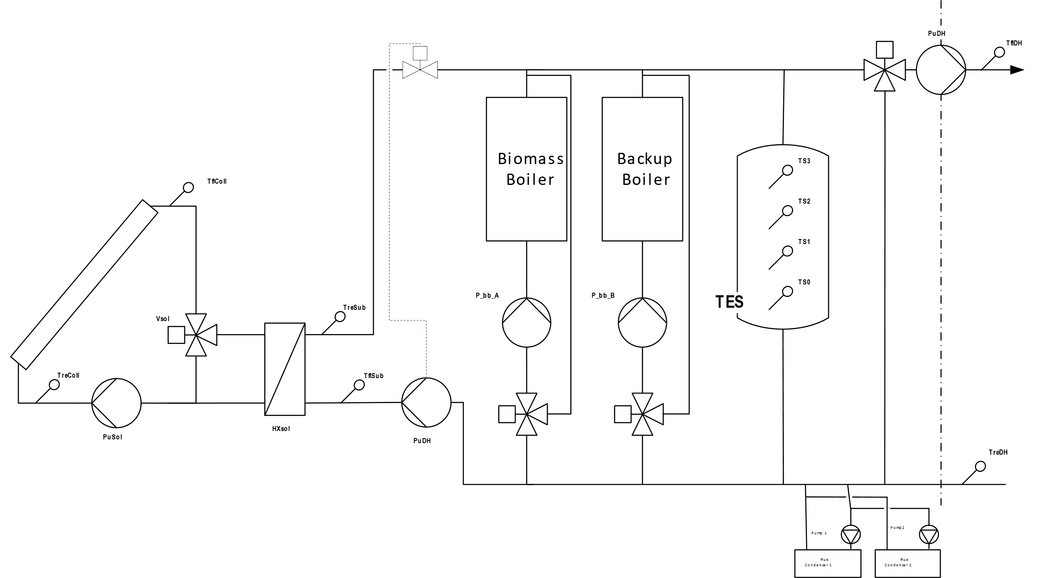 | 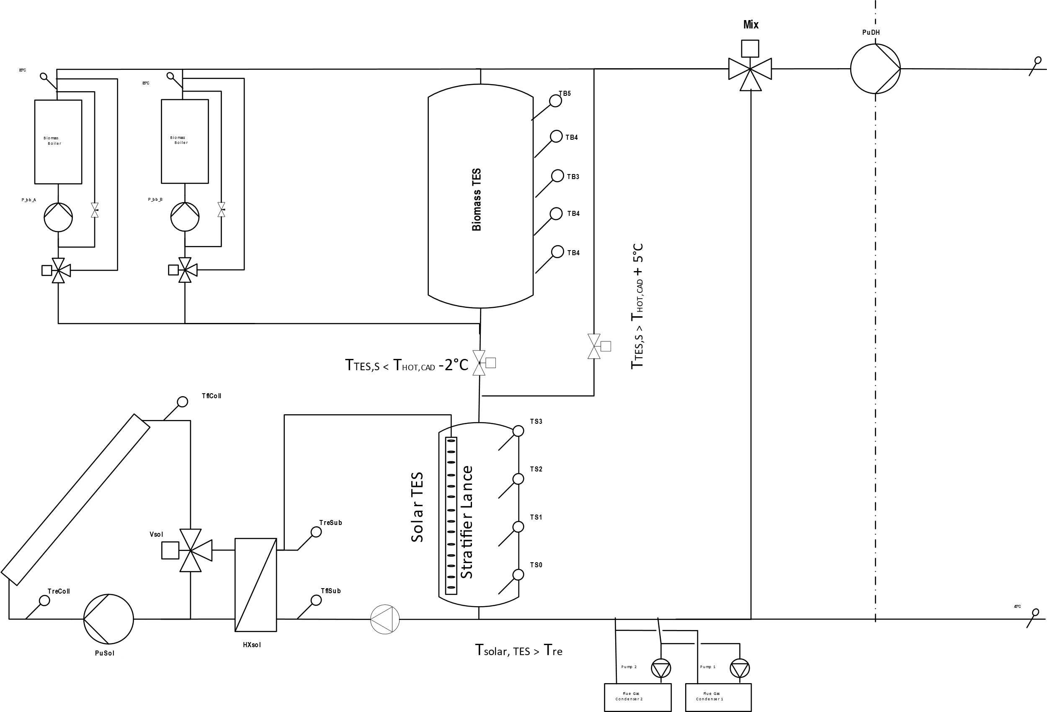
Circuit 1 | Circuit 2
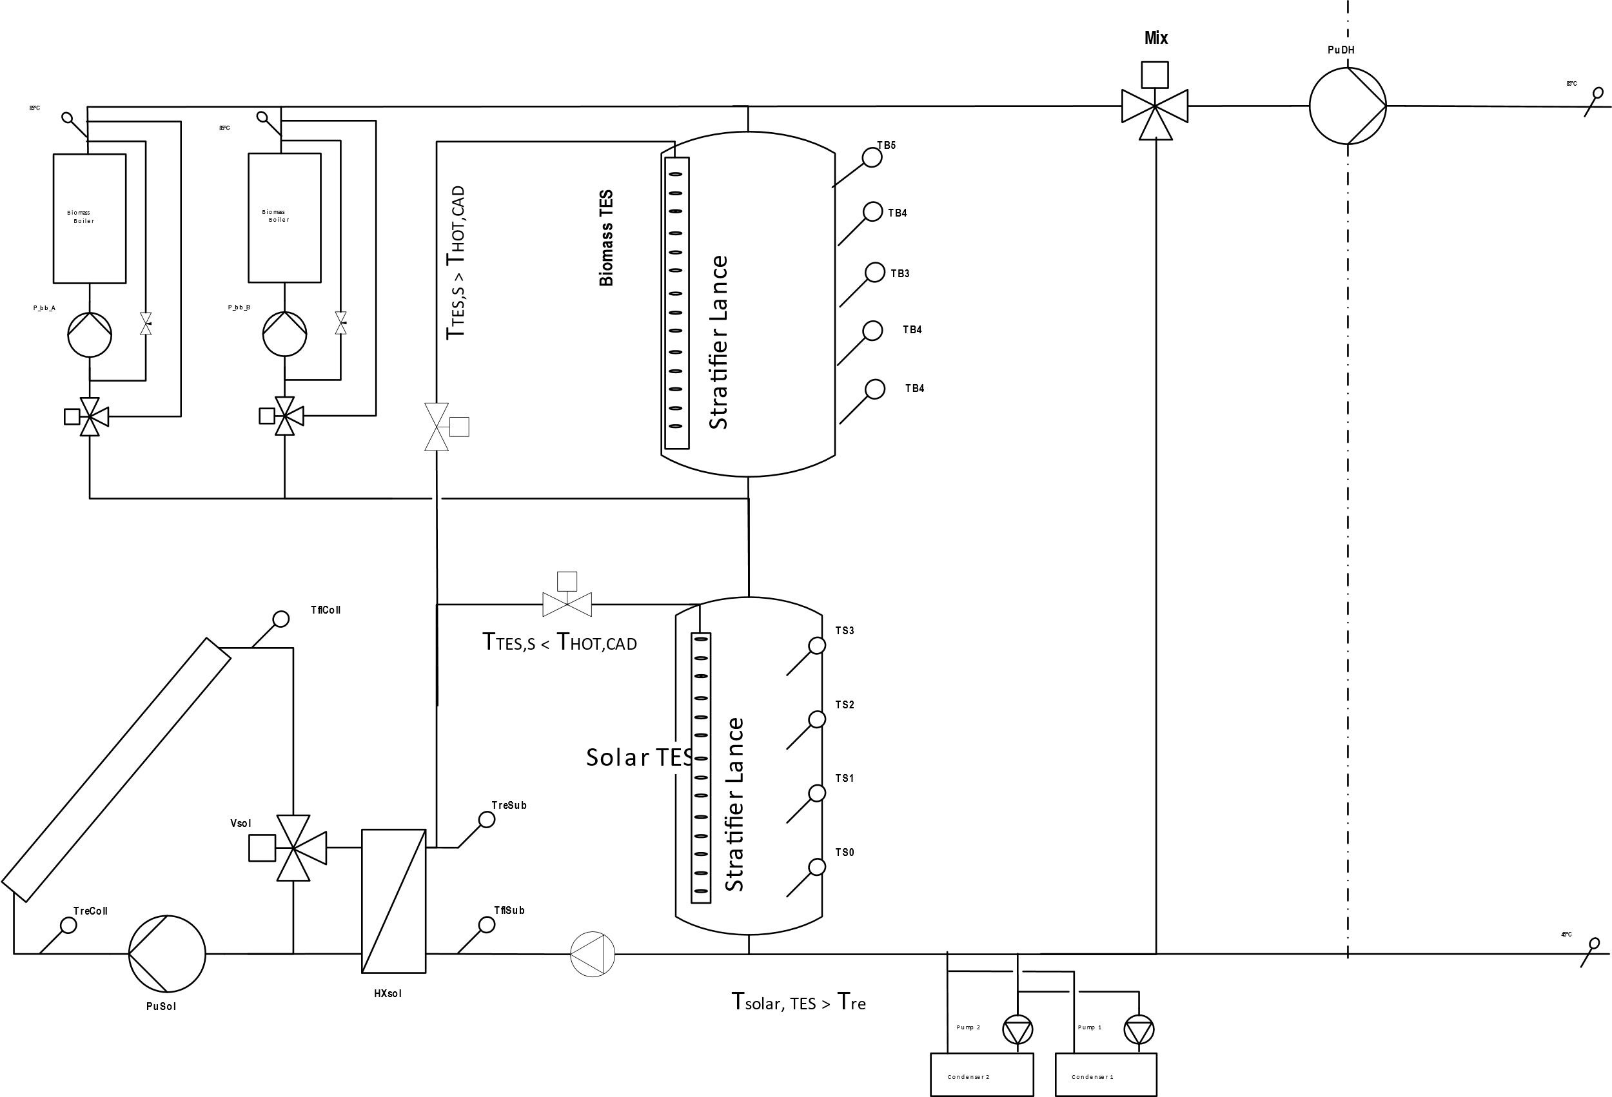 | 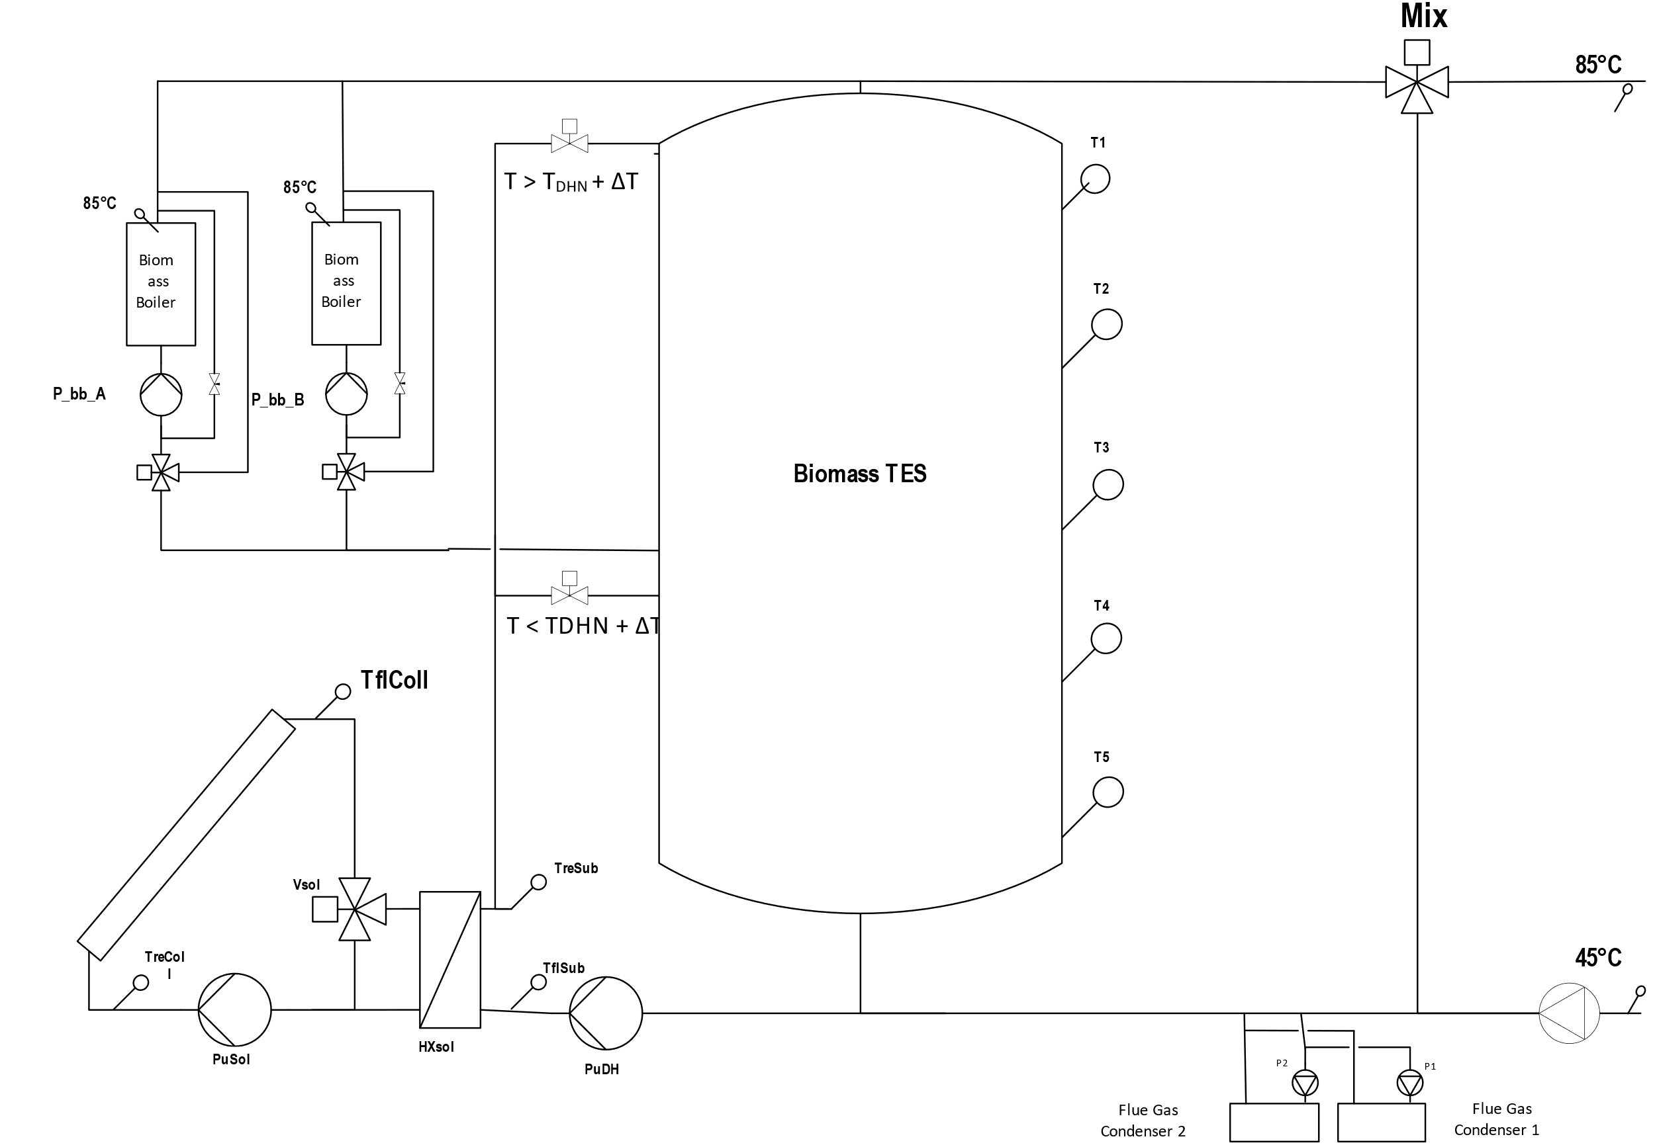
Circuit 3 | Circuit 4
Figure 2: The four hydraulic integration schemes selected for modeling in TRNSYS to investigate hybrid solar – biomass DHNs.
performance across these cases, focus has been placed on a limited number of integration types. Figure 2 present the four hydraulic integration schemes selected for modeling in TRNSYS.
The schematic of Circuit 1 represents a hybrid system in which the thermal solar collectors supply heat in parallel with the biomass boilers, injecting it into the upper part of a single common thermal energy storage (TES). The solar field operates at the boiler supply temperature, typically set 5 K above the district heating network supply setpoint. Thus, in Circuit 1, the solar installation operates in parallel with the wood-chip boilers and downstream of the flue-gas condensation heat recovery system. The TES can be charged and discharged using a relatively simple hydraulic configuration, while preserving thermal stratification. This configuration also avoids the need for dedicated stratification lances to inject solar heat into the TES.
The schematic of Circuit 2 represents, instead, a hybrid system in which solar energy is supplied to a dedicated solar TES, installed in series downstream of the flue-gas condensers. The biomass boilers are equipped with a dedicated separate TES, dimensioned in accordance with the industry recommendations for automatically operated wood-chip systems of this size. Heat stored in the solar TES can be transferred either to the boiler inlet when the solar TES temperature is below the district heating supply setpoint; or directly to the DHN when the solar TES temperature is sufficiently high. Thus, each TES is charged by its respective energy source, while both TES units can be discharged in series, allowing their storage capacities to be shared between the two heat generation systems. Specialized hydraulic components can be used to preserve thermal stratification during charging and discharging, such as a stratification lances on the solar side and a diffuser on the district heating return side. This configuration also improves the resilience and flexibility of the network by distributing heat storage across multiple generation sources. Although the solar TES cannot be charged by the biomass boilers, its additional storage volume helps stabilize the temperature at the boiler inlet, potentially contributing to more stable boiler operation and efficiency. A variant incorporating a bypass valve at the solar TES inlet, allowing the biomass boilers to be connected directly to the district heating return, was discarded after preliminary analysis. The bypass would only be useful during plant start-up, while the solar TES would otherwise remain continuously in operation during normal conditions, providing little practical benefit.
The layout of Circuit 3, visible in the bottom left pane of Figure 2, represents a hybrid system where solar heat can
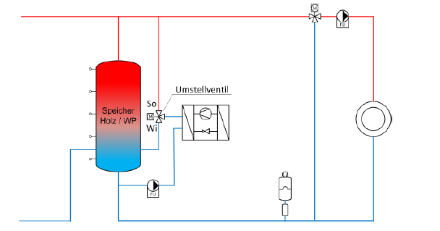 | 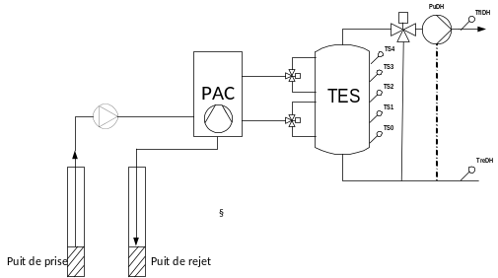
Indirect air HP | Groundwater HP
Figure 3: Configurations for the integration of HPs into the DHN circuit for the case of indirect air HP (left) and groundwater HP systems (right)
be supplied either to a dedicated solar TES installed downstream of the flue-gas condensers, or to the upper part of the biomass TES. Heat stored in the solar TES is normally supplied to the boiler inlet. However, when the solar supply temperature exceeds the district heating setpoint, the heat is injected directly into the upper part of the biomass TES. This creates a series configuration between the solar and biomass TES during solar charging. The two TES units also operate in series during discharge. To preserve thermal stratification, the solar TES requires dedicated stratification devices.
Circuit 4, shown in the bottom right pane of Figure 2, investigates a hybrid system in which solar and biomass energy are integrated into a single TES. Solar heat can be supplied either to the upper part of the TES, when the production temperature allows it, or at the biomass boiler return level. Simulations showed that, since solar storage requires significantly more volume than the 40 m³ allocated to the biomass sub-system, the biomass return connection should be positioned as high as possible while maintaining a section of the storage dedicated to biomass operations. In Circuit 4, solar energy operates mainly as a preheating source in the lower part of the TES. This allows the collectors to operate close to the district heating return temperature for most of the time, maximizing solar efficiency. However, integrating both heat sources into a single TES makes temperature stratification and source separation more complex, which can limit optimal operation.
Configurations based on heat pumps and photovoltaics
The adoptions of HPs in DHN is expanding rapidly in Europe and Switzerland, offering potential reductions in fossil-fuel dependence. However, their overall environmental and sustainability impacts remain uncertain. Combining HPs with PV systems and other renewable sources could improve energy efficiency and contribute to more flexible and resilient heating networks. To benchmark the hybrid wood–solar technology, two scenarios were modeled: a bivalent wood–HP system equipped with an "indirect" air-source HP, replacing the smallest boiler of the reference plant and sized to meet the summer load (Figure 3 - left); and a monovalent HP system based on a water-to-water HP using groundwater as the heat source and covering the whole DHN energy demand (shown in Figure 3 - right). In both cases, the configurations have been assumed grid-connected with surplus PV electricity fed back into the grid.
Technology choices
The design of a solar-biomass hybrid system has to take into consideration the constraints imposed by the application to district heating networks. New generation DHNs have relatively limited temperatures (e.g., 70°C for a IV generation DHN), while older ones feature production temperatures of more than 90°C [14]. At these temperature levels, the integration of solar thermal energy requires the adoption of advanced solar thermal collectors capable of reaching the operating temperatures. For the present study, the solar thermal field of the hybrid configurations is based on High Vacuum Flat Panels (HVFP), particularly the solar thermal collector manufactured by TVP Solar. Depending on the application temperatures, other collectors can be adopted (see Figure 4, adapted from [15]), yet the adoption of this technology allowed the TRNSYS model for the solar field to be based on the monitoring data of the SolarCADII project [16]. Consequently, a loop made of 8 MT4 collectors connected in series was taken as reference to dimension the solar field in the simulated scenarios.
On the other hand, also the heat pump technology adopted in the models has to be compatible with the large temperature gains at elevated temperatures at the condenser required by the DHN. As a consequence, both configurations have been modelled based on ammonia cycles. Furthermore, both HP systems are inherently based
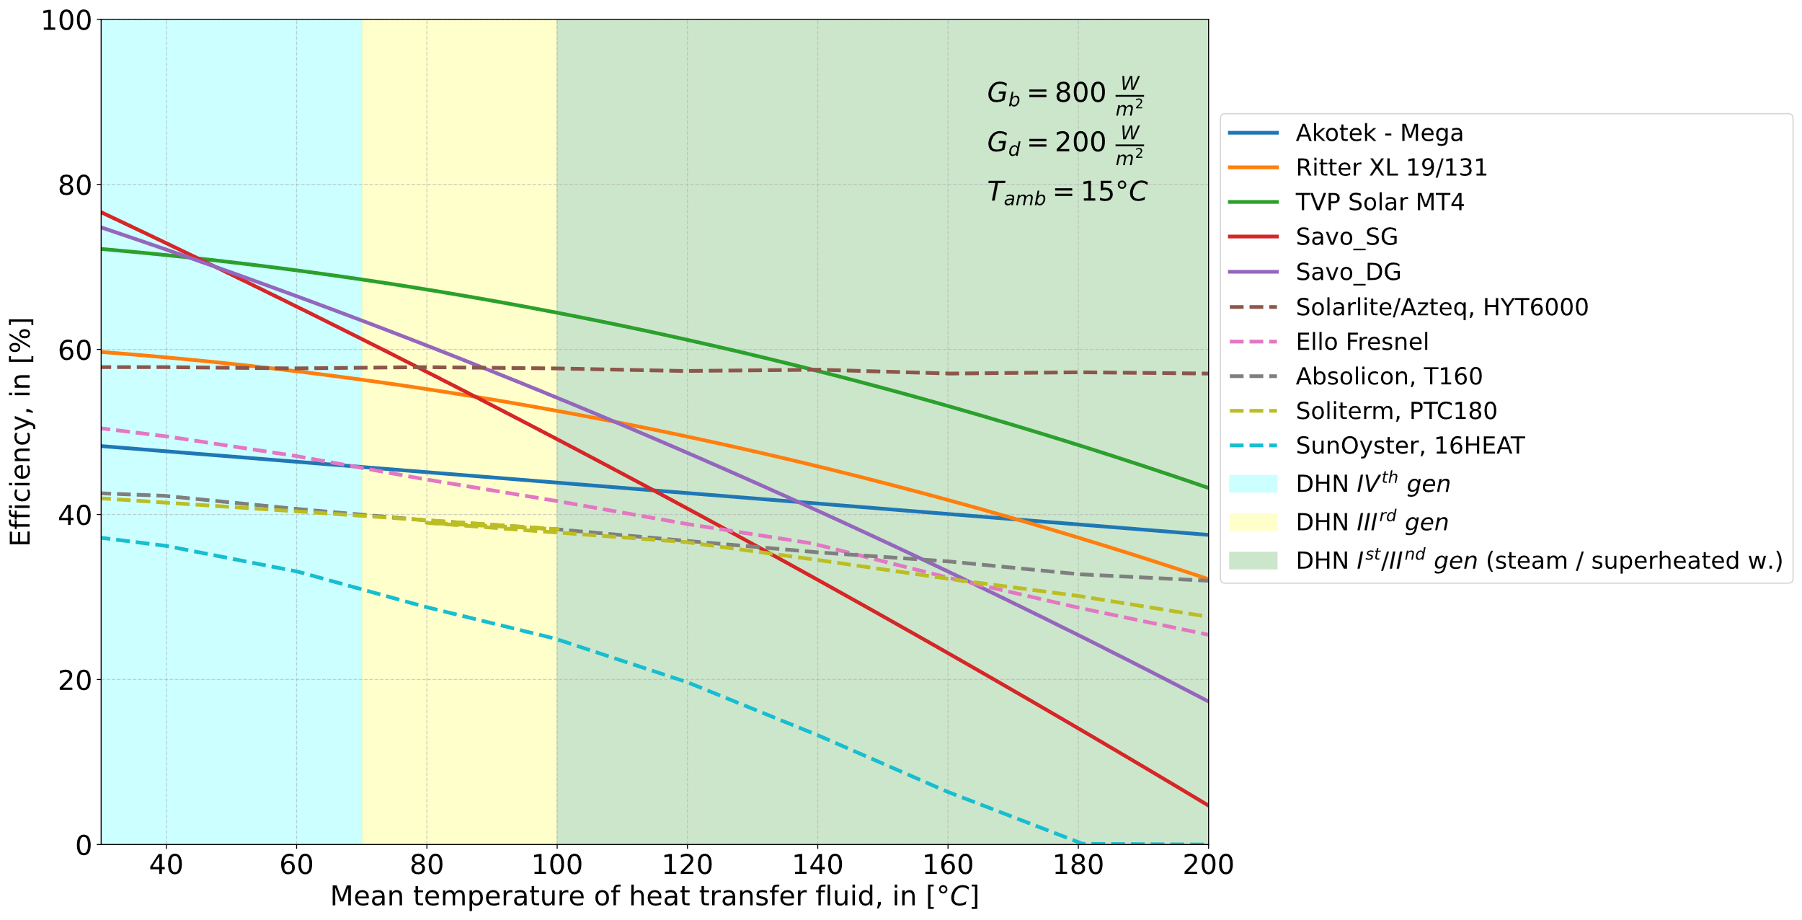
Figure 4: Comparison between the temperature range of different DHN generations and the efficiency of advanced solar collectors for DHN applications (adapted from [15]
on liquid-to-water heat pumps, with the indirect air unit requiring an external air to liquid heat exchanger. Figure 5 shows the performance of the two liquid-to-water HP units modelled in the study based on a thermodynamic model developed in the framework of the SFOE funded project TriSolHP [17]. The bivalent case has focused on a cycle featuring 50-70°C at the condenser and a thermal power of about 690 kW_{th} for an air temperature of 2 to 7°C, while the monovalent case has focused on the model of a 1700 kW_{th} HP featuring 90°C at the condenser for 5°C at the evaporator and a large temperature gain across the condenser (~30°K). Since no optimization of the number of HP units and theirs parallel / series connection has been done, the efficiency of the HP based system could be better optimized, yet the uncertainties on the final HP price model to adopt for the economic calculations discouraged any further refinement of this basic, but cost-effective architecture.
The PV system has been modelled as a grid-connected multi-string solar field with central inverter and no batteries. The solar panel has been chosen of the bifacial type with peak efficiency of 23.3% and 795 W of peak power, while the inverter has a European efficiency (η_{EU}) of 97.5% at 800 V. A reference PV string dimensioned to fit the voltage characteristics of the inverter has then been used to design variable area fields based on the scenario under simulation.
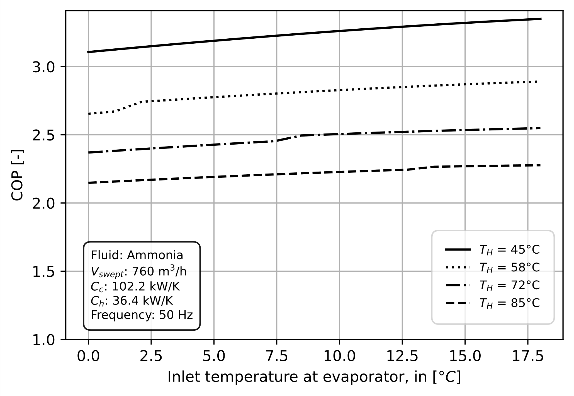 | 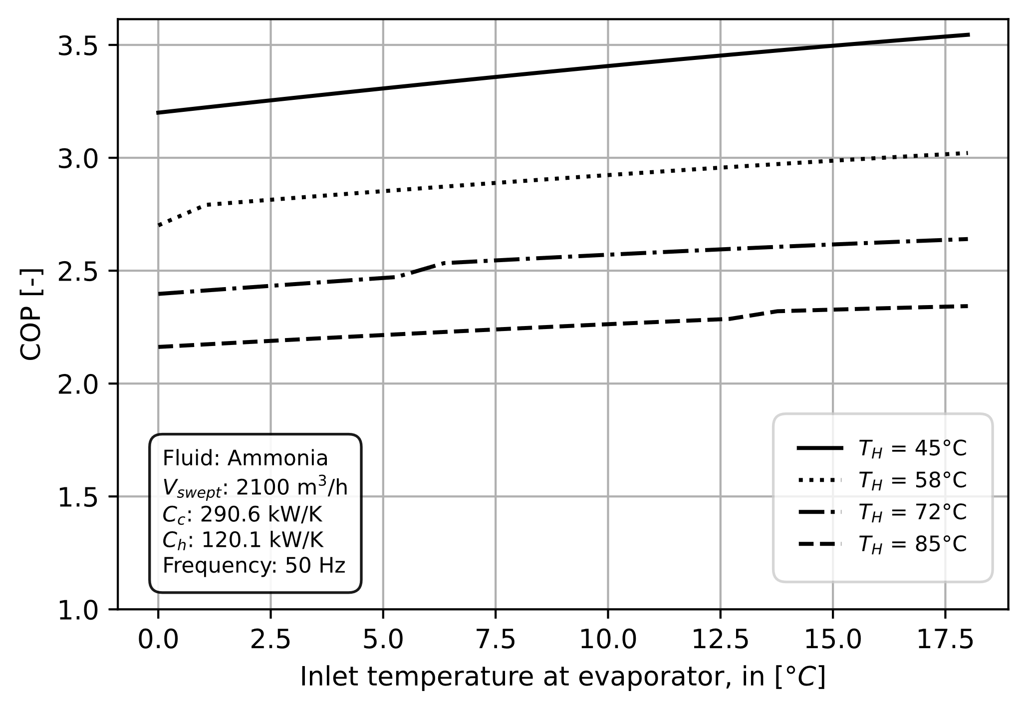
Figure 5: Performance of the heat pump models adopted in the simulation: bivalent case (left) and monovalent case (right)
Sensitivity parameters and key performance indicators
The key performance indicators (KPI) used in the comparison of the different configurations are technical, economic and environmental. Their values are computed from the results of simulations parametrized on a few variables through all the models: the aperture area of the solar field A_{SF}, in [m²], which is the area collecting the solar radiation; the TES specific volume V_{TES,sp} in [m³/m²], quantifying how many m³ of TES is assumed for each m² of solar collectors); the number of PV loops, which determines the surface and peak power of the PV field integrated to the HP production system.
The technical KPIs which have been adopted in the comparison consists, mainly, in: the specific annual solar yield of the solar thermal and PV field (Y_{sol,y} and Y_{PV,y}, in [kWh_{th}/m²/y] and [kWh_{e}/m²/y], respectively), which quantify how much solar energy has been collected and transferred to the system either by the solar thermal collectors or the PV system during one year of operations; the solar fraction SF, in [%], which is the portion of the energy demand covered by solar energy (in the HP cases, it is the portion of the energy demand covered by the HP using PV electricity); the fuel consumption, in [kg/y], and its percentage change with respect to the reference case; the electricity self-consumption, in [%], quantifying how much of the PV electricity is consumed on-site by the HP and the system.
Table 1: Common parameters applied in the discounted-cash flow models to estimate the LCOH values in each configuration.
Parameter | Value | Unit
Lifetime of solar plant / DH connection piping | 25 | y
TES lifetime | 50 | y
OPEX (repair pieces) | 1 | %/y
Discount rate | 3 | %
Fuel density | 240 | kg/m³
Fuel HHV (absolute humidity: 60%) | 22570 | kJ/kg
Electricity fares for indirect air HP | 22.57 – 30.78 | ctsCHF/kWhe
Electricity fares for groundwater HP (range) | 21.52 – 28.82 | ctsCHF/kWhe
Feed-in tariff (range) | 8.26 to 9.65 | ctsCHF/kWhe
Government subsidy for solar thermal | 2400 CHF + 1000 CHF/kW_{th}
By adopting a discounted cash-flow model (see Table 1 for some of the main parameters), the comparison was then focused on the Levelized Cost Of Heat (LCOH, [18]), the mean cost of production required to justify the investment over the lifetime of a particular configuration. For the reference case, instead, the real production costs and their composition, derived from private communications with the management of the DHN of les Ponts de Martel, were used to compute the baseline cost over which to derive the final LCOH of the hybrid configurations. Moreover, the production cost of the reference system (LCOH_{bio,ref}) was adapted to take into account the decrease in fuel consumption and its impact on the portion of the cost related to the amortization of the boiler and other fixed costs non-directly related to the fuel consumption (see equation 1, where F_{v} is the fraction of LCOH_{ref} related to fuel expenditures and 1 – F_{v} corresponds to the expenditure for amortization, rent, insurance, etc..). The reference production cost, in fact, is based on the assumption that the boiler runs a certain amount of hours per year; if a portion of the energy demand is covered by solar energy, the production cost of the biomass unit increases, since the amortization per kWh generated is required to increase to justify the investment during the same lifetime (i.e., for negligible Net Present Value at the end of the service lifetime).
On the other hand, the calculation of the cost of production of the solar part added to the reference system (LCOH_{sol}) had to consider the differing operational lifespans of the individual components. To partially solve this, the LCOH_{sol} is computed for the hybrid plants by assuming a lifetime of 50 years for the TES tank, 25 years for the TES insulation, 25 years for the solar collector field and piping, 25 years for the HP units, and a complete overhaul of the systems on the 26th year of operation (see equation 2, where CAPEX is the expenditures for material costs, OPEX are expenditures due to operation and fuel consumption, r is the discount rate, N is the TES lifetime). Combining the LCOH_{bio} and the LCOH_{sol} allows computing the LCOH_{hybr} as a function of the SF (equation 3).
- ${LCOH}_{bio}=\frac{{(1-F}_{V}) ∙{LCOH}_{bio,ref}}{(1-FS)}+F_{V}∙{LCOH}_{bio,ref}, en \left[\frac{CHF}{MWh}\right]$
- ${LCOH}_{sol}=\frac{{Capex}_{TES} + {Capex}_{ST}∙{\left(1+r\right)}^{-\frac{N}{2}} +{ Capex}_{pp}∙{\left(1+r\right)}^{-\frac{N}{2 } }+ \sum_{t=1}^{N}{\frac{{OPEX}_{t}}{{\left(1+r\right)}^{-t}}}}{\sum_{t=1}^{N}{\frac{Q_{t}}{{\left(1+r\right)}^{t}}}}, en \left[\frac{CHF}{MWh}\right]$
- ${LCOH}_{hybr}=\left(1-SF\right)∙{LCOH}_{bio}+SF*{LCOH}_{sol}, en \left[\frac{CHF}{MWh}\right]$
- $f_{hybr,\left[CO,NOx,FiPar\right]}=\frac{gEmissions\left[CO,NOx,FiPAr\right]}{E_{DH}} in \frac{g\left[CO,NOx,FiPar\right]}{GJ}$
Once the technical and economic perspective had been treated, the emissions of pollutants such as CO, NOx and fine particulate were quantified for the different configurations and scenarios based on the current emission model issued by the QM Bois association [19]. This latter provides emission factors for the different phases of the biomass burner cycle and different pollutants (see Table 2). To compare the emissions in the different configurations, the emission factor of the hybrid plant (f_{hybr}, equation 4) and that of the biomass generating units (f_{bio,}) were computed.
Table 2: Emission factors for industrial pellet boilers of power larger than 500 kW_{th} for each operating phase (source [19])
Operating phase | CO, in [g/GJ] | Fine particulate⁺, in [g/GJ] | NOx, in [g/GJ]
Start | 685 | 50 | 182
Stop | 1209 | 50 | 139
Full load | 45 | 10 | 125
Partial load | 64 | 2.8 | 104
Standby | 665 | 10 | 101
⁺fine particulate matter (PM2,5) and in suspension (PM10)
The former is equal to the annual emissions divided by the annual DHN energy demand, while the latter is equal to the annual emissions divided by the energy produced by the biomass boiler.
Dynamic modelling
To compare the performance of the different configurations with the reference biomass only scenario, several models were developed under TRNSYS. Apart from the basic TRNSYS types adopted for modeling the hydronics and control of the circuits, each model was built as an extension of the reference system. This latter, composed mainly by the two-boiler cascade and a dedicated TES, adopted TYPE869 for the boiler [20] and TYPE340 for the water tank-based TES. The hybrid solar-biomass plants adopted then the solar field model of the SolarCADII plant [16], mainly consisting of TYPE832v501 for the thermal collector field, TYPE55 for the solar heat-exchanger and TYPE16 for the processing of the radiation data for Pont-Les-Martel (source of the weather data: MétéoSuisse). Given the different layouts, a total of four base models were developed, one for each hybrid biomass-solar configuration. Finally, other two base models were developed for the monovalent and bivalent HP cases. In the bivalent case, other than those used to model boiler and TES, TYPE194 was used for the PV field with inverter, TYPE927 for the HP and TYPE511 for the dry cooler, while in the monovalent case the HP was modeled with TYPE402. The performance tables for each HP unit were derived from the thermodynamic model results presented in Figure 5.
Given the difference among the systems, each model required an adapted control algorithm. In the reference system, the boiler cascade was implemented based on the calendar embedded in Figure 1. Boiler operation was dictated by the required DHN supply temperature and flowrate, and by the State of Charge (SoC) of the TES. This latter was defined based on the temperatures in 5 layers of the TES, and it allowed quantifying how much of the TES capacity was available at the DHN supply temperature at a given time. In the implementation, if the SoC is less than 20% the boiler starts, while it is stopped when the SoC reaches 90%. While this control algorithm was applied to each model adopting a biomass boiler, it had to be tailored to each different case. As such, for the biomass-solar hybrid circuits, the control algorithm has been extended to include a solar control based on irradiance (i.e., the fluid starts to circulate when the solar irradiance on the plan of array is larger than 150 W/m²) and the operating nominal temperature range (via a match flow control on the circulation pumps). But while in Circuit 1, solar heat is produced, when possible, at the DHN supply temperature, in Circuit 2, 3 and 4 of Figure 2 the temperature imposed to the solar production is adjusted based on the season to increase productivity when the sun is low and to maximize the coverage of the summer load.
Analogously, the configurations equipped with HP units required the HP control algorithm adapted to each case. While the monovalent case was handled as the biomass only case, with the HP production based on the SoC of the TES during the whole year, the HP operations for the bivalent case were constrained to the same schedule of the smaller biomass boiler unit of the reference plant (i.e., the indirect air HP substitutes the smaller biomass boiler unit dimensioned on the DHW load of 600 kW_{th}). In this latter case, when enabled, the HP preheats the lower part of the TES during winter and inter-seasons or directly supplies the DHN during summer. In both configurations, PV generation was enabled continuously with the excess electricity non consumed by the HPs considered fed back to an ideal grid.
Cost functions
The calculation of the LCOH was based on a discounted cash-flow model applied to each configuration. Expenditures and earnings over the lifetime of the project (assumed 50 y, as the lifetime of the TES) were discounted back to the time of the initial investment using the net present value method [18]. The main costs considered included the initial investment (i.e. CAPEX), operation and maintenance costs (I.e., OPEX), replacement costs on the 26th year for solar thermal field, boilers and HP, as well as government subsidies for solar thermal and PV. Since the heat-cost for biomass only generation was known and derived from field data, the economic model estimated the costs only for some subsystems for each configuration. The CAPEX for the solar thermal – biomass hybrid configurations included the solar thermal field, the TES and the main DH connection piping, while in the HP et PV cases, the model included the investments for the HP, the groundwater HP wells, the external dry-cooler for the indirect air HP case and the Medium Voltage (MV) electrical substation required by the large power HP. The adopted cost functions are listed in the Appendix.
- Results and discussion
Performance comparison among solar-biomass configurations
The dynamic models developed under TRNSY were used to compare the technical performance of the four hydraulic configurations presented in Figure 2 to determine the best way to integrate a solar thermal field with a TES to a DHN network supplied by a biomass boiler. The simulations investigated the performance of each circuit for sizes of the solar field (A_{SF}) between 1000 and 6000 m² and for values of the specific volume of the TES (V_{sp,TES}) between 0.075 and 0.2 m³/m².
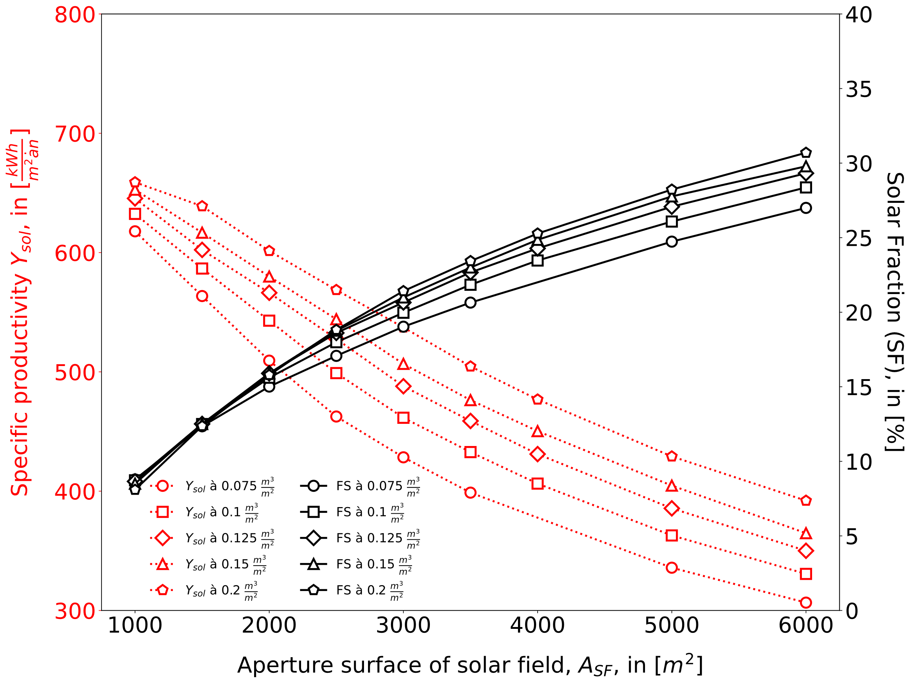 | 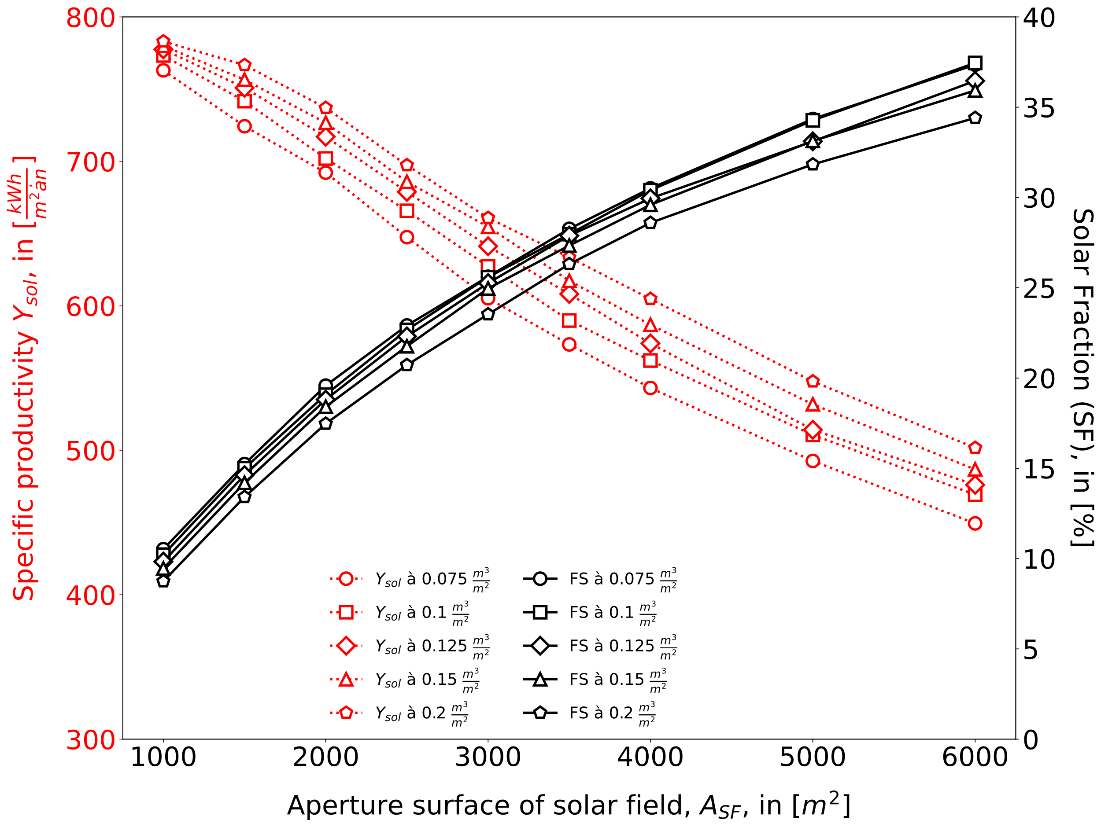
Circuit 1 | Circuit 2
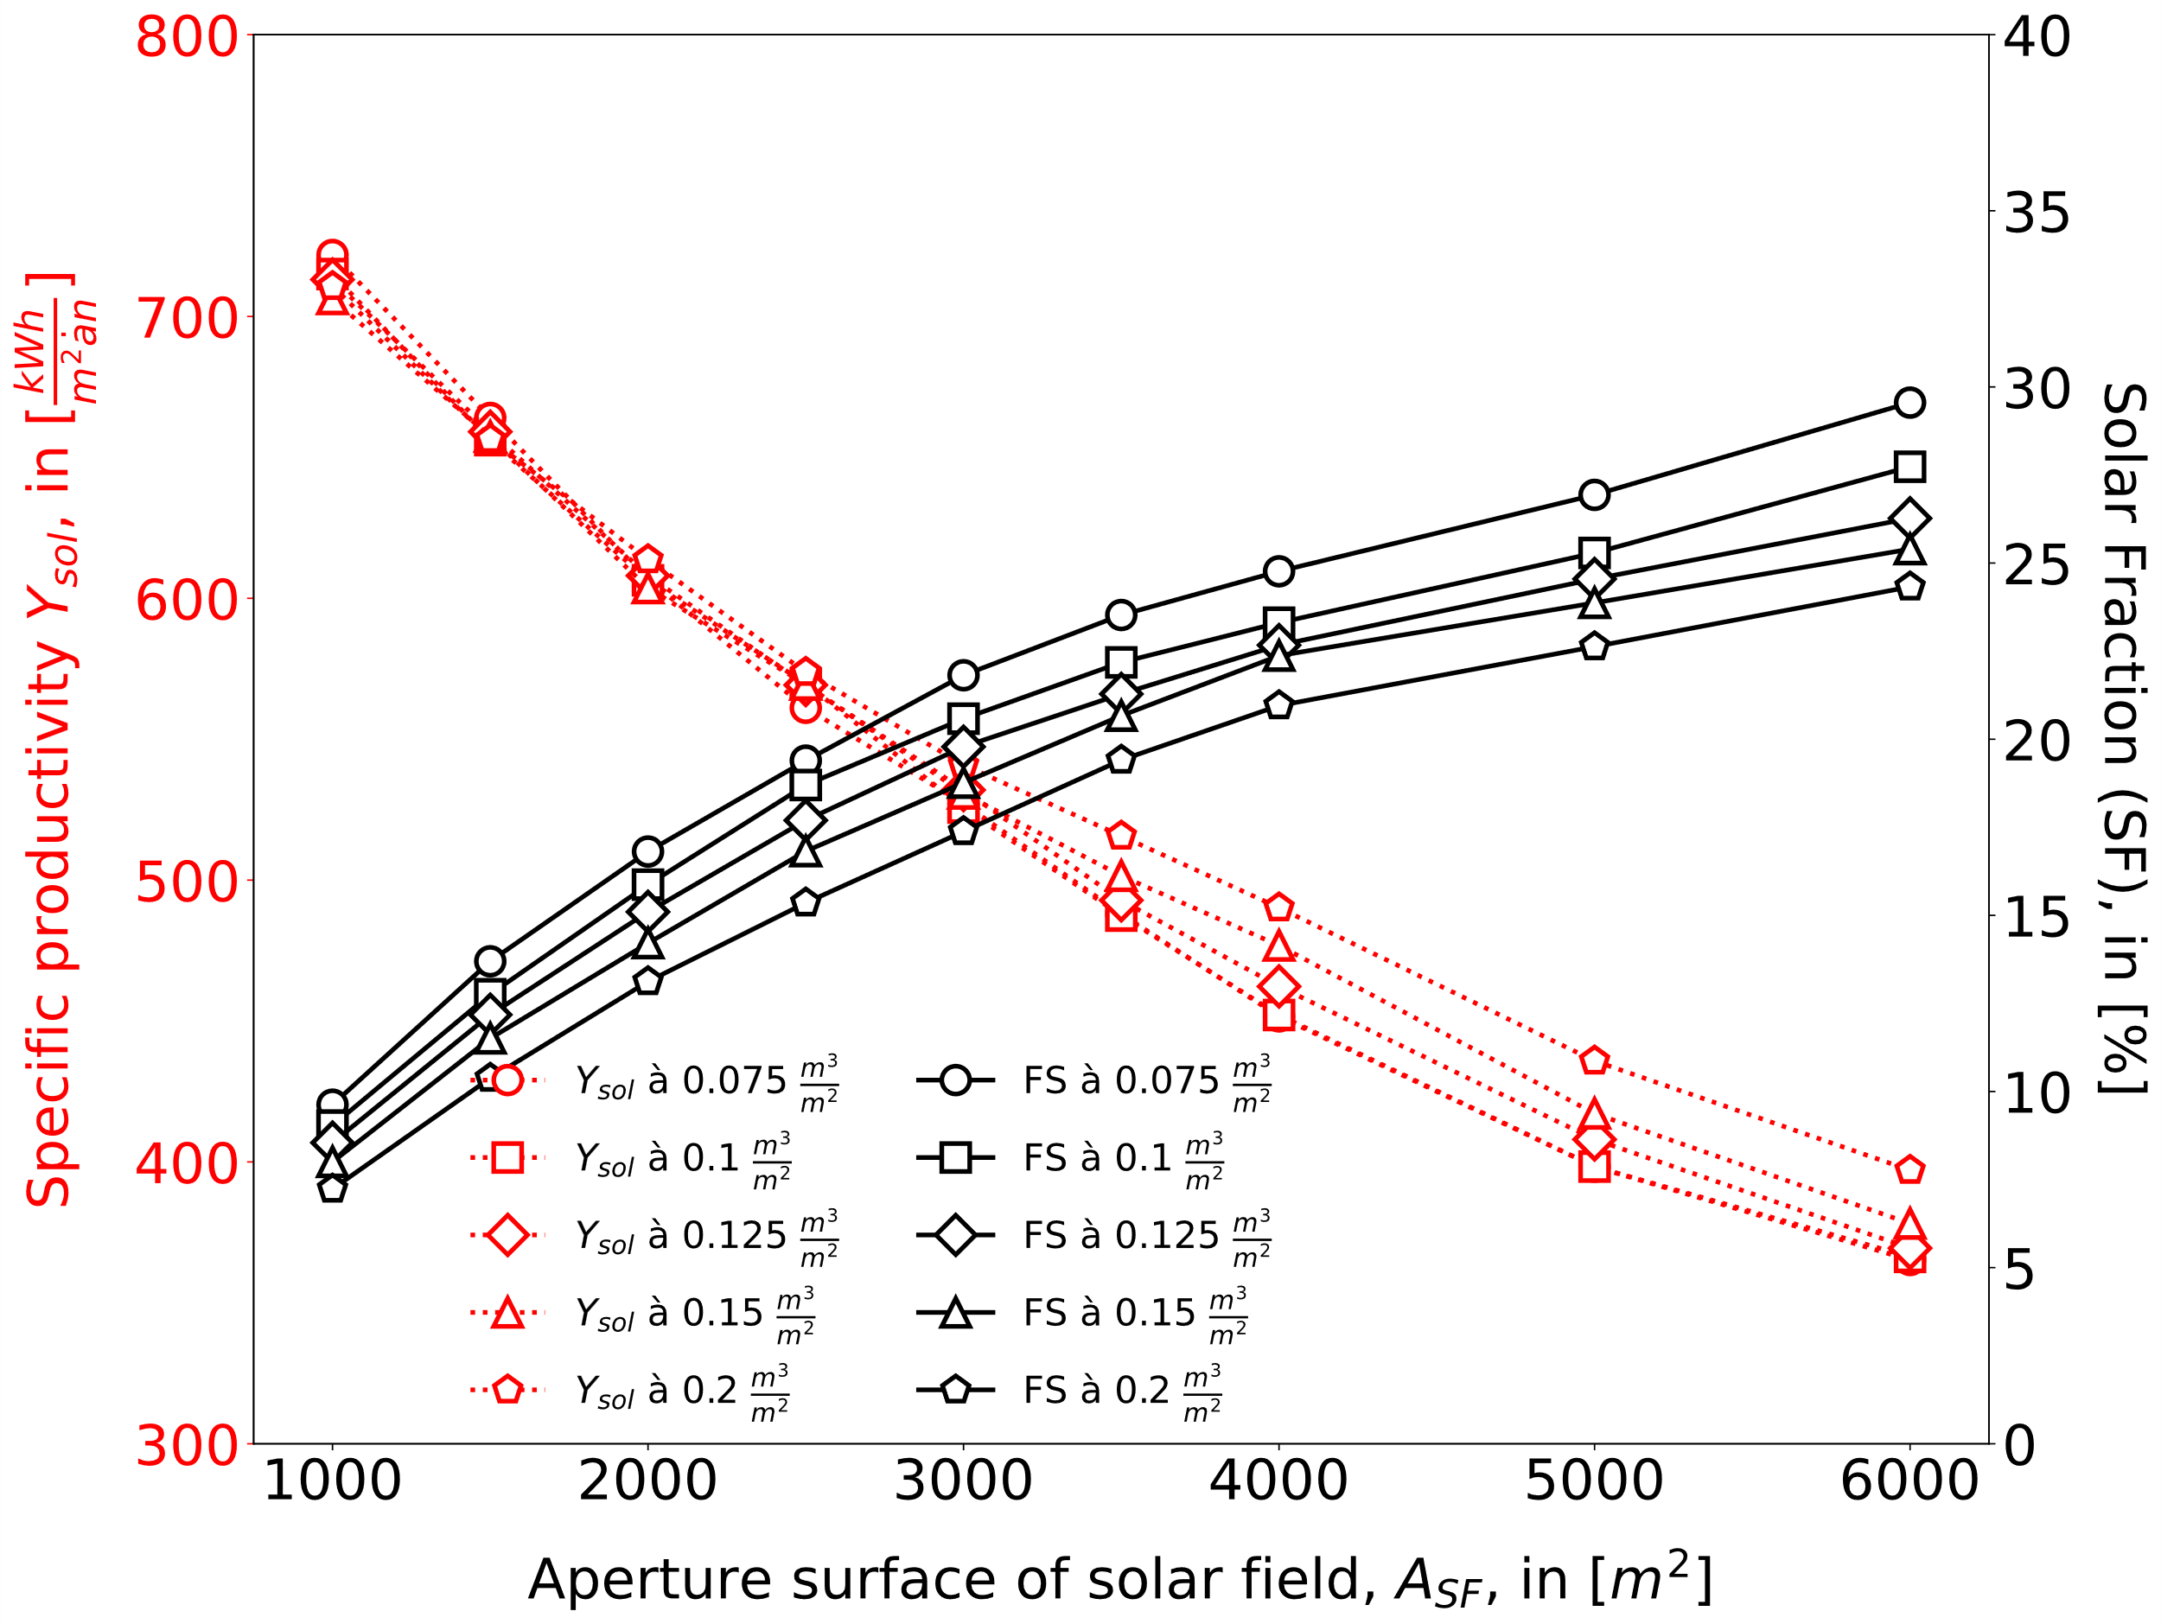 | 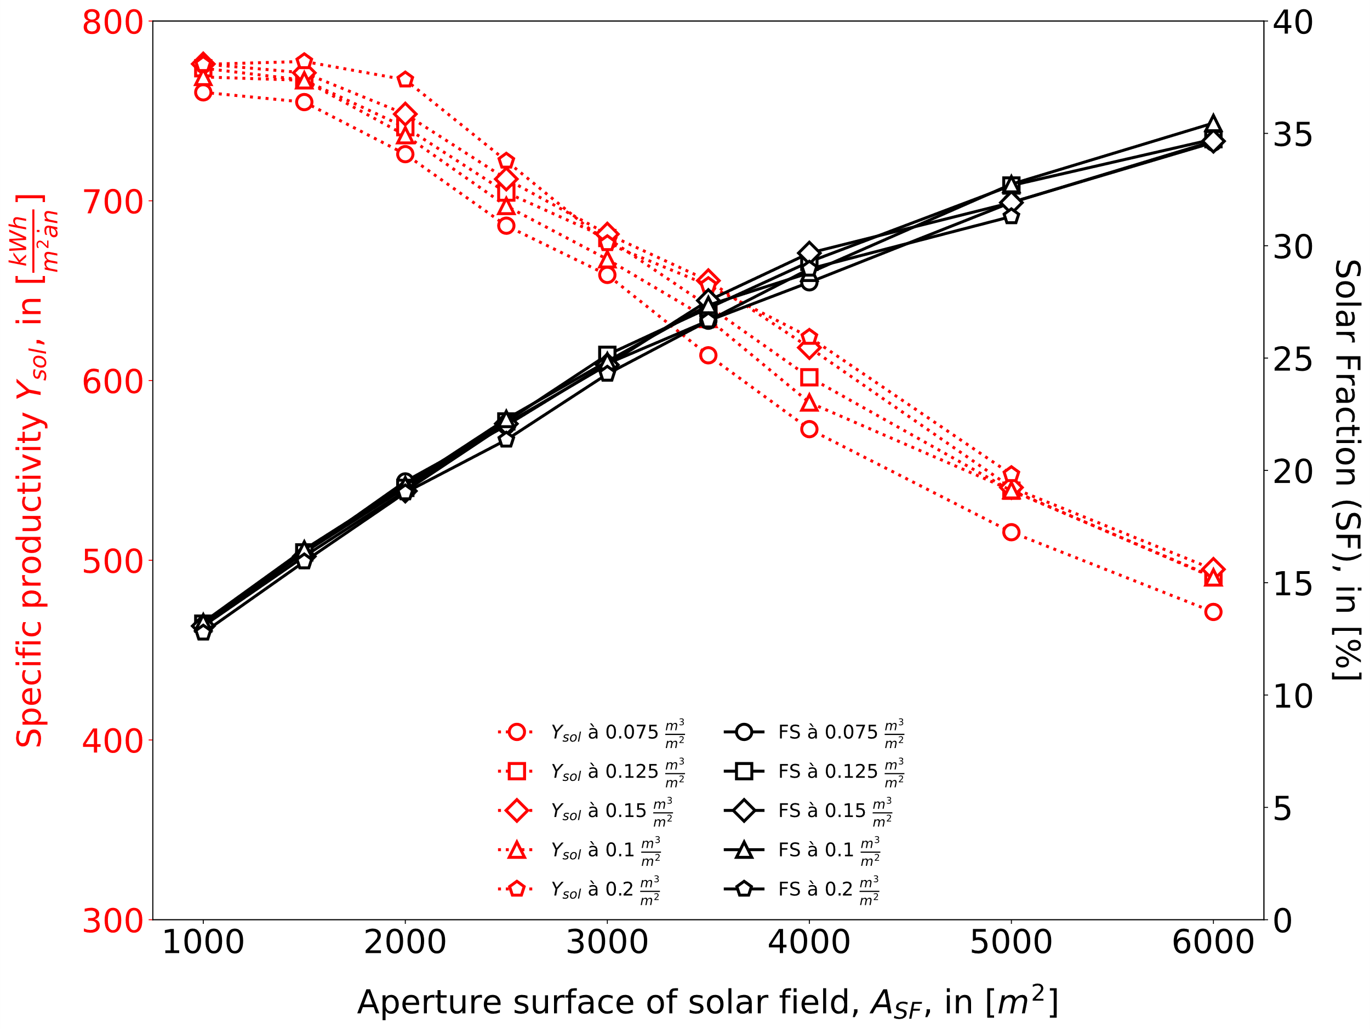
Circuit 3 | Circuit 4
Figure 6: Specific productivity Y_{sol} and solar fraction (SF) as a function of the aperture area of the solar field and the specific TES volume for the four hydraulic layouts under investigation for the integration of solar and biomass energies.
As shown in Figure 6, in each configuration the increase in solar field area increases the solar fraction but with lowering marginal gains. On the other hand, the specific productivity lowers with increasing area of the solar collectors. Both happen because the solar field is increasingly oversized with respect to the amount of energy the DH system can absorb, especially in summer. A larger part of solar energy is then lost to the environment through increased collector losses or due to the solar production being stopped to avoid overheating, decreasing the amount of energy that a m² of collector can deliver in one year. Circuit 1, where the solar field is compelled to produce energy at the DHN supply temperature, features the lowest specific productivity and solar fraction of all configurations, while Circuit 2 performs the best. This latter type of integration assures that the solar field produces energy at the lowest temperature possible, while the possibility to bypass the biomass circuit has a greater impact than the unique TES of Circuit 4. In most cases, the increase of the specific TES volume has a positive impact on the specific productivity and the SF, while in Circuit 3 and 4, an increase in the TES volume at low values of V_{spTES} decreases the performance, indicating that losses are larger for these two configurations at low TES capacity.
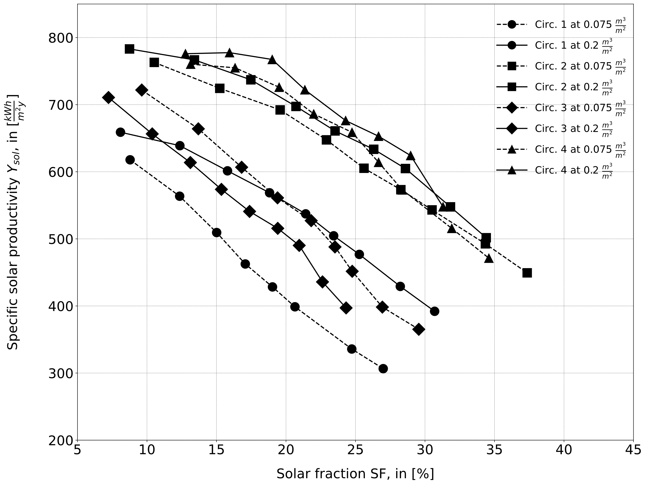 | 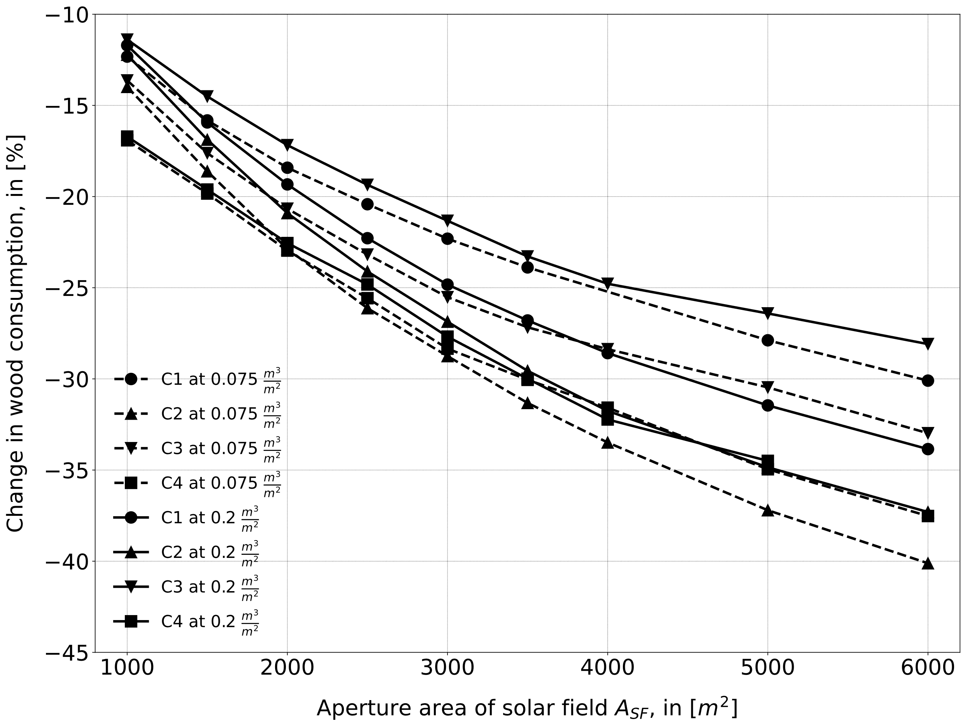
Figure 7: Specific solar productivity (Y_{sol}) as a function of the SF (left) and change in wood consumption for the four circuit under investigation.
Figure 7 shows the performance comparison among the 4 solar biomass hybrid configuration in terms of specific productivity as a function of the solar fraction and for values of V_{sp,TES} of 0.075 and 0.2 m³/m². Circuit 2 and Circuit 4 allow the hybrid installation to supply the DHN with more solar energy than Circuit 1 and Circuit 3 due to the favorable conditions for production and the fact the solar energy is integrated in the lower part of the TES systematically. The way solar energy is integrated into the upper part of the biomass TES might be the cause of an increase in the system losses of the case of Circuit 3. The adoption of a bigger value of specific TES volume increases both the solar yield and the solar fraction.
These relative performances are reflected in the wood consumption for each configuration, which diminishes with increasing solar field area, as shown in Figure 7. For the same configuration with the same solar field, bigger values of specific TES volume tend to limit the wood saving potential with respect to the system with smaller specific TES volumes. The marginal reduction in wood consumption decreases with bigger solar fields as more heat is produced in excess during the year.
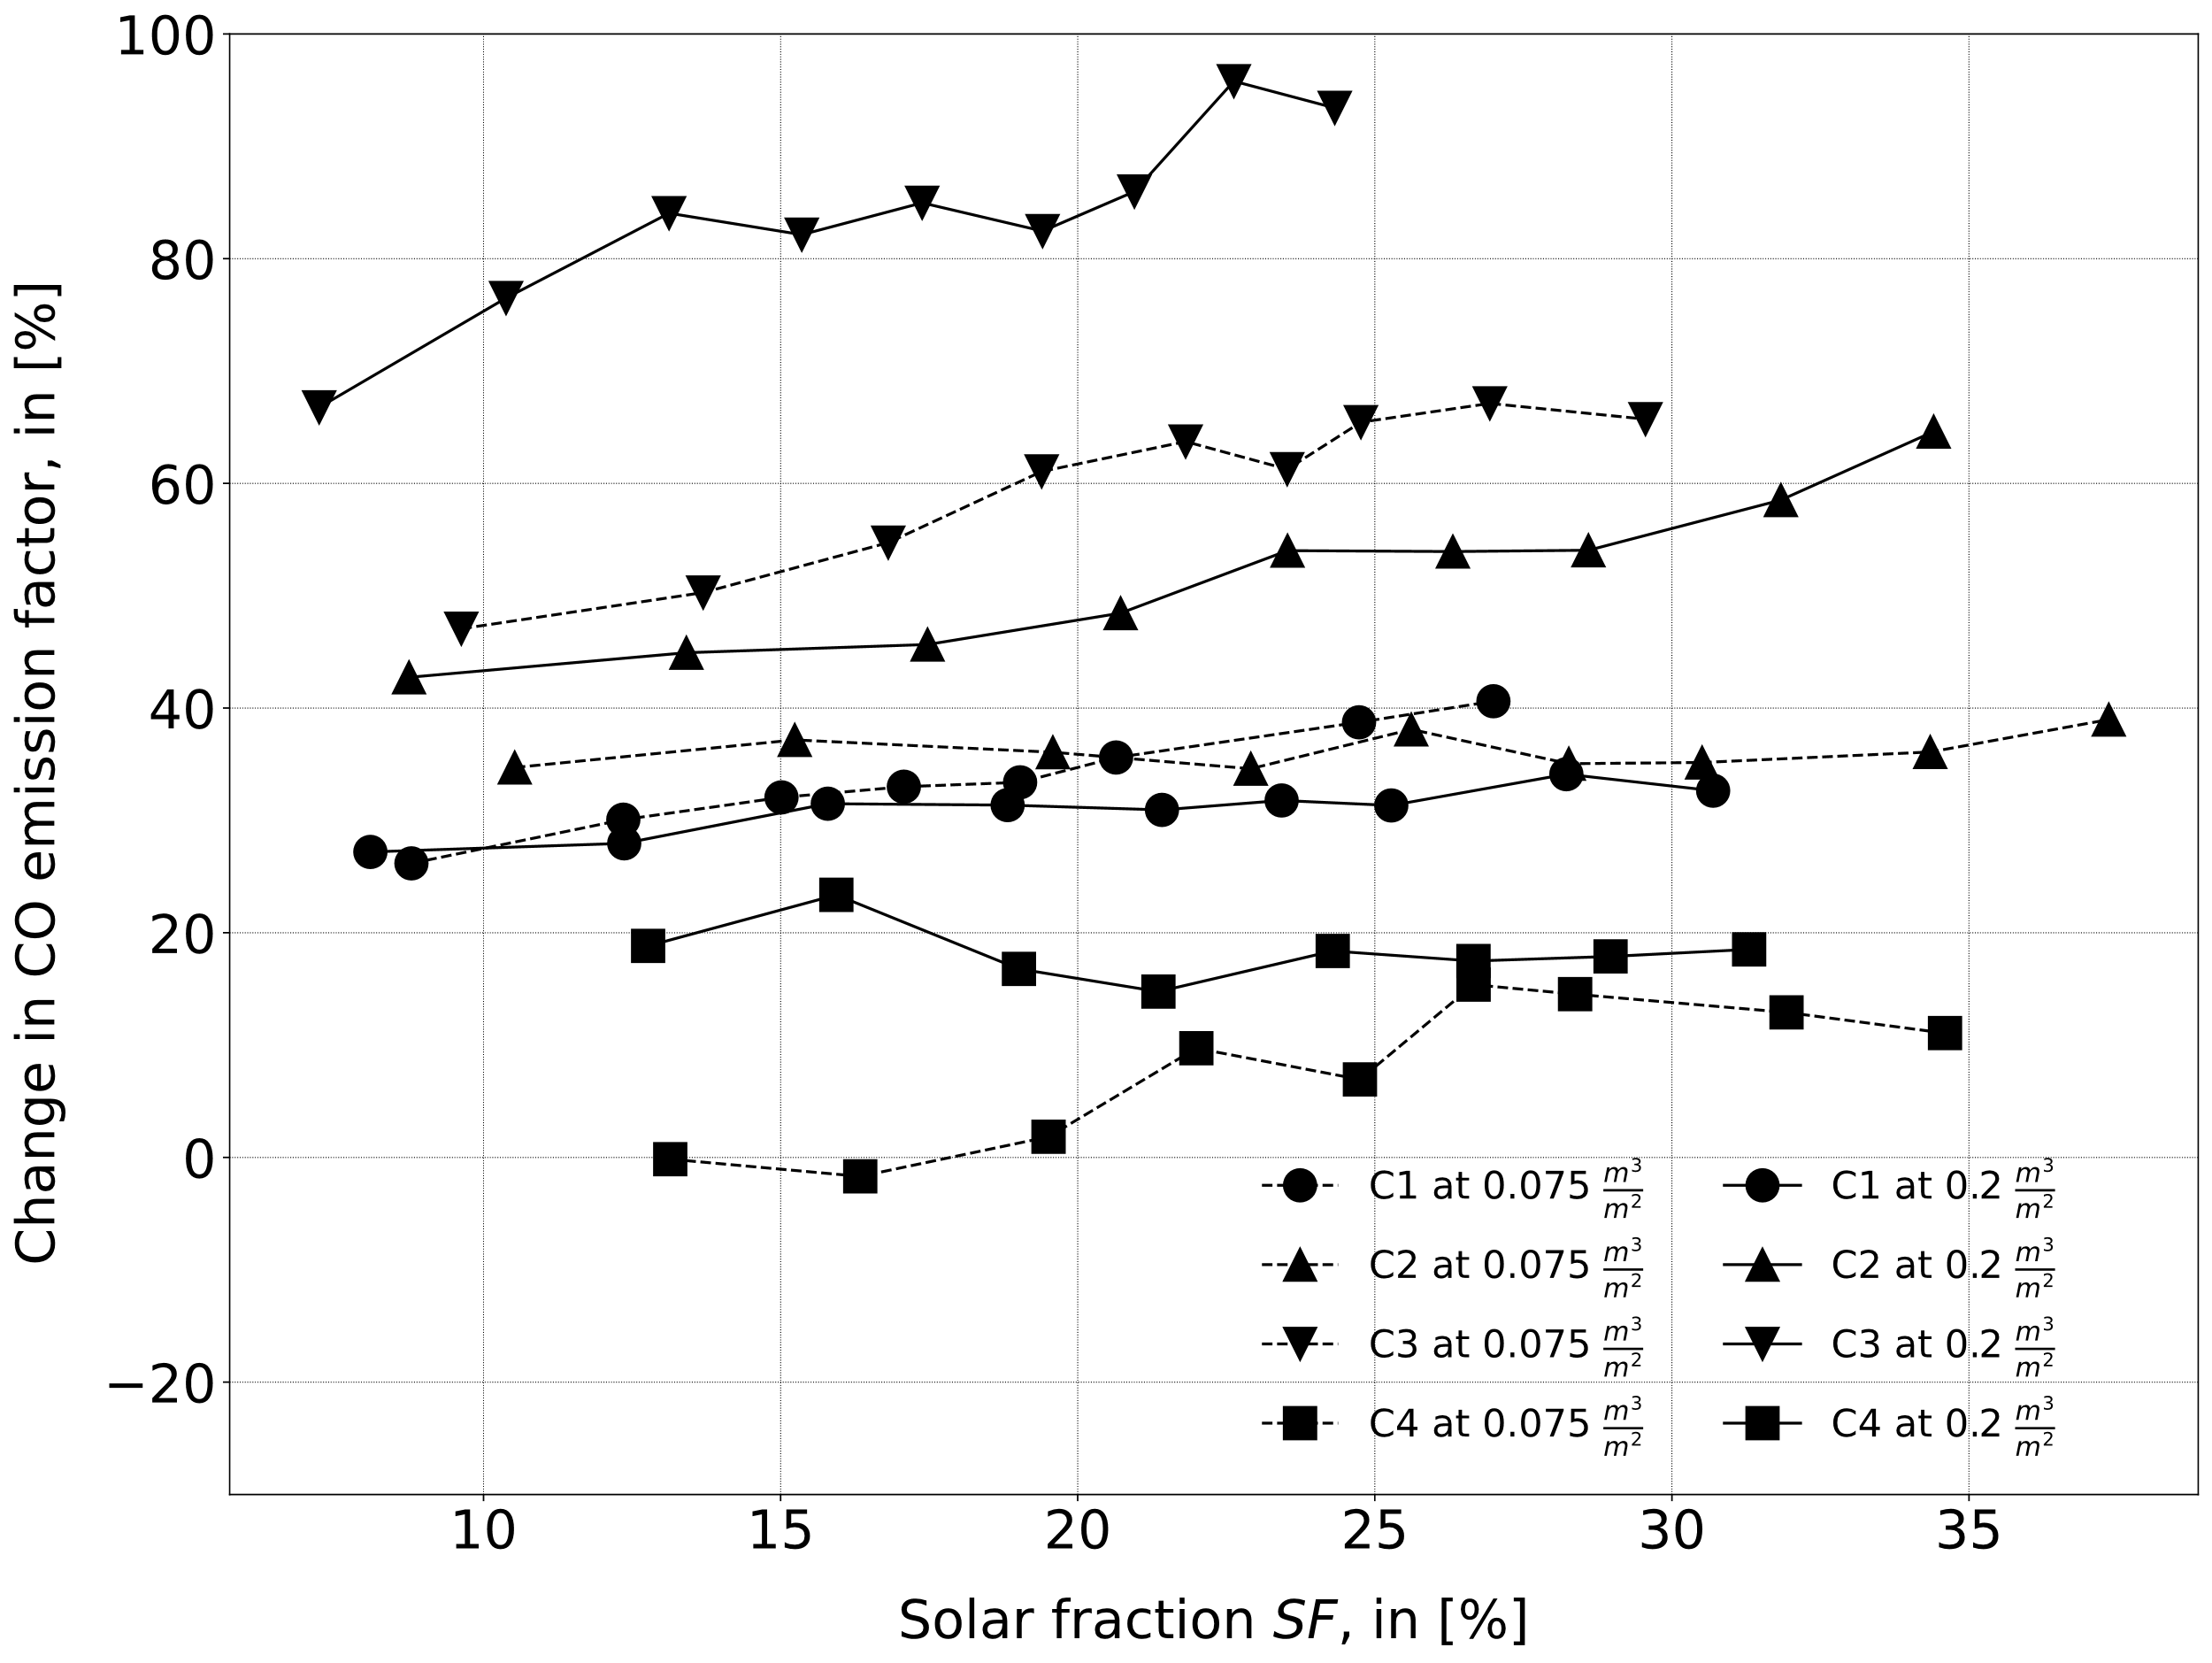 | 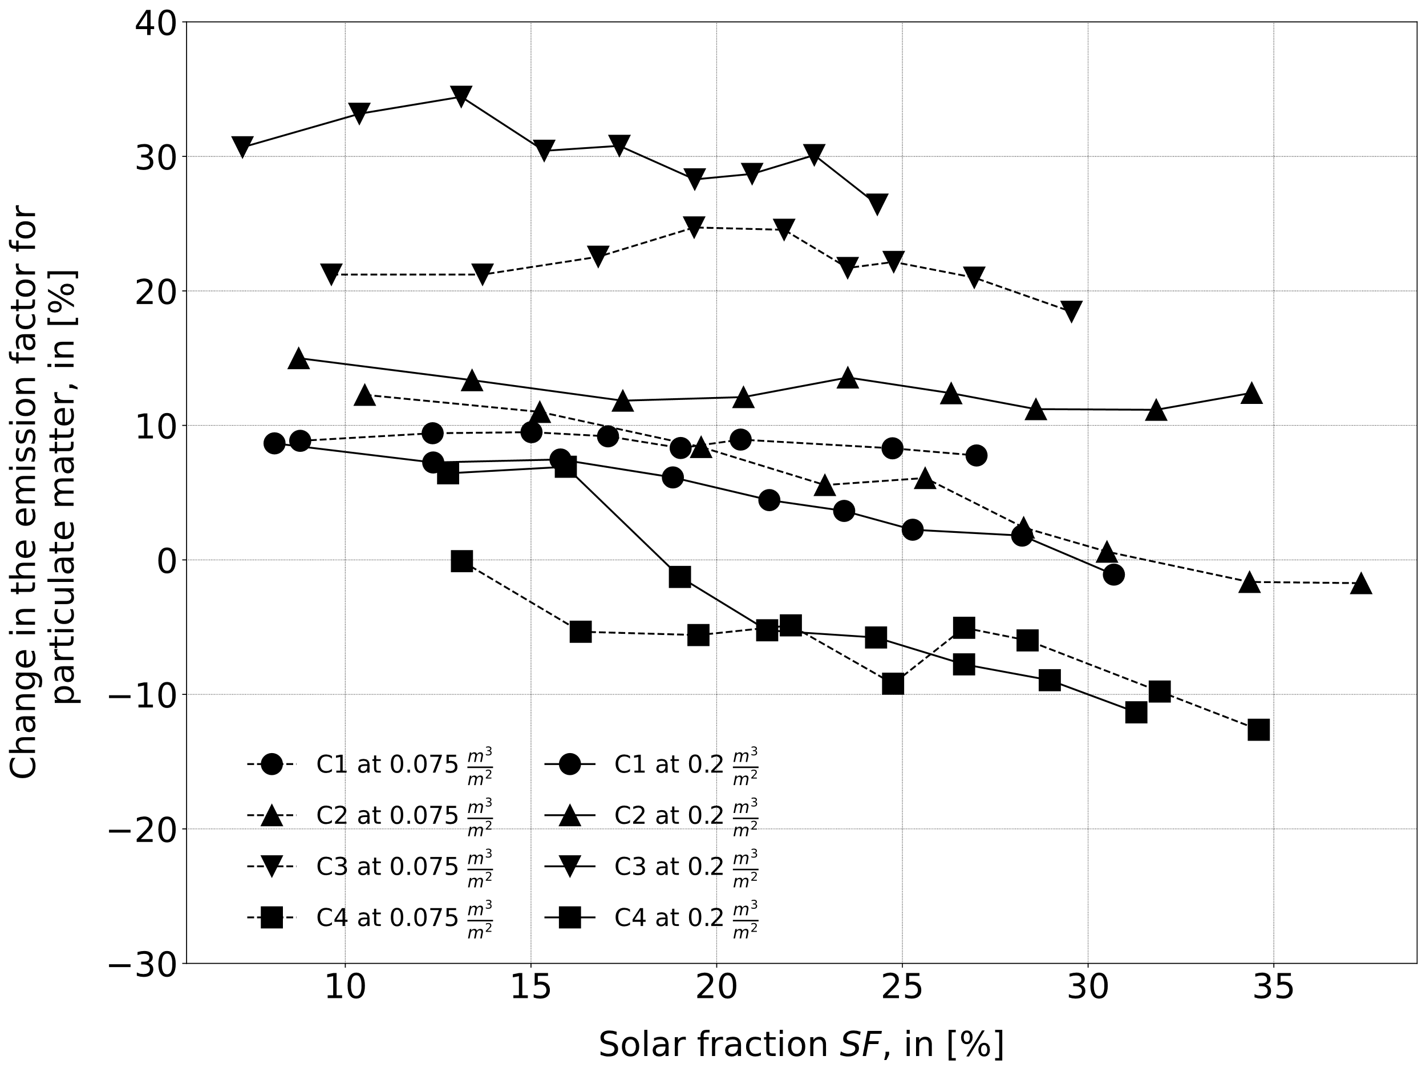 | 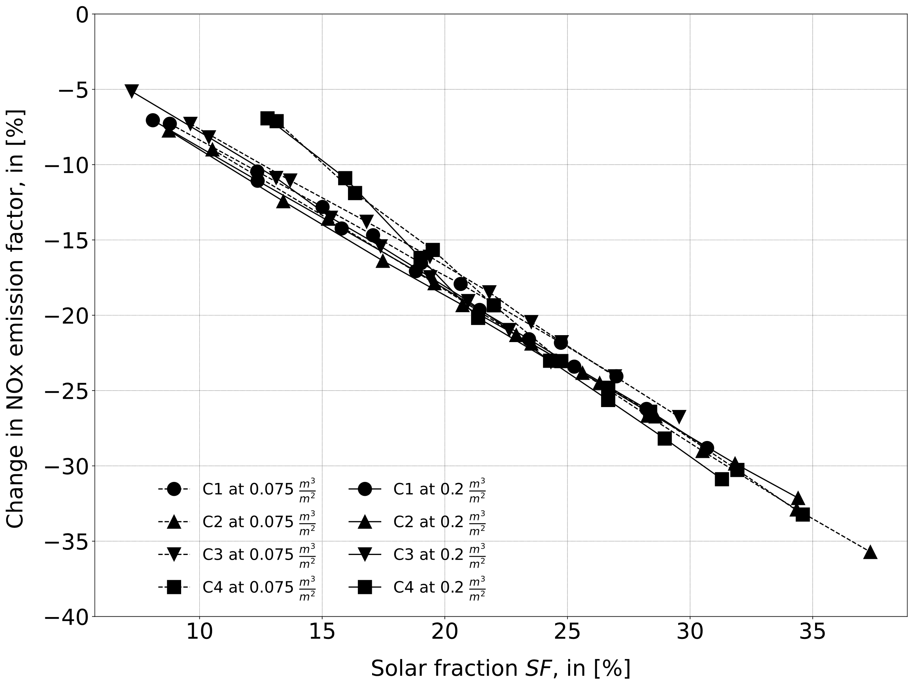
Carbon monoxide | Particulate matter | Nitrogen oxides
Figure 8: Change in emission factor of the hybrid plant for CO, particulate matter and NOx as a function of the SF.
Emission factor of hybrid-solar configurations
The addition of a solar installation, particularly when coupled with a large TES, strongly affects the operation of wood-fired boilers. Solar energy causes the boilers to shut down more frequently and it can increase the number of operating cycles. This latter has the effect of changing the emissions from the boiler due to the variable emission factors that the pollutants have during the different phases of the burner cycle (see Table 2).
The way the solar plant is integrated into the DHN has an impact on the final emission of the plant, as shown in Figure 8 for carbon monoxide (CO), nitrogen oxides (NOx) and fine particulate (FiPar in the image) and for the four circuits under examination. While solar energy decreases the consumption of wood, allowing precious resources to be spared, it increases the number of cycles which the biomass boiler undergoes, increasing the amount of time the boiler is in the startup phase, where CO emissions dominate. The solar hybridization has instead a better effect for particulate matter, and, especially, allows NOx emissions to be reduced considerably.
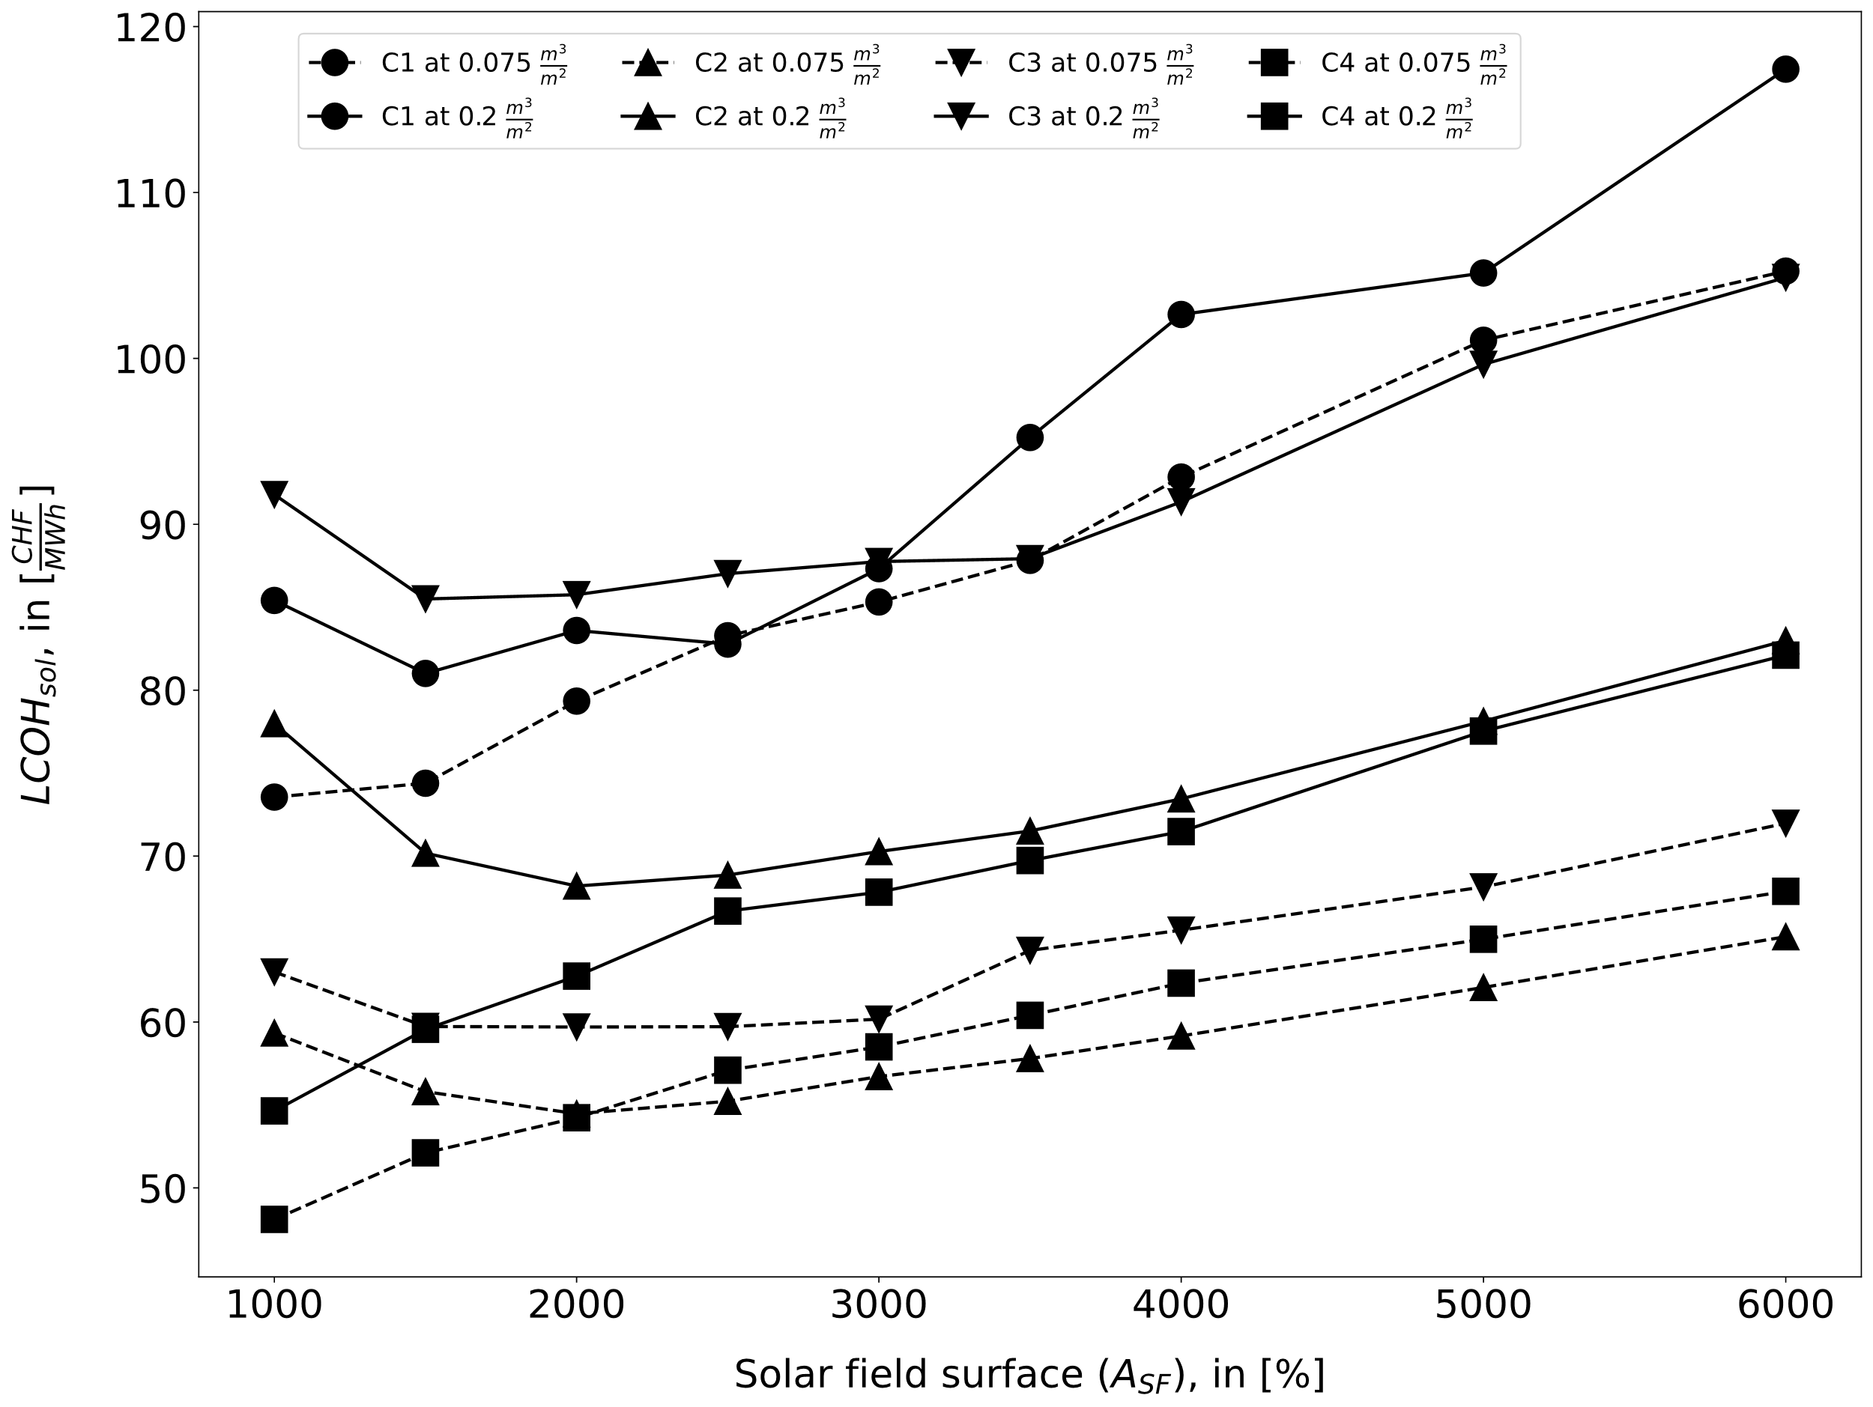 | 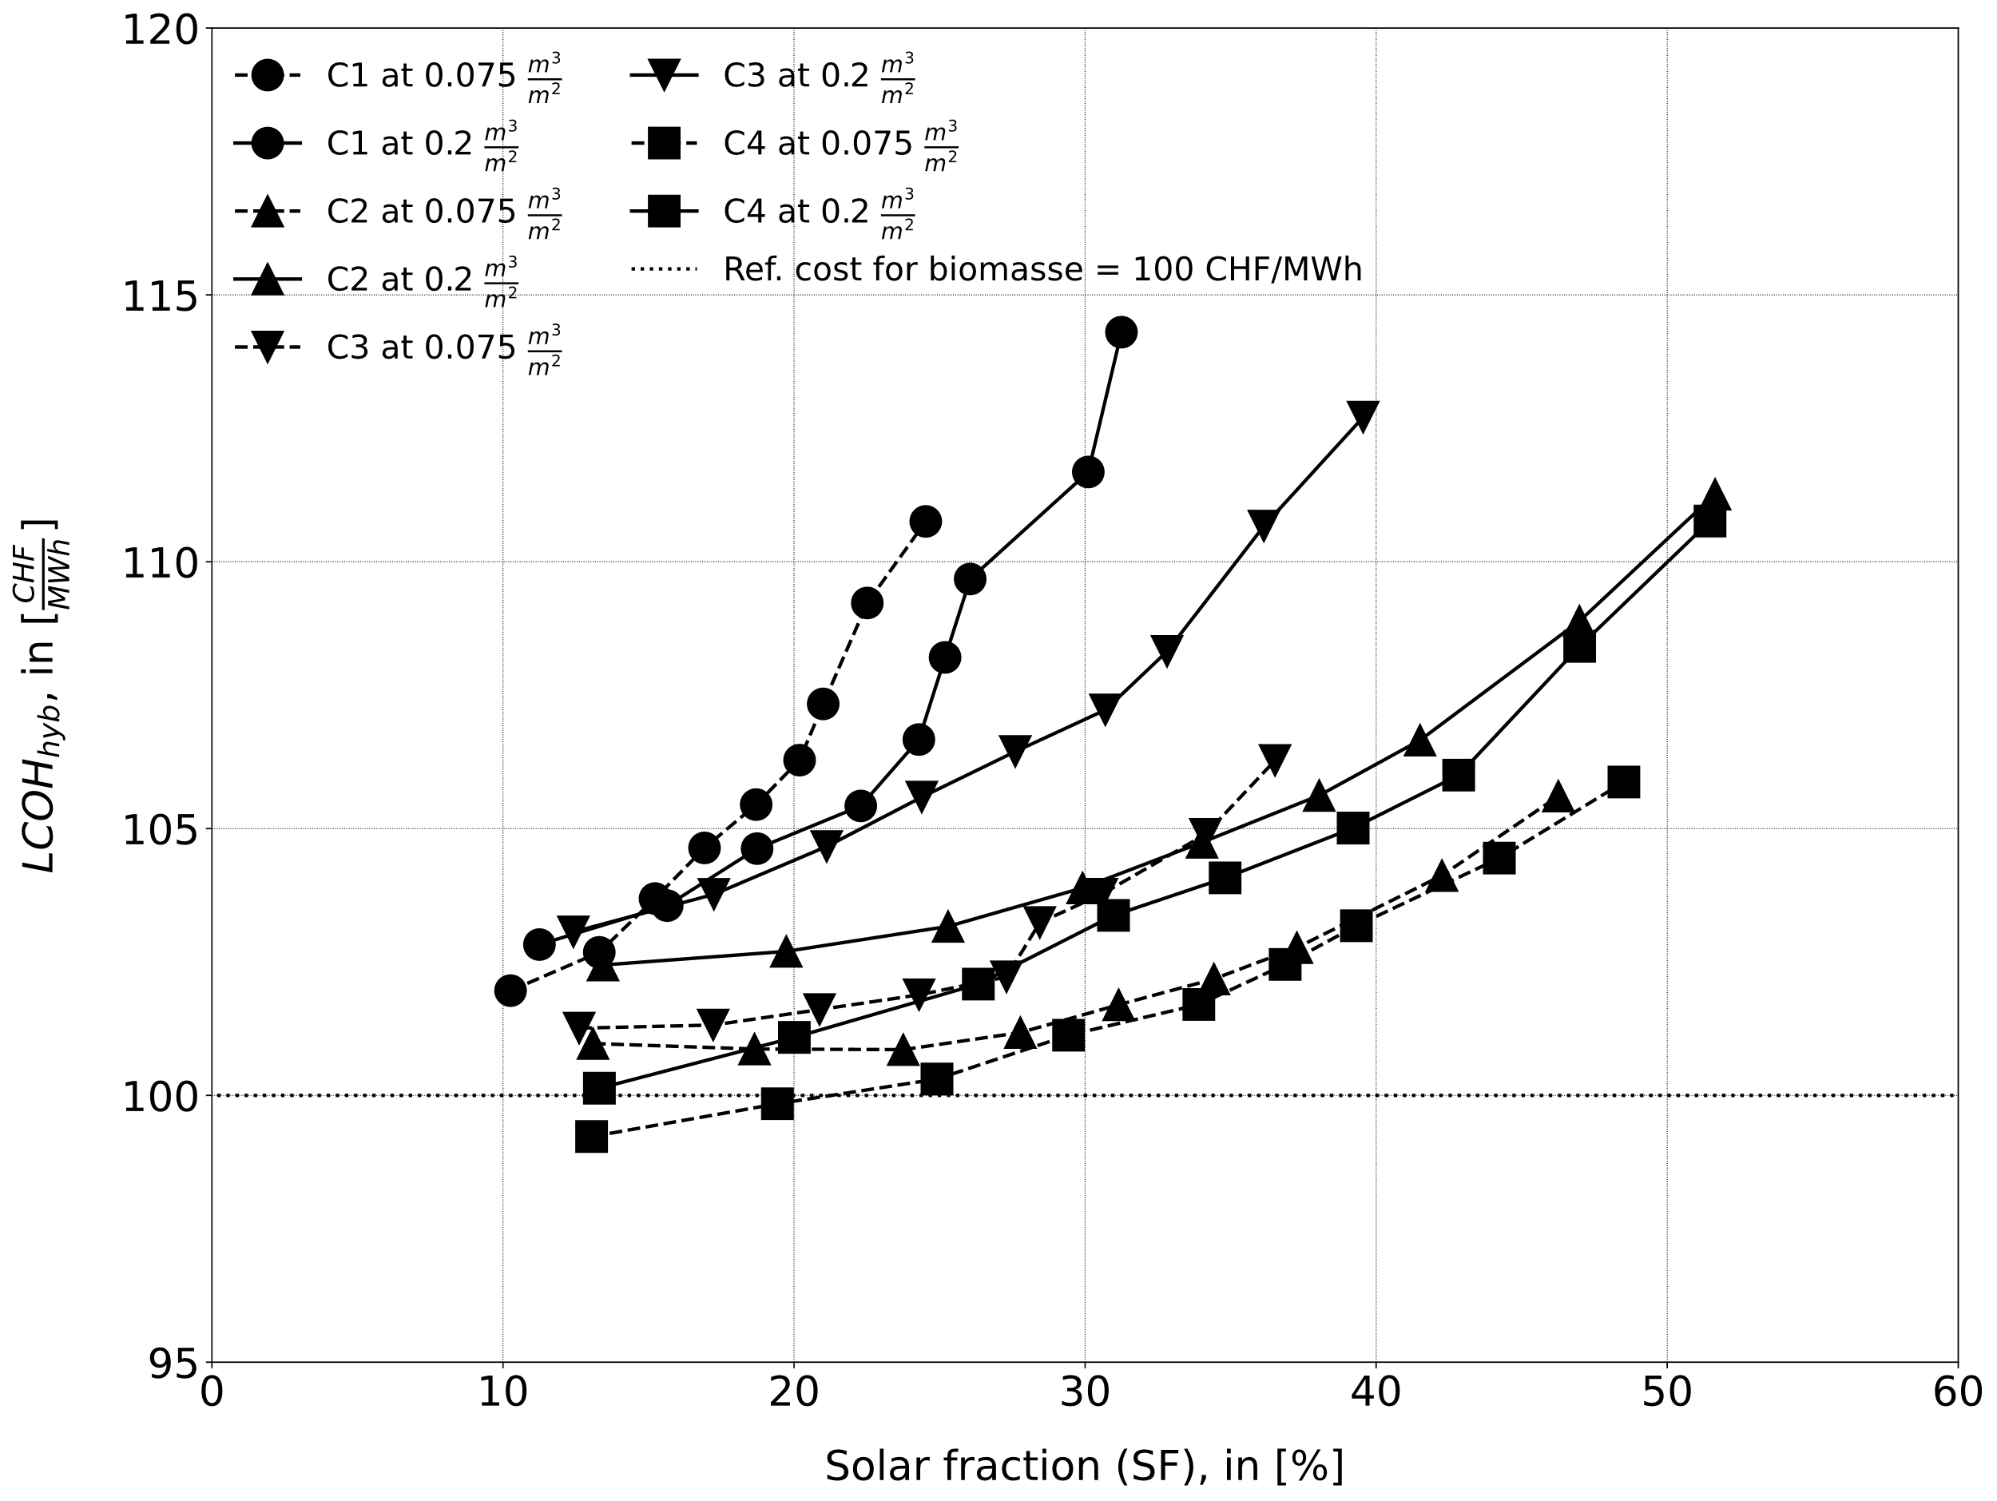
Figure 9: LCOH_{sol} (left) and LCOH_{hyb} (right) for the solar-biomass hybrid circuits.
LCOH calculations
Once the performance of each solar biomass hybrid configuration was established, the discounted cash flow model was applied to derive the mean cost of production, considering, among others, solar field and TES dimensions, wood and electricity consumption and heat sales. By computing the LCOH_{sol}, the LCOH_{hyb} was derived by combining it with the effective LCOH_{bio} (as illustrated in the methodology section), and applied over the service lifetime of the installation, assumed to coincide with the lifetime of the TES (i.e. 50 y). By adopting a refurbishment at mid-life, the service lifetime of solar fields and biomass boiler were aligned to that of the TES.
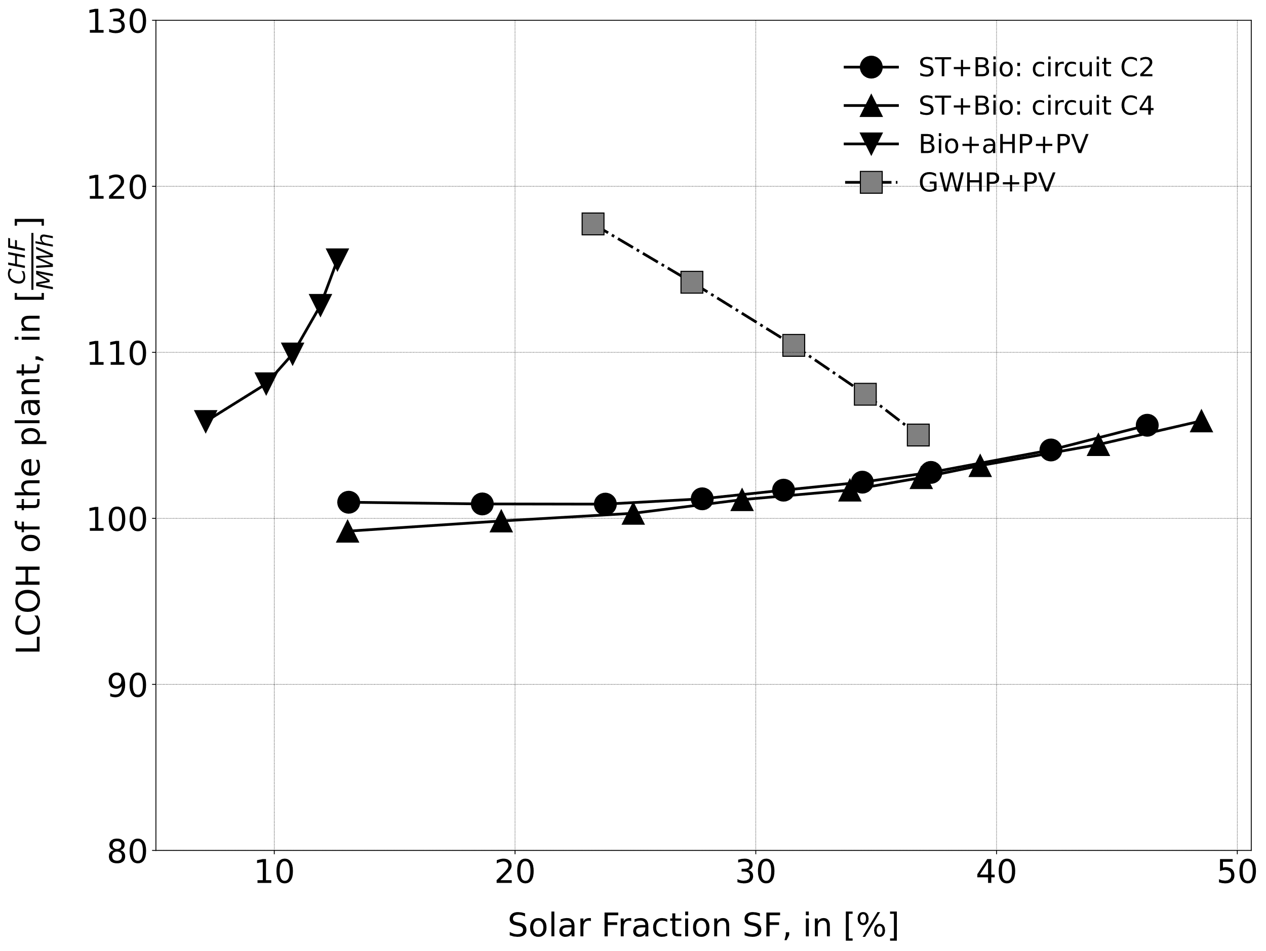 | 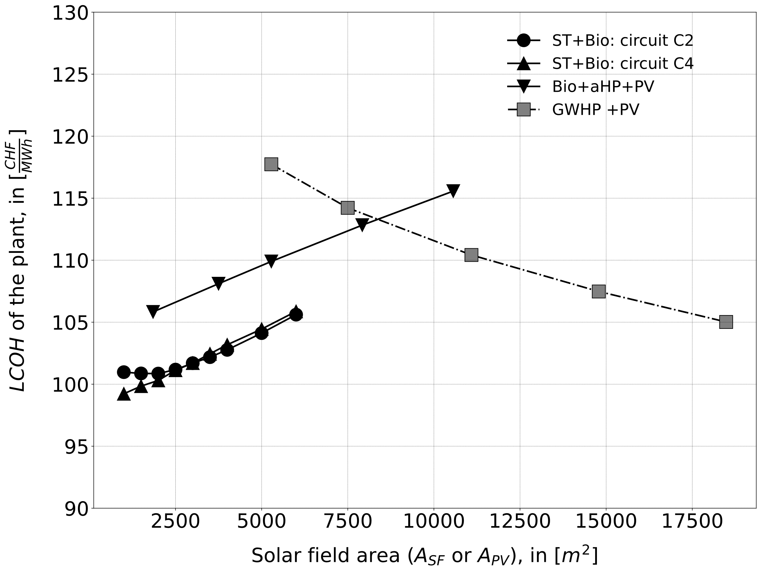
Figure 10 : Comparison of the LCOH of hybrid plants as a function of the SF (left) or the solar surface area (right).
The impact of the different hydraulic configurations on the LCOH_{sol} is shown in Figure 9 (left) for the 4 circuits, while the LCOH_{hyb} is shown in Figure 9 (right). The calculation for the LCOH from the solar and TES subsystems includes the subsides for solar thermal energy in Switzerland (2400 CHF + 1000 * kW_{nom}, where the nominal collector power kW_{nom} is determined based on the Solar Keymark performance test report), which allow solar heat to be competitive when considered alone. Yet, the fact of hybridizing a biomass plant implies that a part of the sold energy won’t be used to amortize the biomass part, increasing the reference costs of heat from biomass. Inevitably, under these assumptions, the cost of production for the hybrid plant is often greater than the production cost of the biomass only plant, as shown in Figure 9 for a reference heat production cost of 100 CHF/MWh_{th}. Only the configuration with a common storage tank, Circuit 4, can generate heat at a lower LCOH than the reference plant, and only at very low values of SF. While increasing the V_{sp,TES} allows SF to rise, it also significantly increases the plant's final LCOH_{hyb}, demonstrating that an oversized storage system negatively impacts the overall economic performance.
To position the solar-biomass hybrid solution on the Swiss domestic market, their values of LCOH_{hyb} were then compared to those of the solutions based on HP units. Figure 10 (left) shows the comparison among the LCOH_{hyb} of the best hydraulic layouts (Circuit 2 and Circuit 4) together with the LCOH computed for the bivalent indirect air HP case and for the monovalent groundwater HP case. Apart from this latter, the LCOH of the hybrid plants (biomass – solar thermal or biomass – PV and HP) depends on the generation cost for biomass only (assumed at 100 CHF/MWh, 40% due to fixed costs and the rest to the fuel). The solar fraction for the HP was computed taking into consideration the heat generated by the HP with PV electricity. As shown in Figure 10(left), a hybrid biomass-HP with PV features an LCOH which has a considerably higher value than those featured by the hybrid solutions deploying solar thermal collectors. This happens mainly because the HP operates a limited number of hours and its amortization constitutes a non negligeable charge. Furthermore, without batteries, the SF that is possible to obtain is quite limited. On the other hand, a single HP can cover the whole demand of the DHN, but at a considerable premium on the LCOH. By adopting a larger TES and extending the PV surface, it is possible in the monovalent HP case, to increase the SF at levels comparable with those reached with solar thermal collectors, with the further improvement on the LCOH given by the feed-in tariff revenue originated by the large PV excess injected into the grid. Yet, this comes at the cost of covering a surface with PV panels which is about 3 times that needed by an equivalent solution based on solar thermal collectors (see Figure 12).
- Conclusions
Hybrid biomass-solar plants are a promising solution to reduce the wood consumption of DHN in view of their future development and expansion. The findings from the OptiCADSol project suggest that widespread adoption of these hybrid systems could preserve critical biomass resources by restricting their use to peak winter demand or industrial processes. Based on Swiss Confederation data—in which DHNs is projected to grow to cover 50% of the total Swiss residential heating demand—the maximum potential reduction in biomass consumption could reach approximately 1 TWh by 2050.
But even if biomass-solar hybrid plants can decrease biomass consumption, the economics of hybridization is complicated by the amortization of several generators over a limited number of hours. Hence, the solutions based on HP don’t seem to be well adapted to the hybridization with biomass, while, when used as the sole heat supplier, they require large areas to install PV modules to surpass the solar fraction achievable with thermal collectors.
- Acknowledgements
The authors gratefully acknowledge the financial support provided by the Swiss Federal Office of Energy (SFOE) for the OptiCADSol project (contract No. SI/502569-01: www.aramis.admin.ch/Grunddaten/?ProjectID=51653)
- References
- Office fédéral de l'énergie (OFEN). (2020) Perspectives énergétiques 2050+. Résumé des principaux résultats. Bern,
- Nussbaumer T, (2018) Guide de planification - Chauffage à distance. Bern.
- CSD ingénieurs SA, (2021) Perspectives chaleur - Perspectives de valorisation du potentiel de chaleur renouvelable du canton de Vaud. Lausanne
- Von Gunten D et al., (2022) SolCAD – Potentiel du solaire thermique dans les chauffages à distance en Suisse. Bern.
- Faninger, G. (2000). Combined solar-biomass district heating in Austria. Solar Energy, 69(6).
- Mohaghegh, M. R., Heidari, M., Tasnim, S., Dutta, A., & Mahmud, S. (2025). Latest advances on hybrid solar–biomass power plants. In Energy Sources, Part A (Vol. 47, Issue 1).
- Ilie, A., & Vişa, I. (2019). Hybrid solar-biomass system for district heating. E3S Web of Conferences, 85. https://doi.org/10.1051/e3sconf/20198504006
- Haller, M., Bales, C., & Streicher, W. (2016). Combined Solar and Pellet Heating Systems for Houses: Improvement of Energy Efficiency and Reduction of Boiler On/Off Cycling.
- Lundgren, J., & Hermansson, R. (2005). Solar Assisted Small-Scale Biomass District Heating System in the Northern Part of Sweden. International Journal of Green Energy, 1(4).
- Fiedler, F., Persson, T., & Bales, C. (2008). Reduction of co-emissions by combining pellet and solar heating systems. Eurosun 2008, 1–7.
- Fiedler, F., Bales, C., & Persson, T. (2007). Optimisation method for solar heating systems in combination with pellet boilers/stove. International Journal of Green Energy, 4(3), 325–337.
- Schneider S et al., (2020). Retour d’expérience énergétique sur le quartier des Vergers à Meyrin - Rapport intermédiaire. UNIGE.
- Good J et al., (2022) Planungshandbuch, Schriftenreihe QM Holzheizwerke Band 4. 3, C.A.R.M.E.N. e.V..
- Jodeiri, A. M., Goldsworthy, M. J., Buffa, S., & Cozzini, M. (2022). Role of sustainable heat sources in transition towards fourth generation district heating – A review. In Renewable and Sustainable Energy Reviews (Vol. 158). https://doi.org/10.1016/j.rser.2022.112156
- Tamm, S., et al. Solar Collector Technologies for District Heating. IEA SHC Task 68 Report RA1. International Energy Agency Solar Heating and Cooling Programme, 2024
- Duret, A et al. (2024). Performance Monitoring of an 800m2 Solar Thermal Plant with Evacuated Flat Plate Collectors coupled to a DHN.EuroSUN2022,https://doi.org/10.18086/eurosun.2022.04.02
- Pauletta, S., Duret, A., Dupont, G., & Jobard, X. (2023). Performance measurements on WISC collectors under artificial environmental conditions. Journal of Physics: Conference Series, 2600(4).
- Louvet, Y., Fischer, S., Furbo, S., Giovanetti, F., Mauthner, F., Mugnier, D., & Philippen, D. (2017). Guideline for levelized cost of heat (LCoH) calculations for solar thermal applications. IEA: Task 54, (1).
- Zotter, P., Nussbaumer, T. (2022). Aktualisierung Emissionsmodell Holzfeuerungen 2020 - Schlussbericht. (OFEV). Verenum AG, Zurich, 21 novembre 2022
- Carlon, E., Verma, V. K., Schwarz, M., Golicza, L., Prada, A., Baratieri, M., Haslinger, W., & Schmidl, C. (2015). Experimental validation of a thermodynamic boiler model under steady state and dynamic conditions. Applied Energy, 138. https://doi.org/10.1016/j.apenergy.2014.10.031
- Bloch L, Sauter Y et Jacqmin F. Observation des prix de marché photovoltaïque 2024. Rapport final, 10 juillet 2025. SuisseÉnergie, 2025
- SuisseEnergie, Coûts d’exploitation des installations photovoltaïques. Consulté le 7 octobre 2025. https://pubdb.bfe.admin.ch/fr/publication/download/8665
- Appendix – Cost function
- The TES system cost was estimated as a linear extrapolation of the trend derived from several offers obtained on the Swiss market for off-ground water-based TES tank volumes from 25 up to 800 m³.
  - ${CAPEX}_{TES}=540.9*V_{TES}+9045 CHF/m^{3}$, where the TES volume (V_{TES}) is in [m³].
- For the solar thermal field, CAPEX was estimated with the following equation, based on private communications with technical partners of the HEIG-VD and for Switzerland.
  - ${CAPEX}_{SF}=2682*{A_{SF}}^{0.826} CHF$, where the solar field area (A_{SF}) is in [m²].
- For the connection between the solar field and the DHN substation, Table 4 was used. The length of the piping was estimated based on the surface of the solar field.
Table 4: CAPEX for DH connection piping, including insulation. Above ground installation.
Inner diameter of conduit, in [mm] | Linear cost, in [CHF/m]
80 | 478
100 | 616
125 | 762
150 | 914
200 | 1091
- For the PV plant, the costs model was derived from [21] while the OPEX (3 ctsCHF / kWh_{e} ) from [22]:
  - ${CAPEX}_{PV}=4862*{P_{PV}}^{0.749} CHF$, where PV is in kWp.
- In the configurations equipped with an indirect air HP, the following laws derived from partner data were used for the liquid-to-water HP unit and the external dry tower:
  - ${CAPEX}_{HP}=1953.1-202.9*\ln\left(P_{HP}\right) CHF/{kW}_{th}$, where P_{HP} is the heating power, in kWth.
  - ${CAPEX}_{aerocooler}=1953.1-202.9*\ln\left(P_{HP}\right) CHF/{kW}_{th}$,.
- In the configurations equipped with a single groundwater HP of 1800 kWth, its CAPEX was derived from partner data or from direct offers:
  - ${CAPEX}_{HP}=250 \frac{CHF}{kWth}$ ,${ CAPEX}_{MT}=300,000 CHF$, ${CAPEX}_{wells}=150 \frac{CHF}{kWth}$

