Simulation of water transport through graphene slit
over a range of temperatures

Taro. Yamada¹ and Ryosuke. Matsuzaki²

¹Deparatment of Mechanical Engineering, Tokyo University of Science, 2641 Yamazaki, Noda, Chiba 278-8510, Japan
Email: 7513131@ed.tus.ac.jp
²Deparatment of Mechanical Engineering, Tokyo University of Science, 2641 Yamazaki, Noda, Chiba 278-8510, Japan
Email: rmatsuza@rs.tus.ac.jp, Web Page: http://www.rs.tus.ac.jp/rmatsuza/index_en.html

Keywords: Graphene, Water transport, Molecular dynamics, Filtration, Energy barrier

Abstract
Recently, extensive research has focused on impregnating resin in laminated graphene to develop high-performance composite materials. However, it is empirically known that basic hydrodynamic laws can not be applied in nanoscale channels. Therefore, it is difficult to predict whether impregnation is possible before forming a graphene composite membrane. In this study, we performed flow simulations of water between graphene slits using molecular dynamics (MD) simulations in order to clarify the influence of the channel width and temperature. When the channel width corresponded to approximately ten water molecules, the permeability obtained from the MD simulations agree well with that of theoretical results. When the channel width corresponded to approximately three water molecules, in the case of gas, the simulation and non-slip theoretical results agreed well. However, in the case of the liquid phase, the MD results were approximately 40% smaller than the theoretical results. When the channel width corresponded to approximately a single water molecule, the water molecules did not permeate the slit. These results suggest that the deviation from hydrodynamic laws increases as the channel width decreases and that an energy barrier occurs with temperature change. Our findings are an important indicator for predicting resin impregnation in nanocarbon composite materials.

1. Introduction
Graphene is an allotrope of carbon and has a stable, one-atom-thick, two-dimensional structure. Because this structure allows free electrons to move freely within the plane, it has superior properties such as mechanical strength, chemical stability, thermal conductivity, electric conductivity, and the like. In recent years, it has become possible to produce monolayer graphene at low cost by improving production techniques like chemical vapor deposition method and ultrasonic separation. Hence, in addition to being used as a single body, it can be widely used as a composite material such as an electrode material, a biomaterial, a structural material, etc.
Focusing on the interaction between fluids, there is a property that the friction of the surface is very low, and studies have focused on the use of graphene as a nano scale film in a mechanical pressure sensor[1] and cell compartment[2]. In the particular case of water, high permeability is known to occur, and its use for atomic level filtration such as desalination or ion separation is being investigated. For example, Geim et al. [3] fabricated graphene membranes and evaluated their permeability to water and other liquids. They found that graphene membranes were largely impermeable to gases like helium, but they were permeable to liquid water, which permeated 10¹⁰ times faster than other liquids. In addition, because graphene has the advantage that it can be chemically functionalized, it can be used as a laminated composite membrane when combined with polymers. In such a composite material membrane, the polymer acts as a filler, and various properties can be imparted to the composite through the proper combination of polymers. Therefore, a graphene composite material film has attracted research attention.
It is empirically known that the influence of the wall surface becomes relatively large during nanoscale flow, and deviation from the basic hydrodynamic laws occurs, including deviation from the continuity equation and non-slip condition[4]. Therefore, even in flow through a graphene filtration membrane, these basic laws cannot be applied, and it is possible that the target permeation performance cannot be obtained.
Recently, extensive research has been performed to impregnate resin in laminated graphene in order to develop high-performance composite materials[5, 6]. Even in this case, due to the unique permeation behavior at the nanoscale, it is possible that macro molding defects occur, such as no resin impregnation and gas residual[7]. Particularly in resin impregnation, resin flows at high temperature upon melting, but verification of nanoscale flow at high temperature is not completely understood.
Thus, we conduct simulations of water flow between graphene slits as a fundamental investigation of resin impregnation behavior in laminated graphene at high temperature. We calculate the permeability obtained from the simulation and compared these values with predictions based on non-slip models. At that time, we change the flow path width and temperature as a parameter and verify how the applicability changes.

2. Methods

2.1. Hydrodynamic model
To make the model as simple as possible, a two-dimensional slit flow with a pressure difference ΔP as the driving force is shown in Figure 1. The permeability is defined as the ratio between the mass flow rate Q passing through the membrane and the pressure difference ΔP before and after permeation, and is used as an indicator of the ability of the fluid to flow. In general, this is calculated using the volumetric flow rate, but the mass flow rate is used to account for density changes between samples due to temperature differences.
$$K_{MD}=\frac{Q}{ΔP}$$ | (1)
From the point of view of fluid dynamics, equation (2) is used to calculate the permeability K_{eq} when flowing between two-dimensional slits of width d under non-slip conditions[8]
$$K_{eq}=\frac{πd^{2}}{32ν}$$ | (2)
where ν is the kinematic viscosity of the fluid and depends on temperature. Therefore, MD simulations are performed to calculate the density ρ and viscosity μ separately from flow calculations.
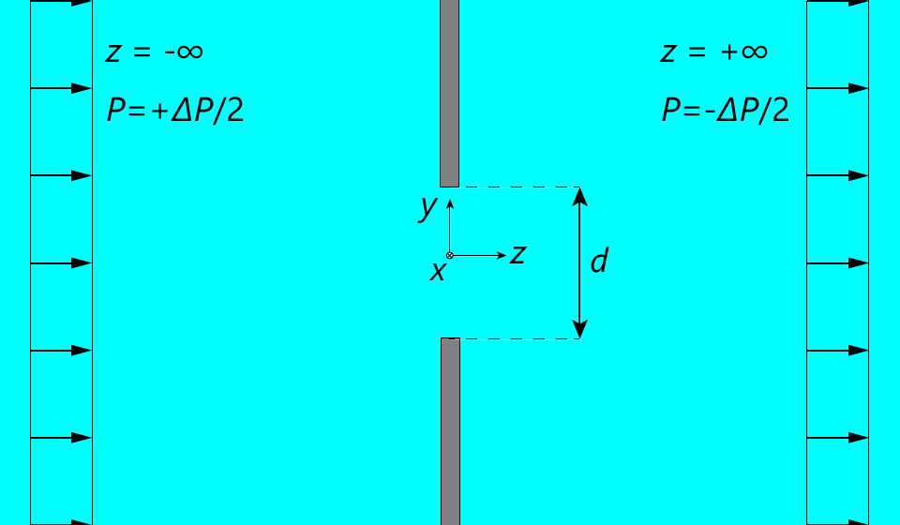
- Two-dimensional hydrodynamic slit model.

2.2. Calculation of physical properties
Because equation (2) is based on a two-dimensional model, the flow rate Q is converted to a flow rate per unit length, l_{x}, in the depth direction (x axis direction in Figure 2).
$$Q=\frac{M}{l_{x}N_{A}}\frac{dN}{dt}$$ | (3)
dN is the number of water molecules permeated in unit time dt, M is the molecular weight of water, and N_{A} is Avogadro’s constant. The pressure in each region before and after permeation is calculated from the virial theorem, and the difference is set as ΔP.
$$P=\frac{Nk_{B}T}{V}+\frac{1}{3V}\sum_{i=1}^{N}{\sum_{\begin{aligned}j=1 \\ j≠i\end{aligned}}^{N'}{〈r_{ij}⋅F_{ij}〉}}$$ | (3)
N is the total number of atoms in the unit cell, k_{B} is Boltzmann’s constant, T is the temperature in the unit cell, and V is the volume of the cell. The viscosity is calculated from the Green Kubo formula[9],
$$μ=\frac{V}{k_{B}T}\int_{0}^{∞}{{〈P_{αβ}\left(t_{0}\right)⊗P_{αβ}\left(t_{0}+t\right)〉}_{t0}dt}$$ | (4)
where <∙∙∙> denotes the ensemble average of the autocorrelation function for the pressure tensor P_{αβ} with
direction components α and β.

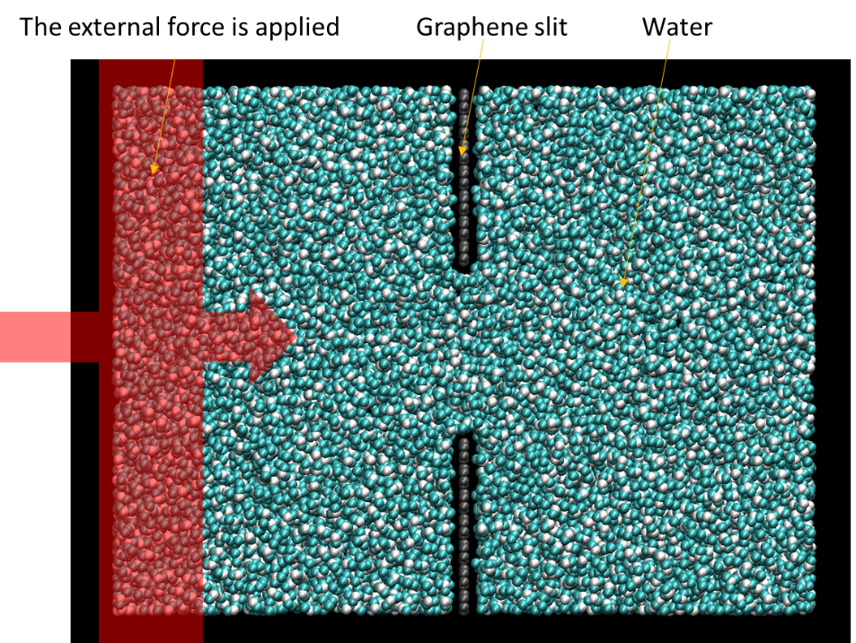
- Computational setup. The red shading denotes the region where the external force is applied.

2.3. MD models
In this study, MD simulations were performed using Large-scale Atomic Molecular Massively Parallel Simulator (LAMMPS). The relevant parameters were taken from the AMBER94 force field[10]. Each parameter is shown in Table 1. Note that the Lennard Jones potential parameters for heterogeneous atoms are calculated using the Lorentz Berthelot combination rules. The charge of the carbon atoms constituting graphene was set to 0 [e]. Actually, carbon atoms become charged by the influence of functional groups and defects, and there is a charge distribution in the membrane, but for simplification, this was not considered. We chose to use the TIP4P/2005 model[11] because the viscosity coefficient has high reproducibility. Regarding the long-range interaction force, a cut-off method is used for the van der Waals force, and the particle-particle particle-mesh (PPPM) algorithm is used for the Coulombic force. The O-H bond length and the H-O-H bond angle of the water molecule are constrained by the SHAKE method so that the time step does not become too short. Periodic boundary conditions were applied in all directions. Other calculation conditions are shown in Table 2.
First, the density and viscosity coefficients at 300, 350, 400, 450, 500, 550, and 600 [K] were calculated. The system has 1718 water molecules and is maintained at constant temperature and pressure (= 1 [atm]) using NPT ensemble. The properties are calculated over a 1 [ns] simulation with a time step of 1.0 [fs].
The simulation model for flow analysis is shown in Figure 2. Two graphenes are located at the center of the unit cell in parallel with slit width d (= 0.4, 0.6, 1.0, and 3.0 [nm]). The selected slit widths correspond to the water molecule diameter of 1.3 to 10, it is reported that the deviation from the hydrodynamic model starts to occur at the maximum width and the water molecule does not permeate through the slit at the minimum width. In the case of liquid, the system has 10⁵ water molecules, and in the case of gas, the system has 10⁴ water molecules. The system dimensions are determined using the density obtained by the NPT ensemble simulation described above so that the dimensional ratio is constant at l_{x}:l_{y}:l_{z} = 1:3:4.
First, the system is relaxed for 0.05 [ns] to eliminate the influence of the initial arrangement of water molecules. Then, the permeability is calculated from the flow simulation results over 0.5 [ns]. Note that, in the case of gas, the simulation time is 2.0 [ns] in order to reduce the deviation. Relaxation and flow simulations are performed in the NVT ensemble with a time step of 1.0 [fs], and the temperature is maintained using a Nosé-Hoover chain thermostat.
The pressure difference before and after slit permeation is required to calculate the permeability. Therefore, a constant force f_{z} is added to each atom located in the 0.5 [nm] region (red shaded region in Figure 2) at one end along the z axis of the cell. Note that, in the case of the gas phase, the force was increased to 10 × f_{z}. By applying equation(3) to the local region before and after passing through the membranes, the difference between them is defined as △P. Actually, the graphene membrane deforms due to the permeation pressure difference, but this study aims to compare with the theoretical model, and this comparison is not appropriate without considering the membrane deformation.

Table 1. Potential energy function parameters used in the simulations. The interaction parameters between different species in the simulated systems are obtained according to the Lorentz–Berthelot rules.
Atomic Parameters
Atom | ε [kcal/mol] | σ [Å] | mass [g/mol] |  | q [e]
C | 0.0859 | 3.3997 | 12.0107 |  | 0.0
H | 0.0000 | 0.0000 | 1.008 |  | +0.5564
O | 0.1852 | 3.1589 | 15.9994 |  | -1.1128
Bond Parameters
Bond | K_{r} [kcal/(mol∙Å²)] |  |  | r_{eq} [Å]
C-C | 469.0 |  |  | 1.4200
O-H | 553.0 |  |  | 0.9572
Angle Parameter
Angle | K_{θ} [kcal/(mol∙radian²)] |  |  | θ_{eq} [deg]
HOH | 100.0 |  |  | 104.52

Table 2. Calculation parameters
NVT damping constant [fs] | 100.0
Timestep [fs] | 1.0
Relaxation time [ns] | 0.05
Flow simulation time [ns] | 0.5 (liquid)  2.0 (vapor)
Van der Waals cutoff [Å] | 12.0
Coulombic cutoff [Å] | 8.5

3. Results and discussion
First, the calculated physical properties at each temperature are shown in Table 3. The values suddenly change as temperature changes from 500 to 550 [K], and the boiling point is considered to exist between 500 to 550 [K] in TIP4P/2005 model. This value is about 150 [K] higher than the general boiling point of water because the TIP4P/2005 model is only used to reproduce the viscosity at room temperature. Therefore, we discuss qualitatively without comparing with reality in the following text. Furthermore, because gas-liquid equilibrium is possible at 550 [K], the flow simulation in the gas phase is only performed at 600 [K], where the fluid is completely shifted to the gas phase.
We calculated the permeability from the flow simulation results. For all slit widths in the liquid phase, the value of K_{MD} increased with increasing temperature. The K_{eq} results show the same tendency. On the other hand, in the gas region, K_{MD} and K_{eq} decrease as temperatures increase above T = 500 [K]. This result is appropriate because the mass permeability is inversely proportional to the kinetic viscosity. At d = 3 [nm] (≈ 10 water molecules), the relative errors between K_{MD} and K_{eq} are about 10%, and they agree well. At d = 1 [nm] (≈ 3.3 water molecules), K_{MD} is approximately 40% smaller than K_{eq} in the liquid phase. This suggests that a decreased channel width leads to increased deviation from the fluid dynamics solution in the liquid phase, and different permeation mechanisms exist for the liquid and gas phases. At d = 0.6 [nm] (≈ 2 water molecules), even in the case of liquid, the water molecules do not permeate for temperatures ranging from 300 to 400 [K], but they do permeate in the T = 450 to 500 [K] range. This suggests that it is impossible to determine whether water molecules can permeate based solely on the molecular diameter and slit width. At d = 0.4 [nm] (≈ 1.3 water molecules), water molecules did not permeate at all temperatures.
The density profile between slits was calculated in order to understand the difference between gas and liquid phases. In the liquid phase at d = 3 [nm], there are peaks at ~0.32 [nm] from the end of the slits, and the density approaches the bulk density near the center of the slit. This distance is equivalent to the intermolecular distance between the carbon atoms in graphene and the oxygen atoms in water molecules, as shown in Table 1. Therefore, the density increases because this distance is stable in terms of energy. At d = 1 [nm], there are peaks at ~0.32 [nm] from the end of the slits, just as in the case of d = 3 [nm]. Moreover, there is a small peak at the center of the slit, and a region of low density occurred between them. That is, the permeation position of water molecules is restricted to the end of the slits and center as the slit width decreases. On the other hand, at d = 1 [nm] in the case of gas phase, this tendency was not observed near the center of the slit. This is because the density is low in the gas phase, and the distance between water molecules exists so that the interaction can be ignored.

Table 3. Physical properties of water from MD results, calculated at 300 – 600 K.
Temperature T [K] | Density $ρ$ [g/cm³] | Viscosity $μ$ [mPa/s] | Kinetic viscosity $ν$ [mm²/s]
300 | 0.990 | 0.838 | 0.846
350 | 0.970 | 0.371 | 0.382
400 | 0.933 | 0.233 | 0.250
450 | 0.884 | 0.151 | 0.171
500 | 0.821 | 0.107 | 0.130
550 | 0.501×10⁻³ | 1.548×10⁻⁴ | 0.309
600 | 0.460×10⁻³ | 1.537×10⁻⁴ | 0.334

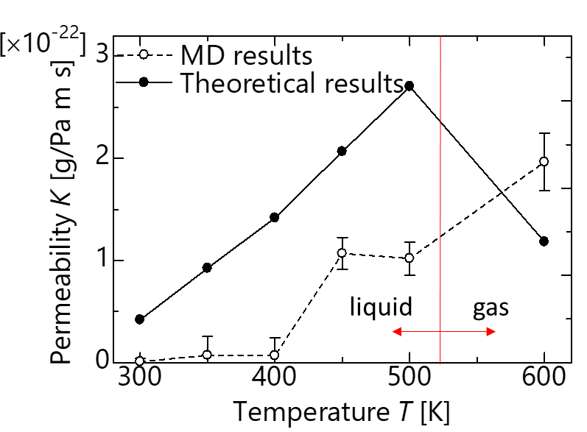
- Permeability as a function of the temperature when the channel width approximately corresponds to the size of a single water molecule.

4. Conclusions
To clarify the influence of temperature and channel width, we performed flow simulations of water through graphene slits using MD simulations. Regarding the influence of channel width, we find that the deviation from the fluid dynamics solution increases as the channel width decreases. Regarding the influence of temperature, we find that different permeation mechanisms govern liquid and gas transport through the graphene slit. In addition, energy barriers emerged when the channel width was narrow, and water permeation changes with temperature. The results of this research are necessary for predicting resin impregnation in nanocarbon composite materials and are expected to aid future modeling studies.

References
[1] F. Guo, G. Silverberg, S. Bowers, S. P. Kim, D. Datta, V. Shenoy, et al., Graphene-based environmental barriers, Environ Sci Technol, 46:7717-24, 2012.
[2] G. Duan, Y. Zhang, B. Luan, J. K. Weber, R. W. Zhou, Z. Yang, et al., Graphene-Induced Pore Formation on Cell Membranes, Scientific Reports, 7:42767, 2017.
[3] R. R. Nair, H. A. Wu, P. N. Jayaram, I. V. Grigorieva and A. K. Geim, Unimpeded permeation of water through helium-leak-tight graphene-based membranes, Science, 335:442-4, 2012.
[4] T. Tajiri, R. Matsuzaki and Y. Shimamura, Simulation of water impregnation through vertically aligned CNT forests using a molecular dynamics method, Scientific Reports, 6:1-7, 2016.
[5] L. Cai, A. Al-Ostaz, X. Li, L. T. Drzal, B. P. Rook, A. H. D. Cheng, et al., Processing and Mechanical Properties Investigation of Epoxy-Impregnated Graphene Paper, Journal of Nanomechanics and Micromechanics, 6:04016005, 2016.
[6] H. Huang, Z. Song, N. Wei, L. Shi, Y. Mao, Y. Ying, et al., Ultrafast viscous water flow through nanostrand-channelled graphene oxide membranes, Nat Commun, 4:2979, 2013.
[7] P. Feraboli, T. Cleveland, M. Ciccu, P. Stickler and L. DeOto, Defect and damage analysis of advanced discontinuous carbon/epoxy composite materials, Composites Part a-Applied Science and Manufacturing, 41:888-901, 2010.
[8] H. Hasimoto, On the Flow of a Viscous Fluid Past a Thin Screen at Small Reynolds Numbers, Journal of the Physical Society of Japan, 13:632-639, 1958.
[9] L. Bocquet and J. L. Barrat, Hydrodynamic boundary conditions, correlation functions, and Kubo relations for confined fluids, Phys Rev E Stat Phys Plasmas Fluids Relat Interdiscip Topics, 49:3079-3092, 1994.
[10] W. D. Cornell, P. Cieplak, C. I. Bayly, I. R. Gould, K. M. Merz, D. M. Ferguson, et al., A second generation force field for the simulation of proteins, nucleic acids, and organic molecules, Journal of the American Chemical Society, 117:5179-5197, 1995.
[11] J. L. Abascal and C. Vega, A general purpose model for the condensed phases of water: TIP4P/2005, Journal of Chemical Physics, 123:234505, 2005.

