Influence of formulation parameters on the properties of thermoplastic fabric reinforced composites

K. Moser¹, C. Burgstaller¹, T. Höftberger¹ and W. Stadlbauer²

¹Transfercenter für Kunststofftechnik GmbH, Wels, Austria
Email: karl.moser@tckt.at, Web Page: http://www.tckt.at
²Fachhochschule Oberösterreich F&E GmbH, Wels, Austria
Email: wolfgang.stadlbauer@fh-wels.at, Web Page: http://www.fh-ooe.at

Keywords: organic sheet, thermoplastic composite, Polyamid 6, e-Caprolactam, infusion

Abstract
Composite materials find widespread use nowadays, often in applications where the superior balance of mechanical properties and low density is an advantage over other materials. Younger aspects like recycling, short cycletimes, thermoforming or overmolding make it necessary to change from thermoset to thermoplastic matrices. Therefore the aim of this was to investigate different thermoplastic polymers as a matrix for glass fibre reinforced composites and their resulting properties. We investigated two different matrices (PA6 and PET) with different glass fabrics which where processed by film stacking in a hot press. The second part of the research compared the PA6 film stacking material with a vacuum bag infusion process of a dry stack which was infused with ε-Caprolactam, which was then polymerised to PA6 to yield composite plates. We found, that the difference in mechanical properties between the two applied thermoplastic polymers is rather low, due tho similar fibre volume fractions and porosity values. For the PA6 composite, infusion and polymerization seems to be a valid approach to yield such materials, giving comparable or even exceeding properties, mainly due to better impregnation of the fibres due to the lower viscosity of the monomer.

1. Introduction

Fibre reinforced composites are nowadays state of the art in many different applications, used in aerospace, wind energy and automotive industries. Such composites typically consist of carbon or glass fibres as well as thermosetting matrix. An emerging trend is to use thermoplastic polymer as matrix, as these exibit some advantages, like low cycle time, thermoformability, improved joining possibilities and ductility.

The fiber bonding not only has an optical influence on the finished products, but due to varying degrees of fiber deflection also has an influence on the mechanics oft he components. Especially when it comes to components with additional structural functionality. For this reason, the aim of the first investigations was to investigate the influence of different glass fabrics or UD non-crimp fabric with different thermoplastic matrix.

As the complexity of thermoplastic composite products extends from simple plate-shaped semi-finished products for thermoforming to more complex, multi-curved finished products, the aim of the second part of the work was to elucidate two different manufacturing processes of thermoplastic composites and to validate the influence of the process on tensile properties.

2. Materials & Methods

2.1. Materials

For the comparing investigations on the two different matrices we used PA6 (Durethan B30S, which was supplied from Lanxess) and PET (Polyclear Refresh PET 1101, which was supplied from Invista) as a matrix. The caprolactame-infusion was carried out with caprolactame from Brüggemann. As catalyser we used C10 and as activator C20P (Act. 1) and C25 (Act. 2) from the same supplier.

The glass fabrics we used for our tests had different binding. Table 1 below lists the different types, their grammage and applied fibre finish.

Table 1. types of fabric.

Type of fabric | grammage  (g/m²) | sizing
Plain | 280 | Silane based
Twill 2/2 | 280 | Silane based
Satin | 296 | Silane based
UD | 220 | Silane based

2.2. Composite production

The samples in our experiments were produced on the one hand via a layer process in a hot press and on the other hand in an infusion process. For the layer process, films with a layer thickness of 0.15 mm were produced from the polymers PA6 and PET using a flat film extruder. The respective glass fabric was cut to the appropriate size, so that plates with 250x350 mm² could be produced. As shown in Fig. 1, the individual layers were inserted in layers alternately in a dipping edge tool. The melting and compacting was carried out in a heating/cooling press at the respective processing temperature of the thermoplastic used. From the plates thus produced, specimens were prepared with a milling cutter.

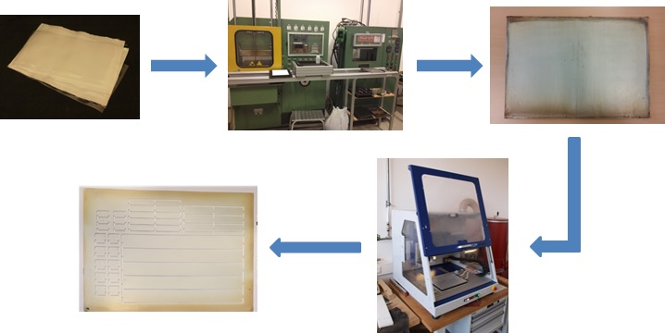

Figure 1. Specimen production by film stacking process

For the infusion of the glass fabric with ε-caprolactame, the required amount was divided into two tincans (Fig. 2). One was mixed after melting in the oven at about 105°C with catalyst, the second with activator. After both masses reached a temperature of 110°C, they were brought together in one tinplate can, homogenized and infused. The polymerization took place at 150°C in the oven.

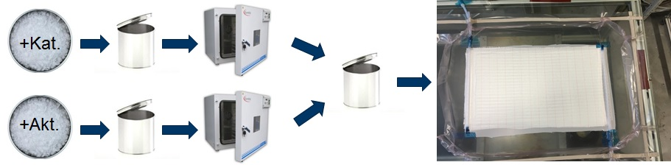

Figure 2. Specimen production by infusion process

From the plates produced, specimens for tensile tests (25x250 mm²) were also prepared using a milling cutter.

2.3. Mechanical Testing and Fibre Volume Fraction

The mechanical characterization of the samples was carried out on a universal testing machine Zwick/Roell type Z150 according to ISO 527-4. The determination of the elastic modulus was carried out at a test speed of 1 mm/min, the measurement of tensile strength at 2 mm/min.

To determine the fiber volume fraction, the density of the individual samples was determined according to ISO 1183 beforehand by means of a Sartorius YDK01 density kit on a Sartorius M-pact AX224 scale. Subsequently, the polymer of the individual samples was burned off with a macro TGA from LECO (TGA 701) at 625°C, so as to obtain the mass fraction of the glass fibres.

3. Results and Discussion

3.1. Comparison of matrix materials

As can be seen from the graphs below in Fig. 3, the UD non-crimp fabric with both PA6 and PET as matrix has the highest values of tensile properties. The elastic modulus is 25.5 MPa with PA6 and 27.3 MPa with PET.

The elastic moduli in the fabric types plain, twill 2/2 and satin are in a very narrow range both with PA6 and also with PET as a matrix, so that no significant influence of the certain type of fabric on the stiffness can be identified here. The lowest value of 14.7 GPa is achieved by the 2/2 twill weave with PA6 matrix. However, the scattering of the measurement results with 4.8 GPa is well over 30%, which indicates a poor sample quality. The highest value (18.0 GPa) in fabric reinforcement was achieved with PET as a matrix and a 2/2 twill weave as reinforcement. All other samples are between these two limits and thus well below the values of the UD non-crimp fabric. This is not surprising, since significant fewer fibers are aligned in the tensile direction within the crimped fabrics.

Figure 3. Tensile properties of PA6 composites (left) and PET composites (right) with different reinforcement fabrics

In terms of tensile strength, the UD non-crimp fabric with PA6 as a matrix stands out with a value of 476 MPa. This is well above the organosheet with PET as a matrix, which yields a strength of 339 MPa and thus is almost 29% lower. This difference may arise from better fabric impregnation or better compatibility and will be part of future investigations.

The 2/2 twill weave and the satin weave are independent of the matrix at a level around 315 MPa. Only the plain weave seems to drop more sharply at 250 MPa (PA6) or 271 MPa (PET). All these results can be explained by the number of ondulations in the different weaves, i.e. the more the fibres are crimped, the lower the strength gets.

3.2. Comparison of processing route

In order to be able to make an ideal comparison of the tensile properties of the two production processes (film stacking vs. infusion), a series of experiments with pure caprolactam plates without fiber reinforcement was carried out to show what proportion of catalyst and activator is most applicable for the polymerization to PA6. As can be seen in Fig. 4, the catalyst levels of 2%, 3% and 4% was varied. Activator C20P (Act. 1) and C25 (Act. 2) were mixed in a 2:1 ratio to the catalyst. It turned out that when using the Act. 1 with a content of 1.5%, we have a drop in tensile modulus by about 23% to 2346 MPa and a drop in tensile strength by about 17% to 64,5 MPa than with contents of activator of 1% and 2%. This could be due to some moisture in the mixture or other influences on the polymerisation.

At Act. 2 it can be observed that the dosages of 1% and 1.5% promise the higher values. A content of 2% in the Act. 2 leads to a drop of approx. 27% to 1571 MPa in the elastic modulus and to a reduction of approx. 22% in the tensile strength to 45.2 MPa.

In general, however, the trend can be seen that through the use of Act. 1 higher stiffnesses and strengths are achieved than under the use of Act. 2.

Figure 4. Tensile properties of PA6 specimen with different catalyst content

For the subsequent experiments with glass fiber reinforced composites, a catalyst content of 3% was chosen. From the following Fig. 5, the elastic modulus and the tensile strength of the different PA6 composites panels are shown on the left, and the strain at tensile strength and as well as the fiber volume fraction achieved can be seen on the right.

In the case oft he fiber volume fraction, it can be seen that the infusion method tends to achieve higher values, since voids are reducedd by applying a vacuum during the infusion, and better fiber permeation can be achieved due to the lower viscosity. Nevertheless, in both methods, a high fiber volume fraction can be achieved.

As could be expected, the trend continues here, that with Act. 1 higher stiffness and strength can be achieved. Although the tensile strength of the sample with Act. 1 shows higher scattering than with Act. 2, the value of 306.9 MPa is significantly higher than that of the sample with Act. 2 (238.1 MPa) and the sample, which was prepared in the film stacking process, which exhibits a tensile strength of 249.9 MPa.

This difference is much smaller for the elastic modulus. Here the infusion plate with Act. 1 achieved with 18.3 GPa the highest value, followed by the pressed plate with 18.0 GPa and the plate with Act. 2 with 17.1 GPa.

Figure 5. Tensile properties of different thermoplastic composites with PA6 matrix produced by film stacking or infusion process

4. Conclusions

Glass fibers are used as reinforcing fibers in many different applications because their potential for lightweight construction is undisputed. The recent application as reinforcing fibers in thermoplastic composites, the interaction with the matrix is a crucial factor that can affect the mechanical properties accordingly. However, our investigations showed that the differences between the selected matrix materials are not significant and can therefore be used according to requirements such as durability, further processing, availability or simply the price. Furthermore, it could be shown that the fabric with which the thermoplastic composites should be reinforced should rather be selected with regard to their ability to be draped, since the tensile mechanics are only influenced marginally by the weavage of the fabric in our investigations. Depending on which subsequent processing is desired, e.g. thermoforming of more complex surfaces from semi-finished products, the ability to drape the individual fabrics may have a significant impact on the mechanical properties but above all on the appearance of the finished product.

It can be clearly seen from the comparison of the two production methods that neither of the two methods has a significant advantage with regard to the tensile properties of the finished composite. Here it can therefore also be said that the pressing method has its advantages in the production of simple 2D or 2.5D geometries, since these are easy to handle and the effort in the production is lower. For more complex geometries, on the other hand, higher infusion machine effort may be worthwhile, which is why we see the strengths of the infusion system in thermoplastic composites here.

Acknowledgments

The authors are grateful to the Contry Upper Austria and the European Union for the EFRE initiative for financial support of the project “ProFVK – Industrielle Produktionsprozesse für die Verarbeitung von FaserVerbundKunststoffen und zur Herstellung von Leichtbaustrukturen”.

