EuroSun2026
Feasibility of Solar Photovoltaics and Small Wind Energy
for Arctic Community Freezers

Mr. Edward Vuong, M.A.Sc. (corresponding author), Dr. Carsen Banister, Ph.D., P.Eng. (presenting author)
Construction Research Centre, National Research Council Canada
edward.vuong@nrc.ca, carsen.banister@nrc.ca
Summary
Processing, preservation, storage, and sharing of harvested country food by Indigenous people across the Canadian Arctic has been an essential part of life and survival for millennia. In a modern context, this results in a need for community freezers to support animal harvesting activities. Since these remote communities have isolated electrical systems and rely almost exclusively on diesel generators for electricity, operational costs are extremely high. With a strong interest in renewable energy integration in the Arctic to reduce costs and emissions, solar photovoltaics present a unique opportunity given the alignment of their power output with the energy demands of a refrigeration system in an Arctic climate. The energy performance of integrating solar photovoltaics with an Arctic community freezer were modelled and explored in detail by this study for the location of Cambridge Bay, Nunavut. The modelling results demonstrate great potential for solar energy in meeting the energy needs of community freezers in the Arctic and in result, the potential to significantly reduce operating costs and greenhouse gas emissions. Integration of a small wind turbine was also explored and data are compared to the electricity usage of an operating freezer based in Baker Lake, Nunavut.
Keywords: refrigeration, solar PV, traditional food, Canadian Arctic, energy modelling, small wind turbine
Field of application for the findings: technology & engineering, societal & policy impact,
Addressed audience: energy engineering experts, policymakers and policy advocates
- Introduction
Indigenous people have inhabited the Canadian Arctic for over 5,000 years and for much of this time solely relied on food and other resources that they harvested from the land, water, and air in their territory. Inhabitation of the Canadian coastal Arctic is by the broad group known as Inuit, or ‘people’ in Inuktut, their overarching language. The regions of their homeland, Inuit Nunangat, and individual communities are shown in Figure 1. Historically, Inuit were largely nomadic, moving with the seasons and resources they needed to survive. The Canadian Government coerced and pressured Inuit into permanent year-round settlements starting in the 1930s and by the mid-1960s, most Inuit ceased to be nomadic.
None of the communities in Inuit Nunangat are connected by road, other than Inuvik and Tuktoyaktuk. Inuvik was planned and built by the federal government in the 1950s and only connected by road to the continental road system in 1979 with the completion of the Dempster Highway. Tuktoyaktuk became accessible by road in 2017 with the completion of the Inuvik to Tuktoyaktuk Highway, making it the first road connection to the Canadian Arctic. The balance of the 50 Inuit communities in Canada are accessible only by air and short seasonal sea access. This is relevant because it makes these remote communities almost entirely dependent on liquid hydrocarbon fuels shipped in annually and fresh food that is flown in on a regular basis.
The traditional subsistence way of life continues in large part for cultural, resiliency, and financial reasons. Community members work together to harvest food for themselves, family, and share with others in need who are unable or not as able to participate directly in the harvesting. Common species of country food harvested include: caribou, moose, beluga whales, seals, Arctic char, lake trout, whitefish, and geese. Thus, there is a demand for reliable, cost-effective community freezers in Arctic communities to enable safe storage of country food. As a result of the reliance on diesel generators, electricity costs are very high in these regions. Examples of current electricity rates are shown in Table 1.
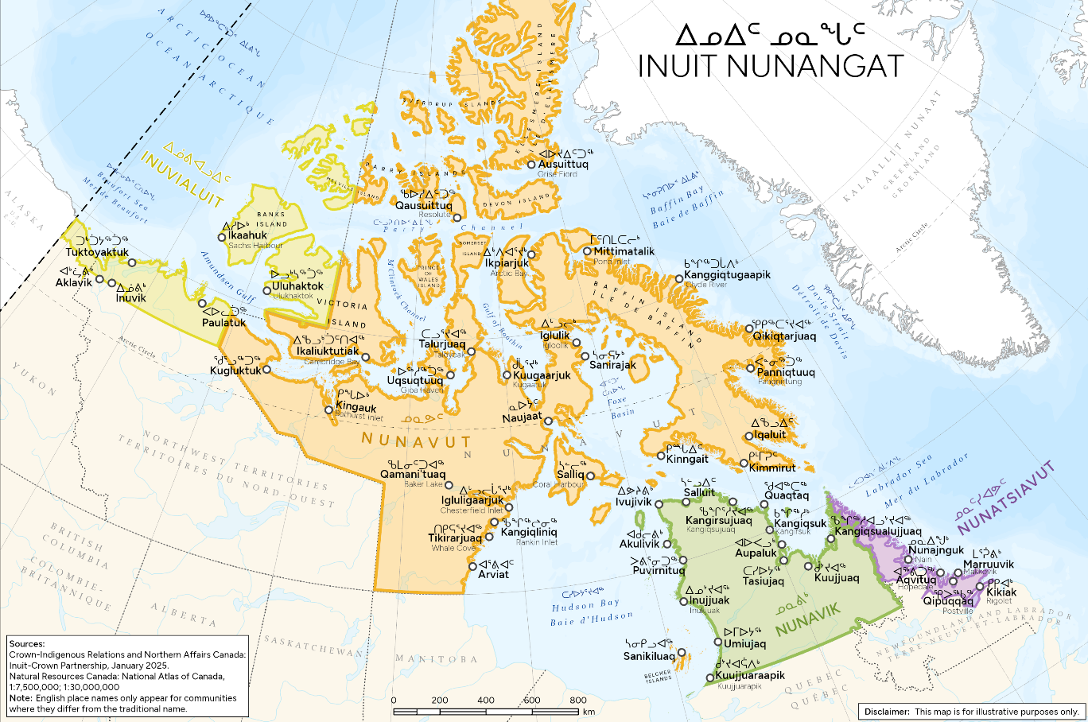
Figure 1. Regions and communities of Inuit Nunangat in Canada (Indigenous Services Canada, 2026)
Table 1: Electricity costs in select Inuit Nunangat regions (Qulliq Energy Corporation, 2026)
(Northwest Territories Power Corporation, 2026)
Jurisdiction | Customer Type | Cost
Nunavut | Non-Government Residential | 74.94 cents/kWh, subsidized to 37.47 cents/kWh
Nunavut | Government Commercial Customers | 105.33 cents/kWh
Northwest Territories Thermal Zone Communities | Residential | 88.96 cents/kWh, subsidized to 35.23 cents/kWh
Northwest Territories Thermal Zone Communities | General Service Government | 99.05 – 396.5 cents/kWh, depending on community
As a result of these combined interests expressed by different representatives and individuals across the Canadian north, there is a strong interest in deploying renewable energy technology to offset electricity costs for refrigeration operations in the Arctic.
This study explores the performance system consisting of a refrigerated container, photovoltaic (PV) array, small wind turbine, and electric battery using simulations. OpenStudio, a building energy simulation tool, was used to parametrically model the combined system in various configurations to evaluate its efficacy in maximizing renewable energy fraction for a refrigerated storage space year-round in the Canadian Arctic. The work also explores the feasibility of an off-grid configuration, but due to the fact that solar and wind energy are not dispatchable, any system requires a dispatchable energy source, whether it is community-scale diesel generators through the local isolated grid or a diesel generator on-site.
- Literature Review
As far as the authors are aware, there are no publications reporting on operation and performance of solar-powered refrigeration at high latitudes for food preservation applications. One similar Arctic application of solar energy for refrigeration loads is for permafrost preservation through active cooling (Sun, Liu, You, Ren, & Chang, 2024). Research on off-grid energy systems in the Arctic is typically focused on reducing diesel consumption by integrating renewable generation, battery, and thermal energy storage to meet non-cooling electrical and heating loads, with a limited consideration for refrigeration and cooling applications.
Duran et al. (2025) found the literature strongly supports the integration of multiple sources of renewable energy generation (solar, wind, geothermal) and energy storage systems, in order for Arctic communities to achieve energy autonomy without connection to a larger electric grid or reliance on diesel as backup fuel. Studies on electricity generation in remote Arctic communities often find wind to be a complementary energy source to solar, especially in off-grid or zero-emission scenarios. A holistic evaluation on environmental challenges (weather, climate, terrain) for Longyearbyen, a remote arctic community on Svalbard (Norwegian archipelago), found wind supplements seasons when PV generation is unavailable or when snowfall accumulates on PV panels (Dimd, Stokkan, & Juel, 2026). In a study evaluating the cost for decarbonizing remote communities, it was determined that wind turbines in the year 2020 are the most affordable solution, whereas solar becomes the lowest cost solution in 2050; this led to the author to suggest that both technologies should be used concurrently in the present (Stringer & Joanis, 2023). While examining an integrated solar, wind, battery, and hydrogen storage microgrid for Sanirajak, Nunavut, Janke et al. (2026) highlighted the importance of dispatch strategy in their model and in comparative studies. The results from these studies would suggest feasible and cost-effective off-grid energy systems necessitate multiple energy sources and storage, and a control strategy that can cohesively leverage their integrated performance.
Research on using solar energy for cooling has largely been undertaken outside of Arctic applications. Key solar cooling technologies include solar PV vapour compression cooling, solar PV thermo-electric cooling, and solar thermal cooling (sorption processes) (Sarbu & Sebarchievici, 2013).
Thermo-electric (TE) cooling leverages the Peltier effect, where an electric current flowing through a thermocouple circuit, resulting in one junction to generate heat (hot side) and the other junction to absorb heat (cold side). Due to their relatively low efficiency, TEs are best suited to small applications in medical or scientific equipment where high precision temperature control is required. They are not well-suited to the scale of refrigeration required for community freezers.
In solar-absorption cooling systems, the refrigerant is absorbed into an absorbent (e.g., lithium-bromide and ammonia solutions) and then pressurized through a generator using solar thermal energy, which replaces the need for a compressor normally required in a vapour-compression refrigeration cycle. However, absorption refrigeration systems have efficiencies significantly lower than electric vapour-compression systems and, since they use heat as the energy source, are not well-suited to Arctic applications unless there is a suitable source of waste or excess thermal energy.
TE and solar-absorption are often used as a supplemental strategy for cooling and refrigeration (Liang, Liang, Ye, & Yu, 2026) and not as the primary refrigeration technology. They are limited by low COP or cooling performance. A commercial TE cooler with a temperature difference of 20℃ across its junction was found to generally have a COP of 0.5 (Kaiprath & V., 2023). Although absorption chillers can be designed to a maintain a space at -18℃ setpoint, under a constant solar irradiance (450 W/m²) and 15℃ ambient conditions, while operating with a 0.52 system COP (the input energy includes solar thermal energy), it also requires a 90℃ generator heat source temperature (Liang, Liang, Ye, & Yu, 2026). Although the motivation for these technologies is to maximize energy utilization, which is an objective for energy systems in the Arctic, their performances and operational requirements are better suited for application in locations with excess solar or waste heat.
Given that solar PV cooling is widely used and has the highest performance, it is the most commercially established system type. As a result, this technology is currently the dominant system in the literature (Herez, et al., 2026) and is often integrated alongside electric batteries and thermal storage (e.g., cold thermal storage) in industrial agriculture applications (Rinchi, Dababseh, & Ayadi, 2026). For this type of system, control and thermal storage strategies have been investigated to improve off-grid resiliency. Not only does vapour-compression have significantly higher efficiency than the alternatives, but maintenance of PV and vapour-compression refrigeration systems is most straightforward because of their commercial maturities. Due to the intermittency of solar and wind resources, most applications will require solar, wind and energy storage working in tandem to provide consistent and reliable off-grid conditions. This work explores the feasibility of doing so for an off-grid Arctic community freezer application.
- Methods
3.1 System Configuration
Community freezers powered by renewable energy can help improve food security in remote Arctic communities by providing refrigerated storage for locally harvested food in areas with high groceries and energy costs. There are significant opportunities to reduce greenhouse gas emissions due to the current near 100% reliance on hydrocarbon fuels for energy in these locations. This study investigates the application of renewable energy systems and a battery array to power a refrigerated container to provide food-safe refrigerated storage year-round. A refrigerated container was considered in this initial modelling work, as it is a uniform, common solution for such applications and can be readily shipped to remote Arctic communities since the majority of goods are delivered by sea. While many communities have a purpose-built community freezer and this may be preferred for spatial organization, there are some examples of refrigerated containers being used for community freezer purposes, such as the one delivered to Iqaluit in 2016 (Canadian Broadcasting Corporation, 2016), freezers used by Inuvialuit Regional Corporation in Inuvik, and those deployed to remote communities such as Paulatuk.
The authors are not specifically recommending refrigerated containers as a community freezer solution; the selection was made for representative modelling purposes. Future work is planned to explore the performance of representative purpose-built community freezer designs.
3.2 Detailed System Operation Modelling
In this study, the overall system is simulated using OpenStudio, an open-source framework for building performance simulation. The model simulates the performance for each parametric run over a year, with Cambridge Bay, Nunavut selected as the representative location for initial modelling. Cambridge Bay is a high Arctic community located on Victoria Island at a latitude of 69°N.
A hill-climbing approach was used to study a series of parametric runs. The hill-climbing process is an iterative method that:
1. Establishes a set of parameters for the run;
2. Attempts to improve upon the performance by modifying a parameter of the system; and
3. Simulates the specified parameters and analyzes the impact on performance.
Only a portion of the parametric runs are presented in this paper due to limited space. The reader can reference the full results from this work by referring to the full report from this collaborative work between National Research Council Canada and Polar Knowledge Canada (Vuong, Banister, & Horeczky, 2025) accessible via the NRC Publications Archive (Government of Canada, 2026).
The results are highly sensitive to the assumptions of the simulation models employed. Due to limited performance data on refrigerated containers available in the literature, assumptions were made regarding its performance parameters (e.g., compressor performance, insulation level) to provide a conservative estimate (i.e., less efficient) of its performance. The sandia PV model used is empirically-based, while the wind turbine model is a combination of kinetic energy equations (physics based) and empirical power correlations. For both power generating systems, empirical correlations were obtained from the modelling software component database.
3.3 Modelling Inputs
A 40 ft container (11.56 m x 2.29 m x 2.61 m) is shown schematically in Figure 3. The modelled container is assumed to be constructed of polyisocyanurate insulation enveloped by two layers of steel.
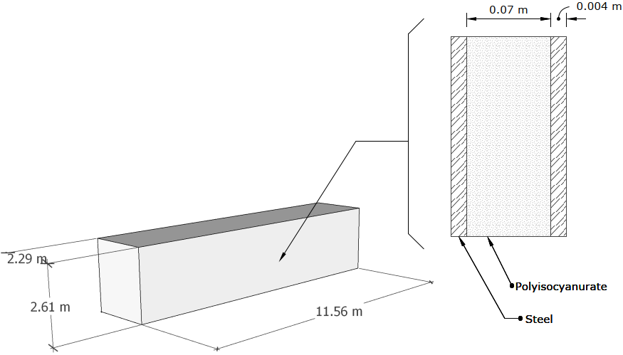
Figure 3: Schematic of the refrigerated container modelled
Thermal Conductivity
Nominal polyisocyanurate thermal conductivity ranges include:
• 0.018 – 0.024 W/(m∙K) according to Berardi (2019);
• 0.022 – 0.025 W/(m∙K) according to ASHRAE Handbook – Fundamentals 2021 Chp 26 Table 1 (ASHRAE, 2021).
The performance of this insulation type contributes significant uncertainty for the energy simulation results since polyisocyanurate experiences significant increase in thermal conductivity with decreasing temperatures due to condensation of the blowing agent remaining in the pore structure. This type of insulation also experiences long-term degradation of thermal performance due to off-gassing of the blowing agent.
Berardi (2019) presented simulated results showing that under several days of continuous circa 17°C conditions in Toronto, the thermal conductivity of a panel of polyisocyanurate increased to 0.04 W/(m∙K) from an initial value of 0.024 W/(m∙K). This temperature-adjusted value was used in the model, which assumes the insulation performance has degraded to 0.04 W/(m∙K). Based on the schematic in Figure 3, the properties of the container’s surfaces (wall, roof, floor) are presented in Table 2.
Table 2: Refrigerated container construction properties
Surface | Thickness [m] | Overall thermal conductance [W/(m²·K)] | RSI [m²·K/W] | R – value [ft²·°F·h/BTU] | Surface area [m²]
Walls | 0.078 | 0.57 | 1.75 | R-10 | 72.3
Roof |  |  |  |  | 26.5
Floor |  |  |  |  | 26.5
Air Infiltration
Air infiltration can introduce additional refrigeration load. The model assumes a nominal flowrate per exterior wall area of 0.185 air change per hour (ACH). It is adjusted based on the wind speed as shown in Equation 1,
$$Infiltration=\left(nominal infiltration rate\right)∙(0.224 ∙wind speed)$$ | Eq. 1
0.224 is an empirical coefficient in units of s/m; it is the default value used in OpenStudio. In this study, air exchanges as a result of opening the container door are not modelled (i.e., the container is assumed to be closed for the entire simulation).
Refrigeration System
Assumptions on the performance (capacity, efficiency, temperature ratings) of the refrigeration unit were made for this study, given the lack of information on the existing container in Cambridge Bay. These performance parameters were selected through a trial-and-error process to ensure that the heat transfer capacity of the refrigeration unit was sufficient to meet the refrigeration load. These values correspond to the inputs of the OpenStudio object: Refrigeration Air Chiller, andare summarized in Table 2.
Table 3. Refrigeration system parameters and values
Parameter | Value
Rated unit load factor | 600 W/K
Rated refrigerant saturation temperature | -33 °C
Rated DT1 (temperature difference between the air inlet and the saturated refrigerant temperature) | 13 °C
Max DT1 | 25 °C
Rated Heating Power (drip pan and other heaters) | 250 W
Rated Fan Power | 375 W
Rated Fan Air Flow Rate | 0.8 m³/s
Defrost Type | None
Solar Photovoltaics
PV panels are arranged along the length of the container on-grade and on a mounting rack above the container as shown in Figure 4. Note the individual panels are illustrative and do not represent the number of panels in each array.
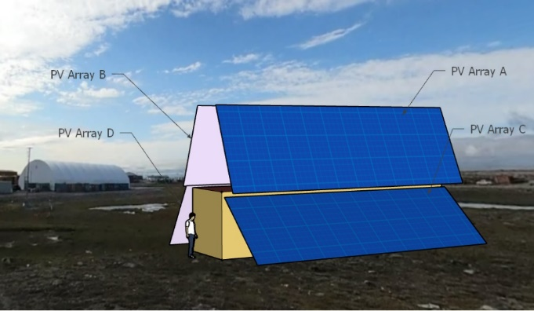
Figure 4: Container with PV arrays (arrays B & D are due north; A & C face south)
The PV simulation assumes a hypothetical monocrystalline PV panel with the properties listed in Table 4 (Standard Test Conditions, STC, are 1000 W/m² at 25°C), modelled using the default Sandia PV object from OpenStudio. Based on the assumed rated power (294 W), the rated current and voltage were adjusted, assuming the current is one-third of the voltage magnitude.
Although a monocrystalline panel was modelled with a particular set of performance behaviours, the results are applicable for other monocrystalline panels with the same rated efficiency at STC. This assumption relies on the limited influence different glass coverings, backing materials, and framing have on the PV cell temperature in contrast to the much higher influence of the PV cell type. Thus, the results are applicable for a range of other monocrystalline panels of different dimensions and rated power.
Table 4. Photovoltaic panel parameters and values
Property | Specification
Rated power at standard test conditions (per panel) | 294 [W]
PV cell area (per panel) | 1.4 [m²]
Rated efficiency (based on cell area) | 21 %
Current at rated power | 9.9 [A]
Voltage at rated power | 29.7 [V]
PV panels are arranged along the length of the container on-grade and on a mounting rack above the container as shown in Figure 4. Note that the individual panels are illustrative and do not represent the number of panels in each array. The individual panels are oriented to allow for two rows of 10 panels along the length of the container. Placing the panels around the container also provides shading to minimize heat gain during the daytime. PV arrays A and B are tilted 70° from the horizontal and are fixed for all configurations examined in the study. This angle should limit the amount of snow cover after a snow fall. On the other hand, PV arrays C and D would likely require manual intervention to clear accumulated snow. Snow cover is not modelled in the simulations. This is unlikely to have a significant impact on the refrigeration system performance since the refrigeration load is minimal or non-existent during the winter, at the end of which any snow cover is likely to have loosened due to melt and fallen to the ground.
Wind turbine
The wind turbine model from OpenStudio uses kinetic energy relations and empirical power coefficient parameters to simulate its performance. The dimensionless power coefficients used were the default set from OpenStudio. The general form of the kinetic energy relation used in OpenStudio is shown in Equation 2.
$$P_{wind}=\frac{1}{2}ρ_{air}A_{R}{{(V}_{wind})}^{3}C_{p}$$ | Eq. 2
Other parameters such as rated power, rated rotor speed, and cut-in/out speed are unique to each wind turbines. These were obtained based from manufacturer specifications and are presented in the report in Table 5.
Table 5: Wind turbine parameters
Design parameters | 3kW – turbine (Wind Turbine Models, 2018a) | 5kW – turbine (Wind Turbine Models, 2018b) | 10kW – turbine (Wind Turbine Models, 2022)
Rated power | 3 kW | 5 kW | 10 kW
Rated wind speed | 10 m/s | 10 m/s | 13 m/s
Rated rotor speed | 260 rev/min | 200 rev/min | 350 rev/min
Height | 10 m^{[1]} | 10 m^{[1]} | 10 m^{[1]}
Number of blades | 3 | 3 | 3
Rotor diameter | 3 m | 4.5 m | 7 m
Cut-in wind speed | 1.5 m/s | 1.5 m/s | 3 m/s
Cut-out wind speed | 52.5 m/s | 52.5 m/s | 60 m/s
Fractional system efficiency | 83.5%^{[2]}
Max power coefficient | 35%²
Max. tip speed ratio | 5 (U.S Department of Energy, 2024)
^{[1]} Assumption based on operating environment (i.e., turbine height can be adjusted during installation)
^{[2]} Default EnergyPlus model values
Battery
The Lithium-ion nickel-manganese-cobalt (Li-ion NMC) battery model from OpenStudio was used in this study. The model uses temperature to compute the instantaneous capacity and to model long-term capacity degradation (LTCD). Although lithium-based batteries perform poorly or are unable to operate in extreme cold, such as in Cambridge Bay where the average temperature in January is -32°C (ECCC, 2023), this study uses a lithium-based battery to conservatively estimate the performance of the combined system which incorporates a factor of safety in the analysis, to mitigate risks of food-spoilage in remote communities. Additionally, refrigeration is not required during periods of extremely low outdoor temperatures in the case of the batteries being in an unconditioned space.
Therefore, the combined system was evaluated using the Li-ion NMC model with and without LTCD. The former option provides a lower band of performances (overestimated battery capacity degradation over time) and the latter forms the higher performing band of results (idealized performance without long term degradation). Evaluating the performance using both options yield a more complete picture of the combined system’s performance.
Thermal Properties of Refrigerated Food
The thermal properties of the refrigerated food are modelled in this study since there is a significant amount of thermal mass present that could alter the performance of the combined system. The food was approximated as a block with uniform thermal properties (and therefore temperature). This simplification was made because OpenStudio is not intended to model the detailed transfer through food objects and a more accurate representation (shape and non-uniform properties e.g., fat, cartilage, sinew) would only result in negligible differences in the results on an annual basis compared to the overall energy consumption of the system. The block interacts with the zone air via convection and with other surfaces (e.g., zone walls, ceilings, floors) via long-wave radiation. Properties of the refrigerated food are presented in Table 6; properties of ground beef were used in the absence of specific information for different cuts in the literature.
Table 6: Refrigerated food properties (ground beef)
Property | Values
Mass | 1370 kg
Volume | 1.33 m³
Conductivity | 0.35 [W/(m∙K)] (Pan & Singh, 2001)
Density | 1033 [kg/m³] (Pan & Singh, 2001)
Specific heat | 3.14 [kJ/(kg∙K)] (ASHRAE, 2022)
- Results and Discussion
Given that this work relies on modelling as a performance predictor, initial results are focused on model verification, ensuring that key aspects of the energy model are performing as expected. The performance results for the solar-only energy system are then presented, and finally a case with a small wind turbine added to explore the limits of what off-grid operation is possible.
4.1 Heat Transfer Across Container Surfaces
The simulation uses conduction transfer functions (CTF) to estimate the heat transfer through the opaque surfaces of the container. It is a quasi-steady state method that captures some of the transient behaviour. The combined conduction heat transfer through all container surfaces exposed to outdoor air (i.e., walls and roof) is calculated for each timestep (10-minute intervals). The daily average conduction through these surfaces for the refrigeration period are presented in Figure 6. Positive values indicate heat gain towards the interior of the container and negative values reflect heat loss through the container. The use of daily averages facilitates easier visual verification when compared to the full steady state heat transfer calculations for the same surfaces. This relationship is shown in Equation 3, where, the steady state heat conduction through a surface $Q_{ss}$, is calculated using the overall thermal transmittance of the surfaces $U$, area of the surface ($A_{exposed area}$) and the daily average outdoor ($T_{outdoor }$) and indoor temperatures ($T_{Indoor})$. These results are also presented in Figure 5. There is a strong agreement between the two relations, which verifies the accuracy of the simulation’s thermal demand profile.

Figure 5: Baseline verification: conduction through the container wall and roof surfaces (March 21st to November 23rd)
$$Q_{ss}=U(A_{exposed area})(T_{outdoor}-T_{indoor})$$ | Eq. 3
4.2 Air infiltration
The daily average operational infiltration (ACH) of the container and the corresponding wind speed for the refrigeration period is presented in Figure 6. Based on Equation 1, the operational infiltration is 0.185 ACH or greater when the wind speed is greater 4.5 m/s. This is observed in the figure, given the average wind speed rarely is greater than 4.5 m/s, the operational infiltration rate is often below the nominal value. The trend of the infiltration rate closely correlates with the wind speed in Figure 6. The total rate of heat transfer loss (negative values) and gain (positive) due to infiltration showing a maximum 121 W gain over the refrigeration period is presented in Figure 7. The rate of heat transfer due to air leakage (advection) is a product of the infiltration rate and the enthalpy difference between the interior and exterior air conditions. The advection is primarily sensible due to a typically low absolute humidity for the location modelled.

Figure 6: Baseline verification: air infiltration and wind speed (March 21st to November 23rd)

Figure 7: Daily average heat transfer via air leakage (positive – gain; negative – loss)
4.3 Solar Photovoltaics
The daily electricity generated by PV array A (rated 5880 W, 70°, south facing) is shown in Figure 8, along with the available solar energy and the PV array’s efficiencies; overlayed on top of the daily values is the 30-day moving average trend line. These results are presented for the entire year; the refrigeration period (March 21st to November 23rd) is highlighted in orange.
The available solar energy is the accumulation of the incident radiation on PV array A for each day, which correlates as expected with the electrical energy generated. The PV efficiency curve represents the ratio of electricity to the solar energy available for each day. It represents the average efficiency of the PV panel only during the hours when it operates (i.e., it excludes the hours when the efficiency is 0%). For example, a particular day in February may have a high average operating PV efficiency for 4 hours, but generate less electricity than a day in May with a lower operating efficiency because solar radiation is available for 19 hours continuously in the spring (even though the solar intensity varies throughout those hours).
These results clearly show an asymmetric solar energy availability across the year, with significantly more solar energy available in the first half of the year compared to the second half of the year. This difference is attributed to cloud cover, as the skies are significantly cleared in the spring and early summer months when the sun returns to the high Arctic and the landscape and sea ice begin to thaw. As the summer goes on and into fall, the relative moisture in the air increases and cloudy and overcast conditions become more prominent. This is challenging from an energy perspective, as refrigeration demand is highest in the middle of the summer and into the early fall.

Figure 8: Baseline verification: PV generation of PV array A (south, 70° tilt)
4.4 Solar Resource Analysis
An initial set of simulations were conducted to explore the PV generation outputs for several sizes of arrays given the approximate footprint available. This analysis assumes PV placements on the roof and ground, along the longitudinal length of the container. Using the baseline performance parameters of the PV panel and container dimensions, a series of PV systems of different capacity were established. The largest PV configuration possible is a 24 kW system consisting of 80 x 294 W panels. The potential PV generation for the variety of PV system sizes are shown in Figure 9.

Figure 9: Annual PV Generation Potential for various Rated PV Capacities
The outputs from the arrays increase largely in a linear form, but deviates slightly from linear due to the different orientations and quantities of panels in each array.
4.5 Solar PV Parametric Study
Two sets of parametric analyses consisting of 1630 simulations in total were completed. Key solar PV parameters are defined in Table 7. The first set accounts for LTCD and the second set does not; each set explored a range of container, PV, battery parameters and thermostat strategies in 815 (80 + 720 + 15, respectively) simulations.
The results from the developed model were calculated for a total of 1630 parametric runs. All of these cases are summarized in Figure 10 which illustrates the annual solar fraction. The ‘Container’ box and whisker plots in Figure 10 represent parameters pertaining to the container, such as orientation, surface properties, and envelope insulation, with the latter having the most significant impact on performance, as expected. The ‘PV & battery’ box and whisker plots represent different scales of PV arrays and battery storage size. Finally, the ‘Thermostat strategy’ box and whisker plots represent different control strategies, primarily trying to utilize floating temperature setpoints based on energy availability to make use of the thermal storage of the freezer contents. The solar fraction ranges from 0.81 to 0.93 across the optimization exercise.
The combined system as modelled experiences periods of insufficient refrigeration during autumn for most years since the simulations were conducted using statistically representative weather data for Cambridge Bay (ECCC, 2024). During September and October, the decline in solar and wind availability results in increasing power deficits, even though refrigeration demand diminishes with cooler temperatures. This is visualized in Figure 11, which illustrates the performance of the final resulting system configuration from the parametric analysis with a 5 kW wind turbine and including battery LTCD. An evaluation of how well the designs operate off-grid require a review of the magnitude and duration of the energy gaps i.e., the difference between the refrigeration energy required and that provided by the PV system and the duration of the individual occurrences because insufficient energy (from PV or the battery)translate into refrigeration interruptions.
Table 7: Solar PV parameter values used in simulations
Design parameters | Parameter description | Values
Number of PV panels | The number of panels used is fixed. | 80
Nominal PV Power | The rated power of the entire PV system at 1000 W/m² at 25°C. | 23.5 kW
PV array A and B tilt | Tilt of the PV panels measured from the horizontal level on either side of the container. | 70°
PV array C tilt |  | 15°, 30°, 45°, 60°, 75°, 90°
PV array D tilt |  | 15°, 30°, 45°, 60°, 75°, 90°
Nominal battery capacity | Storage capacity of the battery. | 44 kWh, 47 kWh, 50 kWh, 53 kWh, 56 kWh
Combined system azimuth angle | The “default” orientation is 0° where the one set of arrays are facing north, and the other faces south. | 0°, 45°, 90°, 135°

Figure 10. Annual operational solar fraction of the parametric analyses, with and without LTCD
4.6 Small Wind Turbine Addition
To further test the feasibility of operating autonomously on clean energy, a 5 kW wind turbine was added to the model. For the highest performing design with the 5 kW wind turbine (with LTCD modelling) shown in Figure 11, the peak power generation (wind plus solar) occurs in May, two months before the peak refrigeration demand in July. During these two months, the battery capacity examined (50 kWh) was large enough to support the system overnight or during less windy conditions until sufficient solar/wind resource was available again to power the refrigeration unit directly and recharge the battery to near full capacity to maintain the daily cycle. However, as autumn approaches, the system was unable to maintain consistent refrigeration. Even though refrigeration demand decreased, declining power generation, coupled with the limited battery capacity to supply energy over longer periods of nighttime, resulted in significant hours of insufficient refrigeration.
The simulation results show the final design of the combined system is estimated to operate with an energy gap of 28 – 135 kWh/yr (approximately 0.4% – 2.1% of the annual refrigeration energy consumption). This is an increasingly small energy gap and the results highlight that the system is able to operate solely on renewable energy for the majority of the year with a renewable fraction around 98-99%, only running into energy shortfall issues for approximately one month.

Figure 11. Monthly system trend and energy gaps (with 5 kW wind turbine, with LTCD)
4.7 Reference Data from Operating Community Freezer
Data for the community freezer in Baker Lake, Nunavut were shared by community representatives. The Baker Lake freezer is purpose-built with a gross footprint of 1,288 ft² (120.0 m²), approximately 4.5 times the refrigerated container gross footprint of 26.5 m² modelled in this study. During the months of highest modelled demand (April to October) the energy consumption of the Baker Lake freezer was approximately 4-6 times that of the container freezer modelled. These data provide a corroboration of the magnitude of energy demands from the model, with surprisingly high demand in the winter months from December through February, which is expected to have occurred due to electric resistance heating in the vestibule area of the freezer that is not refrigerated.

- Conclusions
A detailed model of a refrigerated container and energy system, including solar PV, battery, electronics, and small wind turbine was developed to predict the energy performance of the combination. This modelling work was an exercise in pushing to the limit of what is possible for solar and wind electricity generation in the Arctic for a freezer application. The model performance was verified against expected behaviour and compared to billing data for a larger purpose-built freezer, demonstrating that the modelled results are a realistic representation of expected freezer performance.
The modelling showed that a large array of solar PV applied to this load can meet the annual energy demands of a freezer container in the range of 90%. With the addition of a small wind turbine, although the energy gaps are significantly reduced further and a renewable fraction of circa 98% may be achieved, the system is still unable to fully meet the needs during the late summer months, primarily October. For this application, it would be reasonable to reduce the capacity of the wind turbine and battery to reduce capital costs since an additional dispatchable energy source such as a stand-alone diesel generator or a local grid connection is required. A hybrid energy system can significantly reduce operating emissions and energy costs compared to a refrigerated container powered solely by diesel electricity generation.
Future work is anticipated to include on-grid modelling for communities throughout the territory of Nunavut. In future work, larger, purpose-built community freezer designs will be explored to optimize performance. Integration of solar PV will be explored on a territory-wide scale, exploring the energy and cost implications for all 25 communities throughout the territory of Nunavut.
Acknowledgements
Sheldon Dorey, Senior Administrative Official of Baker Lake, Nunavut and Shawnee Kayuryuk, Community Economic Development Officer of Baker Lake, Nunavut for sharing Baker Lake freezer electricity billing data.
This work was funded by Polar Knowledge Canada and National Research Council Canada.
References

ASHRAE. (2021). 2021 ASHRAE Handbook: Fundamentals. Peachtree Corners: American Society of Heating, Refrigerating and Air-Conditioning Engineers.
ASHRAE. (2022). 2022 ASHRAE Handbook - Refrigeration. Peachtree Corners: American Society of Heating, Refrigerating and Air-Conditioning Engineers.
Berardi, U. (2019). The impact of aging and environmental conditions on the effective thermal conductivity of several foam materials. Energy, 182, 777-794.
Canadian Broadcasting Corporation. (2016, November 10). Iqaluit's hunters have a new community freezer. Retrieved from CBC News: https://www.cbc.ca/news/canada/north/iqaluit-new-community-freezer-1.3844267
Dimd, B., Stokkan, G., & Juel, M. (2026). The role of photovoltaic energy in Arctic energy system transition: Technical potential and challenges in Longyearbyen, Svalbard. Renewable Energy, 271, 125977. doi:https://doi.org/10.1016/j.renene.2026.125977
Duran, S., Turcotte, P. H., Rousse, D., Arasteh, H., Kalivogui, S., Zhang, K., . . . Ilinca, A. (2025). Decarbonization strategies for northern Canada: A review of renewable energy and energy storage in off-grid communities. Energy Conversion and Management: X, 27, 101055. doi:Decarbonization strategies for northern Canada: A review of renewable energy and energy storage in off-grid communities
ECCC. (2023). Canadian Climate Normals 1981-2010 Station Data. Retrieved from Canada.ca: https://climate.weather.gc.ca/climate_normals/results_1981_2010_e.html?stnID=1786&autofwd=1
Government of Canada. (2026). NRC Publications Archive. Retrieved from https://nrc-publications.canada.ca/eng/home/
Herez, A., Jaber, H., Ashour, A., Alsayah, A., Ali, S., & Khaled, M. (2026). Solar cooling technologies: a comparative review of thermal-driven and PV-driven systems, maturity, and deployment challenges. Energy Conversion and Management: X, 32, 102242. doi:https://doi.org/10.1016/j.ecmx.2026.102242
Indigenous Services Canada. (2026, September). Map Room. Retrieved from https://geo.sac-isc.gc.ca/Collection_de_cartes-Map_room/index_en.html
Janke, S., Crawford, C., Ross, M., & Lenio, M. (2026). Green hydrogen energy storage to support microgrid Arctic communities on the pathway to 100% renewable energy. Renewable Energy, 274, 126131. doi:https://doi.org/10.1016/j.renene.2026.126131
Kaiprath, J., & V., K. (2023). A review on solar photovoltaic-powered thermoelectric coolers, performance enhancements, and recent advances. International Journal of Air-Conditioning and Refrigeration, 31(6). doi:https://doi.org/10.1007/s44189-023-00022-y
Liang, E., Liang, Y., Ye, J., & Yu, Z. (2026). Application of a solar-assisted flexible refrigeration cycle in cold storage. International Journal of Refrigeration, 191, 107080. doi:https://doi.org/10.1016/j.ijrefrig.2026.107080
Northwest Territories Power Corporation. (2026, July). Rate Schedule. Retrieved from https://www.ntpc.com/sites/default/files/2026-06/NTPC%20Rate%20Schedule%20-%20June%201%202026.pdf
Qulliq Energy Corporation. (2026, July). Customer Rates. Retrieved from https://www.qec.nu.ca/customer-care/accounts-and-billing/customer-rates
Rinchi, B., Dababseh, R., & Ayadi, O. (2026). A systematic review of off-grid solar cooling and heating technologies. Renewable and Sustainable Energy Reviews, 235, 116960. doi:https://doi.org/10.1016/j.rser.2026.116960
Sarbu, I., & Sebarchievici, C. (2013). Review of solar refrigeration and cooling systems. Energy and Buildings, 67, 286-297.
Statistics Canada. (2006).
Stringer, T., & Joanis, M. (2023). Decarbonizing Canada's remote microgrids. Energy, 264, 126287. doi:https://doi.org/10.1016/j.energy.2022.126287
Sun, Z., Liu, J., You, T., Ren, Z., & Chang, D. F. (2024). Field test study on thermal performance of a novel embankment using solar refrigeration technology. Renewable Energy, 226, 120392. doi:https://doi.org/10.1016/j.renene.2024.120392
Vuong, E., Banister, C., & Horeczky, S. (2025). Arctic Renewable Powered Refrigerated Container: Off-Grid Analysis. Ottawa: National Research Council Canada.

Up to 700 kWh per month in the summer and 1000 kWh in the winter.
Up to 600 kWh per month in the summer and 1000 kWh in the winter.

