EuroSun2026
PERFORMANCE ANALYSIS OF AN ALKALINE WATER ELECTROLYZER POWERED BY SOLAR PHOTOVOLTAICS FOR GREEN HYDROGEN PRODUCTION
Fatima LAGHCHIM ^{1, 3*}, Afaf ZAZA ¹, Izidbih EBEY², El Ghali BENNOUNA ¹, Hicham BEN YOUCEF ³
¹ Thermal Systems Department, Green Energy Park, (IRESEN, UM6P), Km² Route Regional R206, Ben Guerir, Morocco.
² Ibn Tofail University, Faculty of Sciences, Kenitra, Morocco
³ High Throughput Multidisciplinary Research Laboratory (HTMR), College of Chemical Sciences and Engineering (CCSE), Mohammed VI Polytechnic University (UM6P).
Email: Fatima.LAGHCHIM@um6p.ma
Summary
Renewable energy as a backup energy source is becoming increasingly significant due to growing global environmental and ecological concerns. Among the various renewable energy methods used today is the production of hydrogen through water electrolysis. When coupled with solar photovoltaic (PV), the hydrogen produced has the potential to play a key role as a clean energy carrier for sustainable development. In this paper, a detailed PV-AWE system was developed in MATLAB/Simulink, incorporating experimental results to validate the model's reliability. The simulated and experimental I-V and P-V characteristics at STC were compared; the relative error was calculated, with an average value of 3.8% for I_{PV} and 2.4% for V_{PV}. Furthermore, a mathematical model was developed to predict the electrolyzer cell voltage under the experimental operating conditions. The model was validated with experimental data obtained in a 20kW alkaline test rig facility. The average relative error between the modeled and measured values was found to be below 1 % for cell voltage. The PV-AWE simulation results demonstrate that solar irradiance strongly influences DC current, electrolyzer power consumption, and hydrogen flow rate.
Keywords: Renewable energy, solar photovoltaic, hydrogen, clean energy carrier, alkaline water electrolyzer, mathematical model, experimental study.
Field of application for the findings: green hydrogen / Renewable energy systems
Addressed audience: researchers / Engineers
Abbreviations
AWE | Alkaline water electrolyzer
DC | Direct current
DHI | Diffuse Horizontal Irradiance
DNI | Direct Normal Irradiance
GHI | Global horizontal irradiance
HMI | Human-Machine Interface
MPPT | Maximum power point tracking
PEM | Proton exchange membrane
PV | Photovoltaic
RES | Renewable energy sources
RMSE | Root-mean-square error
STC | Standard test conditions
SDM | Single-diode model
WE | water electrolysis
Nomenclature
i | Current density, A/m²
I | Current, A
I₀ | Diode saturation current, A
I_{m} | Current at maximum point, A
I_{ph} | Photocurrent, A
I_{rs} | Reverse saturation current, A
I_{SC} | Short-circuit current, A
I_{sh} | Shunt current, A
$$n_{H2}^{.}$$ | Hydrogen production flow rate, m³/h
P_{C} | Power consumed, W
V_{cell} | Cell voltage, V
V_{m} | Voltage at maximum point, V
V_{OC} | Open-circuit voltage, V

Introduction
The global transition to renewable energy sources has gained significant attention in an effort to mitigate climate change and reduce reliance on fossil fuels. To replace gray hydrogen from fossil fuels and decarbonize hard-to-electrify sectors, green hydrogen -with its high energy density and zero emissions-provides a promising solution (Van Renssen, 2020). In this context, water electrolysis (WE) has attracted increasing attention as a sustainable method for producing hydrogen, particularly when powered by RES like solar. Among different water electrolyzer technologies, alkaline water electrolysis (AWE) is considered a mature, well-developed, and cost-effective technology suitable for large-scale applications, making it a key enabler in the emerging green hydrogen economy. Integrating RES into the operation of electrolyzers offers a highly promising solution for addressing the decarbonization of current hydrogen production pathways. Near-term success will depend on accelerating the deployment of renewables to reduce production costs. One of the recommended RES technologies is solar energy, due to its wide availability and low cost. However, these RES suffer from intermittency due to the variability in environmental and meteorological conditions and site-specificity, resulting in impacts on the performance and durability of the electrolyzer (Nguyen et al., 2024). Therefore, modeling and simulation are essential tools for predicting electrolyzer behavior under intermittent conditions. The study of (Ursúa et al., 2013) experimentally investigates the performance of an AWE under variable wind and PV power conditions. The results demonstrate that the mean energy efficiency of the AWE was 78.6% for the PV emulation on a day with stable irradiance (GHI), and 78.1% on a day with highly variable GHI. While (Zou et al., 2023), developed a MATLAB/Simulink model of a PV-electrolyzer system to optimize solar hydrogen production through maximum power point tracking (MPPT). The results demonstrate that the integration of a DC/DC buck converter controlled by an MPPT improves the matching between the PV array and the electrolyzer, allowing a more efficient use of the solar energy. (Weng et al., 2026) developed a direct-coupled PV-PEM system in MATLAB/Simulink to evaluate the performance of the electrolyzer under real outdoor conditions. The results show that the system performance and energy efficiency are strongly influenced by irradiance and temperature. This article is structured as follows: “Methodology” section presents the adopted methodology, including the study area, mathematical modeling, and simulation & experimental procedure. The “Results” section analyzes and discusses the obtained findings. The “Conclusion” summarizes the key outcomes.

Methodology
To produce green hydrogen, direct current (DC) and an aqueous alkaline solution containing 20 wt% sodium hydroxide (NaOH) are supplied to the electrolyzer cell stack, where electrolysis generates H₂ at the cathode and O₂ at the anode. The operating point of the electrolyzer is determined by the intersection of the current-voltage (I–V) characteristics of the PV array (eq. (1)) and the AWE (eq. (2)). This study aims to evaluate the performance of the PV-AWE system under outdoor climatic conditions. The work consists of two complementary parts: modeling and experimental validation, as illustrated in Figure 1. First, the PV behavior was simulated using the specifications of the JKM470M-7RL3 PV module and measured weather data, namely global horizontal irradiance (GHI) and ambient temperature (T_{amb}). The PV model predicts the current (I_{PV, mo}), voltage (V_{PV, mod}), and power (P_{PV, mod}). The predicted current I_{PV, mod} is then used as an input to the AWE model, together with the AWE specifications, to predict the hydrogen production flow rate ($n_{H2}^{.}$, _{mod}) and electrolyzer power consumption (P_{c, mod}). In the second stage, experimental tests were conducted on the AWE system to characterize its behavior under practical operating conditions. Experimental data were simultaneously collected to support the development and validation of the cell voltage (V_{cell}, _{mod}) and hydrogen flow rate ($n_{H2}^{.}$). In addition, measured current (I _{PV,meas}) and voltage (V_{PV,meas}) data were collected under STC to validate the simulated I-V and P-V characteristics of the JKM470M-7RL3 PV module.
Figure 1: Work methodology.

Site description
The study’s application area is BenGuerir, Morocco. The geographical coordinates and the meteorological data are presented in Table 1. To ensure long-term viability, dependability, and efficiency of the system, a thorough assessment of solar energy resources is required. Global Horizontal Irradiation (GHI), Direct Normal Irradiance (DNI), Diffuse Horizontal Irradiance (DHI), and ambient temperature (T_{amb}) were measured at the Green Energy Park (GEP) meteorological station in Ben Guerir, Morocco. Figure 2 displays the yearly GHI and T_{amb} profiles. The GHI profile indicates a distinct seasonal variation of solar irradiance. At the start of the year, the maximum GHI is usually between 600 and 700 W/m². It increases gradually, with the highest values frequently exceeding 1000 W/m² in the middle of the year. The highest instantaneous values seem to reach about 1200 W/m². GHI decreases gradually after the middle of the year and returns to a value of about 600 W/m² toward the end of the year (Figure 2 (a)). This overall bell-shaped envelope is consistent with the annual variation in solar availability, with more solar radiation during the warmer/sunnier months and less during the cooler months. From Figure 2 (b), January had the lowest average temperature of 2.65°C, while July had the highest average temperature of 46.61°C.
Table 1: Geographical location and meteorological data for the study area (BenGurir).
Latitude (°S) | Longitude (°W) | Altitude (m) | Annual average temperature (°C) | Average GHI (KWh/m²)
32.23 | 7.95 | 446 | 18.9 | 2018

Figure 2: The meteorological data: a) GHI over the year, and b) T_{amb} over the year.
a)
b)
May
14/05/2024
14/05/2024

Numerical Modeling
- PV
In order to simulate the PV module and evaluate the system performance, the current–voltage (I–V) curve needs to be determined. In this study, the nonlinear behavior of the PV module is characterized using a five-parameter single-diode model (SDM) (see Figure 3 (a)). Although different models are available in the literature, the SDM is widely used. The PV module investigated in the current study is the JinkoSolar Tiger JKM465-7RL3 (Figure 3 (b)), with a maximum power of 465 Wp under standard test conditions (STC). The PV module consists of 156 half-cut P-type monocrystalline cells. Detailed technical specifications are summarized in Table 2. The current (I) is calculated as follows (Zaimi et al., 2019), (El Achouby et al., 2018):
$$I=I_{ph}-I_{0}.\left[\exp\left(\frac{q\left(V+I.R_{s}\right)}{n.K.N_{s}.T}\right)-1\right]-I_{sh}$$ | (eq.1)
Where I and V represent the output current and voltage of the PV array, respectively; I_{ph}​ is the light-generated current; I₀ denotes the reverse saturation diode current; q is the elementary charge of an electron ($1.6×{10}^{-19} C$); n is the ideality factor, K is Boltzmann’s constant ($1.38×{10}^{-23}$), and R_{S} and R_{sh} are the series and shunt resistances, respectively.
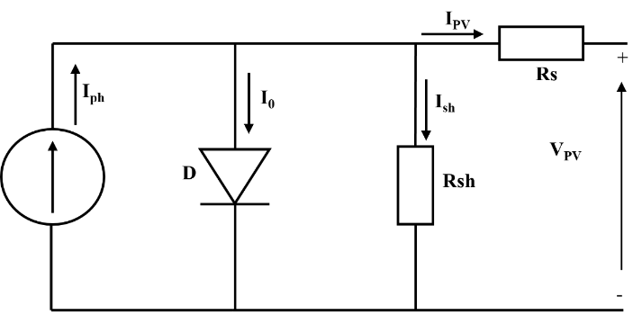
a)
b)
Figure 3: PV model: a) equivalent electrical circuit of a PV cell, and b) Matlab/Simulink subsystem for PV module.
Cell type | P type Mono-crystalline
Open-circuit voltage V_{oc} (V) | 51.92
Short-circuit current I_{sc} (A) | 11.59
Voltage at maximum point V_{mp}(V) | 43.18
Current at maximum point I_{mp}(A) | 10.77
Power at maximum point P_{mp} (Wp) | 465
Number of cells connected in series N_{s} | 156
Series resistance R_{s} (Ω) | 0.0050389
Table 2: PV characteristics at STC.
- DC/DC converter
A DC/DC converter is a power electronic device that adjusts the DC voltage supplied by a source to a desired output voltage level (Li et al., 2017). There are several types of DC/DC converters. In this study, the Boost converter was selected because of its ability to increase the voltage supplied by the PV to meet the operating requirements of the electrolyzer.

- MPPT (Maximum power point tracking)
MPPT is an essential control algorithm that enables a PV system to operate at the current and voltage that provide maximum power. It allows the system’s operating point to be adjusted in real time in response to variations in solar irradiance and cell temperature, thereby ensuring the PV system operates at its maximum power point (Yamuna and Sreedhar, 2025, 2025).

- Alkaline water electrolyzer (AWE)
An AWE is an electrochemical device that splits water into hydrogen (H₂) and oxygen (O₂), using electricity and an aqueous solution of KOH or NaOH, operating under specific operating conditions of current, temperature, and concentrations.
To evaluate the performance of the green hydrogen production system, a model of the electrolyzer was developed in the MATLAB/Simulink environment using the Simscape libraries (Figure 4). This model reproduces the electrical, thermal, and hydrodynamic behavior of the electrolyzer based on the operating conditions of the PV system. The various integrated subblocks ensure the conversion of electrical energy supplied by the PV into chemical energy in the form of hydrogen. The Simulink model architecture also allows the evolution of the main physical parameters. In parallel, a semi-empirical mathematical model was developed in MATLAB to predict the AWE cell voltage (V_{cell, mod}) as a function of temperature and current density, as described by eq.(2). Table 3 summarizes the governing equations.
Figure 4: Simulink Model of the AWE.
Table 3: Equations used for AWE.
Parameter | Equation
Cell voltage
  $$V_{cell}=V_{rev}+\left[r_{1}+r_{2}×T\right]×i+s×log⁡[\left(t_{1}+\frac{t_{2}}{T}+\frac{t_{3}}{T^{2}}\right)×i+1]$$ | (eq.2)
Hydrogen production flow rate
  $n_{H2}^{.}=\frac{I×N_{C}}{2×F}$ (mol/s) | (eq.3)
Power consumption
  $$P_{C}={N_{Cell}×V}_{cell}×I$$ | (eq.4)

- AWE-PV
The four components presented above-(i) the PV system, (ii) the DC/DC converter, (iii) the MPPT, and (iv) the AWE- were integrated into a stand-alone scenario, as illustrated in Figure 5. The V_{cell}, _{mod}, $n_{H2}^{.}$ and P_{c, mod} were calculated using the previously presented equations (Table 3), GHI, PV module characteristics, number of PV modules, and AWE specifications. The system was simulated based on 10-min intervals.

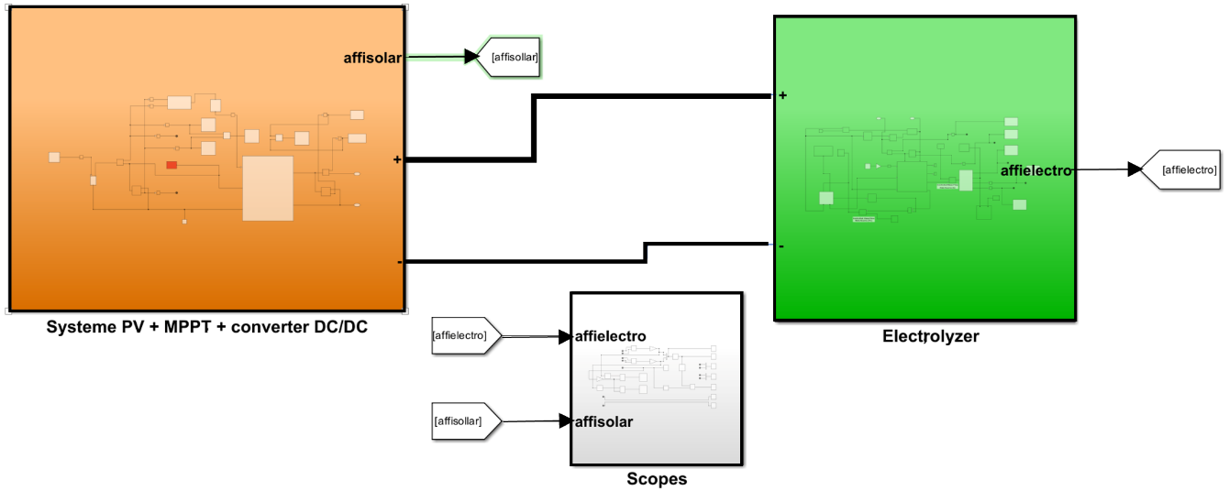

Figure 5: PV-AWE model in MATLAB/Simulink.

Experimental setup
- PV
In order to validate the proposed model, outdoor experiments were conducted using a JKM470M-7RL3 PV module. The PV system was equipped with a monitoring system that recorded the electrical parameters -current, voltage, power- as well as the ambient and PV module temperatures. The I-V and P-V curves were measured under different outdoor operating conditions in BenGuerir, Morocco.
- AWE
An experimental 26 kW AWE was installed at the Green Energy Park in BenGuerir, Morocco, to evaluate its performance under real operating conditions. The system comprises two stacks, each containing 100 cells, supplied with DC and a 20 wt% NaOH electrolyte. The H₂ and O₂ generated in the stack pass through a drying unit to remove residual moisture and improve gas purity. Key operating parameters-including pressure, temperature, current, voltage, and hydrogen flow rate-are monitored through a Human-Machine Interface (HMI) and recorded every five minutes.
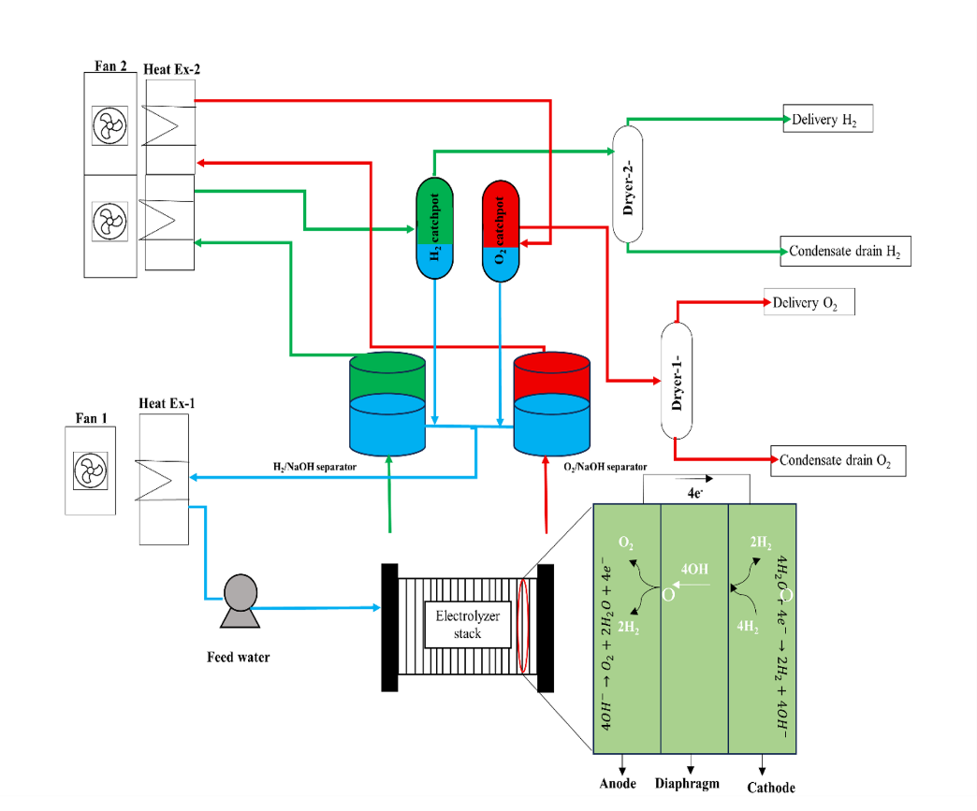

Figure 6: Process flow diagram of the AWE.

Results
The main results from the experiments and simulation are summarized below. As shown in Figure 7(a) the temperature profile exhibits two distinct stages: a rise stage and a stabilization stage. In the rise stage, the temperature increases gradually from an ambient temperature of 23.74°C to 48.5°C, and then stabilizes between 48.5°C and 52°C with small fluctuations of $±$1-2°C. This stabilization occurs when the heat generated inside the cell due to inefficiencies (ohmic losses, overpotentials, etc.) is balanced by the heat dissipated to the environment through convection or the cooling system. The V_{cell, exp}, varied between a minimum value of 2 V and a maximum value of 2.5 V. Overall, the V_{cell, exp}, immediately followed the applied current profile (Figure 7 (b)). Figure 7 (c) presents the variation in current and $n_{H2}^{.}$, and there is a strong linear dependence between current and $n_{H2}^{.}$ , as other authors have observed (Sakas et al., 2022). The I-V and P-V curves of the JKM470M-7RL3 module were generated using the SDM implemented in MATLAB/Simulink under STC (T_{S}=25°C, and GHI_{S}= 1000 W/m²). As shown in Figure 8 (a), as the PV voltage (V_{PV}) increases, the PV current (I_{PV}) decreases. At the open-circuit voltage (V_{OC}) and under short-circuit conditions (I_{SC}), the external current and voltage are zero, respectively. At zero voltage, the PV module delivered a short-circuit current (I_{SC}) of 11.59A. As the voltage increased, the PV power (P_{PV}) rose steadily, and then decreased sharply to zero at the V_{OC} of 51.92 V. To validate the accuracy of the simulation, the simulated and experimental I–V & P–V characteristics under STC were compared. The average relative errors were 3.8% for I_{PV} and 2.4% for V_{PV} (see Figure 8 (a)). To validate the proposed V_{cell} model, the experimentally measured temperature and current density were used as inputs to eq.(2) to calculate the cell voltage. A comparison of the measured and simulated V_{cell} values showed good agreement, as shown in Figure 8(b). Therefore, the proposed model adequately reproduces the behavior of the AWE. To assess the accuracy and validity of the proposed model, the root-mean-square error (RMSE) was calculated, and an average value of 0.87% was obtained. Figure 8 (c) shows the evolution of GHI and hydrogen flow rate ($n_{H2}^{.}$). The GHI profile for the selected day corresponds to a predominantly clear sky day, with slight fluctuations between 07:50 and 09:30. GHI reached a maximum value of 1037.3 W/m² at 13:20. The $n_{H2}^{.}$ Followed a trend similar to that of GHI. The evolution of $n_{H2}^{.}$ started with 0.125 m³/h at 07:00 h and ended with 0.4 m³/h at 19:30 h. The maximum hydrogen production reached that day was 4.2 m³/h at 13:20 h. As was to be expected, the DC current and power consumed by the electrolyzer reflect all the variations in GHI, as illustrated in Figure 8 (d).

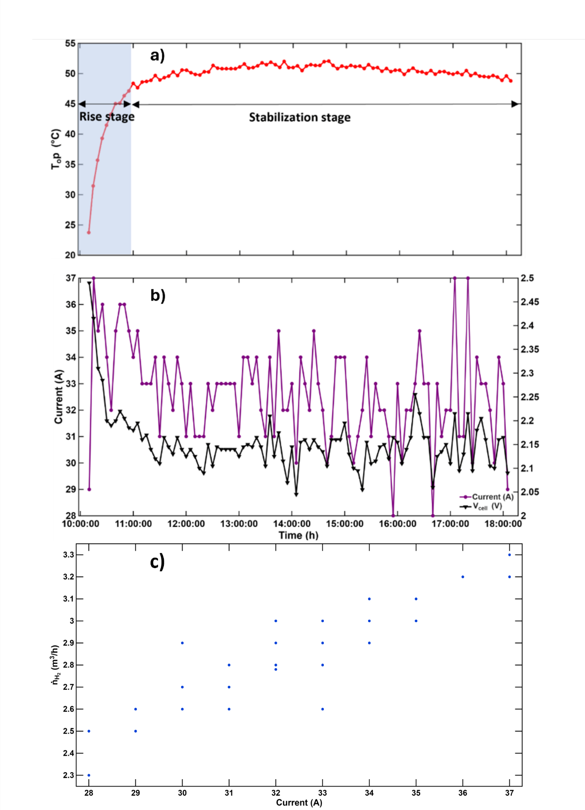
Figure 7 : Experimental results, (a): evolution of T_{op} over time, (b): evolution of the current and V_{cell}, and (c): Variation of current with $n_{H2}^{.}$.

Figure 8: (a): Comparison of simulated and experimental I–V & P–V characteristics at STC, (b): comparison between simulated and measured V_{cell}, (c): $n_{H2}^{.}$ response to GHI: model and experimental Data, and (d): Variation of DC Current and Power Consumption with GHI.

Conclusion
To evaluate the performance of the electrolyzer under real outdoor conditions, this study investigated hydrogen production using an integrated PV-DC/DC-AWE system. To facilitate the simulation and modeling of the integrated system, system blocks of MATLAB/Simulink were used. Furthermore, a semi-empirical mathematical model was developed to predict electrolyzer cell voltage. The simulation results showed good agreement with experimental data. The findings showed that the DC current, $n_{H2}^{.}$, and power consumed by the electrolyzer exhibited similar trends and followed the variations in GHI.

References

El Achouby, H., Zaimi, M., Ibral, A., Assaid, E.M., 2018. New analytical approach for modelling effects of temperature and irradiance on physical parameters of photovoltaic solar module. Energy Conversion and Management 177, 258–271. https://doi.org/10.1016/j.enconman.2018.09.054
Li, S., Liao, H., Yuan, H., Ai, Q., Chen, K., 2017. A MPPT strategy with variable weather parameters through analyzing the effect of the DC/DC converter to the MPP of PV system. Solar Energy 144, 175–184. https://doi.org/10.1016/j.solener.2017.01.002
Nguyen, E., Olivier, P., Pera, M.-C., Pahon, E., Roche, R., 2024. Impacts of intermittency on low-temperature electrolysis technologies: A comprehensive review. International Journal of Hydrogen Energy 70, 474–492. https://doi.org/10.1016/j.ijhydene.2024.05.217
Sakas, G., Ibáñez-Rioja, A., Ruuskanen, V., Kosonen, A., Ahola, J., Bergmann, O., 2022. Dynamic energy and mass balance model for an industrial alkaline water electrolyzer plant process. International Journal of Hydrogen Energy 47, 4328–4345. https://doi.org/10.1016/j.ijhydene.2021.11.126
Ursúa, A., San Martín, I., Barrios, E.L., Sanchis, P., 2013. Stand-alone operation of an alkaline water electrolyser fed by wind and photovoltaic systems. International Journal of Hydrogen Energy 38, 14952–14967. https://doi.org/10.1016/j.ijhydene.2013.09.085
Van Renssen, S., 2020. The hydrogen solution? Nat. Clim. Chang. 10, 799–801. https://doi.org/10.1038/s41558-020-0891-0
Weng, X., Jia, Z., He, W., Hu, Z., Wang, K., Hu, W., Zhang, L., Chu, W., 2026. Experimental and numerical study of a PV direct-coupled PEM electrolysis hydrogen production system. Renewable Energy 256, 124133. https://doi.org/10.1016/j.renene.2025.124133
Yamuna, S., Sreedhar, M., 2025. Optimization of maximum power point tracking controllers for enhanced performance in solar photovoltaic systems. Solar Energy 302, 114011. https://doi.org/10.1016/j.solener.2025.114011
Zaimi, M., El Achouby, H., Ibral, A., Assaid, E.M., 2019. Determining combined effects of solar radiation and panel junction temperature on all model-parameters to forecast peak power and photovoltaic yield of solar panel under non-standard conditions. Solar Energy 191, 341–359. https://doi.org/10.1016/j.solener.2019.09.007
Zou, L., Shen, Q., Yang, G., Li, S., Huang, N., 2023. Improved hydrogen production efficiency of a Photovoltaic-Electrolysis system with P&O Algorithm: A case study. Chemical Physics Letters 832, 140891. https://doi.org/10.1016/j.cplett.2023.140891

