EuroSun2026
TARGET-GROUP-ORIENTED TECHNICAL CHARACTERISTICS – A COMPARISON OF CURRENTLY USED PVT MODELS

María Herrando^{1*}, Raquel Simón-Allué², Iván Acosta-Pazmiño³, Korbinian Kramer⁴
¹Instituto Tecnológico de Aragón, C/ María de Luna 7-8, 50018 Zaragoza (Spain)
² ENDEF, c/P-B 20, Polígono Ciudad del Transporte, 50820 Zaragoza (Spain)
³ MG Sustainable Engineering AB, S:t Olofsgatan 11A, 753 21 Uppsala (Sweden)
⁴ Fraunhofer Institute for Solar Energy Systems ISE, Heidenhofstr. 2, 79110 Freiburg (Germany)
Email: *mherrando@ita.es, raquel.simon@endef.com, ivan@mgsust.com, korbinian.kramer@ise.fraunhofer.de
Summary
This work provides a comprehensive overview of solar photovoltaic-thermal (PVT) system configurations and the numerical simulation models currently employed for their performance assessment. Drawing from the ongoing activities of IEA SHC Task 73, it maps the dominant modelling tools and evaluates user experiences and learning methods. A critical finding is that system integration, rather than the collector unit itself, constitutes the primary modelling hurdle, according to 67% of practitioners. Key data gaps are identified regarding manufacturer performance maps, economic CAPEX/OPEX data, and high-quality experimental validation datasets. Based on these community insights, a target-group-oriented framework is proposed, distinguishing between the specific Key Performance Indicator (KPI) requirements for Market and Research & Development stakeholders. Furthermore, the study highlights "uncovered" physical phenomena, such as icing and condensation. Finally, a roadmap is outlined to prioritise the preparation of integration reference cases, open-access reference models, and educational tutorials designed to transition PVT technology from a niche market into a standardised global energy solution.
Keywords: Liquid-based PVT collectors; Air-based PVT collectors, educational, numerical models.
Field of application for the findings: Forecasting the energy output of PVT heating systems
Addressed audience: Researchers, students, technical office engineers, and public administrations
- Introduction
Global demand for renewable energy continues to rise significantly, driven by environmental awareness and the imperative for sustainability. While solar thermal and photovoltaic (PV) systems have experienced rapid growth, averaging 8% and 37% per year, respectively, since 2010, they still constitute a small fraction of total energy consumption (REN21, 2025). Solar energy's advantages include high predictability at annual and daily scales, as well as low degradation rates over a 25-year lifetime. Photovoltaic-thermal (PVT) collectors are particularly relevant where efficient use of space is essential, as they can be integrated with other solar collectors or HVAC components to meet specific electrical and thermal demands. Despite their promising potential, PVT installations remain a niche market compared to stand-alone solar thermal and PV plants (AEE INTEC, 2025).
In this context, the main goals of the ongoing IEA SHC Task 73 PVT Heating Systems (IEA SHC, 2025) are to create factual awareness of PVT Heating Systems (air- and liquid-based), identify and address hurdles in the innovation systems around PVT heating systems, foster and mobilise the industry and research community on PVT heating systems, and initiate and expand PVT heating installations. One of the ongoing activities is to map and guide the models in use to simulate PVT heating systems, provide a gap report in modelling, as well as propose key performance indicators (KPI) sorted by target group that allow a homogenisation and standardisation of different types of PVT system configurations by location, climate and operation conditions.
- Mapping the models in use
Numerical simulation is critical for the success of PVT solutions, spanning proofs of concept, research, design, sizing, and optimisation. IEA SHC Task 60 (IEA SHC, 2020) gathered community experience using 11 different tools across 24 case studies at both the collector and system levels. The current IEA SHC Task 73 (IEA SHC, 2025) aims to take it a step further by mapping PVT system configurations, how they are modelled, their pros and cons, and the main outcomes and uses of the models.
2.1. Map Distribution using Köppen climate classification
The climate classification plays a foundational role in PVT modelling by providing a standardised framework to categorise systems based on regional weather patterns, which directly influence collector selection, system design, and the characterisation of site-specific physical phenomena. To address this, it is proposed to use a simplification of the Köppen-Geiger climate classification, in particular Köppen-Geiger-Photovoltaic (Ascencio-Vásquez et al., 2019) (from now on, KG-PV), to provide a preliminary framework for grouping PVT systems by environmental trends, facilitating their spatial mapping. KG-PV considers 12 climates (see Fig. 1), designated by two-letter codes. The first letter indicates the Temperature-Precipitation (TP)-zones: A-Tropical, B-Desert, C-Steppe, D-Temperate, E-Cold and F- Polar. The second letter indicates the Irradiation (I)-zones: K-Very High, H-High, M-Medium.
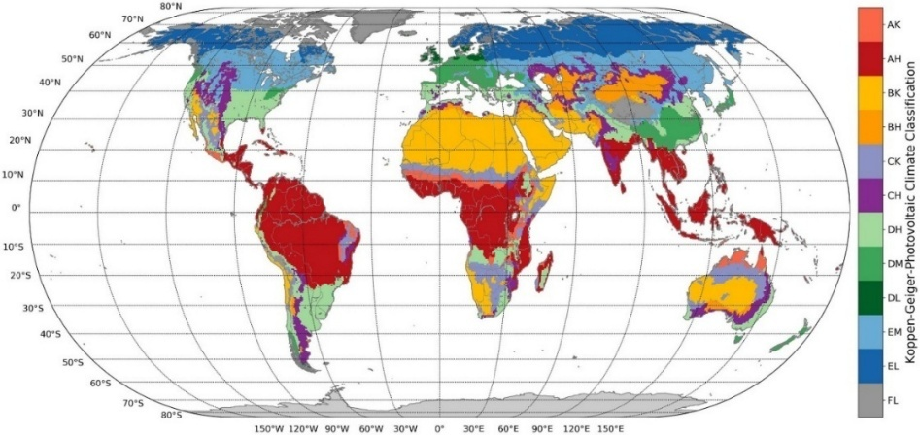
Fig. 1: KG-PV climate classification with the 12 most relevant climate zones (Antarctica excluded) (Ascencio-Vásquez et al., 2019).
This climate classification enables a preliminary categorisation of the PVT system configuration by location, which in turn may provide other benefits such as characterising environmental phenomena (addressing site-specific challenges) and identifying relevant KPIs tailored to specific regions.
2.2. Clustering by main PVT system configuration
Various PVT system configurations have been proposed in the literature and in installations worldwide, depending on the energy requirements and the climate. Due to the variability among existing systems (differing by collector type, final energy use, installation site, system integration, etc.), defining an all-inclusive classification proves challenging. Nevertheless, a broad classification is proposed to encompass the most common configurations reported in the literature and commercial deployments. For this study, two main PVT systems are analysed: liquid and air-based, considering flat-plate and evacuated technologies (excluding concentrating PVT collectors).
2.2.1. Liquid-based PVT systems
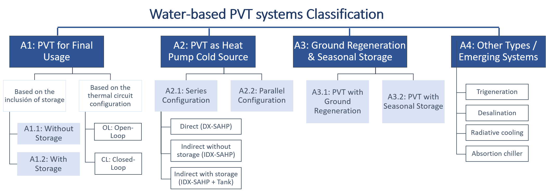
Fig. 2: Liquid-based PVT systems classification.
Liquid-based PVT systems remain the most prevalent to date across market models, PVT collector topologies, and field installations (Herrando et al., 2023). Their distinguishing feature is the use of water as the heat-transfer fluid, sometimes blended with property-enhancing additives, such as glycol, to prevent freezing. Refrigerants are also used when integrating directly with a heat pump. All cases assume electricity generation aimed at partially covering the system's final energy consumption, though this is not used as a classification criterion. According to Task 73, liquid-based PVT systems can be classified into four main categories, as shown in Fig. 2 and detailed below.
A1: PVT for final usage
In this case, the heat generated in the collector is directly used in the final application (DHW, swimming pool, heating network, heated floor, etc.). Auxiliary heating is optional but required to meet the heating demand. Based on the inclusion of thermal storage, two types can be distinguished:
- A1.1: Without thermal storage: PVT-generated heat must be used immediately, restricting applications to daytime thermal demands and making performance highly dependent on solar radiation. While installation is relatively simple, suitable applications are limited to test benches and swimming pools.
- A1.2: With thermal storage (see Fig. 3): Adding a storage tank downstream of the PVT field decouples heat generation from demand by storing thermal energy for later use. Although this increases installation costs and control complexity, it enables a higher utilisation of the generated heat (Axaopoulos and Fylladitakis, 2013).
Based on the thermal circuit configuration, two types can be differentiated:
- Open-loop (OL) (see Fig. 3 left): The same fluid circulates through both the solar collector and the demand circuit, requiring it to meet relevant potable water standards. Example: thermosiphons (Chow et al., 2006).
- Closed-loop (CL) (see Fig. 3 right): Solar and consumption circuits are decoupled via a heat exchanger (either internal or external to the tank). While this slightly lowers thermal efficiency due to heat exchanger losses, it grants full operational freedom regarding the heat transfer fluid (Kalogirou and Tripanagnostopoulos, 2006).
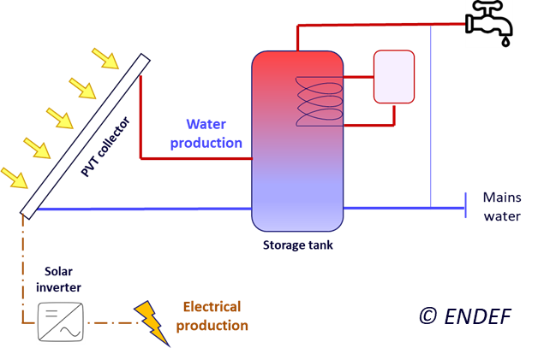 | 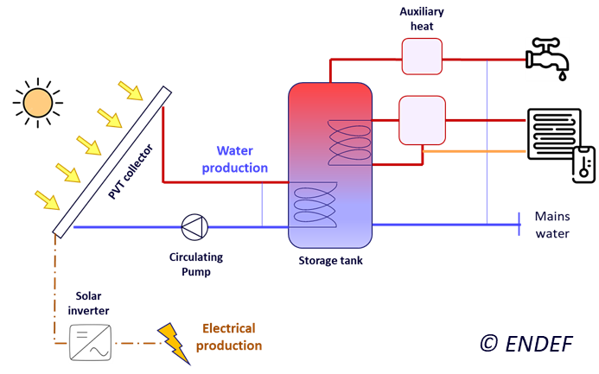
Fig. 3: Schemes for PVT systems for final usage with thermal storage (A1.2): open-loop (left) and closed-loop (right)
A2: PVT integrated with a heat pump
Integrating PVT systems with heat pumps (HPs) enables multiple configurations and use cases, depending on the specific objective. From the thermal perspective, PVT collectors are frequently used to raise the inlet temperature of the HP evaporator, thereby improving its coefficient of performance (COP). This PVT-HP integration can be implemented in series or in parallel, in direct or indirect connection mode and with or without thermal storage. System configuration can become significantly more complex when incorporating reversible HPs that allow for thermal energy storage during cooling mode. From the electrical perspective, the electricity generated by the PVT array is typically used to offset HP power consumption. Specific electrical coupling configurations, such as grid-connected, off-grid, or battery-assisted systems, are beyond the scope of this classification.
Based on the thermal circuit configuration, two types can be distinguished:
- A2.1: Series configuration (see Fig. 4 left):
  - Direct connection: The PVT collector operates as the HP evaporator, sharing the same working fluid (refrigerant). Thermal demand is connected to the condenser side. Commonly referred to as Direct-Expansion Solar-Assisted Heat Pumps (DX-SAHP) (Ji et al., 2009; Vaishak and Bhale, 2020).
  - Indirect connection without storage: The PVT loop is coupled to the HP evaporator, but in separate circuits. Thus, the solar heat-transfer fluid is separated from the HP refrigerant. Commonly referred to as Indirect-Expansion Solar-Assisted Heat Pumps (IDX-SAHP) (Zhang et al., 2013).
  - Indirect connection with storage (see Fig. 4 left): The PVT loop is decoupled from the HP evaporator via a storage tank. It operates via three separate circuits: solar loop, tank-to-evaporator loop, and internal HP circuit. Commonly referred to as IDX-SAHP in series (Dannemand et al., 2020; Obalanlege et al., 2020).
- A2.2: Parallel configuration (see Fig. 4 right): The PVT collector operates almost independently of the HP, as it is not connected to the evaporator. In this setup, both the PVT field and the HP work as parallel heat sources operating at low and high temperatures, respectively, with the PVT field preheating the condenser inlet to maximise overall thermal output (Coca-Ortegón et al., 2023; Herrando et al., 2023).
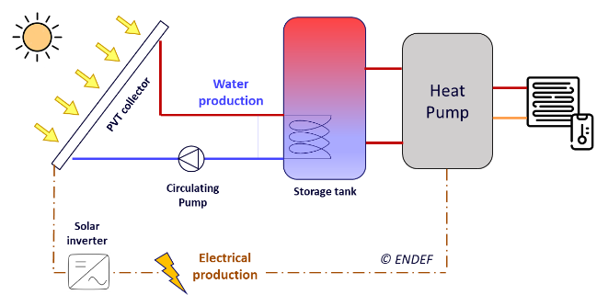 | 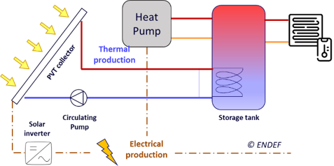
Fig. 4: Schemes for PVT collectors integrated with an HP (A2): in series, A2.1 (left) and in parallel, A2.2 (right)
A3: PVT with ground regeneration/ interseasonal storage
PVT collectors can be integrated with geothermal systems to enhance the utilisation of low-temperature heat and extend operating hours. The recovered thermal energy is used for applications such as borehole regeneration or seasonal storage, helping meet winter heating demands, particularly in cold climates.
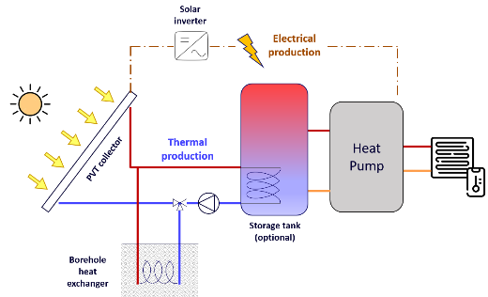 | 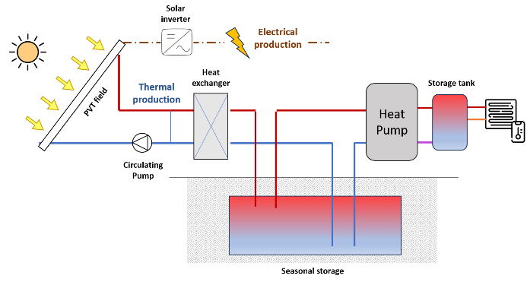
Fig. 5: Schemes for PVT with ground regeneration/ interseasonal storage (A3): ground regeneration, A3.1 (left) and seasonal storage, A3.2 (right)
- A3.1: PVT with ground regeneration (see Fig. 5 left): Excess PVT heat that is not required for immediate use or heat pump operation can be used to thermally recharge the ground around the geothermal field, which acts as a thermal buffer and secondary heat source. This approach is particularly effective and cost-efficient in cold climates, where excessive ground cooling may occur (Chhugani et al., 2023; Liravi et al., 2025).
- A3.2: PVT with seasonal storage (see Fig. 5 right): It incorporates long-term thermal storage to tackle the seasonal mismatch between high summer PVT generation and winter heating demand. It requires a large underground storage to minimise thermal losses and enable seasonal energy shifting (Ul-Abdin et al., 2025).
Note: Configurations where geothermal energy (extracted via boreholes) serves as an additional heat source for the HP, operating independently of the PVT collectors, are categorised under group A2.
A4: Other types/Emerging Systems
This category includes all setups not captured by previous groups. These are emerging or custom-designed systems that integrate PVT collectors with other assets, whose operation and financial feasibility remain areas of ongoing research. Examples include solar combined cooling, heating and power (S-CCHP), desalination, and integration with absorption/adsorption chillers (Buonomano et al., 2017; Chen et al., 2019; Herrando et al., 2020).
2.2.2. Air-based PVT systems
Air-based PVT collectors use air as the heat transfer medium. While air has a lower heat capacity than liquid fluids, these systems require less maintenance and eliminate leakage risks. Most reported applications are still at the development stage (Chaibi et al., 2021; Simón-Allué et al., 2023), with only a few demonstration projects, mainly in façade-integrated systems (Abdelrazik et al., 2022). Commercial use is currently limited to real-time heating, as DHW applications remain under development (Aspetakis and Wang, 2025). These systems can be (see Fig. 6):
- Open/closed loop: They can operate in a closed loop (recirculating air from inside the building and returning it once heated) or an open loop (taking ambient outdoor air and supplying it indoors).
- Natural/forced: Air circulation can be natural (driven by natural convection due to temperature differences) or forced (driven by a fan).
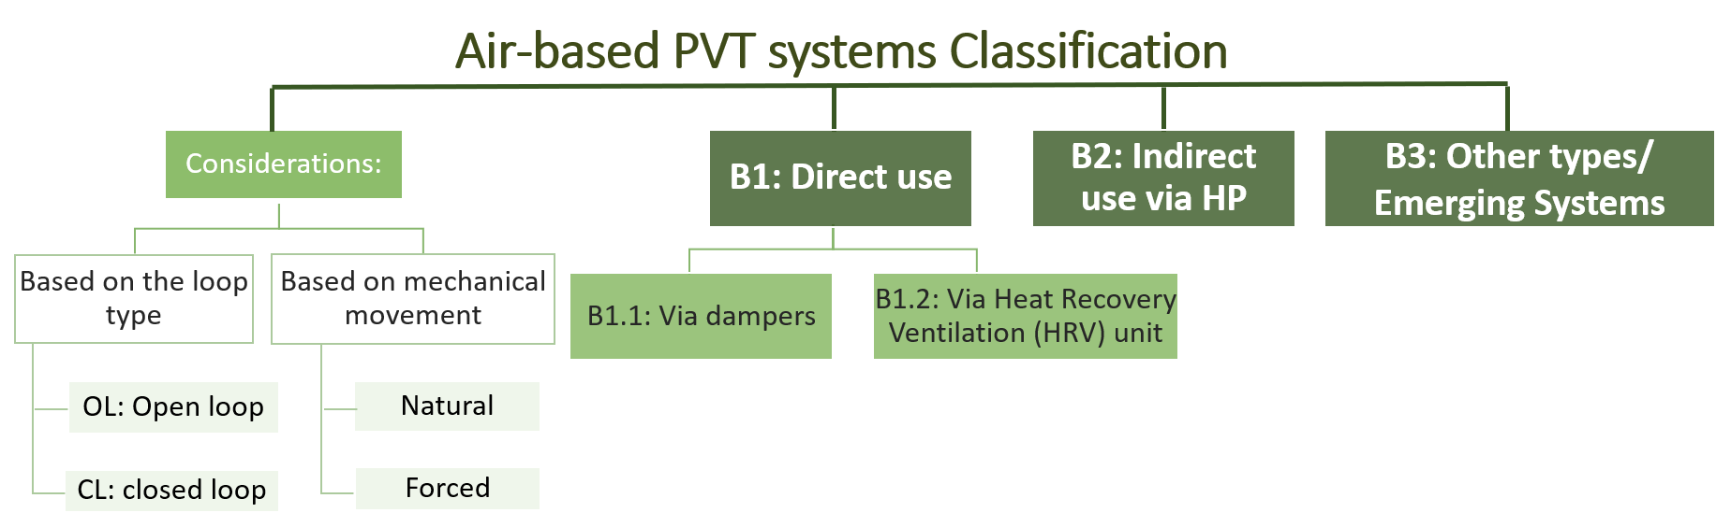
Fig. 6: air-based PVT systems classification.
Based on the connection with other equipment, two main types can be distinguished (see Fig. 6):
B1: Direct use (see Fig. 7 left):
- B1.1: Via dampers: Thermal energy from the collectors is delivered directly indoors. When space heating is unnecessary, the system must be either deactivated or operated using relief dampers to dissipate excess heat.
- B1.2: Via Heat Recovery Ventilation (HRV) unit: The collector outlet feeds the ventilation system inlet, avoiding the intake of cold outdoor air and minimising thermal losses (Ahn et al., 2015; Lamrani et al., 2021).
B2: Indirect use via HP (see Fig. 7 right): the outlet of the air-based PVT collector is connected to an HP, typically an air-source HP, enhancing its COP (Choi et al., 2020; Dumoulin et al., 2021).
B3: Other types/Emerging Systems: This category includes all setups not captured by previous groups. These are emerging or custom-designed systems integrating air-based PVT collectors with other technologies, for instance, with air-to-water heat exchangers for DHW preheating (Aspetakis et al., 2026)
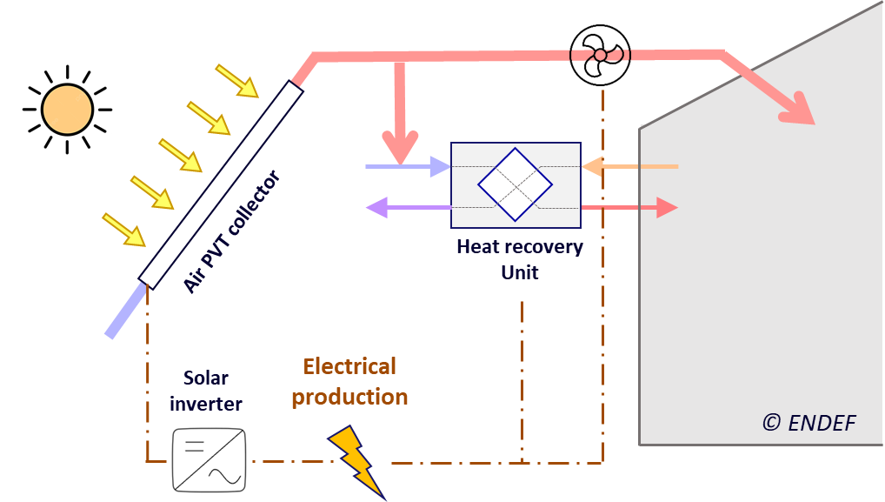 | 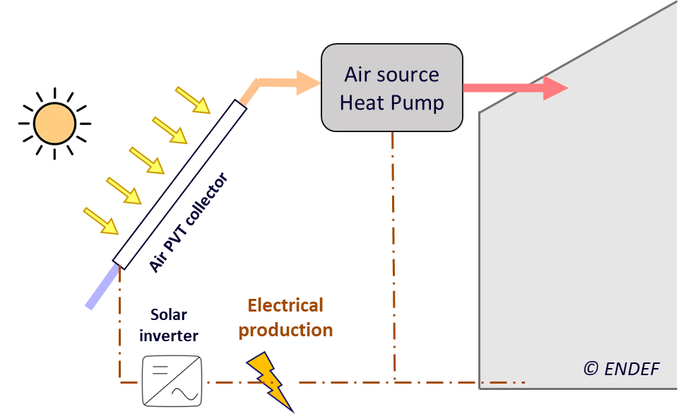
Fig. 7: Main configurations for air-based PVT collectors: direct use through HRV, B1.2 (left) and indirect use via HP, B2 (right)
2.3. Map distribution
Given the wide range of PVT systems and applications, a comprehensive location-based classification is not practical. However, common deployment patterns can be identified based on climatic conditions. Using the KG-PV climate classification and the primary system application, the most prevalent PVT configurations can be grouped into the following categories (see Tab. 1 and Fig. 8):
Tab. 1: Summary of map distribution by system type
PVT System Type | Most Common Climates / Locations | Primary Use
Air-based PVT: B1, B2 | Cold Climates: DL/EL | Space heating & ventilation preheating
Liquid-based PVT: A3 | Cold Climates: DL/EL | Space heating
Liquid-based PVT: A2 | Temperate DM/DL | DHW & space heating
Liquid-based PVT: A1 | Steppe/Temperate: CH/DH | DHW
*C (Steppe), D (Temperate) and E (Cold) climates represent most of the case studies within the IEA SHC Task 60 and Task 73 communities.
1. Cold and High-Latitude Climates (KG-PV Groups E and F border): In regions such as Denmark, Sweden, the Netherlands, Canada, and northern Germany, PVT systems are primarily used to maintain PV electrical efficiency under low ambient temperatures while supplying heat for space-heating applications. Air-based PVT systems are the most common and suitable for these regions because low ambient air temperatures during the day help maintain the PV electrical efficiency, while the extracted heat is highly valuable for ventilation preheating and space heating. Common configurations include:
- Air-based PVT collectors with auxiliary unit (B1.2): Widely used in building-integrated systems, particularly with façade-mounted collectors.
- Air-based PVT collectors with HPs (B2): The collector-heated air serves as a source for an air-to-water HP, reducing frosting risks in heat recovery ventilation (HRV) units during very cold periods.
- Liquid-based PVT with ground regeneration (A3.1): PVT-generated heat is used to recharge geothermal loops, mitigating ground overcooling caused by HP operation and improving long-term system performance.
2. Central Europe and Temperate Regions (KG-PV Groups DM, DL): In countries such as Germany, France, and the UK, configurations are designed for moderate solar resources and seasonal heating needs.
- Liquid-based PVT as HP cold source (A2): Liquid-based PVT collectors are integrated with HPs, both in thermal and electrical components. Mostly found in series configuration (A2.1)
- Liquid-based PVT with ground regeneration (A3.1): PVT collectors are often used to recharge geothermal boreholes or pre-heat the brine loop during winter to improve the Seasonal Performance Factor (SPF)
- Liquid-based PVT with seasonal storage (A3.2): seasonal storage is commonly found in Central Europe; a combination with district heating can also be found.
- Air-based PVT collectors with HRV (B1.2): common for building-integrated applications.
3. Temperate and Mediterranean Climates (KG-PV Group CH and DH): In regions such as Spain, Italy, and Greece, high solar irradiance makes liquid-based PVT systems the dominant choice. Common configurations are:
- Liquid-based PVT for final usage (A1) (open loop): This cost-effective configuration is widely used for DHW production in subtropical climates, where the low risk of freezing eliminates the need for pumps and other complex equipment.
- Liquid-based PVT combined with HP: Parallel Configuration (A2.2): This configuration allows for the provision of heating, cooling and electricity (trigeneration system), with the support of storage tanks. The HP acts as a support unit to heat/cool the tank to the setpoint to provide the heating/cooling demands.
- Emerging systems (A4): PVT combined with other units to produce cooling, heating and power (S-CCHP): Given the high cooling demand in these climates, PVT collectors can be integrated with refrigeration units, such as absorption or adsorption chillers.
- Air-based PVT for direct use (B1): the high irradiance and mild winter temperatures of this area allow the direct use of the heat generated in the air-PVT collectors, via dampers (B1).
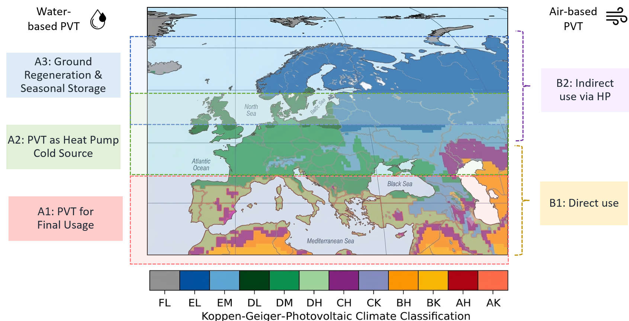
Fig. 8: Map distribution of the most predominant PVT system in Europe.
4. Tropical and Arid Climates (KG-PV Groups A, B):
- Liquid-PVT for final usage (A1): considered the most efficient technology for these regions due to the high year-round demand for preheating and high ambient temperatures.
- Emerging systems (A4): For instance, for desalination: In arid regions, PVT systems are configured to drive thermal desalination (e.g., membrane distillation). The thermal energy from the PV cooling process is used to heat saline water, while the electricity runs the auxiliary pumps.
- Software tools for PVT modelling
3.1. The current PVT software landscape
The PVT community uses a variety of numerical simulation tools, ranging from commercial specific-purpose software for annual performance assessment to general-purpose environments for detailed component analysis. IEA SHC Task 60 outlined an initial analysis of the calculation tools most widely used by the PVT community (Sanz, 2020), highlighting TRNSYS® and Polysun® as the main specific-purpose software options alongside generic software such as EES, MATLAB, or CFD packages (COMSOL, NX, Ansys Fluent, STAR-CCM+). However, that study did not quantify tool usage or contrast their capabilities and modelling frameworks. To capture this, a similar survey was developed within the IEA SHC Task 73 (see Fig. 9).
Beneath the choice of tools lies a more fundamental distinction in the modelling approach, commonly described as a white-box (physics-based), grey-box (semi-empirical/identified parameters), and black-box (data-driven) spectrum (Furbo et al., 2026). White-box models (physics-based) resolve energy, mass and momentum balances across collector layers, up to full CFD. Grey-box models combine a physics-based equation structure with coefficients fitted from standardised tests; the ISO 9806 quasi-dynamic thermal model and the PV temperature-coefficient model are the canonical PVT examples. Black-box models carry no physical structure; they are fast and can reproduce complex measured behaviour, but cannot extrapolate and demand large, validated datasets.
Flexible environments (Python or TRNSYS) can implement any of the three, whereas dedicated packages (Polysun, Modelica) predominantly deploy the grey-box formulation, and CFD packages are inherently white-box. In practice, the grey-box ISO 9806 formulation is the de facto standard, which is why manufacturer-independent characterisation matters. It is important to mention that the coverage pattern observed in Tab. 2 is not incidental. The least supported phenomena are those involving latent heat exchange at the collector surface, for which the ISO 9806 formulation lacks a driving variable, as humidity is not part of its set of independent variables. It follows that these gaps are attributable to the modelling approach rather than to a particular software implementation.
Tab. 2: Characterisation of PVT modelling approaches and their typical coverage of physical phenomena
 | White-box | Grey-box | Black-box
Approach characteristics
Data needs | Geometry & material properties | Standard test coefficients (ISO 9806; PV temp. coef.) | Large, validated monitoring datasets
Strengths | Predictive; extrapolable; interpretable | Efficient, standardised; good within test range | Fast; captures complex measured behaviour
Limitations | Computationally heavy; property data | Valid only within tested envelope | No extrapolation; data-hungry; no insight
Typical tools | Python, Modelica, EES, COMSOL (CFD) | TRNSYS, Polysun, TRANSOL, MATLAB+CARNOT | ML in Python/MATLAB; spreadsheet lookups
Physical-phenomenon coverage
Thermal energy generation | ● | ● | ◐
Electrical (PV) generation | ● | ● | ◐
Dynamic behaviour/thermal inertia | ● | ◐ | ◐
Part-load coupling with heat pumps | ● | ◐ | ◐
Overheating/stagnation | ● | ○ | ○
Wind sensitivity | ● | ◐ | ◐
Radiative (sky) cooling | ● | ◐ | ○
Condensation gains | ◐ | ○ | ○
Ice / frost formation | ◐ | ○ | ○
● well-supported / standard practice ◐ achievable with additional effort or data ○ not typically modelled / impractical
3.2. Adoption across career levels
To better understand the current landscape of PVT simulation, a survey was developed within the PVT4EU project (PVT4EU, 2026) to capture how students and early-career researchers model PVT systems: which tools they use, how they learned, what they represent in their models, and where they get stuck. The objective is to surface the key barriers, data gaps, and training needs so that IEA SHC Task 73 can target its guidelines, tools, and shared resources where they will have the most impact. Master’s students made up 71% of respondents, 67% self-identified as beginners, and 67% had six months or less of PVT experience. Energy Engineering was the dominant background (63%), with respondents spread across eleven countries (led by Sweden and Spain).
As it was observed in IEA SHC Task 60, TRNSYS is the common backbone of both groups (Fig. 9), reflecting the dominance of the standardised grey-box formulation it hosts. Beyond it, the toolchains diverge: the flexible, code-based environments MATLAB and Python, usual hosts for white-box models, are markedly more prevalent among early-career researchers (26% and 23%, respectively) than in the expert community (7% and 17%, respectively), whereas the dedicated design tool Polysun is prominent among experts (24%). Purely data-driven (black-box) modelling remains marginal in both groups, held back by the data scarcity previously mentioned.

Fig. 9: Simulation tools used for PVT modelling by career level/early-career researchers (PVT4EU, n = 24) vs. expert/industry community (IEA Task 73, n = 42) (values are each tool’s share of mentions within its group).
It is important to mention that the maturation of large language models has shifted the cost balance between dedicated and general-purpose approaches: implementation tasks that previously constituted one of the main barriers to custom modelling can now be generated with artificial intelligence (AI) assistance from a specified set of governing equations in a small fraction of the time formerly required, so development effort is no longer the binding constraint. The constraint migrates instead to validation, since such implementations reproduce the requested formulation without assurance of physical correctness and must be benchmarked against analytical limits or standardised test data.
Across 24 respondents, perceived difficulty averaged 3.4 out of 5 and was essentially flat across experience levels. More experience did not make the task feel easier, because the main obstacles are shared-infrastructure gaps (e.g., missing data, open tools, and reference cases) rather than individual capability. It follows that open, validated reference models should target TRNSYS and Python to reach both audiences, while Polysun cannot be ignored where industrial uptake is the goal. This is the type of challenge that the IEA SHC Task 73 aims to tackle.
Modelling is primarily conducted at the system and building scales, focusing on liquid-based PVT collectors integrated into residential heating systems. A significant portion of respondents also model hybrid systems and integration with heat pumps, particularly for series heating and borehole regeneration.
- Key Performance Indicators by target group
One of the challenges in communicating the benefits of PVT systems is the lack of consensus on KPIs to represent both energy performance and economic investment, allowing for system-to-system comparisons. To address this, a survey was conducted among the PVT expert community of Task 73 to establish a clear list of KPIs to serve as a future guide for presenting, evaluating, and comparing potential PVT solutions. The indicators have been categorised based on the study scope (energy or economic) and the target group (research and market purposes).
The following sections present a ranked set of energy and economic KPIs for PVT systems and indicate their relevance to each target group. The proposed list of KPIs is a simplified version of the KPI framework developed in IEA SHC Task 60 (Zenhäusern et al., 2020), with no additional KPIs identified during the consultation.
4.1. Energy-related KPIs
Regarding energy indicators, there is consensus between the two target audiences on the most relevant metrics (see Fig. 10); Gross Yield (GTY, GEY) and Solar Fraction (SF) were highlighted (both receiving over 60% of the votes), along with the Seasonal Performance Factor (SPF) for HP-coupled systems (exceeding 70%).
From a market perspective, the subsequent top-ranked indicators focus on the direct contribution to final energy demand (Self-Consumption Fraction, Primary Energy Consumption) and avoided emissions (Global Warming Potential), which are frequently linked to financial subsidies. Conversely, from a research standpoint, alongside the environmental component, relevant indicators include system performance, such as solar utilisation ratios and instantaneous efficiencies. The largest discrepancy between target groups lies in Non-renewable Primary Energy Consumption, identified as relevant for the market with 54% of the votes, compared to less than 28% for R&D.
Energy KPIs
Fig. 10. Ranking of KPIs relevant from the energy point of view
4.2. Economics-related KPIs
Regarding economic indicators, a larger divergence is observed between the two target audiences (see Fig. 11). From a market perspective, the most straightforward indicators for a customer are the initial investment and annual savings. These metrics are not only the clearest and simplest to understand but also have a direct impact on the end-user's finances. From a research standpoint, however, the most relevant indicators are those that combine production and economic data, such as the Levelized Cost of Heat and Electricity (LCoH, LCoE), closely followed by the Levelized Cost of Energy (LCE) and annual savings. The largest discrepancy is found in initial investment and maintenance costs, both of which are considered significantly more important for the market than for R&D.
Economic KPIs
Fig. 11. Ranking of KPIs relevant from an economic point of view
- Barriers, uncovered phenomena and gaps in research and modelling
Finally, this study aims to identify existing barriers in PVT system modelling and clarify which physical phenomena are fully understood and which demand further standardisation. This analysis is based on survey findings conducted within the PVT4EU project and the IEA SHC Task 73.
5.1. Barriers
Based on the results, integration knowledge is the number one barrier (see Fig. 12 left). Two-thirds of the survey respondents cite lack of integration knowledge, ahead of lack of manufacturer data (54%), validation data scarcity (42%) and lack of open tools (42%). The open-text answers reinforce this strongly: the recurring theme is that difficulty arises not in the PVT unit itself but when coupling it with other components. The perceived difficulty in PVT modelling has a mean rating of 3.4 out of 5, with most respondents choosing 3 or 4. The rating does not show differences between beginners (3.4) and intermediates (3.4).
Concerning data accessibility, economic performance and operational records constitute the primary constraints. (see Fig. 12 right). Cost/economic data (CAPEX/OPEX) and control/operational data are tied as the hardest to obtain (54% each). According to respondents, non-disclosure of manufacturer data, specifically costs, thermal parameters, and control strategies, hampers techno-economic modelling and cross-study comparisons. Missing part-load performance maps restrict dynamic simulations of HP-coupled PVT systems in tools like TRNSYS.

Fig. 12: Main barriers to PVT system modelling (left) and data types reported as hardest to obtain for PVT modelling (right), reported by early-career researchers (n = 24; multi-select).
Two other key barriers identified are the scarcity of high-quality validation data and the mismatch between datasheet specifications and software input requirements. For the first problem, researchers indicate that open-access datasets from real pilot plants are needed to bridge this gap. For the second one, a "constant bottleneck” is reported to manually translate real-world hardware data into simulation environments, which forces greater alignment between manufacturers and software developers. Survey respondents answered that what would help the most during PVT modelling are reference models and worked examples. Reference models (71%) top the list of what would help most, followed by case studies (63%), guidelines and tutorials (58% each), training workshops (54%) and open datasets (50%). This is a coherent request for shared, reusable, example-driven resources, and it falls squarely within the deliverable categories of the IEA SHC Task 73.
5.2. Uncovered phenomena and gaps in research and modelling
The survey of the IEA SHC Task 73 community (see Fig. 13) shows a consensus in the modelling of thermal and electrical generation, categorised as the most well-established phenomena (4/5), probably because they are supported by normative coefficients in standards such as ISO 9806:2017 or IEC 61215. However, the survey reveals greater disparity regarding other phenomena, such as wind effects (2.6/5), overheating (3.1/5), and dynamic behaviour (3.2/5). While mean scores indicate these mechanisms are reasonably well understood and supported by literature models, the scatter in individual responses highlights a clear need for standardisation, particularly for the latter two. There is a consensus on the lower ratings for radiative cooling (2.2), condensation (1.9) and ice formation (1.8), which highlights a critical disconnection between theoretical equations and practical software implementation. Condensation and icing are especially poorly addressed, while these phenomena are critical to PVT-HP systems operating below ambient.
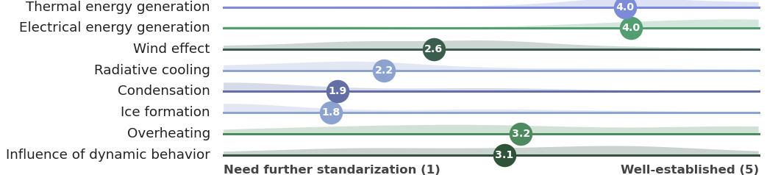
Fig. 13. Perceived maturity level of the main phenomena occurring in PVT systems according to the IEA SHC Task 73 community.
The PVT community needs to improve modelling experience and system accuracy. The survey respondents expressed a strong need for standardised guidelines, open-access reference models, and detailed case studies. There is also a call for information tailored to different learning levels to help beginners transition into more advanced PVT system design.
- Discussion and Conclusions
This work establishes a framework towards defining and standardising the monitoring of operational PVT systems, by identifying the main PVT system configurations, mapping their distribution, proposing KPIs, and categorising the primary modelling gaps currently faced by the community. Classification along the white-to-black-box spectrum shows that the grey-box ISO 9806 formulation is the community’s de facto standard, and the least-covered phenomena, i.e. condensation, frost, radiative cooling and stagnation, are those it cannot represent without extension. The gaps therefore track the modelling approach rather than the software, so community effort is better directed at standardised and validated model extensions than at tool-specific fixes.
A critical outcome is that in PVT modelling, system integration constitutes the primary hurdle rather than the collector unit itself. The most significant barriers cited by practitioners are a lack of integration knowledge and the difficulty in obtaining operational, control, and economic data. These challenges are most pronounced when modellers attempt to couple PVT collectors with HPs, storage tanks, and complex control logic. Data scarcity remains the binding constraint for achieving model reliability and reproducibility. Key gaps include manufacturer performance maps (e.g. part-load conditions), economic CAPEX/OPEX data, and high-quality experimental validation datasets. Currently, the absence of comparable validation cases often forces modellers to rely on heavy assumptions, which can lead to non-reproducible results, a constraint that AI-assisted implementation makes more acute rather than less, since models can now be reproduced faster than they can be validated.
Two different levels of extension are identified for the modelling of latent heat phenomena. For condensation, an additional coefficient acting on a humidity-potential term could in principle be determined within the grey-box approach, provided that i) humidity and collector surface temperature are included in the thermal performance test protocol, and ii) the test sequences are designed to decorrelate these variables from the sky radiation and wind effects. For frost formation, this treatment is not sufficient, since the frost thickness behaves as a state variable with memory rather than as an instantaneous flux. Its representation therefore requires increasing the order of the model instead of extending its set of coefficients. This distinction is relevant when defining priorities for future standardisation work. To address these community needs, further work is proposed in four key areas within the ongoing IEA SHC Task 73:
- Prioritise integration reference cases: The community requires validated, documented examples of PVT systems coupled with heat pumps, storage, and a realistic control logic.
- Release open, validated reference models: Efforts should focus on the dominant tools, TRNSYS, MATLAB, and Python, leveraging validated models that community members have offered to contribute.
- Publish open datasets and harmonise KPIs: There is an urgent need for open-access economic, validation, and high-resolution weather data, while aligning system characterisation with ISO 9806 standards.
- Produce tiered guidelines and tutorials: Future educational material should be designed for beginner-to-advanced levels, as current resources are often reported to assume an advanced level of prior knowledge.
This information will be further developed and expanded in the coming years alongside the ongoing IEA SHC Task 73, aiming to move PVT technology from a niche market into a standardised global energy solution.
- References
Abdelrazik, A.S., Shboul, B., Elwardany, M., Zohny, R.N., Osama, A., 2022. The recent advancements in the building integrated photovoltaic/thermal (BIPV/T) systems: An updated review. Renew. Sustain. Energy Rev 170, 112988.
AEE INTEC, 2025. Solar Heat Worldwide - Global Market Development and Trends 2024.
Ahn, J.G., Kim, J.H., Kim, J.T., 2015. A study on experimental performance of air-type PV/T collector with HRV. Energy Procedia 78, 3007–3012.
Ascencio-Vásquez, J., Brecl, K., Topič, M., 2019. Methodology of Köppen-Geiger-Photovoltaic climate classification and implications to worldwide mapping of PV system performance. Solar Energy 191, 672–685.
Aspetakis, G., Ploskić, A., Wang, Q., 2026. Exploring Air-PVT for buildings in cold climates: Experimentally validated energy system modeling. Appl. Therm. Eng. 292, 130388.
Aspetakis, G., Wang, Q., 2025. Critical review of Air-Based PVT technology and its integration to building energy systems. Energy and Built Environment 6, 121–135.
Axaopoulos, P.J., Fylladitakis, E.D., 2013. Performance and economic evaluation of a hybrid photovoltaic/thermal solar system for residential applications. Energy Build. 65, 488–496.
Buonomano, A., Calise, F., Palombo, A., Vicidomini, M., 2017. Adsorption chiller operation by recovering low-temperature heat from building integrated photovoltaic thermal collectors: Modelling and simulation. Energy Convers. Manag. 149, 1019–1036.
Chaibi, Y., El Rhafiki, T., Simón-Allué, R., Guedea, I., Luaces, S.C., Gajate, O.C., Kousksou, T., Zeraouli, Y., 2021. Air-based hybrid photovoltaic/thermal systems: A review. J. Clean. Prod. 295.
Chen, H., Li, Z., Xu, Y., 2019. Evaluation and comparison of solar trigeneration systems based on photovoltaic thermal collectors for subtropical climates. Energy Convers. Manag. 199, 111959.
Chhugani, B., Pärisch, P., Helmling, S., Giovannetti, F., 2023. Comparison of PVT - heat pump systems with reference systems for the energy supply of a single-family house. Solar Energy Advances 3.
Choi, H.-U., Kim, Y.-B., Son, C.-H., Yoon, J.-I., Choi, K.-H., 2020. Experimental study on the performance of heat pump water heating system coupled with air type PV/T collector. Appl. Therm. Eng. 178, 115427.
Chow, T.T., He, W., Ji, J., 2006. Hybrid photovoltaic-thermosyphon water heating system for residential application. Solar Energy 80, 298–306.
Coca-Ortegón, A., Simón-Allué, R., Guedea, I., Brun, G., Villén, R., 2023. Operational performance of trigeneration PVT-assisted HP system. Energy Build. 296.
Dannemand, M., Sifnaios, I., Tian, Z., Furbo, S., 2020. Simulation and optimization of a hybrid unglazed solar photovoltaic-thermal collector and heat pump system with two storage tanks. Energy Convers. Manag. 206, 112429.
Del Amo, A., Martínez-Gracia, A., Pintanel, T., Bayod-Rújula, A.A., Torné, S., 2020. Analysis and optimization of a heat pump system coupled to an installation of PVT panels and a seasonal storage tank on an educational building. Energy Build. 226, 110373.
Dumoulin, R., Rounis, E.D., Athienitis, A., 2021. Operation and grid interaction modeling of a house with a building integrated photovoltaic thermal system coupled to an air-source heat pump. Sci. Technol. Built Environ. 27, 1311–1329.
Furbo, S., Dannemand, M., Cardoso, J.P., Paulo, B., Jahangir, M.T., Arto Delgado, A., 2026. D5.4: Analysis of the integration of model predictive control strategies (PVT4EU-WP5-D5.4, Version 2.0).
Herrando, M., Coca-Ortegón, A., Guedea, I., Fueyo, N., 2023. Experimental validation of a solar system based on hybrid photovoltaic-thermal collectors and a reversible heat pump for the energy provision in non-residential buildings. Renewable and Sustainable Energy Reviews 178.
Herrando, M., Simón, R., Guedea, I., Fueyo, N., 2020. The challenges of solar hybrid PVT systems in the food processing industry. Appl. Therm. Eng. 116235.
Herrando, María, Wang, K., Huang, G., Otanicar, T., Mousa, O.B., Agathokleous, R.A., Ding, Y., Kalogirou, S., Ekins-Daukes, N., Taylor, R.A., Markides, C.N., 2023. A review of solar hybrid photovoltaic-thermal (PV-T) collectors and systems. Prog. Energy Combust. Sci.
IEA SHC, 2025. Task 73 - PVT Heating Systems [WWW Document].
IEA SHC, 2020. Task 60 - Application of PVT Collectors [WWW Document].
Ji, J., Hanfeng, H., Chow, T., Pei, G., He, W., Liu, K., 2009. Distributed dynamic modeling and experimental study of PV evaporator in a PV/T solar-assisted heat pump. Int. J. Heat Mass Transf. 52, 1365–1373.
Kalogirou, S.A., Tripanagnostopoulos, Y., 2006. Hybrid PV/T solar systems for domestic hot water and electricity production. Energy Convers. Manag. 47, 3368–3382.
Lamrani, B., Draoui, A., Kuznik, F., 2021. Thermal performance and environmental assessment of a hybrid solar-electrical wood dryer integrated with Photovoltaic/Thermal air collector and heat recovery system. Solar Energy 221, 60–74.
Liravi, M., Karkon, E., Dai, Y., Georges, L., 2025. On the proper integration of pre-heating tanks in ground source heat pump systems combined with photovoltaic-thermal panels. Thermal Science and Engineering Progress 60, 103379.
Obalanlege, M.A., Mahmoudi, Y., Douglas, R., Ebrahimnia-Bajestan, E., Davidson, J., Bailie, D., 2020. Performance assessment of a hybrid photovoltaic-thermal and heat pump system for solar heating and electricity. Renew. Energy 148, 558–572.
PVT4EU, PVT4EU project - Photovoltaic Thermal for Europe https://pvt4eu.eu/ (accessed 7.30.26).
REN21, 2025. Renewables 2025 Global Status Report: Global Overview.
Sanz, A., 2020. Systems Numerical simulation tools for PVT collectors - SHC Task 60/Report C1.
Simón-Allué, R., Villén, R., Brun, G., Lara, Y., Guedea, I., 2023. Design, Development, and Performance Evaluation of a New Photovoltaic-Thermal (PVT) Air Collector: From Lab Testing to Field Measurements. Processes 11.
Ul-Abdin, Z., Isabella, O., Santbergen, R., 2025. Performance evaluation of solar heat systems integrated with seasonal heat storage across varied operating modes for building applications: The case of Netherlands. Solar Energy 299, 113772.
Vaishak, S., Bhale, P. V., 2020. Performance analysis of a heat pump-based photovoltaic/thermal (PV/T) system. Clean Technol. Environ. Policy.
Zenhäusern, D., Gagliano, A., Hadorn, J.-C., Lämmle, M., Herrando, M., 2020. Key Performance Indicators for PVT Systems Key Performance Indicators for PVT Systems SHC Task 60/Report D1.
Zhang, X., Zhao, X., Xu, J., Yu, X., 2013. Characterisation of a solar photovoltaic/loop-heat-pipe heat pump water heating system. Appl. Energy 102, 1229–1245.

