Carbon nanotubes grafted on fibres diffuse damage in composites leading to their improved toughness at the micro-scale

Qiang Liu¹, Stepan V. Lomov² and Larissa Gorbatikh³

Department of Materials Engineering, KU Leuven, Leuven, Belgium
Emails: ¹qiang.liu@kuleuven.be, ²stepan.lomov@kuleuven.be, ³larissa.gorbatikh@kuleuven.be, Web Page: http://composites-kuleuven.be

Keywords: carbon nanotubes, damage diffusion, interfacial debonding

Abstract

Grafting of carbon nanotubes (CNTs) on fibres is a promising route to improve the toughness of fibre reinforced polymer composites. This toughness improvement is generally attributed to the additional energy dissipated by the debonding and pull-out of CNTs from the matrix although other mechanisms are also known to contribute to it. In this work, we use a computational framework to reveal different toughening mechanisms and to understand their relative contributions to the toughness of composites with CNT grafted fibers. These mechanisms occur at different length scales and concurrently. Our computational experiments show that there are mainly three contributing toughening mechanisms: damage diffusion and energy dissipation through CNT debonding and fibre/matrix interfacial debonding, with the first one playing a dominant role. Compared to the pristine fibre reinforced composites, the nano-engineered composites show significantly suppressed the fibre/matrix interfacial debonding due to CNT forests, and result in a dramatic improvement of the transverse strength and toughness.

1. Introduction

Grafting of CNTs on fibres has been demonstrated to increase the toughness of fibre reinforced polymer (FRP) composites [1-3]. This beneficial effect of CNTs, however, has not always been reproduced and the reported levels of improvement have been shown to vary significantly from one study to another. It is not surprising as toughness depends on activated failure mechanisms and variety of material parameters controlling them. The toughening effect of CNTs is generally attributed to the additional energy consumed by their pull-out from the matrix when damage develops [4, 5]. However, CNTs have also been shown to re-distribute stresses even prior to the damage onset [6-9] and to engage toughening mechanisms in the matrix itself [10, 11]. Activation of several mechanisms presents an opportunity to influence the damage development and to achieve a considerable increase in toughness of FRP composites. These different mechanisms have not yet been studied concurrently, which is done in the present work through a novel computational approach applied at the microscopic level.

2. Methodology

To investigate the microscopic failure mechanisms in FRP composites with CNT-grafted fibres, a finite-element (FE) model with a direct representation of both CNT/matrix and fibre/matrix interfaces has been developed as shown in Fig. 1(a). The content of CNTs in the matrix is 0.3 wt%, and the volume fraction of microfibres is 60%. The model’s capabilities are demonstrated in the case of a unidirectional carbon fibre/epoxy composite subjected to transverse tension. To reduce computational time, the composite is modelled as a unit cell containing a fibre half and two fibre quarters under periodic boundary conditions. Carbon fibres and CNTs are assumed to be elastic and free of damage during deformation.

Three types of damage mechanisms are introduced into the FE model: 1) fibre/matrix interfacial debonding, 2) CNT/matrix interfacial debonding and 3) ductile damage in the matrix. Both CNT/matrix and fibre/matrix interfaces are modelled with the help of the commonly-used cohesive zone elements. The fibre/matrix and CNT/matrix interface parameters are cited from the experimental data measured by Varna et al. [12] and Cooper et al. [13], respectively. The epoxy matrix is modelled using an elasto-plastic constitutive model with isotropic damage developed by Melro et al. [14, 15], which is implemented by the user subroutine UMAT in the commercial FE analysis software ABAQUS [16]. The material parameters of carbon fibre and CNTs are the same as those reported by Romanov et al. [6-9]. Key interfacial parameters are summarized in Table 1.

Table 1. The key material parameters of fibre/epoxy and CNT/epoxy interfaces.

 | Mode I |  | Mode II
 | Strength  (MPa) | Fracture energy (J/m²) | Strength  (MPa) | Fracture energy (J/m²)
Fibre/epoxy interface | 50 | 2 | 70 | 6
CNT/epoxy interface | 38 | 0.9 | 38 | 0.9

3 Results and discussions

Figures 1(b)~(d) shows the microscopic damage development in the CNT-modified composites and the reference case (the pristine composite without CNTs), which corresponds to the failure of the composites. For the composite with CNT-grafted fibres, CNT debonding and pull-out are observed clearly in Fig. 1 (c); this directly augments energy consumption. More importantly, significant damage diffusion is observed serving as an additional toughening mechanism. The microscopic damage is primarily diffused as matrix cracking in resin rich zones between CNT forests as depicted in Fig. 1(b). Fibre/matrix interfacial debonding is significantly suppressed in most regions due to the presence of CNT forests (Fig. 1(b)). Some partial fibre/matrix interfacial debonding is observed in the region where local CNT content is relatively low as indicated by Fig. 1(c). When CNTs are absent, damage primarily starts from the carbon fibre/matrix interface, and spreads to the matrix subsequently as shown in Fig. 1(d).

The stress-strain curves for the pristine and CNT-modified composites during tension are shown in Fig. 2(a). Compared to the pristine composites, dramatic improvements in the tensile strength and toughness have been obtained for the CNT-modifed composite. To reveal the relative contributions of the three toughening mechanisms, i.e. fibre/matrix interfacial debonding, CNT debonding and damage diffusion, the strain energy consumed by each constituent is recorded, and their change in function of the tensile strain are shown in Figs. 2(b) and (c) for pristine and CNT-modified composites, respectively. Fibre/matrix interface dominates the energy consumption after the peak stress for the pristine composite. For CNT-modified composite, the strain energy consumed by matrix has a dominant contribution, and it is even higer than the total strain energy in the reference composite. Due to the suppressing effect of CNT forests, the fibre/matrix interface has a minor contribution to the total strain energy. It is interesting to note that the energy consumed by CNTs or CNT/matrix interface is very low relative to that consumed by the matrix. We thus conclude that the majour toughening mechanism induced by CNT forests is damage diffusion in the matrix, while both CNT debonding and fibre/matrix interfacial failure have very limited contributions.

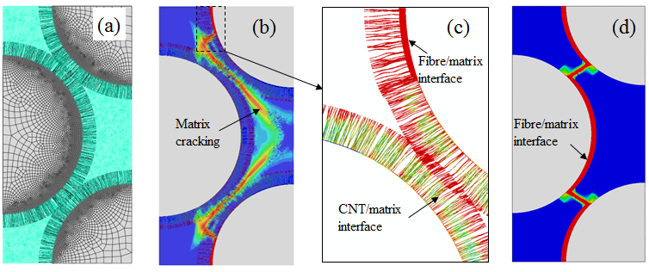
Figure 1. (a) A 3D FE model of a composites with CNT gradfed fibers; (b) and (c) the damage in the matrix and at interfaces for this CNT modified composite; (d) damage in the pristine composite without CNTs for comparison.

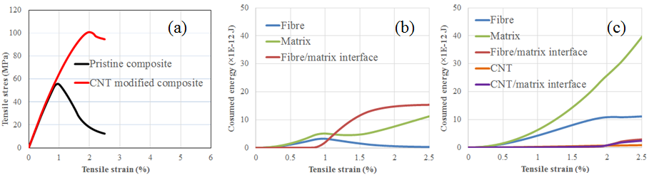

Figure 2. FE simulation results: (a) stress-strain response for pristine and CNT modified composites, the energy consumption mechanisms for pristine (b) and CNT modified (c) composites.

4. Conclusions

In this work, the microscopic damage behaviour in composites with CNT grafted fibres is investigated using a computational FE approach. Three types of damage mechanisms, i.e. fibre/matrix interfacial debonding, CNT/matrix interfacial debonding and the damage in the matrix, are introduced into the analysis. The simulation results indicate that CNT forests effectively suppress fibre/matrix interfacial debonding compared to the case of the composite without CNTs. The presence of CNT forests is found to result in a dramatic improvement of the strength and toughness of the composite.

Three types of toughening mechanisms, i.e. fibre/matrix interfacial debonding, CNT debonding and damage diffusion, are revealed through the present simulation. The damage diffusion exhibits that microscopic damage is diffused as matrix cracking in resin rich zones between CNT forests. The present study indicates that damage diffusion is the major toughening mechanism in the composites with CNT grafted fibres, while CNT debonding and fibre/matrix interfacial dobonding both play secondary roles.

Acknowledgments

The authors acknowledge the support from C24/16/021 project, funded by KU Leuven Research Council. S.V. Lomov holds the Toray Chair for Composite Materials at KU Leuven, the help of which is acknowledged.

References

[1] M.S. Islam, Y. Deng, L. Tong, S.N. Faisal, A.K. Roy, A.I. Minett, V.G. Gomes. Grafting carbon nanotubes directly onto carbon fibers for superior mechanical stability: Towards next generation aerospace composites and energy storage applications. Carbon 96: 701-710, 2016.
[2] N. De Greef, L. Gorbatikh, S.V. Lomov, I. Verpoest. Damage development in woven carbon fiber/epoxy composites modified with carbon nanotubes under tension in the bias direction. Composites Part A: Applied Science and Manufacturing 42(11): 1635-1644, 2011.
[3] N. De Greef, L. Gorbatikh, A. Godara, L. Mezzo, S.V. Lomov, I. Verpoest. The effect of carbon nanotubes on the damage development in carbon fiber/epoxy composites. Carbon 49(14): 4650-4664, 2011.
[4] M. Zhao, L. Meng, L. Ma, L. Ma, X. Yang, Y. Huang, J.E. Ryu, A. Shankar, T. Li, C. Yan. Layer-by-layer grafting CNTs onto carbon fibers surface for enhancing the interfacial properties of epoxy resin composites, Composite Science Technology 154: 28-36, 2018.
[5] H. Qian, E.S. Greenhalgh, M.S. Shaffer, A. Bismarck. Carbon nanotube-based hierarchical composites: a review. Journal of Mateirals Chemistry, 20(23): 4751-4762, 2010.
[6] V.S. Romanov, S.V. Lomov, I. Verpoest, L. Gorbatikh. Modelling evidence of stress concentration mitigation at the micro-scale in polymer composites by the addition of carbon nanotubes. Carbon, 82: 184 -194, 2015.
[7] V.S. Romanov, S.V. Lomov, I. Verpoest, L. Gorbatikh. Can carbon nanotubes grown on fibers fundamentally change stress distribution in a composite?. Composites Part A: Applied Science and Manufacturing, 63: 32-34, 2014.
[8] V. Romanov, S.V. Lomov, I. Verpoest, L. Gorbatikh. Inter-fiber stresses in composites with carbon nanotube grafted and coated fibers, Composite Science Technology, 114: 79-86, 2015.
[9] V.S. Romanov, S.V. Lomov, I. Verpoest, L. Gorbatikh. Stress magnification due to carbon nanotube agglomeration in composites. Composite Structures, 133: 246-256, 2015.
[10] T.M. Herceg, S.-H. Yoon, M.S.Z. Abidin, E.S. Greenhalgh, A. Bismarck, M.S. Shaffer. Thermosetting nanocomposites with high carbon nanotube loadings processed by a scalable powder based method. Composite Science Technology 127: 62-70, 2016.
[11] T.M. Herceg, M.S.Z. Abidin, E.S. Greenhalgh, M.S. Shaffer, A. Bismarck. Thermosetting hierarchical composites with high carbon nanotube loadings: en route to high performance. Composite Science Technology 127: 134-141, 2016.
[12] J. Varna, L. Berglund, M. Ericson, M. Transverse single-fibre test for interfacial debonding in composites: 2. Modelling. Composites Part A: Applied Science and Manufacturing, 28: 317-326, 1997.
[13] C.A. Cooper, S.R. Cohen, A.H. Barber, H.D. Wagner. Detachment of nanotubes from a polymer matrix. Applied Physics Letters, 81(20): 3873-3875, 2002.
[14] A. Melro, P. Camanho, F.A. Pires, S. Pinho. Micromechanical analysis of polymer composites reinforced by unidirectional fibres: Part I - Constitutive modelling. International Journal of Solids and Structures, 50(11): 1897-1905, 2013.
[15] A. Melro, P. Camanho, F.A. Pires, S. Pinho. Micromechanical analysis of polymer composites reinforced by unidirectional fibres: Part II - Micormechanical analyses. International Journal of Solids and Structures, 50(11): 1906-1915, 2013.
[16] V. ABAQUS, 6.14 Documentation, Dassault Systemes Simulia Corporation, 2014.

