Low energy curing methods of resins and natural fiber/resin composites against conventional ones. Comparison on the base of their mechanical performance

G. Petropoulos, E. Kollia, I. Fotiou, S.Tsantzalis and V. Kostopoulos*
Applied Mechanics Laboratory, Department of Mechanical Engineering and Aeronautics, University of Patras, Patras University Campus, GR-26500 Patras, Greece
*corresponding author, e-mail address: kostopoulos@upatras.gr
ABSRACT
Curing process during composite manufacturing is one of the bottlenecks that are both wasteful in terms of time and of energy consumption. Any reduction in curing cycle durations and energy consumption could dramatically affect the environmental impact of composites together with cost. The most widely used processing method to produce aerospace components is autoclave resistance heating bag molding.
In recent years, alternative energy sources for curing have received considerable attention. Among them, microwave and infrared radiation have shown good potential for curing of thermoset polymers and their composites. Both provide reduced curing duration along with energy savings [1–4]. Due to the intrinsic nature of the internal heating (as opposed to external heating by conduction), microwave energy offers the possibility of faster and more uniform cure of thermosets and their composites. In recent years it has been reported that microwave processing of composites gives clear advantages over conventional curing, such as: volumetric and selective heating, reduction of cycle time as well as energy savings [5]. It has been shown that advantages of MW heating can also be realized for industrial manufacturing too [6].
Infrared (IR) heating has already been established as an energy efficient alternative to conventional processing for adhesives and coatings, glass and ceramics, metal processing, medical, and packaging, plastics, rubber, printing, textiles, and wood industry [7]. IR curing directly heats the resin/composite without heating the medium present between the IR source and the resin/composite, by selective energy absorption.
The main purpose of the present study is to investigate and compare the mechanical and thermomechanical properties of different types of materials cured by using conventional and low energy curing methodologies and estimate the energy consumption needed for eache method per unit volume. Towards this direction, two different types of materials were examined. The first one is an epoxy resin 1500/1504, was provided by Resoltech, France, and the second one is a composite plate made of flaxpreg UD 150 prepreg material, provided by Lineo, France.
Differential Scanning Calorimetry (DSC) was used for the quantification of the degree of cure and the glass transition temperature for all cases, while tensile (ISO 527) and three point bending (ISO 178) tests were performed in order to estimate the influence of the curing method in final properties of the two types of the materials.
From the above investigation the following conclusions are drawn:
For the epoxy system (Resoltech 1500/1504)
- It was experimentally confirmed that microwave and infrared curing provide as high degree of cure as the conventional curing.
- microwave curing provides almost equal mechanical properties as the conventional curing, while IR curing concludes to slightly lower values
For the composite system (Flaxpreg UD150)
- Microwave curing although has the lower energy consumption compared against infrared and conventional curing, it concludes to the higher degree of cure and consequently to slightly higher mechanical properties.
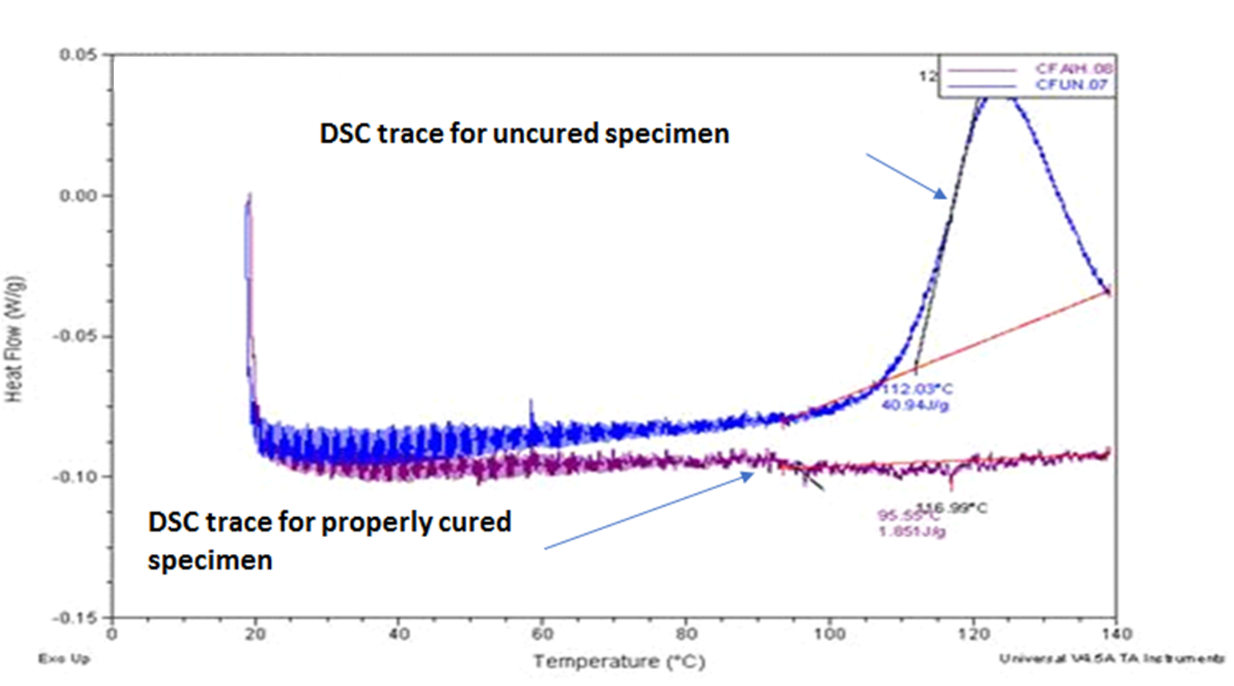
Figure 1: DSC curves of uncured and cured sample in order to calculate the degree of cure.

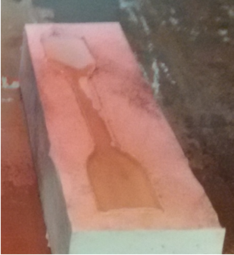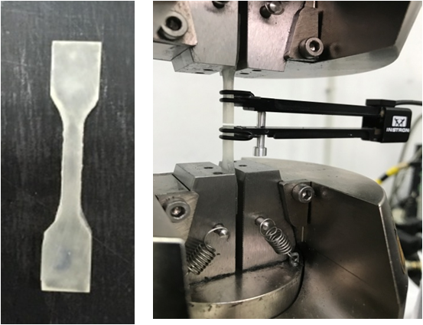
Figure 2: samples of epoxy resin (Resoltech 1500/1504) and tensile experimental test.
reReferences
1. Rao RMVGK, Rao S and Sridhara BK. Studies on tensile and interlaminar shear strength properties of thermally cured and microwave cured glass–epoxy composites. J Reinf Plast Compos 2006; 25: 783–795.

2. Gourdenne AJ. Radiofrequency (27.12 MHz) processing of thermosetting DGEBA epoxy resins. High Perform Polym 2005; 17: 425–448.

3. Adanur S and Arumugham Y. Characteristics of ultraviolet cured glass epoxy composites: experimental procedures and testing. J Ind Text 2002; 32: 93–106.

4. Ribeiro R, Morgan RJ, Bonnaud L, Lu J, Sue H-J, Choi J, et al. Characterization of the electron beam curing of cationic polymerization of diglycidylether of bisphenol a epoxy resin. J Compos Mater 2005; 39: 1433–1447.

5. Thumm, Feher L. M. and Drechsler, K. Gigahertz and Nanotubes – Perspectives for Innovations with Novel Industrial Microwave Processing Technology. Adv. Eng. Mater.,2006;8:26-32.
6. L., Feher and M, Thumm. Microwave innovation for industrial composite fabrication-the HEPHAISTOS technology IEE Transactions on Plasma Science, 2004;32.
7. Belhamra A, Diabi R and Moussaoui A. Technology and applications of infrared heating in the industrial area. J Eng Appl Sci 2007; 2: 1183–1187.

