Effect of In-Situ Treatment on the Quality of Thermoplastic Composite Tubes Made by Automated Fiber Placement (AFP)

S. V. Hoa¹, J. F. Simpson², D. I. Rosca³, D. M. Hoang⁴, F. Shadmehri⁵
Concordia Center for Composites (CONCOM), Mechanical, Industrial & Aerospace Engineering, Concordia University, Montreal, Center for Research in Polymers and Composites (CREPEC)
Montreal, Quebec, Canada
¹hoasuon@encs.concordia.ca, ²jeff_fs@hotmail.com, ³rosca@encs.concordia.ca, ⁴hoangminhduc.ite@gmail.com, ⁵farjad.shadmehri@concordia.ca
Keywords: In-Situ Treatment, Repass, Automated fiber placement (AFP), Thermoplastic composites, Surface roughness

Abstract
Composite structures used as aerosurfaces in aerodynamic applications should have a certain surface finish requirement. In manufacturing of thermoplastic composites using automated fiber placement (AFP) for aerodynamic applications, it is not only desirable to achieve acceptable consolidation by using AFP alone, but also to achieve acceptable surface roughness required for aerosurfaces. In this study, an in-situ treatment called “repass” was implemented on thermoplastic composite tubes made out of carbon fibre/PEEK to improve surface roughness of the samples. Moreover, the effect of this in-situ treatment on some other quality indicators, namely short beam strength (SBS) and void content, was investigated. Autoclave treated tube was used as reference for comparing surface quality and other quality indicators.

INTRODUCTION
Technical advances in the automated manufacturing of composites have attracted increasing interest of aerospace industry due to allowing fabrication of parts with complex geometries. Specifically, automated fiber placement (AFP) has provided a new perspective in the manufacturing of large-scale composite structures in comparison with the traditional manufacturing processes.
Comparing thermoset vs. thermoplastic composites, AFP manufacturing of large-scale thermoplastic composites is being held back due to technical challenges of processing at high temperature. Avoiding autoclave would significantly reduce manufacturing cost and time, however, various parameters involved in the AFP process make it challenging to achieve a desirable quality of an AFP-made laminate without secondary process. Previous studies have shown that the quality of fiber-placed thermoplastic composites strongly depends on the process parameters such as temperature, pressure and layup speed [1-21].
One of the important requirements for structures categorized as aerosurfaces is the surface roughness and surface waviness. The surface finish has a direct impact on the aerodynamic loads as airstream flows over the aero-structure. In-situ manufacturing of thermoplastic composites using AFP, generally leads to a very rough surface if layup is performed on a male tool. Therefore, it is important to find processes that can achieve a good surface finish using an in-situ treatment technique in applications where aerodynamics require a smooth surface finish [22].
In this study, an in-situ treatment called “repass” has been implemented to primarily improve the surface finish quality of the thermoplastic composites for aerodynamic applications. The “repass” treatment was applied on a composite tubes made out of carbon fibre/PEEK material and the effect of that on surface roughness of the tubes was evaluated. Since this in-situ treatment (i.e., repass) could potentially have an effect on other quality indicators, the effect of applying a repass one or two times, between each layer of material, on the short-beam shear strength (SBS) and void content of the rings cut from the tubes is also studied. One of the AFP-made tubes was also treated in the autoclave to obtain reference values for comparison purposes for all quality indicators, namely, surface roughness, short-beam shear strength, and void content.

Manufaturing and treatment of samples
Carbon fiber/PEEK composite tubes were manufactured using a robotic type AFP available at Concordia Center for Composites (CONCOM) lab on a 4-inch diameter mandrel as shown in Figure 1. The AFP system employs a nitrogen hot gas torch to melt the incoming tape and a steel roller for compaction.
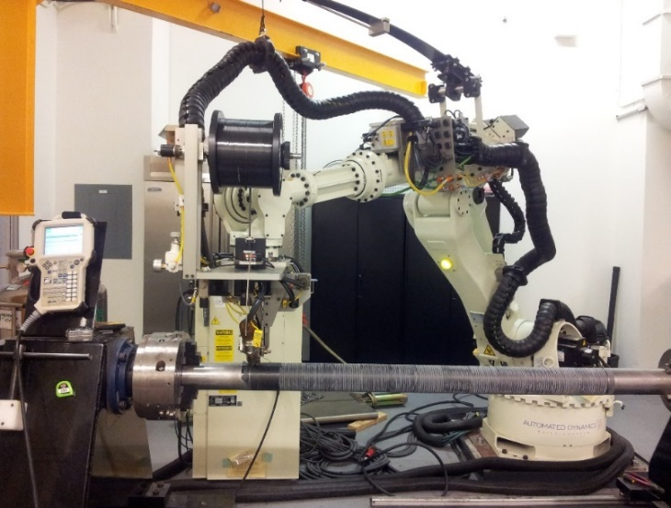
Figure 1: Manufacturing of thermoplastic composite tube at CONCOM

The tubes were made using ¼-inch wide AS4/APC-2 carbon fibre/PEEK tape from CYTEC Solvay Group. The unidirectional tape consists of a 68:32 weight percentage mixture of carbon fiber (AS4) and Polyetheretherketone (PEEK) matrix (APC-2) [23]. The nominal value of fibre volume fraction is 61%. The processing parameters were as follows: 875°C hot gas temperature, 80 lbf compaction force and 2 in/sec layup speed. The total layup sequence was [0]₂₄.

2.1 Repass Treatment
The term “repass” refers to the application of heat and pressure via the AFP head to a substrate layer, without the addition of new material (Figure 2). To observe the effect of repass treatment between layers on the mechanical properties of the finished laminate, the tube was manufactured in four sections; first, a layer of material was placed on the entire length of the tube, then, one repass was performed on half of the tube length, followed by a second repass on one quarter of the tube length (Figure 3). That resulted in having half of the tube length without any repass before moving on to the next layer and repeating the same process. The repasses were performed on every layer by applying heat and pressure using the aforementioned processing parameters, and the torch position remained unchanged. After AFP-manufacturing of the tube, one of the sections with 0 repass was treated in the autoclave and the other sections were prepared for surface roughness measurement, short-beam shear strength (SBS) test and microscopic inspection.
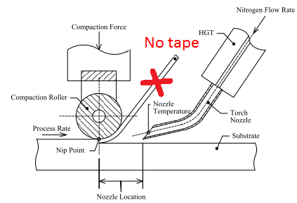
Figure 2: Repass in-situ treatment
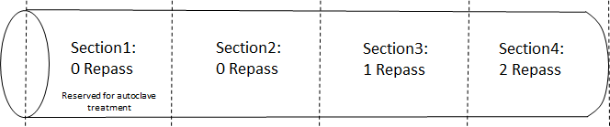
Figure 3: AFP-made tube with repass sections

2.2 Autoclave Treatment

After the AFP layup of the tube, section 1 of the tube with zero repass was bagged and consolidated in the autoclave to be used as reference. The schematic cross-section of the bagged assembly can be seen in Figure 4 with the autoclave cycle shown in Figure 5. The autoclave air temperature was used to control the consolidation cycle. Once treated in the autoclave, the section1 of the tube was prepared for inspection and testing to be used as reference to compare to the non-autoclave treated sections.
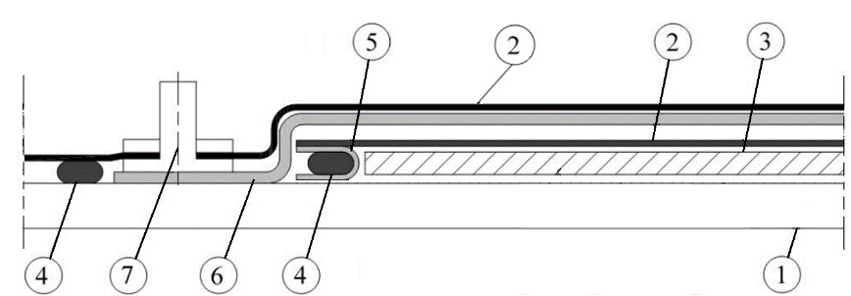
Figure 4: Cross-section of vacuum-bagged laminate: 1. Steel mandrel 2. Bagging film (Thermalimide, Airtech) coated with release agent (Frekote® 770-NC™, Henkel) 3. AFP processed laminate 4. High-temperature sealant tape (SM-5160 TACKY-TAPE®, Schnee-Morehead) 5. 6 oz. plain woven fiberglass cloth 6. Breather (Airweave®UHT 800, Airtech), 7. Vacuum valve (VAC VALVE SSHTR and AHTC 1000 QTD, Aritech)

Figure 5: Autoclave processing cycle of carbon fibre/PEEK

Surface roughness measurements
To determine the effect of the repass treatment on the surface quality, the surface roughness of the tubes manufactured using different number of repass treatments and autoclave treated ones were measured using a Mitutoyo SJ-400 surface roughness tester. The measurements were performed on four different segments around the circumference of the tube and along the tube axis. The measurement setup is shown in Figure 6. Typical roughness graphs along the tube axis is shown in Figure 7. Maximum height deviation ($R_{z}$), which is defined as the mean values of the summation of profile peak height and profile valley depth within the sampling length is reported in Table 1 and plotted in Figure 8.

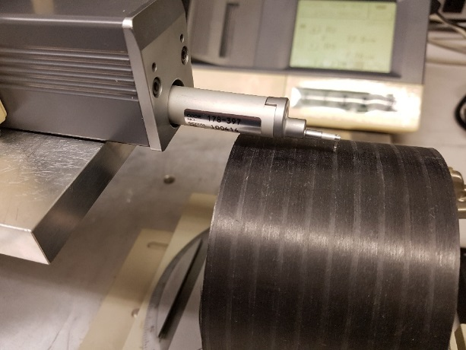
Figure 6: Roughness measurement setup

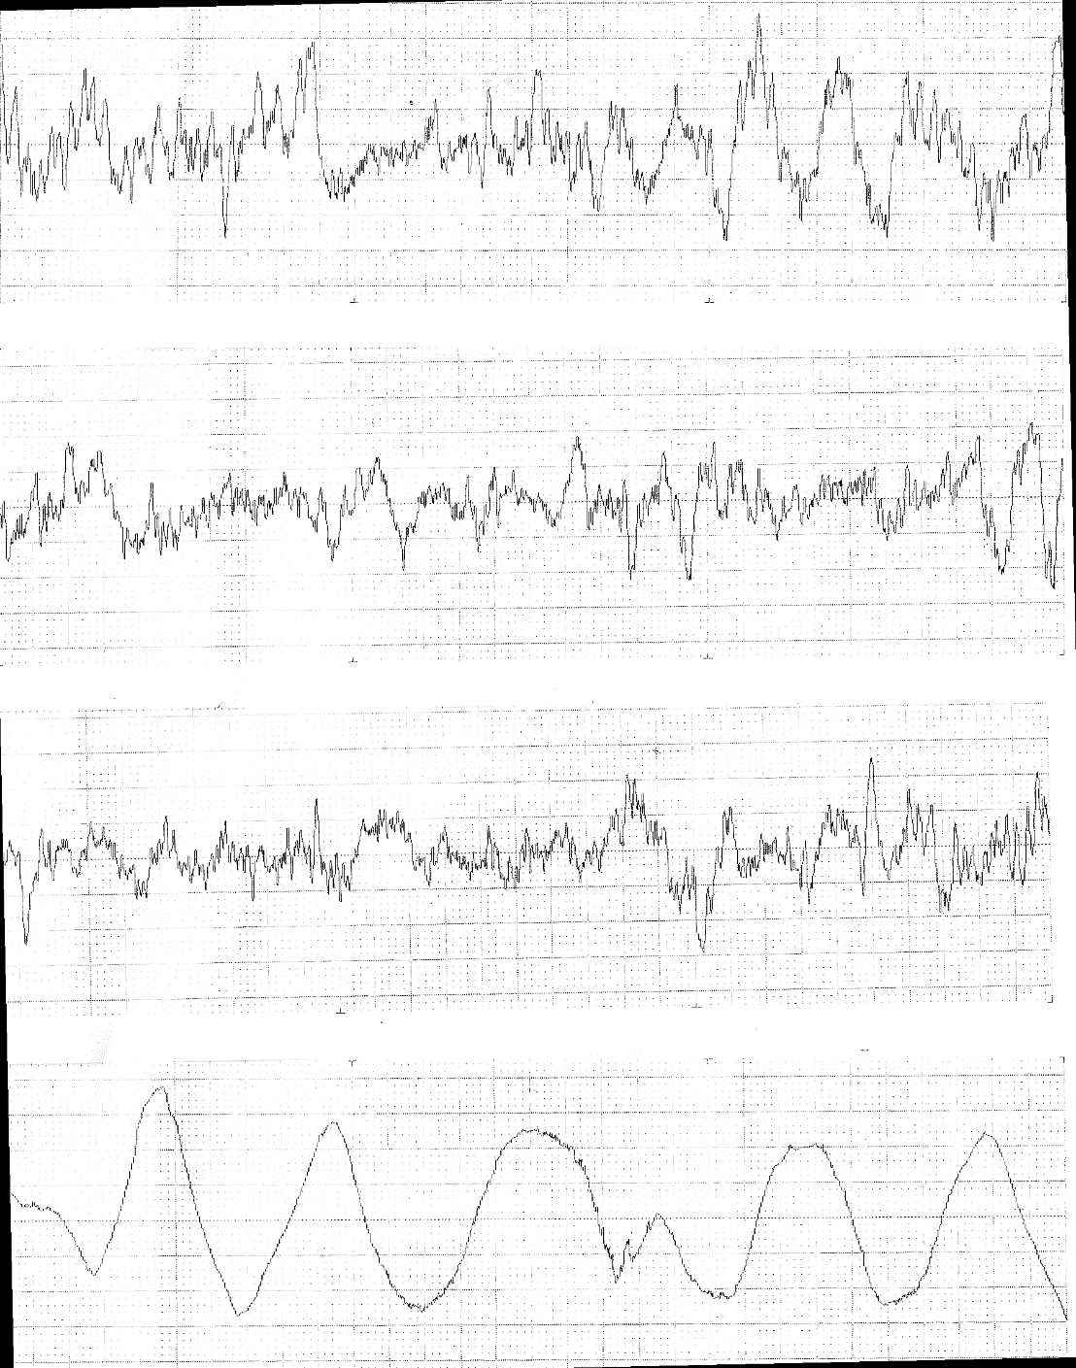
0R= without repass
1R= 1 repass treatment
2R= 2 repass treatment
A= autoclave treatment
Length (mm)
Amplitude, (μm)
0R
1R
2R
A
2 mm
80
80
80
40
Figure 7: Typical effect of the “repass” on roughness

As it can be seen from Table 1, the repass treatment improves significantly the surface roughness compared to non-treated samples. With only one repass, the surface roughness improved by about 2 times (from $41.1 μm$ to$21.6 μm$) in comparison to the samples without any treatment. Another observation is that the second round of repasses roughened the surface of the tube slightly. These results are promising and show the capability of repass in-situ treatment in improving surface roughness of thermoplastic composites made by AFP. Furthermore, as can be seen from Table 1, the autoclave treated tube had slightly smoother surface compared to other tubes. However, looking at the roughness profile along the axis of the tube revealed that the roughness on the autoclave treated tube is due to imprint of bagging materials on the outer surface of the tube. Using a caul plate would probably result in a much smoother surface finish of the tube.

0R= without repass
1R= 1 repass treatment
2R= 2 repass treatment
A= autoclave treatment
Figure 8: Roughness measurement perpendicular to fiber direction

Table 1: Roughness measurement
Sample condition | $$R_{z} (μm)$$ | SD*
Without repass | 41.1 | 3.1
1 repass treatment | 21.6 | 4.3
2 repass treatment | 24.4 | 5.1
Autoclave treatment | 19.5 | 4.2
*SD= Standard Deviation

Shor-beam SHEAR strength test
To investigate the effect of repass treatment on the mechanical properties dominated by the matrix, the short beam shear test was performed according to ASTM D2344. The specimens were prepared according to the ASTM standard from the tubes made with different treatments. Autoclave treated samples were also tested for reference.
The short-beam strength test was performed using a universal testing machine with the capacity of 5 kN. A test fixture in accordance with the ASTM standard D2344 was used, and the loading nose was located equidistant between the side supports (Figure 9). Static loads were applied at a rate of 1 mm/min and tests were continued until a load drop-off of 30% was observed or until the head travel exceeded the specimen nominal thickness. The load versus displacement graphs were recorded for all tests and sample graphs for autoclave treated and repass treated specimens are depicted in Figure 10.

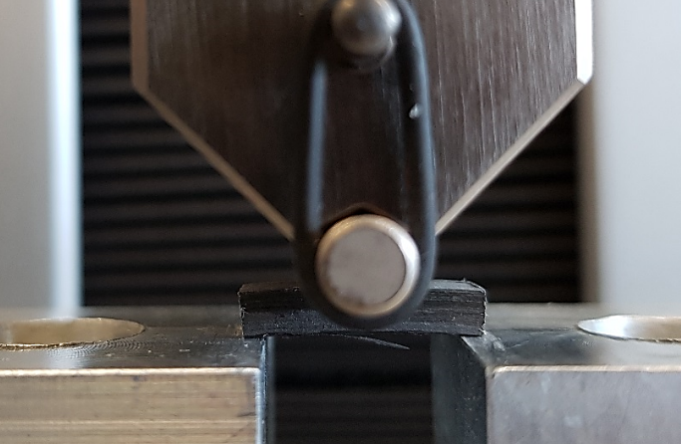
Figure 9: Short-beam strength test setup

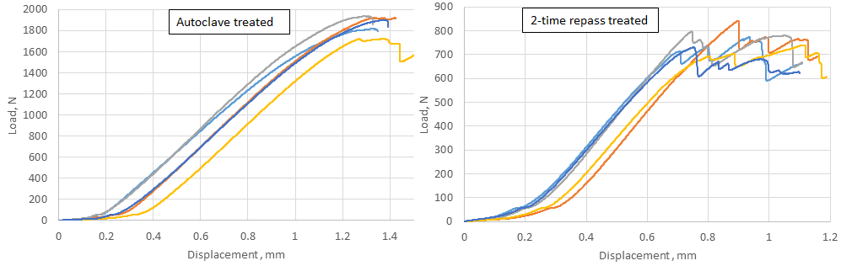
Figure 10: Typical load versus displacement results for autoclave treated and repass treated specimens

At least five specimens per process condition were tested, and the average value and standard deviation were calculated for each series of tests. Table 2 and Figure 11 present the summary of the results. The strength were calculated according to ASTM D2344 as follows:
$F^{sbs}=0.75\frac{P_{m}}{bh}$ (1)
where $F^{sbs}$ is short-beam strength, - $P_{m}$ is maximum load during the test, $b$ is measured width and $h$ is measured thickness of the specimen. Typical failure modes were identified as interlaminar shear for almost all specimens, with a crack started and propagated in the middle of the plies either at the center or at the edge of the specimen.

Table 2: Short-beam strength of AFP-made tubes with different treatments
Sample condition | $$F^{sbs}(MPa)$$ | SD*
Without repass | 28.70 | 2.36
1 repass treatment | 33.60 | 1.01
2 repass treatment | 33.05 | 1.82
Autoclave treatment | 84.20 | 3.27
*SD= Standard Deviation

0R= without repass
1R= 1 repass treatment
2R= 2 repass treatment
A= autoclave treatment
Figure 11: Short-beam strength results
It can be observed that applying one repass treatment after each layer slightly improved the short-beam strength. However, applying the second repass did not improve the short-beam strength at all. Autoclave treated samples had by far the highest short-beam strength among all samples. Looking at Figure 10, one can see clear difference between behaviors of autoclave versus repass treated samples. While the autoclave treated specimens showed more sudden type of failure, the repass treated ones showed more gradual failure behavior.

Micrographic study
To see the effect of repass and autoclave treatments on the microstructure of the specimens, samples were cut, embedded in resin, and polished for microscopic study. Several micrographs with 10X magnification were taken along the thickness of each sample, and then image stitching technique through a plugin in ImageJ software [24-25] was used to stitch the micrographs together to obtain one image with relatively high magnification covering the whole thickness of the sample. Typical micrographs of samples with repass treatment, no- repass treatment and autoclave treatment are shown in Figure 12.
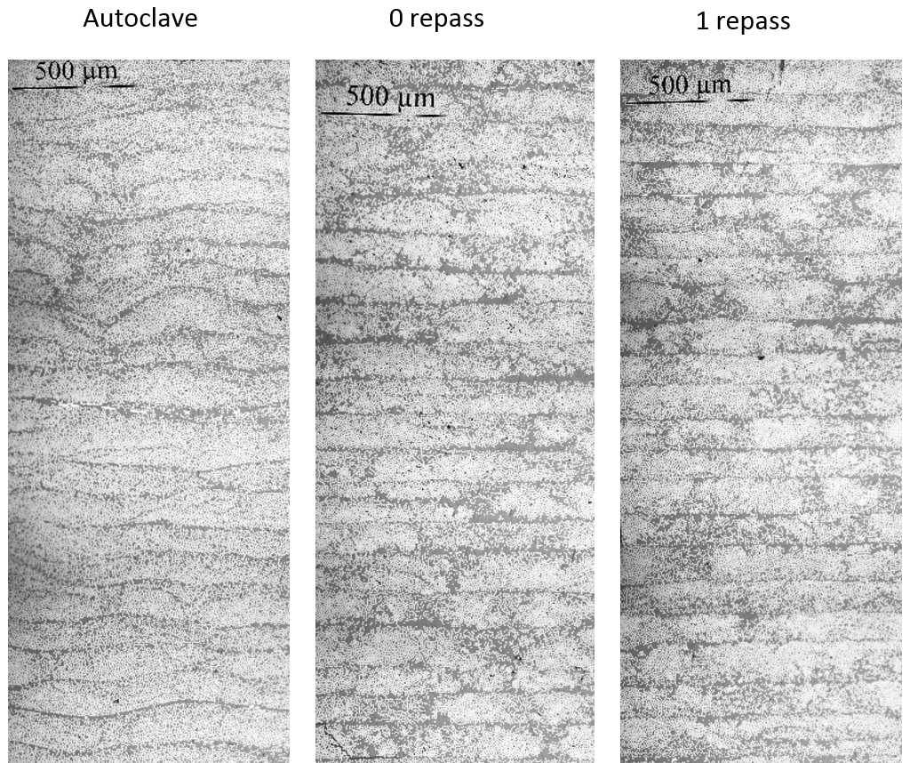
Figure 12: Typical micrographs of samples with different treatments

Comparing autoclave treated samples with no-autoclave treated ones, it can be seen that more resin pockets (resin reach areas) exist on no- autoclave treated samples. Furthermore, it is evident from these micrographs that repass treatments make adjacent layers more distinguishable by separating each layer from its adjacent one (yellow splines in the images). However, autoclave treatment allows the fibers to move at each layer interface in a way that adjacent layers are less distinguishable. This is one of the factors contributing toward higher short-beam strength of these samples.
Void content of different samples were also measured using micrograph image processing by color threshold of the images to distinguish the voids from the resin and fibers. It was observed that void content for all samples (i.e., autoclave treated, repass treated and no- repass treated) was less than 0.5% and no significant effect of repass treatment was witnessed.

Conclusion
The effect of in-situ repass treatment on the quality of AFP-made Carbon fiber/PEEK tubes was investigated. During repass treatments, all process parameters (e.g., torch temperature, compaction force, layup speed etc.) were kept the same. AFP-made tube with autoclave treatment was also analyzed to show the effect of autoclave consolidation on the quality of the thermoplastic laminate and to serve as reference for comparison purpose.
It was observed that the repass treatment improves the surface finish of the laminate considerably, making it more possible to meet aerodynamic smoothness requirements for aerodynamic application. However, repass treatment does not affect short-beam strength of the samples significantly (only slight improvement). Micrograph study revealed that repass treated samples have layers that are more distinguishable from one another. In contrast, autoclave treated samples have no discernable layer separation and less resin rich areas between layers.
ACKNOWLEDGEMENT
The financial support from the Natural Sciences and Engineering Research Council of Canada is appreciated.
REFERENCES
- M. A. Khan, P. Mitschang, R. Schledjewski, Identification of some optimal parameters to achieve higher laminate quality through tape placement process, Advances in Polymer Technology, 2010, 29 (20), 98–111.
- M. A. Khan, P. Mitschang, R. Schledjewski, Parametric study on processing parameters and resulting part quality through thermoplastic tape placement process, Journal of Composite Materials, 2012, 47 (4), 485-499.
- R. Schledjewski, Thermoplastic Tape Placement Process – In-situ Consolidation is Reachable, Macromolecular Engineering, 2009, 38 (9-10), 379-386.
- F. Shadmehri, X. Cai, M. Hojjati, J. Chen, S. V. Hoa, Determination of optimal process parameters for manufacturing thermoplastic composite rings by automated fiber placement, American Society for Composites (ASC), 26th Technical Conference (the second joint US-Canada conference on composites), Montreal, Canada, September 2011
- X. Cai, F. Shadmehri, M. Hojjati, J. Chen, S. Hoa, Determination of Optimum Process Conditions for Processing AS4/APC-2 Thermoplastic Composites by Automated Fiber Placement, The Society for the Advancement of Material and Process Engineering (SAMPE) conference, Baltimore, MD, May 2012.
- J. Fortin-Simpson, M. I. El-Geuchy, F. Shadmehri and S. V. Hoa, Effect of processing parameters on the bending behavior of thermoplastic composite tubes made by automated firber placement process, American Society for Composites (ASC), 28th Technical Conference, State College, PA, 2013.
- S. V. Hoa, Principles of the Manufacturing of Composite Materials. DEStech Publications, Inc., 2nd edition, 2017.
- M. A. Khan, P. Mitschang, R. Schledjewski, Tracing the Void Content Development and Identification of its Effecting Parameters During In-situ Consolidation of Thermoplastic Tape Material, Polymers & Polymer Composites, 2010, 18 (1), 1-15.
- Yousefpour, M. N. Ghasemi Nejhad, Experimental and Computational Study of APC-2/AS4 Thermoplastic Composite C-Rings, Journal of Composite Materials, 2001, 14(2), 129-145.
- Wouter Grouve, Weld Strength of Laser-Assisted Tape-Placed Thermoplastic Composites, Ph.D. Thesis, University of Twente, Enschede, the Netherlands, August 2012.
- John Tierney, John W. Gillespie, Jr., Modeling of Heat Transfer and Void Dynamics for the Thermoplastic Composite Tow-Placement Process, Journal of Composite Materials, 2003, 37 (19), 1745-1768.
- John Tierney, John W. Gillespie, Jr., Modeling of In Situ Strength Development for the Thermoplastic Composite Tow Placement Process, Journal of Composite Materials, 2006, 40 (16), 1487-1506.
- Célia Nicodeau, Continuous welding modeling of thermoplastic matrix composites, Engineering Sciences [physics]. Arts et Métiers ParisTech, 2005.
- Tierney. J. J., R. F. Eduljee, and J. W. Gillespie, Jr., Material Response During Robotic Tow Placement of Thermoplastic Composites, Proceedings of the 11th Annual Advanced Composites Conference, pp. 315-329.
- M. N. Ghasemi Nejhad, R. D. Cope and S. I. Güçeri, Thermal Analysis of In-Situ Thermoplastic-Matrix Composite Tape Laying, Journal of Composite Materials, 1990, 4(1), 29-45.
- Gilles Regnier, Célia Nicodeau, Jacques Cinquin, Jacques Verdu, Francisco Chinesta, A Multiphysic and Multiscale Approach to Model the Continuous Welding of Thermoplastic Matrix Composites, 16th International Conference on Composite Materials (ICCM-16), 2007, Kyoto, Japan.
- M. N. Ghasemi Nejhad, Issues Related to Processibility during the Manufacture of Thermoplastic Composite Using On-Line Consolidation Technique, Journal of Composite Materials, 1993, 6, 130-145.
- M. Hojjati, G. Chouinard, A. Yousefpour, Crystallization Behavior of PEKK Thermoplastic Polymer, The Society for the Advancement of Material and Process Engineering (SAMPE) conference, Long Beach, California. April 30, 2006 – May 4, 2006.
- Mohamed Ibrahim El-Geuchy, Bending Behavior of Thick-Walled Composite Tubes, Ph.D. Thesis, Concordia University, April 2013.
- Minh Duc Hoang, Procedure for making flat thermoplastic composite plates by Automated Fiber Placement and their mechanical properties, M.Sc. Thesis, Concordia University, April 2015.
- S. V. Hoa, Minh Duc Hoang and Jeff Simpson, Manufacturing Procedure to Make Flat Thermoplastic Composite Laminates by Automated Fibre Placement and Their Mechanical Properties, Journal of Thermoplastic Composite Materials, 2017, 30(12), 1693-1712.
- F. Shadmehri, S. V. Hoa, J. Fortin-Simpson, H. Ghayoor, “Effect of In-Situ Treatment on the Quality of Flat Thermoplastic Composite Plates Made by Automated Fiber Placement (AFP)”, Advanced Manufacturing: Polymer & Composite Science, DOI: 10.1080/20550340.2018.1444535, 2018.
- Thermoplastic Composite Material Handbook, Cytec Engineered Materials, 1999.
- C. A. Schneider, W. S. Rasband, K. W. Eliceiri, NIH Image to ImageJ: 25 years of image analysis, Nature methods, 2012, 9(7), 671-675.
- S. Preibisch, S. Saalfeld, P. Tomancak, Globally optimal stitching of tiled 3D microscopic image acquisitions, Bioinformatics, 2009, 25(11), 1463-1465.

