EuroSun2026
SIMULATION OF PARABOLIC TROUGH COLLECTORS IN TRNSYS AND COMPARISON WITH MEASUREMENT DATA

Silas Tamm¹, Magdalena Berberich¹, Dirk Krüger², Javier Iñigo-Labairu², Navina Konz²
Solites – Steinbeis Innovation gGmbH¹, DLR – German Aerospace Center²
tamm@solites.de, berberich@solites.de, dirk.krueger@dlr.de, javier.inigolabairu@dlr.de, navina.konz@dlr.de

Summary
This paper presents a comparison between TRNSYS simulation results and measurement data from a parabolic trough collector plant in Turnhout, Belgium. The investigated concentrating solar thermal plant supplies process heat to an industrial production site and is analyzed within the German research project ProSolNetz. Measurement data from the ongoing commissioning and optimization phase are processed and used as boundary conditions for a TRNSYS model. The model represents the solar field geometry, tracking behavior, row-to-row shading, incidence angle effects, and the thermal behavior of the heat transfer fluid. Since the installed thermal storage system is not yet in regular operation, periods of excess solar heat are managed by defocusing individual collector rows. This operational effect is considered in the model comparison by applying a focusing factor derived from the measurement data. Two representative comparison days are analyzed, including one clear sky day and one partly cloudy day. The results show that the model reproduces the main trends in supply temperature and thermal output with reasonable agreement. Remaining deviations are mainly attributed to uncertainties in collector cleanliness, shading, thermal oil properties, measurement data quality, and the partly unknown control strategy of the plant. Overall, the study demonstrates that the developed TRNSYS model provides a suitable basis for further validation and future tool development within ProSolNetz.
Keywords: parabolic trough collectors, PTC, concentrating solar thermal, CST, TRNSYS, measurement data, simulation comparison, process heat, SHIP, ProSolNetz
Field of application for the findings: Sustainable and Efficient Districts | Sustainable Heat for Industrial Process | Solar Thermal and PVT Collectors and Solar Loop Components
Addressed audience: city planners, civil engineers, energy providing companies, district heating turn-key providers, research institutes
- Introduction and Objective
Within the German research project ProSolNetz, the project’s simulation and calculation tools will be further developed. A first comparison of a TRNSYS model using measurement data from a parabolic trough collector plant in Limassol, Cyprus, has already been carried out and published by Tamm et al. (2026) (TRNSYS, 2026). Using measurement data from additional plants, the TRNSYS model can be further developed, and improved under a broader range of operating and climate conditions. The concentrating solar thermal (CST) plant in Turnhout, Belgium, serves as the comparison case for the TRNSYS model. The consortium of ProSolNetz has direct access to the plant and its operational data, including measurement data acquisition, processing, and performance monitoring.
- Description of the CST Plant in Turnhout
The CST plant investigated in this study is located at the Avery Dennison manufacturing site in Turnhout, Belgium. The installation comprises a parabolic trough collector field with a total aperture area of approximately 5,540 m² and a nominal thermal output of 2.5 MW. The collector field consists of three parallel loops aligned along a north–south axis (0° azimuth deviation). Each loop is composed of four EuroTrough collectors equipped with a single-axis tracking system that continuously follows the sun throughout the day. The first loop contains collectors of various sizes.
The generated solar heat is integrated into the thermal oil network of the industrial production processes. Depending on the production line and operating conditions, thermal energy is required at temperatures of up to approximately 260 °C. The heat exchanger on the collector array side receives a feed at temperatures of up to approximately 295 °C. Heat from the solar field is transferred to the factory network via a heat exchanger system, while a concrete based thermal energy storage system was installed to enable future storage of excess solar heat, see Figure 1. Further details about the plant are available in Krüger et al. (2024).
The plant was commissioned in 2023. However, the commissioning process experienced significant delays due to the insolvency of the companies responsible for the design and construction of the solar field. As a result, commissioning activities were interrupted for an extended period and several technical challenges remained unresolved. Among other issues, malfunctions in the hydraulic tracking system caused mechanical damage to two collector drive pylons.
Operational activities resumed during 2025, when Campina Energie began trial operation of the solar field and further development of operating procedures. Since 2026, the complete collector field has gradually been brought back into service. Nevertheless, some components of the original system concept, including the thermal storage unit, have not yet been fully integrated into regular operation. Consequently, the plant currently operates under conditions that differ from the intended design configuration.
The analyses presented in this work are based on operational and measurement data collected during the ongoing commissioning and optimization phase of the plant, as described by Krüger et al. (2026).
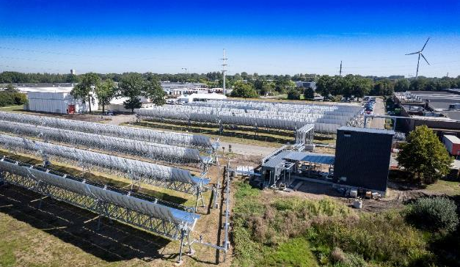
Figure 1: Parabolic trough solar collector array with balance of plant in the centre and storage tank on the right (Photo by Avery Dennison).
During periods of high solar availability, the thermal energy produced by the collector field can exceed the instantaneous heat demand of the site. Since the thermal storage system is currently not available for regular operation, excess heat cannot be stored. To avoid overheating and unnecessary heat generation, individual collector rows are moved out of focus. In this operating mode, the reflected solar radiation no longer reaches the absorber tube and heat production is significantly reduced.
An example of both operating states is shown in Figure 2. The image on the left shows a collector row in focus, where the absorber tube is directly irradiated by the concentrated solar radiation. In contrast, the image on the right shows a collector row in a defocused position. In this case, the reflected radiation does not strike the absorber tube, which therefore appears dark and does not contribute to useful heat production.

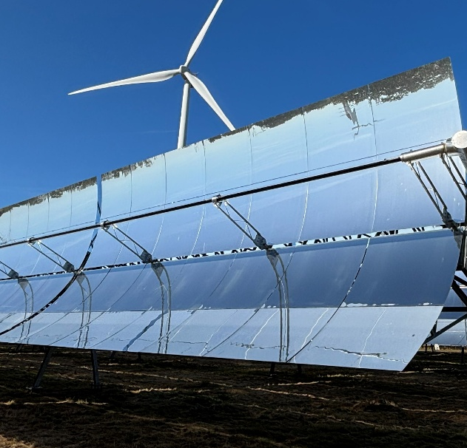
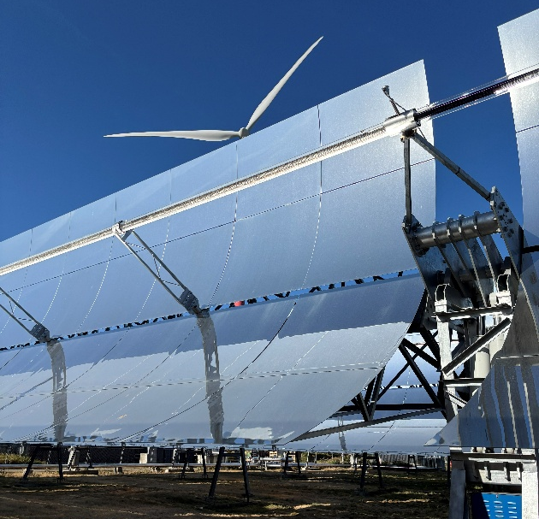
Figure 2: Parabolic trough collectors at the CST plant in Turnhout, Belgium. Left: collector in focus. Right: collector in defocus, 11.08.2026 (Photos by Solites).
- Measurement Data Basis and Data Processing
The measurement data are based on the weather and operational data of the CST plant in Turnhout, Belgium, which are recorded at a time resolution of 5 seconds. The dataset includes meteorological parameters such as direct normal irradiance (DNI), global horizontal irradiation (GHI) and wind conditions, as well as operational data including heat transfer fluid temperatures, mass flow rates, and thermal output. Ambient temperature is not measured on site. Therefore, ambient temperature data from a weather station in Antwerp, located approximately 40 km from the plant, are used. These temperature data are available at an hourly resolution and are provided by Royal Meteorological Institute (RMI, 2026).
Due to the large volume of recorded data, preprocessing and analysis are carried out using Python (Python, 2026). The objective is to identify erroneous measurements, apply appropriate filtering procedures, and prepare a consistent dataset for model comparison. The resulting processed dataset covers the available measurement period of the ongoing year 2026 and serves as the basis for the comparison of the TRNSYS model with the measured plant data.
- Modeling of the Parabolic Trough System in TRNSYS
Weather data are incorporated into the TRNSYS model using Type 16g. The imported dataset contains GHI, DNI, wind speed, and ambient temperature values that were previously processed and quality checked. Based on the geographical location of the plant in Turnhout, Belgium, Type 16g converts the meteorological input data into the solar radiation quantities required for the collector model, including the beam and diffuse radiation components incident on the tracking collector plane.
To account for row-to-row shading effects within the solar field, TRNSYS Type 30c is used. The model evaluates the collector geometry together with the instantaneous tracking position and the north–south alignment of the collector rows to determine the effective beam radiation reaching the collector aperture. Only the reduction of direct solar radiation is considered, while shading effects on diffuse radiation are neglected. This assumption is justified by the design of parabolic trough collectors, whose receiver area is relatively small compared to the aperture area and therefore intercepts only a minor fraction of diffuse irradiance compared to non-concentrating collector technologies.
The collector itself is represented by TRNSYS Type 832. Although originally developed as a generic dynamic collector model, it can also be applied to concentrating solar technologies. As Type 832 does not directly support variable collector inclination angles, the tracking is reproduced through externally calculated incidence angles in both the longitudinal (θL) and transversal (θT) directions. These time-dependent inputs allow the model to accurately describe the behavior of the single axis tracking system. For concentrating collectors, the optical calculation mode is configured with a value of 3 or higher in Type 832. Previous simulations using TRNSYS Type 1357 demonstrated a close agreement between both model approaches, confirming the applicability of Type 832 for parabolic trough collectors. Due to its lower computational effort and easier integration into larger system models, Type 832 was selected for the present study. The collector and solar field characteristics used in the simulations were derived from Janotte et al. (2010) and are summarized in Table 1. In this context, “to header” refers to the pipe length within the collector field up to the field header, where the individual collector rows are hydraulically connected.
Table 1. Collector parameters which are implemented in the TRNSYS model
Parameters EuroTrough, Solarlite and solar field | Unit | Value
Aperture area | m² | 5540
Collectors width | m | 5.77
Number of rows | - | 12
Length of the rows (Loop 1) | m | 80; 90; 110; 125
Length of the rows (Loop 2 & 3) | m | 80
Row distance | m | 10
Length of the pipes in the collector field to header | m | 305
Zero-loss efficiency (beam) η_{0,b} | - | 0.739
Incidence angle modifier for diffuse solar irradiance K_{d} | - | 0
Heat loss coefficient a₁ | W/(m²·K) | 0.032
Temperature dependence of heat loss coefficient a₂ | W/(m²·K²) | 0
Effective thermal capacity a₅ | J/(m²·K) | 2860
Concentration Ratio CR | - | 82

The incidence angle modifier (IAM) characteristics of the EuroTrough collector manufactured by Solarlite are applied in the simulation. The corresponding IAM values were provided by Janotte et al. (2010) and are referred to the gross area of the collector field.
The thermophysical properties of the heat transfer fluid are based on Helisol 5A. Constant fluid properties were implemented in the model using average values derived from the measurement data. This approach reduces computational effort while maintaining a representative description of the thermal behavior of the heat transfer fluid under typical operating conditions.
The solar field is located in Turnhout, Belgium, which is characterized by a temperate oceanic climate with regular rainfall throughout the year and a Köppen-Geiger climate classification of Cfb (Climate-Data.org, 2026). As a result, natural cleaning by rainfall reduces the frequency of collector cleaning operations, if the collectors are actively turned into the rain. Nevertheless, the influence of soiling on collector performance is currently being investigated within the ongoing ProSolNetz project. In TRNSYS, soiling effects can be represented by applying a cleanliness factor.
Several wind turbines are located in the vicinity of the solar field and may cause significant shading effects. A detailed assessment of these shading impacts has not yet been completed and is part of the ongoing work within ProSolNetz. For the present system simulations, a constant shading factor of 20 % is assumed based on previous annual yield calculations within the project ProSolNetz.
Investigations presented by Krüger et al. (2026) indicate that the collector field in Turnhout is currently oversized by a factor of approximately two relative to the site's process heat demand. As the concrete thermal energy storage system is currently not yet in operation, excess solar heat cannot be stored and must therefore be managed by the collector field operation.
To prevent heat overproduction, collector rows are partially or completely defocused during periods of high solar irradiation. Since the detailed control strategy is only partly known, some uncertainty remains regarding the operation of individual collector rows in defocus mode.. This represents a source of uncertainty for the model comparison.
Nevertheless, measurement data provide the number of collector rows operating in focus and defocus mode. Based on these data, a focusing factor is calculated as the ratio of active collector rows in focus to the total number of rows in the field. This factor is subsequently applied to the simulated collector output, enabling a comparison with the measured thermal output while accounting for the reduced active collector area during periods of defocusing.
The measured return temperature of the heat transfer fluid at the heat exchanger on the collector loop side is used as an input variable for the collector field model, together with the mass flow from the three loops. Based on these boundary conditions, the solar thermal energy yield and supply temperatures are calculated. The simulated temperatures are subsequently compared with the measured plant data.
- Selection of Comparison Days
As the operation of the CST plant in Turnhout is not continuous throughout the year and is influenced by site specific operating conditions, a comparison based on selected representative operating periods was carried out. For the comparison, individual days suitable for comparison were identified from the measurement dataset. To assess the model performance under different weather conditions, one predominantly clear-sky day and one day with significant cloud cover were chosen and compared with the corresponding simulation results.
5.1 Analysis of Comparison Day 1: 01 May 2026
Figure 3 presents the supply and return temperatures of the heat transfer fluid in the collector loop on the left axis and the thermal output on the right axis for the period from 04:00 to 20:00 on 1 May 2026. Temperature profiles are shown as solid lines, whereas thermal output values are represented by dashed lines.
The measured plant data are displayed in red, while the corresponding TRNSYS simulation results are shown in brown and grey. The return temperature is only available as measured data (light blue line), since it is used as an input to the TRNSYS model. The temperature sensor for the return temperature is located at the heat exchanger in the collector loop.
Two simulated thermal outputs are shown. “P_thermal_TRNSYS” represents the theoretical collector field output assuming that all collector rows are tracking the sun. In contrast, “P_thermal_TRNSYS_inFocus” accounts for the actual number of collector rows in focus during the evaluation period by applying the focusing factor derived from the measurement data.
The selected day is characterized by predominantly clear sky conditions and a high share of direct normal irradiance, making it particularly suitable for assessing the performance of the parabolic trough collector field under sunny operating conditions.
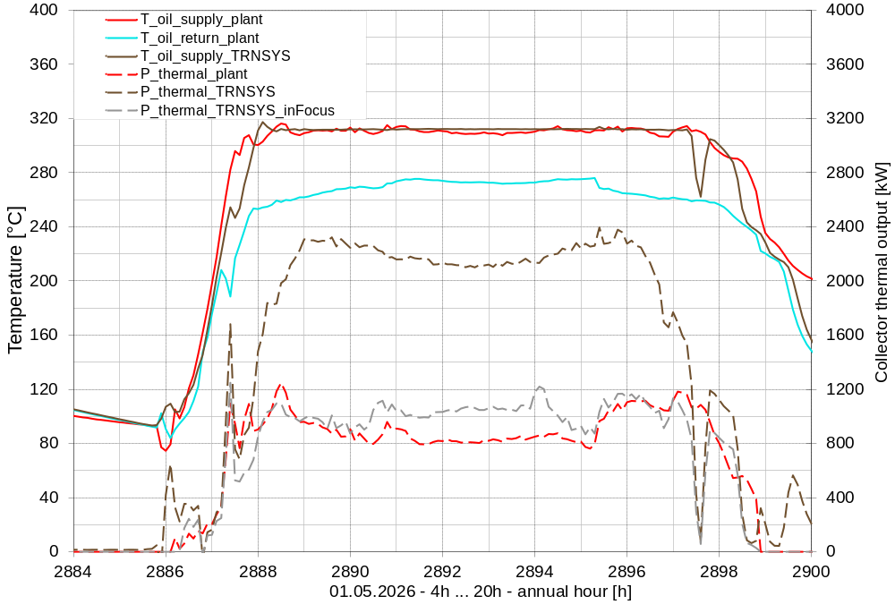
Figure 3: Comparison day 1 (01 May 2026): measurement data and TRNSYS simulation results for the supply and return temperatures and thermal output of the parabolic trough system
The simulated supply temperature follows a smoother and more linear profile than the measured data, primarily because an ideal temperature controller is implemented in the TRNSYS model. In the plant, short-term variations in operating conditions, such as fluctuations in mass flow rate, can lead to temporary deviations in the supply temperature. During the early morning period, temperature differences of up to 35 K are observed between simulation and measurements. During the period from 9:00 to 17:00 (hours 2889 to 2897), however, the agreement improves considerably. Both the measured and simulated supply temperatures reach values close to 312 °C. Throughout this period, the measured supply temperature fluctuates within a range of approximately ±5 K around the simulated values. One possible explanation for these fluctuations is the frequent defocusing and refocusing of individual collector rows. Even when collector rows are defocused, the heat transfer fluid continues to circulate through them. As the collector loops are hydraulically connected, mixing effects occur at the loop outlets, resulting in variations in the measured supply temperature that are not fully captured by the simulation model. A larger discrepancy of the supply temperature can be observed at approximately 17:30 (hour 2897.5), when the simulation shows almost no useful heat production and the calculated thermal output approaches zero. In contrast, the measurement data indicate that thermal energy was still being delivered to the system at that time.
The thermal output in TRNSYS is determined from the mass flow rate, the temperature difference between supply and return, and the specific heat capacity of the heat transfer fluid which is considered as a constant value in this simulation. For Comparison Day 1, the measured thermal energy generated by the plant amounts to 10.58 MWh. In comparison, the simulated heat of the complete collector field, represented by P_thermal_TRNSYS, is 22.54 MWh. When the focusing factor is applied and only the collector rows operating in focus are considered, the simulated heat is reduced to 11.07 MWh. The deviation between the measured daily thermal energy and the simulated thermal energy of the collectors in focus is therefore 4.4 %, indicating a good agreement for the daily energy yield when the actual focusing state of the collector field is taken into account. During the period between approximately 10:00 and 15:30 (hours 2890 to 2895.5), the simulated thermal output of the collector rows operating in focus mode is slightly higher than the measured plant output. In general, the thermal output differs for several possible reasons:
- The actual cleanliness condition of the collector field and the quality of the recorded monitoring data are not fully known. Since collector performance is directly affected by the cleanliness factor, uncertainties in these parameters can influence the agreement between simulation and measurements.
- The available measurement dataset does not provide information on recent rainfall events or the extent to which precipitation may have reduced collector soiling. As rainfall can significantly affect collector cleanliness and optical efficiency, this represents an additional source of uncertainty.
- The simulation assumes temperature independent thermophysical properties of the thermal oil. In particular, a constant value of the specific heat capacity is used, based on the average value derived from the measurement data. In reality, the specific heat capacity varies with temperature and therefore affects the calculated thermal output, which is directly dependent on this property.
- The actual shading losses occurring at the field are not fully known, despite their potentially significant influence on the thermal energy yield. However, these effects are expected to mainly affect the morning and evening hours, when shading is most pronounced.
- Short term operational measures, such as the defocusing of individual collector rows, cannot be fully reproduced in the simulation model. These events can influence both supply temperatures and thermal output and may therefore contribute to discrepancies between measured and simulated results.
- The original measurement data were recorded at 5 second intervals and subsequently aggregated to one minute values during preprocessing. This temporal averaging may smooth short duration events and transient operating effects, resulting in minor deviations between measurements and simulation results.
- The ambient temperature data used in the TRNSYS model were not measured directly at the plant site but obtained from a weather station located approximately 40 km away. Since ambient temperature influences heat losses as well as the thermal behavior of collector field components, differences between the actual on-site conditions and the imported weather data may affect the simulated thermal output and energy yield of the plant.
5.2 Analysis of Comparison Day 2: 25 April 2026
Figure 4 presents the daily profile for 25 April 2026 over the period from 04:00 to 20:00. As in the previous analysis, the measured plant data are compared with the corresponding TRNSYS simulation results. Compared to the clear sky day, a lower fraction of direct solar irradiance is observed, indicating partly cloudy conditions. Short periods of cloud cover occur predominantly during the afternoon, causing temporary fluctuations in the available solar radiation and, consequently, in the thermal output of the collector field.
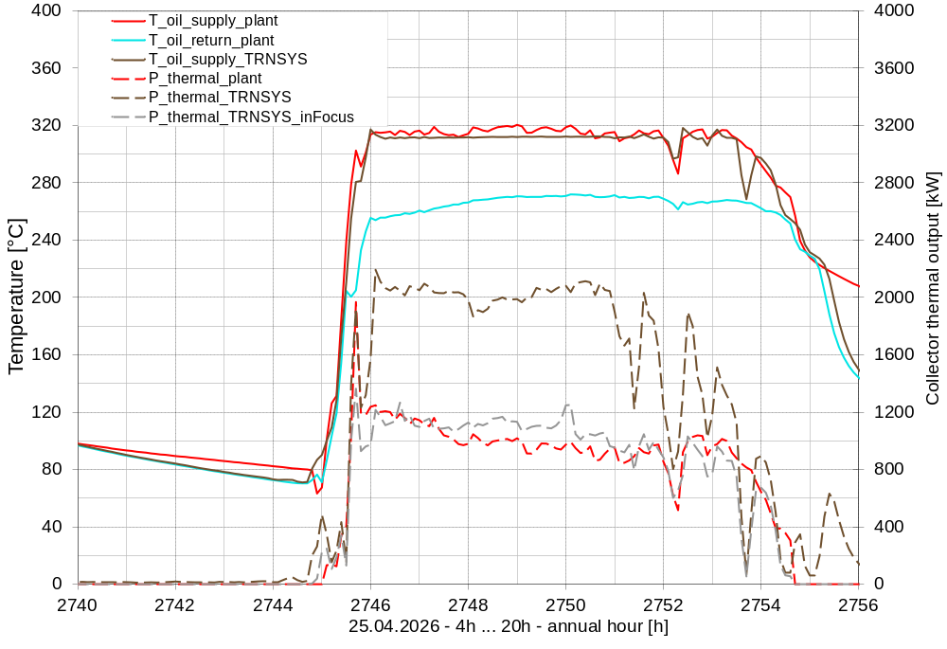
Figure 4: Comparison day 2 (25 April 2026): measurement data and TRNSYS simulation results for the supply and return temperatures and thermal output of the parabolic trough system
The supply temperatures exhibit noticeable fluctuations throughout the day as a result of variations in direct solar irradiance caused by intermittent cloud cover. The largest difference between measured and simulated supply temperatures occurs at 17:30 (hour 2753.5), when the simulated supply temperature is significantly lower than the measured supply temperature (T_oil_supply_plant). A similar behavior was already observed for Comparison Day 1 at 17:30 (hour 2897.5) which is the same time of the day, see Figure 3.
During the period from 10:00 to 15:00 (hour 2746 until 2753), the agreement between measured and simulated supply temperatures improves, although the simulated values remain slightly below the measured temperatures for most of the period. As previously discussed, the simulated temperature profile appears smoother because the TRNSYS model uses an ideal temperature controller and does not capture all short term operational variations occurring in the real plant.
For Comparison Day 2, the measured thermal energy generated by the plant amounts to 8.78 MWh. The simulated thermal energy of the complete collector field, represented by P_thermal_TRNSYS, is 15.73 MWh. After applying the focusing factor, the simulated thermal energy of the collector rows operating in focus is reduced to 8.78 MWh. The daily heat yield therefore shows very good agreement between the measured plant data and the simulated output of the collectors in focus. The simulated thermal output of the collector rows that are in focus generally follows the measured thermal output well. However, at approximately 18:30 (hour 2754.5), a theoretical thermal output is still simulated for a fully focused collector field, whereas both the measured thermal output and the simulated output of the collectors in focus decrease to nearly zero. This behavior can be explained by the fact that all collector rows were defocused at that time, preventing further solar heat generation. Since the possible thermal output (P_thermal_TRNSYS) represents the output of a fully focused collector field, the corresponding simulated supply temperature remains significantly higher than the measured value. In contrast, the measured supply temperature remains only slightly above the return temperature, indicating that solar heat production has effectively stopped. The small remaining temperature difference is likely caused by the thermal inertia of the receiver tubes and pipes, which are still transferring previously stored heat to the heat transfer fluid.
The potential causes of the remaining deviations are similar to those discussed for Comparison Day 1 and include uncertainties related to collector degradation, the assumed thermophysical properties of the thermal oil, field-specific shading effects, and limitations of the available measurement data.
- Summary of the Comparison Results
The comparison between the TRNSYS model and the measurement data from both evaluation days demonstrates that the simulation is able to reproduce the main thermal behavior of the parabolic trough collector field. Overall trends in supply temperature and thermal output are represented with good agreement, while the observed discrepancies can largely be attributed to known uncertainties and operational defocusing effects.
Differences between measured and simulated results arise from several factors. These include uncertainties related to collector cleanliness, unavailable measurements of ambient temperature and limitations in the representation of collector field operation. Furthermore, a measurement uncertainty analysis within the framework of the ProSolNetz project has not yet been carried out. Consequently, the accuracy of the measurement instrumentation and the associated uncertainties cannot currently be fully assessed.
Despite these limitations, the results indicate that the developed TRNSYS model provides a realistic representation of the collector field performance when appropriate boundary conditions are applied. The agreement between simulation and measurements is considered sufficient for an initial comparison of the modeling approach and for comparative performance assessments.
Further improvements are expected as additional operational information and monitoring data become available. In particular, the available measurement dataset already provides a solid basis for validation, while a better understanding of the plant control strategy, collector field operation, shading effects, and collector cleanliness would allow a more detailed calibration of the model and could further reduce the remaining deviations between simulations and measurements.
- Conclusion and Outlook
The results presented in this study reflect the current state of development within the ProSolNetz project. As additional measurement and operational data become available, the modeling approach and its validation can be continuously refined. The initial comparison between TRNSYS simulations and measurement data demonstrates that the developed models are capable of representing the behavior of concentrating solar thermal systems for industrial heat applications with a satisfactory level of accuracy when realistic boundary conditions are applied.
Furthermore, the results are consistent with the findings of Tamm et al. (2026) for a concentrating solar thermal plant located in Cyprus. Although the two plants are located in different climate zones and operate under different conditions, both comparison studies show that the developed TRNSYS model can represent the behavior of parabolic trough collector systems with good accuracy. Nevertheless, the work presented here should be regarded as an initial validation step, and additional investigations are required to further improve model reliability and accuracy.
Future work will focus on extending the model beyond the collector field to include the thermal storage system, the solar loop, and the heat exchanger integration. In addition, longer validation periods will be investigated, including transient operating conditions and nighttime cool down phases. Such analyses require stable and uninterrupted plant operation over extended periods and a comprehensive set of measurement data.
The TRNSYS model will also serve as a basis for the further development and validation of additional tools within the ProSolNetz project. These include SCFW 3.0, ScenoCalcFernWärme (SCFW, 2026), which is being enhanced to support the design and integration of concentrating solar thermal technologies in district heating applications.
The findings also emphasize the importance of an appropriate system design for concentrating solar thermal plants. The investigated plant shows that the installed collector field can frequently provide significantly more thermal energy than required by the industrial process heat demand. Until the planned commissioning of the thermal storage system in September 2026, excess heat cannot be used and has to be managed by defocusing individual collector rows. A more demand oriented system design could therefore have reduced investment costs while maintaining a high share of useful solar heat. For future projects, a detailed analysis of the load profile, storage integration, and control strategy is therefore essential to avoid oversizing and to improve both the technical and economic performance of the system.

- References
Climate-Data.org, 2026. Turnhout Climate (Belgium): Weather and Temperature by Month. Available at: https://en.climate-data.org/europe/belgium/flanders/turnhout-10013/ (accessed 19 August 2026).
Janotte, N., Lüpfert, E., Pitz-Paal, R., Pottler, K., Eck, M., Zarza, E., Riffelmann, K.-J., 2010. Influence of Measurement Equipment on the Uncertainty of Performance Data from Test Loops for Concentrating Solar Collectors. Journal of Solar Energy Engineering 132(3), 031003. https://doi.org/10.1115/1.4001476
Krüger, D., Epp, B., Tamm, S., Mehnert, S., Lüpfert, E., Konz, N., 2026. Process Heat from Parabolic Trough Solar Fields, in: Proceedings of Symposium Zukunft Wärme. Marburg, Germany (currently under rewiev).
Krüger, D., Leicht, J., Fahr, S., Krüger, J., Bonleitner, S., Burger, A., Konz, N., Epp, B., Stengler, J., 2024. Power Transfer Station for Process Heat, in: Proceedings of the 34. Symposium Solarthermie und Innovative Wärmesysteme. https://doi.org/10.52825/st-symposium.v1i.1342
Python, 2026. Available from https://www.python.org/
RMI, 2026. Open Data Weather Observations. Royal Meteorological Institute of Belgium. Available at: https://opendata.meteo.be/download (accessed 29 July 2026).
SCFW, 2026. Available from https://www.scfw.de/
Tamm, S., Berberich, M., Krüger, D., 2026. Parabolic Trough Collectors for Existing District Heating Networks, in: Proceedings of ISEC 2026, Graz, Austria. https://doi.org/10.52825/isec.v2i.3374
TRNSYS-Transient System Simulation Tool, 2026. Available from https://www.trnsys.com/


The project „ProSolNetz“ has received funding from the German Ministry for Economic Affairs and Energy on the basis of a decision by the German Bundestag.
The sole responsibility for the content of this publication lies with the authors. It does not necessarily reflect the opinion of the funding organizations. Neither the funding organizations nor the authors are responsible for any use that may be made of the information contained therein.

