Experimental investigation into through-thickness compression enhancement effect on Mode II fracture energy using bi-axial tests

X. Xu, T. Rev, X. Sun, M. R. Wisnom and S. R. Hallett

Bristol Composites Institute (ACCIS), University of Bristol, University Walk, Bristol BS8 1TR, UK
Email: xiaodong.xu@bristol.ac.uk
Web Page: http://www.bristol.ac.uk/composites/

Keywords: fracture toughness, delamination, bi-axial tests, through-thickness compression (TTC)

Abstract

Through-Thickness Compression (TTC) stresses can affect Mode II fracture energy, G_{IIC}. This effect has been studied using IM7/8552 carbon/epoxy Quasi-isotropic (QI) laminates with 2 extra cut central 0˚ plies inserted into the layup. Bi-axial testing was adopted to demonstrate the TTC enhancement effect and the change of failure mode from delamination to fibre fracture.

1. Introduction

With the increasing use of composite structures for load carrying applications, composite materials are often subject to complex stress states. Delamination is also a major source of failure in composite laminates. Applying Through-Thickness Compression (TTC) on laminates can enhance the inter-laminar shear strength [1], therefore delaying delamination initiation. This is crucial for the design of composite structures which are subject to TTC loads as shown for example in Figure 1.

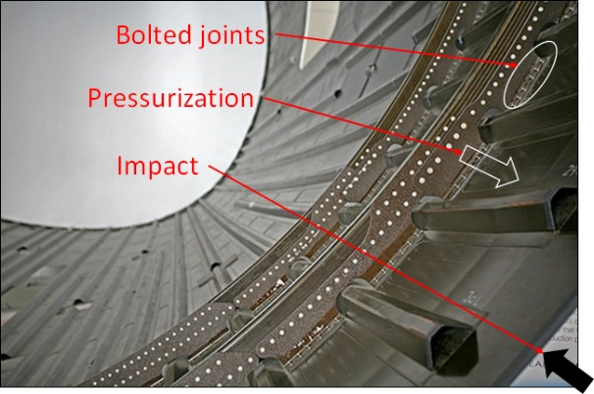

Figure 1. Composite structures which are subjected to different potential TTC loads.

The TTC enhancement effect on Mode II fracture toughness has also been studied [2, 3] using Unidirectional (UD) laminates. The current work also demonstrates that TTC can significantly enhance Mode II fracture energy, using a stacking sequence closer to real-world applications. With sufficient TTC stresses, delamination in specimens with discontinuous plies loaded in tension can be totally suppressed, leading to a change of failure mode from delamination to fibre fracture. This has some profound implications for the design of composite structures.

2. Experimental set-up

Bi-axial tests have been conducted as shown in Figure 2. The specimen configuration is an IM7/8552 carbon/epoxy [(45/90/-45/0)₄(0)]_{s} laminate, which has a quasi-isotropic layup with additional 0˚ plies at the mid-plane that are cut in the middle through the specimen thickness. The bi-axial test rig consists of four independent Zwick/Roell 100 kN hydraulic-driven actuators mounted horizontally on a flat T-slotted steel base, as shown in Figure 2 a). Different TTC loads were applied through two steel indenters as shown in Figure 2 b). The TTC stresses were calculated by dividing the externally applied TTC loads by the nominal compressed area. The TTC loads were monitored throughout the tests. The magnitude of TTC stresses therefore can be maintained, ranging from 10 MPa to 40 MPa. The in-plane loading was applied through two steel extensions with bolted clamps, under displacement control at a rate of 1 mm/min at each end.

  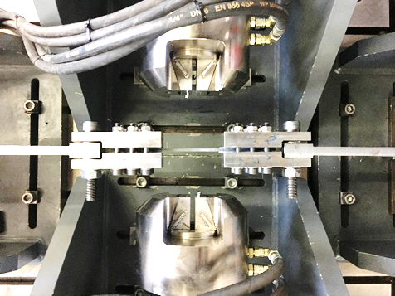 | 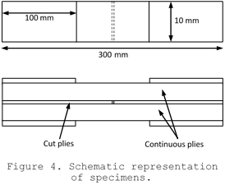
a) Bi-axial test fixtures
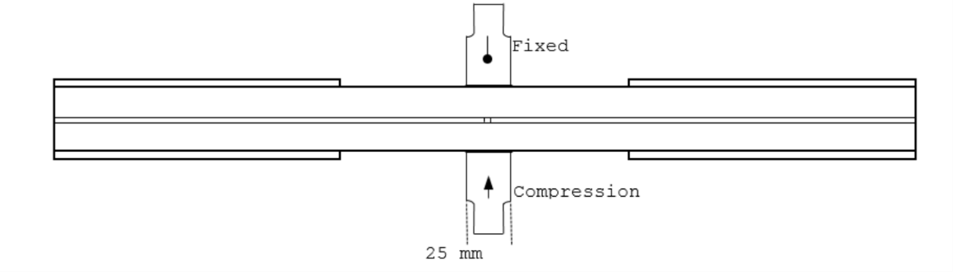
b) Arrangement of indenters

Figure 2. Bi-axial test set-up and specimen configuration (not to scale).

3. Experimental results

A typical load vs. displacement curve from the QI central cut-ply tests is shown in Figure 3. The first load drop is for delamination propagation and the second load drop is for fibre fracture outside the TTC applied region.
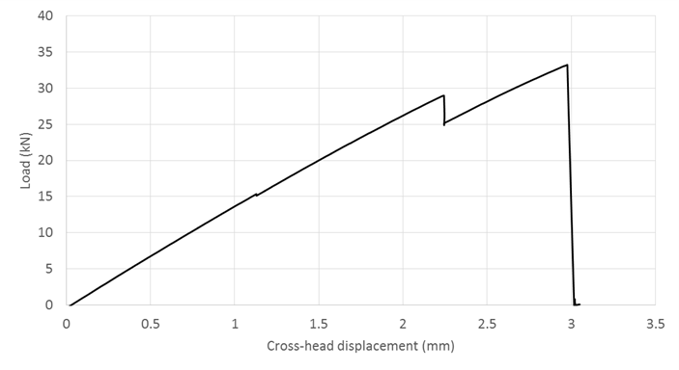

Figure 3. Typical load vs. displacement response.

The delamination load increases with increased magnitude of TTC stress to up to 10 MPa as shown in Figure 4. When the applied TTC stress is high enough, delamination is totally suppressed and only one ultimate load drop can be seen on the load vs. displacement curve. Fibre failure then occurs within the high TTC applied region as shown in Figure 5. From the load at which delamination occurs from the cut plies back to the grips, the fracture energy can be calculated from the closed form solution in Equation 1 which is based on Ref. [4], considering uniform in-plane tensile response. The measured G_{IIC} value increases by 53% from 1.10 N/mm (C.V. 9%) without TTC to 1.68 N/mm (C.V. 7%) with 10 MPa externally applied TTC stress.
 | $$G_{C}=\frac{σ_{net}^{2}(h-t)}{4E^{*}}-\frac{σ_{net}^{2}{(h-t)}^{2}}{4E_{lam}h}$$ | (1)
where $h$ is the total specimen thickness, $t$ is the thickness of the cut plies, $σ_{net}$ is the average net-section stress at the first large load drop from the measured specimen width and the thickness of continuous plies, E_{lam} = 67.5 GPa is the longitudinal Young’s modulus before delamination and E* = 61.6 GPa is the longitudinal Young’s modulus of the remaining load carrying plies in the totally delaminated laminate.

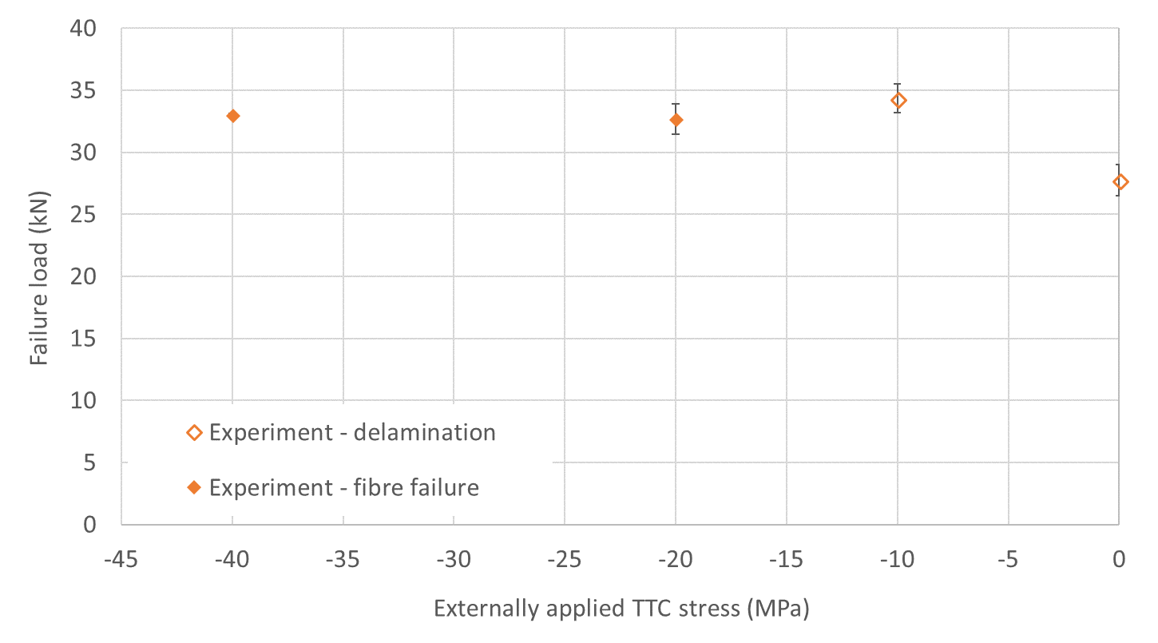

Figure 4. Experimental results under various TTC stresses.
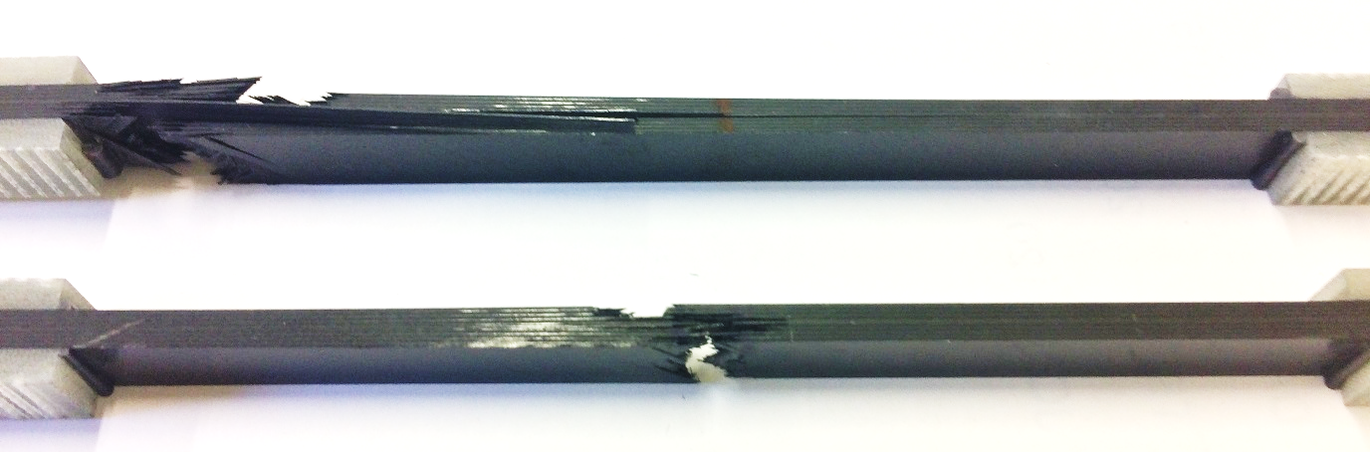
b) Fibre failure outside moderate TTC applied region
c) Fibre failure within high TTC applied region
a) Delamination within moderate TTC applied region

Figure 5. Typical failed central cut-ply specimens with three failure mechanisms.

4. Conclusions and future work

The proposed bi-axial tests of the Quasi-isotropic (QI) laminates with 2 extra cut central 0˚ plies inserted into the realistic layup successfully demonstrates a significant TTC enhancement effect on G_{IIC}. A change of failure mode has been captured from delamination under moderate TTC loads, to fibre fracture under high TTC loads.

A test programme has been conducted to determine the TTC enhancement factor for Mode II fracture energy using Unidirectional (UD) samples with cut central plies [5]. For IM7/8552 laminates, η_{G} = 0.064 MPa⁻¹. This η_{G} will be implemented in an existing Finite Element Analysis (FEA) framework using cohesive interface elements, to predict failures in the current specimens under various TTC loads.

References

[1] K.W. Gan, S.R. Hallett, M.R. Wisnom. Measurement and modelling of interlaminar shear strength enhancement under moderate through-thickness compression, Composites Part A: Applied Science and Manufacturing, 49:18-25, 2013.
[2] W. Cui, M. Wisnom, M. Jones. Effect of Through Thickness Tensile and Compressive Stresses on Delamination Propagation Fracture Energy, Journal of Composites, Technology and Research, 16:329-335, 1994.
[3] G. Catalanotti, C. Furtado, T. Scalici, G. Pitarresi, F.P. van der Meer, P.P. Camanho. The effect of through-thickness compressive stress on mode II interlaminar fracture toughness, Composite Structures, 182:153-163, 2017.
[4] M.R. Wisnom. On the increase in fracture energy with thickness in delamination of unidirectional glass fibre-epoxy with cut central plies, Journal of Reinforced Plastics and Composites, 11:897-909, 1992.
[5] X. Xu, M.R. Wisnom, X. Sun, T. Rev, S.R. Hallett. Experimental determination of Through-Thickness Compression (TTC) enhancement factor for mode II fracture energy, Composites Science and Technology, submitted, 2018.

