Development and mechanical characterization of a non-isocyanate rigid polyurethane foam

E. Kollia¹, K. Andreopoulou² and V. Kostopoulos ^{1,3}

¹Applied Mechanics and Vibrations Laboratory, Department of Mechanical Engineering and Aeronautics, University of Patras, Patras University Campus, GR-26500 Patras, Greece
jkollia@upatras.gr, kostopoulos@upatras.gr, http://www.mead.upatras.gr/lang_el/labs/view_details/1

² Division of Organic Chemistry, Department of Chemistry, University of Patras, Patras University Campus, GR-26500 Patras, Greece
andreopo@upatras.gr, http://www.upatras.gr/en/node/109
³ Institute of Chemical Engineering Sciences, Foundation for Research and Technology
kostopoulos@upatras.gr, http://www.iceht.forth.gr/index-gr.html

Keywords: Non-isocyanate, rigid polyurethane foams, nanoclays, mechanical properties

Abstract

The present work is a first attempt for development of non-isocyanate polyurethane rigid foam. A two-component hybrid non-isocyanate polyurethane compound was used as the baseline. Different types of chemical products were used as blowing agents, among them Petroleum ether and high purity Cyclopentane. Furthermore, the addition of organic nanoparticles at different loading content (2, 3 and 5 wt%) was tested to promote the foaming process, reduce the foam density, homogenize foam cells, increase mechanical properties and fire resistance of the final rigid foams. The main achievement of the present study is that non-isocyanate rigid foams with reasonably good mechanical characteristics can be developed using a commercial available compound. Moreover, the addition of nanoparticles during the foaming process provides a mean to control density.

1. Introduction

Polyurethanes (PU) are versatile polymers, which have traditionally been manufactured from petroleum [1]. The range of polyurethane products includes polyurethane elastomers [2], sheets [2], adhesives [3], coatings [4], and foams [2], spanning uses across a large array of industries and products. Factors, such as the price and availability of petroleum, and societal concerns over global climate change continue to create increased market pressure on the industrial and domestic use of petrochemicals. The polyurethane industry has recently tended towards the replacement of petrochemical materials with renewable resources. Due to the effort of our environmental protection consciousness improvement, Diphenyl methanediisocyanate (MDI) is an important organic isocyanate, with the advantages of low volatility and toxicity to the human body. Therefore, MDI was welcomed by the polyurethane industry. Polyurethane foams can be flexible, semi-rigid or rigid by changing the types or amounts of polyols, polyisocyanates, blowing agents, catalyst and surfactant to suit their end needs [5]. Meng et al. [6] produced an environmentally friendly MDI-based water-blown flexible polyurethane foam by using modified MDI and highly active polyether polyols as the main raw material, and water as blowing agent by the one-shot method. They observed that as the water content was increased during the rise time, the gel time and the density were decreased. Additionally, they observed that with the increase of water content from 2.5% to 4% the tensile strength of the MDI-based polyurethane flexible foam was also increased. Renewable resources such as vegetable oil is rapidly replacing the conventional fossil fuel derived oligomers in polyurethane synthesis [7-9]. Castor oil is a major candidate in these replacement efforts, due to its inherent advantages over other vegetable oils. The major content of the triglyceride fatty acid residue of castor oil is ricinoleic acid. Ricinoleic acid has inherent hydroxyl groups in their parent hydrocarbon chain due to which, the need to introduce hydroxyl groups can be avoided or at least minimized [8]. Some early reports indicate the use of castor oil in creating thermally insulating rigid polyurethane foams [10, 11]. Castor oil modified with maleic anhydride was used to synthesize biodegradable foams [12]. Diethanol amides of castor oil are reported to be used for water blown polyurethane foams [13]. Castor-oil that was partially substituted in the synthesis of flexible polyurethane foam, resulted in an increase of density and hardness index, but a decrease of tensile strength and elongation [14].
Cinelli P. et al. [15] produced soft foams from Kraft lignin using two types of chain extenders, polypropilenglycol triol, castor oil and water as blowing agent. They concluded that the parameters that affect the mechanical properties of foams are the thickness and length of cell strut. It has been reported that the degradation of urethane bond of Rigid Polyurethane Foams (RPUF) starts at 200-250⁰C [16-18]. In order to achieve flame retardancy, it is important to reduce flammable fragment product, decrease flammable gas release rate and avoid sustained combustion. The thermal behaviour of RPUF with different phosphorus flame retardants has been well studied [19]. The results indicated that phosphorus flame retardants could be involved in condensed phase and/or in gas phase. Among the phosphorus flame retardants, ammonium phosphate (APP) mainly took effect in condensed phase and could reduce the product of flammable fragment and help forming a layer of protective char [20]. In contrast, dimethyl methyl phosphonate (DMMP) mainly took effect in gas phase, and could avoid sustained combustion. Gradually, the flame retardant of polymer nanocomposites foams was focused, since they were widely used as building insulation materials. Previous works [21-23] on RPUF nanocomposites displayed quite a few advantages in its flame-retardant properties, such as decreasing the peak Heat Release Rate (pHRR), reducing Smoke Produce Rate (SPR) and reinforcing the char residues. The flame-retardant mechanism of RPUF nanocomposites was related to insulation of mass transfer and heat transfer by nanostructured additives. Hence, the combination of different types of phosphorus flame retardants and nanostructured additives would result in better flame retardancy of RPUF. Modesti et al. [24] studied RPUFs with aluminum phosphinate and different type of modified montmorillonites MMTs, that were pristine montmorillonite, ammonium modified clay and diphosphonium modified clay. The results showed that the addition of MMT, especially diphosphonium modified clay, was helpful in the increase of limit oxygen index (LOI) of RPUFs. W.Xu et al. [25] used three types of typical nanostructured additives, nano ZnO, porous Zeolite and layered MMT, with phosphorus compounds in order to improve the flame retardancy of RPUF and Cyclo-pentane (23 wt%) as blowing agent and polysilicone (1.0 wt%) as foam stabilizer. They calculated that the heat release rate of RPUF with Zeolite/Dimethyl Methyl Phosphonate (DMMP)/ Ammonium Phosphate (APP) flame retardant system was only 91 kW/m², which was 56% lower than that of pure RUPF and 26% lower than RPUF only with DMMP/APP flame retardant system. Moreover, they concluded that in RPUF with APP and DMMP as a flame retardant, the addition of nano ZnO, MMT or Zeolite could change the structure of the char layer and make it more integrity. The integrity char layer performed better insulation and flame-retardant effect.
Growing concerns about toxicity, control of CO₂ emissions, biodegradability and other environmental problems are driving the research for alternative blowing agents.
A considerable body of work has been already published, related to the use of organic isocyanate, such as Diphenyl methanediisocyanate (MDI) but to the authors’ knowledge, the literature regarding the nonisocyanate polyurethane foams (NIPUR) is very limited.
Furthermore, there are very few studies in the literature regarding the use of nanoclays in the reactive PU foaming process. The present study contributes to this field by developing a rigid NIPUR using a conventional nonisocyanate PU bulk material and compares its mechanical properties and density with nano-doped rigid NIPUR foams.

2. Experimental

2.1. Materials

A two-component hybrid non-isocyanate polyurethane compound was used as the baseline, provided by Polymate, Israel. The mixing ratio, part A: part B, used was 100:39 by weight. Different types of chemical products were used as blowing agents, among them Petroleum ether and high purity Cyclopentane, provided by Technobiochem, Greece.
Organic nanoparticles, Cloisite 30B (methyl tallow bis-2-hydroxyethyl) quaternary ammonium modified montmorillonite (d001=18.5Å) with a concentration of 90meq/100 g clay (cation exchange capacity in milliequivalents per 100 gram) provided by Rockwood Additives UK, used for modifying the PU foam.

2.2 Development of rigid PU foam with nanoclays

During the first trials, reference rigid NIPUR foams were produced using two different types of blowing agents, namely: Cyclopentane and Petroleum ether. Since, based on the first trials, the foams using Cyclopentane as blowing agent result to lower density compared to that produced by using Petroleum ether, the study was focused on the first blowing approach.

In the case of nanomodified rigid NIPUR foams, nanoclays were used. Three (3) roll-mill was used to achieve the homogeneous dispersion of the nanoparticles in the final part A mixture. In the present study the distance between the rollers of the 3 roll-mill variates from 120 μm to 5 μm depending on the milling cycle. The sequential gap settings were 120, 40, 10 and 5 μm respectively, and three cycles of milling were repeated for each gap setting. The speed of the roll was maintained at 270 rpm. After the application of the mixing process, part B was added in the blend and stirred well until uniform mixture was obtained. Cyclopentane was then used as blowing agent at 5.5 wt%, instantly stirred and placed in an oven at 600C until it began to foam. The last step of the development was to keep the foams into an oven at 600C for 8h to ensure the completion of the reaction/polymerization process.
There are three different groups of produced and examined rigid non-isocyanate PU foams as indicated below (Figure 1):
1. Reference PU foam, where Petroleum ether was used as blowing agent.
2. Reference PU foam, where cyclopentane was used as blowing agent.
3. PU foam, where cyclopentane was used as blowing agent and different %wt loadings of nanoclays were used.

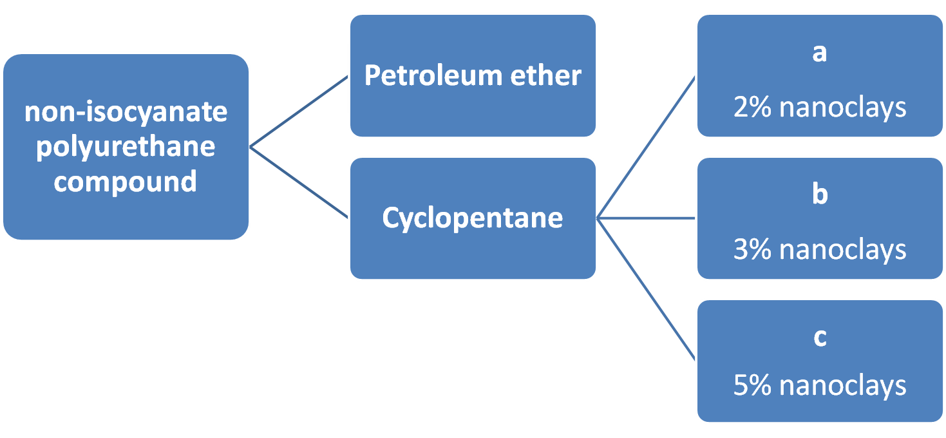
Figure 1. The three different groups of rigid NIPU foams.

Error: Reference source not found depicts some samples of the developed rigid NIPUR foams before the implementation of compression test.

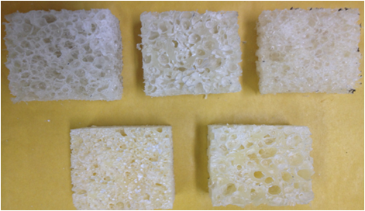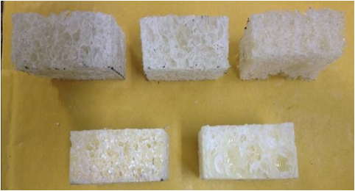

Figure 2. samples of rigid NIPUR foams.

  - Measurements and characterization

The density of rigid foams was calculated based on ASTM D 1622 – 03.
The compressive strength and modulus parallel to the rising direction of foam samples, were measured by using an INSTRON servo-hydraulic testing machine according to ASTM D1621. The test specimens had dimensions of 25.4x25.4x12.7 mm³ and the crosshead speed of compression was set at 1.2 mm/min.

3. Results and discussion
The properties of the nanoclay reinforced foams are mainly dependent on the nanoclay concentration and the manner of dispersion. The effect of nanoclay concentration on the density and the mechanical properties of the NIPU foams are depicted in Table 1. From Error: Reference source not found it is obvious that the blowing agent affects the final density of the foam. The density of PU foams is a key parameter and good indicator of its performance. The foam with cyclopentane, as blowing agent, exhibits a lower density compared to the foam with petroleum ether. The petroleum ether foam was too heavy. The cyclopentane neat NIPU foam presents a lower density compare to the petroleum ether neat foam, about 25%. Due to the aforementioned result, the addition of nanoclays in the NIPUR foams was executed only in the case of the foam with cyclopentane as blowing agent. The main observation, regarding the density of the developed foams, was that the addition of nanoclays has resulted in further reduction of the rigid NIPUR foams density. The cyclopentane foam with 5 wt% nanoclays presents a 66% reduction of density compared to the neat cyclopentane foam, while the addition of 2 and 3wt% of nanoclays in NIPU foam has resulted in a reduction of 34 and 40% respectively.
The compressive strength and the corresponding modulus were evaluated to study the effect of blowing agents and the addition of nanoclays on the mechanical properties of rigid NIPUR foams. To study the effect of nanoclays on the properties of rigid NIPUR foams, foams with cyclopentane as blowing agent and nanoclays 2, 3 and 5 wt% were developed. Type a, b and c corresponds to 2, 3 and 5 wt% of nanoclays content respectively.
As far as the mechanical properties are concerned, observing the following table it is quite evident that there is a significant decrease using cyclopentane as blowing agent. Regarding the compressive strength and modulus of neat cyclopentane, a reduction of 43 and 72% was remarked compare to petroleum ether neat NIPU foam. In the case of 2 wt% doped foam with nanoclays, it was noticed a decrease of 86 and 77% concerning the compressive strength and modulus as shown in table 1, while the foams with 3 wt% nanoclays present a reduction of 80 and 55% respectively. The 5wt% nanoclays foams exhibit the lower density, as mentioned above, nevertheless it provides a significant reduction on the compressive strength and modulus approximately 95 and 92% compared to the cyclopentane neat foam.

Table 1. Properties of rigid NIPU foams.

sample | density (Kg/m³) | Compressive strength at 10% (GPa) | Compressive modulus at 10% (MPa) | Absorbed energy at 10% (J)
Petr. ether | 398 | 8.2 | 157 | 5.9
Cyclopentane | 298 | 4.7 | 43 | 3.9
Nanomodified type a | 197 | 0.65 | 10 | 0.65
type b | 178 | 0.9 | 19 | 1.06
type c | 103 | 0.2 | 3 | 0.5

4. Conclusions
Non-isocyanate NIPU foams were developed using a commercial available compound. Two different types of blowing agents were used, petroleum ether and cyclopentane. The latter led to lighter foam. Based on that, nanoclays were added in the case of the rigid foams with cyclopentane in order to investigate their effect on the density and compressive properties of the foam. The following are the significant features observed:
- Petroleum ether as blowing agent leads to a heavier rigid NIPU foam compare to cyclopentane.
- Nanoclays provide a mean to control the density of foams.
- The foam with 3wt% of nanoclays exhibit the greater compressive properties.
- In case of 5wt% of nanoclays the lower density of the foam was observed.

Acknowledgments

The support of the European Union and the JTI Clean Sky within the H2020 framework of ITD ECO-Design for Airframe activity ecoTECH is gratefully appreciated.

References

- Randall, D.; Lee, S. The Polyurethanes Book; Huntsman Polyurethanes: Belgium, 2002.
- Narine, S. S.; Kong, X.; Bouzidi, L.; Sporns, P. J. Am. Oil Chem. Soc. 2007, 84, 65.
- Somani, K. P.; Kansara, S. S.; Patel, N. K.; Rakshit, A. K. Int. J. Adhes. Adhes. 23, 269, 2003.
- Velayutham, T. S.; Majid, W. H. A.; Ahmad, A. B.; Kang, G.Y.; Gan, S. N. Prog. Org. Coat. 66, 367, 2009.
- KS, Chian and LH., Gan. Development of a rigid polyurethane foam from palm oil. Journal of Applied Polymer Science, vol. 68, 1998.
- Meng, Fanzeng and Ding, Xuejia. The Preparation and Performance Study of MDI-Based Water-Blown Flexible Polyurethane Foam. AASCIT Journal of Materials, vol. 1, 2015.
- Petrović, Zoran S. Polyurethanes from Vegetable Oils. Polymer Reviews, vol. 48, 2008.
- DP, Pfister, Y, Xia and RC, Larock. Recent advances in vegetable oil-based polyurethanes. ChemSusChem, vol. 4, 2011.
- DA, Babb. Polyurethanes from renewable resources. Advances in Polymer Science, vol. 245, 2012.
- Lyon, Garret and L, Goldblatt. Solvent-blown, rigid urethane foams from low cost castor oil-polyol mixtures. Journal of American Oil Chemists' Society, vol. 39, 1962.
- SA, Baser and DV, Khakhar. Castor oil-glycerol blends as polyols for rigid polyurethane foams. Cellular Polymers, vol. 12, 1993.
- J., Wang H., et al. Biodegradable foam plastics based on castor oil. Biomacromolecules, vol. 9,615–623, 2008.
- A, Palanisamy, Rao, B. S. and Mehazabeen, S. Diethanolamides of castor oil as polyols for the development of water-blown polyurethane foam. Journals of Polymers and the Environment, vol. 19, 2011.
- O.O.Ogunleye, F.A.Oyawale and E.Suru. Effects Castor Oil on the Physical Properties of Polyether Based Flexible Polyurethane Foam. Global Journal of Biotechnology & Biochemistry, vol. 2, 2007.
- Cinelli, Patrizia, Anguillesi, Irene and Lazzeri, Andrea. Green synthesis of flexible polyurethane foams from liquefied lignin. European Polymer Journal, vol. 49, 2013.
- R, Bilbao, et al. Kinetics of the thermal decomposition of polyurethane foams in nitrogen and air atmospheres. Journal of Analytical and Applied Pyrolysis, vol. 37, 1996.
- ML, Hobbs, KL, Erickson and TY., Chu. Modeling decomposition of unconfined rigid polyurethane foam. Polymer Degradation and Stability, vol. 69, 2000.
- L, Jiao, et al. Thermal degradation characteristics of rigid polyurethane foam and the volatile products analysis with TG-FTIR-MS. Polymer Degradation and Stability, vol. 98, 2013.
- Lorenzetti, A., Modesti, M. and Besco, S. Influence of phosphorus valency on thermal behaviour of flame retarded polyurethane foams. Polymer Degradation and Stability, vol. 96, 2011.
- G, Montaudo, et al. Mechanism of thermal degradation of polyurethanes. Effect of ammonium polyphosphate. Macromolecules vol. 17, 8, 1984.
- A.Lorenzetti, et al. Synthesis of phosphinated polyurethane foams with improved fire behavior. Polymer Degradation and Stability, vol. 97, 2012.
- L, Song, et al. Study on the properties of flame retardant polyurethane/organoclay nanocomposite. Polymer Degradation and Stability, vol. 87, 2005.
- S, Semenzato, et al. A novel phosphorus polyurethane foam/montmorillonite nanocomposite: preparation characterization and thermal behavior. Applied clay science, vol. 44, 2009.
- M, Modesti, et al. Synergism between flame retardant and modified layered silicate on thermal stability and fire behaviour of polyurethane nanocomposite foams. Polymer Degradation and Stability, vol. 93, 2008.
- Wei, Xu, Guojian, W. and Xiaorui, Zheng. Research on highly flame-retardant rigid PU foams by combination of nanostructured additives and phosphorus flame retardants. Polymer Degradation and Stability, vol. 111, 2015.

