EuroSun2026
A NOVEL DIFFUSER CONCEPT BASED ON A TPMS–PCM COMPOSITE FOR WATER TANKS

A.V. Anacreonte^{1,2,*} , E. Gaudino^{1,2}, F. Capolupo^{1,2}, A. Di Napoli^{1,2}, M. Pesapane^{1,2}, C.D’Alessandro³, A. Caldarelli⁴, B. Catalano^{2,5}, E. Di Gennaro^{2,5}, M. Musto^{1,2,}, N. Bianco¹, and R. Russo^{2,*}

¹ Department of Industrial Engineering, Università degli Studi di Napoli Federico II, Napoli, Italy
² Institute of Applied Sciences and Intelligent Systems, Consiglio Nazionale delle Ricerche, Napoli, Italy
³ TVPSOLAR SA, Geneva, Switzerland
⁴ CNR-SPIN Napoli, Napoli, Italy
⁵ Department of Physics, Università degli Studi di Napoli Federico II, Napoli, Italy

Email(s): vitalianoalessandro.anacreonte@unina.it; eliana.gaudino@na.isasi.cnr.it, fabio.capolupo@unina.it, annalisa.dinapoli@na.isasi.cnr.it, mara.pesapane@na.isasi.cnr.it, dalessandro@tvpsolar.com, antonio.caldarelli@na.isasi.cnr.it, benedetta.catalano@na.isasi.cnr.it, emiliano.digennaro@unina.it, marilena.musto@unina.it, nicola.bianco@unina.it, roberto.russo@na.isasi.cnr.it
Summary
Stratified water thermal energy storage systems coupled with solar collector fields may be subjected to time-dependent inlet temperatures that promote mixing and degrade thermal stratification. This study proposes a PCM-enhanced inlet diffuser as a passive thermal-buffering solution for sensible heat storage tanks. The concept combines a metallic triply periodic minimal surface scaffold with a phase change material, allowing the incoming water to exchange heat with a latent-capable composite before entering the storage volume. Its transient response was investigated numerically under sinusoidal thermal forcing at volumetric flow rates of 1.75, 3.50, and 7.00 m³ h⁻¹. The insert reduced the standard deviation of the transmitted temperature oscillation by approximately 67.8%, 44.1%, and 23.1%, respectively. Local heat-transfer and liquid-fraction analyses revealed a trade-off between thermal damping and utilization of the active material. At low flow rate, the strongest attenuation was accompanied by heat transfer concentrated near the inlet and partial utilization of the downstream PCM. Conversely, increasing the flow rate distributed the exchange more uniformly and increased the activated latent-storage capacity from 41.2% to 79.3% of the theoretically available value. These findings demonstrate the potential of PCM-enhanced TPMS diffusers as passive thermal buffers and provide a basis for future axially graded designs tailored to variable solar-driven operating conditions.
Keywords: Thermal energy storage, phase change material, inlet diffuser, TPMS, thermal buffering
Field of application for the findings: Thermal Energy Storage, Solar Thermal Energy, PCM, Porous Media.
Addressed audience: Researchers, engineers, and industry professionals in solar thermal energy.
- Introduction
Thermal energy storage (TES) systems play a key role in the integration of renewable energy sources by enabling flexible and efficient management of the temporal mismatch between thermal-energy supply and demand (IRENA, 2020). Among the available technologies, stratified sensible-heat storage systems are particularly attractive for solar thermal plants and hybrid energy systems. By maintaining hot and cold regions within the same storage volume, thermal stratification preserves useful temperature levels and improves the energetic and exergetic quality of the stored heat (Frazzica and Cabeza, 2019; Han et al., 2009). Under actual operating conditions, however, these systems are frequently subjected to time-dependent inlet conditions caused by variations in solar input and interactions with the demand side (Karim et al., 2018). The resulting disturbances can promote mixing, weaken thermal stratification, and reduce both stored exergy and overall system performance (Chekifi and Boukraa, 2023; Fertahi et al., 2018).
Although inlet conditions are widely recognised as a major factor affecting stratified-storage performance (Karim et al., 2018), most previous studies have focused on steady or idealised boundary conditions and on the influence of inlet velocity, diffuser configuration, and turbulence (Lou et al., 2021). Comparatively less attention has been devoted to dynamically varying inlet conditions, despite their relevance to practical TES operation (Chang et al., 2022; Wang et al., 2022). A previous investigation showed that inlet-temperature oscillations can substantially degrade stratification in water-based sensible heat storage systems (Anacreonte et al., 2025). The sensitivity of latent thermal energy storage systems to non-uniform or fluctuating thermal boundary conditions has also been demonstrated (Huo et al., 2019; Li et al., 2020).
A possible passive mitigation strategy is to exploit the high energy-storage density and near-isothermal thermal response of phase change materials (PCMs) (Pielichowska and Pielichowski, 2014). Their practical application is nevertheless limited by low thermal conductivity and by the need for appropriate containment to prevent leakage during melting (Li et al., 2012). Conductive porous supports, particularly metallic foams, have therefore been extensively investigated as a means of enhancing heat transfer within composite PCM systems (Xu et al., 2017). More recently, triply periodic minimal surface (TPMS) architectures have emerged as deterministic and geometrically tuneable alternatives to stochastic porous structures (Gado, 2024). Their periodicity, large interfacial area, and controllable topology can provide favourable and reproducible thermal behaviour in metal-PCM composites (Qureshi et al., 2021). Existing investigations have, however, mainly considered the enhancement of PCM melting and solidification under prescribed charging conditions, whereas their use as passive flow-through thermal buffers under oscillatory forcing remains comparatively unexplored.
Against this background, the present study introduces a PCM-enhanced inlet diffuser for water-based stratified sensible heat storage systems. The proposed concept combines an I-WP metallic TPMS scaffold with a phase change material, allowing the incoming fluid to exchange heat with a latent-capable composite before entering the storage volume. The diffuser is conceived as a compact passive solution suitable for integration into new or retrofitted storage systems exposed to variable solar-driven operating conditions. Its behaviour is investigated numerically under sinusoidal inlet-temperature forcing at three representative volumetric flow rates. The analysis quantifies the attenuation of the downstream temperature oscillation, examines the axial distribution of the local heat transfer, and evaluates the spatial and cyclic utilisation of the PCM. These results are subsequently used to identify the trade-off between global temperature damping and latent-storage utilisation and to derive implications for the axial grading of future diffuser designs.
- Conceptualization and Mathematical Formulation
To limit the propagation of short-term inlet-temperature fluctuations into a sensible thermal storage tank, the proposed diffuser combines a highly conductive metallic I-WP scaffold with a phase change material. The metallic structure distributes heat within the composite, whereas the PCM absorbs and releases latent heat during the heating and cooling portions of the imposed cycle. The resulting assembly acts as a compact passive thermal buffer upstream of the storage volume.
As illustrated in Fig. 1, the heat-transfer fluid enters through the central pipe, impinges on the diffuser bottom, and is redirected upwards through the surrounding structured region. This region consists of alternating water-flow and PCM-filled passages, both incorporating the metallic I-WP structure originally described by Schoen (1970). In the water passages, the interconnected void space of the scaffold provides the hydraulic pathway through which the fluid flows. In the adjacent closed passages, the scaffold voids are filled with paraffin, forming the latent-heat-storage composite. The active region is 50 mm high and comprises five cubic I-WP unit cells stacked along the flow direction. Each unit cell has a side length of 10 mm and a projected transverse area of 100 mm². The metallic scaffold has a porosity of 80%, corresponding to a metal volume fraction of 20%. The remaining pore volume is occupied by water in the flow passages and by paraffin in the PCM passages.
The periodic arrangement allows the full diffuser to be represented by an asymmetric representative elementary volume comprising one water-filled I-WP passage and one adjacent PCM-filled I-WP passage, as highlighted in Fig. 1. This reduction retains the local interaction among the flowing water, metallic scaffold, and PCM while substantially decreasing the computational cost. Within the representative domain, the numerical model resolves fluid flow and forced convection through the water-filled pore space, heat conduction through the AlSi10Mg scaffold in both passages, and sensible and latent energy storage in the paraffin. Temperature and normal heat flux are continuous across all internal conjugate heat-transfer interfaces. The thermophysical properties of the PCM and AlSi10Mg are reported in Tabs. 1 and 2, respectively, and were taken from Yang et al. (2024).
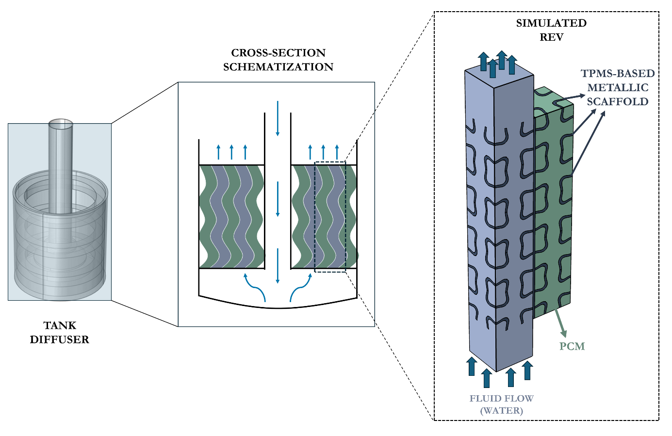
Fig. 1: Conceptual representation of the PCM-enhanced inlet diffuser. From left to right: full tank-diffuser assembly, cross-sectional representation of the flow redistribution within the diffuser, and simulated representative elementary volume comprising one upward-flow water passage and one adjacent I-WP–PCM composite passage. The arrows indicate the water-flow direction, while the dashed outline identifies the portion of the periodic structure retained in the numerical model.

Tab. 1: Thermophysical properties of the phase change material (paraffin) (Yang et al., 2024). | Tab. 2: Thermophysical properties of the metallic scaffold (Yang et al., 2024).
  Paraffin | Parameter | Value
   | Melting temperature (°C) (solidus/liquidus) | 52.43/62.38
   | Latent heat (kJ·kg⁻¹) | 146.42
   | Density (kg·m⁻³) (solidus/liquidus) | 916 / 880
   | Specific heat capacity (kJ·kg⁻¹·K⁻¹) (solidus/liquidus) | 2.46 / 2.51
   | Thermal conductivity (W·m⁻¹·K⁻¹) (solidus/liquidus) | 0.24 / 0.14
  AlSi10Mg | Parameter | Value
   | Density (kg·m⁻³) | 2670
   | Specific heat capacity (J·kg⁻¹·K⁻¹) | 895
   | Thermal conductivity (W·m⁻¹·K⁻¹) | 151

The transient fluid flow is assumed laminar, incompressible, and governed by the Navier–Stokes and continuity equations,
$$ρ\frac{∂u}{∂t}+ρu∙\left(∇u\right)=- ∇p+ μ∇^{2}u$$ | (eq. 1)
$$∇⋅u=0$$ | (eq. 2)
where $u$ is the velocity vector (m·s⁻¹), $p$ is the pressure (Pa), $ρ$ is the fluid density (kg·m⁻³), and m the dynamic viscosity (kg m⁻¹ s⁻¹). The energy equation is used for both water and PCM domain, and expressed as follow:
$$ρ c\frac{∂T}{∂t}+ρ c u∙∇T+∇∙q= 0$$ | (eq. 3)
$$q=-k∇T$$ | (eq. 4)
where $T$ is the temperature (K), $ρ$ is the density (kg·m⁻³), $c$ is the specific heat capacity at constant pressure (J·kg⁻¹·K⁻¹), $u$ is the velocity field (m·s⁻¹) obtained from mass and momentum equations, and $k$is the thermal conductivity (W·m⁻¹·K⁻¹). The advective term is active only in the flowing-water domain, whereas heat transport within the stationary solid domains is governed by transient conduction. Phase change within the paraffin domain is modelled through the apparent heat capacity method, whereby the latent contribution is incorporated into an effective temperature-dependent heat capacity. Accordingly,
$$c=c_{s}\left[1-α\left(T\right)\right]+c_{l}α\left(T\right)+L\frac{dθ_{l}\left(T\right)}{dT}$$ | (eq. 5)
where $c_{s}$ and $c_{l}$ are the specific heat capacities of the solid and liquid phases (J·kg⁻¹·K⁻¹), $L$ is the latent heat of fusion and $θ_{l}\left(T\right)$ represents the local liquid fraction. The phase transition is smoothed over the solid-liquidus temperature interval, allowing the latent heat contribution to be included continuously within the transient energy equation while avoiding an explicit tracking of the moving phase interface. Although buoyancy-driven motion may arise once the phase change material becomes liquid, natural convection within the PCM domain is neglected in the present model. This assumption is assessed through a characteristic Rayleigh number,
$$Ra=\frac{gβΔTH^{3}}{να}$$ | (eq. 6)
where $g$ (m s⁻²) is the gravitational acceleration, $β$ (K⁻¹) is the thermal expansion coefficient, $ΔT$ a representative temperature difference across the PCM domain, $H$ the characteristic length, $ν$ is the cinematic viscosity, and $α$ is the thermal diffusivity. Considering $ΔT=20 °C$, $H=50 mm$, and $β={10}^{-4} K^{-1}$, the maximum Rayleigh number is approximately $Ra_{max}=2∙{10}^{6}$, which remains below the lower bound of the critical range reported for the onset of buoyancy-driven convection in comparable phase-change enclosures (Wang et al., 1999). Accordingly, fluid motion within the PCM is neglected and $u=0$ is imposed in this domain, so that heat transfer is described by transient conduction coupled with sensible and latent energy storage.
The governing equations are completed by prescribing the hydraulic and thermal boundary conditions of the representative domain. Water enters the fluid channel with a uniform velocity corresponding to the imposed volumetric flow rate, while a zero-gauge-pressure condition is prescribed at the outlet. No-slip conditions are applied at the water–solid interfaces, where conjugate heat transfer is ensured through continuity of temperature and normal heat flux. The remaining external boundaries are treated consistently with the reduced-domain representation so as to reproduce the local behaviour of the periodically repeated diffuser structure. The inlet temperature is imposed as a sinusoidal thermal forcing,
$$T_{in}\left(t\right)=T_{mean}+A\sin\left(\frac{2π}{τ_{p}}t\right)$$ | (eq. 7)
where A is the oscillation amplitude (°C), $T_{mean}$ (°C) is the mean inlet temperature, and $τ_{p}$ (s⁻¹) is the forcing period. In the present study, $T_{mean}=55 °C$, $A=10 °C$, and $τ_{p}=300 s$, so that the imposed thermal cycle spans the phase-change interval of the paraffin and repeatedly activates its latent thermal capacity.
The coupled thermo-fluid problem is solved using the finite-element method in COMSOL Multiphysics® under fully transient conditions. The water, metallic scaffold, and phase change material domains are spatially discretized within the same computational framework, allowing the conjugate thermal interactions described above to be resolved directly at their interfaces. Time integration is performed using a backward differentiation formula scheme with a fixed time step. The resulting transient solution is post-processed in terms of the fluid temperature downstream of the active region, local interfacial heat-transfer quantities, and the liquid-fraction field within the phase change material, which form the basis of the performance analysis presented in the following section.
- Results and Discussion
Three volumetric flow rates, equal to 1.75, 3.50, and 7.00 (m³ h⁻¹), were selected as representative operating conditions for a medium-scale sensible thermal storage tank, with a storage volume of approximately 25 m³. The corresponding inlet velocities in the representative fluid channel were then derived from the equivalent open-flow area of the diffuser. Assuming a diffuser diameter ($D_{diff}$) of 300 mm, a central 50 mm inlet pipe ($D_{pipe}$), and an open flow fraction ($ε_{A}$) of 0.5 due to the alternating fluid and IWP-PCM channels, the corresponding inlet velocity was evaluated as:
$$u_{in}=\frac{\dot{V}/3600}{ε_{A}\frac{π}{4}\left(D_{diff}^{2}-D_{pipe}^{2}\right)}$$ | (eq. 8)
where $u_{in}$ (m s⁻¹) is the inlet velocity of the single channel in the REV and $\dot{V}$ (m³ h⁻¹) is the equivalent volumetric flow rate of the diffuser. Using this relation, the selected volumetric flow rates correspond to inlet velocities of approximately 0.014, 0.028 and 0.056 (m s⁻¹), respectively.
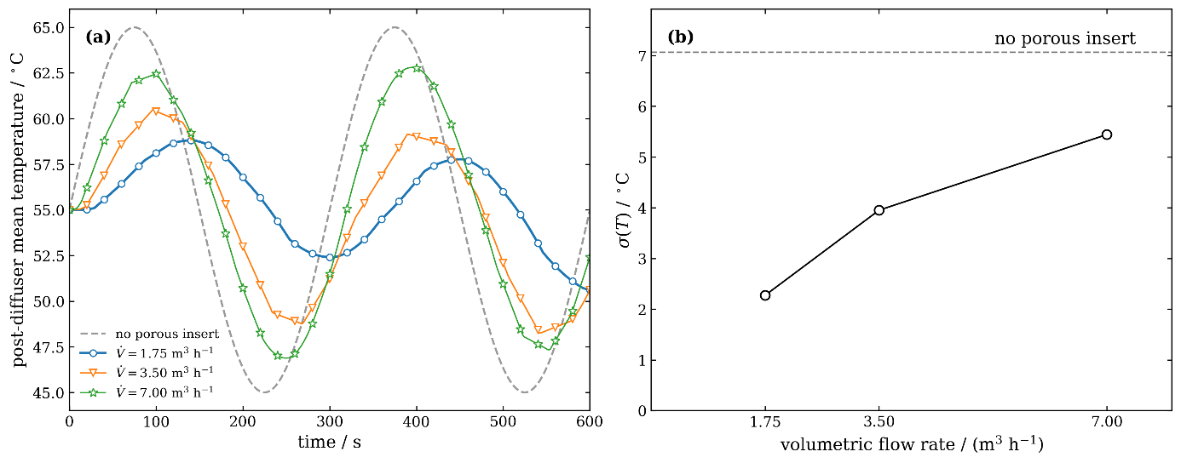
Fig. 2: Thermal response of the diffuser equipped with the asymmetric IWP–PCM insert under the three investigated volumetric flow rates. (a) Temporal evolution of the mean post-diffuser temperature compared with the undisturbed profile obtained in the absence of the porous insert. (b) Standard deviation of the post-diffuser temperature as a function of volumetric flow rate; the dashed horizontal line indicates the corresponding value for the undisturbed condition.
The capability of the asymmetric IWP–PCM insert to passively mitigate temperature fluctuations was assessed under the three representative operating conditions defined above, corresponding tothe aforementioned volumetric flow rate values. Fig. 2(a) shows the temporal evolution of the mean post-diffuser temperature for the three cases, together with the undisturbed temperature profile obtained in the absence of the porous insert. In all investigated conditions, the presence of the composite substantially reduces the amplitude of the thermal oscillation transmitted downstream of the diffuser. The smoothing effect is strongest at the lowest flow rate, where the outlet-temperature excursion is markedly reduced and the response also exhibits a noticeable delay with respect to the imposed forcing. As the volumetric flow rate increases, progressively larger residual oscillations are observed, with the post-diffuser response approaching the undisturbed profile at 7.00 (m³ h⁻¹). To quantify the residual temperature fluctuations, Fig. 2(b) reports the standard deviation of the post-diffuser temperature over the entire investigated time interval. The metric is defined as
$$σ\left(T\right)=\sqrt{\frac{1}{N}\sum_{i=1}^{N}{{\left(T_{i}-T_{mean}\right)}^{2}}}$$ | (eq. 9)
where $N$ is the number of sampled values, $T_{i}$ (°C) is the instantaneous post-diffuser temperature, and $T_{mean}$ is the mean temperature of the corresponding time series. The undisturbed condition exhibits $σ\left(T\right)=7.07 °C$, whereas the IWP–PCM insert reduces this value to 2.26, 3.79, and 5.41 °C at 1.75, 3.50, and 7.00 (m³ h⁻¹), respectively. These values correspond to reductions of approximately 67.8%, 44.1%, and 23.1% relative to the undisturbed condition. The residual temperature ripple therefore increases monotonically with volumetric flow rate, while remaining lower than the undisturbed condition throughout the investigated range. This behaviour is consistent with a progressive reduction of the characteristic interaction time between the flowing water and the thermally active composite as the flow rate increases. Although the temperature response quantifies the overall damping performance, it does not reveal how heat transfer is distributed along the device. The local wall heat flux and the corresponding effective heat-transfer coefficient were therefore analysed at representative phases of the forcing cycle.
  - Local heat-transfer distribution
To clarify the local mechanisms underlying the thermal response discussed in Section 3.1, Fig. 3 compares the axial distributions of the normal heat flux and effective heat-transfer coefficient at three representative phases of the imposed thermal cycle. The profiles were obtained from the second cycle, whereas the first cycle was treated as an initial transient buffer. For each of the 20 axial bands, the magnitude of the normal heat flux was averaged over the corresponding exchange surface. The effective heat-transfer coefficient was calculated as
$$h_{eff}\left(z,t\right)=\frac{{\left\langle \left|q''_{n}\left(z,t\right)\right|\right\rangle }_{A}}{{\left\langle \left|T_{w}\left(z,t\right)-T_{b}\left(z,t\right)\right|\right\rangle }_{A}}$$ | (eq. 10)
where $T_{w}$ and $T_{b}$ are the surface and bulk-fluid temperatures, respectively, and ${\left\langle ⋅\right\rangle }_{A}$ indicates the area-weighted average. The magnitude of the heat flux therefore describes the local intensity of the thermal exchange, while the sign of $T_{w}-T_{b}$ was retained separately to distinguish heat absorption from heat release.
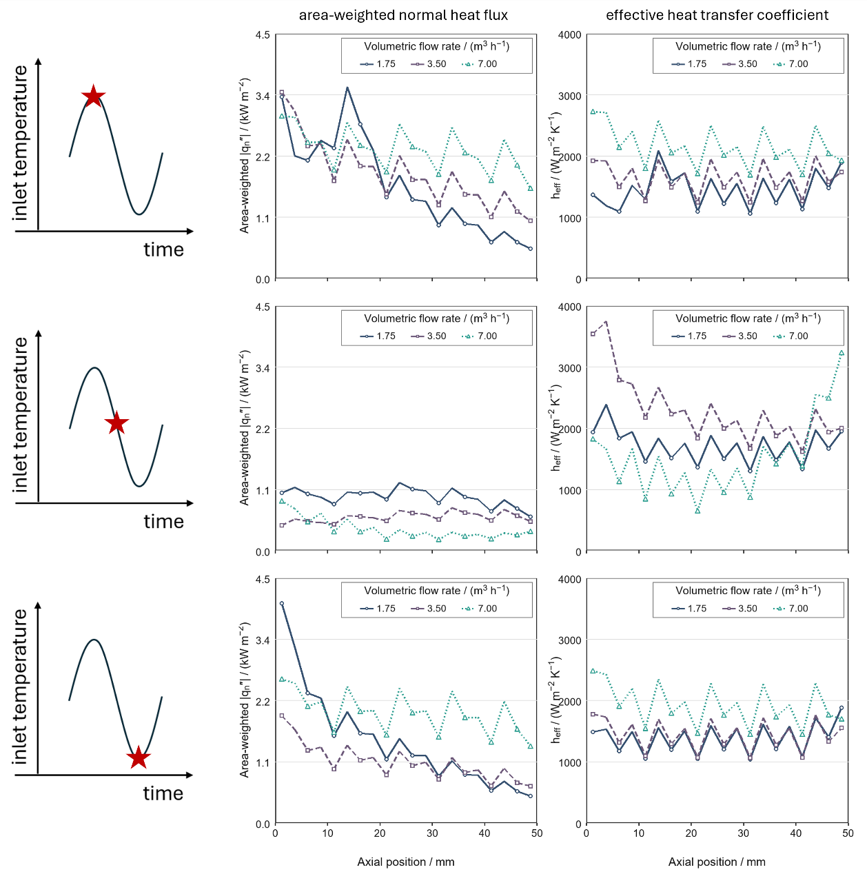
Fig. 3: Axial distributions of the area-weighted normal heat-flux magnitude, $|q_{n}^{''}|$, and effective heat-transfer coefficient, $h_{eff}$, for the three investigated volumetric flow rates. Rows correspond to the representative phases $π/2$ $π$, and $3π/2$of the second thermal cycle, identified by the red markers on the schematic inlet-temperature profiles. The axial coordinate is measured from the channel inlet, and the exchange surface is divided into 20 axial bands.
The three rows of Fig. 3 correspond to the nominal phases $π/2$, $π$, and $3π/2$, as identified by the markers on the schematic inlet-temperature curves. The axial heat-flux profiles show that the volumetric flow rate affects not only the magnitude of the thermal exchange but also the fraction of the surface that is effectively involved. At 1.75 m³ h⁻¹, the heat flux is concentrated near the channel inlet and decreases markedly along the flow direction. Conversely, at 7.00 m³ h⁻¹, appreciable heat-flux values are maintained over almost the entire channel length. At $π/2$, the ratio between the mean heat flux over the last and first 10 mm of the channel increases from 0.27 at 1.75 m³ h⁻¹ to 0.74 at 7.00 m³ h⁻¹. A similar variation is observed at $3π/2$, for which the corresponding ratio increases from 0.20 to 0.72. The intermediate flow rate consistently exhibits an intermediate axial distribution. Therefore, the reduced temperature damping observed at higher flow rates is accompanied by a more extended utilization of the heat-transfer surface.
At $π/2$, the bulk-fluid temperature is higher than the wall temperature for all three operating conditions, indicating heat transfer from the fluid towards the metallic structure and the PCM. At $3π/2$, the temperature difference reverses and the previously stored thermal energy is released back to the fluid. Despite the reversal of the heat-transfer direction, the axial shapes obtained during the two active half-cycles remain similar, particularly at 3.50 and 7.00 m³ h⁻¹. For these two flow rates, the correlation between the heat-flux profiles at $π/2$ and $3π/2$ exceeds 0.99. This result indicates that the spatial distribution of the exchange is primarily controlled by the flow regime and channel geometry, whereas its direction follows the imposed thermal cycle. The differences in profile magnitude nevertheless show that the absorption and release stages are not perfectly symmetrical.
The effective heat-transfer coefficient generally increases with flow rate during the thermally active phases. At $π/2$, the axial mean values of $h_{eff}$ are approximately 1.46, 1.65, and 2.16 kW m⁻² K⁻¹ for flow rates of 1.75, 3.50, and 7.00 m³ h⁻¹, respectively. At $3π/2$, the corresponding values are approximately 1.39, 1.45, and 1.93 kW m⁻² K⁻¹. The profiles also exhibit recurring axial fluctuations, with comparable positions during the heating and cooling stages. Their systematic occurrence is consistent with the periodic TPMS architecture and the resulting local modulation of the flow and exchange conditions. Accordingly, the overall profile level and axial envelope are more physically significant than the individual local peaks. Around the nominal phase $π$, both the heat flux and the temperature difference between the wall and bulk fluid decrease as the system approaches a reversal of the heat-transfer direction. The three flow rates do not reach this condition simultaneously: the two lower-flow cases remain in the heat-absorption stage, whereas the highest-flow case has already entered the heat-release stage. This behaviour provides further evidence of a flow-dependent delay in the local thermal response. However, because $T_{w}-T_{b}$ becomes locally as low as approximately 0.1 K, the corresponding $h_{eff}$ values are highly sensitive to the small denominator. The peaks obtained around $π$ should therefore not be used to rank the heat-transfer performance of the three operating conditions.
Overall, the local surface analysis demonstrates that increasing the flow rate distributes the thermal exchange over a larger portion of the device, even though the resulting temperature attenuation per passage decreases. To determine whether this broader surface utilization also produces a more extensive activation of the storage medium, the liquid-phase fraction within the PCM is examined in the following section.

  - PCM utilization and latent-storage activation
The spatial utilization of the PCM was evaluated from the liquid-phase fraction during the second thermal cycle. The PCM volume was divided into 20 axial bands, consistently with the surface analysis presented in Fig. 3, and the liquid fraction was volumetrically averaged within each band. Fig. 4 shows the resulting space–time distributions, $\overline{θ}\left(z,t\right)$, for the three volumetric flow rates. The volume-averaged liquid fraction within each axial band was calculated as
$${\overline{θ}}_{l}\left(z,t\right)=\frac{1}{V_{z}}\int_{V_{z}}{θ_{l}}\left(x,t\right) dV$$ | (eq. 11)
where $θ_{l}(x,t)$ is the local (element-wise) PCM liquid fraction, ranging from 0 for completely solid PCM to 1 for completely liquid PCM, and $V_{z}$ is the PCM volume contained within the axial band located at $z$. The local cyclic utilization of the PCM was then defined as
$$Δ{\overline{θ}}_{l}\left(z\right)=\max_{t∈C}\left[\overline{θ}\left(z,t\right)\right]-\min_{t∈C}\left[\overline{θ}\left(z,t\right)\right]$$ | (eq. 12)
where $C$ denotes the representative thermal cycle. Therefore, $Δ{\overline{θ}}_{l}\left(z\right)$ represents the fraction of the local PCM volume that undergoes a reversible phase change during the representative cycle. A value close to zero indicates negligible latent-storage activation, whereas a value close to one indicates that almost the entire local latent capacity is involved in the melting – solidification cycle. The corresponding activated latent energy was evaluated as
$$Q_{lat,act}=ρ_{PCM}L\int_{V_{PCM}}{Δ}θ_{l}\left(x\right) dV$$ | (eq. 13)
where $ρ_{PCM}$ is the PCM density, $L$ is its latent heat of fusion, $V_{PCM}$ is the total PCM volume, and ${Δθ}_{l}\left(x\right)$ is the local liquid-fraction variation during the second cycle.
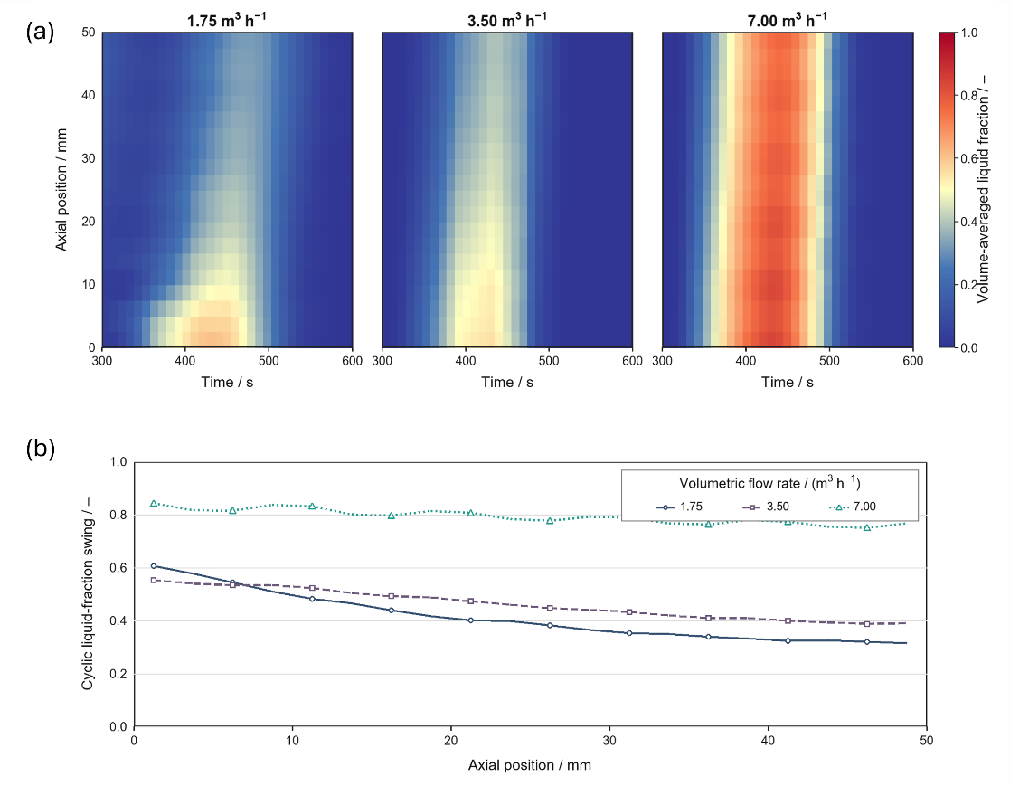
Fig. 4: (a) Space-time evolution of the volume-averaged PCM liquid fraction, ${\overline{θ}}_{l}\left(z,t\right)$, during the representative thermal cycle for the three investigated volumetric flow rates. (b) reports the local cyclic liquid-fraction variation, $Δ{\overline{θ}}_{l}\left(z\right)$, representing the fraction of latent-storage capacity activated within each of the 20 axial bands.

At 1.75 m³ h⁻¹, the phase transformation is more pronounced in the lower part of the PCM domain and progressively weakens along the axial direction. The upper region therefore undergoes a comparatively limited variation in liquid fraction. At 3.50 m³ h⁻¹, the transformation extends further downstream, although an appreciable axial gradient remains. At 7.00 m³ h⁻¹, large liquid-fraction variations occur throughout almost the entire PCM height. This evolution is consistent with the heat-flux profiles reported in Fig. 3: the broader axial distribution of the surface heat transfer at high flow rate is accompanied by a more extensive involvement of the adjacent storage material. The overall latent capacity activated during the cycle was estimated by integrating the local liquid-fraction variation over the PCM volume. The theoretically available latent energy within the representative domain is approximately 470 J. Of this capacity, approximately 194 J is cyclically activated at 1.75 m³ h⁻¹, corresponding to 41.2% of the available latent storage. The activated energy increases to approximately 217 J, or 46.1%, at 3.50 m³ h⁻¹ and reaches approximately 373 J, or 79.3%, at 7.00 m³ h⁻¹. Thus, the highest investigated flow rate activates almost twice the latent-storage capacity mobilized at the lowest flow rate.
The axial variation of $Δ{\overline{θ}}_{l}\left(z\right)$ further quantifies the different utilization patterns. At 1.75 m³ h⁻¹, the mean liquid-fraction variation decreases from 0.559 over the first 10 mm to 0.321 over the last 10 mm. At 3.50 m³ h⁻¹, the corresponding values are 0.540 and 0.393. The axial difference is substantially reduced at 7.00 m³ h⁻¹, for which the liquid-fraction variation remains high in both regions, with mean values of 0.827 and 0.761. Increasing the flow rate therefore produces a more spatially uniform cyclic activation of the PCM. Local regions approaching complete melting were also identified by considering $θ_{l}≥0.95$. Within the first 10 mm (the length of IWP unit cell) of the PCM domain, the maximum fraction of volume satisfying this condition during the cycle is approximately 8.7%, 1.4%, and 29.5% at 1.75, 3.50, and 7.00 m³ h⁻¹, respectively. In the last 10 mm, this condition is practically absent at the two lower flow rates, whereas it reaches approximately 12.7% of the local volume at 7.00 m³ h⁻¹. Consequently, the higher flow rate promotes a more extensive and uniform exploitation of the available latent capacity, while also increasing the portion of PCM that approaches complete melting during the hottest part of the cycle.
- Discussion
The combined analysis of the transmitted temperature signal, local heat transfer, and PCM phase evolution reveals a trade-off between thermal damping and spatial utilization of the active material. At low flow rate, the diffuser produces the greatest reduction in the amplitude of the outlet-temperature oscillation. However, the thermal exchange is strongly concentrated near the channel inlet, and a substantial portion of both the exchange surface and PCM volume remains comparatively underutilized. At high flow rate, the attenuation achieved during a single passage decreases, but heat transfer extends over a larger fraction of the device and activates a considerably greater portion of the available latent-storage capacity. This behaviour can be explained by the different thermal evolution of the fluid along the channel. At low flow rate, the longer residence time allows the fluid temperature to approach that of the surrounding structure over a relatively short axial distance. The resulting reduction in the local temperature difference weakens the thermal driving force downstream, thereby concentrating the exchange and phase transformation in the lower region. This condition is effective in changing the fluid temperature and therefore in damping the imposed oscillation, but it does not promote uniform utilization of the complete device. Conversely, at high flow rate, the fluid undergoes a smaller temperature change per unit channel length and retains a significant thermal difference from the surrounding structure further downstream. The local exchange is consequently distributed over a greater axial distance, although the final temperature variation obtained during a single passage is smaller.
The two performance indicators therefore do not improve in the same direction. Increasing the flow rate from 1.75 to 7.00 m³ h⁻¹ reduces the relative attenuation of the transmitted temperature oscillation, while increasing the activated latent-storage capacity from approximately 41% to 79% of the theoretically available value. The highest flow rate also produces a more uniform axial liquid-fraction variation, with comparable PCM utilization in the lower and upper portions of the device. Thus, outlet-temperature attenuation alone does not provide a complete measure of diffuser performance. The fraction of active PCM, the uniformity of its utilization, and the occurrence of local regions approaching complete melting must also be considered.
These results suggest that a uniform axial distribution of hydraulic passage area and PCM volume is unlikely to be optimal over the complete operating range. The larger thermal load observed close to the inlet indicates that a greater latent-storage capacity may be beneficial in the lower part of the diffuser. Moving downstream, the PCM fraction could be progressively reduced as the local cyclic thermal load decreases. A complementary increase in the open flow area would simultaneously reduce the mean fluid velocity along the channel, modifying the local residence time and redistributing the heat-transfer load. Conceptually, this arrangement could be obtained through two complementary truncated-pyramid-like regions: an expanding fluid passage and an adjacent PCM region whose cross-section decreases in the flow direction.
Such an axially graded configuration could combine a relatively high inlet velocity, required to promote thermal penetration into the device, with a progressive downstream reduction in velocity. At the same time, the larger PCM volume near the inlet would accommodate the higher local cyclic load and limit the risk that the available latent capacity becomes insufficient in this region. The reduced PCM fraction downstream would avoid allocating excessive storage material to portions of the device that are only weakly activated under low- and intermediate-flow conditions. This configuration should nevertheless be regarded as a design implication derived from the present results rather than as an already optimized geometry.
The appropriate degree of axial grading is expected to depend strongly on the design flow rate. A pronounced concentration of PCM near the inlet may be suitable at low and intermediate flow rates, for which the upper portion of the present geometry remains only partially active. At 7.00 m³ h⁻¹, however, the upper PCM region contributes substantially to the thermal cycle. Excessively reducing the downstream PCM volume could therefore limit latent-storage availability at high flow rates and increase the occurrence of local complete melting. The graded geometry should consequently be designed either for a specified nominal operating condition or as a compromise over the expected flow-rate range.
Future optimization should consider several competing objectives: attenuation of the transmitted temperature oscillation, maximization of the cyclically activated latent capacity, uniformity of PCM utilization, limitation of local saturation, and hydraulic performance. In particular, the thermal benefits of modifying the channel cross-section must be evaluated together with the associated pressure drop and pumping requirements. Further investigation of the proposed axial grading will therefore require a parametric analysis of the fluid and PCM cross-sectional distributions, followed by validation at diffuser scale. Within the scope of the present study, the results establish the physical basis for this optimization and demonstrate that global damping performance and local latent-storage utilization must be considered jointly when designing PCM-enhanced diffusers for sensible thermal storage systems.
- Conclusions
This study investigated a PCM-enhanced TPMS inlet diffuser as a passive solution for attenuating inlet-temperature oscillations commonly associated with the variable thermal output of solar collector fields. Such fluctuations can propagate into sensible heat storage tanks, promoting mixing and degrading thermal stratification. Under the three investigated volumetric flow rates, the proposed insert reduced the standard deviation of the post-diffuser temperature from the undisturbed value to 2.26, 3.79, and 5.41 °C at 1.75, 3.50, and 7.00 m³ h⁻¹, respectively. These values correspond to reductions of approximately 67.8%, 44.1%, and 23.1%. The greatest damping was therefore obtained at the lowest flow rate, owing to the larger temperature variation experienced by the fluid during its passage through the thermally active structure. The local analysis showed, however, that thermal damping and utilization of the active material do not improve simultaneously. At low flow rate, heat transfer and phase transformation were concentrated near the channel inlet, leaving the downstream surface and PCM volume only partially utilized. Increasing the flow rate distributed the thermal exchange over a larger fraction of the device and increased the activated latent-storage capacity from approximately 41.2% to 79.3% of the theoretically available value. The diffuser design must therefore balance attenuation of the transmitted temperature oscillation against uniform and effective exploitation of the PCM. The results provide a physical basis for future axially graded configurations, combining greater latent-storage capacity near the inlet with a progressively increasing fluid passage area. Further optimization should evaluate this concept over the expected operating range while accounting for thermal performance, local PCM saturation, pressure drop, and pumping requirements.

- References
Anacreonte, V.A., Vitobello, R., Musto, M., 2025. Impact of inlet fluctuations on the stratification of a sensible thermal energy storage. Renewable Energy 252, 123484. https://doi.org/10.1016/j.renene.2025.123484.
Chang, Z., Li, X., Falcoz, Q., Zhuang, C., Li, Y., 2022. Quasi-analytical study of dynamic performance of the thermocline heat storage system under time-varying inlet flow and temperature environment. Solar Energy 244, 264–278. https://doi.org/10.1016/j.solener.2022.08.024.
Chekifi, T., Boukraa, M., 2023. CFD applications for sensible heat storage: A comprehensive review of numerical studies. Journal of Energy Storage 68, 107893. https://doi.org/10.1016/j.est.2023.107893.
Fertahi, S.E.-D., Jamil, A., Benbassou, A., 2018. Review on solar thermal stratified storage tanks (STSST): Insight on stratification studies and efficiency indicators. Solar Energy 176, 126–145. https://doi.org/10.1016/j.solener.2018.10.028.
Frazzica, A., Cabeza, L.F. (Eds.), 2019. Recent Advancements in Materials and Systems for Thermal Energy Storage: An Introduction to Experimental Characterization Methods. Springer International Publishing, Cham. https://doi.org/10.1007/978-3-319-96640-3.
Gado, M.G., 2024. Improving the charging performance of latent heat thermal energy storage systems using triply periodic minimal surface (TPMS) structures. Journal of Energy Storage 103, 114310. https://doi.org/10.1016/j.est.2024.114310.
Han, Y.M., Wang, R.Z., Dai, Y.J., 2009. Thermal stratification within the water tank. Renewable and Sustainable Energy Reviews 13, 1014–1026. https://doi.org/10.1016/j.rser.2008.03.001.
Huo, Y., Zong, J., Rao, Z., 2019. The investigations on the heat transfer in thermal energy storage with time-dependent heat flux for power plants. Energy 175, 1209–1221. https://doi.org/10.1016/j.energy.2019.03.149.
International Renewable Energy Agency (IRENA), 2020. Innovation Outlook: Thermal Energy Storage. International Renewable Energy Agency, Abu Dhabi. https://www.irena.org/publications/2020/Nov/Innovation-outlook-Thermal-energy-storage (accessed 28 August 2026).
Karim, A., Burnett, A., Fawzia, S., 2018. Investigation of stratified thermal storage tank performance for heating and cooling applications. Energies 11, 1049. https://doi.org/10.3390/en11051049.
Li, W.Q., Qu, Z.G., He, Y.L., Tao, W.Q., 2012. Experimental and numerical studies on melting phase change heat transfer in open-cell metallic foams filled with paraffin. Applied Thermal Engineering 37, 1–9. https://doi.org/10.1016/j.applthermaleng.2011.11.001.
Li, Z., Yu, X., Wang, L., Lu, Y., Huang, R., Chang, J., Jiang, R., 2020. Effects of fluctuating thermal sources on a shell-and-tube latent thermal energy storage during charging process. Energy 199, 117400. https://doi.org/10.1016/j.energy.2020.117400.
Lou, W., Luo, L., Hua, Y., Fan, Y., Du, Z., 2021. A review on the performance indicators and influencing factors for the thermocline thermal energy storage systems. Energies 14, 8384. https://doi.org/10.3390/en14248384.
Pielichowska, K., Pielichowski, K., 2014. Phase change materials for thermal energy storage. Progress in Materials Science 65, 67–123. https://doi.org/10.1016/j.pmatsci.2014.03.005.
Qureshi, Z.A., Al-Omari, S.A.B., Elnajjar, E., Al-Ketan, O., Abu Al-Rub, R., 2021. Using triply periodic minimal surfaces (TPMS)-based metal foam structures as skeleton for metal-foam–PCM composites for thermal energy storage and energy management applications. International Communications in Heat and Mass Transfer 124, 105265. https://doi.org/10.1016/j.icheatmasstransfer.2021.105265.
Schoen, A.H., 1970. Infinite Periodic Minimal Surfaces Without Self-Intersections. NASA Technical Note D-5541. National Aeronautics and Space Administration, Washington, DC. https://ntrs.nasa.gov/citations/19700020472 (accessed 28 August 2026).
Wang, W., Shuai, Y., Qiu, J., He, X., Hou, Y., 2022. Effect of steady-state and unstable-state inlet boundary on the thermal performance of a packed-bed latent heat storage system integrated with concentrating solar collectors. Renewable Energy 183, 251–266. https://doi.org/10.1016/j.renene.2021.11.005.
Wang, Y., Amiri, A., Vafai, K., 1999. An experimental investigation of the melting process in a rectangular enclosure. International Journal of Heat and Mass Transfer 42, 3659–3672. https://doi.org/10.1016/S0017-9310(99)00024-1.
Xu, Y., Ren, Q., Zheng, Z.J., He, Y.L., 2017. Evaluation and optimization of melting performance for a latent heat thermal energy storage unit partially filled with porous media. Applied Energy 193, 84–95. https://doi.org/10.1016/j.apenergy.2017.02.019.
Yang, Z., Zhang, T., Li, W., Zhou, Y., Li, X., Liu, F., 2024. Experimental and numerical assessments of thermal transport in phase change material embedding additively manufactured triply periodic minimal surfaces: A comparative evaluation. Applied Thermal Engineering 245, 122850. https://doi.org/10.1016/j.applthermaleng.2024.122850.

