**Kinematic-Dynamic simulation and Test Campaign of**

**a 2D Aerospace structure dedicated to LAGARD Project**

E. C. Kaslis1, D. E. Mazarakos1, A. Ampatzoglou1, D. E. Vlachos2, V. Kostopoulos1

1Applied Mechanics Laboratory, Department of Mechanical Engineering & Aeronautics,

University of Patras, GR – 26504, Patras, Greece

Email: [kaslis@upatras.gr](mailto:kaslis@upatras.gr), Web Page: <http://www.aml.mech.upatras.gr/index.php>

2Adamant Composites Ltd., GR – 26504, Patras, Greece

Email: vlachos@adamant-composites.gr, Web Page: <http://www.adamant-composites.gr/>

**Keywords:** Space telescopes, Deployable structures, Kinematic and Dynamic analysis, ADAMS

**Abstract**

In this survey, the kinematic-dynamic analysis of a 2D deployable truss and the relevant test campaign are presented. This deployable truss is the main part of an octagonal 9-bay space deployable structure that was developed during ESA-LAGARD Project. The scope of the structure is the accommodation of parts of a space telescope for future ESA science missions. The functional specifications demand high stiffness and accuracy in the fully deployed configuration. The truss is consisted of CFRP beams, connected with titanium rigid connectors. The truss is actuated by a fully controlled motorized mechanism. For each bay, longerons members are rotated around a hinge point leading to the translation of a frame of batten elements. This consecutive action leads to the full deployment of the 9-bay octagonal structure. The kinematic - dynamic analysis task is critical for the design as it is needed for the sizing of the motorization system. A rigid body approach was proposed for the truss’s kinematic and dynamic response using analytical formulas in order to verify the numerical models in MSC ADAMS. The truss’s flexibility and deformations were further investigated combining FE models. The Test campaign for the truss is also proposed including the basic set-up, the auxiliary equipment, the loads’ application and the main output monitoring.

1. Introduction

During the last decades, there is a high demand in the astrophysics and astronomy scientific community for deep space investigation tools. Space telescopes are the main tools that are used for this scope. In order to capture high resolution deep space images, X-ray and Gamma-ray telescopes are used. The operating principle of such telescopes (due to high photons energetic nature) has guided the engineers to design high focal length telescopes, meaning telescopes with focal length up to tens of meters. The simplest and most efficient solution to achieve such focal length levels in space is to employ deployable structures with a low packaging ratio.

The 2 most known concepts in the field of deployable space structures-masts are ADAM (NASA, USA) (Figure 1) and HALCA (JAXA, Japan) (Figure 2) [1]-[2]. The ESA-LAGARD project set out to develop a European solution for a modular deployable mast. This project is led by Adamant Composites Ltd (Prime Contractor, Greece) and UPat Applied Mechanics Laboratory (Partner, Greece). This paper addresses the necessary kinematic and dynamic analyses performed for a 2D module, which is the basic unit of the full structure. The load cases studied provided valuable information for the prediction of 2D module behavior during deployment phase, the motors’ power consumption and the developed loads at the connectors. These data could be extrapolated for the design and analysis process of the full 3D LAGARD Structure.

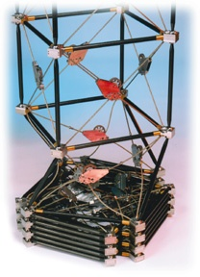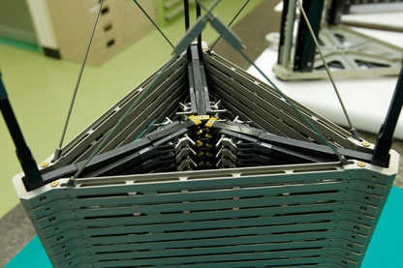

Figure 1. ADAM mast Figure 2. HALCA mast

1. Description of 3D Deployable Truss Structure – 2D Basic Module

The deployable structure-mast is a 3D truss and it is consisted of 2D repetitive frames. The 2D frame is the basic module of the 3D deployable mast. This module is placed peripherally and longwise in order to build a 9-bay octagonal 3D mast, a view of which is shown in Figure 3.



Figure 3. 9-bay octagonal 3D mast

The 2D basic module has to be scalable and modular. The 3D deployable mast’s functional specifications are presented in Table 1.

Table 1. Structure specifications

|  |  |
| --- | --- |
| **Specification** | **Limitations** |
| **Deployment length** | Between 11 m and 21 m |
| **Package ration** | Less than 10% |
| **Coefficient of Thermal Expansion** | Less than 5e-6 |
| **Total mass** | Less than Length x Diameter x 12 kg/m2 |
| **Stability Ratio in Operation** | Less than 10e-4 |
| **First Bending eigen frequency** | Greater than 1 Hz |
| **Operational temperature** | Between -10 °C and 30 °C |
| **Survival temperature** | Between -60 °C and 60 °C |
| **Launch environment and attachments** | Ariane 5 |

The final layout for the 2D basic module and 3D deployable mast (the first stage only) relative to the requirements are presented in Figure 4. The materials selection (carbon tubes for struts, CFRP cables and titanium connectors), the mechanical properties of which are shown in Table 2, was a crucial parameter during the design process in order to meet the technical specifications, such as CTE, Stability ratio etc.

Table 2. Struts, Connectors and Cable properties

|  |  |
| --- | --- |
| Pultruded strut: T700/Epoxy | |
| E11 (GPa) | 140 |
| E22 (GPa) | 12.1 |
| E33 (GPa) | 12.1 |
| G12 (GPa) | 4.4 |
| G13 (GPa) | 4.4 |
| G23 (GPa) | 3.2 |
| ν12 | 2.48e-1 |
| ν13 | 2.48e-1 |
| ν23 | 4.58e-1 |
| ρ (kg/m3) | 1610 |
| Connectors: Titanium | |
| E (GPa) | 113.8 |
| ν | 0.342 |
| Cable: CFRP | |
| E (GPa) | 126.4 |
| ν | 0.35 |

For the motorization subsystem, stepper motors (GPL 052-2S/41.6.1) are used for the deployment of the 3D truss structure, one bay at a time. The actuation subsystem is consisted of 8 pins (one at each corner of the truss) which are moving linearly on a ball screw and engage with the truss through a system of levers.

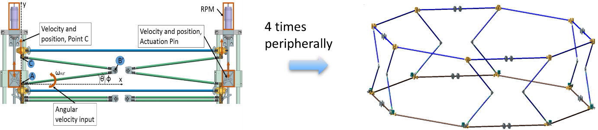

**Figure 4**. Semi-deployed 2D truss (left) and One-bay semi-deployed 3D truss (right)

1. Kinematic and Dynamic Analysis (2D Basic Module)

The main scope of the kinematic and dynamic analysis of the 2D basic module truss during the design process was to investigate key parameters for the 2D module’s operation:

* The necessary actuation torque at each lever (For the step motors power selection)
* Linear velocity (deployment speed) of each upper batten and
* Cable behavior. (Linear response, nonlinear instabilities)

An iterative process was established and the design flow chart is presented in Figure 5.

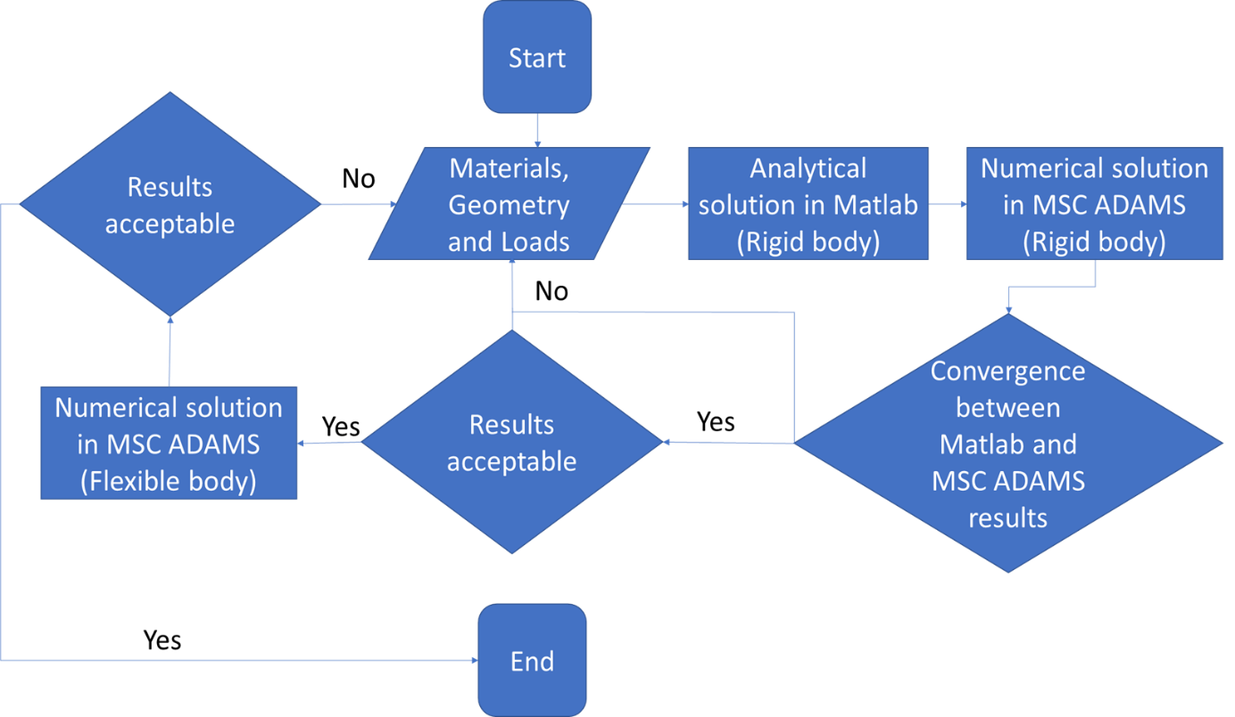

Figure 5. Design flow chart

The rigid body analysis is based on kinematic and dynamic analysis [3]-[12] of the 2D module’s components (longerons, battens etc.). For each component, the kinematic and dynamic analytical equations were used in order to describe the motion. A MATLAB code was developed using the analytical equations, including all the necessary data for each part (inertia, mass, dimensions etc.). The basic kinematic/dynamic model including the loads is presented in Figure 6.

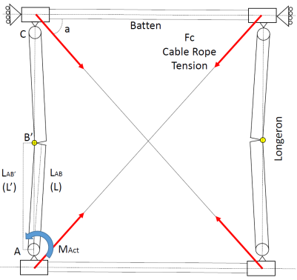

Figure 6. Basic kinematic/dynamic model for the 2D basic module

The basic kinematic data and the calculations are included in Table 3. The deployment is a time dependent process and it is based on the linear velocity of the upper batten. Through this, the necessary torque angular velocity for the motors’ power could be estimated.

Table 3. Basic kinematic calculations for the 2D module’s response

|  |  |
| --- | --- |
| Time allocation for deployment: 1800seconds | |
| For the X-Ray: 9 bays, approximately 210seconds per bay | |
| The total velocity at point B’ (VB’) is function of the input velocities $V_{xB'}$ $V_{xB'}$, $V_{yB'}$ $V_{yB'}$: | |
| $$V_{xB'}=ω_{ΑΒ}L_{AB'}sinφ$$ | |
| $$V_{yB'}=ω_{ΑΒ}L_{AB'}cosφ$$ | |
| From the above equations, the angle φ is given by: | |
| $φ=\tan^{-1}\left(\frac{VxB}{VyB}\right)$ $φ=\tan^{-1}\left(\frac{VxB}{VyB}\right)$, and the angular velocity ωAB is calculated. | |
| Also, $θ=φ-k$ $θ=φ-k$ | |
| The angular acceleration, αAB is derived from the angular velocity: | |
| $$a_{ΑΒ}=\frac{d}{dt}ω_{ΑΒ}$$ | |
| It is also valid that, ωAB=-ωBC and αAB=-αBC | |
| = | |
| Linear acceleration in the x direction of the center of mass (CoM) of Longeron B’C | |
| $$a_{GBCx}=a_{AB}*Y_{B^{'}}+ω_{AB}^{2}*Χ_{Β^{'}}+a_{BC}*Y_{GBC}-a_{BC}*Y_{B^{'}}+ω_{BC}^{2}*Χ_{GΒC}-ω_{BC}^{2}*Χ_{Β'}$$ | |
| Linear acceleration in the y direction of the center of mass (CoM) of Longeron B’C | |
| $$a_{GBCy}=a_{AB}*X_{B}-ω_{AB}^{2}*Y_{Β}+a_{BC}*X_{GBC}-a_{BC}*X_{B}-ω_{BC}^{2}*Y_{GΒC}+ω_{BC}^{2}*Y_{Β}$$ | |
| Linear acceleration in the y direction of point C | |
| $$a_{Cy}=a_{AB}*X_{B^{'}}-ω_{AB}^{2}*Y_{Β^{'}}+a_{BC}*X_{GBC}-a_{BC}*X_{B^{'}}-ω_{BC}^{2}*Y_{GBC}+ω_{BC}^{2}*Y_{Β^{'}}$$ | |
| Linear acceleration in the x direction of the center of mass (CoM) of Longeron AB’ | |
| $$a_{GABx}=a_{AB}*Y_{GAB}+{ω_{AB}}^{2}*Χ_{GAB}$$ | |
| Linear acceleration in the y direction of the center of mass (CoM) of Longeron AB’ | |
| $$a_{GABy}=a_{AB}*X_{GAB}+{ω_{AB}}^{2}*Y_{GAB}$$ | |
| $$Y_{C}=2*L_{AB^{'}}*sinφ$$ | Position of point C, Y-axis, (m) |
| $$Y_{B'}=L_{AB^{'}}*sinφ$$ | Position of point B’, Y-axis, (m) |
| $$X_{B'}=L_{AB^{'}}*cosφ$$ | Position of point B’, X-axis, (m) |
| $$X_{GBC}=L_{GBC}*cosθ$$ | CoG of member BC, X-axis, (m) |
| $$Y_{GBC}=Y_{c}-L_{GCB}*sinθ$$ | CoG of member BC,Y-axis, (m) |
| $$L=L_{CB'}*cosφ-L_{GCB}*cosθ$$ |  |
| $$Η=L_{CB'}*sinφ-L_{GCB}*sinθ$$ |  |
| $$a=atan⁡(\frac{Y_{c}}{L_{bat}})$$ | Cable angle a (rad) |
| Gravity field=0 m/s^2 | Deep space operation and deployment simulation |

The MATLAB code with analytical equations for truss’s kinematics and dynamics was further used for the calibration of the contact elements at MSC ADAMS. Having the same input file (batten’s linear velocity), a numerical model in MSCADAMS was developed in order to simulate the 2D module’s motion and include flexibility effects at the latter stage. For the linear velocity input profile at point C (Figure 7), the MSC ADAMS contact settings (Table 4) were estimated in order to avoid penetration and rebound forces using Equation 1.

$Contact force=\left\{\begin{matrix}Max (0, k{\left(x_{1}-x\right)}^{e}-STEP\left(x,x_{1}-d,c_{max},x_{1},0\right)\dot{x} :x<x_{1} \\ 0 :x≥x_{1}\end{matrix}\right\}$ (1)

Table 4. MSC-ADAMS contact parameters for rigid body modeling

|  |  |  |
| --- | --- | --- |
| **Parameter** | **Value** |  |
| Distance between two objects, x | Default |
| Relative velocity between two objects, $\dot{x}$ | Default |
| Trigger distance, $x_{1}$ | Default |
| Stiffness coefficient, k (N/m) | 1e+10 |
| Stiffness force exponent, e | 2.2 |
| Damping Coefficient, $c_{max}$, (N*s/m) | 1e+8 |
| Damping ramp up distance, d (m) | 1e-4 |

The input velocity profile is an important factor for the analysis in order to have a normalized motion without acceleration and jerk peaks. These peaks could create impact forces preventing the 2D truss’s functionality.

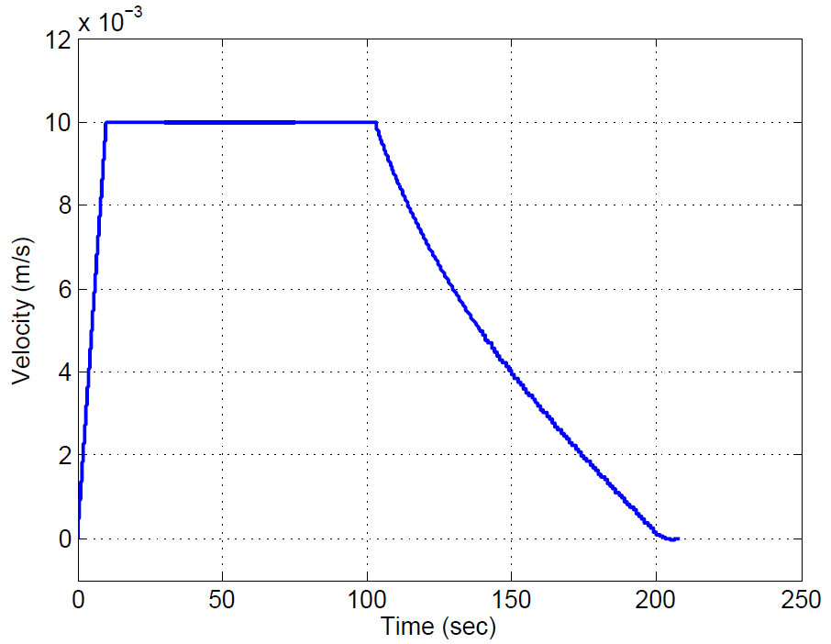

Figure 7. Linear Velocity ($v_{Cy}$ $v_{Cy}$) versus time for point C

The results for the comparisons between MATLAB rigid body code and MSC-ADAMS rigid model analysis after the calibration are presented in Figure 8.

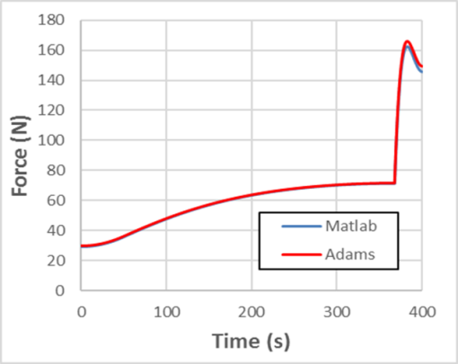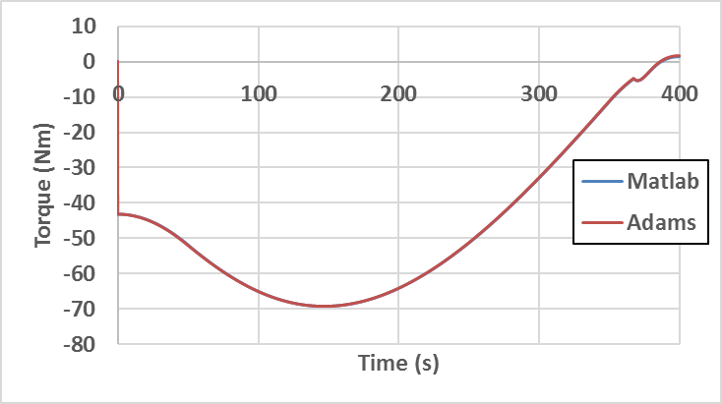

Figure 8. Comparison between analytical (MATLAB) and numerical (MSC ADAMS) solutions for reaction force at upper batten (left) and actuation torque (right)

As the initial rigid body analysis was completed, additional flexibility parameters were considered. Due to the longerons’ angular velocities and accelerations, inertia loads applied to the 2D basic module lead to elastic deformations. These deformations could be critical for the early design stage and additional calculations were applied. Additional FEA models were used in conjunction with MSCADAMS including the battens and longerons dynamic characteristics (eigenfrequencies/eigenvalues). Both rigid and flexible models in MSC ADAMS are presented in Figure 9 and Figure 10 respectively. The dynamic characteristics of a longeron using FEA and the comparisons for flexible body kinematic analysis are presented in Figure 11.

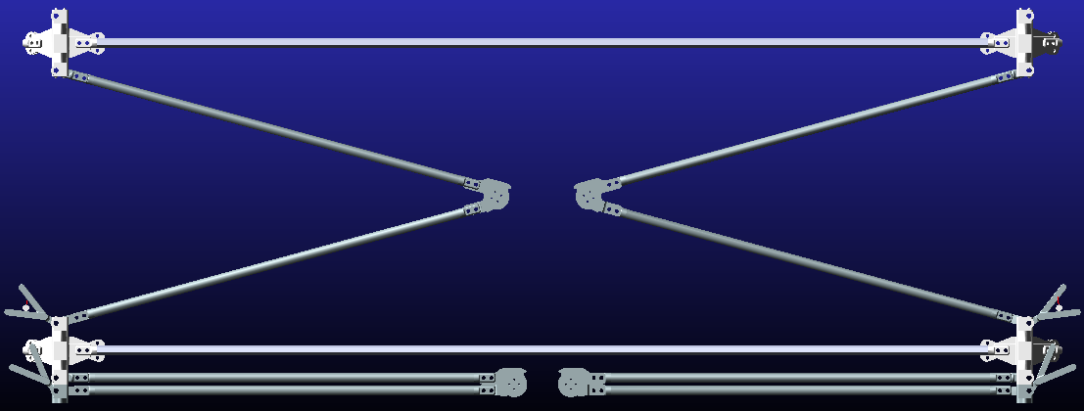

Figure 9. Rigid body model in MSC ADAMS

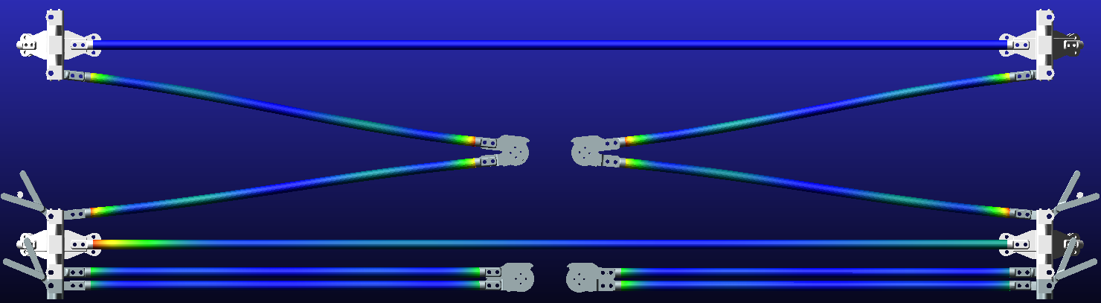

Figure 10. Flexible body model in MSC ADAMS

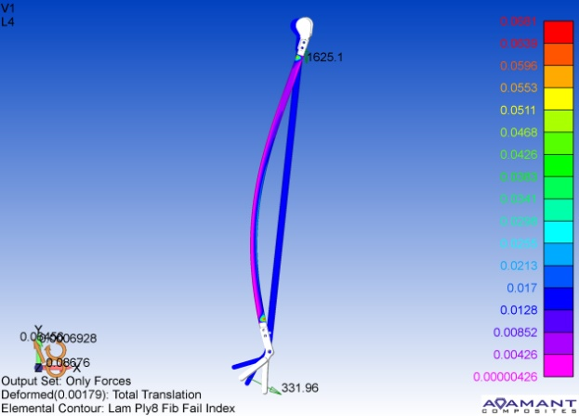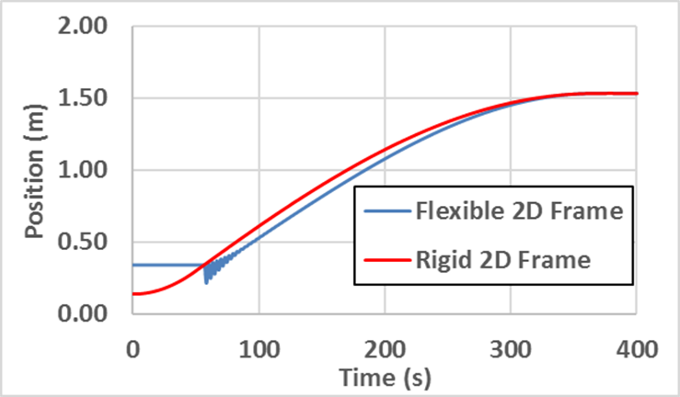

Figure 11. Upper batten position

The oscillations at the beginning of the deployment procedure were identified as a major issue. Additional substructures were used to increase the damping during operation and to normalize the deployment process.

1. **Test Campaign**

The test campaign describes all the necessary tests for the numerical models’ verification and normal functions during operation (deployment/stowing etc). The Testing Plan includes: a) gravity off-loading system, where the component or structure is supported in a way that the effect of its mass is minimised (needed in order to simulate zero gravity conditions), b) functional tests in thermal vacuum chamber in order to investigate the structure’s response in high temperature conditions and c) mechanisms tests, both in air and in vacuum environment, studying the friction parameters among the components. The 2D basic module’s behaviour during deployment was further investigated following the Testing Plan. A 2D basic module gravity off-loading test was set up (Figure 12) using high quality equipment (Table 5). The major scope was the verification of 2D numerical simulations (both MATLAB and MSCADAMS) and the observation of possible instabilities (friction nonlinearity, material properties differences etc.)

Table 5. Test campaign equipment

|  |
| --- |
| **Equipment** |
| 6 CFRP tubes |
| 2 Mechanisms |
| 2 Cables |
| 2 Brushed DC motors (Dunkermotoren GR42x25) |
| 4 Strut nodes made of aluminum |
| 1 Table made of aluminum beams |
| 2 Linear guideways |
| 2 sensors |

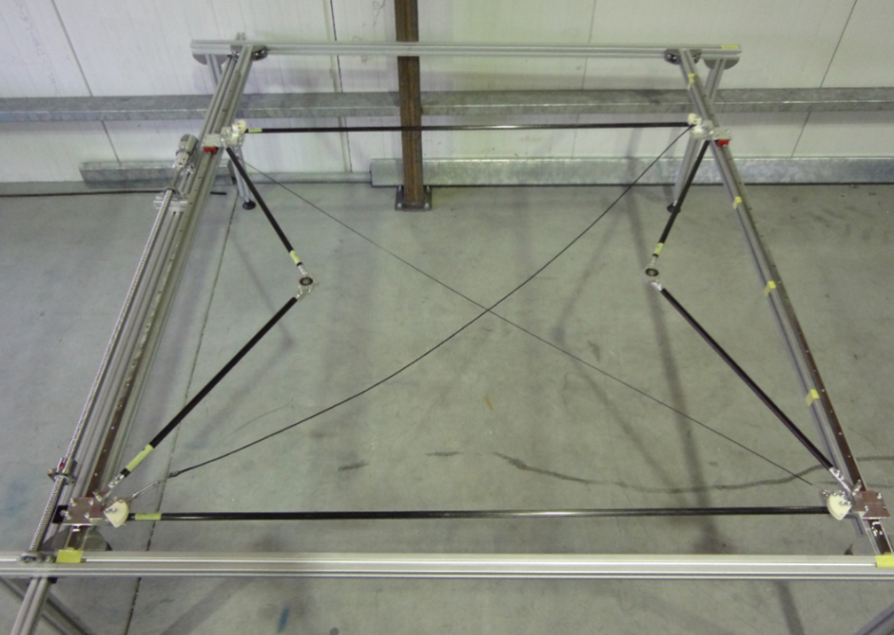

Figure 12. Test campaign set-up

The functional test proved that the deployment process was valid. Only some minor discrepancies due to friction forces were observed. The numerical results for rigid and flexible body and the tests are in good agreement.

1. Conclusions & Future Work

In this survey, a MATLAB code was developed using analytical equations for truss’s kinematic and dynamic simulation. This simulation was used for the verification of a MSC-ADAMS model and calibration of the contact parameters. and they are in excellent agreement for rigid body assumptions. Furthermore, the simulation of flexibility effects via MSC ADAMS provides useful results for the 3D truss optimization process. Moreover, the gravity offloading test of 2D basic module truss was useful to observe possible nonlinear effects during deployment.

For future work, the 2D basic module gravity off-loading test including thermal effects is the next step. The MATLAB code could also be upgraded in order to include thermal and nonlinear friction effects.

Acknowledgments

The authors wish to acknowledge: Dr A. Vavouliotis (Managing Director, Adamant Composites Ltd and Mr. D. Lamprou (Systems Engineer, Adamant Composites Ltd) for the opportunity to participate in LAGARD project’s design and development phases. Special thanks to all the colleagues and friends (both UPat-AML and Adamant Composites Ltd) for their valuable assistance and the excellent collaboration all these years.

References

[1] A review on large deployable structures for astrophysics missions, L. Puig et al., 2010

[2] Advances in deployable structures and surfaces for large apertures in space, J. Santiago-Prowald et al., 2013

[3] Modeling and analysis of a large deployable antenna structure, Z. Chu et al., 2014

[4] Dynamic analysis of the deployment for mesh reflector deployable antennas with the cable-net structure, Y. Zhang et al., 2017

[5] Deployment analysis and control of deployable space antenna, L. Tuanjie, 2012

[6] Deployment analysis considering the cable-net tension effect for deployable antennas, Y. Zhang, 2016

[7] Theoretical analysis and experiments of a space deployable truss structure, R. Zhang et al., 2014

[8] MATLAB for Engineers, H. Moore, 2014

[9] Vector Mechanics for Engineers: Dynamics, F. P. Beer et al, 2015

[10] MSC ADAMS view help, MSC ADAMS, 2016

[11] Space Vehicle Mechanisms: Elements of Successful Design, Conley, 1998

[12] LAGARD Project Technical Note TN2100: Design and Analysis, Adamant Composites Ltd, 2016