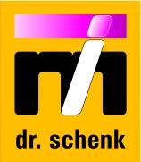

production of Composites Base Material and Prepregs -

INDUSTRY 4.0: HOW OPTICAL QUALITY CONTROL CONTRIBUTs TO HIGHER YIELD

Hans Oerley
Dr. Schenk GmbH Industriemesstechnik, Einsteinstrasse 37, D-82152 Planegg, Germany
Email: hans_oerley.drschenk@yahoo.de, Web Page: http://www.drschenk.com

Keywords: Inspection, Quality Control, Process Monitoring

Abstract
Automatic Optical Inspection Systems (AOI) are applied to control the production of composite materials. The information achieved with AOI systems is an important contribution for the Management Execution System (MES), providing an overview on the performance of the production in a Smart Factory.

1. Introduction
A Smart Factory is based on a large variety of intelligent systems, spanning from machine control to complex devices measuring product quality. In this respect a modern automatic optical inspection system (AOI) allows deep insight into production performance and is an important contributor to Big Data.
Optical control of homogenous, monochrome materials is somewhat state of the art. Today’s inspection systems are to a certain extend able to do this job. However, in case of production of composite base materials and prepregs, new challenges are arising, especially with quality control of colored or textured material. New developments in AOI systems offer great chances for improving product quality and customer satisfaction, while lowering production costs.

2. Basic Technology for AOI Systems
AOI systems for web control are based on three components:
- digital line cameras (CCD or CMOS technology)
- LED line illumination (several wavelengths possible)
- evaluation electronics, comprising dedicated hard- and software

3. Materials and Production Steps
AOI systems can be applied in several steps throughout the production of composite materials:
- Control of rovings for correct fiber orientation, gaps, coatings / impregnations, ...
- Inspection of fiber mats or fabrics
- Check of prepregs made out of carbon or glass fibers (coating homogeneity, cracks, particles included in the prepreg, ....)

4. Main Features of AOI Systems for Composites
- Quality control for detection of local product irregularities
Small local irregularities and defects (such as lumps, foreign material, tear drops, broken filaments, particles, holes, coating voids etc.) can interfere with or inhibit the function of the material, especially regarding its mechanical properties. Detecting these problems in-line is a safeguard against delivery of defective products to the customer. Inspection can be provided for the base material (e.g. glass or carbon fiber nonwovens or cloth) being the input step for prepreg production. This can be completed by optical control of the prepreg itself, again looking for defects such as missing impregnation, broken fibers, insects, and many more (see figures 2 – 5).
- In-line monitoring of material properties, covering the whole width of the material
Concurrent with the detection of small local defects the AOI system can evaluate material properties over the whole width and length of the material, such as the thickness of the base material (formation, thickness homogeneity), surface homogeneity, coating homogeneity, etc.
(see Fig. 6 and 7)
- Process control for optimization of the production process
Both results (local defect detection and large area monitoring of material properties) enable very fast and efficient production control and optimization. Deviations in the production process are reported without delay, allowing immediate reaction to keep the production within the determined process window.
- Defect Reports, Process control for optimization of the production process
Detailed reports, for instance on the web quality, can be automatically generated, for example as basis for subsequent production steps. Thus a flexible and expandable basis to derive strategies for process optimizations or machine service actions and even supply administration with data for product planning and yield optimization has been created.

5. MIDA technology
Multiple Image Defect Analysis (MIDA) makes it possible to look at a defect from different views simultaneously using multiple inspection channels. By combining the inspection channels or defect views, the inspection system can pick up defects more reliably and evaluate the defect types more precisely. This helps to identify the defect source within the production line fast and easily. With this information the process can be adjusted quickly, saving resources, time and ultimately money.

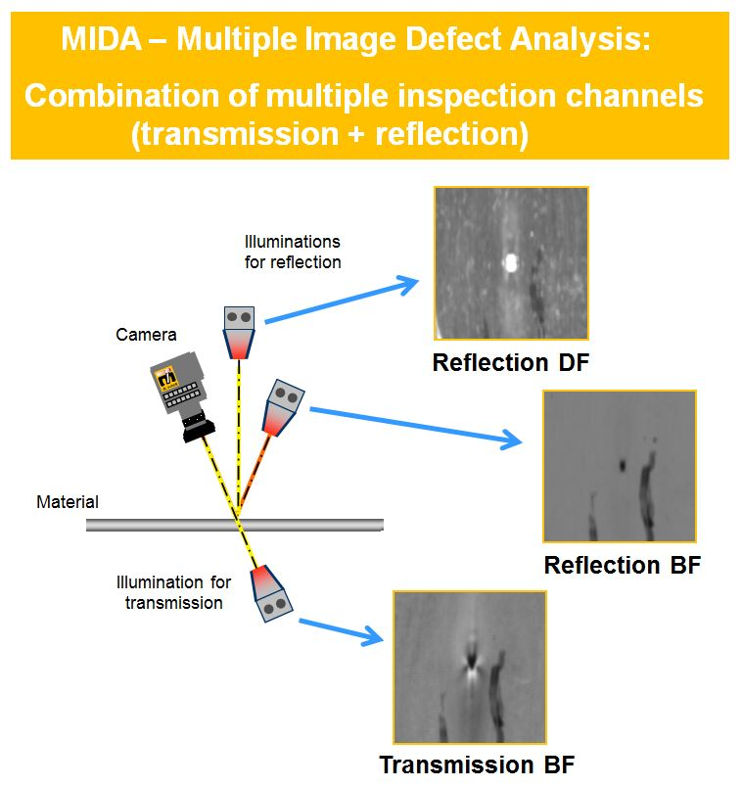

Figure 1. MIDA, simultaneously showing a defect in 3 different inspection channels or views

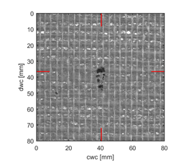
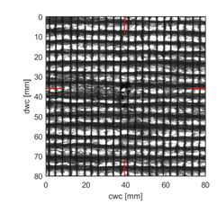

Figure 2. Oil stain (left: Transmission Brightfield / right: Adaptive Background Illumination)

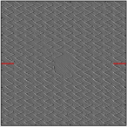
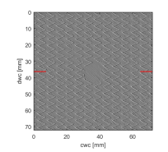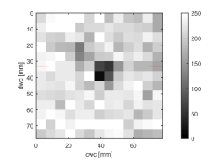
Figure 3: Missing stich ( left: Reflection Darkfield / right: Tile Histogram)

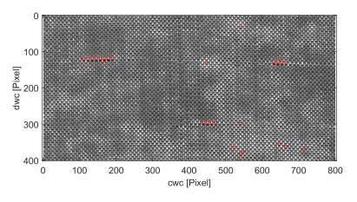
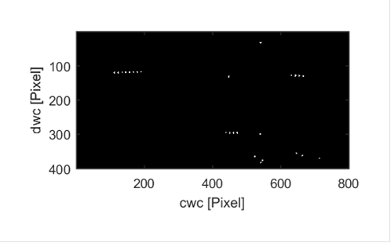

Figure 4: Wire fracture dots in a glass fiber fabric ( left: Reflection Darkfield / right: Binary Image)

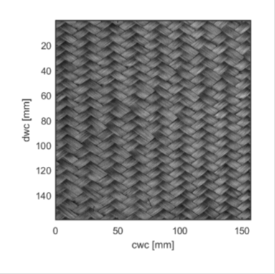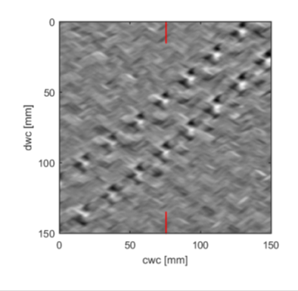
Figure 5: Missing threads / gap in carbon fabric (left: Gray Image / right: AOI, Reflection Brightfield)

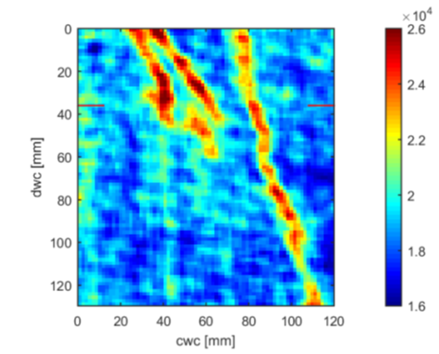
Figure 6: Impregnation inhomogeneities (AOI, left: Transmission Brightfield / right: Homogeneity Map)

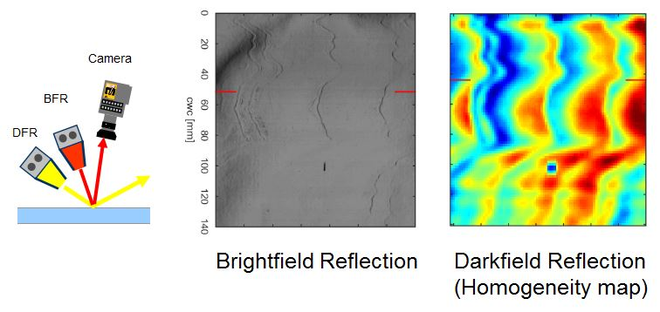
Figure 7: Coating layer inhomogeneities (AOI, left: Reflection Brightfield / right: Homogeneity Map)

6. Visual Intelligence – MIDA X, the next generation in AOI technology

Only a very small part of web materials is truly homogeneous with a perfectly smooth surface; but there are many structured / textured plastic films or films with a rough and hazy surface. Therefore simple application of thresholds for defect detection and evaluation sometimes fails: If thresholds are moderate, no false defects (owing to the irregular material topology) are picked up. On the other hand, with a remarkable number of defects, only the part exceeding the defined threshold will be detected while their actual size will not be registered. If one applied more of those tight thresholds, these defects would show up correctly (right size), but artefacts (which are not equal to defects) would flood the system. This means that the problem cannot be solved by threshold adaption. So, what is the user to do?

The solution is a combination of defect detection with moderate thresholds and integrated simultaneous special evaluation of the defect. During this step, new and sophisticated algorithms can be applied that far surpass simple filters (e.g. low-pass / high-pass filter). For example, these algorithms can enhance the contrast of the defect area, collect scattered defect parts (e.g. insect legs), find defect edges, and much more – eventually resulting in accurate defect classification. When the defect type is precisely defined, the system can reliably decide between go and no-go defects, leading to an improvement of the yield of the production line.

Example for MIDA X
Fig. 8 gives an example for the capabilities of MIDA X: Standard inspection systems “see” small contaminations and insects (esp. squashed insects’ bodies) as similar and cannot differentiate between the two. While (some) contaminations may be considered tolerable, in most cases the delivery of material containing insects must be strictly avoided. To be safe, both kinds of defects are often considered NG. MIDA X allows the manufacturer to accurately differentiate between acceptable contaminations and unacceptable insects, thus increasing their yield.

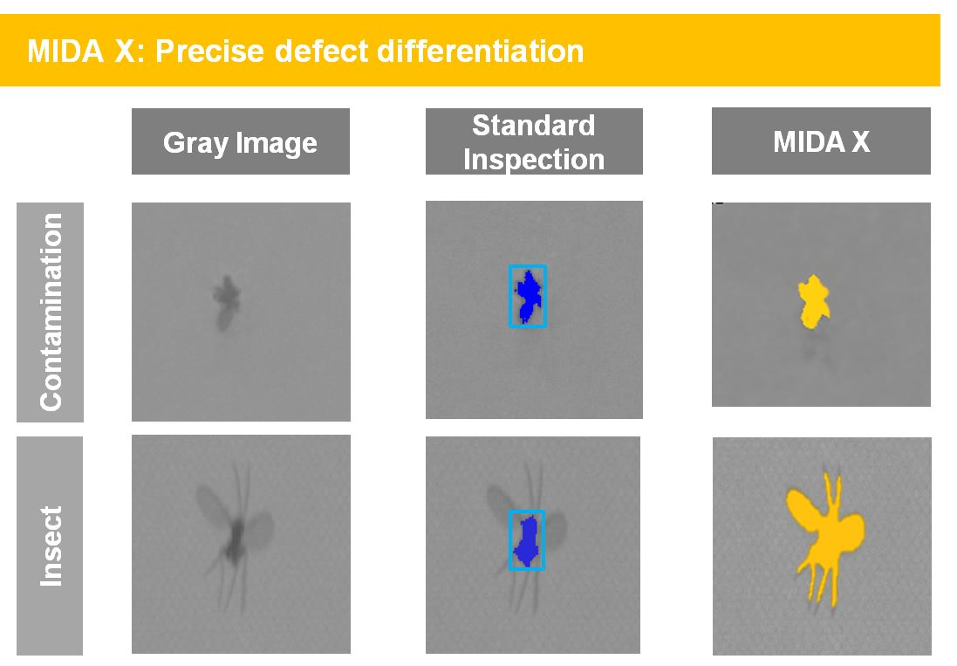
Figure 8: Precise defect evaluation by MIDA X

7. AOI: Data Provider for MES and Industry 4.0
Looking ahead, AOI systems do not only monitor the production process locally, but are well on the way of becoming a crucial element of Industry 4.0. Smart machines and smart subsystems are contributing to define a smart factory. (Fig. 9)

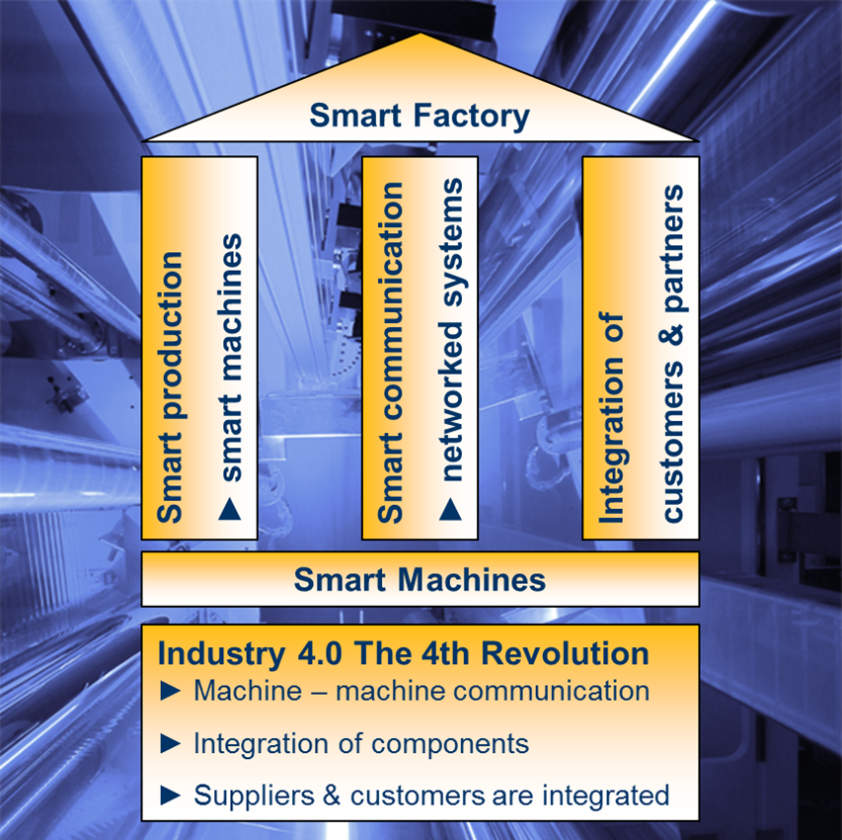

Figure 9: Smart Factory

The results and further quality data collected by optical inspection systems are recorded synchronously with other process parameters like line speed, pressures and temperatures in a central data acquisition system. Based on these high resolution data, meaningful performance indicators (PIs) for different purposes can be derived and transferred e.g. to the MES (Manufacturing Execution System) (Fig. 10).

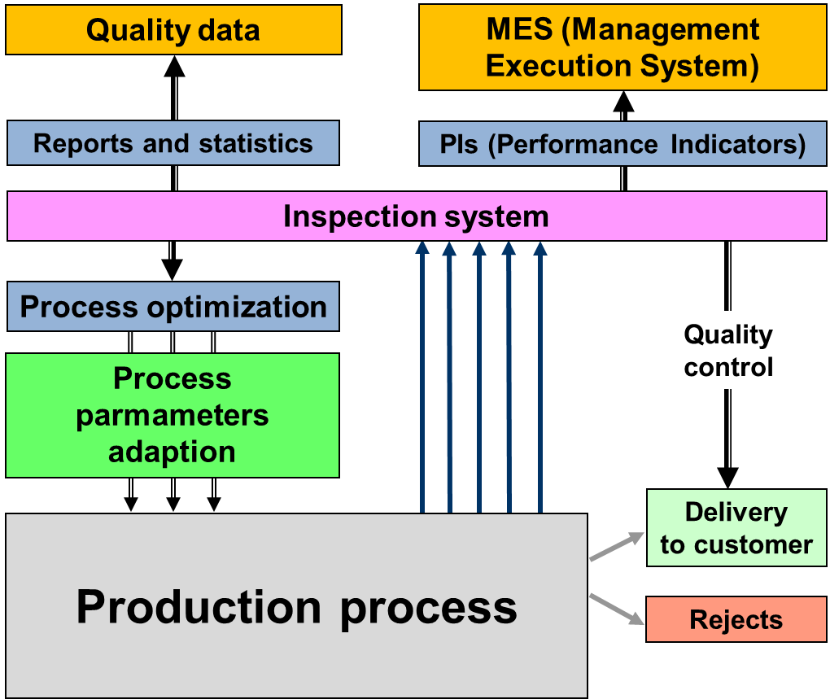

Figure 10: AOI for process monitoring and quality data collection

By trending PIs, the condition of the production process can be monitored. In case of deviations the original high definition data can be examined for in-depth root-cause analysis. Detailed reports, for instance on the web quality, can be automatically generated too, for example as the basis for supply claims. Thus a flexible and expandable basis to derive strategies for process optimizations or machine service actions, and even supply administration with data for product planning and yield optimization, has been created.

.......... you only can control what you can measure !

