EuroSun2026
REINFORCEMENT LEARNING FOR ADAPTIVE CONTROL
OF DECENTRALISED FEED-IN OF SOLAR HEAT
INTO DISTRICT HEATING NETWORKS

Thilo Walser (corresponding author), Maya Neyhousser, Dirk Mangold
Solites - Research, consulting & transfer for sustainable thermal energy systems in the Steinbeis network
walser@solites.de, www.solites.de
Summary
This work presents the control optimisation of decentralised district heating feed-in stations using artificial intelligence. Reinforcement learning, a subfield of machine learning (ML), is used for the optimisation of adaptive PID parameters. A digital twin of a decentralised solar thermal feed-in station into the district heating of Düsseldorf was implemented by coupling a TRNSYS simulation model with a hardware control unit. After the validation against measurement data, the digital twin was employed to develop, configure and pre-train the learning algorithm, enabling a training acceleration factor of 340 compared to training in a real plant. Simulations performed with the digital twin show up to 7% higher solar heat feed‑in and up to 8% lower set‑point temperature deviation over one year when using adaptive control instead of PID parameters that were manually tuned by experts. The pre-trained controller was successfully deployed in the real plant of the solar thermal feed-in station. A continuous test over 23 days confirms the controller’s real-time capability and validates the potential to improve control performance through continuous adaptation of PID parameters. The approach therefore increases the reliability and efficiency of decentralised feed-in of solar heat into district heating systems and is transferrable to other kinds of feed-in substations.
Keywords: Machine Learning, Artificial Intelligence, Reinforcement Learning, Solar Thermal, Decentralised Feed-In Stations, District Heating, Control Optimisation, Digital Twin, Cloud-based Controller
Field of application for the findings: District Heating, Solar Thermal Systems, Renewable Energy
Addressed audience: Scientific Community, District Heating Operators, Solar Thermal System Suppliers
- Introduction
The EU Green Deal aims to achieve net-zero greenhouse gas emissions by 2050, with a particular focus on decarbonising the heating and cooling sector. Mathiesen et al. (2023) suggest in a study on future heating systems that district heating (DH) networks should supply 48% of the total heat demand in the EU by 2050 (compared to 13% in 2023). In 2022, renewable energy and waste heat contributed only 42.6% of the energy supplied to DH networks (Euroheat & Power, 2024). The transformation of the sector is therefore essential to achieve the EU climate goals. Large-scale solar thermal (ST) plants already offer a proven, economically viable, and flexible solution for transforming existing DH networks and supplying new systems with renewable heat. Most of the existing systems are integrated centrally, meaning that the collector fields are usually connected to the primary heat generation facility which allows reheating and adjustment of the solar delivered heat. In urban areas, the availability of suitable areas for ST systems near the network’s heat generation facilities is often limited. Therefore, decentralised ST systems installed ground mounted or on roofs of larger buildings offer an attractive alternative to central integration.
Controlling decentralised feed-in of solar heat into DH networks is challenging due to heat production fluctuations, varying network conditions as well as feed-in temperature requirements. Experimental testing of the ST feed-in station in Düsseldorf highlighted the significant impact of the tuning of PID control parameters on feed-in duration and temperature deviation from set point (Schramedei et al. 2023). The tuning of PID parameters is usually performed manually applying heuristics proposed by Ziegler & Nichols (1942), by many years of experience or by trial and error. The manual tuning is time-consuming, requires expertise and can lead to unsatisfactory control performance, especially in highly dynamic systems. With adaptive PID control, the parameters are automatically tuned and adjusted to different operating conditions, overcoming the limitations of manually tuned static PID controllers.
Adaptive Reinforcement learning (RL)-based control outperformed state-of-the-art control strategies in several studies. Korupu und Manimozhi (2025) showed automatic and precise adaptation of PI parameters in an industrial water supply system based on RL, resulting in a significant improvement in control performance under varying operating conditions. In a pumped hydroelectric energy storage system, a RL‑based controller was able to efficiently adapt the turbine control to varying headwater pressure conditions, fully replacing the manual retuning of PID parameters (Enyekwe et al. 2023). Sabahi et al. (2024) demonstrated the online adaptation of PID parameters in microgrids to cope with volatile conditions, including fluctuating demand and weather conditions. Zhang & Zhao (2022) proved considerable potential of RL for reducing energy consumption while improving temperature control performance in heating, ventilation and air conditioning systems. Carlucho et al. (2020) investigated the adaptive PID control on various robotic platforms. For an underwater robot operating with prescribed constant yaw and roll rates, the controller demonstrated a strong ability to accurately maintain the desired velocities. Studies on hydraulic servo systems have shown that RL controllers can outperform conventional control approaches by offering superior dynamic response and robustness, especially under varying load conditions and in the presence of nonlinear system behaviour (Yuan et al. 2022). Lee & Jung (2024) combined RL with internal model control strategies to achieve significantly better performance in marine boiler control compared to traditional methods, characterized by lower overshoot of the controlled variable, higher setpoint-tracking accuracy, and faster convergence to desired operating conditions.
This work builds on those previous studies to implement a RL-based adaptation of control parameters for a decentralised solar heating system.
- The digital twin
2.1 Digital twin description
A digital twin of the experimental plant was developed to implement and pre-train the adaptive controller in a risk-free and controlled learning environment. It consists of a TRaNsient SYstem Simulation (TRNSYS) simulation model of the ST feed-in station in the district heating in Düsseldorf coupled with a duplicate of the controller hardware and software used in the experimental plant, as shown in Figure 1. The symbols are defined in the nomenclature (Appendix).
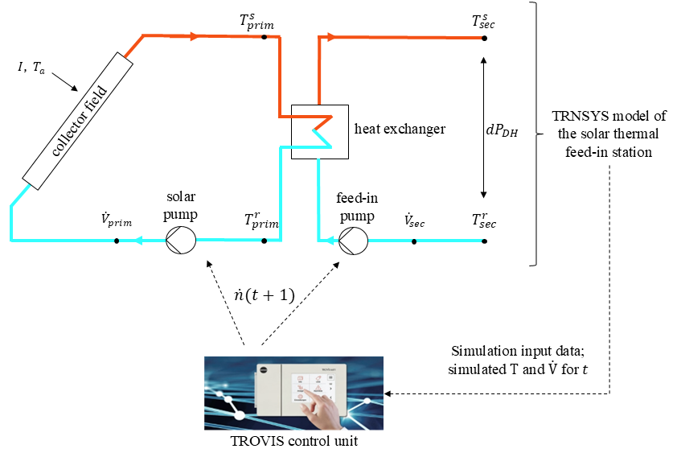
Figure 1: Digital twin consisting of a TRNSYS simulation model coupled with the hardware controller
The plant uses two hydraulic circuits separated by a heat exchanger. The primary circuit consists of a ST collector field, supply and return connecting pipes and a collector pump. The secondary circuit links the plant to the DH network comprising connecting pipes and a feed-in pump. The described components are modelled applying the TRNSYS types listed in Table 1.
Table 1: Overview of TRNSYS types applied in the simulation model
Component | TRNSYS model
Solar collector field | Type 832 v5.10 (Haller, 2014)
Heat exchanger | Type 5 (TRNSYS, 2017)
Pumps | Type 110 (TRNSYS, 2017)
Pipes | Type 331 (Dahm, 2001)
The programmable control and automation unit TROVIS 6611-2 provided by the SAMSON AG controls the feed-in station with a software application specifically developed for this plant (Schramedei et al., 2023). For the digital twin, the hardware controller is coupled with TRNSYS using the calling Python type 3157. The control unit receives the simulated temperatures and flow rates, and the simulation input data ($I$, $T_{a}$, ${ T}_{sec}^{r}$, ${dP}_{DH}$) for time step t. Subsequently, it determines the control signals and the set rotational speed for the pumps in the primary and secondary circuit. The collector pump starts when the solar irradiance exceeds a predefined ambient-temperature dependent threshold. The pump operation stops when the irradiance falls below a threshold or when the supply temperature in the primary circuit drops below a specified value. The feed-in pump is switched on when the supply temperature in the primary circuit exceeds 84 °C and operates until the feed-in temperature falls below 72 °C. Further details on the conditions required for pump operation are described by Schramedei et al. (2023).
The pump rotational speeds $\dot{n}$ are controlled with PID controllers. The control variable for the pump in the primary circuit is the set volume flow calculated in eq. 1.
${\dot{V}}_{prim}^{set}= \frac{η_{c}({\overline{T}}_{c}, T_{a})∙G∙A_{c}}{\left(T_{prim}^{s,set}-T_{prim}^{r}\right)∙c_{p}∙ρ}$ (eq. 1)
For the secondary pump, the control variable is the set temperature for feed-in $T_{sec}^{s,set}$, which is 80 °C. The volume flows are calculated in TRNSYS for t+1 based on the control signals and rotational pump speeds for t. Within the primary circuit, the resulting flow rate is assumed to vary linearly with the rotational speed of the collector pump. In the feed-in circuit, however, the volumetric flow rate depends nonlinearly on both the pump rotational speed and the differential pressure in the DH network. To capture this relationship, an artificial neural network trained on historical operating data is employed to predict the volumetric flow rate based on the measured differential pressure ${dP}_{DH}$ and the PID-controlled pump rotational speed.
The simulation time step is 60 s. The computation time required for each time step varies throughout the simulation due to both the fluctuating computational effort of the TRNSYS model and variations in the data exchange time between TRNSYS and the hardware in the controller unit. The PID controllers require an equidistant computation interval during plant operation. Therefore, a constant time of 1 s is assumed for each simulation time step, corresponding to the maximum observed computation time. Whenever the computation time falls below this value, the program is paused until the predefined computation time of 1 s is reached.
During plant operation, the digital twin accelerates training compared to learning in the real environment by a factor of 60. Moreover, the digital twin can skip times when the solar irradiance is too low. Those effects lead to an acceleration factor of approximately 340 for an entire operating year.
2.2 Validation of the digital twin
The digital twin is validated with historical measurement data applying static reference values for the PID parameters which are the proportional gain $K_{P}$, the integration time $t_{I}$ and the derivative time $t_{D}$. The reference values were determined during the testing and optimisation phase of the experimental plant, representing the parameter combination that achieved the most robust control behaviour among all evaluated combinations (Schramedei et al. 2023). To account for the acceleration of the simulation model compared to real time, the reference values for $t_{I}$ and $t_{D}$ are multiplied with 1/60 which is the ratio of computation time to the simulation time step. The reference value of $K_{P}$ is reduced by a factor of 3 for the simulation, as the real plant responds more slowly to changes in the boundary conditions than the simulation model due to differing thermal inertia. For the same reason, the simulation input data is smoothed by applying a 10‑minute moving average to the measured values.
Figure 2 shows the measured and simulated return (r) and supply (s) temperatures in both primary (prim) and secondary (sec) circuit, volume flow rates and irradiance for a day with a smooth irradiance curve until 12:30 and increasing fluctuations in irradiance in the afternoon. The irradiance threshold to start the solar pump is reached at 9:00. In both the real plant and the simulation model, the feed-in pump starts at 9:50 when $T_{prim}^{s}{> T}_{prim}^{s,set}$. In the real plant, the feed-in pump stopped and restarted twice between 16:30 and 17:30 due to a too low feed-in temperature $T_{sec}^{s}$. In contrast to the real system, the feed-in pump in the simulation operates continuously until 17:30 without interruption. The overshoot of $T_{sec}^{s}$ after starting the feed-in pump is higher than in the real plant. Moreover, setpoint deviations are larger, and feed-in outside the desired temperature range, indicated by the black dotted lines, occurs more frequently. In the real plant, however, $T_{sec}^{s}$ fluctuates with higher frequency compared to the simulation. The comparison demonstrates that the digital twin accurately reproduces the system behaviour of the real plant. The described differences between the real plant and the digital twin simulation are caused by thermal capacitance effects and differences in the PID controller update intervals.
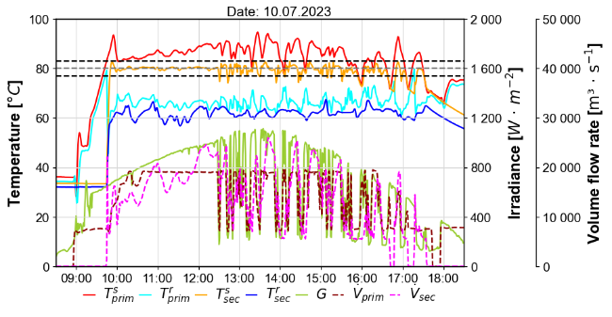
Figure 2: Simulated temperatures and volume flows (top) versus measurements (bottom)
The simulated daily sum of solar heat feed-in $Q_{sec}$ shown in Figure 3 matches well the values calculated from measurements within a range of ± 0.2 GJ except for outliers. The yearly sum for 2023 is 250 GJ, which is 6 % above the value calculated from measurements. These sums include only those days for which measurement data were available, no solar stagnation occurred and for which the connection between TRNSYS and the hardware controller in the digital twin could be maintained continuously throughout the entire day. The higher solar heat feed-in obtained from the simulation can be explained by the fact that the real plant exhibits performance losses relative to the efficiency parameters specified in the Solar Keymark certification data and that pipe heat losses in the solar circuit are underestimated in the simulation model.
The daily averages of simulated feed-in temperature deviation from the setpoint temperature ${\overline{e}}_{T_{sec}}$ are higher than the measured values, confirming the observations described before. The yearly average is 3.25 K in simulation which is 1.3 K higher than the value calculated from measurements.
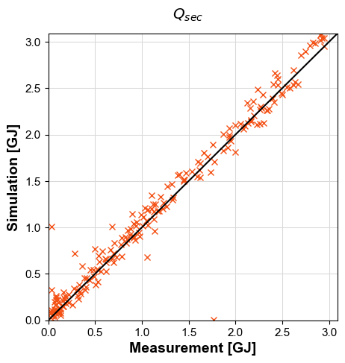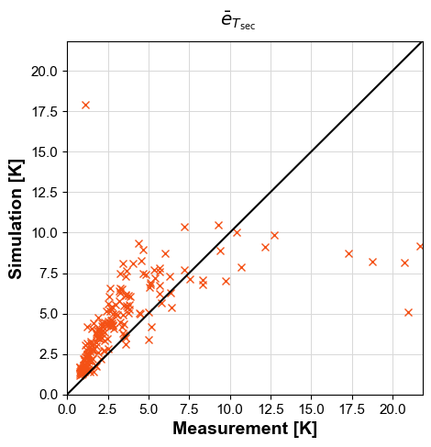
Figure 3: Simulated versus measured daily sum of solar heat feed-in (left) and daily average of temperature deviation from set point (right) for the year 2023
- Reinforcement learning framework
3.1 Reinforcement learning algorithm
The deep deterministic policy gradient (DDPG) algorithm is applied, as it is suitable for adaptive PID control given its applicability in continuous state and action spaces, its ability to update actions in near real time and its online learning ability. Figure 4 shows a simplified scheme of the algorithm developed by Lillicrap et al. (2015). As usual in RL, DDPG consists of an agent operating within a learning environment by performing actions to achieve a defined goal. In order to learn from previous experiences and improve action selection, the agent receives a reward which is a numerical value that evaluates the performed action with regards to the defined goal.
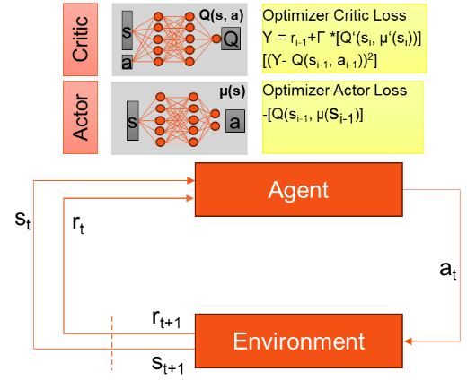
The environment provides the agent with the state of the previous action, update time step (sₜ), the reward (r_{t+1}) for the executed action (aₜ), and the resulting subsequent state (sₜ₊₁). The agent provides aₜ, in this case the PID controller parameters ($K_{P}$, $t_{I}$, $t_{D}$) for both pump speed controllers. The policy function µ describes the agent’s decision‑making strategy. DDPG uses two different artificial neural networks. The actor network applies µ to determine the vector aₜ composed of continuous control values within a pre-defined range. The critic network evaluates the performed action and estimates the Q‑value, which is defined as the expected cumulative reward of future states with the discount factor for future states Γ. The training in the digital twin starts with a “warm-up” phase with random actions. After this warm-up, learning is performed by activating the optimizers for both networks to minimize the loss with regards to the respective loss function.
Figure 4: Simplified scheme of DDPG
3.2 States and reward function
The state variables were selected with the objective to define a minimal set of features to capture all the information necessary for the agent to make an optimal choice of PID controller parameters. The selected state space includes variables representing the state of the solar system that are influenced by the performed actions (${\dot{V}}_{prim}$, ${\dot{V}}_{sec}$,${ T}_{prim}^{s}$, $T_{sec}^{s})$ and variables representing the boundary conditions ($I$,${ T}_{sec}^{r}$, ${dP}_{DH}$, ${ T}_{a}$) that are uninfluenced by the performed actions. Both the current state at time $t_{0}$ and the change relative to the past time step are computed. In the case of $I$, a recent value is used as the irradiance influences the system with a delay. Furthermore, moving-average state variables were introduced to mitigate the effects of measurement noise and short-term disturbances. As the solar thermal system exhibits significant thermal inertia, its behaviour is influenced not only by the instantaneous operating conditions but also by recent system states. The moving averages of both the variable value and the change related to the previous time step therefore provide additional information about the operating conditions and improve the robustness of the controller. In total, the state space consists of 26 features listed in Table 2.
Table 2: List of state variables
State category | Variables (X) | Applied formula
Current state | $T_{sec}^{r}$, ${dP}_{DH}$, ${\dot{V}}_{prim}$, ${\dot{V}}_{sec}$, $e_{T_{prim}}$, $e_{T_{sec}}$ | $$X(t_{0})$$
Recent state | $$I$$ | $$X(t_{0}-300s)$$
Current state change | $T_{sec}^{r}$, ${dP}_{DH}$, ${\dot{V}}_{prim}$, ${\dot{V}}_{sec}$, $T_{prim}^{s}$, $T_{sec}^{s}$ | $$∆X\left(t_{0}\right)$$
Recent state change | $$I$$ | $$∆X\left(t_{0}-300s\right)$$
Moving average | $I$,${ T}_{sec}^{r}$, ${dP}_{DH}$, ${\dot{V}}_{prim}$, ${\dot{V}}_{sec}$, $e_{T_{prim}}$, $e_{T_{sec}}$,${ T}_{a}$ | $$\frac{1}{900s}\int_{t_{0}-900s}^{t_{0}}{X(t)dt}$$
Moving average of state change | $I$,${ T}_{sec}^{r}$, ${dP}_{DH}$ | $$\frac{1}{3600s}\int_{t_{0}-3600s}^{t_{0}}{\left|∆X\left(t\right)\right|dt}$$
Elapsed time since pump start ($t_{on})$ | $${\dot{V}}_{sec}$$ | $$\left\{\begin{aligned}t_{0}-t_{on}, t_{0}-t_{on}<3600s \\ 3600 s, t_{0}-t_{on}≥3600s\end{aligned}\right.$$
$∆X= X\left(t\right)-X(t-60s)$ (eq. 2)
$e_{T}= \left|T^{s}-T^{s,set}\right|$ (eq. 3)
All state and action variables are normalized to the range [-1,1] using predefined lower and upper scaling bounds. The actor network uses a tanh output layer, and the outputs are scaled to the defined action range.
The reward function consists of several terms representing the control objectives that define the desired system behaviour. The most important objectives are to maximize the solar heat feed-in in the desired temperature range $T_{sec}^{set,s}$± 3 K and to minimize the set point deviation of the feed-in temperature $T_{sec}^{s}$. Deviations outside the desired temperature range are therefore penalized more severely than deviations within the range. Furthermore, fluctuations of the feed-in temperature need to be minimized to reduce the thermal cycling stress of the DH network piping. Extremely high collector outlet temperatures need to be prevented to minimize the risk of solar stagnation. The weighting factors of the individual reward terms were varied iteratively to identify a configuration that led to the desired system behaviour. This results in the reward function given in eq. 7, where $r>0$ indicates that the feed-in pump is operating and the system behaviour is evaluated favourably. The average reward $\overline{r}$ is calculated for the interval between two actions $∆t_{action}$ as given in eq. 8. $∆t_{action}$ is set to 15 minutes for the pre-training in the digital twin and reduced to 5 minutes for the application in the experimental plant.

$$r_{base,1}\left(t\right)=-{0.1}/K∙ e_{T_{sec}}(t)-{∆T_{sec}^{s}\left(t\right)}/{60 K}$$ | (eq. 4)
$$r_{base,2}\left(t\right)=\left\{\begin{aligned}r_{base,1}(t)-{0.5}/K∙\left(T_{\sec^{s}\left(t\right)}-95 °C\right), T_{\sec^{s}\left(t\right)}≥95 °C \\ r_{base,1}(t), T_{\sec^{s}\left(t\right)}<95 °C\end{aligned}\right.$$ | (eq. 5)
$r_{base,3}\left(t\right)=r_{base,2}\left(t\right)-{|T}_{\sec^{s}\left(t\right)}-T_{\sec^{s}\left(t-1\right)}|$ | (eq. 6)
$$r\left(t\right)=\left\{\begin{aligned}{5∙{10}^{-5}}/W∙ {\dot{Q}}_{sec}\left(t\right)+r_{base,3}\left(t\right), {\dot{V}}_{sec}\left(t\right)>0, e_{T_{sec}}\left(t\right)≤3 K \\ {\dot{{5∙{10}^{-5}}/W∙ {\dot{Q}}_{sec}\left(t\right)-\left({e_{T_{sec}}\left(t\right)}/K-3\right)+r_{base,3}\left(t\right), \dot{V}}}_{sec}\left(t\right)>0, e_{T_{sec}}\left(t\right)>3 K \\ 0, {\dot{ \dot{V}}}_{sec}=0 \end{aligned}\right.$$ | (eq. 7)
$$\overline{r}\left(t_{0}\right)=\frac{1}{∆t_{action}}\int_{t_{0}-∆t_{action}}^{t_{0}}{r(t)dt}$$ | (eq. 8)
3.3 Hyperparameters
In ML, hyperparameters are defined as configuration parameters that are specified prior to training and govern the learning process and network optimisation. Based on the hyperparameter settings proposed by Carlucho et al. (2020), the individual values were iteratively refined until satisfactory training convergence and the desired control performance were obtained.
Both the actor and critic consist of fully connected neural networks with two hidden layers containing 256 neurons each. ReLU activation functions with α = 0.3 are used in the hidden layers. The actor output layer applies a tanh activation function to generate normalised control signals, while the critic output layer uses a linear activation function to estimate Q-values. Network training is performed using the Adam optimizer with learning rates of 10⁻⁴ and 10⁻³ for the actor and critic networks, respectively. The replay buffer size is set to 20 000 samples and the batch size to 128. The selected batch size corresponds to four days of operation in the digital twin, assuming eight hours of feed-in per day. The length of the warm-up period equals 10 times the batch size. The target networks are updated using a soft-update parameter τ = 0.0005. Γ is set to 0.99. For exploration purposes, noise is added to the output of the actor network. The noise is sampled using the Ornstein-Uhlenbeck process with a standard deviation of 0.05 and a decay rate of 0.9998.
3.4 Cloud-based control framework
The controller of the experimental plant is connected to a web-based cloud system, enabling data exchange via the communication protocol Modbus. A web Application Programming Interface (API) is used to retrieve measurement data for each action update step needed to calculate the new state vector and the reward obtained for the previous action. The RL algorithm then updates the PID parameters as a function of the new state vector and sends them to the controller via the web API. The algorithm is retrained with data gathered in the real environment after each update step. The retraining is required to adjust the pre-trained RL models to discrepancies between the experience collected in the real environment and that generated within the digital twin. This framework allows for an adaptive PID control and online learning in near real time.
- Adaptive control results
4.1. Performance of the adaptive controller in the digital twin
The digital twin is applied for pre-training of the DDPG algorithm over 11 episodes. Each episode consists of a complete simulation run with input data from the entire year 2023. As demonstrated in Figure 5, the reward increases significantly during the first 2 episodes, then the learning slows down. After episode 4, the reward no longer shows a continuous increase, indicating that the learning progress has begun to stabilize. The best overall reward is obtained in episode 9 with a relative improvement of 22.7 % compared to episode 1.
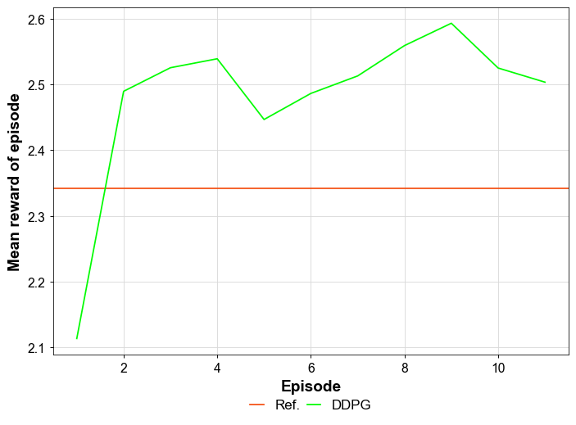
Figure 5: Reward course for pre-training of the DDPG algorithm
The trained DDPG is tested with pre-trained RL models from episode 9 and input data from the year 2024 to evaluate the generalisation capability of the algorithm. As described in section 3.2, the applied reward function consists of multiple terms that optimise for various criteria, which makes the resulting value difficult to interpret. Therefore, the performance indicators in Table 3 are used to quantify the relative improvement (%Δ) of the simulation results obtained with the adaptive DDPG controller compared to the reference case, which is the simulation with static PID parameters. With DDPG, the simulated heat fed into the DH network within the set temperature range of 80 °C ±3 K increases and the simulated mean feed-in temperature deviation from the set point decreases, indicating an improvement in control performance. The adaptive controller shows a higher relative improvement in the training run than in the test run. This can be explained by the training process, where multiple episodes are executed using the exact same dataset, which implies the risk of overfitting to the training data.
Table 3: Training and test result of DDPG algorithm and reference in digital twin
Performance indicator | Training (2023) |  |  | Test (2024)
Performance indicator | DDPG | Ref. | %Δ | DDPG | Ref. | %Δ
Feed-in heat in ±3 K range [GJ] | 212.4 | 198.7 | +6.9% | 164.2 | 161.3 | +1.8%
Mean temp. dev. from set point [K] | 2.99 | 3.25 | -8.0% | 3.32 | 3.57 | -7.0%
Figure 6 shows the density of the normalized actions that are transferred to the PID controller for the solar pump. The density is a measure of how frequently a selected action value occurs relative to other action values. It is defined such that its integral over the entire action space equals one. For the solar pump, the actor network tends to output values near the lower limit of the action range for $K_{P}$ and values at the upper limit for $t_{I}$. For the feed-in pump, all three PID parameters are most frequently selected near the lower limit, as shown in Figure 7. For the solar pump, the PID parameters are distributed across a broader range, suggesting a higher level of parameter adaptation to changing operating conditions and system states.
Figure 8 compares the simulated system behaviour using static PID control with the adaptive DDPG-based PID control for a cloudy summer day. As described before, the DDPG algorithm chooses relatively low values for $K_{P}$, and high values for $t_{I}$ of the solar pump, resulting in a delayed control response of ${\dot{V}}_{sec}$ and relatively high values of $T_{prim}^{s}.$Consequently, the feed-in temperature can be maintained more reliably within the desired range during periods of fluctuating irradiation, as observed between 12:30 and 15:45. The feed-in duration is thus increased compared to the reference case. Moreover, the temperature overshoot after the feed-in pump starts is reduced with the DDPG-based PID control.
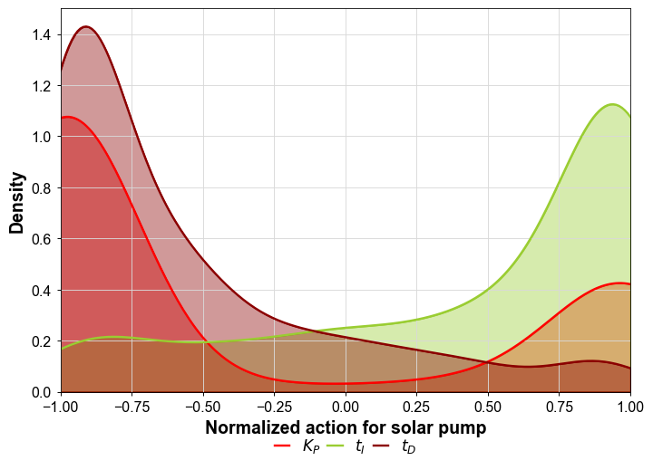
Figure 6: Density plot for normalised action transferred to the PID controller of the solar pump
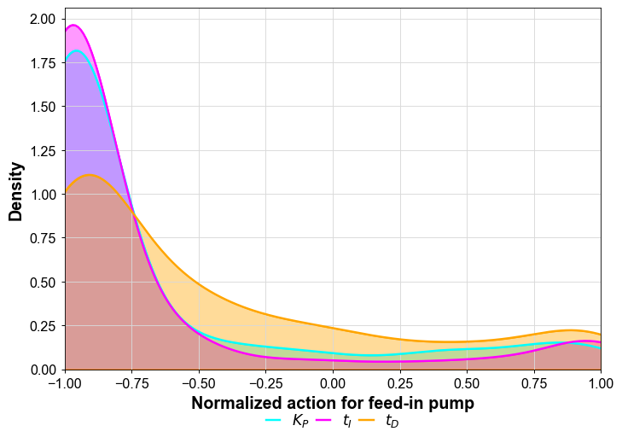
Figure 7: Density plot for normalised action transferred to the PID controller of the feed-in pump

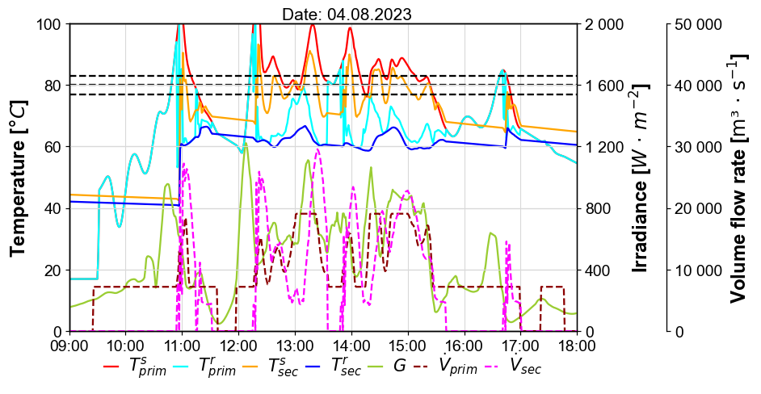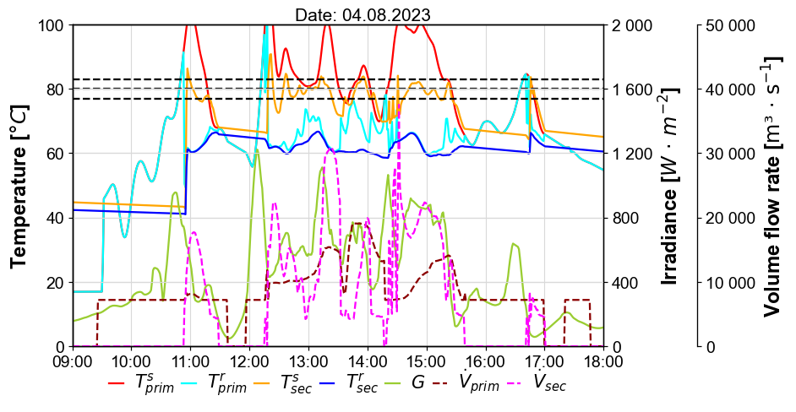
Figure 8: Static PID control (top, reference) versus adaptive DDPG-based control (bottom) for one representative day simulated in the digital twin

4.2. Performance of the adaptive controller in the experimental plant
The pre-trained DDPG algorithm was continuously tested in the real plant for 23 days in October 2025. Figure 2 shows the measured temperatures, volume flow rates and irradiance for two test days. For most of the period with ${\dot{V}}_{sec}>0$, $T_{sec}^{s}$ remains within the set range (black-dotted lines). Temperature deviations and resulting pump switch-offs occur due to insufficient solar irradiance. They are not caused by the controller, as ${\dot{V}}_{sec}$ is at its lower limit during these periods.
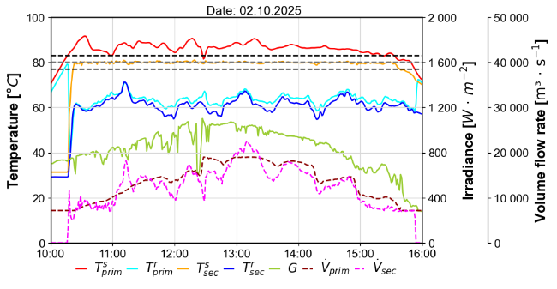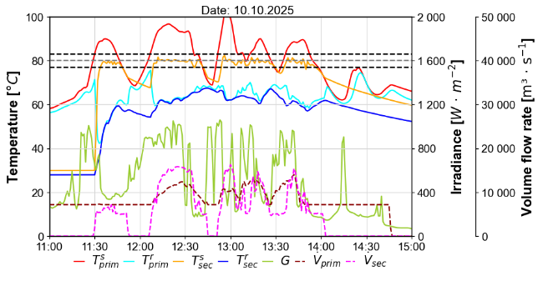
Figure 2: Measurement results for two exemplary days of adaptive DDPG controller testing
The system behaviour is highly dependent on the underlying weather and DH network conditions. Unlike in the digital twin, it is not possible to reproduce days with comparable boundary conditions in the experimental plant Therefore, a direct comparison of the DDPG controller's behaviour with the reference controller under identical operating conditions cannot be performed. To facilitate a meaningful comparison between the adaptive DDPG controller and the reference, digital twin simulations with static PID parameters were performed over the entire evaluation period. The ratio between the mean set point deviation ${\overline{e}}_{T_{sec}}$obtained from measurements and that resulting from the simulation with static PID parameters quantifies the change in control performance compared to the reference. A decrease in the ratio indicates an improvement, as the measured values is then lower than expected with static PID parameters. Figure 9 shows the evaluation for the October months in the reference period 2022 to 2024 and the DDPG testing period in 2025. As demonstrated in the subplot on the right, the ratio depends on the specific day. In average the ratio is below 1, indicating that set point deviations are usually overestimated in the simulation, as described in section 2.2. The ratio is in a similar range for October months in 2022 to 2024. The simulated average ${\overline{e}}_{T_{sec}}$ is 3.25 K for those years, the value obtained from measurements is 2.16 K. In October 2025, ${\overline{e}}_{T_{sec}}$obtained from measurements is 1.78 K, which is below the 2022–2024 average, whereas the simulated value is 3.89 K and therefore above the average. The average ratio therefore decreases from 0.66 to 0.46, indicating that control performance is improved by 31 % with the DDPG-based PID controller for the test period in October 2025 compared to the reference period.
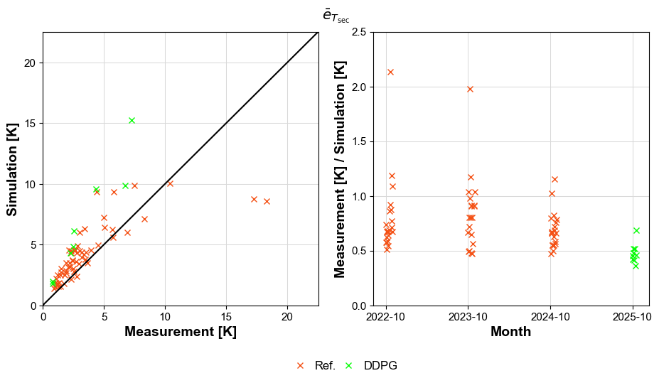
Figure 9: Mean set point deviation of feed-in temperature in simulation with static PID parameters vs. measurements from the experimental plant with static PID parameters (Ref.) and adaptive DDPG control for October months 2022 – 2025
- Conclusion
The results described in this work show a successful pre-training of an adaptive, RL-based control algorithm with a digital twin. The simulation demonstrates improved control performance compared to a static PID controller that was already optimized manually by experts. Its deployment in the operational real environment confirms the controller’s real-time capability and further validates the potential to improve control performance through continuous adaptation of PID parameters. As the temperature can be maintained more reliably within the desired range and feed-in heat is increased, the presented approach increases the performance of decentralised feed-in substations. The performance gain was demonstrated for a decentralised solar thermal system, which represents the most challenging renewable energy technology to control due to the strong fluctuations in heat generation caused by varying solar irradiation. Therefore, the proposed approach is expected to be transferable to other renewable energy sources with less demanding control requirements.
Future work will focus on continuous testing in the real environment to evaluate the control performance for different seasons. Moreover, the transferability of the RL algorithm to a different hydraulic variant of the feed-in station will be analysed. Even further control optimisation might be possible by replacing the PID controller by a RL-based speed control of the hydraulic pumps. Future work will study the control performance improvement of that approach as well as its robustness to system states that are not represented in the training dataset.
Acknowledgement
The work in the joint project “saM_soL - Self-learning PID controller for self-optimizing grid feed-in stations - e.g. for solar thermal systems” coordinated by SAMSON AG (Reference number: 03EN6027) is supported by the Federal Ministry for Economic Affairs and Energy (BMWE), based on a resolution of the German Parliament.
References
Carlucho, I., De Paula, M., Acosta, G.G., 2020. An Adaptive Deep Reinforcement Learning Approach for MIMO PID Control of Mobile Robots. ISA Transactions 102, 280–294. DOI: 10.1016/j.isatra.2020.02.017
Dahm, J., 2001. District Heating Pipelines in the Ground - Simulation Model.
Enyekwe, I., Bai, W., Lee, K.Y., Nag, S., 2023. Speed Control of an Adjustable Speed Pumped Storage Hydropower Plant with a Deep Reinforcement Learning-Based Governor. Journal of Machine Intelligence and Data Science. DOI: 10.11159/jmids.2023.004
Euroheat & Power, 2024. DHC Market Outlook, June 2024.
Haller, M., 2014. TRNSYS Type 832 v5.10: Dynamic Collector Model by Bengt Perers - Updated Input-Output Reference. Ostschweizer Fachhochschule OST, Institut für Solartechnik.
Korupu, V. L., Manimozhi, M., 2025. Leveraging Deep Reinforcement Learning for Effective PI Controller Tuning in Industrial Water Tank Systems. Engineering, Technology & Applied Science Research. DOI: 10.48084/etasr.9602
Lee, C.-M., & Jung, B.-G., 2024. Adaptive Control of Ships’ Oil-Fired Boilers Using Flame Image-Based IMC-PID and Deep Reinforcement Learning. Journal of Marine Science and Engineering, 12(9), 1603. DOI: 10.3390/jmse12091603
Lillicrap, T.P., Hunt, J.J., Pritzel, A., Heess, N., Erez, T., Tassa, Y., Silver, D., Wierstra, D., 2015. Continuous control with deep reinforcement learning.4th International Conference on Learning Representations, ICLR 2016. arXiv:1509.02971.
Mathiesen, B. V., Wild, C., & Nielsen, S., 2023. Heat Matters: The missing link in REPowerEU: 2030 district heating deployment for a long-term fossil-free future. Aalborg university.
Sabahi, K., Jamil, M., Shokri-Kalandaragh, Y., Tavan, M., Arya, Y., 2024. Deep Deterministic Policy Gradient Reinforcement Learning Based Adaptive PID Load Frequency Control of an AC Micro-Grid. IEEE Canadian Journal of Electrical and Computer Engineering. DOI: 10.1109/ICJECE.2024.3353670
Schramedei, R., Schwutke, R., Ott, S., Walser, T., Klöck, M. & Schmidt, T., 2023. SWD.SOL II–Evaluierung der dezentralen Einbindung von solarer Wärme in das KWK-Fernwärmesystem der Stadtwerke Düsseldorf AG: Endbericht. DOI:10.2314/KXP:1856405486
TRNSYS, 2017. TRNSYS 18 - a TRaNsient SYstem Simulation program, Volume 4, Mathematical Reference.
Yuan, X., Wang, Y., Zhang, R., Gao, Q., Zhou, Z., Zhou, R., & Yin, F., 2022. Reinforcement Learning Control of Hydraulic Servo System Based on TD3 Algorithm. Machines 10, no. 12: 1244. DOI:10.3390/machines10121244
Zhang, Y. & Zhao, Q., 2022. Energy Saving Algorithm of HVAC System Based on Deep Reinforcement Learning with Modelica Model. 5277-5282. DOI: 10.23919/CCC55666.2022.9901641
Ziegler, J. G.; Nichols, N. B., 1942. Optimum Settings for Automatic Controllers.

