EuroSun2026

STUDY OF ETTRINGITE-RICH CEMENTITIOUS MATRICES FOR THERMOCHEMICAL ENERGY STORAGE: FROM LABORATORY CHARACTERIZATION TOWARDS SYSTEM INTEGRATION
S. Bonnin ^{a,b}, A. Malley-Ernewein ^{c}, F. Kuznik ^{b}, K. Johannes ^{b}, E. Gengembre ª
ª Holcim Innovation Center, 95 rue du Montmurier, 38291 Saint Quentin Fallavier, France
^{b} INSA Lyon, CNRS, CETHIL, UMR5008, 69621 Villeurbanne, France
^{c} Universite Claude Bernard Lyon 1, CETHIL, UMR5008, CNRS, INSA Lyon, Villeurbanne, F-69100, France
salome.bonnin@holcim.com ; alexandre.malley@univ-lyon.fr ; edouard.gengembre@holcim.com ; frederic.kuznik@insa-lyon.fr ; kevyn.johannes@insa-lyon.fr
Summary
In the context of the global transition toward renewable energy, efficient heat storage systems are essential for overcoming the intermittency of sources such as solar power providing the required grid flexibility. Thermochemical energy storage materials offer a promising solution to this challenge, with ettringite emerging as a leading candidate because of its low production cost, low operating temperature (< 100 °C), and high theoretical energy density. However, the integration of ettringite-rich cementitious materials at the system level yielded an energy density of 104 kWh/m³ in the literature, which is lower than the storage capacity observed for the powder form of the material. Scaling up research from laboratory to system scale requires appropriate material processing that is both cost-effective in terms of raw materials and manufacturing time. To reduce this gap, this study proposes a novel manufacturing process using a one-step granulating plate technique with a cementitious formulation named “C80P20”. Experimental characterization was conducted on 1.2 mm shaped grains to analyze the reaction kinetics and reactivity under representative operating conditions. The results indicate that despite a surface-limited hydration mechanism, the most promising granules reach an estimated volumetric energy density of up to 146 kWh/m³ at the grain scale, supporting the potential of this new shaping method for large-scale heat storage applications.
Beyond this new manufacturing method, the study also provides a better understanding of the phenomena limiting heat and mass transfer in these types of self-supporting materials with an integrated thermochemical salt. This approach aims to facilitate industrial scalability and maximize energy density at the grain-bed level.
Keywords: Ettringite, Cement paste granules, Wet granulation, Physicochemical structure, Thermochemical heat storage, Cyclability
Field of application for the findings: Thermal Energy Storage
Addressed audience: Researchers
- Introduction
Environmentally friendly energy sources as solar energy and wind are accessible, but they are intermittent by nature: there is often a mismatch between production and consumption periods which is a significant impediment to their widespread deployment. Thus, development of energy storage, such as heat storage, is needed to accompanied the energy transition to overcome the intermittency of these clean energies. Storage can substitute fossil fuels which are currently ensuring, regardless of seasonal constraints, thermal comfort and the reliability of the energy supply for residential heating and domestic hot water (Ayaz et al., 2021).
Despite their theoretical promise and attractive advantages – high energy storage density, negligible heat losses over long periods, and potential for long-term storage (Solé et al., 2015) - Thermochemical energy storage (TCES) technologies are still in the early stages of development. Actually, they face several critical shortcomings, such as the lack of reactor-scale experimentation, that hinder their widespread commercialization (Galazutdinova et al., 2024).
The cost of hydrated salts suitable for TCES and the difficulty of incorporating them into a durable matrix are the main obstacles hindering reactor-scale testing. For these reasons, ettringite has emerged as a promising thermochemical material. This salt can be produced in large quantities from cement, yielding a low-cost (< €1,000/m³) and self-supporting material within a reactor. Furthermore, at the powder scale, it exhibits a high energy density of 547 kWh/m³ for the pure salt (Chen et al., 2021b).
Ettringite is a crystalline mineral material (3CaO⋅Al₂O₃⋅3CaSO₄⋅32H₂O or Ca₆Al₂(SO₄)₃(OH)₁₂·26H₂O) which is theoretically composed of 32 water molecules chemically bonded to its structure and appear to be thermosensitive: Under the effect of the temperature, the crystalline ettringite structure is modified into an amorphous structure, known as meta-ettringite, when hydrogen and oxygen molecules detach in the form of water molecules (H₂O). The fundamental mechanism for thermochemical heat storage and release is the reversible dehydration and hydration of the ettringite/meta-ettringite couple, as depicted in the following equation (Eq. 1):
$$Ca_{6}{Al}_{2}{\left({SO}_{4}\right)}_{3}{\left(OH\right)}_{12}·26(H_{2}O)+Heat ↔ Ca_{6}{Al}_{2}{\left({SO}_{4}\right)}_{3}{\left(OH\right)}_{12}·x{(H}_{2}O)+\left(26-x\right)H_{2}O$$ | (eq. 1)
The endothermic dehydration of ettringite is employed as heat storage: during the reaction, 26 water molecules can be released from the crystalline structure under the influence of temperature. Conversely, when chemical bonds between these water molecules and the meta-ettringite are created, reforming the ettringite structure, the heat release occurs as an exothermic process.
Ettringite can be synthesized from cement, making it an economical material compared to its competitors. It is a chemically stable alternative to phase-change materials for low-temperature applications (below 100 °C). However, transitioning from a pure salt to a structured, ettringite-rich matrix at the reactor scale faces heat and mass transfer problems related to the geometry of the material. This resulted in a decrease in energy density, from 262 kWh/m³ (powder) to 104 kWh/m³ (material) (Chen et al., 2021a).
- Objectives
An ettringite-rich cementitious material capable of addressing durability, kinetics, and structural integrity issues is critically needed to address these limitations highlight, particularly in a thermochemical reactor. This type of material have to achieve high permeability for efficient heat and mass transfer with adequate mechanical resistance and thus, requires controlling its porous network (Ndiaye et al., 2020).
Consequently, for successful system-level integration, the evaluation criteria must extend beyond material-specific properties such as the hydration energy density. The analysis presented in this study broadens to include macroscale parameters such as the material bed architecture (bulk density, porosity, and specific surface area) and dynamic performance (reaction kinetics and mass transfer limitations). The technoeconomic characteristics (manufacturing process and material geometry) are addressed. This work objective is composed in two points: i) to maximize the ettringite density of a composite bed derived from an ettringite-rich cementitious mixture called “C80P20”; ii) to study its thermochemical potential with a view to integration into a thermal storage system.
To this end, a new manufacturing process has been proposed to produce material granules from the C80P20 cementitious mix. Compared with crushed hardened cement paste, wet granulation produces dense, spherical particles with a higher ettringite density potential. This study also suggests a new method to calculate the ettringite content of ettringite-rich cement pastes using thermogravimetry analysis.
The analysis of thermochemical cycles directly on the shaped 1.2 mm granules makes it possible to account for heat and mass transfer phenomena within the final self-supporting material. The study thus provides a more profound understanding of the dominant phenomena occurring during the dehydration and hydration of the manufactured materials, facilitating the assessment of their integration into an industrial system.
- Methodology
A systematic and comparative review on the design of cementitious materials for TCES has led to the development of technical recommendations for standardizing characterization and testing protocols for these cementitious materials (Skevi et al., 2025). Methods for sample preparation, material characterization, and energy performance evaluation were selected for the present work based on the RILEM TC 299-TES report.
  - Materials
To be capable of producing ettringite, supersulfated cements (SSC) or calcium aluminate cements (CAC) combined with calcium sulfates – or calcium sulfoaluminate cements (CSA) can be used. As described by Ndiaye et al., CSA cements are particularly interesting, depending on their chemical composition (Ndiaye et al., 2020) as they can produce larger quantities of ettringite with relatively rapid kinetics, up to 80% ettringite by weight after 28 days. The reaction of C3A into ettringite is allowed thanks to the addition of a portion of ordinary Portland cement (OPC) and the major strength-giving phase is provided especially by CSH gel from C2S and C3S (Park et al., 2021; Richardson, 1999). The hydration of a cementitious mixture known in the literature as “C80P20” – a mix of 20 wt% of OPC 80 wt% of preblended CSA – designed the choice of storage material (Chen et al., 2021a).
  - Sample preparation
In this study, ten materials were manufactured: two materials by crushing a hardened cement paste (CHCP) (Chen et al., 2021a) and eight according to a wet granulation process (WG), with different water/cement (W/C) ratios controlled by the addition of a superabsorbent polymers. Crushing process is commonly used in the recycling of aggregates and concrete, when wet granulation is a process used in the pharmaceutical industry (Agba D. Salman et al., 2006; Coudray et al., 2017).

The hydration of CSA cement pastes into ettringite begins with the formation of an initial structural skeleton within less than an hour. This phenomenon is therefore accompanied by very high hydration kinetics.
(Zhang and Glasser, 2002). These pastes can be shaped during the production step thanks to this characteristic which offers the possibility of developing innovative manufacturing processes. A disc granulator, with a pan inclined at 55° and set to a speed of 30 revolutions per minute, is used to perform the wet granulation process in a laboratory at 20°C. The cementitious mixture is placed inside the pan before rotation begins. Water is sprayed onto the mixture to enable wet granulation. The rapid setting of the cement mixture upon contact with water allows granules to form as the pan rotates. Granule size can be controlled by adjusting the fineness of the sprayed water droplets, as well as the speed and orientation of the disc granulator.
Therefore, the material is formed at the same time as water is added, in a one-step process, limiting the dust losses and reducing the manufacturing time. This production method appears to be faster and more cost-effective than the CHCP process, which follows a two-step approach that lengthens the overall preparation time. Following the formulation of a fluid cement paste, a mandatory setting time is required before the material can be shaped. The desired final shape and size were achieved by subjecting the hardened paste to mechanical compression. This process increases the amount of equipment required and extends the overall preparation time, while also producing irregularly shaped grains. The crushing process generates a significant amount of fine dust, requiring specialized handling and resulting in material loss, which is identified as a major drawback of this process.
  - Material analysis and selection
After a seven days rest period in a temperature-controlled laboratory at 20 °C, the samples were characterized. On grains with a diameter of 1 to 3.15 mm, structure analyses were performed: bulk density, mercury intrusion porosimetry (MIP), BET specific surface area (N2 adsorption) and scanning electron microscopy (SEM). Thermogravimetric analysis (TGA) and X-ray diffraction (XRD) need the grains grounded to a fineness of less than 125 µm to samples analysis.
A Mettler-Toledo TGA-DSC 3+ was utilized to carry out TGA measurements under a nitrogen flow from 30 to 600 °C temperatures range at a heating rate of 2.5 K/min. The phase assemblage was analyzed with X-ray diffraction qualitative analysis (XRD): DX Bruker D8 Advance with a copper tube (CuKα radiation beam, 25 kV, 40 mA) was equipped and a 3–65 ° (2θ) scanned range with a step of 0,135 s for 10 min in the ambient environment. In order to extract the ettringite content from the diffractograms, a quantitative analysis method was developed using and redefining the Rietveld files. The X-ray diffraction qualitative analysis (XRD) method used in this study was employed to track the phase assembly. A quantitative analysis method was developed from the diffractograms of the XRD analysis to extract the ettringite content by redefining the Rietveld files.
Then, a new method using TGA analysis was developed and compared to the method using XRD used for ettringite quantification: the XRD method is based on crystallographic peaks, and the TGA methodology is based on water loss from the sample. This new and dual method of characterization is more accessible and allows for validation of the ettringite content within the materials.
The hypothesis used to determine the ettringite content of each sample is that the AFt decompose between 40 °C and 180 °C releasing 24 water molecules (Chen et al., 2021b; Jiménez and Prieto, 2015; Ndiaye et al., 2017). The calculation is described in the following equation (Eq. 2).
$$Ettringite rate \left(wt\%\right)=100 ×wt\% loss\left[40°C-180°C\right]× \frac{1}{\left(\frac{30×M_{H2O}}{M_{AFt30}}-\frac{6×M_{H2O}}{M_{AFt6}}\right)}$$ | (eq. 2)
The ettringite formation content as a function of the water-to-cement weight ratio (W/C) is illustrated in Figure 1. The water-to-cement ratios is increased from 0.4 to 0.66 thanks to the incorporation of superabsorbent in the materials. The granulation process itself limits the amount of superabsorbent polymers in the cement mix leading to a maximum W/C ratio of 0.66 during the experimental tests –The results show an increase in the ettringite content from approximately 60 % to 80 % by weight (cf. Figure 1) correlated with the W/C ratio values.
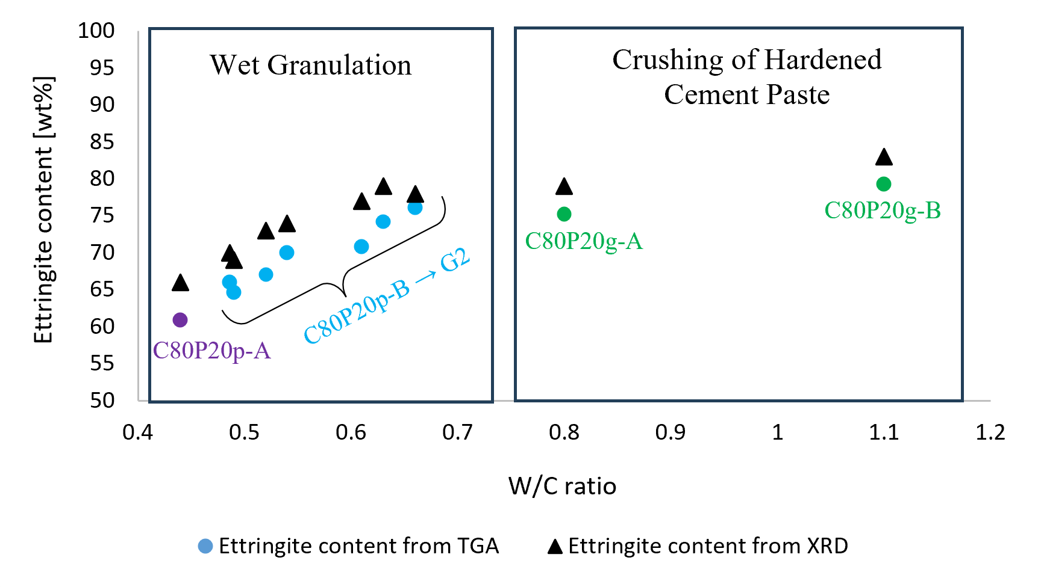
Fig. 1: Ettringite content in the cement paste samples from the results of the TGA and XRD analyses. C80P20p-A is manufactured by WG without superabsorbent. Materials C80P20p-B to C80P20p-G1, as well as C80P20p-G2, are manufactured by WG using various superabsorbents at mass contents of 0.5% and 1%. C80P20g-A and C80P20g-B are manufactured by CHCP.
The initial chemical analyses of the ten materials allow for a preliminary understanding and selection of promising materials for thermochemical analysis. Figure 2 shows the four materials selected according to this initial analysis. References materials for both manufacturing processes (CHCP and WG) are C80P20p-A and C80P20g-A, respectively. Promising materials candidates, C80P20p-D and C80P20p-G2, for thermochemical energy storage are characterized by a W/C ratio greater than 0.6 with a single-step manufacturing process.
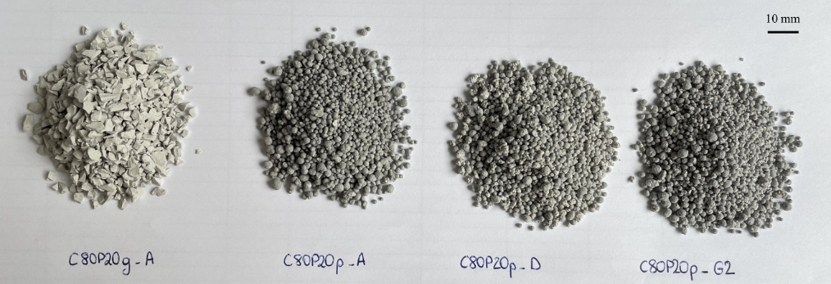
Fig. 2: Picture of the 4 formulations selected for the next stage of the study (1-3.15 mm diameter granulometry)
Electron microscopy (SEM) using a Quanta FEG 400 instrument was used to observe the surface and internal microstructure of 1 to 3.15 mm grains of C80P20g-A and C80P20p-A materials. The observation of the surface and internal microstructure of two products manufactured and their comparison using two different processes is allowed by this analysis. The surface to be observed was coated with a 10-15 nm gold-palladium layer. The samples were then observed under high vacuum with an accelerating voltage of 15 kV and a secondary electron detector. Identification of the ettringite phase in the matrix was confirmed by energy-dispersive X-ray spectroscopy (EDS).
The thermochemical loading/unloading cycle of the four C80P20 selected materials were characterized thanks to a thermogravimetric analysis and differential scanning calorimetry (TGA/DSC) coupled with a humidity control system (Sensys Evo TG-DSC and Wetsys, Setaram Instruments) used to provide humid nitrogen flow.
In the instrument, two 1.2 mm diameter grains were placed side by side in the crucible and thereby ensuring similar moisture flow around both grains. Consequently, no mass independence test was performed. The objective is to investigate the diffusion characteristics specific to the introduced grains rather than phenomena related to flow within the crucible.
The materials were studied during dehydration under a nitrogen flow rate of 10 ml/min for the TGA-DSC instrument and during hydration under a 50 ml/min for the Wetsys humidifier in order to study the complete storage cycle.

In order to determine the charging/discharging conditions of ettringitic materials and in the final the application range of the material, the thermodynamic equilibrium of the reaction has to be known. The key thermodynamic parameters of the Ett32/Met9 working couple were experimentally evaluated through a study on the synthesis and characterization of ettringite and the operating conditions of a potential thermal battery using ettringite as a storage material were determined too (Baquerizo et al., 2016; Chen et al., 2021b). Notably, the temperature during the charging step (i.e. the dehydration) must be carefully controlled: dehydrate ettringite above 90°C in a dry environment can result to the elimination of the last six water molecules (chemically bound as hydroxyl groups: OH⁻), which are essential for maintaining structural integrity.
Three-phase cycles – dehydration / cooling / hydration – are used to thermochemically test the sample:
- dehydration phase consists of a temperature increase from 20 °C to 80 °C at 10 K/min, followed by a hold at 80 °C for 15 hours;
- cooling phase consists of a ramp from 80 °C to 20 °C at 99 K/min followed by a hold at 20 °C for 3 hours to remove sensible heat from the material;
- hydration phase consists of creating an environment at 20 °C and 80 % relative humidity (RH) or 1900 Pa for 24 hours to allow measurement of the exothermic heat of hydration initiated by blowing humid air.
Water vapor pressure values used during the experiments depend on the temperature to both prevent condensation within the system and place the sample under the conditions necessary for hydration.
To conclude on the advantages of using ettringite in a cementitious matrix, a cycling test was carried out in a climate chamber. The C80P20p-G2 granules underwent 50 loading/unloading cycles, with thermochemical analysis performed after the 50 cycles. The climate chamber allowed for the programming of a sequence of dehydration stages at 80°C and 0% RH, followed by hydration stages at 20°C and 95% RH.
- Results and discussion
The relevant unit to assess the scaling up potential for heat storage technology is the ettringite density (kg_{ettringite}/m³_{bulk material}) which can be evaluated through the bulk density of the packed bed material and the ettringite content in each material. The two formulations manufactured on the granulation plate C80P20p-D and C80P20p-G2, appear to be the most promising candidates on the basis of the results of the ettringite density and BET specific surface area, for thermal energy storage applications. C80P20p-G2 has the highest ettringite volumetric content of 745 kg_{ettringite}/m³_{bulk mat}. C80P20p-D and C80P20p-G2 have the highest BET specific surface area of 14.4 and 14.1 m²/g, respectively. This analysis suggests that the high specific surface area of these materials is promising for promoting heat and mass transfer during the hydration reaction and therefore potentially increasing the final heat released by the material.
To assess the impact of the physicochemical differences among the four materials on their potential for thermochemical heat storage and release, they were subjected to a dehydration-hydration cycle. The results of the monitoring mass and stored/released heat are listed in Table 1. The three materials produced on the pellet plate C80P20p-A, C80P20p-G2, and C80P20p-D showed slightly different dehydration energies and mass losses: 687 J/g, 763 J/g, and 846 J/g, respectively. These results highlight that the higher the ettringite content is, the greater the amount of stored heat and the quantity of water exchanged. The results suggest that the difference in porosity and BET specific surface area does not impact the storage capacity of the two materials C80P20p-D and C80P20g-A: the amount of water desorbed and heat stored between the materials are similar, as is their mass ettringite content (77 wt%).
Tab. 1 : TGA/DSC analysis results for two grains tested with a diameter of 1.2 mm for the promising C80P20 materials
Sample name | Mass (mg) | Dehydration |  |  | Hydration
 |  | Mass loss [wt%] | Energy [J/g_{initial hydrated material}] | Energy [kJ/mol_{H2O}] | Mass gain [wt%] | Energy [J/g_{initial hydrated material}] | Energy [kJ/mol_{H2O}] | Energy density [kWh/m³]
C80P20g-A (W/C=0.8) | 4.012 | -24.3 | 834.3 | 61.9 | 20.2 | -601.3 | -51.4 | 132
C80P20p-D (W/C=0.66) | 5.22 | -24.9 | 846.3 | 61.2 | 18.2 | -540.0 | -47.7 | 126
C80P20p-A (W/C=0.44) | 5.376 | -19.5 | 686.6 | 63.2 | 16.4 | -501.0 | -53.4 | 146
C80P20p-G2  (W/C=0.61) | 7.19 | -23.1 | 763.2 | 59.4 | 16.9 | -480.0 | -47.4 | 134
C80P20p-G2 (W/C=0.61) – 50 cycles | 3.57 | -24.4 | 968.9 | 71.5 | 18.7 | -519.3 | -50.0 | 145
The results of TGA/DSC cycles on 1.2 mm diameter granules showed that the storage capacities of the grains depend on the amount of ettringite, but the hydration energies of the four materials tested are similar, as if their internal composition had no impact on the hydration kinetics. Indeed, variations in porosity, specific surface area, and ettringite content show no clear correlation with the hydration energy of the grains.
The SEM images presented in Figure 3 support the explanation that this phenomenon is due to the significant ettringite formation on the grain surface, as well as the hypothesis of a predominant hydration reaction at the surface. It leads to equivalent hydration energies for the four materials tested. Indeed, the expansion of ettringite needles on the surface of the grain shown in the Fig. 3 are promoted by the cure of the grains produced by WG in a sealed, airtight container (RH > 98 %). A barrier layer, which can block the diffusion of water vapor into the core of the grain during hydration, is produced by the needle expansion and thus limiting the reaction primarily to the outer layer.

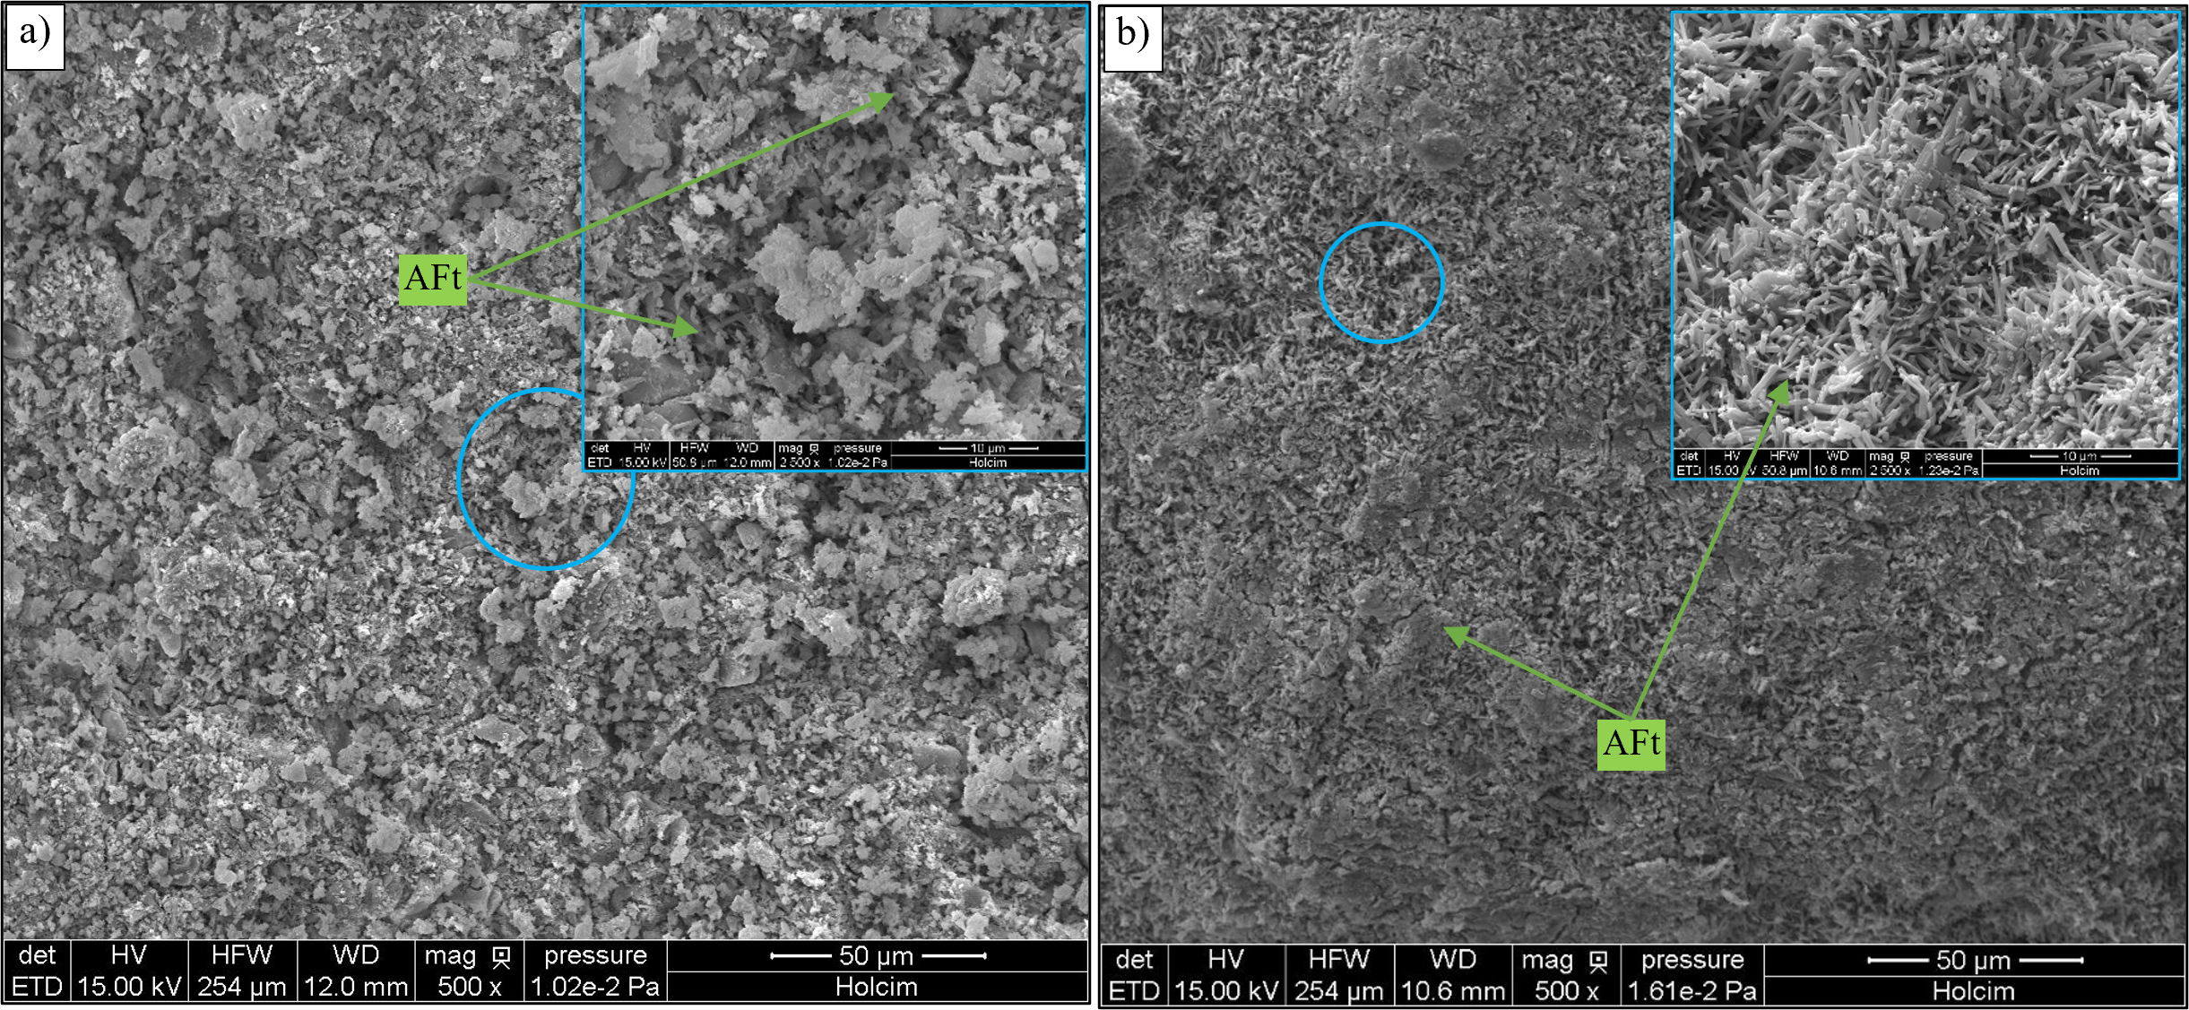
Fig. 3: SEM images of a) the surface of C80P20g-A grain by CHCP; b) the surface of C80P20p-A granule by WG

Heat of hydration values ​​range from 480 J/g to 601 J/g for materials C80P20p-G2 and C80P20g-A, respectively. Materials C80P20p-A and C80P20p-D show intermediate values, with hydration energies of 501 J/g and 540 J/g, respectively. Their energy densities can then be estimated by using the bulk density of each material: the volumetric estimation identifies C80P20p-A as having the highest energy density of 146 kWh/m³, the results across all four materials are uniform, with a standard deviation of 8.4 kWh/m³. The results of hydration energy over 50 cycles indicate that the energy density of the material remains constant over 50 cycles with an energy density of 519 J/g, or 145 kWh/m³ for the C80P20p-G2 granules. The hydration energy after 50 cycles is higher than the energy after manufacturing. There is greater mass gain, and the energy in kJ/mol of water is higher. These results suggest that a greater quantity of ettringite reacted during the test on the material aged by 50 cycles. Indeed, the ettringite dehydration/rehydration mechanism can promote the formation of secondary ettringite, particularly at the solid–gas interface (Collepardi, 2003).
The development of a wet granulation process using cement to produce a self-supporting, ettringite-rich cementitious material is the main novelty of this study. Indeed, crushed cement paste or foam as processes for producing ettringite from cement for thermochemical heat storage applications, are well-established. This study presents a new material with high thermochemical potential; its spherical shape and controllable diameter are expected to optimize granule packing and thus resulting in better stress distribution to provide good mechanical stability and homogeneous intergranular porosity. These combined characteristics make the material a promising candidate for easy integration into systems such as fixed-bed reactors.
- Conclusion
The demonstration of the feasibility of the one-step wet granulation technique as a high industrial manufacturing viability method is the major outcome of this work: the WG process significantly reduces manufacturing time and complexity while enhancing safety when compared to the multistage CHCP method. The four selected materials differ in ettringite content, porosity and specific surface area. However, these differences have little impact on the hydration energy of the grains. These findings support the hypothesis of limiting hydration at the grain surface, which is covered with ettringite according to SEM images.
The C80P20p-A material developed and characterized in this study present higher energy density than the 117 kWh/m³ (Ndiaye et al., 2020) and 104 kWh/m³ (Chen et al., 2021a) values reported in the literature at the reactor scale with a calculated energy density of 146 kWh/m³. The calculated energy density material is extrapolated from a precision TGA/DSC analysis measurement on two granules of C80P20p-A. To confirm the promising results of the C80P20p-A material as a granule for packed bed reactor, whether it is more effective than other ettringite-rich cementitious materials developed in previous studies, a reactor-scale test would be needed. This study highlights the heat and mass transfer limitations associated with this type of self-supporting thermochemical material. The use of wet granulation enables the production of spherical granules rich in surface ettringite, thereby offering high thermochemical/reactive potential.
Since the reactivity is concentrated at the grain interface, the material is particularly vulnerable to surface degradation. A cyclability study revealed that the active layer is thermochemically stable over 50 dehydration/hydration cycles. Understanding how atmospheric exposure affects this critical reaction interface over repeated cycles is important for predicting the operational lifespan of these thermochemical storage systems.
- References
Agba D. Salman, Michael Hounslow, Jonathan P.K. Seville, 2006. Granulation, Elsevier. ed.
Ayaz, H., Chinnasamy, V., Yong, J., Cho, H., 2021. Review of Technologies and Recent Advances in Low-Temperature Sorption Thermal Storage Systems. Energies 14, 6052. https://doi.org/10.3390/en14196052
Baquerizo, L.G., Matschei, T., Scrivener, K.L., 2016. Impact of water activity on the stability of ettringite. Cement and Concrete Research 79, 31–44. https://doi.org/10.1016/j.cemconres.2015.07.008
Chen, B., Johannes, K., Horgnies, M., Morin, V., Kuznik, F., 2021a. Characterization of an ettringite-based thermochemical energy storage material in an open-mode reactor. Journal of Energy Storage 33, 102159. https://doi.org/10.1016/j.est.2020.102159
Chen, B., Johannes, K., Ratel, L., Horgnies, M., Morin, V., Kuznik, F., 2021b. Investigation on ettringite as a low-cost high-density thermochemical heat storage material: Thermodynamics and kinetics. Solar Energy Materials and Solar Cells 221, 110877. https://doi.org/10.1016/j.solmat.2020.110877
Collepardi, M., 2003. A state-of-the-art review on delayed ettringite attack on concrete. Cement and Concrete Composites 25, 401–407. https://doi.org/10.1016/S0958-9465(02)00080-X
Coudray, C., Amant, V., Cantegrit, L., Le Bocq, A., Thery, F., Denot, A., Eisenlohr, L., 2017. Influence of Crushing Conditions on Recycled Concrete Aggregates (RCA) Leaching Behaviour. Waste Biomass Valor 8, 2867–2880. https://doi.org/10.1007/s12649-017-9868-2
Galazutdinova, Y., Clark, R.-J., Al-Hallaj, S., Kaur, S., Farid, M., 2024. New Thermochemical Salt Hydrate System for Energy Storage in Buildings. Energies 17, 5228. https://doi.org/10.3390/en17205228
Jiménez, A., Prieto, M., 2015. Thermal Stability of Ettringite Exposed to Atmosphere: Implications for the Uptake of Harmful Ions by Cement. Environ. Sci. Technol. 49, 7957–7964. https://doi.org/10.1021/acs.est.5b00536
Ndiaye, K., Cyr, M., Ginestet, S., 2020. Development of a cementitious material for thermal energy storage at low temperature. Construction and Building Materials 242, 118130. https://doi.org/10.1016/j.conbuildmat.2020.118130
Ndiaye, K., Cyr, M., Ginestet, S., 2017. Durability and stability of an ettringite-based material for thermal energy storage at low temperature. Cement and Concrete Research 99, 106–115. https://doi.org/10.1016/j.cemconres.2017.05.001
Park, S., Jeong, Y., Moon, J., Lee, N., 2021. Hydration characteristics of calcium sulfoaluminate (CSA) cement/portland cement blended pastes. Journal of Building Engineering 34, 101880. https://doi.org/10.1016/j.jobe.2020.101880
Richardson, I.G., 1999. The nature of C-S-H in hardened cements. Cement and Concrete Research 29, 1131–1147. https://doi.org/10.1016/S0008-8846(99)00168-4
Skevi, L., Ke, X., Ginestet, S., Ouellet-Plamondon, C., Gomes, F., Cyr, M., 2025. Reviewing experimental studies on chemical thermal energy storage in Cementitious composites: report of the RILEM TC 299-TES. Mater Struct 58, 292. https://doi.org/10.1617/s11527-025-02803-w
Solé, A., Martorell, I., Cabeza, L.F., 2015. State of the art on gas–solid thermochemical energy storage systems and reactors for building applications. Renewable and Sustainable Energy Reviews 47, 386–398. https://doi.org/10.1016/j.rser.2015.03.077
Zhang, L., Glasser, F.P., 2002. Hydration of calcium sulfoaluminate cement at less than 24 h. Advances in Cement Research.

