Preparation of Eco-Friendly Unsaturated Polyester Resin for FRP Composite

Yi-Yu Liu, Chun-Chieh Hsieh, Chih-Hsiang Tsai

R&D Center, Qualipoly Chemical Corporation,
No.2, Yong Gong 5th Rd., Yong An Dist., Kaohsiung City 82841, Taiwan (R.O.C.)
Email: yyliu@qualipoly.com.tw, Web Page: http://www.qualipoly.com/en/

Keywords: unsaturated polyester resin, DCPD, FRP composite

Abstract
Eco-friendly unsaturated polyester resins were successfully prepared by chemical modification of DCPD (dicyclopentadiene). FRP composite of these DCPD-modified unsaturated polyester resin were then studied to identify the relationship in physical properties. The mechanical strength, hardness, impact strength, transmittance of the FRP composites were characterized by American Society for Testing and Materials (ASTM) methods. It was found that the DCPD content could successfully be controlled to obtain high solid content of the resin (eco-friendly). The results of this study can provide useful information for preparation of eco-friendly unsaturated polyester resin and their application to FRP products, such as yacht, pipes, and tanks.

Introduction
DCPD (dicyclopentadiene) is the dimmer with thermodynamically stable form at room temperature by Diels–Alder reaction of cyclopentadiene (CPD). This reagent is mainly obtained as a by-product in the olefin cracking process or during the synthesis of ethylene product (C5) [1]. Due to high chemical activity of DCPD, it can be used as a raw material for petroleum resins and fine chemicals.
Unsaturated polyester resins are the condensation products of unsaturated acids or anhydrides and diols with diacids. Since 1930, unsaturated polyester resins have been used remarkably for wide range of applications making them a thermosetting system of major importance [2, 3]. General purpose unsaturated polyester resins were prepared by using maleic anhydride, phthalic anhydride and glycols [4]. For thermoset products, the resultant resin was blended with styrene for cross-linking and small amount of peroxide as initiator. These types of resins are useful in making trays, shower stalls, boats, swimming pool, water tanks etc.
The properties of unsaturated polyesters and their cured products largely depend on the nature of chemical structure of the starting resins. The incorporation of various types of moieties into the polyester backbone allows tailoring and preparation of various resins for different applications [5]. One of the compounds that can be widely applied as a comonomer for polyester synthesis is dicyclopentadiene (DCPD) due to their availability, low cost, and reactivity [6, 7].
In this article, the synthesis of DCPD-modified unsaturated polyesters for FRP composite have been presented as shown in Fig. 1. The characterization of prepared DCPD-modified unsaturated polyesters for FRP composite have been carried out using American Society for Testing and Materials (ASTM) methods.

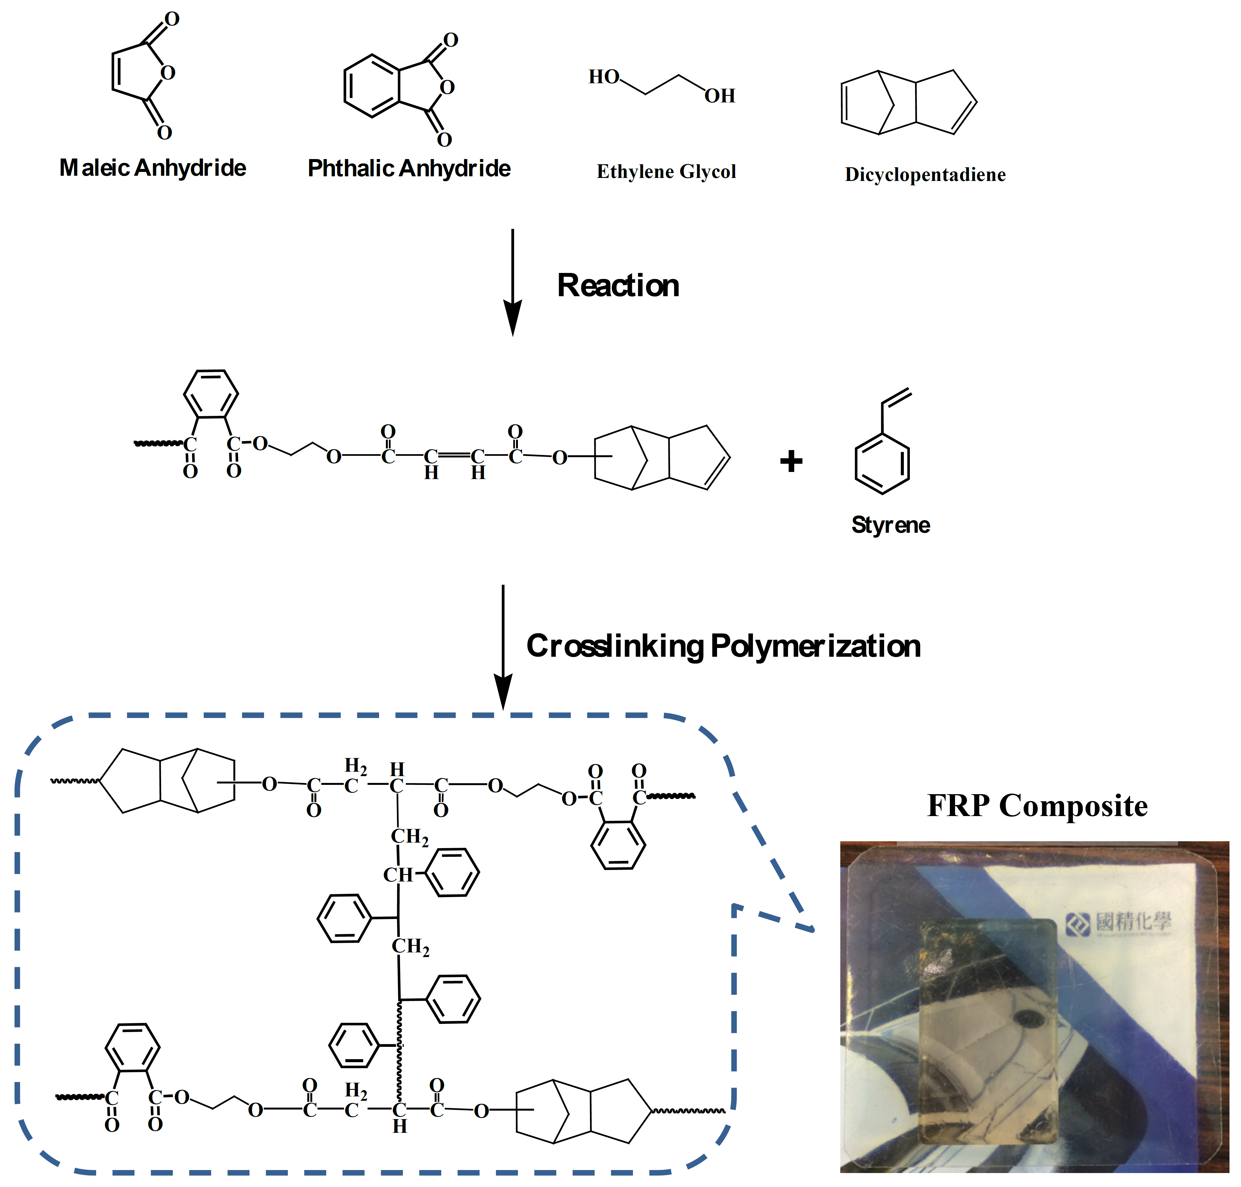
Figure 1. Schematic representation of preparation of eco-friendly unsaturated polyester resin for FRP composite.

Material
Dicyclopentadiene (DCPD), maleic acid (MA), ethylene glycol (EG), and Phthalic Anhydride (PA) were obtained from Formosa Plastics Group (Taiwan). Methyl Ethyl Ketone Peroxide (MEKPO) was from AkzoNobel (USA). Styrene (SM) was delivered by Grand Pacific Petrochemical Corporation (Taiwan).

Method
DCPD-modified unsaturated polyesters were prepared via two steps reaction. DCPD (1 mol), MA (1.05 mol), and DI water (1 mol) were placed into a 500 mL three-necked flask equipped with a mechanical stirrer, thermometer, and condenser. The mixture was heated to 105 ℃, and stirred rigorously for a further 6 hr maintained at this temperature by Diels-Alder reaction . In this stage, MA-modified of DCPD has been obtained. Then, EG (2.5 mol) and PA (0.4 mol) were added. The reaction mixture was heated up to 200 ℃ for 8 hr by condensation reaction. After cooling, SM (30%, compare with polymer) were added for obtaining the eco-friendly (high solid content) unsaturated polyester resin. Finally, FRP composite were obtained by using DCPD-modified unsaturated polyester, MEKPO, and fiberglass.

Results and Discussion
The comparison of styrene emission between common UPR and DCPD-modified UPR was shown in Fig. 2. Obviously, the styrene emission of common UPR (6.25%) was higher than DCPD-modified UPR (3.34%) because of DCPD-modified UPR has higher solid content at same condition as shown in table 1. Therefore, the eco-friendly unsaturated polyester resins were successfully prepared by chemical modification of DCPD.
The transmittance comparison of FRP composites between common UPR and DCPD-modified UPR was shown in Fig. 3. The transmittance of DCPD-modified FRP composite (75%) was higher than common FRP composite (35%) because of refractive index of DCPD-modified UPR was close to fiberglass.
The physical property comparison of FRP composites between common UPR and DCPD-modified UPR was shown in Table 1. Obviously, DCPD-modified FRP composite has good performance, including water resistance, mechanical properties, and so on. Therefore, the DCPD-modified unsaturated polyester resins can be widely applied to FRP products with good performance, such as boats, yachts, bath tubs, oil tanks.

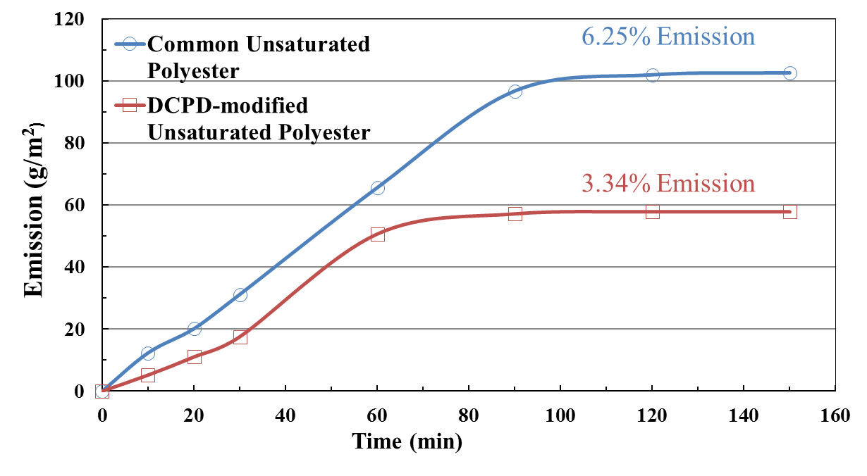
Figure 2. The comparison of styrene emission between common UPR and DCPD-modified UPR.

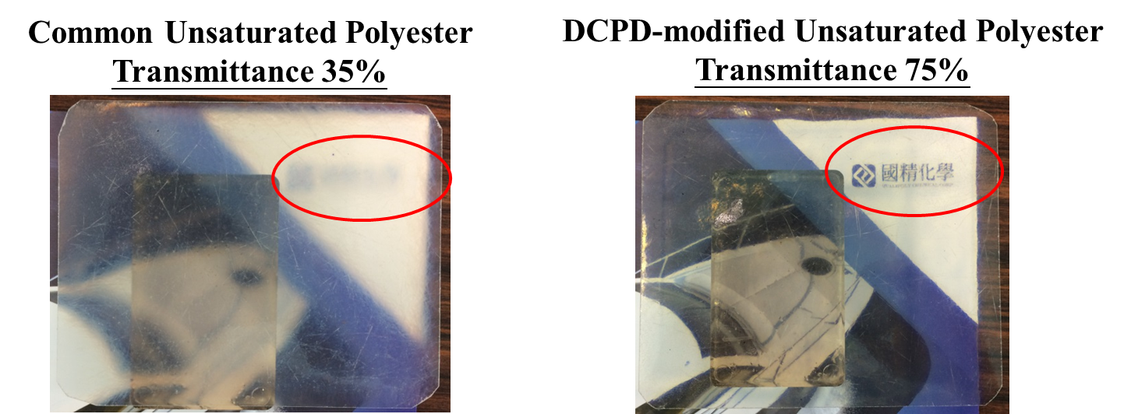
Figure 3. The transmittance comparison of FRP composites between common UPR and DCPD-modified UPR.

Table 1. The physical property comparison of FRP composites between common UPR and DCPD-modified UPR.
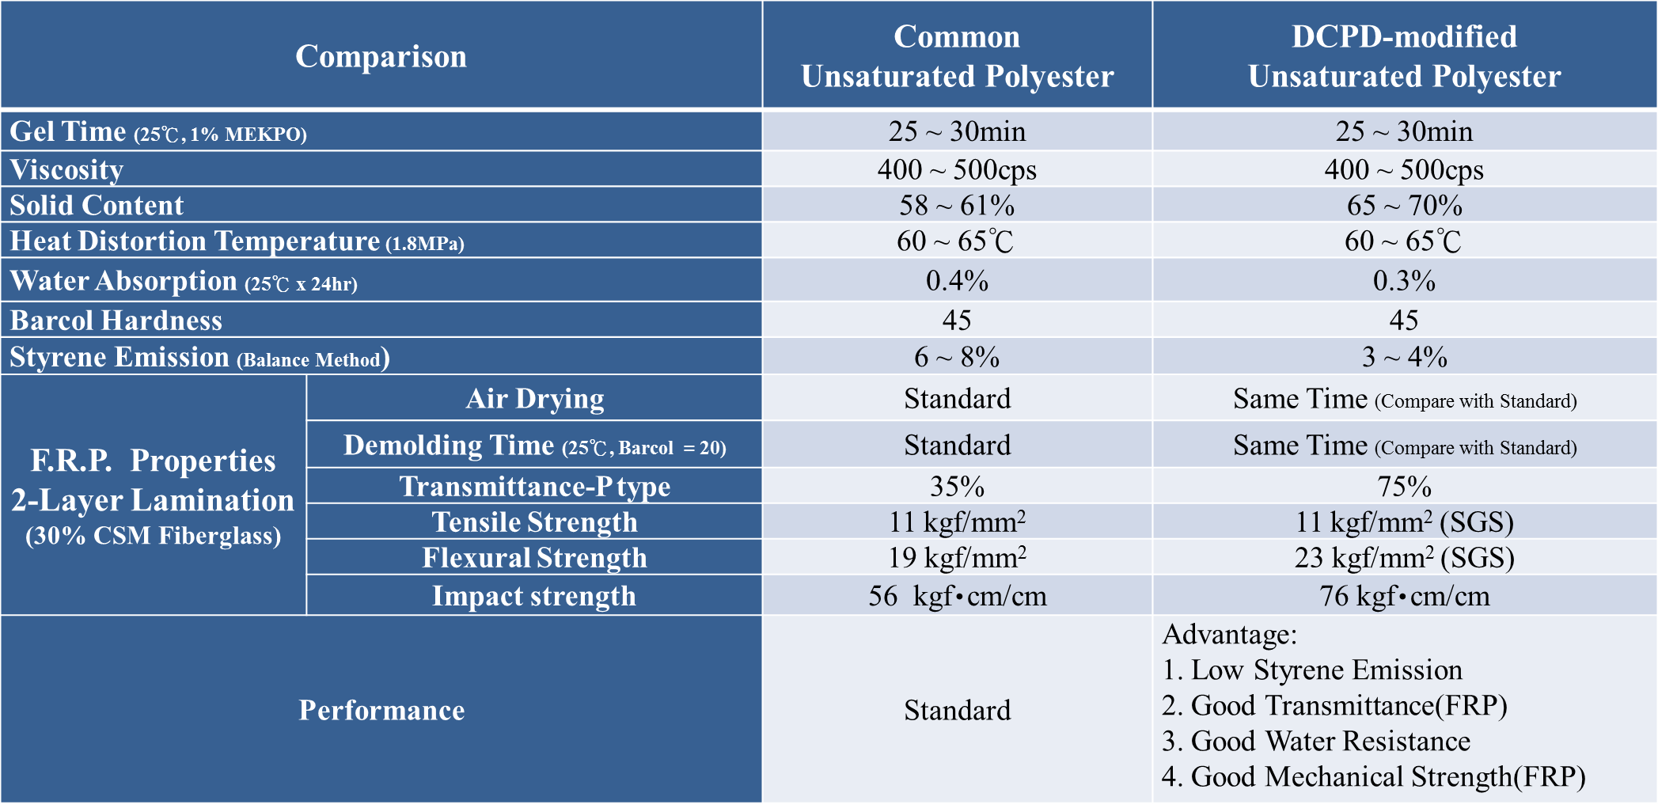

Conclusion
Eco-friendly unsaturated polyester resins were successfully prepared by chemical modification of DCPD. Furthermore, DCPD-modified FRP composite has good performance, including low styrene emission, transmittance, water resistance, mechanical properties, and so on. The results of this study can provide useful information for preparation of eco-friendly unsaturated polyester resin and their application to FRP products, such as yacht, pipes, and tanks.

References
[1] M. Worzakowska. Novel DCPD-modified polyester containing epoxy groups: thermal, viscoelastic, and mechanical properties of their wood flour filled copolymers. Polymer Bulletin, 68:775–787, 2012.
[2] A. Frodet and P. Arland. Unsaturated Polyesters. Pargamon Press, 1989.
[3] H.F. Mark, N.G. Gayord, and N.M. Bikales. Encyclopedia of Polymer Science and Technology. John Wiley and Sons, 1970.
[4] B. Dholakiya. Polyester. Intech, 2012.
[5] T. Wang, P.Y. Wan, Q.P. Yu, and M. Yu. Synthesis and characterization of dicyclopentadiene-cresol epoxy resin. Polymer Bulletin, 59:787–793, 2008.
[6] G.H. Hsiue, S.J. Shiao, H.F. Wei, W.J. Kuo and Y.A. Shai. Novel phosphorus-containing dicyclopentadiene-modified phenolic resins for flame retardancy applications. Journal of Applied Polymer Science, 79:342–349, 2001.
[7] K.G. Johnson and L.S. Yang. Preparation, Properties and Applications of Unsaturated Polyesters: Modern Polyesters Chemistry and Technology of Polyesters and Copolyesters. Wiley, 2003.

