EuroSun2026
IEA HPT Project 68 Task 2 - Sector Collaboration for the Market Uptake of HTHPs: Mapping Barriers, Opportunities, and Integration Pathways
Florian Schlosser (corresponding author)¹, Sanduni Pathiraja², Seon Tae Kim³, Roger Padullés I Solé⁴
¹ Paderborn University, Germany, florian.schlosser@uni-paderborn.de
² Danish Technological Institute, Aarhus, Denmark
³ German Aerospace Center, Institute of Low-Carbon Industrial Processes, Cottbus, Germany
⁴ Technical University of Denmark, Copenhagen, Denmark
Summary
High-temperature heat pumps (HTHP) represent a key enabling technology for industrial decarbonization. Despite technical maturity, their large-scale deployment remains limited due to process-specific, economic, and systemic barriers. Within the framework of the IEA HPT Project 68 – Task 2, a structured sector collaboration approach addresses these challenges through coordinated stakeholder engagement within several industrial sectors: district heating, pulp and paper, dairy, brewery, textiles, pharmaceuticals, chemicals, recyclate and petrochemical industries. This abstract exemplarily summarizes the intermediate outcomes of these Sector Collaborations, presenting a comprehensive mapping of value chains, sector-specific barriers, and opportunities linking technological, economic, and organizational aspects to stakeholder perspectives for HTHP adoption. Enhanced sectoral understanding and communication supports standardization, modularization, and integration, thereby accelerating the market uptake of HTHP technologies.

Keywords: High-Temperature Heat Pumps, Sector Collaboration, Integration concepts, Stakeholder Mapping
Field of application for the findings: Industrial heat pump applications
Addressed audience: High-Temperature Heat Pumps Track
- Introduction
HTHPs represent a pivotal technology for industrial decarbonization by enabling the replacement of fossil-fuel-based process heat with efficient, electrically driven systems. Although more than 40 demonstration cases have been documented within IEA HPT Project 68 Task 1, market adoption remains limited due to economic, technological, and systemic barriers. These include high capital costs caused by missing standardization and modularization, process-specific integration challenges, and unfavorable electricity-to-reference price ratios. Additionally, knowledge gaps regarding suitable system integration points and limited full-scale demonstrators impede market uptake. To overcome these challenges, IEA HPT Project 68 Task 2 focuses on establishing sector collaboration among key stakeholders to overcome barriers by synergistically leveraging opportunities, and to identify and implement integration and roll-out strategies for HTHPs across major industrial sectors. This manuscript provides insights into the work carried out in Task 2 of Project 68 and illustrates this using the pulp & paper, brewery and textile sectors as examples.
- IEA HPT Project 68 – Task 2: Sector Collaboration
Task 2 aims to accelerate industrial HTHP deployment by promoting structured cross-sector collaboration. Through coordinated activities within representative industries - such as pulp and paper, dairy, brewery, textiles, pharmaceuticals, chemicals, recycling, petrochemical industries, and district heating - the project develops a shared understanding of sector-specific barriers and opportunities. Collaborative workshops (“Sector Collaborations”) provide a methodological framework to jointly explore process characteristics, map value chains, and define technological integration possibilities.
These collaborations yield key outputs: a barrier-opportunity matrix linking technical, economic, and organizational factors to stakeholder roles and actions outlining specific steps for technology providers, industrial end users, policymakers, and system integrators. The project highlights enabling measures including business model development, demonstration, standardization, and risk‑sharing mechanisms. Such a structured engagement approach fosters knowledge transfer, reduces uncertainties in implementation, and supports systemic market integration of HTHPs.
- Stakeholder Mapping
Stakeholder mapping serves as a diagnostic framework that systematically characterizes actors along the sector-specific HTHP value chain. Relevant stakeholder groups include technology suppliers, industrial end users, system integrators, utility and energy providers, engineering consultants, research institutions, and public authorities.
The analysis identifies shared barriers and opportunities:
- Technological: Limited demonstrator projects, high safety requirements, and process constraints such as transient process conditions and flexibility requirements.
- Economic: High initial investment costs, uncertain electricity prices, and lack of financial incentives and business models.
- Regulatory and organizational: Approval procedures, limited standardization, and fragmented supply chains.
Opportunities arise from coordinated R&D, new business models (e.g., heat-as-a-service), renewable electricity integration, and knowledge dissemination. The barrier–opportunity matrix developed under Task 2 relates each challenge to specific stakeholder actions. For instance, manufacturers can address modular design and interoperability issues, while end-user can share process insights and success stories.
- Examples from sector collaborations
Pulp & Paper
The pulp and paper industry is an energy-intensive process sector characterized by continuous production, large thermal loads, and highly integrated energy-supply systems. Depending on the mill configuration, production comprises mechanical or chemical pulping, stock preparation, sheet forming, mechanical pressing, thermal drying, and finishing. In integrated mills, these processes are closely linked to site-specific steam networks, combined heat and power (CHP) plants, and internal fuel streams. Consequently, energy demand, available waste-heat sources, and temperature requirements vary considerably between sites, paper grades, and operating conditions.
Paper drying is particularly relevant for the integration of HTHPs, as it accounts for a substantial share of the thermal energy consumed by a paper machine. After sheet formation and mechanical dewatering, the remaining moisture is removed in a sequence of steam-heated drying cylinders. The required surface and steam temperatures generally increase along the dryer section. At the same time, the process produces large volumes of warm, humid exhaust air. Even after heat recovery for air preheating, this exhaust stream can provide a high-capacity heat source for an HTHP evaporator. Its suitability depends primarily on its temperature, humidity, and dew point, as well as on their variation during operation. On the heat-supply side, the HTHP condenser can provide generate steam. Where higher steam temperatures or pressures are required, the heat pump can be combined with mechanical steam compression. Alternatively, the HTHP can supply the highest required temperature level directly, allowing the existing steam cascade to remain in operation, although this configuration may result in a lower coefficient of performance.
Despite this technical potential, several sector-specific barriers currently impede a broader HTHP rollout (cf. Fig. 1). First, the economic viability of electrified heat supply strongly depends on the electricity-to-gas price ratio. Unfavourable price ratios can lead to high operating expenditure, particularly at sites where heat is currently supplied by efficient CHP systems or low-cost internal fuels. Long investment cycles, high requirements regarding plant availability, and uncertainty about future energy prices further complicate investment decisions. Second, paper-machine operating conditions are both complex and transient. Variations in steam demand, production rate, paper grade, exhaust-air temperature, and humidity affect the available source heat and the required heat-sink temperature. These variations make it difficult to design an HTHP based solely on nominal operating conditions. Third, paper machines and their energy systems are highly site-specific. Differences in dryer configuration, steam cascades, heat-recovery systems, and utility infrastructure limit the direct replication and scalability of standardized integration concepts. Finally, operators may be reluctant to introduce large-scale HTHPs into production-critical processes because unplanned interruptions or deviations in drying conditions can affect product quality and production output. The limited number of long-term and large-scale industrial references reinforces concerns regarding reliability and operational risk.
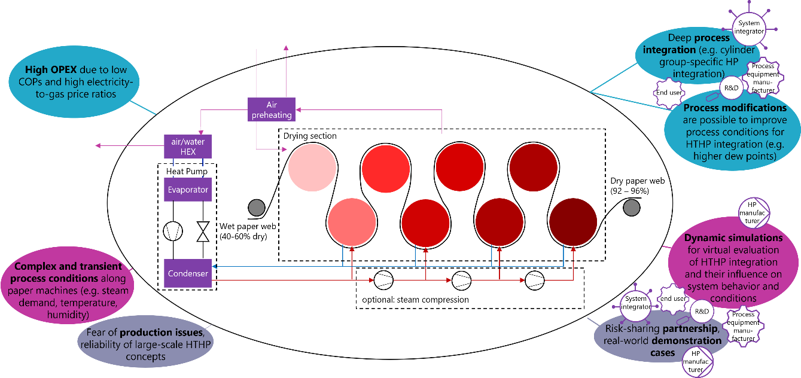
Fig. 1: Barriers & opportunities for HTHP uptake in Pulp and Paper sector (own illustration based on Awan et al. (2026), EHPA and Cepi (2023), Schlosser et al. (2026), Stathopoulos et al. (2026))
These barriers can be addressed through a combination of deeper process integration, process adaptation, simulation, and cooperation among relevant stakeholders. Early collaboration between end-user, HTHP manufacturers, process equipment suppliers, system integrators, and research institutions can facilitate the development of solutions tailored to individual cylinder groups and steam-pressure levels. Such deep process integration enables heat to be supplied at the temperature level at which it is required, thereby reducing unnecessary temperature lift and improving system efficiency. Where feasible, process modifications can further improve the boundary conditions for HTHP operation. Examples include changes to ventilation and heat-recovery systems that increase the temperature, humidity, or dew point of the available exhaust stream, as well as adaptations to the dryer steam system that create suitable integration points.
Dynamic process and system simulations are particularly important for assessing these concepts. Unlike steady-state calculations, dynamic models can represent changes in production rate, paper grade, ambient conditions, moisture content and flow behavior, and steam demand. They therefore enable virtual evaluation of the effects of HTHP integration on both the paper machine and the site-wide energy system. This approach supports appropriate equipment sizing, control-system development, economic assessment under variable electricity and fuel prices, and the identification of operational risks before implementation.
Finally, risk-sharing partnerships and real-world demonstration projects are needed to establish confidence in the technology. Demonstrations under representative industrial conditions can verify technical performance, availability, product-quality impacts, and economic feasibility over relevant operating periods. Transparent reporting of these results can reduce perceived investment risks and provide a basis for modular and increasingly standardized solutions. Although complete standardization is constrained by the heterogeneity of paper machines, standardized equipment modules, interfaces, and assessment methods could reduce engineering effort and total investment costs. Together, these measures can accelerate HTHP deployment in the pulp and paper sector while maintaining the reliability required for continuous industrial production.
Brewery
Brewing is a batch-oriented production process characterized by simultaneous heating and cooling demands at different temperature levels. After raw-material handling and milling, malt is mixed with water during mashing. The mash is subsequently transferred to the lautering stage, where the liquid wort is separated from the spent grains. The wort is then boiled, typically at approximately 100 °C in the wort kettle, before being cooled to the fermentation and conditioning temperature. Fermentation, maturation, and product tanks require refrigeration, whereas mashing, lautering, wort boiling, cleaning-in-place (CIP), and hot-water preparation represent the main heat demands. Consequently, breweries offer favorable technical conditions for heat recovery and heat-pump integration: low-temperature waste heat is generated by wort cooling and refrigeration while hot water is required repeatedly by several process steps.
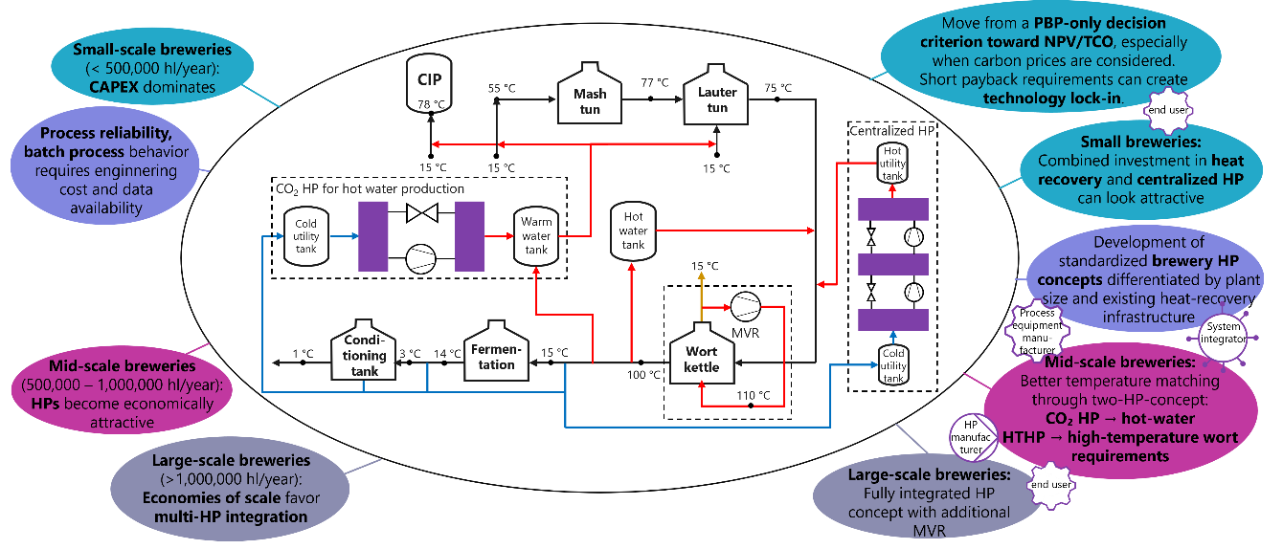

Fig. 2: Barriers & opportunities for HTHP uptake in Breweries – Matching concepts to plant size (own illustration based on Padullés et al. (2026))
The temporal mismatch between heat supply and demand nevertheless complicates integration. Brewing operations are discontinuous, and the duration, sequence, and frequency of batches vary between plants and products. Thermal energy storage (TES) systems are therefore generally required to decouple waste-heat availability from hot-water consumption. Furthermore, the temperature requirements range from refrigeration levels to approximately 75 – 80 °C for hot-water and CIP applications and up to the boiling temperature of wort. A heat-pump concept must therefore be designed not only according to annual energy balances, but also according to process schedules, temperature profiles, TES capacities, and the existing heat-recovery infrastructure.
Conventional wort coolers can transfer heat from hot wort to brewing water, thereby simultaneously reducing refrigeration demand and providing warm or hot water. Because this direct heat recovery avoids an additional energy-conversion step, it should normally be exploited before heat-pump electrification is considered. Heat pumps can subsequently upgrade remaining surplus heat from refrigeration systems, process cooling, or low-temperature water circuits to useful temperature levels.
Generally, breweries can be divided into three indicative size classes. These categories are not universal industry definitions but reflect the influence of production volume on heat-pump economics and system architecture.
Small-scale breweries
Heat pump implementation in small-scale breweries, defined here as plants producing less than approximately 500,000 hl/year, are usually dominated by capital expenditure and fixed project costs. Engineering, instrumentation, control integration, installation, and commissioning costs are distributed over comparatively small production and energy-saving volumes. Process variability may also be high because craft and specialty breweries frequently produce a broad portfolio in relatively small batches. This increases the importance of plant-specific operating data and can make the estimation of simultaneous heating and cooling loads more uncertain.
For small breweries, the combination of effective wort-cooling heat recovery, TES, and a centralized HTHP (HTHP) is generally the most logical configuration. A centralized unit minimizes the number of heat pumps, hydraulic interfaces, process modifications, and control interactions. It can therefore reduce engineering effort, controls complexity, installation costs, and operational risks compared with a highly distributed system.
However, as a centralized HTHP needs to meet the highest temperature requirements resulting in low Coefficients of Performance (COP), much of the total economic benefit originates from the heat-recovery system itself. If wort-cooling heat recovery and suitable hot-water TES already exist, the additional energy savings attributable to heat-pump electrification may be insufficient to meet the short payback periods commonly expected by industrial companies. Conversely, combined investment in improved heat recovery and a centralized heat pump can appear attractive.
Mid-scale breweries
Mid-scale breweries, producing approximately 500,000 to 1,000,000 hl/year, often represent a particularly attractive segment for industrial heat pumps. Their annual heat demand and operating hours are sufficiently high to justify more advanced integration, while plant layouts and production systems may remain less complex than those of very large breweries.
For these plants, process integration by temperature matching becomes increasingly important. Rather than installing one centralized heat pump sized to meet the highest temperature required anywhere in the brewery, a more efficient architecture may use separate systems for distinct temperature levels. For example, a CO₂ heat pump can provide hot water efficiently, while an HTHP supplies the smaller heat fraction required for higher-temperature applications, potentially including support for wort heating. Such a configuration limits unnecessary temperature lifts.
This approach can improve efficiency and reduce electricity consumption. Its disadvantages are a greater number of interfaces and more demanding system integration. The economic optimum therefore depends on the relative importance of efficiency gains compared with additional equipment, engineering, and control costs. Mid-scale breweries consequently require careful techno-economic optimization rather than the automatic selection of either a single centralized or a fully decentralized solution.
Large-scale breweries
Large-scale breweries with annual production exceeding 1,000,000 hl/year benefit most clearly from economies of scale. Engineering, installation, and equipment costs become smaller relative to annual production, operating hours, and energy savings. Large plants are therefore better positioned to implement multiple heat pumps, dedicated heat-recovery loops, large TES, and advanced process controls.
A fully integrated concept can match different waste-heat sources to different process sinks and temperature levels. In addition to refrigeration-heat recovery and HTHPs, mechanical vapor recompression (MVR) may be applied to recover vapor from wort boiling. Recompressing the vapor increases its pressure and condensation temperature, allowing its latent heat to be reused in the boiling or heating process. Combining MVR with multiple heat-pump concepts may slightly improve the efficiency of a fully integrated system and substantially reduce the residual demand for steam or fossil-fuel heat. However, despite being particularly attractive at large scale or where MVR systems are already in place, such fully integrated solutions may not always be the most cost-effective option; simpler two-heat-pump configurations can achieve very similar efficiency with lower investment costs and reduced complexity.
Nevertheless, this architecture requires extensive process-integration expertise. Heat recovery, TES, multiple heat pumps, MVR, and process scheduling must be considered holistically. Successful implementation therefore depends on cooperation between the brewery, heat-pump manufacturers, system integrators, engineering consultants, refrigeration specialists, and process-equipment suppliers.
Barriers to a stronger heat-pump rollout
A major barrier is the industrial requirement for process reliability. Brewing is product- and hygiene-critical, and interruptions in wort production, fermentation cooling, hot-water availability, or CIP can cause production losses that exceed the expected energy-cost savings. Breweries may therefore be reluctant to connect core process operations to unfamiliar heating technologies. Redundancy, backup boilers, robust control strategies, and clearly defined fallback modes are often required, but these measures increase capital expenditure.
A second barrier is the batch-wise and site-specific character of brewery operation. Reliable design requires time-resolved data on process temperatures, mass flows, batch schedules, hot-water use, refrigeration loads, and TES levels. Such data are frequently unavailable, distributed across different control systems, or not measured at sufficient temporal resolution. The resulting uncertainty increases engineering costs and encourages conservative designs.
Existing heat-recovery infrastructure is another decisive factor. Where wort-cooling heat recovery already supplies a large share of the hot-water demand, the remaining heat-pump potential can be substantially smaller than a plant-level energy balance initially suggests. Evaluations that attribute the entire benefit of an integrated project to the heat pump may therefore overestimate its profitability. Existing infrastructure and the targeting of heat recovery and heat pumps should be considered holistically as part of a retrofit.
Investment criteria can create an additional barrier. Decisions based exclusively on simple payback period may favour low-cost but less efficient architectures or reject strategically valuable heat pump projects. This is particularly relevant when carbon prices, future fuel-price risks, renewable-electricity availability, and the avoidance of future boiler investments are excluded. Short payback requirements can also result in technological lock-in by encouraging continued use of existing fossil-fuel infrastructure.
Finally, the market currently lacks broadly applicable yet sufficiently differentiated standard solutions. Each brewery has a different combination of process equipment, temperature levels, TES capacities, refrigeration systems, and existing heat recovery. Purely tailor-made solutions are expensive, especially for small plants, whereas completely standardized systems may fail to capture the available efficiency potential.
Opportunities for accelerating deployment
The strongest opportunity lies in developing standardized brewery heat-pump concepts differentiated by plant size and existing heat-recovery infrastructure. Modular packages could include predefined hydraulic layouts, TES configurations, control functions, monitoring systems, and interfaces to refrigeration and brewery-control systems. Standardization would reduce engineering and transaction costs without assuming that one architecture is suitable for all breweries.
For small plants, packaged solutions combining wort-cooling heat recovery, hot-water TES, and one centralized HTHP could provide a robust entry point. For mid-scale plants, modular multi-temperature concepts could improve temperature matching - for example, by combining a CO₂ heat pump for hot-water production with an HTHP for higher-temperature wort-related requirements. For large breweries, fully integrated concepts incorporating several heat pumps, refrigeration recovery, TES, and optional MVR offer the greatest decarbonization potential.
Improved data acquisition and digital process models can further reduce project risk. Temporary metering campaigns, automated extraction of control-system data, and dynamic simulation can identify heat source and heat sink overlap, determine appropriate TES sizes, and evaluate operation under different production schedules. Performance guarantees based on clearly defined operating conditions could increase confidence among plant operators and investors.
Economic decision-making should also move beyond a payback-period-only criterion toward net present value, total cost of ownership, and carbon-abatement cost. Such assessments can include carbon prices, anticipated fuel and electricity prices, equipment lifetime, maintenance costs, available subsidies, renewable-electricity procurement, and the value of avoiding future fossil-boiler replacement. This broader perspective can prevent lock-in to cheaper but less efficient architectures.
In summary, heat pumps have considerable potential to reduce fossil-fuel consumption in breweries, but the optimal architecture is strongly scale-dependent. Small breweries require simple and capital-efficient centralized solutions; mid-scale breweries benefit from improved temperature matching; and large breweries can exploit fully integrated multi-heat-pump and MVR concepts. Across all size classes, deployment depends on prioritizing direct heat recovery, improving process data, reducing integration costs, ensuring operational reliability, and aligning investment criteria with long-term decarbonization objectives.
Textile
The textile sector is characterised by a globally distributed and highly fragmented value chain. The supply chain in the textile industry is typically represented in four Tiers, that describes the production process from raw material extraction (Tier 4), raw material processing (Tier 3), fabric manufacturing (Tier 2), finished product assembly (Tier 1) and distribution (Tier 0) (Fashion For Good, 2023). From an energy perspective, Tier 4 is the most relevant and significant. During the fabric manufacturing, the fibres, yarns and fabric go through multiple thermally intensive steps to achieve the required aesthetic properties desired for the various fabric products. These steps primarily categorised into 1) pre-treatment steps such as sizing, singeing, bleaching, mercerizing and 2) colouring steps such as dyeing, printing and 3) finishing steps such as drying. These operations require substantial quantities of hot water, steam, and hot air. Heating demand generally occurs at low and medium temperature levels, although the required temperatures depend on the fibre type, product type, product quality, processing route and machinery. Finishing processes typically require higher temperatures above 150 ºC. At the same time, textile plants generate considerable amounts of recoverable heat in warm wastewater, exhaust air, and steam condensate. The simultaneous presence of heat demand and waste-heat sources makes textile manufacturing processes a promising application field for industrial heat pumps.
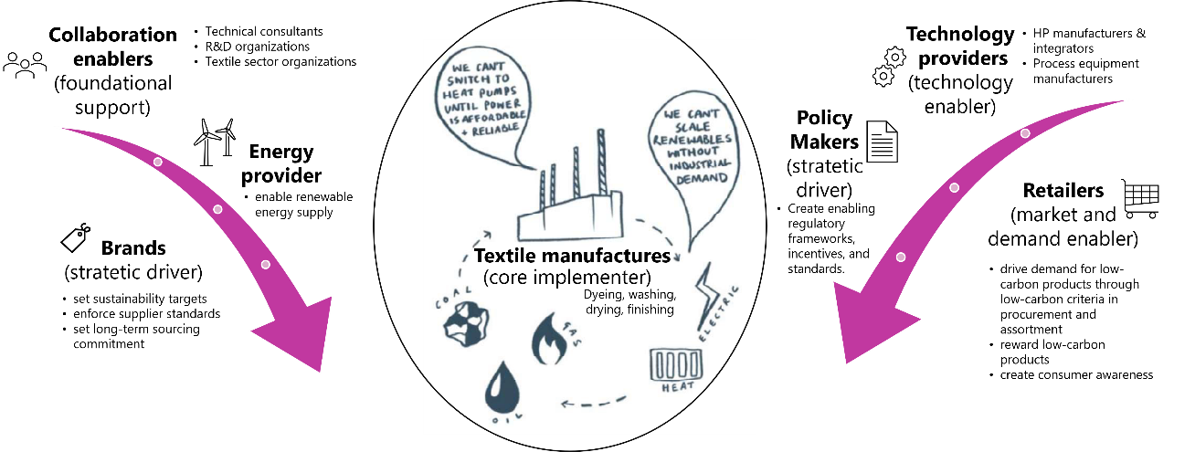
Fig. 3: Barriers & opportunities for HTHP uptake Textile sector - Decarbonisation across the value chain (own illustration based on Pathiraja (2026), Fashion Revolution (2025), Schlosser et al. (2026))
Heat pumps can upgrade otherwise unusable waste heat to a temperature level suitable for process-water heating, drying-air preheating and heating, boiler-feed-water heating and utility level steam production. Their integration can therefore reduce fossil-fuel consumption and direct greenhouse-gas emissions while improving overall energy efficiency. However, deployment remains limited despite the technical availability of relevant solutions. The slow rollout is therefore not primarily a technology problem. Rather, it results from the interaction of economic uncertainty, limited sector-specific expertise, inadequate infrastructure, fragmented decision-making, and insufficient market incentives.
One important barrier is the lack of full-scale demonstrators under representative industrial conditions. Textile manufacturers are generally reluctant to modify core production processes because product quality, colour consistency, production availability, and delivery schedules are commercially critical. Demonstration projects can reduce perceived risks by providing transparent evidence on system performance, achievable temperature levels, product quality, operational flexibility, maintenance requirements, and lifecycle costs. Experience from European demonstration plants should consequently be transferred to major textile-producing regions. This transfer must go beyond presenting successful case studies: it should include operating data, standardised monitoring procedures, integration concepts, economic assessment methods, training for local engineers and plant operators and also financing mechanisms to support investment.
A second barrier is the lack of sector-specific technical expertise, particularly in producing regions where access to industrial heat-pump specialists and experienced engineering companies is limited. Heat-pump deployment requires detailed knowledge of both the technology and the manufacturing process. Source and sink temperatures, temporal load profiles, wastewater quality, fouling risks, production schedules, utility systems, and available space must all be considered. Process-integration and pinch-analysis studies can identify suitable heat sources and prioritise applications with small temperature lifts and high annual operating hours. Engineering and planning guidelines tailored to dye houses and finishing plants could further reduce transaction costs and prevent oversized or poorly integrated systems. Capacity building among consultants, equipment suppliers, research organisations, and plant personnel is therefore as important as further technological development.
The carbon intensity and reliability of electricity supply constitute another challenge. Electrification does not automatically lead to substantial emission reductions where power systems remain dominated by fossil fuels. In addition, weak grids, connection constraints, and unreliable electricity supply can discourage manufacturers from replacing fuel-based heating systems. These barriers may be addressed through on-site photovoltaic generation, renewable-electricity power-purchase agreements, TES, demand-side management, and coordinated investment in electricity infrastructure. Hybrid systems can also provide transitional solutions where full electrification is not immediately feasible. Nevertheless, heat pumps should be assessed based on both their energy performance and the present and expected carbon intensity of electricity.
Investment decisions are further complicated by volatile electricity and fuel prices, peak-demand charges, grid-capacity limits, and uncertainty regarding future production volumes. Although heat pumps can offer low operating costs, they often require higher upfront expenditure than conventional boilers. A narrow focus on simple payback periods may therefore disadvantage projects that provide long-term emission reductions and lower exposure to fossil-fuel price risks. Suitable responses include concessional financing, investment guarantees, contracts for renewable electricity, carbon pricing, and remuneration for demand flexibility. Co-investment across the value chain can distribute risks more equitably. Brands and retailers, for example, can provide long-term purchasing commitments, price premiums, or direct financial support to suppliers investing in low-carbon process heat.
This value-chain perspective is particularly important because the actors financing decarbonisation are often not those capturing its benefits. Manufacturing facilities generally face the investment and operational risks, whereas brands and retailers may receive much of the reputational and market value associated with lower-carbon products. Procurement contracts should therefore incorporate measurable energy and emissions criteria as well as longer-term commitments. Shared-savings models, green supply-chain finance, and contracts that allocate part of the decarbonisation cost to downstream actors can help overcome this split incentive.
The market side should not be overlooked. Brands and retailers can create demand for low-carbon textiles through procurement standards, product-level carbon information, supplier-development programmes, and credible sustainability claims. Consumers could, in turn, choose low-carbon products offered by sustainable brands and retailers, provided that environmental information is reliable, understandable, and protected against greenwashing. Consumer choice alone cannot finance the transformation of industrial heat supply, but it can reinforce corporate commitments and create an additional incentive for value-chain investment.
Overall, accelerating heat-pump deployment in textile manufacturing requires a coordinated approach rather than a purely technological intervention. Priority should be given to reducing process heat demand, maximising direct heat recovery, matching suitable waste-heat sources with process sinks, and applying heat pumps where temperature levels and operating profiles support efficient operation. Demonstration, knowledge transfer, renewable electricity procurement, appropriate financing, and long-term collaboration among manufacturers, brands, retailers, utilities, researchers, regulators, and consumers can then convert the sector’s substantial technical potential into widespread industrial implementation.
- Conclusion
The intermediate results of IEA HPT Project 68 Task 2 underline that coordinated sector collaboration is a crucial enabler for industrial HTHP market uptake across diverse industries. The collaborative approach of stakeholder integration provides a structured framework to translate barriers into practical opportunities and actionable strategies. The development of the barrier-opportunity matrix and sector-specific integration schemes - such as for pulp and paper and the brewery sector - and the mapping of stakeholder along the value chain - as shown by the textile sector - demonstrate how stakeholder-driven innovation and systemic cooperation can accelerate the transition toward sustainable, low-carbon industrial heating solutions.
- References
Awan, O., Lunewski, J., Raval, J., Norouzian, A.; Kuperjans, I., Bekaert, P., 2026. Energy efficiency and decarbonization in the paper industry: A review of drying technology and HTHPs. Sustainable Energy Technologies and Assessments, https://doi.org/10.1016/j.seta.2026.105095.
EHPA, Cepi, 2023. Through pumps to pulp: greening the paper industry’s heat. European Heat Pump Association (EHPA) & European Paper Industries (Cepi). Available at: https://www.ehpa.org/wp-content/uploads/2023/02/EHPA-Cepi-Heat-pumps-in-the-paper-industry_February-2023.pdf.
Fashion For Good, 2023. What is textile processing? Understanding the fashion supply chain and its environmental impact. Available at: https://www.fashionforgood.com/our_news/what-is-textile-processing-understanding-the-fashion-supply-chain-and-its-environmental-impact/.
Fashion Revolution, 2025. What fuels fashion? https://www.fashionrevolution.org/transparency/.
Padullés, R., Andersen, M.S.P., Mogensen, N.B., Walden, J., Zühlsdorf, B., Jensen, J.K., 2026. Generalized electrification solutions for breweries: A Pinch Analysis-based approach to Heat Pump integration and process decarbonization. Energy Conversion and Management, https://doi.org/10.1016/j.enconman.2026.121292.
Pathiraja, S., 2026. Sector collaboration workshop: Decarbonizing the textile sector. 5th HTHP Symposium 2026, Copenhagen.
Stathopoulos, P., Rose, C., Tran, A.P., Verma, M., Mazzolla, E., Mairs, R., Awan, O., Schlieckau, T., Grassauer, J., 2026. HTHPs in the Pulp & Paper Industry: Challenges, Opportunities and Priorities from a Stakeholder Panel. 5th HTHP Symposium 2026, Copenhagen.
Schlosser, F.; Ahrendt, F.; Wittstadt, U.; Rose, C.; Stathopoulos, P.; Pathiraja, S.; Andersen, M.S.P.; Zühlsdorf, B. (2026): Insights from IEA HPT Project 68 - Task 2: Fostering market uptake of HTHPs through Sector Collaboration and Stakeholder Integration. 5th HTHP Symposium 2026, Copenhagen.

