EuroSun2026
NEW AUTONOMOUS AND SUSTAINABLE CONCEPT FOR THE ENERGY SUPPLY OF ERRIKOUSA ISLAND

Summary
A new concept to generate clean electricity on a selected remote Greek island with a population of less than 500 inhabitants has been developed, using only renewable energy sources (RES) and energy storage systems. The new energy plan takes into account the clean energy transition framework for islands and applies it to Errikousa, a selected island in the Ionian Sea. It also compares the proposed plan with the island's current energy coverage. The electricity demand coverage needs on this island are met by using conventional fuels with the operation of diesel engines. The authors selected and used appropriate software to optimise and design the energy systems. For the energy study of the island, integrated simulation models were created both for the current total energy supply and for different scenarios of the newly developed energy planning.
Keywords: energy transition, clean energy, remote island, simulation model, RES, storage system
Field of application for the findings: The findings inform island energy planners, municipal authorities, and utilities on replacing diesel with renewables plus storage. The results can guide policymakers and program designers on clean‑energy transition strategies for islands. They also provide researchers and engineers with modelling and optimisation workflows for microgrids and hybrid systems in remote, low‑population islands. They help investors, grantmakers, and technology vendors evaluate project viability and system sizing.
Addressed audience:academicians, energy researchers, policy makers and authorities, energy developers

- Introduction
In Greece, there are a considerable number of remote islands, most of which are not interconnected with the mainland electricity grid of Greece. It is very common that such remote places with high potential for usage of renewable energy systems aren’t being fully taken advantage of. A new project to generate electricity on the selected remote Greek island Errikousa with a population of around 500 inhabitants has been developed, using only renewable energy sources (RES) and energy storage systems. This article describes this new concept scenarios for an energy system for Errikousa island in Greece and the simulations which ran with an software application. The simulations results are then compared with the current supply of energy in the island.
The decarbonization of energy supply represents one of the key challenges of the energy transition, particularly for remote islands that are not connected to a mainland electricity grid. Due to their geographical location, many isolated islands still rely on diesel-powered generators to meet their electricity demand. Although these systems provide a reliable energy supply, they are associated with high operating costs, significant fossil fuel consumption, and considerable carbon dioxide (CO₂) emissions. At the same time, many Greek islands offer excellent natural conditions for the utilization of renewable energy sources. High annual solar irradiance and favorable wind conditions provide significant potential for meeting the local electricity demand sustainably while reducing dependence on fossil fuels.
Against this background, this study develops and evaluates a sustainable energy concept for the Greek island of Errikousa. The objective is to design a fully renewable electricity supply system capable of replacing the existing diesel-based power generation. The proposed concept combines photovoltaic (PV) arrays, wind turbines, and a battery energy storage system (BESS) to compensate for the fluctuating nature of renewable energy generation while ensuring a reliable electricity supply. A diesel generator is retained exclusively as a backup system for exceptional operating conditions.
To evaluate the proposed energy concept, both the existing energy supply system and the newly developed renewable energy system were modeled using the simulation software TOP Energy. Based on site-specific meteorological data and an hourly load profile, electricity generation, battery operation, and load coverage were simulated over an entire year of operation. The simulation results were analyzed with respect to electricity demand coverage, CO₂ emissions, and the achievable degree of energy autonomy and were compared with the existing energy supply system. The objective is to demonstrate the technical feasibility of a fully renewable electricity supply for Errikousa Island and to highlight the potential of such an energy concept for other comparable remote islands.
- Description of current situation
According to IPTO 2020 the majority of the island's energy is provided by diesel generators and imported electricity via underwater cables from Independent Power Transmission Operator (IPTO). Table 1 shows a list of the available and running diesel generators on Errikousa Island.
The Public Power Corporation (PPC 2020) uses according to Kaldellis et. al. 2007 autonomous thermal power plants (CHPs) to meet the needs of the Aegean and Ionian islands.
It is important to note that the seven generators with a total capacity of 1.11 MW can produce more than the required demand of the island. These generators are switched on and off according to the real-time electricity demand.
Tab. 1: List of diesel generators on Errikousa Island as described in HEDNO 2022
No. | Generator | Capacity [kW]
1 | G1 | 80
2 | G2 | 80
3 | G3 | 80
4 | G4 | 90
5 | G5 | 200
6 | G6 | 180
7 | G7 | 400
Fig. 1 shows a typical summer electricity demand curve on Errikousa island, where there is an influx in tourism. The electricity usage differs greatly between summer months and winter months as the number of tourists change.

Fig. 1: Typical summer energy demand curve in Errikousa Island according to HEDNO 2022
A model was prepared with TOP Energy for the current electricity supply system of Errikousa island (Fig. 2).
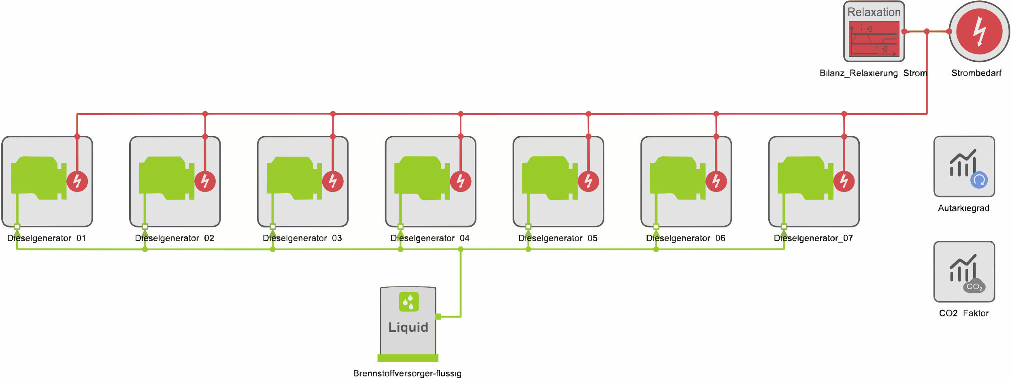
Fig. 2: Current electricity supply system of Errikousa Island
- New concept for energy production in Errikousa
It is important to describe first the potential of renewable energy sources. This is followed by the new energy planning with the aim of 100% renewable energy use and modelling with appropriate software.
3.1. Renewable energy production
It is a fact that the vast majority of the remote Aegean and Ionian islands are characterised by a very high solar, but also a remarkable wind potential. Both numbers are recorded on global solar atlas and global wind atlas (Fig. 3 and Fig. 4). The choice of renewable energy technologies is illustrated by a potential analysis which focuses on the location of the island and therefore the impact on the potential potential returns.
Regarding the solar potential Errikousa receives enough of sunlight throughout the year, making it a good location for the installation of solar panels. The solar potential for the island of Errikousa is above 1400 kWh/m² per year.
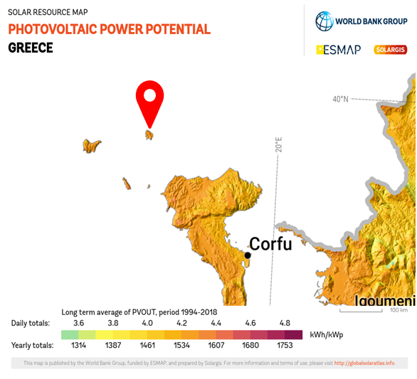
Fig. 3 Photovoltaic power potential of Errikousa (Solargis 2026)
The annual global solar irradiation is approximately 1,685.7 kWh/m². The specific PV yield is around 1,569.4 kWh/kWp per year. Consequently, photovoltaics offers the greatest generation potential at the site.
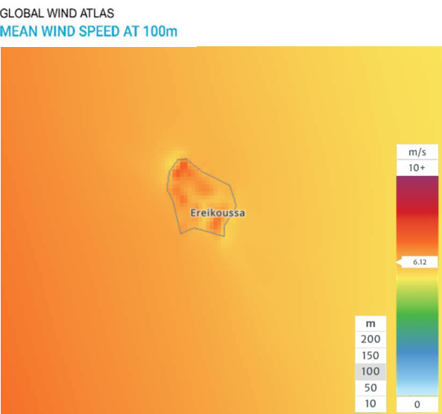
Fig. 4 Wind power potential of Errikousa (Global Wind Atlas 2026)
The average wind speed on Errikousa Island is around 4.5 m/s at 10 m (NASA 2018). For wind energy purposes, an average wind speed of 6.35 meters per second was determined at a height of 50 meters. Consequently, the wind conditions are suitable for smaller wind turbines. Errikousa also features a harsh and hilly terrain with several elevated locations that are exposed to the wind. These topography features generate considerable wind speeds and turbulence, making wind energy generation possible.
Photovoltaics generate a large amount of energy, particularly during the day and in summer, while wind energy provides power at night and during periods of lower solar output.
3.2. New concept
Taking into account the pressing need to meet the island's energy needs without further use of conventional and therefore polluting fuels, the prospects for the development of a new energy system on the island, based among others on the exploitation of the available solar and wind potential and the use of energy storage systems, are proposed and explored
3.3 Simulation model development
The authors selected and used appropriate software to optimise and design the energy systems. For the energy study of the island, integrated simulation models were created both for the current total energy supply and for different scenarios of the newly developed energy planning. Fig. 5 shows a possible concept with PV arrays, wind turbines and a battery for Errikousa island, as well as a backup diesel engine.
The energy comparison is carried out using real data describing hourly step by hour the production of the renewable energy plants for a full year of operation. The climate impact is presented on the basis of a CO₂ balance and taking into account the reduction of fuel requirements. Following the modeling of the existing energy supply system, 4 new renewable energy concept were developed and implemented in TOP Energy. The objective was to design a fully renewable electricity supply system capable of reliably covering the island's annual electricity demand while minimizing the use of fossil fuels.
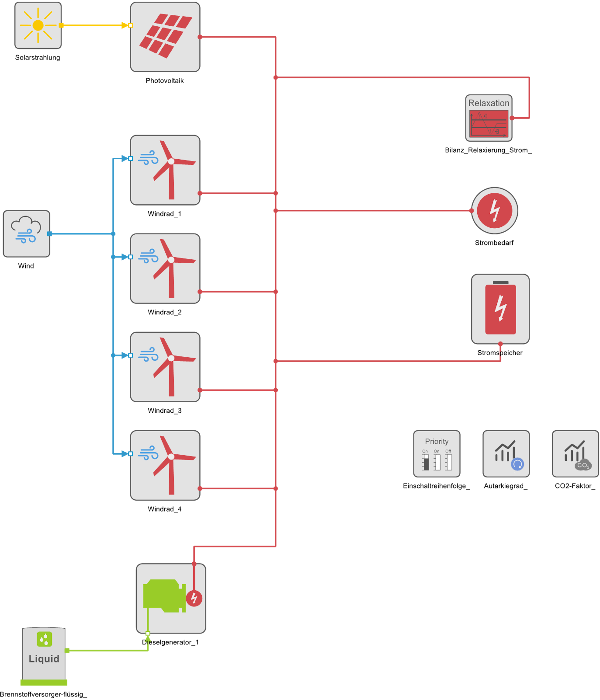
Fig. 5: TOP Energy model of one of the proposed energy systems
(i) The first developed energy concept combines multiple renewable energy sources with an electrical energy storage system. The primary electricity supply is provided by 5 offshore wind turbines, each with an installed capacity of 200 kW. Due to the relatively stable wind conditions on Errikousa Island, wind power represents the main source of electricity generation and ensures a continuous power supply, including during nighttime.
In addition, a PV system with an installed capacity of 500 kW_{p} was integrated into the energy system. The PV system takes advantage of the island’s high annual solar irradiance and contributes significantly to the electricity supply, particularly during daylight hours. By combining wind and solar power, the complementary generation profiles of both technologies can be utilized, partially compensating for the fluctuations inherent to each renewable energy source.
To store excess electrical energy, a BESS with a storage capacity of 10 MWh and a maximum charging and discharging power of 400 kW each was integrated into the energy system. The battery stores surplus electricity generated during periods of high wind and solar power production and supplies it when renewable energy generation is insufficient. This enables a reliable electricity supply despite short-term fluctuations in renewable energy generation.
As an additional safety measure, an 80 kW diesel generator was integrated into the model. The generator serves exclusively as a backup system and is only activated when neither the renewable energy sources nor the BESS are able to meet the current electricity demand. However, the objective of the system design was to avoid the use of the diesel generator during normal operation.
The energy management strategy in TOP Energy was defined such that electricity generated by the wind turbines and the photovoltaic system is primarily used to meet the current electricity demand. Any surplus electricity is subsequently stored in the battery energy storage system. When the renewable electricity generation is insufficient to satisfy the demand, the battery is discharged to compensate for the energy deficit. The backup diesel generator is activated automatically only if both the renewable energy generation and the available battery storage capacity are insufficient to supply the load
The simulation was carried out using site-specific meteorological data and an hourly load profile covering one full year of operation. This approach allowed both seasonal variations and daily fluctuations in renewable electricity generation and electricity demand to be realistically represented. The developed simulation model provides the basis for evaluating the proposed energy concept with respect to electricity generation, battery operation, supply reliability, CO₂ emissions, and the degree of energy autonomy.
(ii) The concept proposed herein comprises a 1 MW peak photovoltaic solar field, four 240 kW wind turbines, and a 3 MWh battery storage system. One of the existing diesel generators is also integrated into the simulation to cover sudden demand spikes.
More specifically, the PV array was modelled with a performance ratio of 0.80, a module inclination of 30°, and a temperature coefficient of −0.38 %/°C. The wind turbines are set at a hub height of 150 m and having a cut-out wind speed of 20.01 m/s. As for the battery, the maximum charging and discharging power were set to 500 kW, corresponding to a maximum C-rate of approximately 0.17 C. The battery operates within a state-of-charge range of 10–90 %, while an initial energy content of 2.7 MWh (90 % SOC) was assumed at the beginning of the simulation. Charging and discharging efficiencies of 96% were considered, together with relative storage losses of 0.05% per day.
The simulated system is set to operate according to a defined dispatch priority. PV and wind generation are assigned with the highest priority, ensuring that renewable electricity is used first to supply the load. The battery storage is assigned as the second priority and is used to store renewable electricity during periods of surplus generation and to supply electricity during periods of insufficient renewable production. The diesel generator is assigned with the lowest priority and therefore acts as a backup unit when the electricity demand cannot be covered by renewable generation and the battery.
In addition to the main energy components, the simulation also includes evaluation blocks to test for the degree of autonomy and CO₂-emissions. These indicators are used to assess the technical and environmental performance of the proposed concept and to compare it with the existing diesel-based electricity supply. The overall objective of the proposed configuration is to maximize the utilization of locally available renewable energy, reduce diesel fuel consumption and its associated CO₂-emissions, while maintaining a reliable electricity supply for Errikoussa.
(iii) The third model consists of one PV system with an installed capacity of 1 MW, three wind turbines with a capacity of 330 kW each, a BESS with a nominal capacity of 2.5 MWh and a diesel generator with a capacity of 350 kW as backup. The detailed configuration and dimensioning of the individual components are described below.
The PV system serves as one of the main renewable energy sources of the system. It has an installed peak capacity of 1 MW. The PV modules are modeled with a tilt angle of 30º and an azimuth angle of 0º, corresponding to a south-facing orientation. The electricity production is calculated based on the available solar radiation and the corresponding operating conditions of the PV system. The PV system therefore provides the main daytime renewable supple and contributes significantly to the annual electricity production.
The wind turbines are the second main renewable energy source in the supply system and complement the PV system. The system consists of three turbines with a capacity of 330 kW each, which results in a total installed wind capacity of 990 kW. The cut-in speed of the turbine is 3 m/s with an electrical output of 14 kW. The electrical output and increases with increasing with speed, reaching the peak nominal power of 330 kW at ta wind speed of approximately 12 m/s and remains constants up to a wind speed of 25 m/s. With the wind speed above 25 m/s, the turbine output automatically falls to zero in order to protect the turbine under high-wind conditions. The wind turbines therefore contribute to the electricity supply during periods with suitable wind conditions and periods with limited PV generation (mainly nighttime or wintertime).
The BESS is used to balance differences between the renewable electricity generation and the electricity demand. Surplus electricity from the renewable energy sources is stored in the battery when the generation exceeds the demand. Meanwhile during periods of insufficient renewable generation, the battery is discharged to cover the electricity supply. The battery has a nominal capacity of 2.5 MWh, with approximately 2.4 MWh of usable energy. It also has a maximum charging and discharging power of 500 kW, which exceeds the maximum island load of approximately 392 kW, meaning that the battery can theoretically supply the entire instantaneous load during periods without renewable generation.
The battery storage capacity was dimensioned based on a planning approach for off-grid energy systems according to an SMA planning guideline. According to SMA, the usable battery capacity depends primarily on the electricity consumption, the required bridging time and the average battery discharge efficiency.
First, the annual electricity demand of 975.45 MWh was converted into an average daily electricity demand. This results in an average daily demand of approximately 2.67 MWh/d. For the system, an autonomy factor of 0.85 days (~20.5 hours) was assumed. A battery efficiency of 96% and a maximum permissible depth of discharge (DoD) of 95% were also assumed for the dimensioning. The nominal battery capacity was then calculated as follows:
$$E_{bat,nom}=\frac{E_{day} ∙ AF}{η_{Bat} ∙ DOD}=\frac{2.67\frac{MWh}{day} . 0.85}{0.96 . 0.95}=2500kWh$$
Where E_{bat,nom} is the nominal battery capacity, E_{day} is the average daily electricity demand, AF is the assumed autonomy factor, η_{Bat} is the battery discharge efficiency, and DoD is the permissible depth of discharge. Therefore, a nominal battery capacity of approximately 2.5 MWh was obtained and selected for the simulation.
The diesel generator is used as a backup source to ensure the electrical supply security of the system. It has a capacity of 350 kW and is operated only when renewable energy generation and the remaining battery storage are insufficient to cover the electricity demand. The generator therefore provides additional supply during limited renewable energy conditions and improves the stability and reliability of the overall system.
The simulation uses an hourly time step and covers a complete year of operation. The electricity demand profile is combined with hourly renewable resource data to determine the electricity production of the individual generation units. For the PV system, solar irradiation data are considered, while hourly wind speed data are used for calculating wind turbine electricity production. The climate impact is presented on the basis of a CO₂ balance and taking into account the reduction of fuel requirements.
(iv) The fourth proposed energy concept comprises a PV farm with an installed capacity of 600 kW and three airborne wind energy (AWE) kites with a total installed capacity of 300 kW.
The PV farm is based on the Jinko Tiger Neo 650 W bifacial TOPCon module (Jinko 2026). It consists of 924 modules, each with a nominal power output of 650 W and a surface area of 2.7 m². The estimated performance ratio is 0.80, while the temperature coefficient is −0.29%/°C.
The operational data for the kites are taken from a chapter by Ranneberg et al. 2018. The kites are based on the 100 kW EnerKíte model and operate at a hub height of 100 m.
The 180 kW diesel generator from the existing system is retained as a backup generator. It is intended to supply the demand in situations where the PV array, AWE kites, and battery storage are unable to provide sufficient power.
TOP-Energy was also used during the development of this energy concept to determine the required power and energy capacity of the battery storage system, i.e., to perform the battery sizing. The primary function of the battery in this concept is to compensate for periods of insufficient renewable energy generation, such as during nighttime or periods of low wind speeds. Before sizing the battery, the minimum and maximum state of charge (SoC) were defined as 20% and 90%, respectively.
For the initial sizing procedure, a TOP-Energy model containing only the two main renewable energy sources and the electricity demand was created. In addition, a further component was included to record the power surplus and deficit throughout the simulation. The resulting time-series data were subsequently exported for further analysis. To ensure that the battery can cover the demand during periods of insufficient renewable generation, its power rating must be greater than the maximum recorded power deficit.
To avoid oversizing the battery, the storage capacity was increased in increments of 100 kWh, starting from 2 MWh. The sizing procedure was terminated when the maximum recorded power deficit was below the 180 kW power rating of the backup diesel generator. At this point, the remaining power deficit could be covered by the diesel generator, indicating that the overall system was capable of meeting the electricity demand under the simulated conditions.
This sizing procedure resulted in a BESS with an energy capacity of 4.8 MWh and a power rating of 400 kW. It should be noted that a battery of this size represents a relatively large storage system. Furthermore, the sizing procedure is based solely on the electricity demand and weather data from a single year, which may not adequately represent the interannual variability of the system. Therefore, further analysis using datas from multiple years or a more advanced optimization-based sizing method is recommended to obtain a more robust sizing result.
In the proposed energy concept, meeting the electricity demand is assigned the highest priority. Consequently, the PV array and AWE kites first supply the electricity demand before any surplus renewable energy is used to charge the battery. The battery is preferentially charged using available renewable energy and is discharged when renewable generation is insufficient to meet the demand. The backup diesel generator is activated only when the demand cannot be fully covered by the renewable energy sources and battery storage.
- Simulation results
The main objective when implementing renewable energy sources is to lower the emissions of carbon dioxide. The currents sources of energy in Errikousa island still include diesel as a source, which has a high CO₂-emission factor of 1.1. With the simulations, it will be possible to completely eliminate the usage of diesel and replace it with sustainable sources. Four different energy concepts are proposed and simulated with TOP Energy.
(i) The first proposed energy concept was evaluated using an hourly simulation performed with the TOP Energy software over one full year of operation. The simulation analyzed the electricity generation from renewable energy sources, the operation of the battery energy storage system, and the utilization of the backup diesel generator. The primary objective was to demonstrate that the island’s annual electricity demand can be fully supplied by renewable energy sources.
Fig. 6 illustrates the temporal distribution of electricity generation and electricity demand over the entire simulation year. Seasonal variations in PV generation are clearly visible, while the electricity generation from the wind turbines remains comparatively stable throughout the year. Whereas the PV system provides high power output, particularly during the summer months, wind power contributes significantly to the electricity supply throughout the entire year. The BESS compensates for temporal mismatches between electricity generation and demand, thereby ensuring a continuous and reliable power supply. Throughout the entire simulation period, the island's electricity demand was fully met.

Fig. 6: Annual simulation results for 2023
Fig. 7 illustrates the energy flows during a typical summer day. During the midday hours, the PV system reaches its maximum power output due to the high solar irradiance. Together with the wind turbines, it is able to fully meet the island's electricity demand. As electricity generation temporarily exceeds the demand, the surplus energy is used to charge the battery energy storage system. During the evening and night time hours, PV generation decreases to zero, while the wind turbines continue to generate electricity. During these periods, the battery energy storage system supplies part of the electricity demand by discharging the energy stored earlier. As a result, the island's electricity demand can be fully met even outside daylight hours.

Fig. 7: Simulation results for a typical summer day
Fig. 8 illustrates the energy flows during a typical winter day. Compared to the summer period, the electricity generation of the PV system is significantly reduced due to lower solar irradiance. Consequently, wind power provides a larger share of the island's electricity supply. At the same time, the BESS compensates for short-term mismatches between electricity generation and demand, thereby supporting a continuous and reliable electricity supply. Despite the reduced PV generation, the island's electricity demand can still be fully met by the renewable energy system throughout the winter day.

Fig. 8: Simulation results for a typical winter day
Since the backup diesel generator was not activated during the entire simulation period, no direct CO₂ emissions were produced during normal operation. Consequently, the existing diesel-based electricity supply can be completely replaced by renewable energy sources.
Furthermore, the proposed energy system achieves a degree of energy autonomy of 100%. Throughout the annual simulation, the island's entire electricity demand was supplied exclusively by the combination of wind turbines, the PV system, and the battery energy storage system. The integrated backup diesel generator served solely as a safety reserve and was not required at any time during the simulation. These results demonstrate that the selected sizing of the renewable energy generation units and the BESS is sufficient to ensure a fully autonomous electricity supply for Errikousa Island.
(ii) Also the second concept achieved 100% autonomy with zero carbon dioxide emissions that year.
Fig. 9 illustrates the hourly energy balance for the same representative summer day (7 July 2023). The electricity demand fluctuates between 130 kWh and 210 kWh, with the highest consumption in the evening.

Fig. 9: Energy balance of a summer day
During the night and early morning, the load is predominantly supplied by wind energy. PV generation begins around 7 a.m. to contribute to the energy mix and provides a major share of the daytime electricity supply.
By 8 a.m., the combined output of the PV and wind systems exceeds the instantaneous demand, marking the start of renewable energy surplus that continues through midday. In the evening, PV production decreases and eventually reaches zero, leaving wind energy as the primary source. When wind generation alone is insufficient, the battery discharges to support the remaining load, which is most notable during late-night hours.
This summer profile highlights the complementary interaction between the components: PV provides a significant contribution during daylight hours, wind generation provides continuous steady generation, and the battery compensates for short-term deficits.
This result illustrates an important characteristic of the proposed hybrid concept. While PV generation becomes particularly relevant during the high-demand summer period, wind energy can provide a substantial contribution during winter. The complementary seasonal behavior of the two renewable energy sources therefore improves the overall reliability of the autonomous electricity supply.
The simulation results show that the proposed concept maintains a degree of autonomy of 100 %, while operational CO₂ emissions are reduced from 649.5 t/a in the reference system to 0 t/a. During the simulated year, the electricity demand is fully covered by the combination of photovoltaic generation, wind power and battery storage, and the diesel generator is not required for electricity production. Consequently, the proposed system achieves a 100 % reduction in direct operational CO₂ emissions while maintaining the same level of energy autonomy as the existing system.
(iii) For the third concept the results show that the PV system produces approximately 473 MWh/a, while the wind turbines generate a total of about 507 MWh/a. The diesel generator produces only 4.73 MWh/a, which corresponds to approximately 0.48% of the total electricity production. The total annual electricity production of the system is 984.76 MWh/a.
During the summer months, the electricity demand increases significantly. At the same time, photovoltaic production is also higher because of the stronger solar irradiation. Wind energy complements the PV system and contributes to the electricity supply throughout the year.
On the same summer day, the electricity demand is considerably higher. PV supplies a large part of the load during the day, while wind power supports the system during other periods. In the late afternoon and evening, when PV production decreases but demand remains high, the battery is discharged to cover the remaining electricity demand.
The diesel generator is only used as a backup when the renewable sources and battery are not sufficient.
One of the main objectives of the new concept is to reduce the CO₂ emissions caused by diesel generation. According to the simulation, the annual CO₂ emissions decrease from approximately 648.67 t/a to 3.15 t/a, corresponding to a reduction of about 99.5%. The simulated system reaches a self-sufficiency rate of 100%, meaning that the electricity demand of the island can be fully covered without an external electricity supply. The share of renewable electricity is approximately 99.5%, since a small amount of diesel generation is still required.
(iv) The renewable energy sources in the fourth proposed energy concept are able to sufficiently cover the electricity demand of Errikousa based on the 2023 demand and weather data, with only limited reliance on the backup diesel generator. During the winter months, the AWE kites provide the majority of the renewable electricity generation, owing to the higher wind speeds and lower solar irradiation during this period. In contrast, during the summer months, electricity generation from the PV array increases due to the higher solar irradiation.
On July 12, 2023, (Fig. 10) wind power generation is low during the early morning and evening hours. Consequently, although the average electricity demand during the day is below 200 kW, the PV array and AWE kites need to provide up to 600 kW between 08:00 and 14:00 to generate sufficient surplus electricity to charge the battery storage for the evening hours.
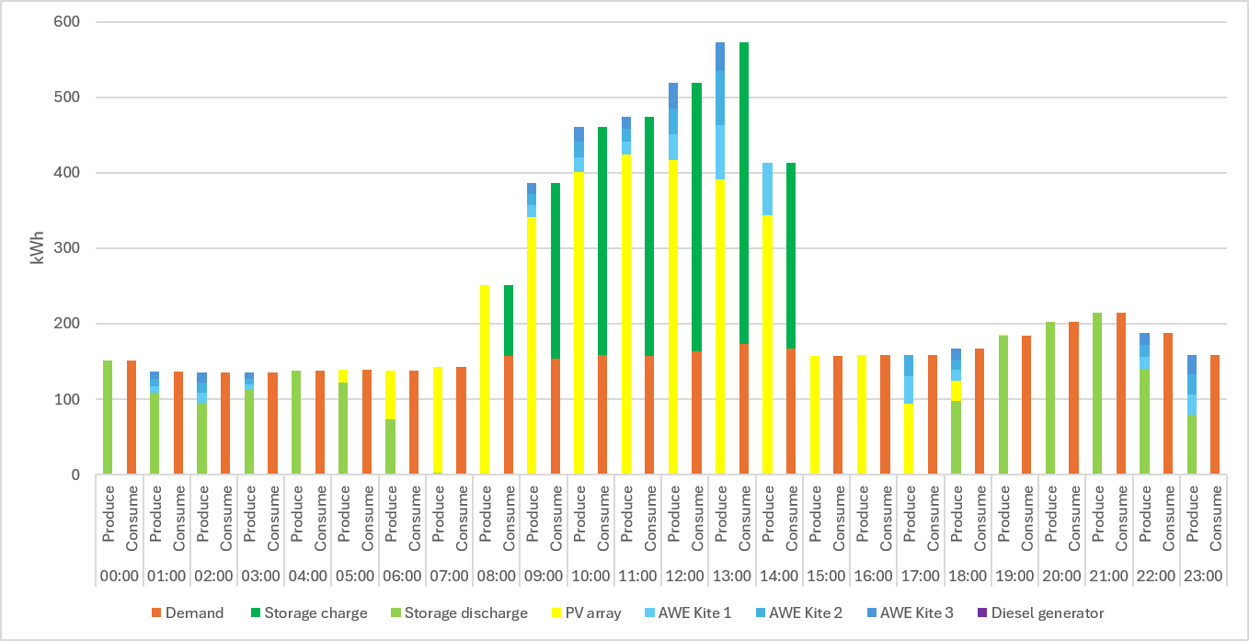
Fig. 10 Summer characteristic day - July 12th
If the PV array and AWE kites were instead allowed to operate at their maximum available power based on the 2023 weather data for Errikousa, the total annual electricity generation could reach up to 2.66 GWh. Furthermore, the limited operation of the backup diesel generator results in an estimated reduction in CO₂ emissions of 648.53 t CO₂/a.
- Conclusion and future steps
A few new concepts for the production of electricity on a selected remote Greek island with a population of less than 500 inhabitants has been developed for the island of Errikousa in the Ionian archipelago, using only renewable energy sources (RES).
The electricity demand coverage needs on this island are so far covered by the use of conventional fuels with the operation of diesel engines. To meet the island's urgent energy needs without using polluting fuels, the authors explored a new system based mainly on the island's solar and wind potential. The authors also evaluated energy storage solutions to support that system.
In this study, several energy concepts were developed based on the electricity demand and weather data for Errikousa from 2023. Through simulations conducted using TOP-Energy, the renewable energy sources in all proposed concepts were found to be capable of sufficiently covering the island’s electricity demand, with limited reliance on the backup diesel generators. The resulting reduction in diesel generator operation could substantially reduce CO₂ emissions compared with the existing energy system.
However, this study remains primarily theoretical and was conducted within the scope of an undergraduate thesis. The proposed energy concepts primarily focus on replacing fossil fuel-based electricity generation with renewable energy sources to the greatest extent possible, while economic optimization and the practical feasibility of constructing and operating the proposed systems at the actual site were not considered in detail. For a more comprehensive and realistic energy plan, factors such as investment and operating costs, available land and infrastructure, system installation and maintenance, grid integration, and long-term energy demand should be incorporated into the planning and optimization process.
Furthermore, the energy concepts were designed to fully cover the current electricity demand of the island. However, the calculated annual renewable electricity generation substantially exceeds the current annual demand. This indicates that the proposed renewable energy systems may have sufficient generation potential to support additional future electricity demands on Errikousa. Potential applications could include seawater desalination and the electrification of mobility, such as electric vehicles. Further studies should therefore investigate how the excess renewable generation could be utilized to support future energy-intensive applications while maintaining a technically and economically viable energy system.
References:
Design of Off-Grid Systems with Sunny Island 4.4M / 6.0H / 8.0H Devices. [online] SMA 2026 Solar Technology AG Available at: https://files.sma.de/downloads/OffGrid-System-PL-en-27.pdf [Accessed 14 July 2026]
Interconnection of Cyclades Phase D Santorini-Folegandros-Milos-Serifos. [online] IPTO 2020 Available at: https://www.admie.gr/en/node/113968 [Accessed 22 Apr. 2023].
Jinko Solar Co., Ltd. (2024). Tiger Neo 66HL4M-BDV 625–650 Watt photovoltaic module datasheet. Available at: https://jinkosolar.eu/ [Accessed 17. July 2026].
Kaldellis J. K., Zafirakis D., 2007, Present Situation and Future Prospects of Electricity Generation in Aegean Archipelago Islands, Energy Policy Journal, Vol.35 (9), pp.4623-4639.
NASA ArcGIS Web Application. [online] Nasa.gov. 2018 Available at: https://power.larc.nasa.gov/data-access-viewer/ [Accessed 28 March 2026].
Publication of NII Daily Energy Planning Data. [online] HEDNO 2022. Available at: https://deddie.gr/en/ [Accessed 29 March 2026].
Public Power Coorporation (PPC), 2020, Detailed Map of the Stations, available at: https://www.dei.gr/ [Accessed January 2021].
Ranneberg, M., Wölfle, D., Bormann, A., Rohde, P., Breipohl, F., Bastigkeit, I. (2018). Fast Power Curve and Yield Estimation of Pumping Airborne Wind Energy Systems. In: Schmehl, R. (eds) Airborne Wind Energy. Green Energy and Technology. Springer, Singapore. https://doi.org/10.1007/978-981-10-1947-0_25
Solargis 2026 Solar resource map © 2021 Solargis. Available at: https://solargis.com
Solar Atlas 2026 Solar radiation data [online]. Available at: https://globalsolaratlas.info/ [Accessed 17 August 2026]
Wind Atlas 2026 Wind speed and power data [online]. Available at: https://globalwindatlas.info/en/ [Accessed 17 August 2026]

