TESTING AND FINITE ELEMENT ANALYSIS OF A HIGH LEVEL LEAFSPRING SURROGATE /DEMONSTRATOR COMPONENT

Pascal Albrecht¹, Mike Wienand², Juergen Becher³ and Christos Derdas^{4*}

¹TCS Composites AT Europe, Henkel AG & Co KGaA Standort Heidelberg, Henkel-Teroson-Str. 57
D 69123 Heidelberg Germany
Email: pascal.albrecht@henkel.com, Web Page: http://www.composite-lab.com/en.html
²Process Engineering A&S, Henkel AG & Co KGaA Standort Heidelberg, Henkel-Teroson-Str. 57
D 69123 Heidelberg Germany
Email: mike.wienand@henkel.com, Web Page: http://www.composite-lab.com/en.html
³Global Engineering Center,AT-PD, Henkel AG & Co KGaA Standort Munich, Gutenbergstrasse 3, 85748 Garching, Germany
Email: juergen.becher@henkel.com, Web Page: http://www.composite-lab.com/en.html
⁴Global Engineering Center,AT-PD, Henkel AG & Co KGaA Standort Munich, Gutenbergstrasse 3, 85748 Garching, Germany
Email: christos.derdas@henkel.com, Web Page: http://www.composite-lab.com/en.html
*Corresponding Authoer

Keywords: Composite leafspring, Fatigue, Polyurethane, FE Analysis, Stiffness Degradation

Abstract
Composite materials are finding their way in demanding automotive chassis applications like the suspension in an increasing manner. The present paper discusses the testing and fatigue testing results of a thick, large scale composite leafspring demonstrator, manufactured using HP-RTM with Henkel’s AG & Co. KGaA polyurethane resins specially designed for HP-RTM and suspension components. Flexural fatigue tests have been conducted at an R of 0.1 and with a Frequency of 1.5Hz Apart from failure modes that appeared, the S-N behavior, and the stiffness degradation behavior of the specimens is discussed, providing fitting coefficients so that stiffness degradation can be associated with the stress amplitude. The work in this paper aims to act as the common ground between real life applications and academic research work in the field of thick composite components aimed towards automotive applications. Finally, some FE modelling aspects are addressed.

1. Introduction

Composite materials are finding their way in demanding automotive chassis applications like the suspension in an increasing manner. Especially leafsprings have found their way in mass produced vehicles like the Volvo XC90, S90 and V90 models and their application is bound to increase in other platforms/vehicles. Due to their nature, composites represent excellent candidates for such components, since they permit establishment of load paths and subsequently lightweighting of the components along with benefits associated with increased damping. In order for composites to achieve such a place in the modern and future automobiles, the resin chemical technology had to develop innovative resins which would demonstrate increased fatigue resistance and permit at the same time very fast manufacturing times. One such resin technology is polyurethane resins. Towards this goal, Henkel Ag & Co KGaA has developed the Loctite MAX 2 resin, which is currently in use in the manufacturing of the mentioned Volvo XC90, S90 and V90 leafsprings[1].

Academically, a lot of work has been done in fatigue behavior of composites due to the early adoption of composites as a material of choice for both aerospace and wind energy applications. Prominent researchers have completed a lot of work on fatigue life prediction of Glass fiber reinforced composites with excellent results, like the work conducted by [2] where stiffness degradation versus remaining life was studied for angle ply GFRP tension-tension fatigue specimens. Historically, several damage mechanisms have been identified as present in fatigue [3-4]. Stiffness degradation is one of the indicators of identifying fatigue damage and [5] has proposed a system including piezoelectric sensors. In terms of stiffness degradation, fatigue allowables have been proposed based on the stiffness degradation measurements [6]. Generally, for fatigue, an authoritative source for the subject is [7].

Flexural fatigue and its simulation has found additionally a lot of attention as a research area. Indicatively, [8] and [9] are mentioned. Especially in [9], an improved formulation for the bending stiffness is proposed by the authors, covering limitations of [10].

The present paper aims to demonstrate the fatigue testing and stiffness degradation work that has taken place in especially thick composite components, -close to application level- in terms of thickness and size and will act as the basis of a series of further research on such behavior, aiming to provide a common ground of research between small scale specimens and real-life application components. Finally, some FE modelling aspects of the static tests are addressed

2. Materials and Methods

The present paper deals with the fatigue testing of a special leafspring demonstrator specimen. 13 such specimens were manufactured in Henkel’s “Composite Lab” prototyping facility located in Heidelberg, Germany and tested in the Global Engineering Center of Henkel in Munich Germany. The leafspring demonstrators tested were manufactured using Henkel’s Loctite MAX 2 polyurethane high fracture toughness resin -already commercialized for mass production of leafsprings for the automotive industry- as matrix. The reinforcement comprised of 30 layers of Saertex U-E-PB-1226 UD fabric, which already incorporates the binder Henkel FRP 2000. The preforms were injected with an injection speed of 40 g/sec. Injection time was around 20 seconds. Volume fraction of leafsprings was calculated to be 55%. Figure 1 shows the High-Pressure RTM
mold available in Heidelberg for such prototyping by customer and for internal test programs for engineering capability development. Leafspring demonstrators have a length of 800 mm, a width of 80 mm and a thickness of 25 mm.

Tests were conducted -as mentioned above- in Henkel’s Global Engineering Center in the specialized test bench available. A 100KN Instron load cell was used, along with one of the hydraulic actuators available for testing in the facility. The jig shown in Figure 1 was custom manufactured to cover permit variable span lengths. Span length chosen was 600 mm so as to minimize through the thickness shear load. Measurements from stiffness were taken every 100 cycles, up to 1000 cycles, every 1000 cycles up to 10000 cycles and then every 10000 cycles

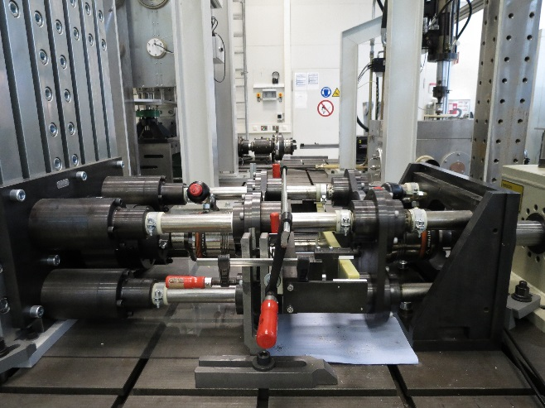 | 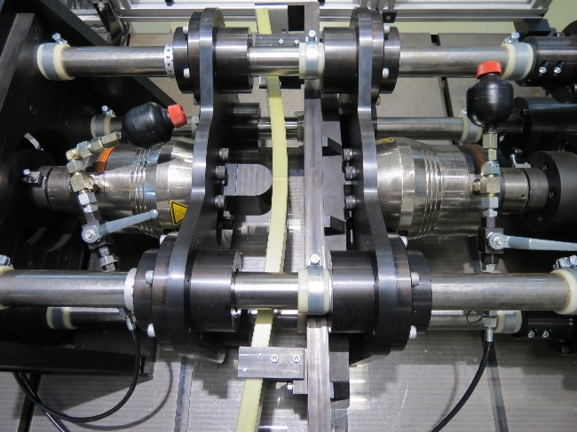
(a) | (b)

Figure 1: Testing jig with leafspring demonstrator specimen

3. Results & Discussion

3.1. S-N curve

Initial static testing of three specimens revealed an average static strength of 640.8 MPa, with a standard deviation of 48.93 MPa, an ultimate flexural strain of 1.77% and a modulus of 36156 MPa with a standard deviation of 1146.6 MPa

The ten specimens were tested at R=0.1 and at a frequency of 1.5 Hz, at varying mean and amplitude levels so as to generate the S-N curve of the specimen.

Table 1. Datapoints tested

Specimen No | Minimum Stress (MPa) | Maximum Stress  (MPa) | Mean stress  (MPa) | Amplitude  (MPa) | Ratio of Ultimate to Maximum stress | Cycles  (-)
PK1 | 52.96 | 529.60 | 291.28 | 238.32 | 0.83 | 27999
PK2 | 53.03 | 530.25 | 291.64 | 238.61 | 0.83 | 98496
PK3 | 49.10 | 491.01 | 270.05 | 220.95 | 0.77 | 212215
PK4 | 49.04 | 491.01 | 270.05 | 220.95 | 0.77 | 141653
PK5 | 46.70 | 466.97 | 256.84 | 210.14 | 0.73 | 419346
PK6 | 46.70 | 466.97 | 256.84 | 210.14 | 0.73 | 250710
PK7 | 41.92 | 419.24 | 230.58 | 188.66 | 0.65 | 490740
PK8 | 37.91 | 379.10 | 208.50 | 170.59 | 0.59 | 1400359
PK9 | 37.91 | 379.10 | 208.50 | 170.59 | 0.59 | 1034316
PK10 | 34.12 | 341.19 | 187.65 | 153.53 | 0.53 | 2000014

The corresponding S-N curve is presented in Figure 2

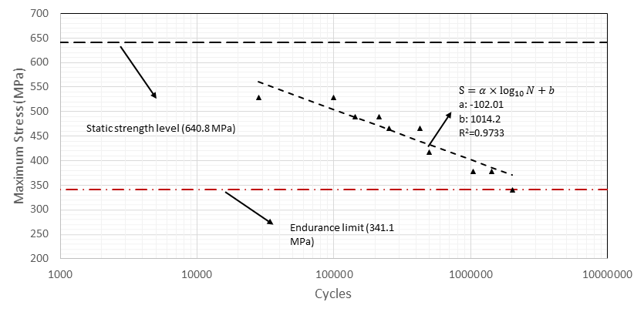

Figure 2: S-N diagram for the tested specimens

3.2. Failure modes of specimens

Figures 2& 3 demonstrate the failure modes encountered at different load levels during the campaign, namely at maximum stress of 530.25 MPa (PK1), 491.01 MPa (PK4), 466.97 MPa(PK6) and 379.10 MPa (PK9)

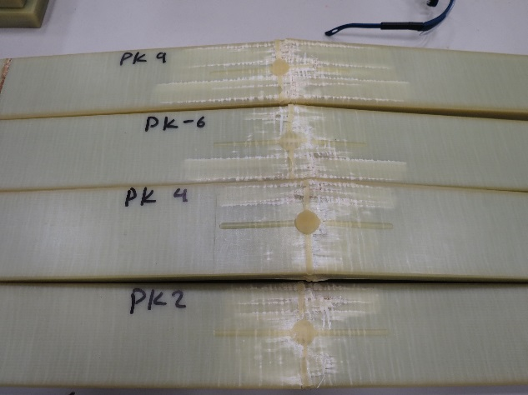 | 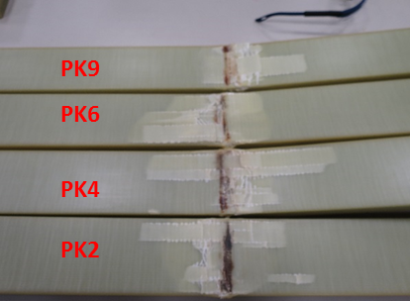
(a) | (b)

Figure 3:Failure at tensile and compressive side (b)of specimens

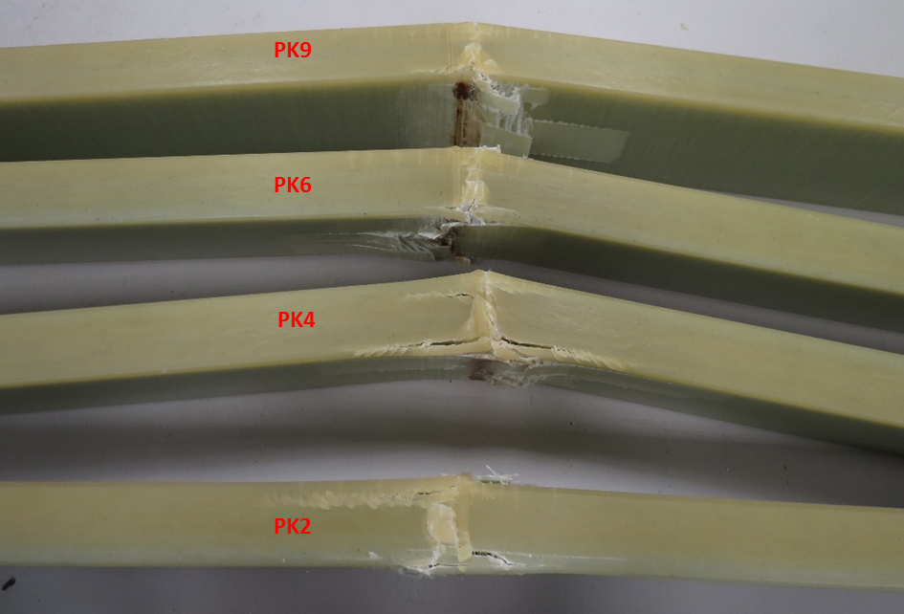

Figure 4: Side view of failed specimens

During testing, damage has begun to appear in the compression side, and then fracture occurred with damage demonstrating on both surfaces of the beam. In terms of tensile damage, the reader can see, that the damage extent is higher the longer the test duration is. An interesting finding can be discerned in the side of the beams (Figure 4), where some through the thickness cracks appear in the tensile side, which do not seem to propagate significantly. Again, as the test duration (specimen life increases, the extent and density of those cracks, increases also). These cracks will be further investigated.

3.3. Damage modelling

The stiffness of the specimens was being monitored and the data was extracted so as to permit the actual definition of stiffness degradation functions. We will define stiffness degradation by employing Equation 1:
$$D=\frac{E}{E_{0}}$$ | (1)
Whereas E is the modulus as extracted from the dynamic stiffness measurements of the test machine at a cycle N and E₀ is the initial modulus. At the same cycle, the used life percentage N_{used}, is defined by Equation 2:
$$N_{used}=\frac{N}{Nf}$$ | (2)
, where N is the cycle number and N_{f} is the number of cycles to failure (life of the specimen). As expected, when N_{used}, reaches one, the specimen has failed. The stiffness degradation D is plotted against N_{used} for all seven specimens that have failed before reaching 2000000 cycles and with a life of above 100000. Figure 2a demonstrates the stiffness reduction at a stress amplitude of 220.95 MPa, Figure 2b demonstrates the same at 210.14 MPa, figure 2c demonstrates the same at 188.66 MPa and figure 2d demonstrates the same at 170.59 MPa.
As it can be seen in Figure 2a, specimen PK4 has demonstrated a significantly out of family behavior and as such has not been included in the conducted fitting process. Fitting has been performed using Equation 3, where A and t are the fitting parameters

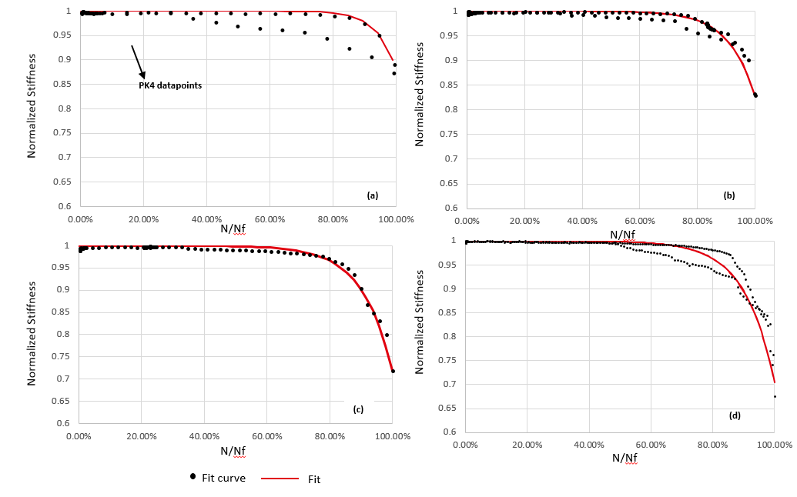

Figure 5: Normalized stiffness vs remaining life % at different stress amplitudes and mean values

$$D=1-A×e^{\frac{1-N/Nf}{t}}$$ | (1)
.
Table 2, below, show the fitting results

Table 2: Fitting parameters and correlation coefficients

Stress Amplitude | A | t | R²
220.95 | 0.1199 | -0.0597 | 0.9978
210.14 | 0.1712 | -0.0919 | 0.9764
188.66 | 0.2858 | -0.0943 | 0.9946
170.59 | 0.2954 | -0.0963 | 0.9652

As the interested reader can see, there seems to be a good correlation between the fit and the stiffness behavior. This permits the actual definition of the stiffness degradation in the specimens as a function of stress amplitude.

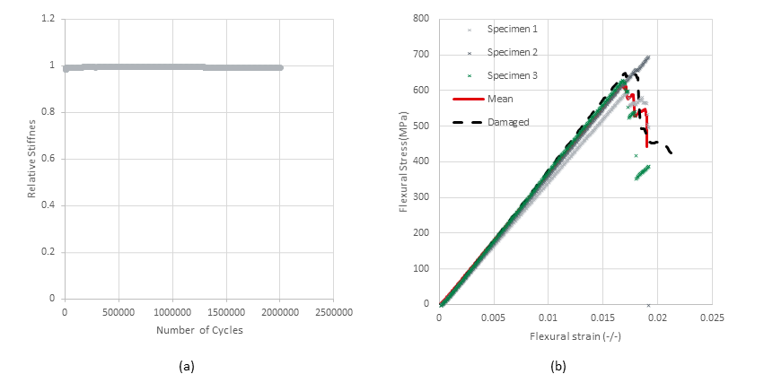

Figure 6:
Figure 6(a) represents the stiffness progress over number of cycles for the specimen that reached 2000000 cycles (PK10). As it can be seen, no significant drop in stiffness has been observed. Figure 6(b) presents the 3 statics tests along with their mean and the stress strain curve of the fatigued specimen.

3.4 FE Analysis

Parallel to the static and fatigue testing work conducted for the paper, an FE model was developed in order to initially assess the static behavior of the leafspring, with the scope of that being used for implementing damage behavior . The model has been developed using LS-DYNA 3D /Implicit. The model consists of quarter symmetry to enhance the speed of solution and utilizes *MAT_58 and *MAT_59 with thickshells and solid elements. The results for MAT_58 and Mat_59 in terms of damage variables are presented in Figures 7(a) and (b) accordingly.
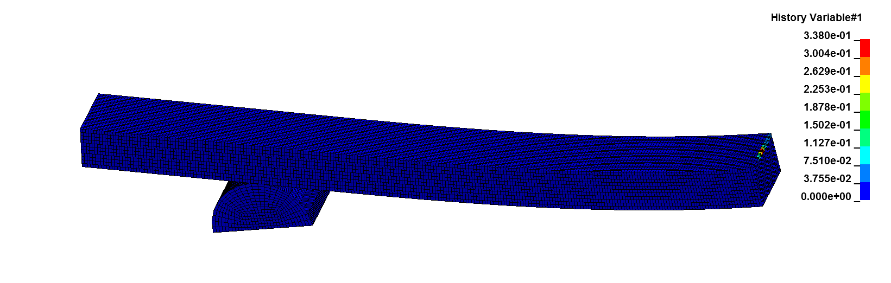
(a)
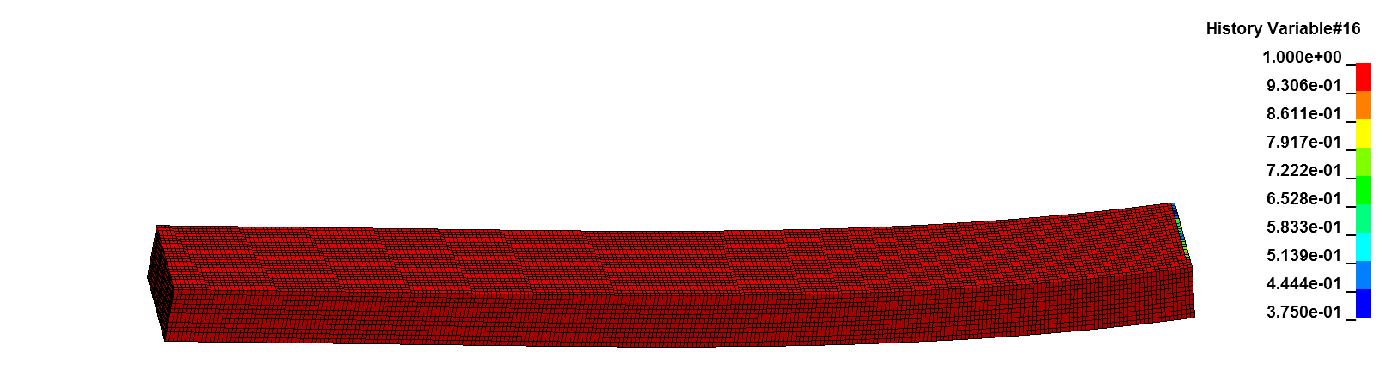
(b)

Figure 7: Damage variable for *MAT_58 model(a) & Failure variable for *MAT_59 FE model

It should be clarified here that *MAT_58 demonstrates damage developed (that meaning that the material of the element is intact when the value of the variable is 0, while *MAT_59, visualizes failure (that meaning that the material is intact when the variable is equal to 1).
Additionally, the forces at the point of failure are 35220 N for *MAT_59 and 34872 N for *MAT_58. It should be noted that the mean failure force for the three stratic tests has been 36155 N, signifying a difference of 2.5 % for MAT_59 and 3.5 for *MAT_58. Calculated displacement was again within the expected experimental vs finite element analysis acceptability ranges. The accuracies achieved between experiment and anaylsis cannot be used to determine the optimal modelling method for composite leafsprings, nonetheless since we can expect that failure occurs essentially in plane. Further testing is required at significantly lower span lengths in order to actually determine which material model and element type can and should be used for such applications

4. Conclusions

The testing and fatigue modelling efforts for a very thick fatigues specimen has been described in this paper. Various aspects of fatigue have been addressed, these being the S-N curve of the specimen, the stiffness degradation, which has been found to be dependent of stress amplitude in a monotonic way and of course the evidence pointing out to the fact the defined 2000000 cycles represent an endurance limit for testing (since no stiffness degradation during fatigue but also no drop of load during static testing). Additionally

References

[1] https://www.henkel.com/press-and-media/press-releases-and-kits/2017-03-14-henkel-partnership-with-benteler-sgl-pays-off-with-composite-leaf-springs-on-more-volvo-models/748194
[2] A. Vahid Movahedi-Rad, Thomas Keller, Anastasios P. Vassilopoulos. Fatigue damage in angle-ply GFRP laminates under tension-tension fatigue, International Journal of Fatigue,109:60-69, 2018
[3] B. Harris. Fatigue in composites. Science and Technology of the fatigue response of fibre-Reinforced Plastics, Woodhead Publishing (2003)
[4] K.L. Reifsnider, A. Talug.Analysis of fatigue damage in composite laminates. Int J Fatigue,2(1), pp. 3-11, 1980
[5] T. Peng, Y. Liu, A. Saxena, K. Goebel.In-situ fatigue life prognosis for composite laminates based on stiffness degradation. Compos Struct,132, pp.155-165, 2015
[6] T.P. Philippidis, A.P. Vassilopoulos: Fatigue design allowables for GRP laminates based on stiffness degradation measurements, Composites Science and Technology,60(15):2819-2828, 2018
[7] Vassilopoulos, Anastasios P. (2010). Fatigue Life Prediction of Composites and Composite Structures. Woodhead Publishing
[8] W Van Paepegem, J Degrieck. Simulating damage and permanent strain in composites under in-plane fatigue loading. Computers & structures,83 (23-24):1930-1942, 2005
[9] W Van Paepegem, R Dechaene, J Degrieck. Nonlinear correction to the bending stiffness of a damaged composite beam. Composite structures 67 (3), 359-364, 2005
[10] F.L.Matthews, N.C.R.Buskell, J.M.Hodgkinson, J.Morton(Eds.). Fatigue damage modelling of composite materials from bending tests, Proceedings of the Sixth International Conference on Composite Materials (ICCM-VI) & Second European Conference on Composite Materials (ECCM-II), 20–24 July 1987

