EuroSun2026
Design and Thermal Performance Evaluation of an Unglazed PVT Module with a Detachable Heat Recovery Unit

Hong-Jin Joo 1(corresponding author), Young-Sub An 1, Min-Hwi Kim 1, Deuk-Won Kim 1, Wang-Je Lee 1
Affiliation(s) Korea Institute of Energy Research
Email(s) joo@kier.re.kr
Summary
This study examines the thermal performance of a retrofit-compatible photovoltaic-thermal (PVT) heat recovery module that can be attached directly to commercially available photovoltaic modules. Unlike conventional integrated PVT systems, the proposed design separates the heat recovery unit from the PV module. The intention was not only to recover useful thermal energy from existing PV installations, but also to make the system easier to fabricate, install, and maintain.
To evaluate the concept, four prototype configurations were prepared and tested under outdoor steady-state conditions following ISO 9806-based procedures and the Korean PVT standard KS B 8297:2025. The experiments were designed to identify how PV module integration and rear-side insulation affect thermal performance. The best-performing prototype showed a peak thermal efficiency of 56.68% and an average thermal output of 163.6 W/m², meeting the Korean performance requirement for unglazed PVT modules. The results also made it clear that the quality of rear insulation and the thermal contact condition at the interface play an important role in overall heat recovery.
Overall, the study shows that a detachable retrofit-type heat recovery unit can offer a realistic route for converting conventional PV modules into PVT systems without relying on fully integrated manufacturing. This approach may be especially relevant for applications where existing PV assets are already available and additional thermal use is being considered as a way to improve total solar energy utilization.
Keywords: Unglazed Photovoltaic-Thermal (PVT), Retrofit application, Detachable heat recovery unit, Standardized testing, modular design
Field of application for the findings: The findings of this study are relevant to the design and deployment of retrofit-compatible PVT systems for existing photovoltaic installations. They also provide experimental evidence that can support the development of modular PVT technologies with improved manufacturability, installation flexibility, and compliance with standardized thermal performance requirements.
Addressed audience: researchers, PVT manufacturers, system designers, testing and certification organizations
- Introduction
PVT systems offer a practical way to improve the overall use of solar energy by producing electricity and heat from the same installation area. This is particularly relevant where available space is limited. In conventional PV modules, only part of the incoming solar radiation is converted into electricity, while a considerable portion remains as heat. That heat raises the operating temperature of the module and can reduce electrical performance. For this reason, recovering thermal energy from PV systems has long been regarded as a meaningful approach to increasing energy yield per unit area.
At the same time, the wider use of PVT technology is still influenced by practical constraints. Many existing systems are based on integrated designs in which the PV module and thermal absorber are permanently combined. These configurations can provide good thermal performance, but they also tend to involve more complex manufacturing and less flexibility in maintenance or replacement. This issue becomes more important when retrofit applications are considered, because many PV systems are already in operation and may be upgraded more realistically through the addition of a thermal recovery function than through complete replacement. In addition, recent standardization efforts, including KS B 8297:2025 in Korea, have increased the need for performance verification under clearly defined test conditions.
In this context, the present study investigates an unglazed PVT module equipped with a detachable heat recovery unit designed for application to commercially available PV modules. The study does not focus only on collector design itself. It also considers whether a modular retrofit-oriented concept can provide acceptable thermal performance while remaining practical in terms of fabrication and field application. To examine this, prototype configurations were tested under outdoor steady-state conditions, with particular attention to the effects of module integration and rear-side insulation.
- Experimental Method and Test Conditions
A detachable heat recovery unit was developed for mounting on the rear side of commercially available PV modules, rather than being integrated during PV manufacturing. The experiments focused on unglazed PVT configurations with different module and insulation conditions. This was important because the study was concerned not only with the collector concept itself, but also with how the concept would work in a realistic retrofit setting.

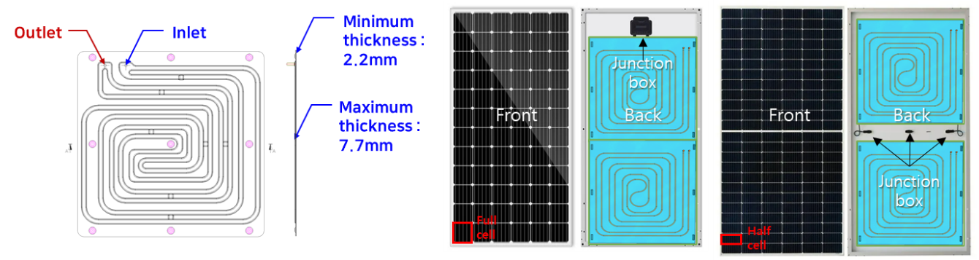
Fig. 1: Concept and application of the detachable heat recovery unit for unglazed retrofit PVT modules.
Four prototype configurations were included in the outdoor tests. One consisted only of the heat recovery unit and was used as a reference for the basic heat collection behavior. Another was combined with a glass-to-backsheet BIPV module. The remaining two used a standard glass-to-backsheet PV module, with the rear insulation material changed between them. This arrangement made it possible to examine how module integration and insulation quality influenced the thermal response of the system.

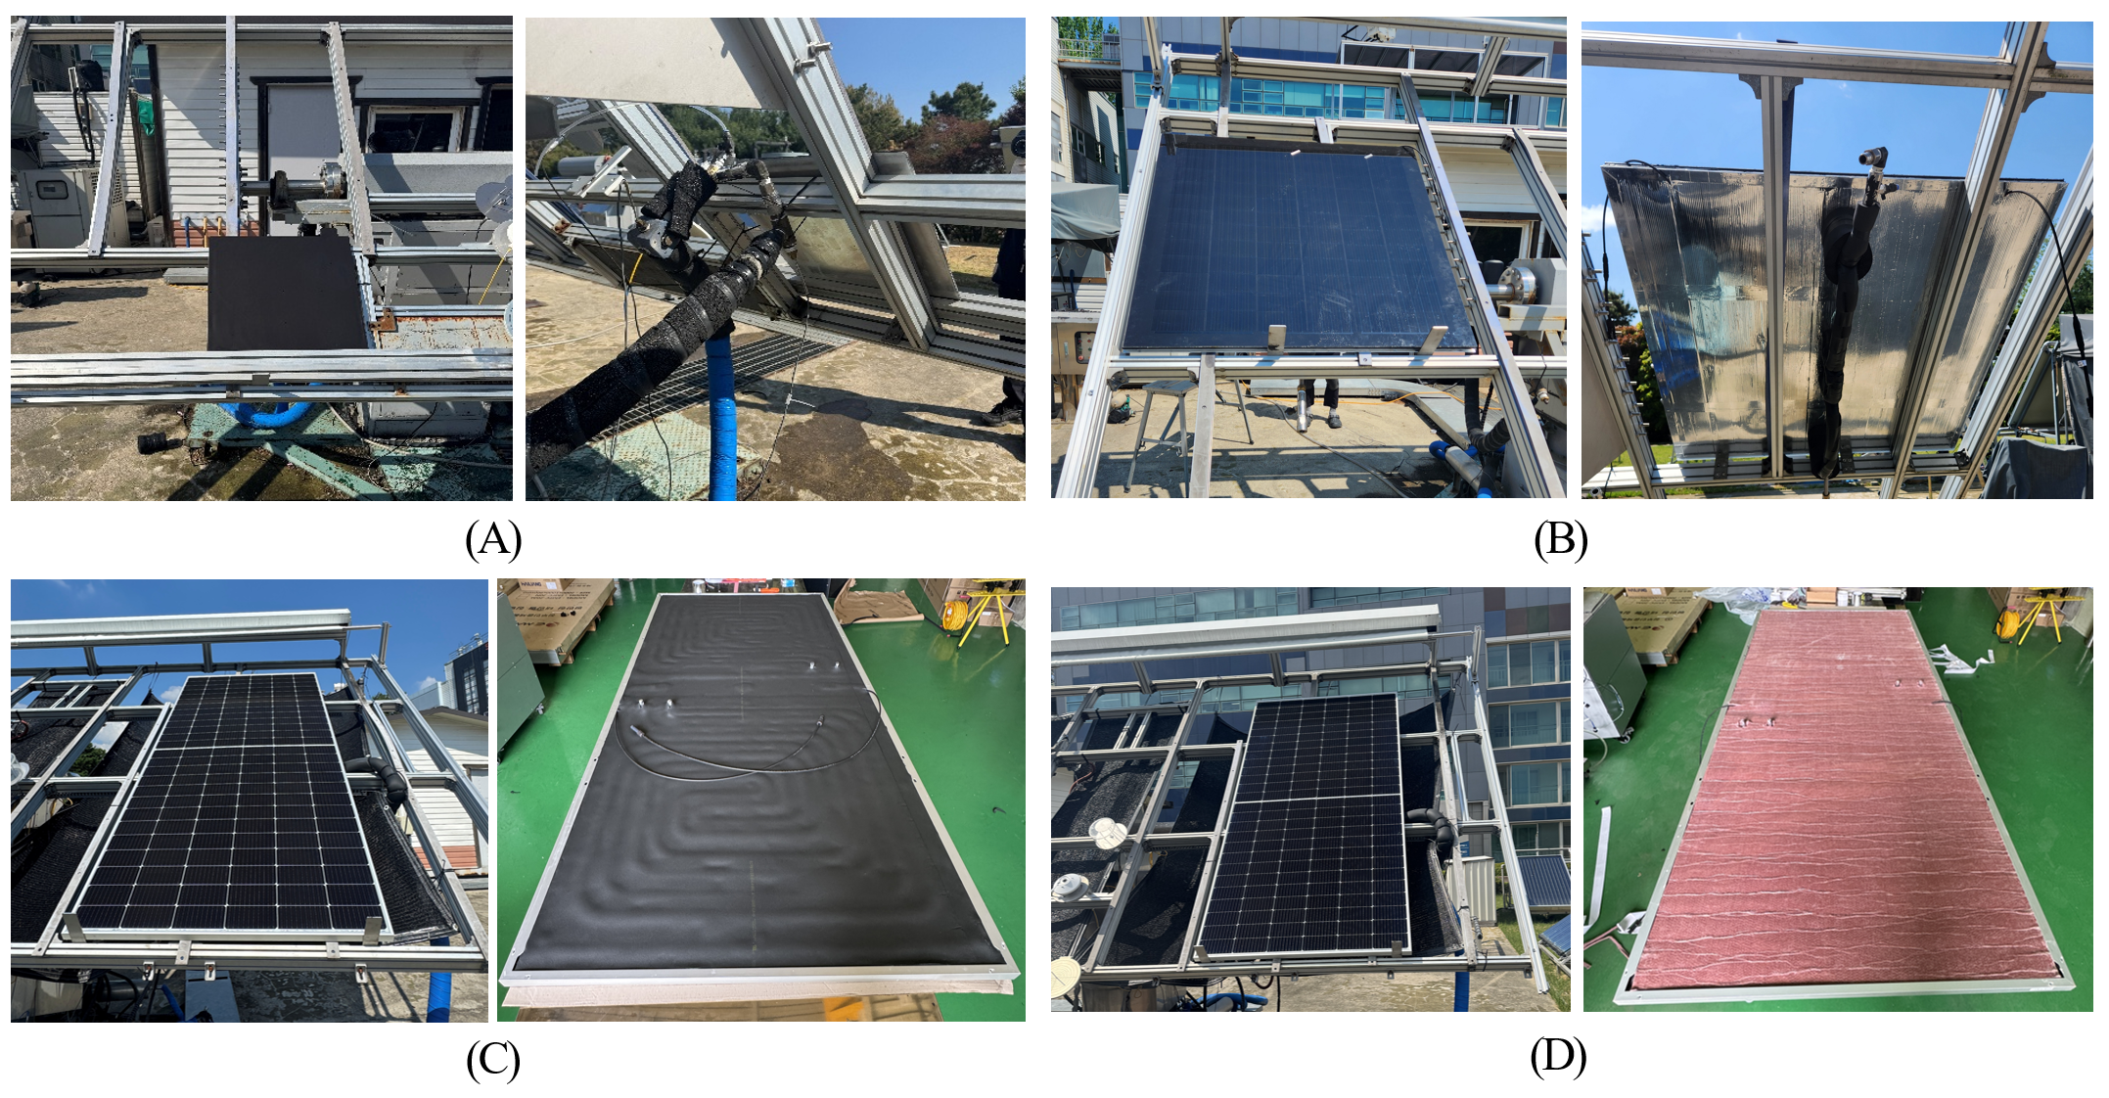
Fig. 2: Photographs of the four prototype configurations used for outdoor thermal performance testing: (A) standalone heat recovery unit, (B) glass-to-backsheet BIPV-coupled specimen, (C) glass-to-backsheet PV specimen with nitrile butadiene rubber foam insulation, and (D) glass-to-backsheet PV specimen with aerogel insulation.
Thermal performance was assessed under outdoor steady-state conditions following ISO 9806 procedures and the Korean PVT standard KS B 8297:2025. The tests were carried out at an accredited facility, and useful heat gain was determined over a range of inlet temperature conditions. Instantaneous thermal efficiency was calculated from the ratio of useful thermal output to incident solar irradiance on the collector area. The resulting efficiency curve was expressed in terms of reduced temperature difference so that the prototype configurations could be compared on the same basis.
- Results and Discussion
Fig. 3 shows clear differences in thermal efficiency among the four prototype configurations. Prototype A, which consisted only of the standalone heat recovery unit, exhibited the highest peak thermal efficiency of 89.38%. This reflects the inherent heat collection capability of the unit itself. After coupling with a PV module, the efficiency decreased, but prototype B, the BIPV-coupled configuration, still achieved a peak thermal efficiency of 60.2% and an average thermal output of 159.3 W/m².
Prototype C, which used a standard glass-to-backsheet PV module with NBR foam insulation, showed lower performance, with a peak thermal efficiency of 50.3% and an average thermal output of 98.1 W/m². In prototype D, where the rear insulation was changed to aerogel, the peak thermal efficiency increased to 56.68% and the average thermal output reached 163.6 W/m². Since prototypes C and D shared the same PV platform, the difference is mainly attributable to the rear-side insulation condition.
Overall, the detachable heat recovery concept appears technically viable for retrofit PVT applications. The results also highlight the importance of rear-side insulation and thermal contact in determining useful heat recovery.
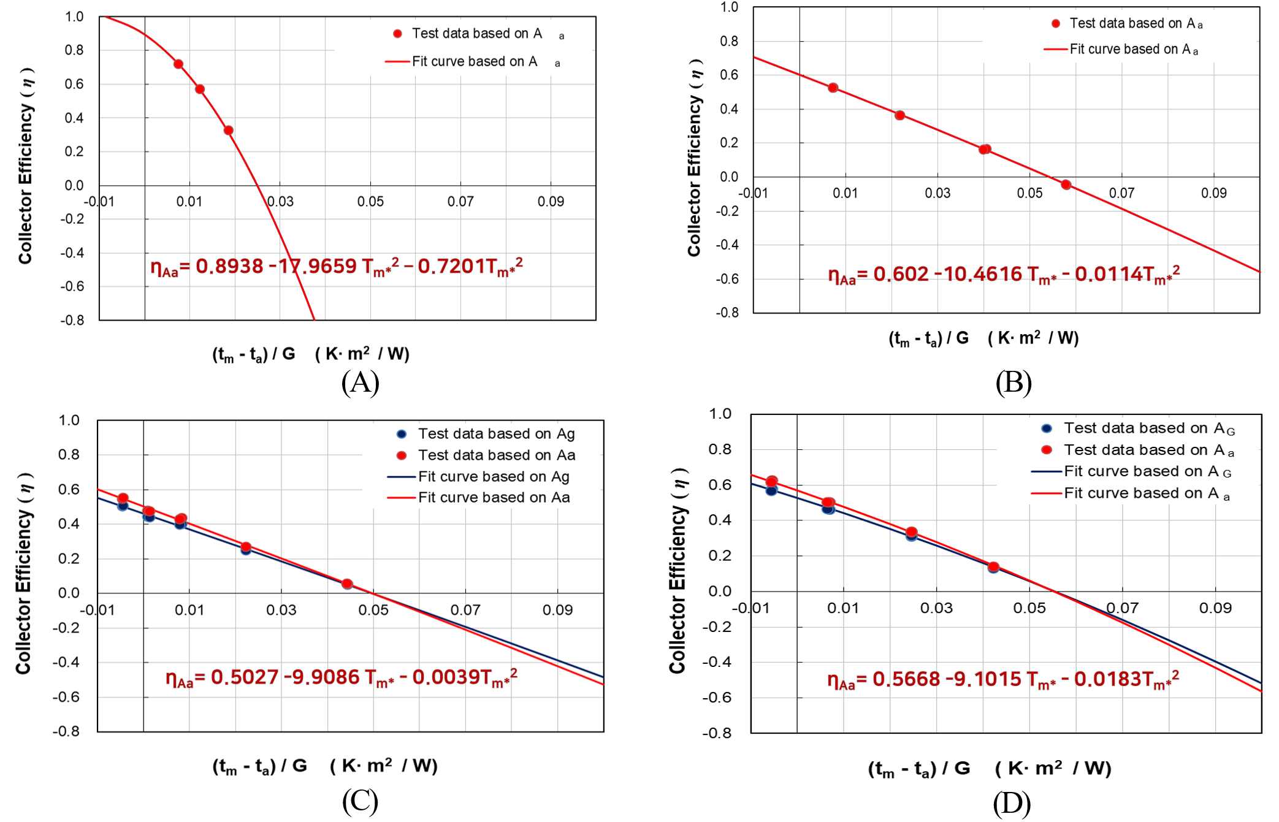
Fig. 3: Thermal efficiency curves of the four prototype configurations, showing the influence of module integration and rear-side insulation on the thermal behavior of the unglazed PVT module.

- Acknowledgements
This work was conducted under framework of the research and development program of the Korea Institute of Energy Research(C6-2403-74)
- References
Korean Agency for Technology and Standards (KATS), 2025. Crystalline Silicon Photovoltaic-Thermal (PVT) Modules (KS B 8297:2025), Korean Industrial Standards, Republic of Korea.
International Energy Agency (IEA), Renewables 2023: Analysis and Forecast to 2028, IEA, Paris, 2023. https://www.iea.org/reports/renewables-2023.
Joo, H.J., An, Y.S., Kim, M.H., Kong, M., 2023. Long-term performance evaluation of liquid based photovoltaic thermal (PVT) modules with overheating-prevention technique, Energy Conversion and Management 296, 117682.
European Solar Thermal Industry Federation (ESTIF), Solar Keymark: The main quality label for solar thermal products in Europe, 2024. https://solarkeymark.eu/ (accessed January 12, 2026).
D.-W. Kim, W. Lee, K.-h. Lee, Thermal Performance of Double-Glass Evacuated Tube Solar Collectors: Flow Rate Variation Under International Standard Testing Conditions, Energies 18 (2025) 5388. https://doi.org/10.3390/en18205388.
H.J. Joo, Y.S. An, M.H. Kim, M. Kong, Long-term performance evaluation of liquid-based photovoltaic thermal (PVT) modules with overheating-prevention technique, Energy Conversion and Management 296 (2023) 117682. https://doi.org/10.1016/j.enconman.2023.117682.
Solar Rating & Certification Corporation (ICC-SRCC), Solar Thermal Collector Certification and Ratings, 2024. https://solar-rating.org/ (accessed January 12, 2026).

