EuroSun2026
EVOLUTION OF HEAT PUMPS GEG-EMISSION USING DYNAMIC ELECTRICITY MIX, 2017-2025

Matthieu Chaigneau¹, Björn Nienborg^{1*} (corresponding author)
¹Fraunhofer Institute for Solar Energy Systems ISE, Heidenhofstraße 2, 79110 Freiburg, Germany
Email(s): matthieu.chaigneau@ise.fraunhofer.de, bjoern.nienborg@ise.fraunhofer.de
Summary
Heat pumps are recognized as a key technology for decarbonization. However, many studies assessing heat pump emissions rely on static emission factors or focus on only one or two years, which does not account for the variability in electricity sources. In countries like Germany, with an electricity mix supplied of carbon intensive fossil power plants on the one hand and a steeply increasing share of renewables on the other hand, this may lead to a misjudgment of the actual emissions. The objective of this study is therefore to assess the evolution of heat pump emissions considering the German electricity mix of the past 8 years and the growing volatility driven by the deployment of wind and solar energy. Combining calculated hourly emission factors for the years 2017 to 2025 and results from simulations of a heat pump system and a gas system, emission using dynamic emission factors or yearly average will be compared to each other. Using these results and forecasted electricity mix for Germany, a trend for the future years will be discussed.
Keywords: heat pump, CO2eq-emission, electricity mix
Field of application for the findings: Sustainable Heating and Cooling Systems for Buildings: Heat Pump Systems for Buildings
Addressed audience:

- Introduction
The building sector in Germany caused over 100 million tons of CO_{2eq} in 2022 and 2023, making it the sector with the fourth highest emissions (Umweltbundesamt, 2025). Heat pumps (HP) are seen as the crucial decarbonization technology within the building sector (IEA - International Energy Agency, 2022).
Although many studies evaluate emissions from HP operation in European countries (Litjens et al., 2018; Gajewski et al., 2019; Buday and Buday-Bódi, 2023) using a static, annual electricity emission factor (EF), this approach does not capture the temporal variability in emissions driven by fluctuations in the electricity mix, particularly those due to renewable generation (Gandhi, 2026).
In a recent German study for the year 2024 (Chaigneau et al., 2025), the authors reported that heat pump emissions calculated using dynamic quarter-hourly emission factors were 14–18% higher than those derived from a static method, yet still 58–65% lower than emissions from gas boiler variants. However, this study covered only a single year, which does not allow assessment of how the dynamic–static discrepancy evolves as the share of renewables in the electricity mix grows.
In the present article, quarter-hourly EFs for the years 2017 to 2025 in Germany are calculated and combined with heating system simulations — covering an air/water heat pump with and without rooftop PV, and a gas boiler reference — to quantify how heat pump emissions and the discrepancy between static and dynamic calculation approaches have evolved over time. The correlation between this discrepancy and the growing share of renewable electricity is analyzed, and implications for future trends are discussed.

- Methodology

The overall methodology follows the approach introduced in (Chaigneau et al., 2024, 2025), combining calculated historical quarter-hourly emission factors for the German electricity mix with building and heating system simulations performed in Polysun. The general workflow is illustrated in Figure 1 and will be described in following subchapters.

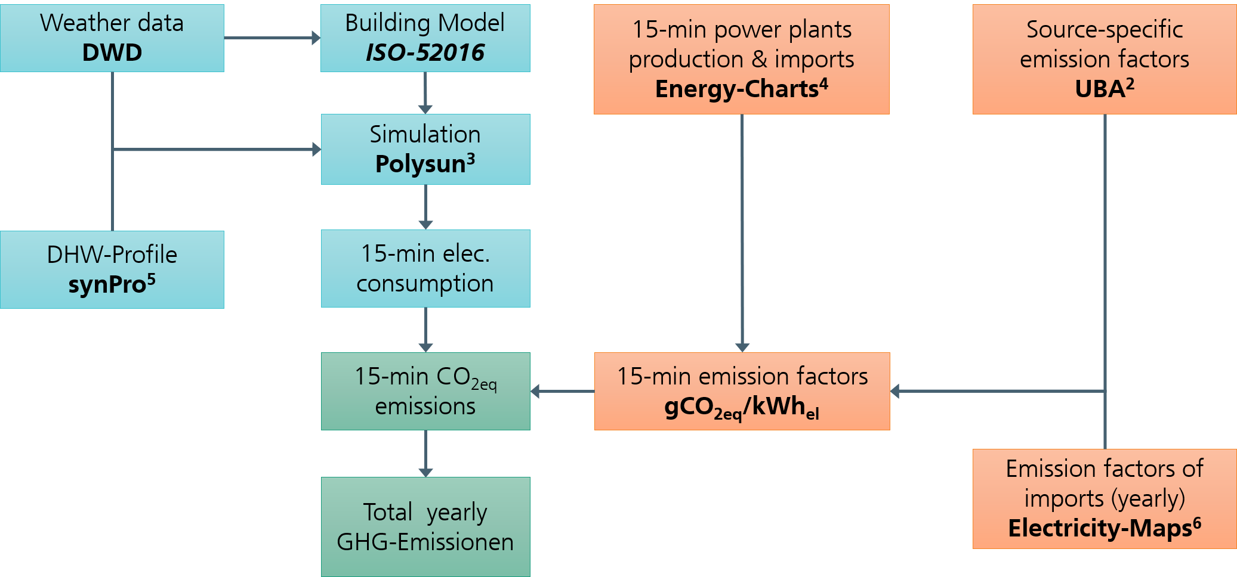
Figure 1: Flowchart of the calculation methodology

2.1. Dynamic Emission factors
The right branch of Figure 1 describes the calculation of dynamic electricity emission factors (EF). Quarter-hourly energy production and import/export data are retrieved from Energy-Charts (Gandhi, 2026) and combined with source-specific emission factors published by the German Environment Agency (Lauf et al., 2025). The resulting EFs are corrected to account for electricity imports and exports — using a yearly constant country-specific EF as a simplification — as well as for pumped hydro storage and network losses. A detailed description of the import correction, pumped hydro storage methodology, and network loss assumptions is provided in (Günther et al., 2025).

2.2. Building and System Simulation

The left branch of Figure 1 covers the simulation workflow. Historical weather data (temperature, humidity, wind speed, and solar radiation) from the German Weather Service (DWD) station in Potsdam — the standard climate reference for Germany — are used as input for each of the years 2017 to 2025. Based on this data, an hourly heat demand profile for a Single-Family House (SFH) is calculated following the ISO 52016 norm. The building geometry represents an existing SFH (Chaigneau, 2025), characterized by a specific nominal heat load of 71 W/m². The domestic hot water (DHW) demand profile is generated using the synPro tool (Fischer et al., 2016) and remains consistent across all years
For each year, three heating systems are simulated in Polysun: a gas boiler system and a monoenergetic air/water heat pump (AWHP) system, the latter both with and without rooftop photovoltaic (PV) system rated at 10 kWp. A simplified block diagram of both systems is shown in Figure 2. The AWHP systems are dimensioned in accordance with German guidelines published as VDI 4645. To optimize the utilization of PV electricity, a control strategy is applied where surplus PV power is used to overheat the DHW tank to store energy. Similarly, during the heating season, surplus electricity is directed to the space-heating buffer tank for thermal storage. The simulations yield 15-minute resolved electricity consumption profiles (and gas consumption for the gas system), which serve as the basis for the emission calculations.
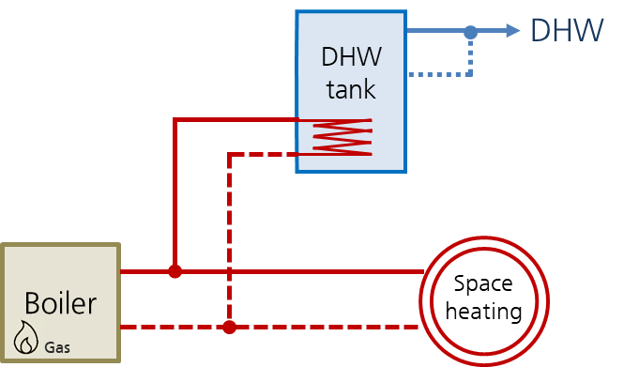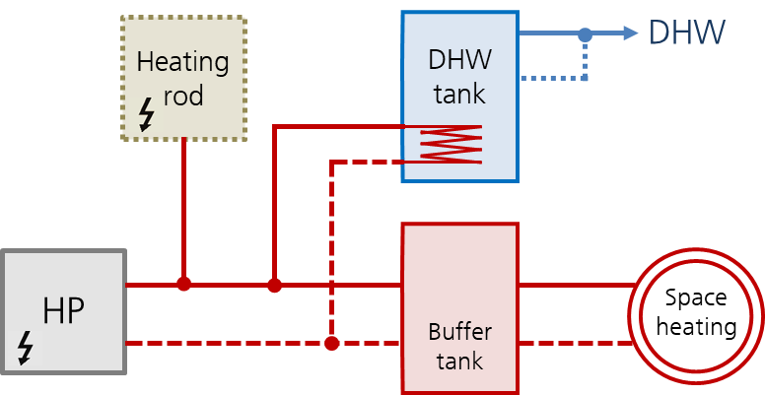
Figure 2: Simplified Block Diagram of the gas boiler system (left) and the heat pump system (right).

2.3 Data evaluation
Combining the 15-minute electricity consumption profiles from the simulations with the quarter-hourly dynamic EFs, CO_{2eq} emissions are calculated for each time step of each year, and subsequently aggregated to annual values. For the gas system, a constant emission factor of 252 gCO_{2eq}/kWh_{th} is applied, accounting for the full supply chain including processing and transport, as reported by the UBA (Lauf et al., 2025).
To assess the discrepancy between static and dynamic calculation, results obtained using the dynamic methodology are systematically compared against those calculated with a static emission factor, defined as the annual load-weighted average EF of the electricity mix. The relative difference by which the dynamic calculation exceeds the static result is referred to hereafter as the dynamic deviation. This comparison is performed for all simulated years, allowing both its quantification and the analysis of its evolution over time as the share of volatile renewable energy sources in the German grid increases.
- Results
3.1 Dynamic Emission Factors

Figure 3 presents the calculated dynamic emission factors for the years 2017 to 2025 as heat maps, where the x-axis represents the days of the year and the y-axis the time of day. All heat maps share a common color scale to allow direct visual comparison across years. The annual load-weighted static EF is indicated above each heat map.
The most prominent trend is the consistent greening of the German electricity mix over the observed period. The static EF decreases steadily from 516 gCO_{2eq}/kWh_{el} in 2017 to 319 gCO_{2eq}/kWh_{el} in 2025, a reduction of approximately 38%. Two years stand out as notable exceptions to this trend. The year 2020 shows an unusually low static EF, attributable to the combined effect of the COVID-19 lockdowns — which reduced German electricity demand by approximately 10% — and favorable conditions for wind and solar generation, making it an outlier in the otherwise gradual downward trend. Conversely, 2022 exhibits a noticeably higher EF compared to adjacent years, a consequence of the energy crisis triggered by the conflict in Ukraine, which led to increased coal-fired generation to compensate for reduced gas availability. Additionally, April 15, 2023, marked the official shutdown of Germany’s last three nuclear power plants. This event further transformed the energy mix, slightly impacting the emission factors during the transition to compensatory sources.
The growing contribution of solar PV to the electricity mix is clearly visible in the heat maps as a characteristic elliptical green region centered on midday during the summer months, reflecting the daily generation profile of rooftop and utility-scale PV. The influence of wind power, while more intermittent and less geometrically regular, is also apparent: extended periods of low emission factors can be observed even in winter months, driven by strong wind generation episodes.
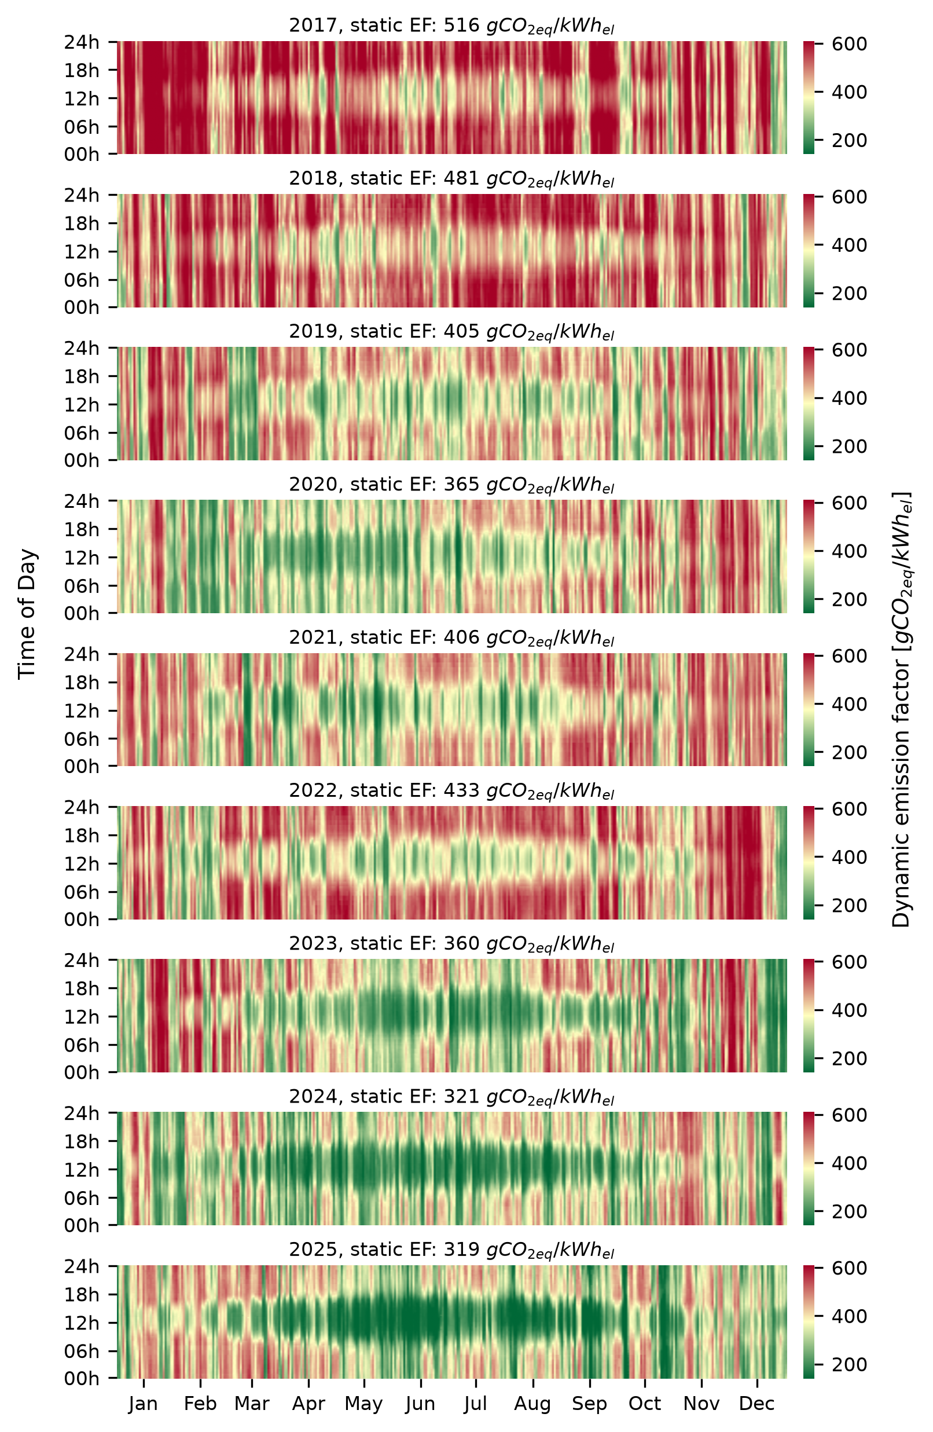
Figure 3: Dynamic emission factors of years 2017 to 2025 represented as heatmaps.

3.2 Simulation Results
The energetical simulation results for each year are summarized in Table 1. The seasonal performance factor (SPF) of the air/water heat pump (AWHP) is strongly influenced by winter climate conditions, reflected in the average ambient temperature between October and March and the number of hours below 0°C. The harshest winters in the study period are 2021 and 2018, with respectively 940 and 901 hours below freezing point and average winter temperatures of 4.2°C and 4.1°C, resulting in the highest heat demands (27,722 and 24,835 kWh/year) and the lowest seasonal performance factors. Conversely, 2020 stands out as an exceptionally mild year, with an average winter temperature of nearly 6°C and only 335 hours below 0°C, yielding one of the highest SPF values of the entire period. The year 2024 records the lowest overall heat demand at 22,867 kWh. The SPF remains largely unaffected by the presence of PV. PV self-consumption ratios range between 17% and 27%, with higher values observed in recent years.

Table 1: Simulated energetical results per year. SPF: Seasonal Performance Factor of the AWHP.
Year | Heat demand [kWh] | Avg. winter T [°C] | Hours < 0°C | SPF (no PV) | SPF (PV) | PV self-cons. [%]
2017 | 27,029 | 4.8 | 870 | 3.2 | 3.2 | 17.8
2018 | 24,835 | 4.1 | 901 | 3.1 | 3.1 | 19.1
2019 | 24,137 | 5.6 | 419 | 3.2 | 3.2 | 20.2
2020 | 23,454 | 5.9 | 335 | 3.4 | 3.4 | 20.8
2021 | 27,722 | 4.2 | 940 | 3.1 | 3.1 | 17.5
2022 | 24,058 | 5.6 | 686 | 3.2 | 3.2 | 18.8
2023 | 24,439 | 5.8 | 615 | 3.3 | 3.3 | 26.3
2024 | 22,867 | 6 | 445 | 3.3 | 3.3 | 26.8
2025 | 24,491 | 4.8 | 740 | 3.4 | 3.4 | 25.7

3.3 Comparison of yearly emissions
Figure 4 presents the specific CO_{2eq} emissions in gCO_{2eq}/kWh_{th} for each year as a stacked bar chart. For each year, the left bar (green) corresponds to the AWHP without PV and the right bar (orange) to the AWHP with PV. The lower portion of each bar represents emissions calculated using the static EF, while the upper portion represents the dynamic deviation. The specific emissions of the gas reference system are shown as a dotted line and remain nearly constant across all years, decreasing only marginally from 276 gCO_{2eq}/kWh_{th} in 2017 to 275 gCO_{2eq}/kWh_{th} in 2025 — a negligible effect attributable to the slightly improved electricity mix powering auxiliary pumps and standby loads.

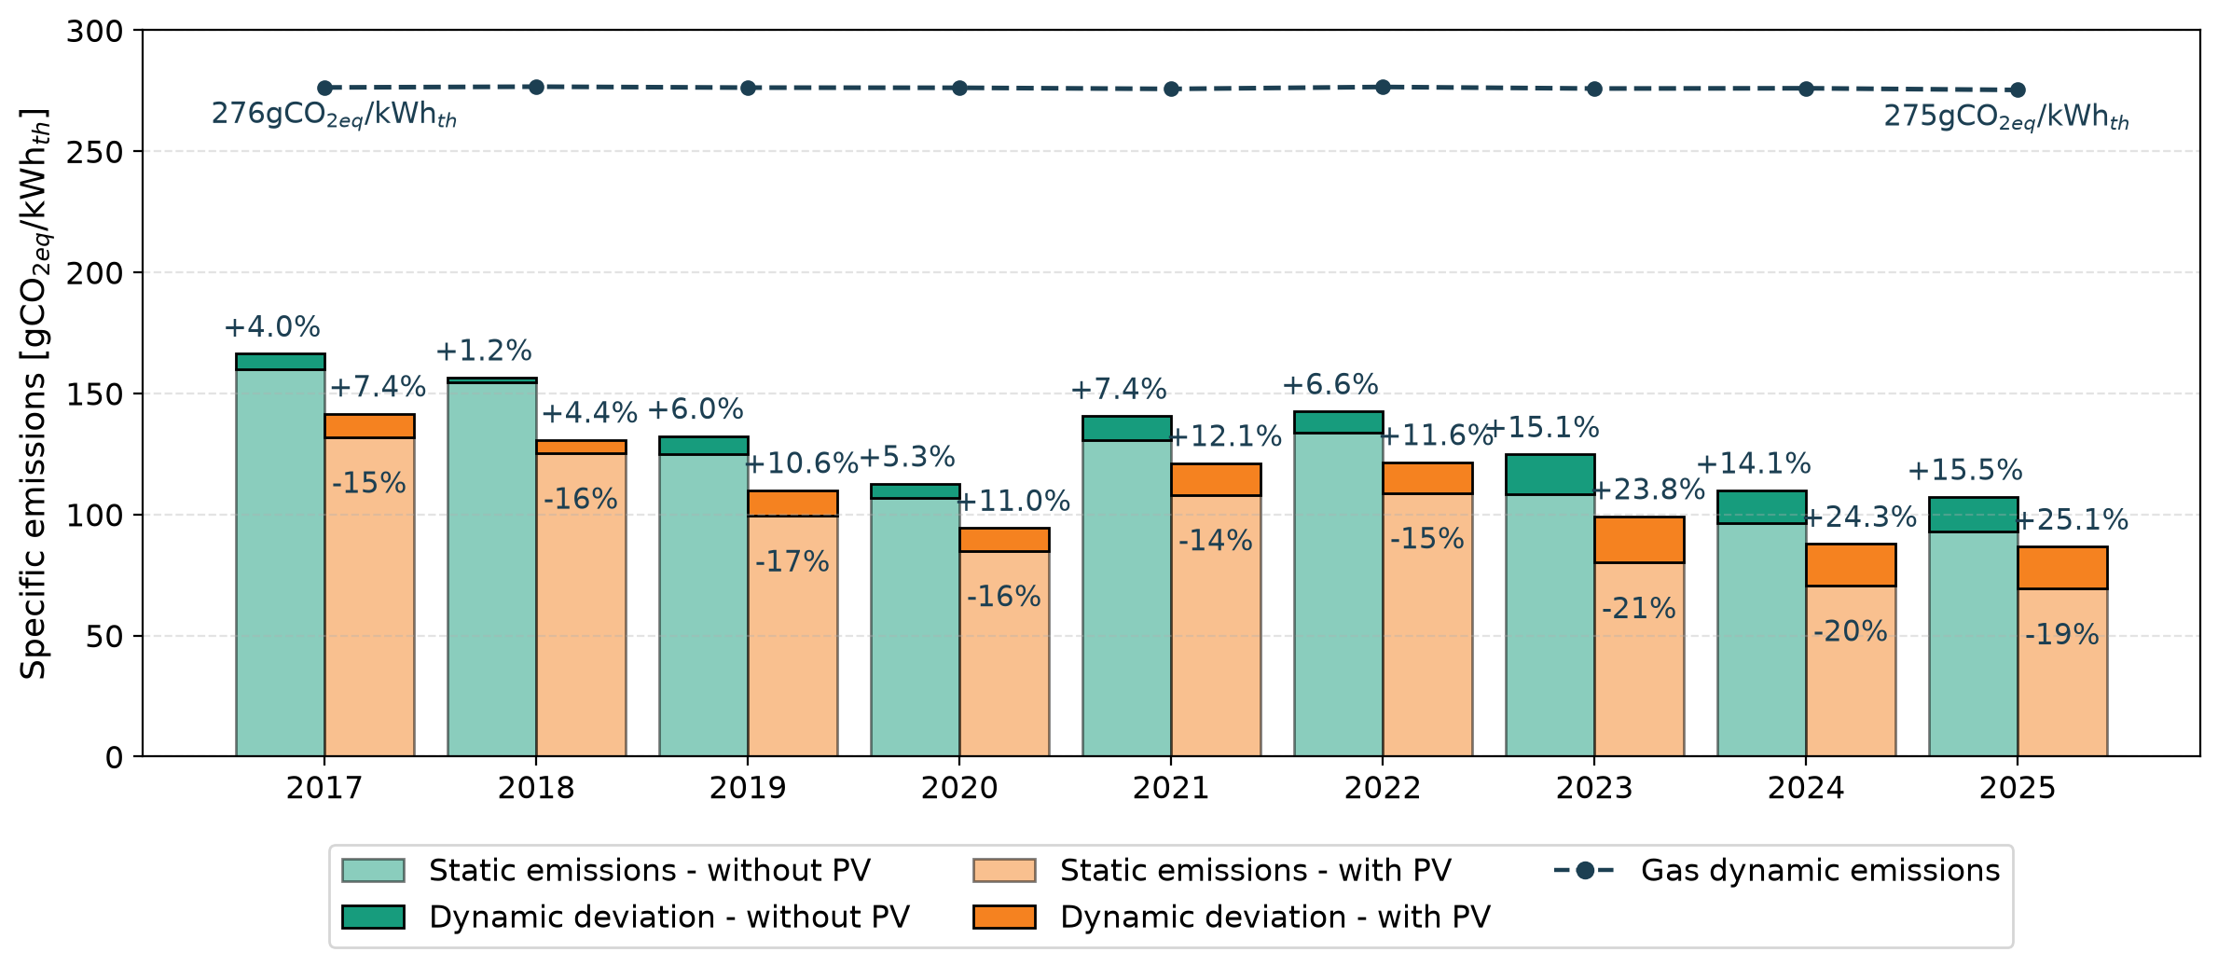
Figure 4: Static and dynamic emissions of the Air-Water Heat pump system, with and without PV, and dynamic emissions of Gas system for the years 2017 to 2025.
The overall trend is a clear reduction of AWHP-specific emissions over the study period, from 166 gCO_{2eq}/kWh_{th} in 2017 to 107 gCO_{2eq}/kWh_{th} in 2025 (dynamic calculation, without PV), meaning that by 2025 the AWHP already achieves approximately 2.5 times lower specific emissions than the gas system. However, two opposing trends can be observed: while total emissions decrease, the dynamic deviation grows. In 2017 and 2018 it remains low at 1–4%, whereas in 2024 and 2025 it reaches 14–16%, indicating that as the electricity mix becomes more volatile — driven by the increasing share of wind and solar — the static EF increasingly underestimates real emissions.
For AWHP systems equipped with PV, solar self-consumption further reduces specific emissions by 14 to 21% depending on the year, with the variation primarily driven by weather conditions. The same PV-specific emission factor of 56 gCO_{2eq}/kWh_{el} applied in the dynamic EF calculation is used here for self-consumed PV electricity. The dynamic deviation is proportionally larger for PV systems, which can be partly explained by the lower absolute emission baseline making the relative deviation more sensitive.
The year 2020 again emerges as a clear outlier: its specific emissions approach the levels of 2024–2025, consistent with the anomalously low static EF observed for that year.

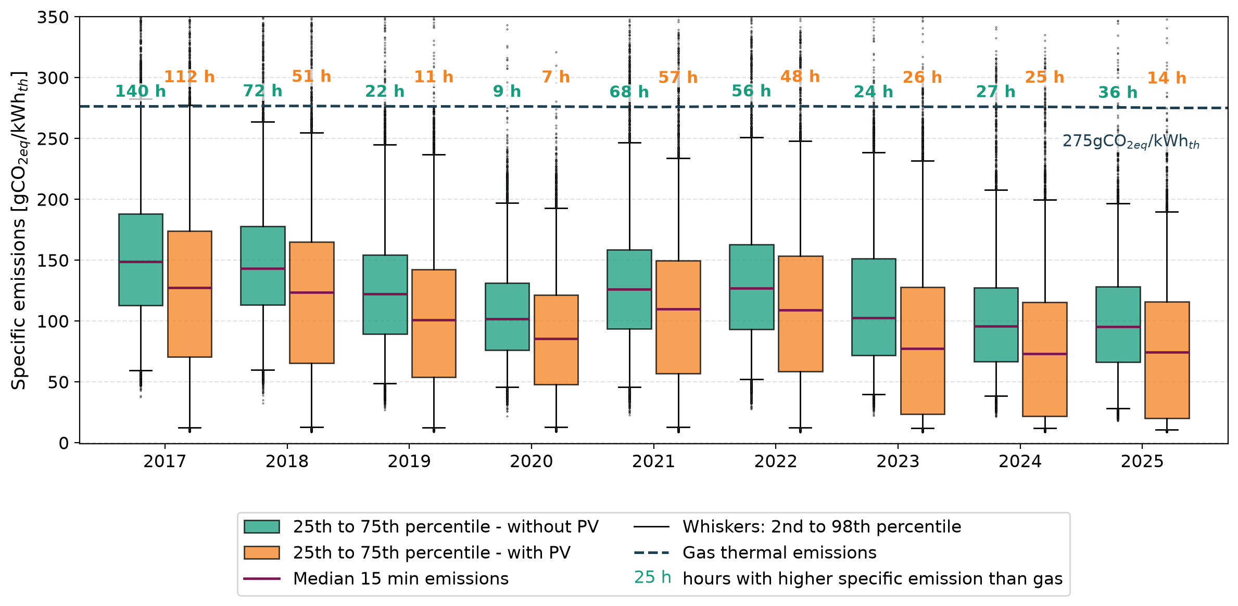
Figure 5: Boxplot of the dynamic emissions of the Air-Water Heat Pump system, with and without PV for the years 2017 to 2025. Emissions of gas system as comparison. The numbers above the gas line represent the number of hours for which the HP systems have higher specific emissions than a gas system.

Figure 5 provides a more detailed view through boxplots, again with green representing without PV and orange with PV. Boxes span the 25th to 75th percentile of 15-minute specific emission values, the median is indicated by a purple line, and whiskers extend to the 2nd and 98th percentiles, with individual outliers shown as grey points. The gas system EF is again shown as a dotted reference line. Above this line, the number of hours during which the AWHP specific emission factor exceeds that of the gas system is annotated — in green for the system without PV and orange for the system with PV.
The boxplots confirm the general downward trend in emissions, including a reduction in the upper tail of the distribution: the upper whiskers show a consistent decrease over time, reflecting fewer hours with very high instantaneous emission factors. The number of hours during which AWHP emissions exceed the gas reference also decreases, from 140 hours in 2017 to 24, 27 and 36 hours in 2023, 2024 and 2025 respectively — with no systematic increasing trend despite the growing volatility of the grid. The year 2020 stands out once more as a clear outlier, with only 9 hours above the gas threshold for the system without PV and just 7 hours for the system with PV.

3.3 Renewable Share as a Driver of the Dynamic Deviation
Figure 6 plots the dynamic deviation against the load-weighted share of renewable electricity in the German mix for each simulated year. Three renewable categories are shown: solar (orange), wind — onshore and offshore combined — (blue), and both combined (green). Hydropower is intentionally excluded from this analysis, as its dispatchable nature does not contribute to the short-term volatility that drives the dynamic deviation.
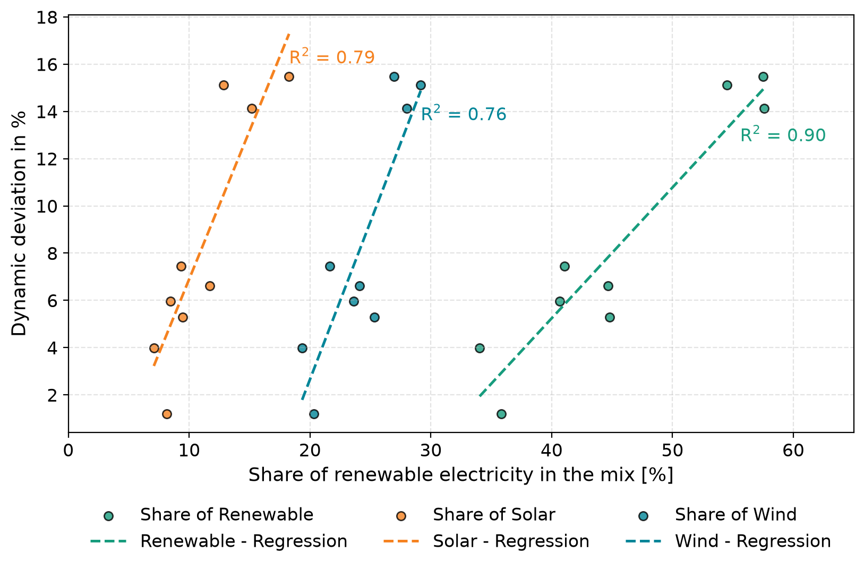
Figure 6: Increase of emissions using dynamic emissions factors vs share of renewable electricity in the mix. The correlation is higher for the overall renewable energy.

Positive correlations are observed for all three categories. The strongest is with the overall renewable share (R² = 0.90), followed by solar (R² = 0.79) and wind (R² = 0.76), confirming that the combined deployment of wind and solar is the primary driver of the growing discrepancy between static and dynamic emission calculations.
However, this trend cannot be extrapolated to higher renewable shares for several reasons. First, for a sufficiently decarbonized grid, the absolute level of the static EF will be so low that the comparison between heat pump and gas emissions becomes largely irrelevant — the heat pump will unambiguously outperform gas regardless of the calculation methodology. Second, the further deployment of renewable energy in Germany will need to come along with grid enforcement and extension of (short term) storage capacity Third, projecting a future electricity mix is inherently uncertain, as it depends not only on economic factors but also on policy decisions. Finally, source-specific emission factors for wind turbines and PV panels are themselves expected to decrease in the coming years, as the manufacturing of these technologies increasingly benefits from a cleaner electricity mix in producing countries — meaning the overall grid EF will continue to fall even if the renewable share growth rate slows.
- Conclusion
This study assessed the CO_{2eq} emissions of an air/water heat pump (AWHP) system — with and without rooftop PV — over the period 2017 to 2025, using dynamically calculated quarter-hourly emission factors for the German electricity mix. The results lead to three main conclusions.
First, the German electricity mix has improved substantially over the study period, with the static EF decreasing from 516 gCO_{2-eq}/kWh_{el} in 2017 to 319 gCO_{2-eq}/kWh_{el} in 2025. This directly translates into a reduction of AWHP-specific emissions, from 166 gCO_{2eq}/kWh_{th} in 2017 to 107 gCO_{2eq}/kWh_{th} in 2025. By 2025, an AWHP without PV already emits approximately 2.6 times less CO_{2eq} per unit of useful heat than a gas system, compared to approximately 1.6 times in 2017. However, the greening of the grid is accompanied by growing volatility, driven by the increasing share of wind and solar generation.
Second, this volatility is reflected in the dynamic deviation, which grows from only 1–4% in 2017–2018 to 14–16% in 2024–2025. This indicates that static emission factors increasingly underestimate real heat pump emissions as the energy transition progresses, and that dynamic methodologies are becoming more important for accurate assessment.
Third, a clear positive correlation is established between the share of renewable electricity and the dynamic deviation. However, establishing a reliable future trend remains difficult: a further expansion of renewables will require adaptions to the current grid structure fostering flexibility, source-specific emission factors will likely decrease as manufacturing processes improve, and a cleaner grid will in any case continue to reduce absolute heat pump emissions — making the dynamic deviation a progressively less critical concern in terms of the overall climate performance of heat pump systems.
- References

Buday, T., Buday-Bódi, E., 2023. Reduction in CO2 Emissions with Bivalent Heat Pump Systems. Energies 2023.
Chaigneau, M., 2025. Gebäudetyp Einfamilienhaus (EFH). Info-Sheet Beispiel für Effizientes Heizen. Fraunhofer ISE. https://www.effizientes-heizen.de/documents/Effizientes-Heizen_Infosheet_Gebaeude_EFH_final.pdf. Accessed 4 August 2026.
Chaigneau, M., Häußler, S., Nienborg, B. (Eds.), 2024. Umweltauswirkungen von Wärmepumpen mit dynamischem Emissionsfaktor, 308-327.
Chaigneau, M., Häußler, S., Nienborg, B., 2025. Evaluation of heat pumps CO2eq-emissions based on dynamic electricity emissions factors. J. Phys.: Conf. Ser. 3140 (2), 22017.
Fischer, D., Wolf, T., Scherer, J., Wille-Haussmann, B., 2016. A stochastic bottom-up model for space heating and domestic hot water load profiles for German households. Energy and Buildings 124, 120–128.
Gajewski, A., Gładyszewska-Fiedoruk, K., Krawczyk, D.A., 2019. Carbon Dioxide Emissions during Air, Ground, or Groundwater Heat Pump Performance in Białystok.
Gandhi, L., 2026. Energy-Charts. Die Seite für interaktive Grafiken zu Stromproduktion und Börsenstrompreisen. Fraunhofer-Gesellschaft zur Förderung der angewandten Forschung e.V. https://energy-charts.info/. Accessed 4 August 2026.
Günther, D., Moll, J., Wapler, J., 2025. Bewertung der Treibhausgasemissionen durch den Betrieb von Wärmepumpen unter Berücksichtigung zeitvariabler Faktoren. Fraunhofer Institut für Solare Energiesystems ISE, Freiburg. Accessed 24 March 2025.
IEA - International Energy Agency, 2022. The Future of Heat Pumps. World Energy Outlook Special Report. https://www.iea.org/reports/the-future-of-heat-pumps/. Accessed 20 February 2025.
Lauf, T., Memmler, M., Schneider, S., 2025. Emissionsbilanz erneuerbarer Energieträger 2023. umweltbundesamt.de/sites/default/files/medien/11850/publikationen/ 03_2025_cc_emissionsbilanz_erneuerbarer_energien_2023.pdf. Accessed 21 March 2025.
Litjens, G., Worrell, E., van Sark, W.G.J.H.M., 2018. Lowering greenhouse gas emissions in the built environment by combining ground source heat pumps, photovoltaics and battery storage. Energy and Buildings, Amsterdam.
Umweltbundesamt, 2025. Treibhausgas-Emissionen in Deutschland. https://www.umweltbundesamt.de/daten/umweltzustand-trends/klima/treibhausgas-emissionen-in-deutschland#emissionsentwicklung. Accessed 26 February 2026.

