EuroSun2026
Heat pumps in districts – workflow guidelines
Franziska Bockelmann (corresponding author)¹, Fabian Ochs², Carsten Wemhöner³
¹ Steinbeis-Innovationszentrum (siz) energieplus, Germany
franziska.bockelmann@siz-energieplus.de
² Universität Innsbruck, Institut für Konstruktion und Materialwissenschaften, Arbeitsbereich für Energieeffizientes Bauen, Austria
fabian.ochs@uibk.ac.at
³ OST – Ostschweizer Fachhochschule, IET - Institut for Energietechnik, Rapperswil, Switzerland
carsten.wemhoener@ost.ch
Summary
Positive Energy Districts are a key concepts of the urban energy transition and require both technological innovations and integrated planning processes. In order to identify suitable supply concepts, IEA HPT Project 61 is investigating different grid topologies for building clusters with heat pumps. The techno-economic analyses compare centralized, semi-centralized and decentralized solutions for space heating and domestic hot water. The results show that centralized solutions benefit from access to efficient heat sources but cause higher grid investments and heat losses. Decentralized approaches offer higher flexibility and lower infrastructure costs but are heavily dependent on available local sources. The developed planning workflow supports systematic, cost-optimized decision-making and provides a basis for future integrated planning methods in PEDs. It provides important guidance for choosing between centralized, decentralized, and hybrid heat pump concepts.
Keywords: heat pump, district, workflow, guidelines, costs, energy demand
Field of application for the findings: design of energy concepts, heat pumps in districts, supply grids
Addressed audience: owner, municipality, designer and planner, research and development
- Introduction
With the goal to support the energy transition in cities Positive Energy District (PED) can serve as a vision and support to improve technologies and the planning process. (Hedman, et al., 2021; Lindholm, et al., 2021)
IEA HPT Project 61 entitled “Heat pump in Positive Energy Districts” investigates heat pump integration in high performance districts by simulation and monitoring. A comprehensive analysis of system design for districts with a focus on the integration of heat pumps (HP) is being implemented. The aim is to achieve an efficient and economical supply concept through innovative technologies, planning tools, and efficient building concepts. In addition, the planning of HP systems for PEDs and for existing or highly densified districts is much more complex due to the significantly greater design freedom. Different energy needs on different temperature levels such as space heating (SH), domestic hot water (DHW) and space cooling have to be considered. Depending on the load profile, which is a function of the type of building (residential, non-residential) and the climate and the HP source availability (on site or nearby) different HP system design and integration options on district level are available.
A cost-optimized planning workflow is being developed to facilitate the decision-making process for the appropriate system solution. While decentralized HPs generally offer the best system performance, centralized systems are often more cost-effective in terms of investment. Booster HPs at the decentralized level enable lower distribution temperatures and are particularly interesting for heterogeneous building structures. Case studies from Germany, Austria, and Switzerland demonstrate the applicability of the approach. (Figure 1) The aim is to create a basis for integrated, cost-optimized planning of supply concepts for districts in order to efficiently advance the energy transition in urban areas. The results thus contribute to sustainable districts development and the optimization of heat pump systems in the context of the acceleration of the energy transition.
A state-of-the-art analysis of certified high-performance districts in Germany, Austria and Switzerland and the 61 PED documented in the “100 PED in Europe until 2025” (JPI UE, 2020) approved that heat pumps are the main building technologies together with photovoltaics on-site electricity production, followed by and partly integrated with district heating and combined heat and power (Wemhöner, et al., 2024). Based on the state-of-the-art generic system concepts for the heat pump integration options are elaborated and documented. Favorable systems are evaluated in more detail as techno-economic analysis by simulations, which are also related to monitoring results of real heat pump installations in clusters of buildings and districts. By the monitoring results validation of the system models can be performed, while simulation results enable optimization potentials to be identified and implemented in the monitoring plants.
Integration options have been clustered in five top-level categories depicted in Figure 1, from the individual building level to the entirely central integration in a heating and cooling centre providing the building services by a thermal grid. Respective options are also linked to monitoring systems which deliver practical measurements for the evaluation.

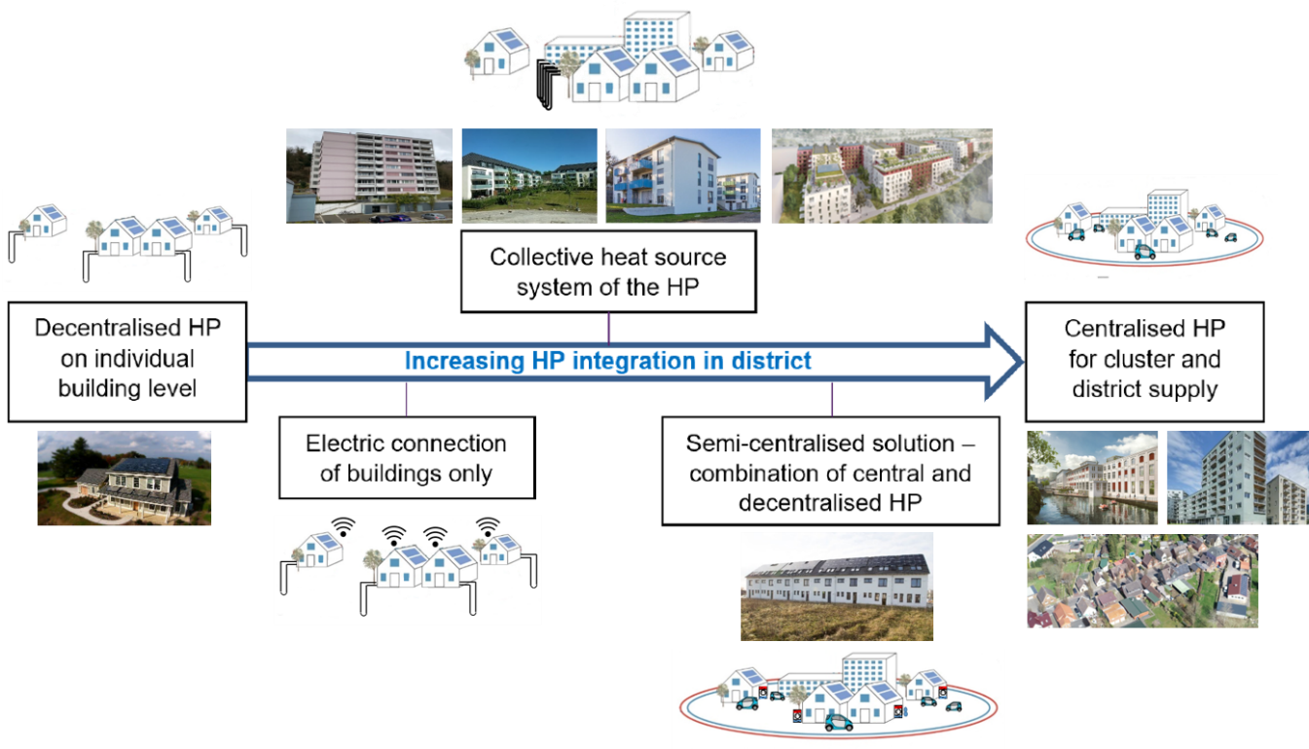
Fig. 1: HP integration options, from individual (building-level) HPs, over decentralized HPs with low or medium temperature loop to centralized HP with high temperature district heating

- Method
The example districts and blocks used in the preliminary study for Project 61 are at different stages of construction. The projects in Germany relate to groups of buildings where the systems are already in operation or which are existing buildings currently due to be fitted with new supply concepts. The projects in Switzerland and Austria relate to larger groups of over a hundred flats and are in the planning and extended commissioning phases. The projects, together with their key data, serve as the basis for analyzing the different renewable energy integrations and are not being fitted with new systems.
The study examines 12 districts and blocks in terms of possible network structure and implementation. The districts have different structures and sizes of building groups (see appendix):
- The districts under consideration comprise between 4 and 134 buildings.
- The total gross floor area ranges from 4,800 to 168,400 m².
- The grid length varies between 110 and 1,700 m, with heat line densities ranging from 142 to 9,984 kWh/m, and
- the specific heat demand of the districts is between 6 and 105 kWh/(m²a).
Various options are available for the design and integration of HP systems in the PED. The following topologies were used for the analysis (Figure 2):
- Variant 1: Central (one per district) with high grid temperature level (67/40 °C):
A fully centralized solution in which all the energy is generated in a central heating plant and transmitted to the consumer via a high-temperature grid. This means that the installation at the individual house is kept to a minimum and is limited to a heat transfer station and, where necessary, a hot-water storage tank.
- Variant 2a: Mixed - central grid HP for SH, decentral DHW (on building), with mid grid temperature level (35/30 °C):
The space heating system is powered directly from the grid. A return-flow heat pump is integrated locally to ensure the hot water supply, which is provided by fresh-water systems in the individual flats.
- Variant 2b: Semi-central - central low temperature HP + decentral booster HP on building or flat level, with mid grid temperature level (20/10 °C):
Low source temperature for the decentralized booster heat pump for space heating and domestic hot water supply. Domestic hot water provision is also supplied by fresh water systems in the individual flats.
- Variant 3: Decentral (building-wise HP) with low grid temperature level (0/-3 °C):
Often referred to as ‘fifth-generation district heating’. This means that only the source temperature from the geothermal borehole heat exchanger – 0 °C (annually constant) – is distributed to fully decentralized heat pumps, which cover all space heating and domestic hot water requirements.
- Variant 4: Building-wise HP without grid connection:
The variant without a district heating network is used as a basis for comparison. Each building has its own heat pump with a low-temperature heat source.

For all variants, the initial configuration assumes a central geothermal heat source with an constant annual flow temperature of 0 °C. Space heating is operated at a flow temperature of 35 °C for variants 1 and 2a, and at 58 °C for the other variants. Domestic hot water is assumed to have a flow temperature of 58 °C (circulation in variants 2b and 3) or 65 °C in variant 1.
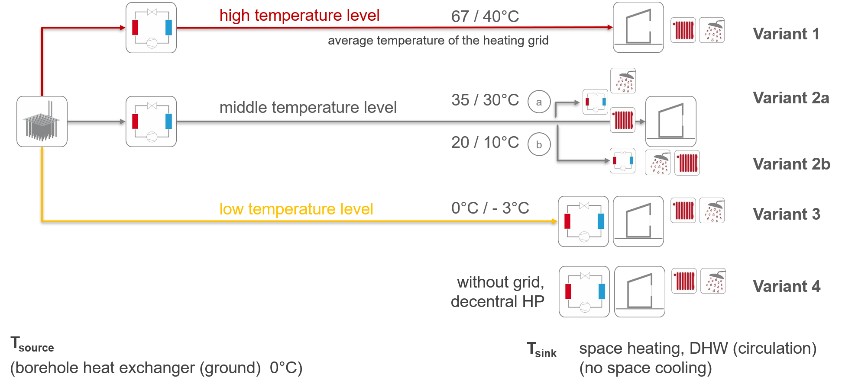
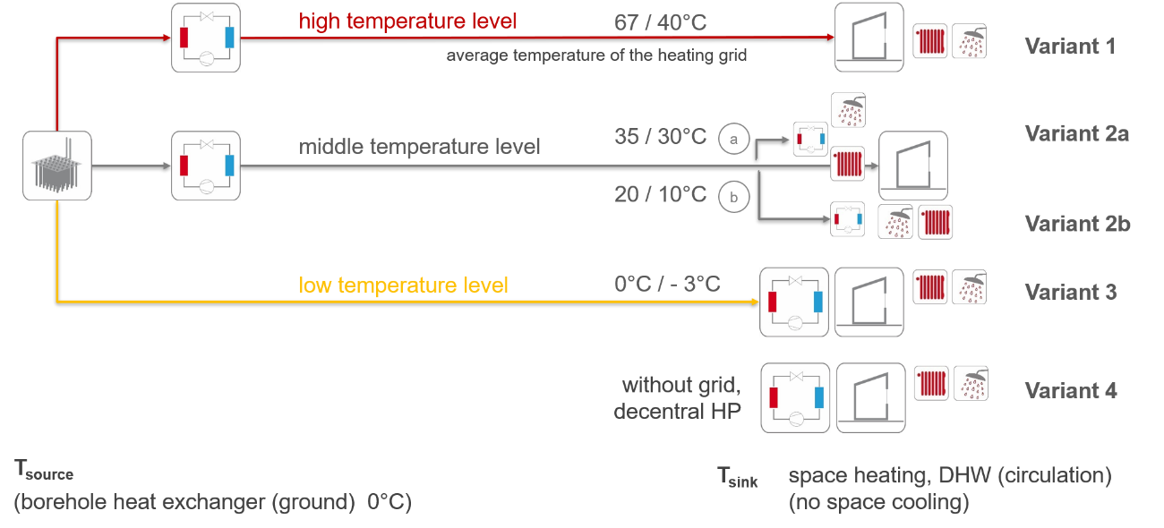
Fig. 2: Heat pump topologies and temperature boundary conditions

The system behavior of the various variants is modelled using simplified (annual) approaches and assumptions, resulting in an annual energy balance for each system variant. The boundary conditions applied include, amongst others:
- The low-temperature source (geothermal borehole heat exchanger field) is assumed to be a storage system that supplies the required source output at a constant temperature of 0 °C.
- The COP of the heat pumps / the system is determined on the basis of a constant exergetic efficiency η_{ex} of 0.5 in accordance with the second law of thermodynamics, which is multiplied by the Carnot COP (COPC) corresponding to the respective system source and sink temperatures.
- System losses or gains in the network and storage components are accounted for by proportional shares based on the temperature difference relative to the respective environment or on the amount of energy transferred.
The options are assessed by means of an energy comparison focusing on the electrical energy required for the heat pump and auxiliary power to meet the heating demand of the districts (including heat and distribution losses in the grid). No distinction is made between the electricity consumption of centralized heat pumps and that of decentralized heat pumps. For the purposes of the comparison, it is assumed that there is a single operator/supplier and that the district is therefore subject to a single electricity tariff. The target value of the energy calculation is the amount of electricity required to operate the heat pump, which also serves as the input value for calculating operating costs (OPEX). Capital expenditure (CAPEX) is determined on the basis of investment in the components and the network, maintenance costs – calculated as a percentage of capital expenditure – and operating costs for electricity.
- Results
As temperatures do not vary between the blocks within the system configurations, and the COP of the heat pumps is always calculated using the same efficiency rating, the system efficiency ratios do not differ between the districts. The electricity demand for auxiliary power for the peripheral equipment in the plant room and in the distribution network is currently not taken into account in the system efficiency figures. For the circulation and distribution pumps, a guideline value of 1.5 % is assumed for the relative electricity demand (ratio of pumping energy to the total amount of heat supplied). The system efficiency is derived solely from the COPs of the heat pumps.
Based on the analyses of the districts and variants, it can be summarized that (Figure 3)
- variant 2a (central heat pump and booster heat pump for domestic hot water) achieves the highest system efficiency, averaging 3.3.
- variant 3, the low-temperature grid, shows no variation across the districts and yields 2.7.
- the lowest system utilization rate is found in the high-temperature network, with an average of 2.2.

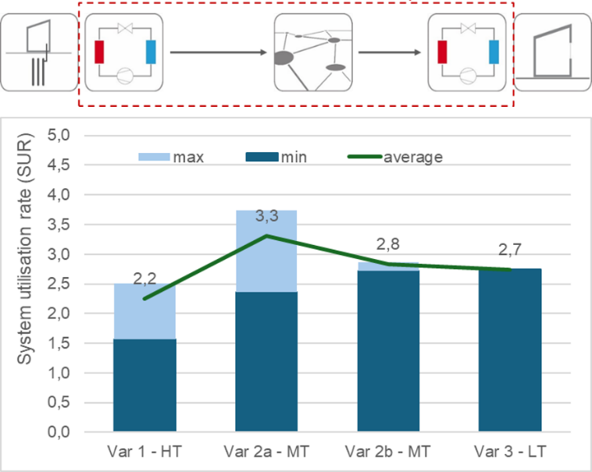
Fig. 3: System boundary for performance factor calculation (top) and results for system utilization rate (SUR)(bottom)

Across the districts, the required annual electricity supply ranges from 9.2 to 43.9 kWh/(m²·a) (Figure 4), depending on the supply concept and district characteristics. Within each district, however, the electrical demand of the individual HP configurations varies only slightly. The observed differences between districts depends on varying energy needs and from differing district heating losses caused by variations in pipe lengths.
The analysis clearly indicates that decentralized concepts achieve better performance than centralized solutions. Among all configurations, the semi-central system (Var. 2a) demonstrates the lowest electrical demand across the PEDs, mainly due to its high system efficiency. In contrast, the highest average electricity consumption is observed for Variant 1, the high‑temperature network with a central heat pump, where reduced system utilization and the impact of elevated network temperatures become evident.
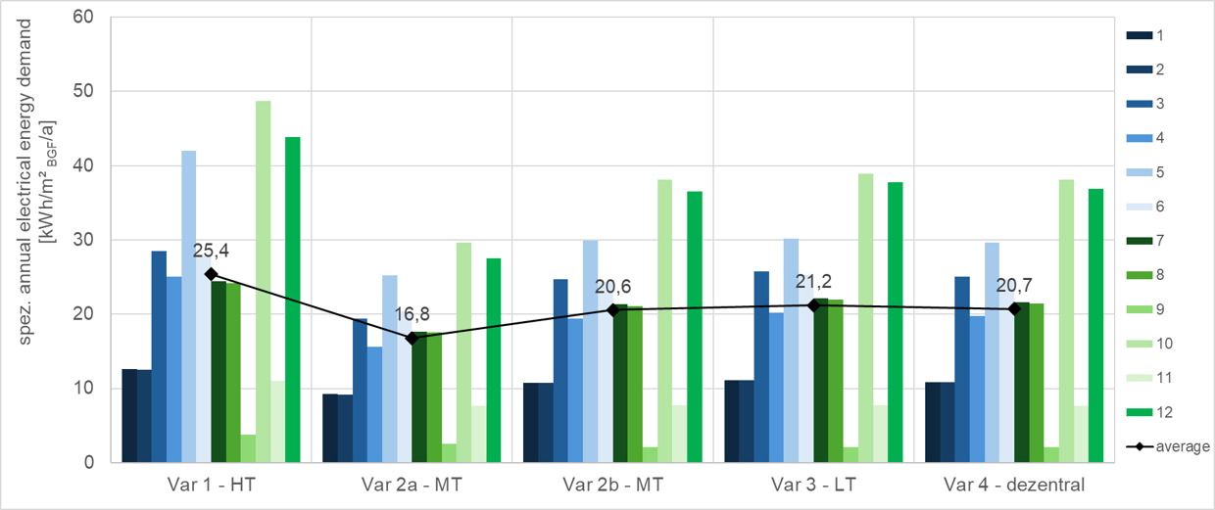
Fig. 4: Specific annual electrical energy demand of the various heat pump systems
The evaluation of the specific total annual (gross) costs shows a strong dependence on the reference temperature level as well as on the investment requirements for network infrastructure and thermal storage. Lowering network temperatures and relocating the heat pump from a central to a decentralized position significantly reduces the total annual costs in relation to heat demand, i.e., the heat production costs. The concepts with a low‑temperature grid (Var. 3) and the semi-central configuration (Var. 2a) achieve the lowest heat production costs, alongside the fully decentralized solution without a district heating grid. In comparison, the high-temperature network results in considerably higher costs. Across all systems, heat production costs range from 167 to over 1,000 € per MWh. (Figure 5)

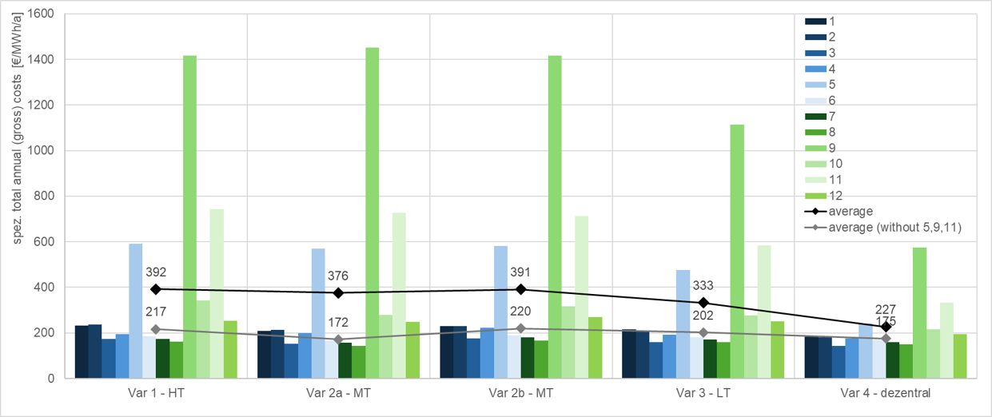
Fig. 5: Specific total annual (gross) costs of the various heat pump systems in relation to heat demand – heat production costs

- Workflow and Design Guidelines
In individual buildings, especially new buildings, there are no technical obstacles to the installation of heat pumps. Even in existing buildings, this is a mature technology that can be used in many buildings with existing radiators and can replace fossil fuel-based heating systems. However, connecting buildings via a heating network fed by heat pumps poses a challenge. (Ochs, et al., 2024; Sassenou, et al., 2024)
For a design workflow for HP systems for districts, local boundary conditions such as source availability and temperature level of the heating networks, as well as the energy requirements of the individual buildings and the possible heat pump topologies, must be developed and taken into account. Depending on the function of the building type (residential, non-residential), the layout, and the availability of heat pump sources on site (or nearby), various options are available. The design workflow follows the cost-optimality approach as suggested by the EPBD. Design variables for PEDs with focus on the HP system topology are schematically shown in Figure 6.

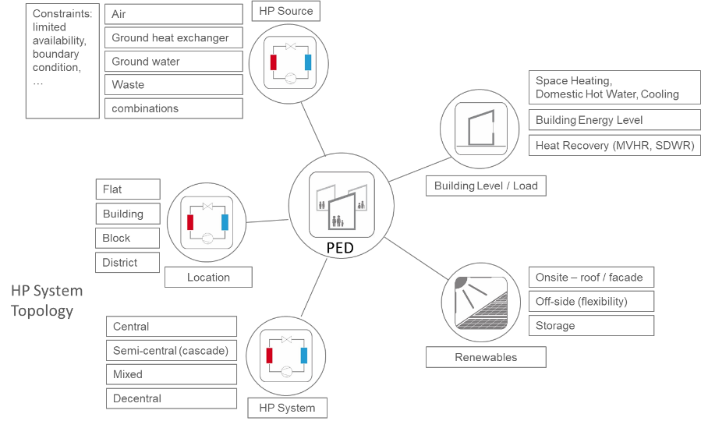
Fig. 6: Heat pump system design variables

The following proposed workflow guidelines can support decision-making and can serve as a basis for a future integral planning approach for PEDs. Based on the results of the network study and analysis of the different topologies, as well as the evaluation of the monitored districts in the Project 61, the following conclusions can be drawn for planning guidelines:
- Basis of the design: specification of boundary conditions regarding total heat demand, network length and layout, heat line density, availability of heat sources, climate, potential for renewable energies on-site.
- Optimization of buildings: high efficiency standards with low-temperature distribution systems and maximum PV yield form a good basis.
- Preference for decentralized or semi-centralized heat pump concepts: decentralized heat pumps with minimal distribution losses and maximum performance.
- Minimization of grid temperatures: design of grid for the lowest possible temperatures that are still compatible with the requirements of the buildings. 5th generation heating grids or semi-centralized systems with medium temperatures (central heat pump + booster heat pump for hot water) reduce investment costs and pipe losses.
- Placement of the source: restrictions on the choice of heat source for the heat pump in decentralized solutions without a grid. More options and easier connections of sources with network topologies.
- 5th generation heating grid at low temperature level enable buildings to be cooled in summer within the framework of a network/system. Cooling within the framework of other topologies is only possible with an additional ‘cooling grid’ or separate systems.
- Simultaneous operation of heat pumps for various building requirements, such as heating, cooling and domestic hot water supply, enables waste heat recovery for other functions, e.g. through simultaneous hot water production and space cooling within the district.
- Limitation of network size and complexity: compact districts with corresponding grid are more economical and energy-efficient than widely scattered buildings and large districts.
- High energy efficiency of heat pumps and systems enable to achieve ambitious energy/emission targets.
- The topology of the heat pump system determines its efficiency!
- Annuity method for calculating total annual costs.
- Safety aspects to be considered with natural refrigerants are becoming more relevant from a centralized to a decentralized perspective.
- Conclusion
The cost‑optimal integration of heat pump (HP) systems in districts on the path toward becoming Positive Energy Districts (PEDs) is essential for achieving high overall performance. A key prerequisite for reaching PED status is a very high energy efficiency at the building level. Since the suitability of specific HP topologies is strongly influenced by local boundary conditions, a simulation‑based planning workflow is necessary. Techno‑economic analyses help identify promising applications and provide guidance for the integration, sizing, and control of HP systems in PEDs. In this context, decentralized building‑level solutions are systematically compared with fully centralized concepts, considering both technical and economic parameters.
While central systems often appear advantageous due to potentially lower upfront infrastructure costs, decentralized heat pump configurations typically deliver superior system performance, benefiting from reduced thermal losses and improved operational efficiencies. In districts with heterogeneous building stock, decentral booster heat pumps that enable lower distribution temperatures can offer additional advantages. The proposed planning workflow supports informed decision‑making and can serve as a foundation for future integrated planning methodologies for PEDs.
The findings show that low‑temperature system concepts consistently outperform high‑temperature ones. Consequently, decentralized solutions should be prioritized over semi‑centralized or fully centralized approaches. Avoiding a thermal network eliminates substantial investment costs, and the construction of such a network is only economically justified when heat density is sufficiently high—conditions that are often not met in PEDs. Overall, the choice of system topology has a greater impact on performance than the efficiency of the individual heat pump.
- References
Bockelmann, F.; Ochs, F.; Wemhoener, C.; 2025. Workflow für Wärmepumpensysteme in der Quartiersversorgung. DGK. Berlin
Hedman Å., Rehman HU., Gabaldon A., Bisello A., Albert-Seifried V., Zhang X., et al.; 2021. IEA EBC Annex 83 Positive energy districts. Buildings 2021,11(3), 130
JPI UE; 2020. Europe towards positive energy districts - a compilation towards sustainable urbanisation and the energy transition, Brussels
Lindholm, O.; Rehman, H.U.; Reda, F.; 2021. Positioning positive energy districts in European cities. Buildings 2021, 11(1), 19; https://doi.org/10.3390/buildings11010019
Ochs, F., Magni., M., Dermentzis, G., 2022. Integration of heat pumps in buildings and district heating systems-Evaluation on a building and energy system level; Energies 15 (11), 3889; https://doi.org/10.3390/en15113889
Ochs, F.; Tosatto, A.; Venturi, E.; Breuss, S.; Magni, M.; Dermentzis, G.; Wemhöner, C.; 2024. Characteristic Load Curves of Positive Energy Districts, Solar Energy Advances, Elsevier; https://doi.org/10.1016/j.seja.2024.100081
Ochs F., Venturi, E., Breuss, S., Bockelmann, F., Wemhoener, C., 2025. Towards Positive Energy Districts Heat Pump System Topology Design Guidelines, ISEC 2026
Sassenou, L.-N., Olivieri, L., Olivieri, F., 2024. Challenges for positive energy districts deployment: A systematic review, Renewable and Sustainable Energy Reviews, Volume 191, 114152, ISSN 1364-0321
Venturi, E.; Ochs, F.; Magni, M.; Dermentzis, G.; 2024. EuroSun, Evaluation of positive energy districts with district heating and heat pumps. ISES and IEA SHC Int. Conference on Sustainable and Solar Energy for Buildings and Industry.
Wemhoener, C., Bockelmann, F., Ochs, F.; Hummel, S., 2024. Annex 61 – State of heat pumps in positive energy districts; Proceedings Zero Carbon in the Built Environment ZCBE Conference, Nottingham
Wemhoener, C.; Ochs, F.; Betzold, Ch.; Bockelmann, F.; Zimmermann, J.; 2024. IEA HPT Annex 61 – Simulation von Wärmepumpen in Plusenergiequartieren; Proceedings Bausim 2024, Vienna
Wemhoener, C., Ochs, F., Breuss, S., Betzold, Ch., Bockelmann, F., Zimmermann, J., 2025. Heat pump integration in Positive Energy Districts - Simulation and monitoring results of IEA HPT Annex 61 – Journal of Physics: Conference Series, Volume 3140, Operation – Heating & cooling systems, 2025

- Appendix
Tab. 1: Background information on the example districts
