EuroSun2026
Experimental investigation on fronTherm – a novel facade heating, cooling and ventilation system

Olaf Vogel¹ (corresponding author), Sebastian Asenbeck¹, Ulrich Leibfried², Stephan Fischer¹
¹Institute for Building Energetics, Thermotechnology and Energy Storage, University of Stuttgart (Germany)
²Consolar Solare Energiesysteme GmbH, Lörrach (Germany)
olaf.vogel@igte.uni-stuttgart.de
Summary
In this work, fronTherm – a novel system that enables the simultaneous renovation of the building facades and the heating system without causing major work inside the building – is introduced and investigated experimentally. This heating, cooling and ventilation system consists of a small heat pump which is integrated into an insulation element and supplies heat for the interior by heat conduction over the wall and heated supply air. A prototype fronTherm module is tested in a dual climate chamber to perform tests under varying boundary conditions. The experimental results confirm the functionality of the novel heating and ventilation system in a laboratory environment and identify potential for further improvement regarding the contact quality between module and wall as well as the airtightness of the supply air stream.
Keywords: Serial renovation, heat pump, ventilation concept, building energy systems, solar heating
Field of application for the findings: Renovation of existing buildings, building heating and cooling
Addressed audience: Building planners, researchers and engineers in HVAC and heat pump systems
- Introduction
The building sector has not been meeting its climate neutrality targets for several years (Loga, Tobias et. al 2015). A far-reaching renovation of the building stock – reduction of heat demand (measures on the building envelope) and decarbonization of heat generation – is needed. This requires renovation rates that seem inconceivable given the available skilled labor capacity today. Another major obstacle is that both investments usually have to be made together, and that work on the building envelope (e.g., insulation and window renewal) as well as in the technical and living or utility rooms (heat generators, heating and, where applicable, cooling surfaces) are required. In practice, this often leads to a delay in renovation measures or only the replacement of the heat generator, combined with undesirably high CO₂ emissions for decades to come. In the transformation of energy supply in existing buildings, in addition to renewable local and district heating, the use of heat pumps will play a decisive role (Walberg, Dietmar et. al. 2022).
Furthermore, air/brine heat pumps generally require an outdoor unit or a ground probe to extract the heat from the outside air or the ground. Both systems are often not applicable, especially in inner-city locations, particularly in apartment buildings, due to noise pollution and limited space (air source heat pumps) or the lack of spatial or geological conditions for geothermal probes.
Therefore, the research project fronTherm develops a novel heating system that enables the simultaneous renovation of the building envelope and heating system without causing major work inside the building. It is intended to enable the efficient use of solar and heat pump technology and can also be used error-free by trained personnel. It could thus enable a significant increase in renovation rates in a disruptive way, thereby making a significant contribution to the energy transition in the building sector. The solution concept is based on facade heating and cooling units (known as fronTherm modules), which can be mass-produced and are installed on the outside of the facade, see Figure 1. The fronTherm modules are available both as horizontal and vertical version to allow the flexible application to different buildings. Each module contains a micro heat pump with a condenser surface for heat dissipation on the inside facing the building wall, and an evaporator surface on the outside facing the ambient air and sun (heating mode). This surface can also be equipped with PV modules on suitably exposed facades. In the case of cooling, the condenser becomes the evaporator surface and vice versa. The facade heating and cooling units serve as the only source of heat and cooling for the building.
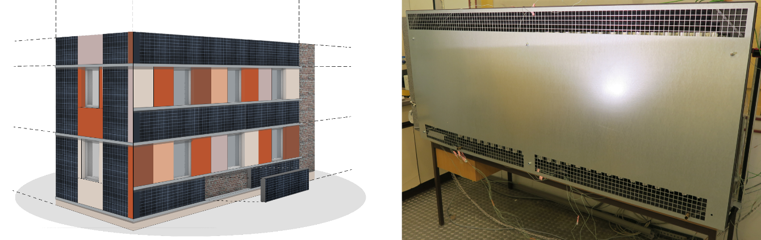
Figure 1: Renovation concept with innovative facade heating and cooling units with PV (left) and a functional prototype (right)
In this way, a single renovation measure can simultaneously take four steps toward climate neutrality:
- Reduction of heating and cooling load through insulation of the facade
- Installation of PV to generate the electrical energy required to operate the heat pumps in the annual balance and thus cover the heating requirements in the balance sheet
- Replacement of old heating systems with efficient heat pump technology
- Cooling in summer. The facade heating and cooling units are connected to the heat pump system

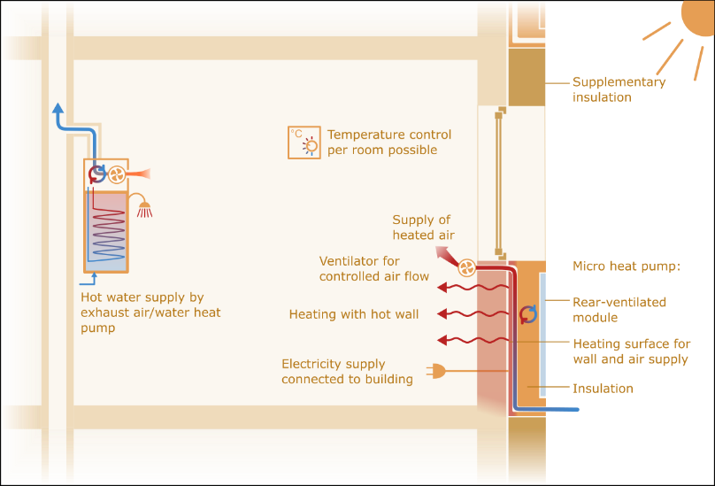
Figure 2: Operating principle for heating mode
Figure 2 shows a schematic representation of the operating principle for the heating mode. Since ventilation heat losses account for an increasing proportion of the heating load in energy-efficient buildings, the concept includes a solution for mechanical residential ventilation that can also be implemented in existing buildings at relatively low cost. This is based on a classic exhaust air system. The central component for this is the exhaust air/water heat pump for heating drinking water, which centrally in each residential unit – typically in the bathroom – draws in the exhaust air, cools it and discharges it to the environment via a wall outlet. At the same time, outside air flows into the living spaces through the facade units, where an additional ventilator is placed in the supply pipes to ensure a sufficient air flow. The supply air can be preheated in winter to temperatures of up to around 50 °C using the integrated heat pump. The preheated supply air also helps to heat the exterior walls equipped with facade units.

- Experimental setup
The fronTherm prototype used for the studies presented in this work is a horizontal version with outer dimensions of 2.1 m width, 0.9 m height and 0.25 cm depth. The frame of the module is made of EPP, which also insulates the hot condenser from the cold evaporator. The condenser is a serpentine aluminum refrigerant coil on a thin aluminum sheet that is in contact to the adjacent wall. Foam rubber cushions are used to ensure a good contact between the sheet and the wall. The evaporator is a serpentine aluminum refrigerant coil that is installed between two rows of wavelike thin aluminum plates. In the front of the module a metal plate is placed with lattice-shaped openings at the bottom and top. The ambient air enters the evaporator area through the upper opening, is cooled down by the evaporator and leaves through the lower opening. This induces a natural, which allows a sufficient heat transfer from the ambient to the refrigeration circuit. Further, a compressor with inverter and a maximum electrical power input of 200 W as well as a thermostatic expansion valve a used.
The experimental investigation is done in two steps and is focused on the heating operation. At first, a functional test of the fronTherm module regarding achievable heating power, heating efficiency in terms of COP and sound power level is performed at different values for compressor speed, supply air ventilator speed as well as temperature levels for condenser and evaporator. For this purpose, the module is tested in an insulated dual climate chamber with one side representing the building interior at room temperature (20 °C) and the other side the ambient at different temperatures, which can be controlled in the range of -10 °C to 10 °C, see Figure 3. The module is installed on a plasterboard within a multi-layer area placed in a window, which connects the warm and cold side as shown in Figure 3. Behind the plasterboard is an absorber plate that dissipates the heat conducted from the module and allows for a precise measurement of that heat flux using an electromagnetic flowmeter and Pt100 temperature sensors. Further, the inlet water temperature and the mass flow through the absorber circuit can be adjusted for a control of the condensation temperature. A layer of insulation is placed between the absorber plate and the warm side of the climate chamber to minimize the undesired heat flux towards the warm side, which can be determined via installed surface temperature sensors. A second plasterboard for mechanical stability completes the setup on the room side. Compared to a regular wall, the applied structure allows faster measurement cycles at varying boundary conditions due to significantly lower thermal capacity and a reduced response time. The heat supplied to the room via the supply air flow can be determined by a measurement of the air flow with a hot-wire anemometer and the temperature change between inlet and outlet. Further, the refrigerant pressure at the outlets of condenser and evaporator as well as the temperatures at various positions of the refrigerant circuit and on the surfaces of condenser and evaporator are measured.
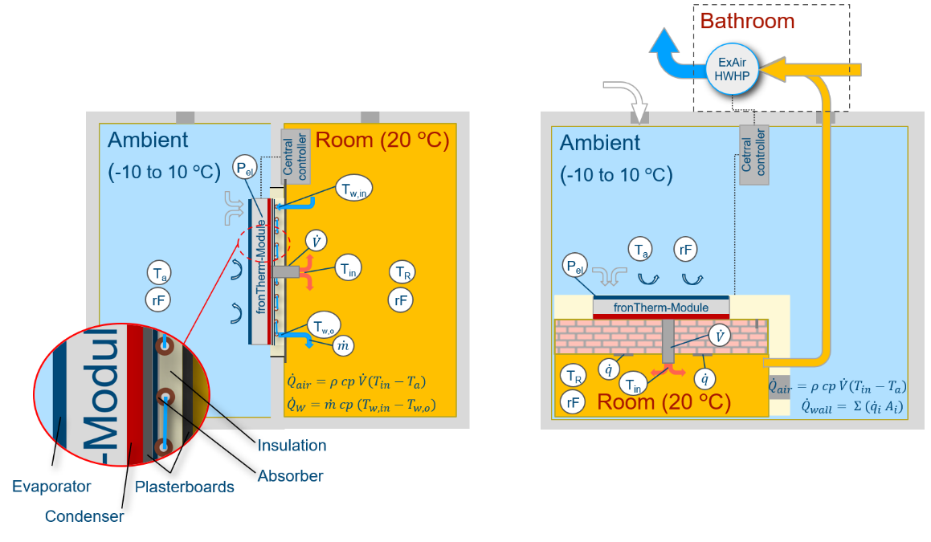
Figure 3: Test setup of the functional test (left) and the system test (right)
The determination of the wall- and air-sided heat extraction as well as the electric power consumption allows the calculation of the heat pump efficiency (COP) at different boundary conditions, which provides the basis for an overall system performance evaluation. Further measured quantities are used to gain more insight into the thermal behavior of the module as well as the states in the refrigerant loop, in order to evaluate and further optimize the prototype design with respect to thermal performance.
In the second step of the experimental investigation, a complete system test is conducted, including a realistic wall setup, an exhaust air/water heat pump which is installed for hot water production in each apartment and the central fronTherm system controller. In a second climate chamber measurement setup, another module is therefore placed on a regular wall where the module is mounted on to be able to perform dynamic tests under realistic conditions. In contrast to the absorber circuit, heat flux plates are used to determine the heat flux of the module to the interior room through the wall.
- Experimental procedure
3.1 Preliminary tests at a glass plate
A very important factor for the conduction of heat from the condenser sheet to the wall and thus to the interior is the contact between the condenser sheet and the wall. As this cannot be evaluated anymore once the module is mounted to the wall, it is preliminary mounted onto a glass plate as it is shown in Figure 4 (left). This allows to visually inspect the contact quality as well as to use an infrared camera. For the latter, the module is running at a medium capacity in order to heat up the condenser and consequently also the glass plate. Since glass is impermeable to infrared radiation, the infrared camera visualizes the outer surface temperature of the glass plate which is strongly influenced by the heat conduction between condenser sheet and glass. At first, the test is done with a bare aluminum surface and at second, the surface is coated with black color to increase the thermal radiation by a higher emissivity.
3.2 Functional test sequence
For the functional test of the fronTherm module regarding behavior and performance of the refrigeration circuit as well as the achievable heating power by wall and air supply, a standardized test sequence is defined. This varies the main boundary conditions that influence the module at a given ambient temperature. These are the operating power, which can be set by the control voltage Uset_cpr, the air supply volume flow, which can be adjusted by the control voltage Uset_vent, and the wall temperature, which can be controlled by the water inlet temperature Tw_set of the absorber circuit. The defined sequence can be seen in Figure 4 (right) and runs in time periods of 3 hours for each combination of the boundary conditions. Further, the resulting power level and air volume flow are shown. At first, the operating power is increased in four steps applying control voltages of 2 V, 5 V, 7 V and 10 V at a constant air flow of around 15 m³/h and an absorber circuit inlet temperature of 20 °C. Afterwards the air flow is changed to around 13 m³/h and the operating power is reduced applying the same control voltages, but in descending order. Finally, the same procedure is run at an absorber circuit inlet temperature of 30 °C.
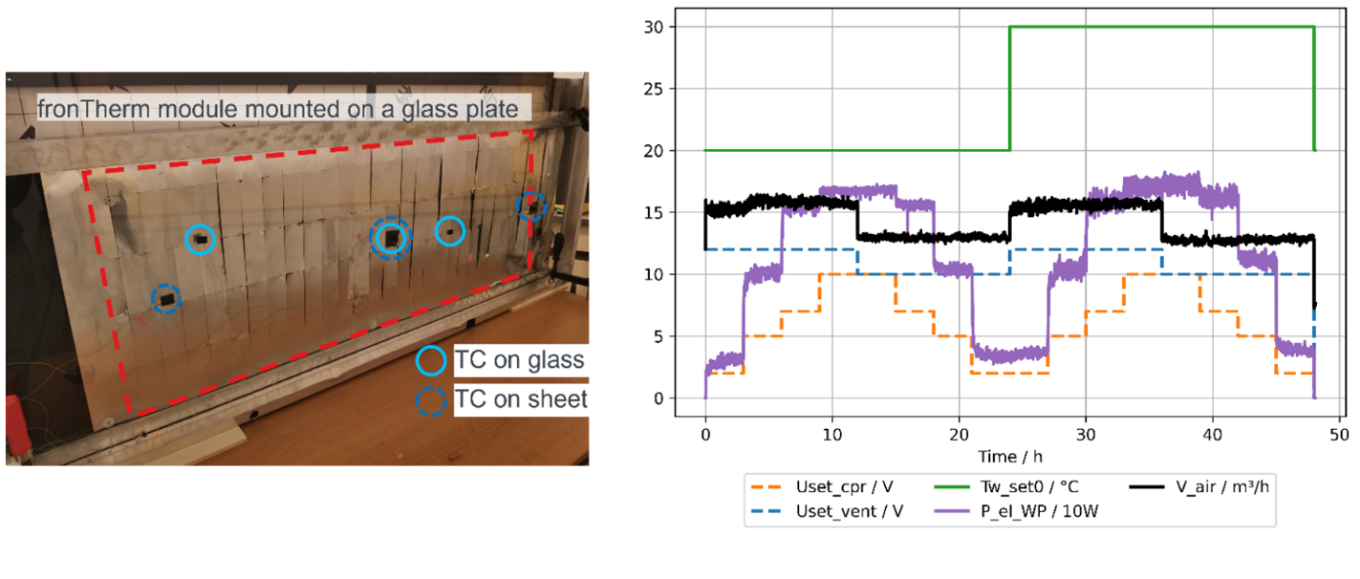
Figure 4: Rear view on the fronTherm module mounted on a glass plate (left) and standardized test sequence of the functional test with variation of the main boundary conditions (right)

- Results and discussion
4.1 Preliminary tests
The results of the preliminary tests with the module mounted on the glass plate to evaluate the contact quality between the condenser sheet and the wall are given in Figure 5. An uneven temperature distribution as well as temperature differences of up to 10 K on the glass pane—which corresponds to the surface of the exterior wall in practice – is found for bare aluminum. This indicates that there are considerable gaps between condenser sheet and wall, which are filled with air. Thus, there is still significant room for improvement in terms of the contact quality. However, the heat transfer coefficients derived from the results are sufficient to achieve the design heat transfer rate despite the air gaps that occur between the condenser plate and the glass pane/wall surface. Furthermore, the capacitor plate was painted black to enhance the effect of thermal radiation. This results in a reduced temperature difference, more uniform heat transfer, and thus an increase in the achievable heat transfer rate. For the next prototype, the mounting system as well as the condenser design will be revised to improve the contact quality.
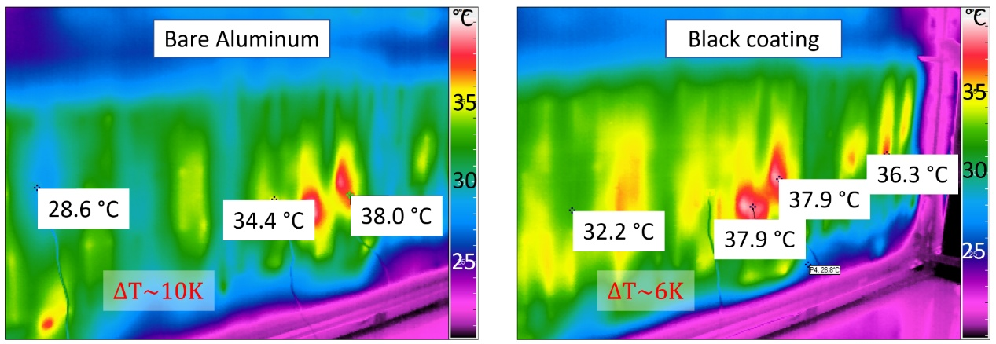
Figure 5: Results of the contact quality tests with the module mounted on a glass plate
4.2 Results of the component tests
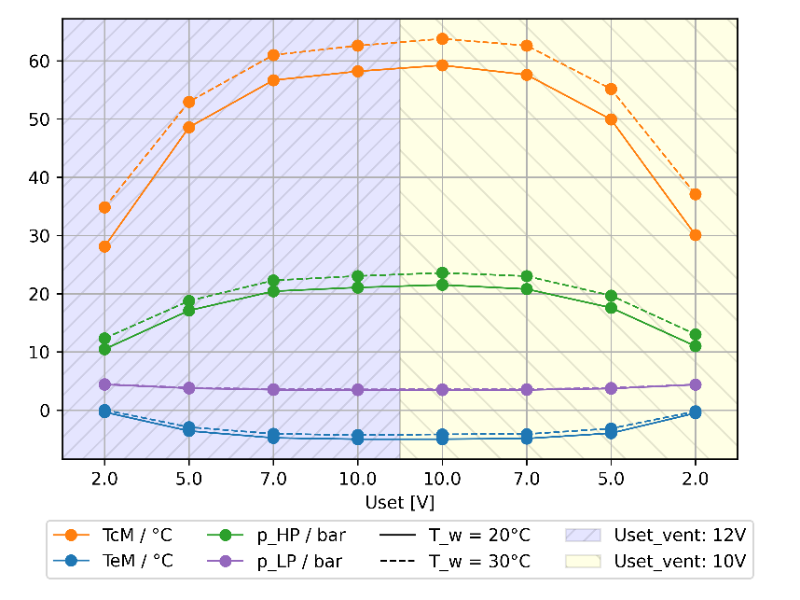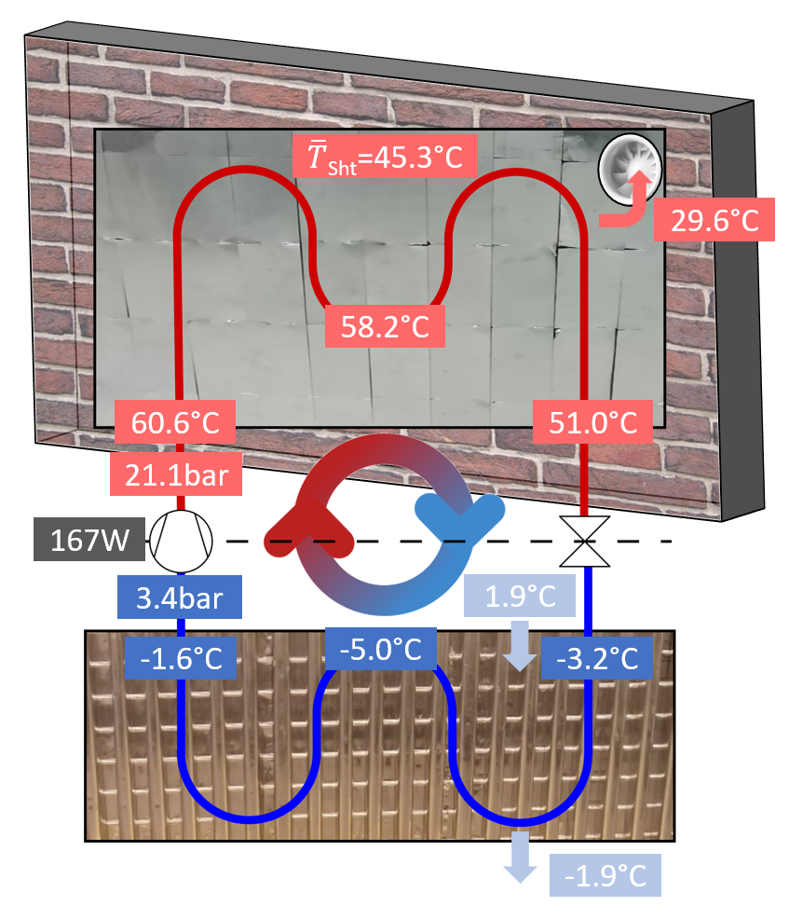
Figure 6: Results of the functional test sequence for the refrigeration circuit at 2 °C ambient temperature (left) and overview of conditions at the fronTherm module at a specific operating point (right)

In Figure 6 (left), the results of the standardized functional test sequence at an ambient temperature of 2 °C are shown. As expected, it is found that the compressor power level has the highest impact on the conditions within the refrigeration circuit. At the lowest power level, the condensation temperature is around 30 °C to 35 °C with pressure of 10.5 bar to 13 bar. The evaporation temperature is around 0 °C with a pressure of around 4.5 bar. At the highest power level, the condensation temperature can reach temperatures above 60 °C with pressures above 23.5 bar. The evaporation temperature is around -5 °C with a pressure of around 3.5 bar for the highest power. Furthermore, the decreased air volume flow has a minor influence on the refrigeration circuit. However, the change in air volume flow was rather little (15 m³/h to 13 m³/h). A significant higher effect is found for the variation of the water inlet temperature of the absorber circuit. This increases the condensation temperature by around 4 K and the corresponding condensation pressure by around 2 bar. For the practical application, this confirms that the wall temperature can be adjusted by controlling the compressor power level.
The results for the conditions at the fronTherm module at a specific operating point is shown in Figure 6 (right). The ambient temperature is around 2 °C, the compressor is set to full power, which is 167 W under this boundary conditions, the air supply volume flow is around 15 m³/h and the water inlet temperature of the absorber circuit is set to 20 °C. It is found that average temperature of the condenser sheet is around 45 °C and that the supplied heated air has a temperature of around 29.5 °C. This is considerably lower than expected and indicates that there are significant leakages in the air circuit, which will be addressed for the next prototype using a revised design of the sealing between module and wall.
- Conclusion and outlook
This work introduces the novel fronTherm modules – a facade heating, cooling and ventilation system. The operating principle as well as the prototype and experimental setup are presented and the experimental procedure is given. The experimental results confirm the functionality in a laboratory environment.
Preliminary tests with the module mounted on a glass plate identified a necessary improvement of the contact quality between the condenser sheet of the module and the wall to ensure efficient heat conduction. A black coating of the sheet can compensate for possible air gaps by increased thermal radiation.
For a functional test, the module is placed on a multi-layer wall including a absorber circuit and volume flow measurement to determine the thermal performance of the module under controllable boundary conditions. A standardized test sequence is presented and the results show the effects of variations of compressor power, air flow and wall temperature.
Future work will include the evaluation of the thermal performance measurements including the determination of efficiency values by applying the presented functional test sequence at different ambient temperatures. Further, the system test setup will be used to investigate the performance of the fronTherm system on a realistic wall. Finally, a residential building will be equipped with 6 fronTherm modules to test the system under real ambient and user conditions.
- Acknowledgements
The authors thank the German Federal Ministry for Economic Affairs and Energy for funding under FKZ 03EN6036D.
- References
[1]: Loga, Tobias et al.: Deut¬sche Wohngebäudetypologie – Beispielhafte Maßnahmen zur Verbesserung der Energieeffizienz von typischen Wohngebäu¬den. 2., erw. Auflage, IWU, 2015.
[2]: Walberg, Dietmar et al.: Wohnungsbau: Die Zukunft des Bestandes – Studie zur aktuellen Bewertung des Wohngebäudebe¬stands in Deutschland und seiner Potenziale, Modernisierungs- und Anpassungsfähigkeit. Baufor¬schungsbericht Nr. 82 der Arbeits¬gemeinschaft für zeitgemäßes Bauen e.V., 2022.

