CARBON/POLYAMIDE 6 Thermoplastic Composites for underwater applications

Mael Arhant¹, Pierre-Yves Le Gac¹, Maelenn Le Gall¹, Christophe Briançon² and Christian Burtin³, Peter Davies¹,

¹Ifremer, Marine Structures Laboratory, Centre de Bretagne, F-29280, France
Email: mael.arhant@ifremer.fr, Web Page: http://www.ifremer.fr
Email: pierre.yves.le.gac@ifremer.fr
Email: maelenn.le.gall@ifremer.fr
Email: peter.davies@ifremer.fr
²CETIM, Technocampus EMC2, F-44340, France
Email: christophe.briancon@cetim.fr, Web Page: http://www.cetim.fr
³Ecole Centrale de Nantes, Institut de Génie Civil et Mécanique (GeM), F-44321, France
Email: christian.burtin@ec-nantes.fr, Web Page: https://gem.ec-nantes.fr/

Keywords: Thermoplastic, Polyamide, Carbon fibres, Ageing, Hydrostatic pressure

Abstract

The composite materials used at sea are today nearly all based on thermoset resins (polyester, epoxy). However, there is an increasing number of thermoplastic matrix polymers available on the market (PP, PA, PPS, PEEK…), which offer possibilities for forming by local heating, attractive mechanical properties and the potential for end of life recycling. The main reasons for the slow adoption of these materials are that they require a completely different manufacturing route compared to the current materials, as they have a more complex microstructure, and that there is little experience with them, particularly for thick structures. The aim of this study was to design, manufacture and test thermoplastic composite pressure vessels for 4500 meter depth, in order to establish a technical, economic and ecological assessment of the use of these materials to replace traditional composites underwater. Finite element calculations have been carried out to optimize the stacking sequence with respect to the external pressure and buckling resistance. Thick thermoplastic cylinders were manufactured and tested until implosion, showing a good agreement with calculations. Overall the results show that it is possible to use C/PA6 thermoplastic composite cylinders for deep sea applications, as implosion pressures higher than 600 bar (6000 meter depth) were achieved.

1. Introduction

More than 70% of the oceans still remain unexplored and in order to reach these unexplored areas, it is necessary to design exploration and monitoring devices that are able to withstand high hydrostatic pressures. For many years, metals have been used underwater. However, due to their excellent specific properties, composite materials are starting to replace existing deep sea structures. The use of composites for pressure hulls of underwater vehicles and submarines has been an ongoing research topic for many years, since early work in the UK by Smith and colleagues in the 1970's [1]. Over the last 30 years, several metallic pressure hulls have been replaced by composite materials, for unmanned submersible vehicles and in the military area. Over the years, various US Navy and ONR (Office of Naval Research) programmes and several European projects (e.g. EUCLID RTP 3.8, DEVILS, MAST-AUV, MAST-Composite Housings), all of which IFREMER was involved in, have resulted in a solid database of test results from implosion studies on a range of materials and geometries [2]. Several academic studies have worked on the performance and the optimization of these pressure vessels underwater. These have included buckling [3], failure envelope determination [4], post buckling behaviour [5], and studies of winding angles [6].
Most of the composite materials used underwater today are thermoset-based (polyester, epoxy). These pressure vessels, initially manufactured by filament winding, require high thicknesses (more than 10 mm) and obtaining such thicknesses without defects is a real challenge; residual stresses and delaminations upon curing are common and can lead to premature failures. Moreover, these materials require long curing cycles that can be a limitation for the industry.
To prevent this, there is an increasing number of thermoplastic matrix polymers available on the market (PP, polyamide, PPS, PEEK, PEKK…), which offer possibilities for forming by local heating, attractive mechanical properties, good environmental resistance, the potential for end of life recycling and manufacturing times several orders of magnitude faster than their thermoset counterparts. More ductile, and repairable by local melting, they offer a real potential for greatly improved devices. From a scientific point of view, most of the previous studies conducted on these materials were focused on aircraft structures, i.e. thin structures, and several studies have made connections between manufacture and microstructure. Nevertheless, results concerning thermoplastic composite cylinders subjected to hydrostatic pressure are quite rare. A study in the USA on Carbon/PEEK (C/PEEK) was described by Gruber et al [7]. At Ifremer, studies were performed from 2000 onwards, to examine different thermoplastic matrix polymers for cylinders [8]. Early work by IFP and Aerospatiale in the 1980’s was followed by various other projects over the last 25 years to develop thermoset composite tubes with metal liners, and the publication of guidelines by the DNV. Other groups have focused on thermoplastic matrix composites, in particular the Dutch company Airborne which supplies down-lines for sub-sea intervention with various thermoplastic polymers and the British company Magma which is developing C/PEEK composites.
The objective of the current study was to manufacture thick thermoplastic composite cylinders (over 10 mm) by Laser Assisted Tape Placement that can resist high hydrostatic pressures (above 450 bar). Their behaviour has been compared to that of existing carbon/epoxy cylinders used at Ifremer for deep sea applications. These are 1.2 meters long, have an inner diameter of 120 mm and a thickness of 12 mm. In the literature, a significant amount of work has been performed concerning C/PEEK composites. However, for the application of interest, i.e., oceanographic applications, these are very expensive, so cheaper thermoplastics (Polyamide 6) have been investigated here: To the knowledge of the authors, no experimental results are currently available in the literature concerning the implosion of C/PA6 composites cylinders. Another aim of this study was to try and predict the implosion pressures of these materials, even if this subject is known to be difficult, as demonstrated by the World Wide failure exercise [4].
This work is also part of a project that included the durability of such hydrophilic polymers. It is not clear what their durability will be in such harsh environments when using such high thicknesses (>10 mm). Understanding and being able to predict the effect of prolonged deep sea immersion on both the water diffusion and the mechanical properties is essential when long service lives (several years) are considered. This has been addressed in recent research papers on the subject, in which a specific water diffusion model for Polyamide 6 has been proposed [9], and used to predict the evolution in mechanical properties in the neat Polyamide 6 [10]. This was then extended to Carbon/Polyamide 6 in [11]. Most of the results can be found in [12]

2. Materials and methods

2.1. Materials

The material of interest here is a C/PA6 pre-impregnated tape from Celanese® (reference: CFR-TP PA6 CF60-01). It has a fibre volume fraction of 48% and a thickness of 190 µm (information given by the supplier). The thermoplastic composite cylinders were compared to a carbon/epoxy used at sea at Ifremer for deep sea applications. It is a commercial wet filament wound carbon/epoxy cylinder and is made of HTS45 fibres and a proprietary epoxy matrix. It has a fibre volume fraction of 60%.

2.2. Manufacturing process

In 2013, the CETIM (Technical Centre of the Mechanical Industries), located in Nantes (France), invested in a Laser Assisted Tape Placement (LATP) machine. Controlling the process and its parameters (placement velocity, temperature, roller pressure, etc.) allows a thorough evaluation of the potential of these materials for such applications. This machine uses a Kuka robot coupled with an AFPT placement head, as shown in Figure 1.

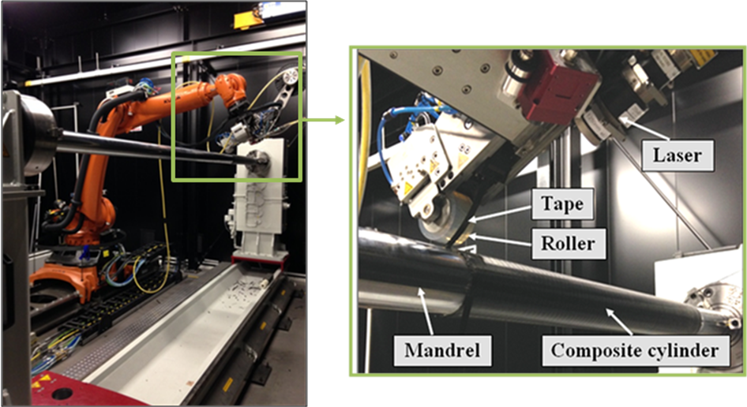
Figure 1. C/PA6 Thermoplastic cylinder manufactured by LATP at CETIM composite manufacturing facility using Kuka robot and AFTP heating head

Two different composite cylinders have been investigated here. First, the C/Epoxy reference was produced by wet filament winding at a sequence of [±55°] relative to the tube axis. Second, a C/PA6 thermoplastic composite cylinder was manufactured by Laser Assisted Tape Placement at the CETIM composite facility in Nantes. It was wound using an optimised sequence [0/±88°]. It has been shown and stated several times in the literature that this sequence should perform better than the [±55°] sequence when subjected to hydrostatic pressures [3]. The dimensions, sequences and geometry of the different composite cylinders are presented in Table 1.

Table 1. Dimensions and geometry of the cylinders tested during this work

Tube | Length (mm) | Inner Diameter (mm) | Wall thickness (mm)
C/Epoxy ±55 | 600 | 120 | 12.7
C/PA6 0/±88 | 500 | 100 | 12.1

The first cylinder was manufactured on a mandrel of 120 mm diameter and the second one was manufactured using a mandrel of 100 mm diameter. It may be noted that the second cylinder, laid at [0/±88°], was manufactured with reinforcements at the end of the cylinder to prevent failure at this location. The process parameters used to manufacture the thermoplastic cylinder are shown in Table 2. These were optimised over time following the reception of the LATP machine by the CETIM. The processing temperature was optimised using an infrared camera close to the laser head that allowed parameters to be adjusted in order to obtain an homogeneous temperature field all along the process. Moreover, it may be noted that for the application of interest, i.e. deep sea applications, the loading is of a compressive nature, and it is clear for these applications that the fibres need to be straight to avoid microbuckling, which is known to limit the compressive properties, so the overlaps were limited here.

Table 2. Process parameters used for manufacturing thermoplastic composite cylinders

Material | Sequence | Laying speed (m/min) |  | Temperature (°C) | Roller pressure (bar)
C/PA6 | [0/±88]₂₆ | ± 88° | 6.3 | 280 | 3
C/PA6 | [0/±88]₂₆ | 0° | 3.0 | 300 | 3

2.3. Implosion tests

The two cylinders were tested to implosion in a 2400 bar capacity pressure vessel at IFREMER in Brest, with continuous recording of pressure, temperature and strain gauge measurements. The pressure was increased at 12 bar/min until failure. The pressure vessel is shown in Figure 2.A together with the C/PA6 cylinder just before test. Strain gauges were bonded around the perimeter at the centre of the cylinder, as shown in Figure 2.B. Using this number of strain gauges allows the determination of whether the cylinder implodes due to buckling or due to materials failure (compression).

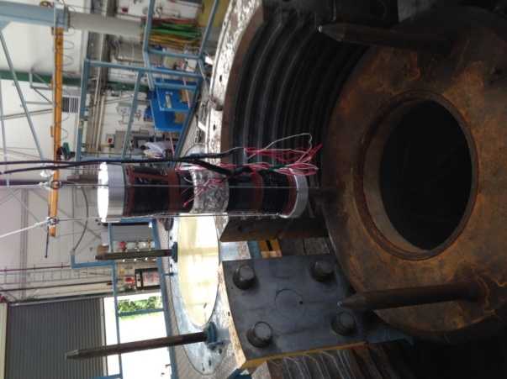  (A) | 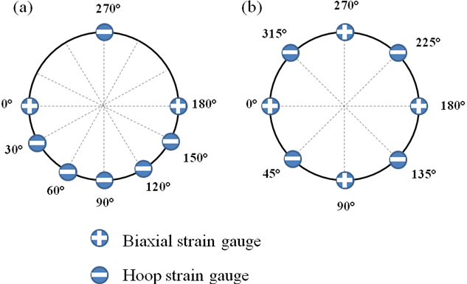  (B)

Figure 2 : (A) 2400 bar pressure used for implosion test showing the 100 mm diameter C/PA6 cylinder right before test (B) Strain gauges configuration used for the composite cylinders (a) C/Epoxy [±55] (b) C/PA6 [0/±88]

Also, for each implosion test, end covers were bonded to the cylinder extremities in order to protect the ends and provide a suitable surface to seal the end plates. Then, the strain gauges have to be protected from water and connected to the recording system. Each end fixture is specifically designed for a given cylinder.

2.4. Finite element modelling

Finite element calculations have been performed on the C/PA6 cylinder in order to analyse the implosion tests that were performed here using the commercially available software Abaqus. The mechanical property input values were measured on composite panels manufactured by thermo-compression within the same project [11]. The composite cylinders were meshed using hexahedron elements (type C3D8R), 7 through-thickness elements were used. The end covers were also meshed using hexahedron elements. The interface between the composite tube and the end covers is considered without friction. The tube and the end fixtures are blocked in axial displacement in order to avoid rigid body movements without affecting the external pressure. The pressure is applied on the lateral faces of the end fixtures and on the external surface of the composite cylinder. An axial load is also applied and equal to the hydrostatic pressure divided by the end covers' section.

3. Results & Discussion

3.1. Quality control

Ultrasound inspection is of particular interest here because it allows the overall quality of a given cylinder to be checked at a relatively low cost compared to X-Ray Tomography. With ultrasonic C-scan, the through thickness attenuation of an entire cylinder can be investigated. However, the results that are obtained are only qualitative and not quantitative. A Sofratest ultrasonic inspection system was used to measure through thickness attenuation using 2 MHz focused transducers by placing the cylinder on a rotating table in a water tank. The attenuation levels provide a rapid indication of the overall quality in terms of voids. Results are shown in Figure 3, in which low attenuations levels are shown in red and high attenuation levels are shown in blue and black. It may be noted that the colour scales are different for the two cylinders and that the control of the entire cylinder is in accordance with the mapping presented here.

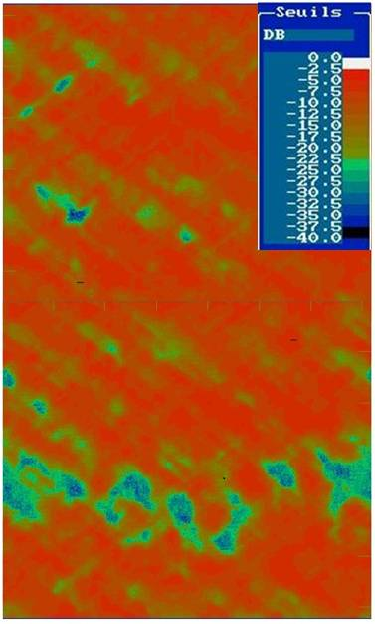 | 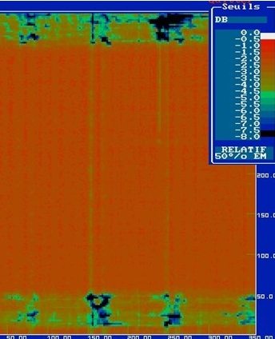
(A) | (B)
Figure 3. Results from Ultrasonic C-scans of (a) C/Epoxy [±55] (b) C/PA6 [0/±88]

Based on Ifremer's experience [8], high levels of through thickness attenuation (over 20dB) usually correspond to the presence of significant voids. On the other hand, low levels of attenuation (below 10dB) indicate a good cylinder quality for this wall thickness. These ultrasonic C-scans highlight two main results. First, it is shown that the C/Epoxy cylinder, Figure 3.A, has high localised levels of attenuation, meaning that there are defects at these locations. On the contrary, the carbon/polyamide 6 cylinder is of very good quality (the attenuation scale is much smaller, below 8dB), Figure 3.B. Voids are mostly localised at the end of the thermoplastic cylinder (in the reinforcements). These US inspection results show that the thermoplastic composite cylinder that was manufactured at the CETIM composite facility by Laser Assisted Tape Placement is of excellent quality in terms of voids compared to the C/Epoxy cylinder processed by wet filament winding. These results were confirmed by X-ray tomography.

3.2. Implosion tests

Once the quality of the two cylinders had been checked, implosion tests were performed in a hyperbaric chamber at 12 bar/min until failure. It may be noted that the cylinders were partially filled with water to limit the shock wave at implosion that can damage the pressure vessel.

3.2.1. Implosion test on C/Epoxy cylinder wound at [±55]

The carbon/epoxy reference cylinder imploded at a pressure of 77.2 MPa (772 bar). The strain gauge data in the hoop direction are plotted radially in Figure 4 for different pressures until failure. This type of representation allows the type of failure to be determined, i.e. either buckling or compression failure. It may be noted that the strain gauge data presented here are of compressive nature.

Figure 4. Radial plot of the hoop strains in the C/Epoxy cylinder wound at [±55]

The black line represents the compressive strain response just before implosion. An elliptical shape is identified before failure, suggesting that the failure mode was overall buckling (mode II) of the C/Epoxy cylinder. These C/epoxy cylinders are used today in applications down to 4500 meters (around 450 bars). Therefore, a safety factor of 1.7 is applied when working at 450 bars compared to the implosion test pressure. This first implosion test represents the implosion pressure reference that is targeted for the thermoplastic composite cylinders.

3.2.2. Implosion test on C/PA6 cylinder wound at [0/±88]

The C/PA6 cylinder imploded at a pressure of 61 MPa (610 bar). The strain gauge data in the hoop direction are plotted radially at different pressures along the test until failure in Figure 5.
Figure 5. Radial plot of the hoop strains in the for the C/PA6 cylinder laid at [0/±88]

Unlike the first cylinder's response, the plots presented in Figure 5 do not tend towards an elliptical shape at failure. this suggests a different failure mode (compression failure) for this thermoplastic cylinder with the optimized sequence. These results also show that it is possible to use these thermoplastic composites at depths down to 4000 meters with a safety factor of 1.5.
The results were then compared to the finite element calculation results. The response in terms of strains as a function of hydrostatic pressure until failure is presented in Figure 6.
Figure 6 : Experimental hoop strains compared to the finite element calculations

The results show an excellent agreement between the experimental data and the finite element prediction. In addition, the in-plane compressive stresses (σ₁₁) within the tube at 610 bar were found to be close to 450 MPa, which is relatively low. To compare these results, uniaxial compression tests performed on unidirectional specimens manufactured by press forming in [11] gave results slightly above 500 MPa. This is quite close to the values found by finite element calculations. However, it is known that predicting the failure of such thick structures is difficult, as highlighted in reference [4].

5. Conclusion

The aim of this paper was to study the implosion performance of thermoplastic composite cylinders compared to the C/Epoxy reference used today at Ifremer. First, the quality of these cylinders was checked using Ultrasonic C-scan and X-ray tomography. Results from ultrasonic C-scan showed high levels of attenuation (>20dB) in the C/Epoxy cylinder and very low attenuation levels were found in the C/PA6 cylinder (<8dB). These results indicate that the thermoplastic composite cylinder is of a much better quality in terms of voids than the thermoset counterpart. These results were also confirmed by X-ray tomography. Results from finite element analysis showed a very good correlation between the experimental results and the prediction concerning the cylinder laid at 0/±88. Results showed a higher implosion pressure for the C/Epoxy reference, at 772 bar. The C/PA6 stacking sequence was optimised to 0/±88°, which provides a much stiffer behaviour than the ±55° angle. This cylinder imploded at 610 bar. This value is still lower than the C/Epoxy counterpart but one has to keep in mind that the fibre volume fraction for the thermoplastic cylinders is lower than that of the C/Epoxy (0.48 for C/PA6 and 0.6 for C/Epoxy).
Finally, these tests show that it is possible to use C/PA6 cylinders for underwater applications at depths down to 4000m (with a safety factor of 1.5), but further study is needed to achieve equivalent performance to the carbon/epoxy cylinders.

References

[1] C. S. Smith, ―Design of submersible pressure hulls in composite materials,‖ Mar. Struct., vol. 4, no. 2, pp. 141–182, 1991.
[2] D. Graham, ―Eighth International Conference on Composite Structures, Composite pressure hulls for deep ocean submersibles,‖ Compos. Struct., vol. 32, no. 1, pp. 331–343, Jan. 1995.
[3] T. Messager, M. Pyrz, B. Gineste, and P. Chauchot, ―Optimal laminations of thin underwater composite cylindrical vessels,‖ Compos. Struct., vol. 53, no. Issue 3, pp. 301–307, 2001.
[4] M. J. Hinton, P. D. Soden, and A. S. Kaddour, ―Strength of composite laminates under biaxial loads,‖ Appl. Compos. Mater., vol. 3, no. 3, pp. 151–162, 1996.
[5] S.-H. Hur, H.-J. Son, J.-H. Kweon, and J.-H. Choi, ―Postbuckling of composite cylinders under external hydrostatic pressure,‖ Compos. Struct., vol. 86, no. 1–3, pp. 114–124, Nov. 2008.
[6] C.-J. Moon, I.-H. Kim, B.-H. Choi, J.-H. Kweon, and J.-H. Choi, ―Buckling of filament-wound composite cylinders subjected to hydrostatic pressure for underwater vehicle applications,‖ Compos. Struct., vol. 92, no. 9, pp. 2241–2251, Aug. 2010.
[7] M. B. Gruber, M. A. Lamontia, M. A. Smoot, and V. Peros, ―Buckling Performance of Hydrostatic Compression-Loaded 7-Inch Diameter Thermoplastic Composite Monocoque Cylinders,‖ J. Thermoplast. Compos. Mater., vol. 8, no. 1, pp. 94–108, Jan. 1995.
[8] P. Davies, ―Thermoplastic Composite Cylinders for Underwater Applications,‖ J. Thermoplast. Compos. Mater., vol. 18, no. 5, pp. 417–443, Sep. 2005.
[9] Arhant, M., Le Gac, P. Y., Le Gall, M., Burtin, C., Briançon, C., & Davies, P. (2016). Modelling the non Fickian water absorption in polyamide 6. Polymer Degradation and Stability, 133, 404-412.
[10] Le Gac, P. Y., Arhant, M., Le Gall, M., & Davies, P. (2017). Yield stress changes induced by water in polyamide 6: Characterization and modeling. Polymer Degradation And Stability, 137, 272-280.
[11] Arhant, M., Le Gac, P. Y., Le Gall, M., Burtin, C., Briançon, C., & Davies, P. (2016). Effect of sea water and humidity on the tensile and compressive properties of carbon-polyamide 6 laminates. Composites Part A: Applied Science and Manufacturing, 91, 250-261.
[12] Arhant, M., Burtin, C., Briançon, C., & Davies, P. (2016). Thermoplastic composites for underwater applications. PhD thesis. https://hal.archives-ouvertes.fr/tel-01668495/document

