Modified-PEEK matrix carbon fiber composites
for aerospace application

T. Hayashi¹ and T. Ishikawa²

^{1,2}Advanced Moldings and Composites Laboratory, Mitsubishi Chemical Corporation,
1-2, Ushikawa-dohri 4-chome, Toyohashi-shi, 440-8601, Japan
Email: ¹hayashi.takahiro.mx@m-chemical.co.jp,
Email: ²ishikawa.takeshi.me@m-chemical.co.jp,
Web Page: https://www.m-chemical.co.jp/en/index.html

Keywords: carbon fiber, thermoplastics, aerospace, composites

Abstract
Regarding heat resistance and chemical resistance of polymers in composite materials, neither conventional PPS, PEI nor PEEK matrix composite is enough in the aerospace industry. Therefore, we have developed modified-PEEK resins, which resulted 20°C higher T_{g} than conventional PEEKs by adding a higher Tg material. In this study, we showed some properties of modified-PEEK matrix carbon fiber composites, such as mechanical property in higher temperature, fluid resistance and flammability. These results indicated that the modified-PEEK composites should be applicable for aerospace structural components.

1. Introduction

Carbon fiber reinforced plastics (CFRPs) have been applied as lightweight materials for high fuel saving in aerospace and automotive industries. Especially, carbon fiber reinforced thermoplastics (CFRTPs) have been focused on excellent properties of impact resistance, a short molding cycle and recyclability. Recently a composite material has been adopted for a component in an aero engine of the Airbus A320 neo using an advanced thermoplastic as a matrix resin because of its excellent impact resistance[1-2]. Among some advanced thermoplastics, PEI (polyetherimide) resin is one of the most popular resins to be used for airplane components because of its cost and heat resistance. However, fluid resistance of some PEI resins shows poor to some solvents, as shown in Table 1. So some surface treatments must be required to preserve the PEI composite products during long running of aircrafts. On the other hand, PEEK (polyetheretherketone) resins have a great property of fluid resistance, however Tg (glass transition temperature) of the resin, showing an index of heat resistance, is relatively low. Therefore, we have developed modified-PEEK resins, which show higher Tg than conventional PEEK as shown in Table 1, by adding a higher Tg material. In this study, we measured some properties of modified-PEEK composites, such as heat resistance, fluid resistance and flammability.

Table 1. Advantages and disadvantages of thermoplastic matrix resins for aerospace application.

Matrix resin | PPS | PEI | PEEK | Modified-PEEK
Polymer type | Crystalline | Amorphous | Semi-crystalline | Semi-crystalline
Mechanical property | ＋ | ＋ | ＋＋ | ＋＋
Moldabilitiy | ＋ | ＋ | 0 | 0
Heat resistance | 0 | ＋ | ＋ | ＋＋
Fluids resistance | ＋ | － | ＋ | ＋

2. Experiment

2.1. Materials procedure

We used several thermoplastic prepregs to compare with modified-PEEK composites. Carbon fiber Pyrofil MR50R (Mitsubishi Chemical) is used as reinforcement in the modified-PEEK prepregs. Modified-PEEK film was fabricated, mixing PEEK resin and the higher Tg material. Thermoplastic UD prepregs were produced by film stacking method using the carbon fiber and the film, whose fiber areal weight is 75 g/m² and resin content is 34%. Laminated UD prepregs were heated up to 380~400°C on hot platen and cooled down to 200°C on cold platen by a double platen hydraulic press, as shown in Fig 1. Cooling rate of the molding was around 100°C/min. All lamination for each measurement in this study is described in Table 2. We fabricated two kinds of modified resin; modified-PEEK1 and modified-PEEK2 in this study. In modified-PEEK2, content of higher Tg materials is 1.5 times larger than that in modified-PEEK1.

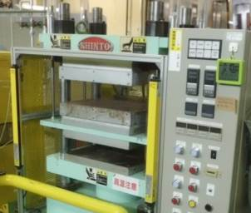

Figure 1. Double platen hydraulic press, upper platen is hot press and lower is cold press.

Table 2. All laminations and thickness for each measurement

Measurements | Temperature dependence of transverse strength | Fluid resistance on transverse strength | Flammability
Lamination | [90]₂₈ | [90]₂₈ | [0]₄₂
Thickness | 2 mm | 2 mm | 3 mm

2.2. Measurements

T_{g} of composites was measured by dynamic mechanical analyzer (Q800, TA instrument) in bending mode, where test frequency is 1 Hz and heating speed is 5°C/min. In order to investigate temperature dependence of transverse (90°) strength of composites, three-point bending tests were performed, based on ASTM D790 at room temperature (RT), 121, 141 and 160°C. For fluid resistance, some specimens, prepared as same dimension for the described bending test, were soaked in the Jet fuel (JET A-1) or MEK (methylethylketone) solvent at room temperature. After two weeks, the bending test was conducted to measure transverse strength affected by the two fluids. In order to obtain flammability of composites, OSU-HRR (Heat release rate) was measured by a fire instrument (RHR-1-X, Govmark) for 5 minutes as shown in Fig. 2. The fire test is based on FAR Part 25 appendix F part IV, where maximum HRR during the test and total HR at 2 minutes should be less than 65 kWmin/m² and 65 kW/m², respectively, to pass aerospace applications.

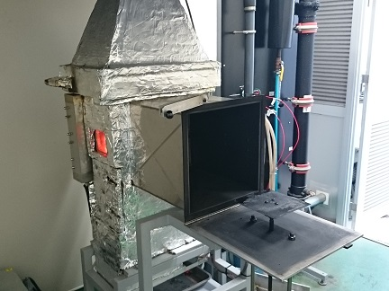

Figure 2. Fire instrument for OSU heat release rate.

3. Results and discussions

3.1. Heat resistance

Fig. 3 shows T_{g} of some thermoplastic composites, measured by dynamic mechanical analyzer. In this figure, T_{g} of PEEK, PEI, PEKK are reasonable, referring T_{g} of their neat resin. In the case of modified-PEEK1 and modified-PEEK2, T_{g} of the two composites resulted 165°C, which is 20°C higher than conventional PEEK composite.

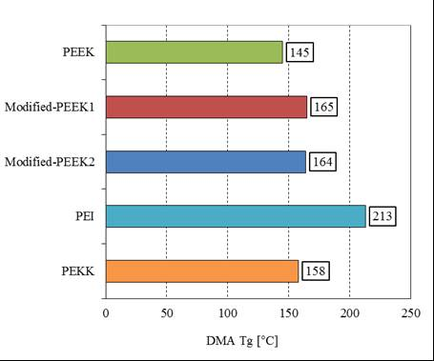

Figure 3. T_{g}s of thermoplastic composites by DMA.

Fig. 4 shows temperature dependence of the transverse flexural strength of the several thermoplastic composites. In the case of PEEK composite, the flexural strength around 140°C, which is around T_{g} of PEEK resin, decreased to 80% compared with that at room temperature.

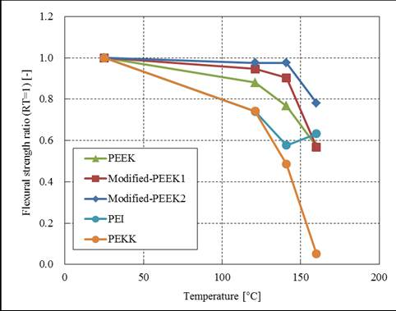

Figure 4. Temperature dependence of transverse flexural strength of thermoplastic composites.

For the two kinds of modified-PEEK composites, the flexural strength around 140°C decreased to 90~95%. And also strength of modified-PEEK2 composite at 160°C decreased to 80%, compared with that at room temperature. Then, the decrease of the strength of modified-PEEK composites resulted lower than that of PEEK composite over 120°C, because T_{g}s of the modified-PEEK resins increased. Although PEI and PEKK composites show higher T_{g}, their transverse flexural strength drastically decreased around 120~160°C. This result can be rationalized as follows. Same behavior were reported about PEI and PES (polyethersulfone) matrix composite [3, 4], which are amorphous polymers. Thus, we consider that amorphous polymer matrix composites show the decrease of strength below their T_{g}s. For PEKK composite, cooling rate was so rapid in molding, and then crystallization of PEKK polymer was lower and not enough, than molded by longtime autoclave. Consequently, we showed two kinds of modified-PEEK composites had higher actual heat resistance, regarding transverse strength of composite.

3.2. Fluids resistance

Fig. 5 shows transverse flexural strength of some PEEK composites after soaking in the fluids for two weeks. In the case of PEEK composite, transverse flexural strength hardly decreased after soaking in MEK and Jet fuel. On the other hand, strength of modified-PEEK1 composite decrease to 95% and that of modified-PEEK2 deceases to 90%, compared with that in dry condition.

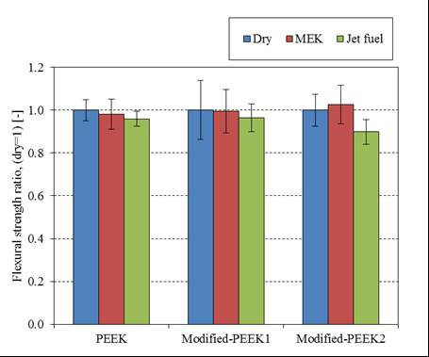

Figure 5. Transverse flexural strength of thermoplastic composites after fluid test.

3.3. Flammability

Fig.6 shows fire test result of some thermoplastic composites. All thermoplastic composites with thickness of 3 mm were passed in FAR fire test standards, because maximum HRR and total HR at two minutes were less than 65 kW/m2 and 65 kWmin/m2, respectively. By comparing each composite, maximum HRR and total HR at two minutes of modified-PEEK1 and modified–PEEK2 composites were almost equivalent as PEEK and PEI composites, and lower than PPS composites.

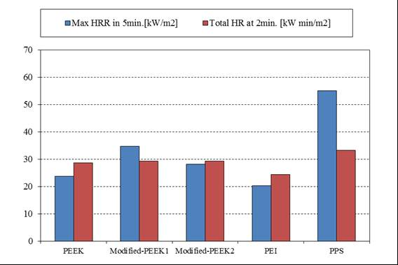

Figure 6. Maximum HRR during fire test and total HR at two minutes of thermoplastic composites.

4. Conclusions

In this study on our developed modified-PEEK composites, we can obtain following conclusions.

- Transverse flexural strength decreased to 90~95% around 140°C and decreased to 80% at 160°C, compared with that at room temperature. The retention ratio in strength around the 140~160°C are higher than other thermoplastic composites.
- After jet fuel soaking test for two weeks, transverse strength of modified-PEEK1 composite decrease to 95% and that of modified-PEEK2 deceases to 90%, compared with that in dry condition.
- By FAR fire test, maximum HRR and total HR at two minutes of modified-PEEK1 and modified–PEEK2 composites were passed and almost equivalent as PEEK and PEI composites, and lower than PPS composites.

References

- T. Murakami, H. Morita and K. Oikawa. Development of composite fan system”, IHI technical report, 53(4): 63-67, 2013.
- “Winners of JEC innovation awards announced”, Composite World, January 2017, https://www.compositesworld.com/news/winners-of-jec-innovation-awards-announced-, accessed December 2017.
- R.Frassine and A. Pavan. Viscoelastic effects on the interlaminar fracture behaviour of thermoplastic matrix composites: I. Rate and temperature dependence in unidirectional PEI/carbon-fibre laminates. Composites Science and Technology 54:, 193-200, 1995.
- T. Irisawa, Y. Tanabe, R. Hashimoto, N. Nagao and M. Arai. The study of interfacial shear strength between thermoplastics having high thermal stability and carbon fiber. Proceeding of JISSE15 (15th Japan International SAMPE Symposium and Exhibition), 1C03, 2017.

