Structural and Optical Properties of Se-doped CdS nanorods Grown by PVD method
Mohammad Amin Baghchesara¹*, Ramin Yousefi², Mohsen Cheraghizade³
¹Department of Metallurgy and Materials Engineering, Masjed-Soleiman Branch, Islamic Azad University, Masjed-Soleiman, Iran
²Department of Physics, Masjed-Soleiman Branch, Islamic Azad University, Masjed-Soleiman, Iran
³Young Researchers and Elite Club, Ahvaz Branch Islamic Azad University, Ahvaz, Iran
**Corresponding authot. E-mail: amsara2000@gmail.com, Tel: (+98) 9194798823; Fax: (+98) 614260093;

Keywords: Se-doped CdS nanorods, Undoped CdS nanorods, Anionic doping, PVD, EDX, SEM, XRD, Photoluminescence, UV-visible.

Abstract
In this work, the optical properties of Se-doped CdS and undoped CdS nanorods, were grown on Si substrate using physical vapor deposition (PVD) method, were investigated. The average diameter sizes of the Se-doped CdS and undoped CdS nanorods were 416 and 1100 nm, respectively. In addition, the Energy Dispersive spectroscopy (EDS) analysis confirmed the presence of Cd, S and Se in the CdS nanostructure. X-Ray diffraction (XRD) results were confirmed by the standard data CdS card. Furthermore, the XRD confirmed that selenide was incorporated into the crystal structure, successfully. Optical studies were done using UV-Visible and Photoluminescence (PL) spectroscopy. The PL exhibited partly similar with different intensity optical properties for the Se-doped CdS and undoped CdS nanorods. In addition, the visible peak of the Se-doped CdS nanorods was redshifted with respect to that of the undoped CdS nanorods. Finally, nanostructures bandgap were determined by analyzing UV-Visible spectra results.

1. Introduction
CdS, as one of the most semiconducting materials, has a wide range of applications owing to its type of structure, electronic distribution, and polarity [1-2]. In addition, it has received considerable attention during recent years because of their numerous excellent properties in optoelectronic, photonic, photovoltaic fields [3-11]. CdS belongs to Cadmium Chalcogenide family. It is an II-VI wide direct band gap (2.42 eV) semiconductor. This particular property makes it a key element for solar cell applications. As is well known, the impurity-doping of semiconductors with selective elements greatly affects their basic physical properties such as their morphological, electrical, optical, and magnetic properties, which are essential for their practical application. In last decades, many efforts have been carried out to the production of high quality CdS nanostructures with various techniques, and its investigation. However, it seems that less attention has been paid to the anionic doping effect (as different point of view) on the morphology of CdS nanostructures and their optical properties.
According to the mentioned reason, in this research, Se-doped CdS nanostructures were grown on silicon substrates using a thermal evaporation method as simple and economic with low temperature operation technique. The effects of selenide presence as an anionic dopant on the morphology and optical properties of the CdS nanostructures were characterized using scanning electron microscope (SEM), X-ray diffractometer (XRD), photoluminescence (PL), and UV-visible spectrometers.

2. Experimental
The growth of Se-doped CdS nanostructures was performed in a horizontal furnace. This system included a quartz tube vacuum chamber that contained the precursor materials (CdS and Selenide) and substrate was placed within the vacuum chamber. First, n-type Si <100> substrates were cut in 1×1 dimension. They were then lightly rinsed with an HCl, NH₄OH and HF with de-ionized water mixture separately for about 10 min in order to remove the alkaline dopants, acidic dopants and native oxide layer, respectively. Finally, Si substrates were ultrasonically cleaned for about 10 min at 30 ºC using ethanol and de-ionized water and were dried immediately. Cadmium sulfide (CdS) powder (99.99%) and Selenide (Se) powder (99.99%) were used as the base material and anionic dopant material, respectively. The CdS powder was placed at the closed center of the furnace quartz tube and a Si <100> substrate was situated downstream of the precursor materials (about 32-42 cm away from the center of the furnace), while the selenide powder was placed on the opposite side of the substrate, with respect to the CdS alumina boat. CdS and Se were heated to 500 and 220 ºC resp., and the temperature of the substrate during the growth process for the Se-doped CdS nanostructures was maintained at different temprature (370/400/430) ºC. High purity Ar gas was fed at about 20 mmg into the furnace, while the furnace had been connected to a rotary pump with the constant pressure of 720 mmg. The growth process was allowed to proceed for 90 min. A vacuum of 50 Torr was maintained inside the tube furnace during the deposition of the nanostructures. Undoped CdS were also grown under the same conditions using a catalyst-free substrate.
The crystal structure and morphology of the products were investigated using a field emission scanning electron microscope (FESEM, Quanta 200 F) and an X-ray diffractometer (XRD, Siemens D5000). The elemental contents of the products were investigated using energy dispersive X-ray analysis (EDX, Quanta 200 F). Room temperature photoluminescence (Varian-Cary Eclipse) and UV-Visible (Perkin Elmer UV winLab lambada 900) spectroscopy were employed to study the optical properties and crystallinity of the Se-doped CdS and undoped CdS nanorods. A He–Cd laser with a wavelength of 350 nm was used for the PL measurements.

3. Results and discussion
SEM was performed for magnified image of the produced samples. Scanning electron micrographs of the Undoped CdS and Se-doped CdS nanostructures were presented in Figs. 1(a) and 2(a). The images show the nanorod and broken nanorod shape for Undoped CdS and Se-doped CdS, respectively. It could be observed that with Se-doping to the CdS nanostructure, the average sizes of prepared samples are decrease to 416 nm (form/ out of 1100 nm for Undoped CdS nanorods). Energy Dispersion X-ray analysis (EDX) was also done to confirm the presence of possible elements in the manufactured specimens. Figs. 1(b) and 2(b) are the EDX spectrum of Undoped CdS and Se-doped CdS, and it reveals the presence of Cd, S, Se and Si (as because of deposition on Si substrate).
Further detailed structural analysis of CdS nanostructures was performed using an X-ray diffractometer (XRD). During the characterization procedure of XRD, CoKα (λ= 1.5406 Å) laser is used. Fig. 3 shows the diffraction pattern of Undoped CdS nanorod on Si. Here, three peaks were identified; (111) at 24.53º, (200) at 29.95º and (222) at 54.82º. All these peaks were matched with standard data card of CdS (JCPDS card no. 00-042-1411). Peak number three has the lowest full width at half maximum (FWHM), which indicates better crystalline properties of nanostructures that have grown in this position. Therefore, it should have a minimum line defects density. Fig. 3 represents XRD patterns of the Undoped CdS and Se-doped CdS nanorod. As can be seen, the XRD pattern peaks of Se-doped CdS were totally accepted with that of the Undoped CdS nanorod. As same as demonstrated for peak No. 3 for Undoped CdS, peak No. 1 of Se-doped CdS has the lowest FWHM, so this position could be a suitable place for better crystalline properties of nanostructures.
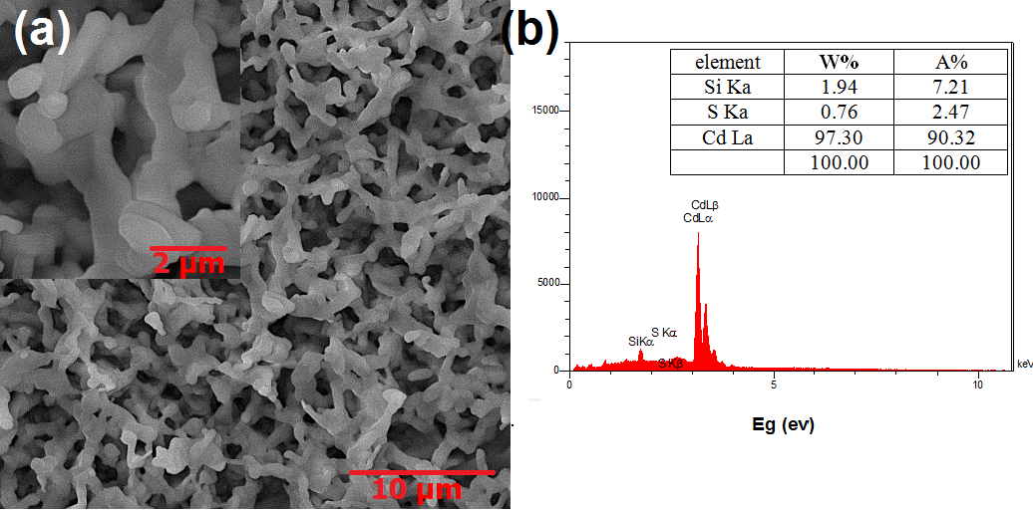
Fig. 1(a) SEM image of undoped CdS nanorods. (b) EDX spectra of undoped CdS deposited on Si

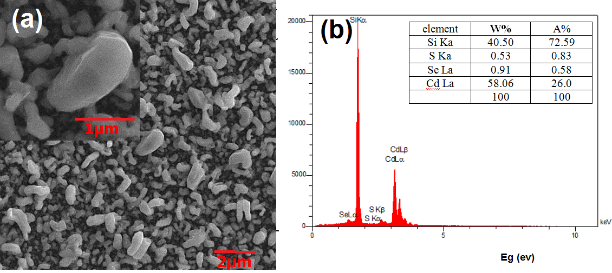
Fig. 2(a) SEM image of Se-doped CdS nanorods. (b) EDX spectra of Se-doped CdS deposited on Si.

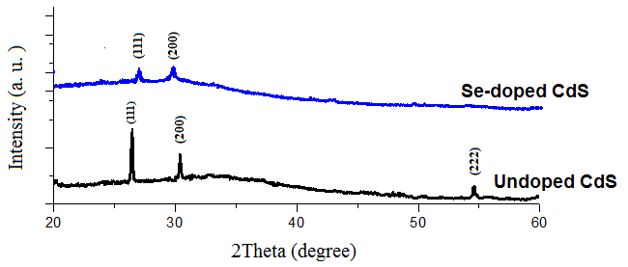
Fig. 3 XRD results of undoped CdS accompany with Se-doped CdS.
The ionic radius of the substitute Se²⁻ (r _{Se}²⁻ = 1.98 Å) is bigger than that of S²⁻ (r _{S}²⁻ = 1. 84 Å). Thus, doping with Se causes a slight shift in the peaks toward lower diffraction angles. This shift is shown in Fig. 3. This result means that selenide is incorporated into the crystal structure, causing the CdS crystal lattice to expand. On the other hands, decreasing in XRD peaks intensity accompany with increasing the FWHM for Se-doped CdS compared to the Undoped CdS samples, resulted in diminishing the crystalline properties.
PL study is a powerful method for investigating purity approximation or the effects of impurity doping on optical properties of CdS nanostructures, because doped CdS nanostructures are expected to have different optical properties in comparison with undoped CdS. Fig. 4 shows the room temperature and at a region from 300 nm to 700 nm, PL spectra of the undoped CdS and Se-doped CdS nanorods. It is well known that CdS nanorods produced a photoluminescence emission peak in the blue, green and red region of the electromagnetic spectrum (visible area). As shown in Fig. 4, the PL spectra show strong peaks at 554 nm and 555 nm for the undoped CdS and Se-doped CdS nanorods, respectively, in the visible region (380–750nm). Compared with the undoped CdS nanorods, the PL spectrum of the Se-doped CdS nanorods shows an obvious redshift in the visible emission towards upper/ higher wavelengths. This redshift in the visible emission is because of the Se doping and its effect as impurity in the CdS nanorods. Consequently, it makes a reducing trend in the band gap of Se-doped CdS with respect to that of the undoped CdS nonorods. Also, enhancing the Se-doped CdS intensity peaks in comparison with undoped CdS, indicates a significant decrease in surface to volume ratio of nanostructures.That, could be clearly seen in the SEM micrographs. Finally, The full width at half maximum (FWHM) of the UV peak of the Se-doped CdS nanorods (34.12 nm) is smaller than that of the undoped CdS nanorods (37.58 nm).

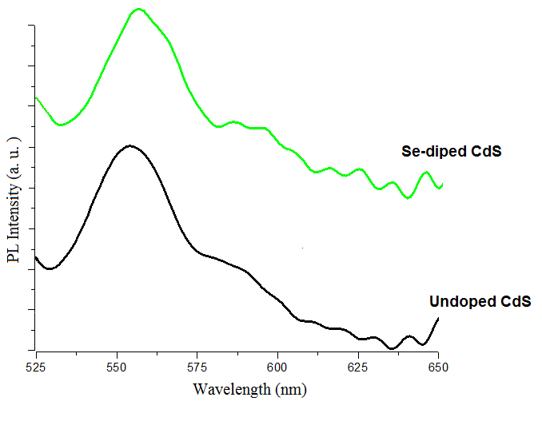
Fig. 4 Photoluminescence spectra of undoped CdS accompany with Se-doped CdS.
Addition of the PL, analysis of CdS samples were carried out using UV-Visible spectroscopy. This characterization method is generally used in order to bandgap determination. UV-visible spectroscopy was performed in room temperature. The UV-Visible spectra for the undoped CdS and Se-doped CdS nanorods are presented in Fig. 5. As known, the bulk bandgap of CdS is 2.42 eV.

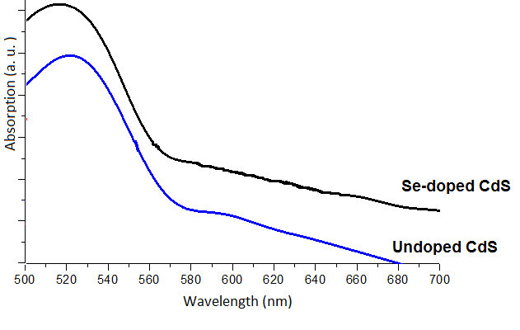
Fig. 5 UV-Visible spectra of undoped CdS accompany with Se-doped CdS.
Beside, the bandgap of produced samples: undoped CdS and Se-doped CdS nonorods were calculated by Tauc’s formula (figs. 6 (a), (b)), which is defined as
(αhν)^{1/n} = B(hν-E_{g}) Equ. (1)
Where, α is the absorption coefficient, h is the Planck’s constant, v is the frequency of vibration, B is the proportionality constant and Eg is the characteristic bandgap.
Depicted diagrams (figs. 6 (a), (b)) according to the mentioned formula show 2.23 and 2.14 eV for undoped CdS and Se-doped CdS nanorods, respectively. These determined bandgap values compared to the direct CdS bandgap (2.42 eV) represents a redshift due to the increasing surface and density with the reason of / based on defects on higher level positions. From another point of view, undoped CdS bandgap with respect to that of the Se-doped CdS nanorods has a redshift, causing by increasing Selenide as impurity. Thus, the presence of Selenide in nanocrystals decreases the optical bandgap of nanostructures.

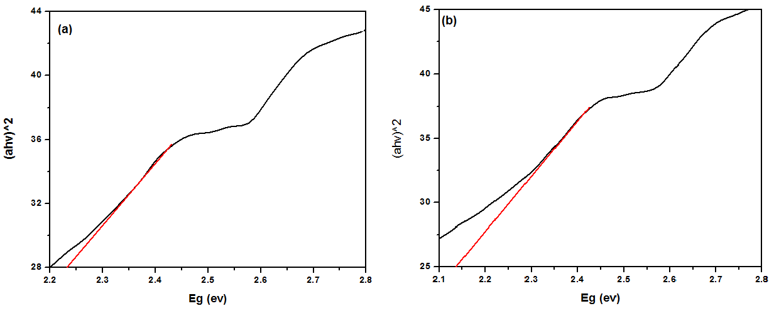
Fig. 6 Tauc’s digram bandgap determination for (a) undoped CdS nanostructures, (b) Se-doped CdS nanostructures.

4. Conclusion
The Se-doped CdS and Undoped CdS nanorods were successfully grown on Si substrate, using physical vapor deposition (PVD) technique. The samples were characterized for optical and structural properties. EDX was detected the presence of possible elements. The SEM images showed uniform nanostructures. The average crystallite size of Se-doped CdS and Undoped CdS nanorods were about 416 nm and 1100 nm, respectively. Therefore, Se as doping to the CdS nanostructure, plays a reduction role for the average sizes of prepared samples. PL spectroscopy showed the emission at 554 nm for the undoped CdS and 555 nm for Se-doped CdS nanorods. In addition, the visible peaks of the PL spectra were redshifted for the Se-doped CdS nanostructures in comparison with the undoped CdS nanorods. The optical bandgaps for undoped CdS and Se-doped CdS nanorods were measured to be 2.23 and 2.14 eV, respectively.

Acknowledgment
Authors gratefully acknowledge Masjed-Soleiman Branch, Islamic Azad University, for its financial support in this research work.
References
[1] Abdulwahab S. Z. Lahewil, Y. Al-Douri, U. Hashima , N. M. Ahmed, Structural, Analysis and Optical Studies of Cadmium Sulfide Nanostructured, Procedia Engineering 53 ( 2013 ) 217 – 224.

[2] N.V. Hullavarad, S.S. Hullavarad,P.C. Karulkar, Cadmium sulphide (CdS) nanotechnology: synthesis and applications, J Nanosci Nanotechnol. 2008 Jul;8(7):3272-99.

[3] Jun Zhang, Jiaguo Yu, Mietek Jaroniec, Jian Ru Gong, Noble Metal-Free Reduced Graphene Oxide-Zn x Cd 1−x S Nanocomposite with Enhanced Solar Photocatalytic H 2 -Production Performance, Nano Lett. 2012, 12, 4584−4589.

[4] Fengzhen Liu, Xin Shao, Jinqing Wang, Shengrong Yang,Xianhua Meng, Xuehua Liu, Min Wang, Ethylene glycol assisted hydrothermal synthesis of graphene sheets supporting CdS nanospheres for quenched photoluminescence, Materials Science in Semiconductor Processing 16 (2013) 429–434.

[5] Qin Li, Beidou Guo, Jiaguo Yu, Jingrun Ran, Baohong Zhang, Huijuan Yan, Jian Ru Gong, Highly Efficient Visible-Light-Driven Photocatalytic Hydrogen Production of CdS-Cluster-Decorated Graphene Nanosheets, J. Am. Chem. Soc., 2011, 133 (28), pp 10878–10884.

[6] Mohammad Amin Baghchesara, Ramin Youseﬁ, Mohsen Cheraghizade, Farid Jamali-Sheini d, Abdolhossein Saáedi, Photocurrent application of Zn-doped CdS nanostructures grown by thermal evaporation method, Ceramics International 42 (2016) 1891–1896.

[7] S. Chen, X. Zhang, Q. Zhang, W. Tan, Trioctylphosphine as both solvent and stabilizer to synthesize CdS nanorods, Nanoscale Res. Lett. 4 (2009) 1159–1165.

[8] R. Laihia, J.A. Leiro, K. Kokko, K. Mansikka, The x-ray Kβ 2.5 –emission band and the electronic structure of Zn, ZnS and ZnSe crystals, J. Phys.: Condens. Matter 8 (1996) 6791.

[9] R.N. Ahmad-Bitar, Effect of doping and heat treatment on the photoluminescence of CdS ﬁ lms deposited by spray pyrolysis, Renew. Energy 19 (2000) 579–586.

[10] A.I. Oliva, J.E. Corona, R. Patiño, A.I. Oliva-Avilés, Chemical bath deposition of CdS thin ﬁ lms doped with Zn and Cu, Bull. Mater. Sci. 37 (2014) 247–255.

[11] S. Celebi, A.K. Erdamar, A. Sennaroglu, A. kurt, H.Y. Acar, Synthesis and characterization of poly (acrylic acid) stabilized cadmium sulﬁde quantum dots, J. Phys. Chem. 111 (2007) 12668–12675.

