EuroSun2026
SECONDARY-SIDE OPTIMIZATION OF DISTRICT HEATING CONNECTIONS

Alexander Thür (corresponding author), Sandra Forndran, Manfred Sommer, Philipp Hell
University of Innsbruck, Unit of Energy Efficient Building
alexander.thuer@uibk.ac.at
Summary
For the transition of the energy system to 100% renewable energy sources district heating systems play an important role, especially to enable heat recovery of industrial waste heat or large scale heat pump applications to use excess electricity from PV or wind power to be stored as heat. The basis for an efficient district heating network is lowest possible return temperature and high temperature spread for low heat losses and high heat transport and storage capacity. The return temperature is mainly determined by the quality of heat consumption of the heat consumers. Standard return temperatures are around 50°C to 55°C, very often much higher up to 70°C but in principle easy to reach 40°C and less as also examples in Scandinavia show. Further optimization potentials are minimized peak power in order to keep nominal power of the substation low which also reduces capacity price for the costumer. For this, high potential exists in good hydraulic design and good control concepts of buffer storage integration. This can easily and simple be reached by avoiding design and operation mistakes which unfortunately take place often just based on kind of “phobia” of not sufficient domestic hot water or space heating. Examples from on-site investigations combined with system simulations show huge potentials of easy to reach “low hanging fruits” of secondary side optimization measures. Practical examples of monitored improvements show results of successful simple measures in practice and further potentials by means of simulations.
district heating networks, return temperature, consumer optimization
Field of application for the findings: district heating operation
Addressed audience: planners, installers, scientists
- Introduction
The transition of the energy system to 100% renewable energy sources means, among other things, utilizing or recovering as much as possible of the energy that has already been used through a cascade of processes. To a very large extent, recovery is only possible through the use of waste heat. This requires efficient and flexible heating networks to transport waste heat from where it is generated to a potential consumer and, where possible, to balance out any time lag between heat supply and heat demand. The basis for a district heating network that operates efficiently and thus economically (low heat losses, high transmission capacity, low flow rates, etc.) or that can efficiently absorb waste heat (as directly as possible or via heat pumps) is the lowest possible return temperature from consumers and the highest possible temperature spread respectively. Low system return temperatures are also essential in order to make the highest possible heat capacity of storage systems available to the district heating network.
Since the return temperature is determined solely by the heat consumer of a district heating network, it’s internal hydraulic system, and it’s control system, it is of highest interest to motivate consumers to design and operate inside the consumer’s area of responsibility the heating system in best possible way. Additionally for costumer motivation to do secondary side optimization, some district heating operators give a discount on heat price, if a certain return temperature is not passed. Additionally, also base cost of demand rate can be reduced significantly without any comfort loss.
As part of the INNERGY real-world laboratory, which focuses on “increasing the flexibility of district heating networks”, the INNERGY flagship project analyses district heating consumers and proposes optimization opportunities on the secondary side, or implements them as demonstration projects.
In order to operate an entire district heating network efficiently, and thus cost-effectively, there must be optimal coordination among heat producers, district heating network operators, and heat consumers. The goals of secondary-side optimization at the heat consumer’s end therefore include:
- Reduction of fixed costs by establishing an accurate, non-excessive billing capacity for which a capacity price or base rate (currently between 25 and 100 EUR/kW) must be paid, regardless of whether heat is drawn off and, if so, how much. From the heat consumer’s perspective, the power profile is generally defined (apart from fluctuations caused by control systems), and through the intelligent use of flexibility and storage capacities, power peaks can often be significantly reduced.
- Ensuring a reliable supply by maintaining the contractually specified return temperature; otherwise, the district heating network operator will attempt to lower the return temperature by fully automatically closing the primary-side control valve, thereby at least restricting—or even completely cutting off—the heat supply.
- Some district heating network operators offer a bonus for each kilowatt-hour consumed below a reduced return temperature in order to ensure compliance with particularly low return temperatures (e.g., 5% for temperatures below 50°C).
- Reduction of operating costs through lower heat consumption resulting from the proper operation and maintenance of the heat distribution system by users, building maintenance staff, or those responsible for building services—without compromising comfort, but by reducing waste heat.
- Methods
Methodologically, existing operational data from the district heating network operator and, where available, from the customer are analysed. Additionally, during site inspections, the current condition of the technical rooms, as well as the heating distribution systems and the hot water supply and distribution systems, is assessed both quantitatively and qualitatively. Based on this, optimization potentials are identified, evaluated in terms of implementation effort regarding possible control optimization, hydraulic balancing, or simpler and more complex hydraulic modifications, proposed and implemented where possible. Additionally, the optimization potentials are modelled using Polysun system simulations to estimate the expected improvements. Furthermore, based on the monthly readings of the heat meters and the corresponding climate data (heating degree days), the actual maximum loads and the realistically required design-loads are determined.
It should be noted that this article, perhaps somewhat unusually, does not merely present and discuss project results in a strictly “scientific” manner, but is also intended to encourage readers to question the ways of thinking and processes that have become entrenched over the past few decades, in order to realize optimization and cost-saving potentials that are actually very easy to implement (Thür et al., 2026).
- Underlying Factors Leading to Typical Problems
3.1. Sizing of Power Requirements and Heat Generators
The heat output required by the heat generator is generally determined by the building itself, specifically, by its size, insulation quality, and type of use. However, in many cases, the actual output of the heat generator (district heating transfer station, boiler, or heat pump, etc.) also depends heavily on the design, the hydraulic concept, and the control strategy used to operate the system at the consumer’s site. Existing heating systems are generally based on the following basic design principles:
- Heating load calculations were performed in accordance with the standard; however, these calculations err on the side of caution with significant margins, as they do not account for internal heat sources (electricity consumption from cooking, refrigerators and freezers, electrical appliances with standby power consumption, etc., as well as occupants) or external heat gains from solar radiation through the windows as an additional heat source. Furthermore, the assumed design outdoor temperature is an extreme value that occurs only ten times in 20 years as a two-day average and neglecting climate change.
- Based on this, boilers were also oversized with sufficient reserves to ensure they could cover the calculated heating load (including its reserve!) plus the generously estimated hot water demand, plus perhaps a small safety margin based on gut feeling.
- Since, in boilers, only a portion of the fuel is converted into actually usable heat with a certain efficiency (during steady-state operation, according to the data sheet) or, in practice, often with an even significantly lower efficiency (during real-world, dynamic operation with load fluctuations and especially during start/stop operation), the boiler’s rated output was selected to be correspondingly higher as a precaution.
As a result, heating systems have very often been installed in the past with a rated output that can be more than double the actual demand. See below for examples. The common practice of simply reading the nameplate of the currently installed boiler when planning a new district heating connection, and using that to determine the rated capacity of the district heating transfer station, is therefore the basis for an overpriced district heating system.
After a series of on-site evaluations within the INNERGY-project including analyzing monthly data of heat meter or recorded data from central building control systems a clear picture of oversizing can be shown in Figure 1. As main conclusions the following can be drawn:
- The power of 99% of all measured data (P₉₉) is clear below the installed capacity (P_{inst}) in the range of 20% up to 80% as a maximum, but in average only 49% (=P₉₉ / P_{inst}). This means in fact, the installed capacity in average is the double of needed power! This also was investigated in average in an existing district heating network in Tirol with about 80 costumers.
- The calculated nominal power (P_{HGT}), based on annual measured heat consumption and associated heating degree days and design ambient temperature, in average results in 55% (=P_{HGT} / P_{inst}) of the installed capacity.
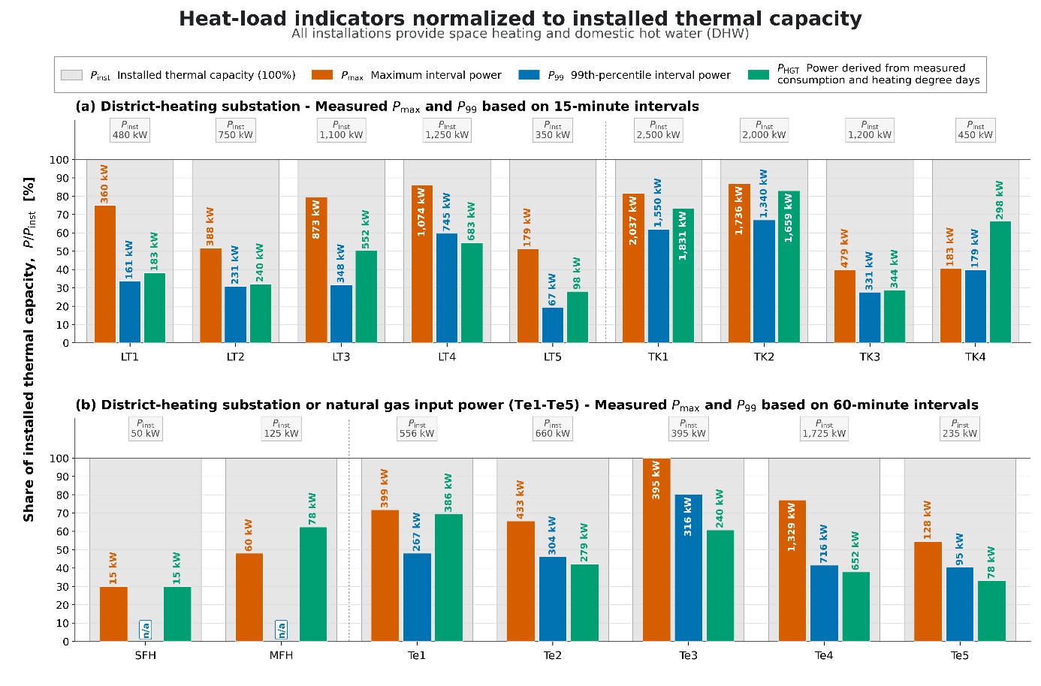
Fig. 1: Analysis of several buildings comparing installed heat capacity (P_{inst}) with measured maximum power (P_{max}), measured 99%-percentile power (P₉₉) and theoretical calculated needed nominal power (P_{HGT}) based on annual measured heat and associated heating degree days.
- The calculated nominal power (P_{HGT}) in average is 113% higher than 99% (P₉₉) of all monitored data. Only in the buildings Te3 and Te5 P_{HGT} is significantly lower than P₉₉. But, for all “Te#” marked buildings the value P₉₉ is measured as “natural gas consumption”! If corrected by a realistic utilization ratio of the gas boiler of 80%, only for Te3 the P_{HGT} is slightly lower than P₉₉: 95%.
Finally, this leads to the conclusion and consequence, when a building shall be connected to a district heating system: if annual measurement data of the old heating system are available, the value “P_{HGT}“ gives a much more accurate and realistic value to define the nominal power of the district heating substation. Therefor also the capacity price, which as fixed cost have to be paid, will be in a realistic range and not the double as often observed.
3.2. Hydraulic Design and Operation in the Technical Room
Buffer tanks are primarily designed to store energy in the form of heat, thereby balancing out fluctuations in heat supply and heat consumption. Unfortunately, it is very often observed that, out of fear of supply shortages on the part of heat consumers (heating and hot water), buffer tanks are reheated as quickly as possible or to the maximum temperature in order to be able to cover any possible peak load from the heat consumers. Unfortunately, this often results in the buffer storage tank no longer functioning as a “storage tank” with good temperature stratification, but rather as a “heavily mixed hydraulic distributor.” Three key areas should be considered in this context:
- The flow rates of the charging pump(s) from the district heating station to the buffer tank or on to the hot water storage tank are designed for maximum load (plus a safety margin), but are not adjusted to actual, realistic operating conditions. Furthermore, the capabilities of modern pumps with speed control are often not utilized to continuously regulate the flow rates according to demand.
- The process of recharging a storage tank is typically controlled by temperature sensors located inside the tank. With just one temperature sensor positioned relatively low in the storage tank, using the setpoint temperature as the minimum temperature and a hysteresis that a) is positive—meaning an even higher shut-off temperature—and b) is set relatively low to avoid overheating the storage tank unnecessarily. As a result, the recharging cycle occurs relatively frequently, and the lower portion of the storage tank is maintained at, near, or even above the setpoint temperature, which leads to a high return temperature.
- With two temperature sensors positioned at different heights, the upper sensor is set to a temperature that corresponds to the setpoint, and the lower sensor is set to a cut-off temperature, which is often the same value, to ensure the storage tank is fully charged. Depending on the switching volume between the two temperature sensors relative to the total volume of the storage tank, this results in a faster or slower cycling rate or return temperature. For safety reasons, this switching volume is often kept relatively small, or the lower cut-off temperature sensor is positioned very far down or at the very bottom, which prevents any significant temperature stratification from developing and results in a relatively high return temperature.
In terms of hydraulic design, it is common practice to supply the two heat consumers, heating and hot water, in parallel and independently of one another from a control systems perspective after the district heating transfer station. As a result, the mixed return temperatures are transferred to the district heating transfer station, and depending on the ratio of the flow rates, low return temperatures from the heating system (ideally when well-regulated or when underfloor heating is present) can rarely be utilized because domestic hot water production—which requires high temperatures of at least 55°C for hygiene purposes—typically has a significant impact on the return temperature. A fundamentally simple solution would be the cascaded use of heat: first, domestic hot water production at the required high temperatures in continuous operation, followed by supplying the heating circuits with the temperature level “left over” from domestic hot water production, supplemented by a bypass pump that raises the temperature level as needed. This cascade concept is described in more detail below and is currently in use in Munich and Rosenheim, for example, based on a similar principle.
Hydraulic short circuits, which take many different forms, are a recurring phenomenon. They may occur only sporadically and are often hidden in inconspicuous places, but they can have a significant impact on the return flow temperature at the district heating transfer station, as they are often associated with high flow rates.
- Non-pressurized heating manifolds, or even pressurized heating manifolds with an open, unregulated bypass valve: the supply flows directly into the return.
- The hot water charging circuit that runs or runs for significantly too long due to faulty temperature measurement or control settings, and transfers heat only when cold water flows in on the secondary side due to hot water consumption.
- Systems with ventilation units that also include a water-based air heating coil are often connected via a bypass valve just before the air heating coil to ensure a quick response. While this ensures that a long supply line is always kept at the correct temperature, the bypass circuit causes part of the flow to be directed directly into the return for the purpose of load control, which often results in a significant increase in the return temperature. When the air heating coil is inactive, this circuit then functions solely as a hydraulic short circuit that directs the supply flow directly into the return flow. Especially in cases where such an air heating coil is actually intended only as emergency peak-load heating—that is, when the outdoor temperature is very low—the bypass circuit is generally in “standby” mode almost continuously; in other words, the flow is routed directly into the return unless this circuit is completely shut off when it is not needed. Unfortunately, for safety reasons related to frost protection, this branch often remains in continuous operation.
- Hydraulically decoupled floor heating circuits (for corrosion protection when using mixed materials or due to diffusion-open plastic pipes) with an unregulated primary circuit, the primary circuit is operated with an incorrect control setting, or the heat exchanger’s capacity is (presumably) undersized, resulting in operation at a significantly elevated primary-side temperature. If the heating circuit is shut down on the secondary side, the primary-side flow rate may not be shut off. The primary-side flow control for regulating the secondary-side flow temperature functions correctly only as long as both circuits are in operation. When the secondary side is shut down, the primary-side control attempts to maintain the temperature and even increases the flow rate to the maximum, resulting in the flow being pumped directly into the return.
- Radiators in common areas or hallways that have not been calibrated and whose thermostatic valves have been removed so that no one can adjust them or even steal them.
- Rooms with multiple radiators, some or most of them are turned off (to save energy!?) and only one or a few are supposed to heat the room. For these active radiators, the thermostatic valves inevitably open fully, as this is the only way they can deliver their maximum heating output; however, this also means that the heating flow rate is at its maximum, and consequently, the return temperature is significantly elevated.
3.3. Sizing and Operation of the Heat Dissipation System
The oversized heating load calculation, as described in general terms above, serves as the basis for designing the heat distribution system (typically radiators, underfloor heating, or wall-mounted heating panels), which—just to be on the safe side—is rounded up slightly so that the width of the radiator visually matches the window above it, or so that the entire floor is covered with underfloor heating pipes at standard pipe spacing.
If at all, a hydraulic “balancing” is often performed during commissioning merely as a check to see “whether all the pipes get warm anyway.” A hydraulic “adjustment” to the flow rates (which are actually already too high due to the inflated heating load calculation) is probably paid even less attention to, under the assumption that the thermostatic valve will handle the fine-tuning anyway.
To ensure that it does not get too cold, it is not uncommon for the heating curve (flow temperature to the heating system as a function of the outdoor air temperature) to be set slightly higher as a precaution; the heating output of the heat distribution system is thus increased accordingly—or, more accurately, significantly overestimated.
As the final link in the chain, thermostatic valves are installed to “regulate” the room temperature; however, because of the standard 1-to-5 scale on the control knob, most users are led to operate them incorrectly: for many, “1” means “low heat output” and “5” means “high heat output.” So, if it feels too cold, they simply “turn it up” for more heat; if it gets too warm, they simply “turn it down” for less heat. Unfortunately it is not common knowledge that a thermostatic valve is an active control device which measures the room temperature and controls the flow rate as a proportional controller with the set temperature defined by the numbers on the thermostatic valve. Typically “3” stands for a set temperature of 20°C and “5” is equal to a set temperature of 28°C. Therefore if the user turns the valve to “5” this leads to complete open valve and further on much to high room temperature and high return temperature as well.
In Figure 2 as an example for 5 district heating sub-stations the distribution of return temperature (x-axis) weighted with the transferred heat (y-axis) as percentage of the annual heat consumption is shown. All 5 buildings in average (dotted vertical lines) have weighted return temperatures above 55°C, from 57.04°C in best case to 73.75°C in worst case.
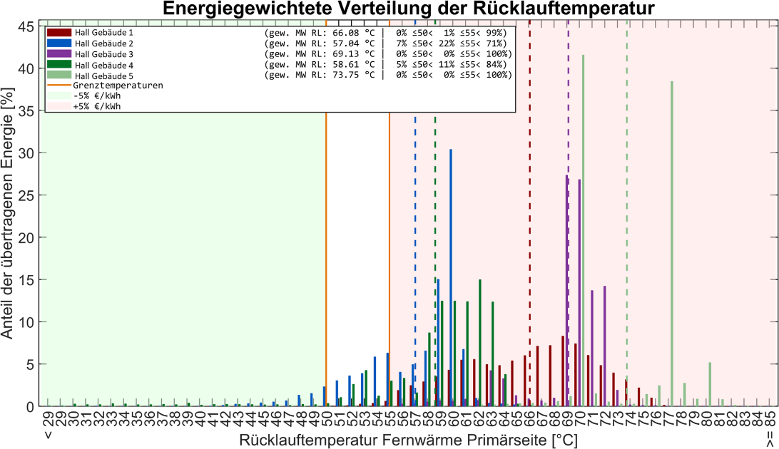
Fig. 2: As an example, five buildings in Hall i.T. with district heating systems that have hydraulic short circuits in the secondary heat distribution system and correspondingly high return temperatures.
Main reasons for these high temperatures are hydraulic short cuts in the heat distribution system as discussed before in chapter 3.2.
- Examples of Optimizing Nominal Power
4.1. Single family house – hydraulic adjustment of buffer storage loop
A single-family house in the Montafon valley, built in 1980, originally had a multi-fuel boiler with a rated output of 48–61 kW that was operated as an oil-fired boiler. The reported average annual oil consumption for heating and hot water was 4,000 liters.
A district heating transfer station with a rated output of 50 kW was installed, but it was already contractually agreed that, while 35 kW are technically available, only 25 kW would be billed. As of 2021, a base rate of 1,275 EUR was therefore to be paid. As shown in Figure 3, the district heating system supplies one heating circuit and, in parallel, a hot water charging circuit. Measurement data was provided by the district heating network operator, and as Figure 4 shows, peak power levels ranging from 30 kW to 45 kW actually occurred as 15-minute averages. An on-site analysis quickly revealed that these power peaks occur during hot water production. The regulating valve (circled in yellow in Figure 3) in the domestic hot water charging circuit was in position 3.9—practically fully open. With the measured flow rate of 0.9 m³/h and a typical temperature spread of 65°C/25°C, this calculates to the 42 kW that was actually observed. The regulating valve was then set to 0.3, which reduces the flow rate to approximately 0.15 m³/h—corresponding to a power output of 7 kW at 65°C/25°C.
Figure 5 shows the district heating output and the primary-side temperatures during the coldest period of the winter of 2025/2026 following the optimization. The heating output averages about 10 kW per day at an outdoor temperature of up to -10°C; when the hot water charging circuit activates, the hourly average output increases by approximately 5 kW, peaking slightly higher at about 8 kW initially. The reason for these high peaks at the beginning is essentially the extremely fast-acting activation valve (circled in blue in Figure 3) for the hot water charging circuit, which the primary-side control valve of the district heating transfer station naturally cannot follow quickly enough. If a typical control valve for a heating circuit mixer with a response time of 4 minutes were used instead of this activation valve, this problem would also be significantly mitigated.
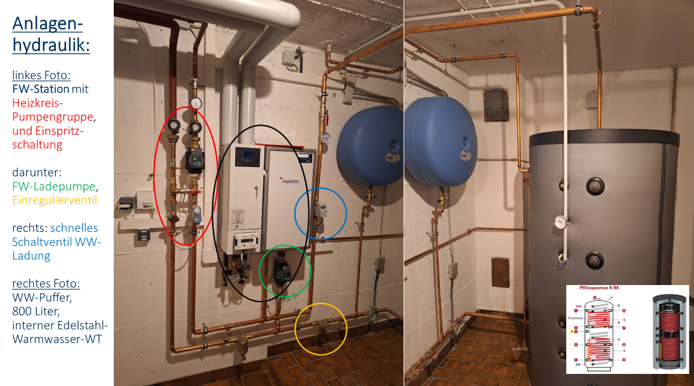
Fig. 3: Technical room in a single-family home in Montafon, Vorarlberg. Heating circuit with injection control and an 800-liter hot water storage tank featuring an internal stainless steel corrugated pipe that functions as a continuous-flow water heater.
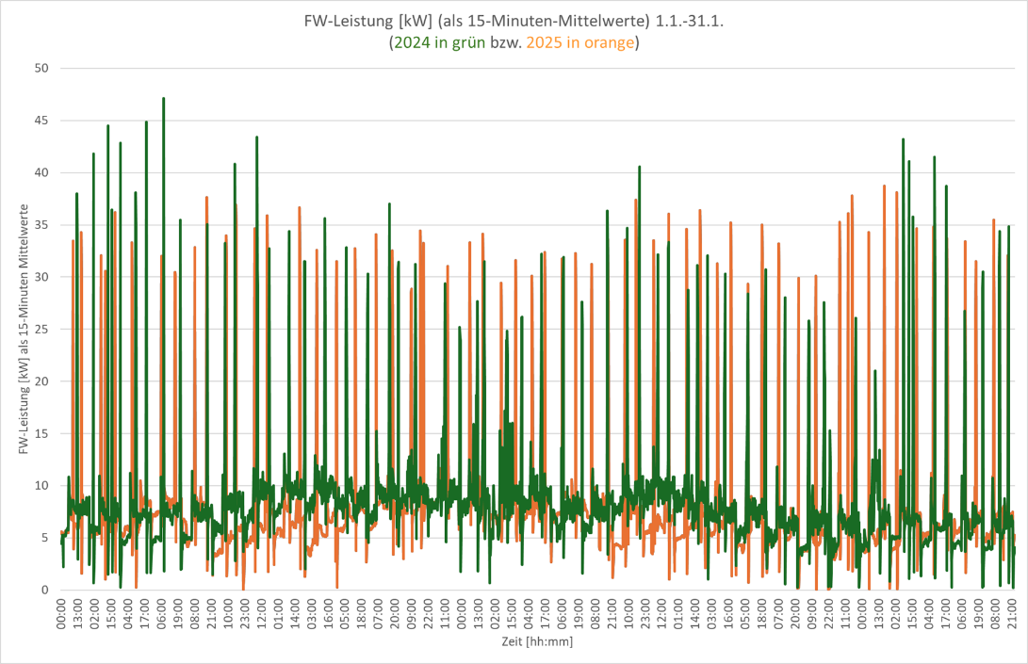
Fig. 4: District heating output before optimization in January 2024 and 2025, respectively. Peak outputs above 15 kW correspond to periods when the hot water system is activated.
Even in this case, if the estimate based on the specified oil consumption of 4,000 L/year—corresponding to 40,000 kWh/year— adjusted for a boiler efficiency of 80%, a design heating degree-day total of 3,443 Kd, and a standard design temperature of -16°C, the result is a rated output of 14 kW.
This example shows how the proper hydraulic integration of a storage tank—which allows it to fulfill its function as a “heat storage unit”—helps to significantly smooth out power peaks instead of generating massively excessive power peaks, as was the case in the original design. Ultimately, the billed power was even reduced to 13 kW, resulting in annual savings of 663 EUR (based on 2021 rates) for the single-family home.
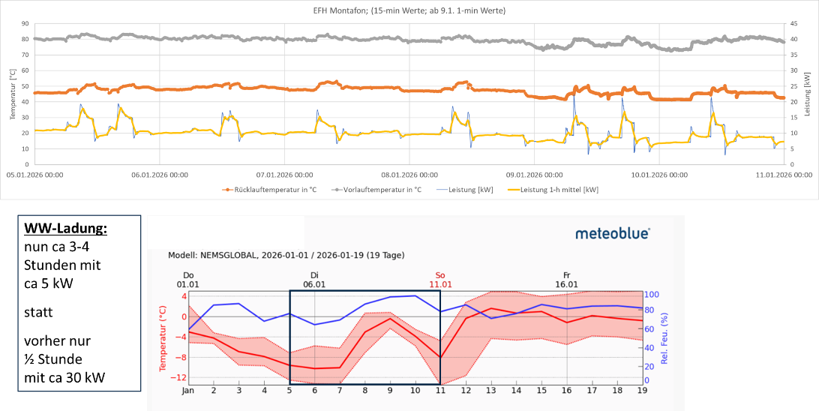
Fig. 5: District heating output after optimization during the coldest period of the winter of 2025/2026. Output (right y-axis) ranges from 10 kW for space heating only to approximately 15 kW (short peaks up to 20 kW) corresponding to periods when hot water production is activated. Temperatures are measured on the primary side at the district heating transfer station.
4.2. Apartment Building
An apartment building with 20 residential units in Dornbirn, Vorarlberg, completed in 1972, was originally equipped with an oil-fired boiler, which was later replaced by a gas boiler and then connected to the district heating system. A 125-kW district heating transfer station was installed, which directly supplies two heating circuits and heats an 800-liter hot water storage tank via an internal smooth-tube coil (see Figure 6). By analysing the monthly data from the heat meters, the maximum monthly power outputs for the period from January 2024 to January 2026 were determined, revealing that the highest recorded power output was 59.8 kW!
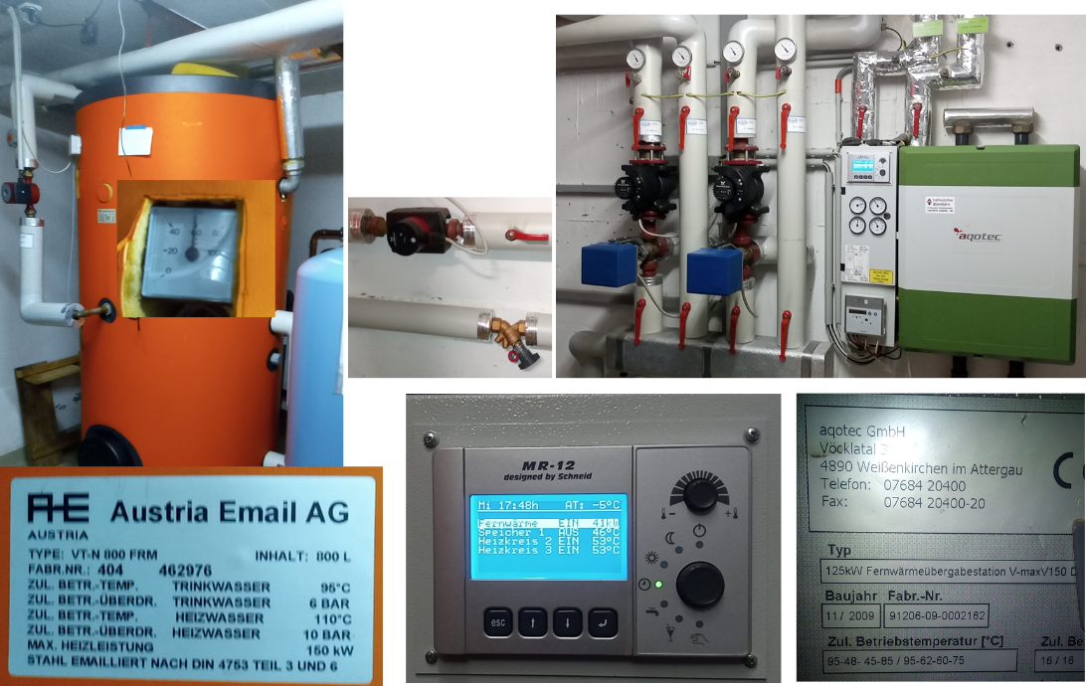
Fig. 6: Technical room in an apartment building with 20 residential units in Dornbirn. Two heating circuits with a single-pipe system and an 800-liter hot water storage tank with an internal smooth-tube heating coil and circulation (Source: personal photos)
The annual district heating bill for 2024 showed an annual heat consumption of 153,352 kWh; for this period, the number of heating degree-days was 2,590 Kd, and the standard design ambient temperature was -11.6°C. This results in a heating load of 78 kW (=153,352 x (20-[-11,6]) / {2590 x 24}); a new billing capacity of 80 kW—a reduction of 36%—was agreed upon, which will result in savings of 1,500 EUR/year in 2025.
As shown in Figure 7, during the coldest period of the winter 2025/2026, the maximum hourly-averaged district heating output was 60 kW at a daily average temperature of approximately -8°C. The additional output during hot water production ranged from approximately 15 kW to a maximum of 20 kW; therefore, even extremely cold periods with a daily outdoor temperature of -12°C should be easily manageable with the now permitted total output of 80 kW.
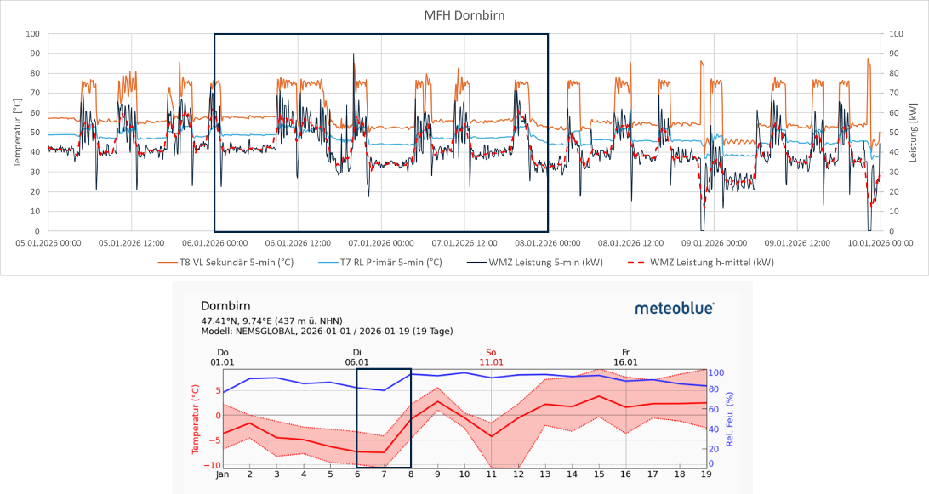
Fig. 7: District heating output and temperatures during the coldest period of the winter of 2025/2026. VL temperatures above 70°C indicate periods when hot water production was activated.
- Examples of Return Temperature Optimisation
As discussed in chapter 3.2 high return temperature in most cases are not defined by the radiators and much less by floor heating systems but mostly due to bad hydraulics and/or control settings in the technical room.
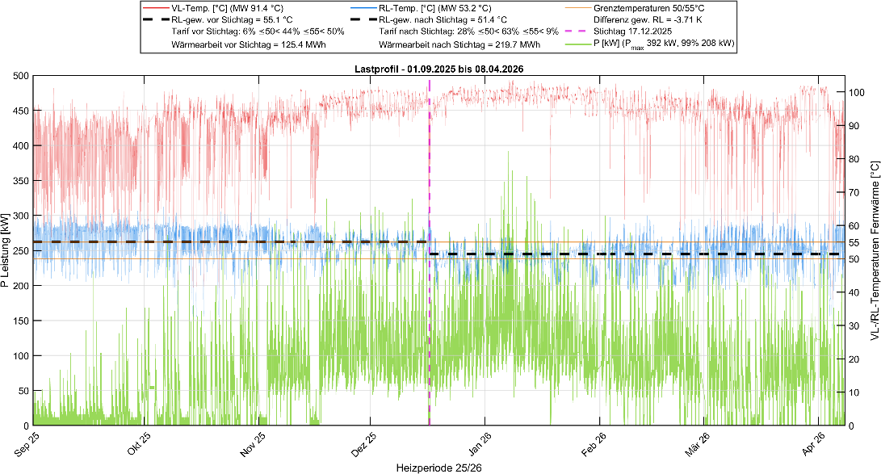
Fig. 8: Primary-side flow and return temperatures, as well as the power curve of the DH transfer station, with 15-minute averages.
An older existing building (early 20th century) with a nominal solar thermal system capacity of 480 kW had a 15-minute peak power draw of 392 kW during the analyzed measurement period, while 99% of the readings were below 208 kW (=43% of the installed capacity); the weighted primary-side return temperature was 55.1°C prior to optimization (see Figure 9, left). During the site inspection on December 17, 2025, a system separation for underfloor heating with a primary-side return temperature of 60°C was found (Figure 9, right), which turned out to be the setpoint in the control system. Since underfloor heating typically operates at significantly lower temperatures, the setpoint was reset to 35°C (a further reduction to 30°C is being considered). For the entire building, this resulted in a reduction of the primary-side weighted return temperature to 51.4°C—a decrease of 3.7 K. Consequently, the proportion of district heating consumed at temperatures above 55°C has decreased from 50% to 9%, while the proportion at temperatures below 50°C has increased from 6% to 28%.
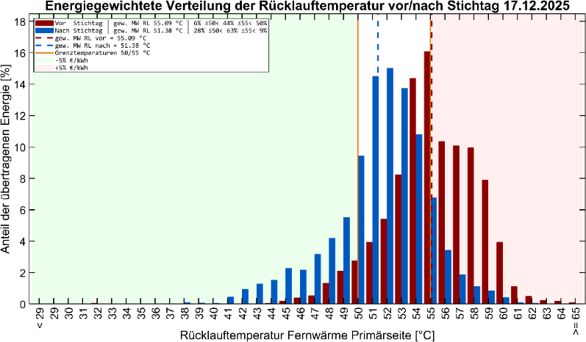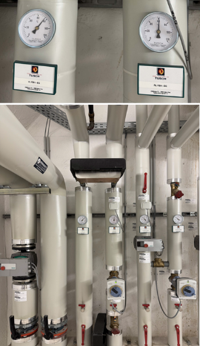
Fig. 9: Left: Total underfloor heating return temperature before (red columns) and after (blue columns) optimization; right: System separation for underfloor heating with a primary-side return temperature of 60°C before optimization.
- Potentials for Return Temperature Reduction based on System Simulations
As part of a demonstration project, a multi-family passive house with approximately 60 residential units was analyzed, including its heating system. The hydraulic system shown in Figure 10 exemplified the classic misconception that the heating system has a higher return temperature than the domestic hot water system (including a circulation heater), as evidenced by the location of the heating return at the top of the right-hand buffer tank.
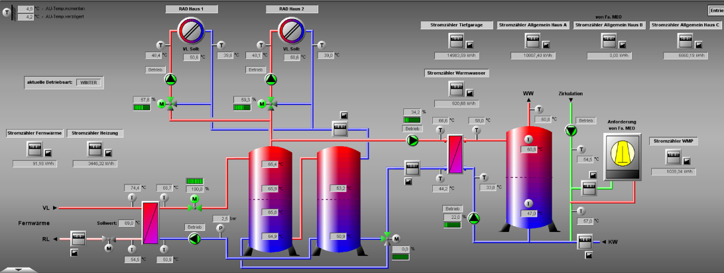
Fig. 10: Schematic of the technical room in a multi-family Passive House with approximately 60 residential units and a district heating connection.
The system was modeled by Forndran et al. (2026) using the Polysun simulation program (see, Figure 11), the measured heat load profiles for heating and domestic hot water consumption were applied as load profiles, and the three charging pumps were parameterized such that the actual measured district heating consumption as well as the return temperatures were achieved with an accuracy of less than 0.5 percentage points in their frequency distribution (see “Original” in Figure 11, right). Based on this base-case model optimization potential for return temperature reduction was analyzed by system simulation for hydraulic flow rate adjustments and a different hydraulic configuration as well.
6.1. Example of flow rate optimisation
Simply by small adjustment of the space heating connections (space heating return pipe to the lowest buffer tank position and space heating flow pipe to the middle of the buffer tank cascade) and significant reduction of the maximum flow rates of the three supply pumps, the optimization measures resulted in the distribution of return temperatures shown as “PumpOpt” in Figure 11 (right), resulting in an average return temperature that is nearly 10°C lower:
- The DH supply pump was reduced from a maximum of 11.5 m³/h to 7.0 m³/h (-40%).
- The DHW supply pumps were reduced from a maximum of 5.0 m³/h to 2.5 m³/h (-50%).
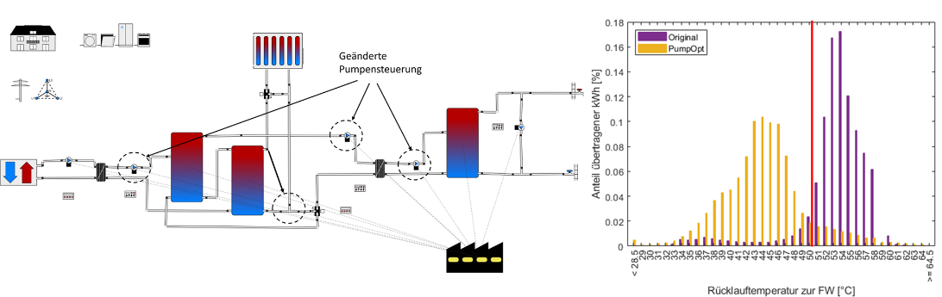
Fig. 11: Simulation results of the technical room optimizations with regard to the secondary-side district heating return temperature.
6.2. Cascade concept as advanced hydraulic concept
Based on the simple optimization steps in Chapter 6.1, the hydraulic system in the technical room was simulated as a conversion from the traditional “parallel architecture” (heating and hot water are supplied in parallel from the buffer tank) to the “cascade concept” (see Figure 12) and the hot water charging pump was further reduced from a maximum of 7.0 m³/h to 4.5 m³/h (an additional -36%, for a total of -61%). The “cascade concept” means that, in principle, the flow rate drawn by the space heating circuit from the buffer tank is first routed through the domestic hot water circuit, and the remaining temperature is then available to the space heating circuit—which is sufficient for the majority of operating conditions. If the temperature at the inlet of the space heating mixing valve assembly is insufficient, the “bypass pump” is activated as an “additional” load and controlled by a simple PI controller so that the exact required heating flow temperature is maintained at the mixing valve.
In the summer, when there is no need for heating, the bypass pump is used by default as a primary-side charging pump; it is positioned somewhat “unorthodoxly” in the circuit. The bypass pump is also activated during the transitional season when, due to low heating demand, the domestic hot water recharge is insufficient and the hot water storage tank is at risk of not being fully recharged—a situation that must, of course, be avoided for hygiene reasons to prevent Legionella.
The distribution of return temperatures according to “Optimum Var” in Figure 12 (right) could thus be reduced by an average of approximately 5°C to just below 40°C.

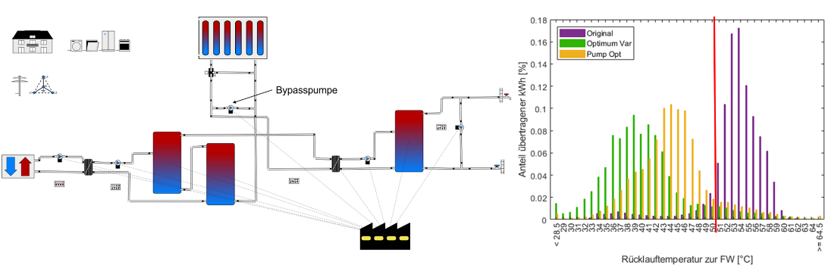
Fig. 12: The technical room was modeled hydraulically using a cascade design.
Only in the summer do return temperatures remain above 50°C (vertical red line) due to the reheating required to compensate for circulation losses. By using a small air-source heat pump (which, of course, can no longer be described as a minor optimization measure) that compensates for the circulation losses from 55°C to 60°C by utilizing the heat losses in the technical room (i.e., as heat recovery), the return temperatures could be lowered further, and the 50°C limit could be easily stayed below even in the summer (see also Figure 10, far right): however, this air-source heat pump was at the time a) poorly integrated hydraulically and b) operated on a trial basis only with surplus PV power to optimize self-consumption).
There is even further potential in this example in the proper hydraulic balancing of the radiators, which, unfortunately, could not be implemented correctly in this demonstration project either. The screenshot in Figure 10 clearly illustrates the potential: with an outdoor temperature of approximately 4°C and a flow temperature of 48°C, a return temperature of 39°C can only be explained by errors, as discussed at the beginning of this article.
- Conclusion
As several examples from on-site evaluations and detailed feasibility studies showed, in most cases it is not the point to use highly sophisticated and complex scientific methods to be able to realize technical reliable and economic district heating connections which avoid high base capacity price and also allow low return temperatures which further on enables the district heating operator efficient and economic operation of the entire network. In many cases the reasons for bad operation behavior of heating systems are bad quality of acting persons not doing proper planning in the design phase or commissioning and maintenance during operation. Just installing and operate in a proper way as theoretical planned and designed is a first important step for success. But also being not too afraid to try to optimize by settings of control parameters, which in worst case also can be re-adjusted if the required comfort is not matched. Trying innovative hydraulic designs of course maybe is a little more tricky because correction measures might be of higher effort and cost, but if in the planning phase already a plan B is incorporated, the worst case scenario might be very limited in effort and cost for correction or adaption.
- Acknowledgements
The INNERGY real-world lab is being conducted as part of the flagship initiative “100% Renewable Energy Real-World Labs” (www.reallabore.at) under the BMK’s FTI priority area on the energy transition.
- References
Thür, A., Forndran, S., Valentini, L.V., Sommer, M., 2026. Sekundärseitige Optimierung von Fernwärmeanschlüssen. Proceedings of the 29th Int. e-nova Conference, Intelligent Energy and Climate Strategies; https://doi.org/10.82405/978-3-9505410-7-6_36
Forndran, S., Valentini, L.V., Thür, A., Streicher, W., 2026. Hydraulic optimizations for customer-side return temperature reduction to district heating networks. Energy Reports, Volume 16; https://doi.org/10.1016/j.egyr.2026.109592

