DEVELOPMENT OF POROUS POLYMER MATERIALS BASED ON DICYCLOPENTADIENE FROM HIGH INTERNAL PHASE EMULSION WITH SURFACE MODIFICATION

Dmitrii Rusakov^{B}, Petr Khakhulin^{A,B}, Angelika Menner,^{B} Alexander Bismarck^{B,C}
A: Russia, Tomsk Polytechnic University, Department of Technology of Organic Substance and Polymer Materials;
B: Austria, University of Vienna, Institute of Materials Chemistry & Research, PaCE
C: United Kingdom, Imperial College London, Department of Chemical Engineering

Keywords: High Internal Phase Emulsions (HIPE), dicyclopentadiene (DCPD) ring opening metathesis polymerization (ROMP), diazonium salts, surface modification

Abstract

Emulsion templated high porocity polydicyclopentadiene (PDCDP) has been prepared by Ring Opening Metathesis Polymerisation (ROMP). Unsaturated double bonds in the macroporous PDCDP surface were modified by Heck reaction for amination and radical addition reaction to introduce trifluoromethyl groups. As consequence of the modification, the surface properties of porous PDCD dramatically changed as evidenced by vastly different wetting behavior of the porous polymers.

1. Introduction

Porous polymers are widely used in various fields of human activity. Porous polymers have numerous advantages, such as high surface area, low density and good mechanical properties. They have found applications as separation membranes and filters, as scaffolds in tissue engineering, catalyst carriers, and as templates for porous ceramics and porous carbons [1]. Porous polymers are commonly produced by chemical or physical blowing [2]. However, an alternative route for the production of tailor-made macroporous polymers is emulsion templating. This method uses high internal phase emulsions (HIPEs) whose continuous yet minority phase consists of monomers. HIPEs are viscous, pasty-like emulsions with a dispersed internal phase volume, usually an aqueous phase, exceeding 74% of the emulsion volume stabilized either by surfactant or particulates [3]. After polymerization of the continuous monomer phase and extraction of the internal phase, macroporous polymers are obtained. Depending on the nature of the HIPE template, the pore size of the produced macroporous polymers can range from several nanometres to several hundred micrometres [4]. The emulsifier is crucial as it determines the pores morphology and pore interconnectivity [5]. Several extensive reviews cover all aspects of various polyHIPE materials and provide descriptions of surfactants used, and application examples (filtration membranes, catalyst support, supporting material in organic synthesis, bone graft application and as sensors) of these materials [4-9]. However, the major disadvantage of polyHIPE materials is their low mechanical properties [10]. This problem can be solved by using dicyclopentadiene (DCPD) as a monomer for polyHIPE preparation. DCPD is a by-product of petroleum refining with relatively low cost [11]. The product of the DCPD polymerization is polydicyclopentadiene or polyDCPD, which is a tough, highly crosslinked thermoset polymer with high mechanical properties and high heat deflection temperature [12].

The polymerization of the DCPD proceeds via the ring opening metathesis polymerization (ROMP) mechanism. ROMP polymerization requires the use of catalyst complexes based on the transition metals such as molybdenum, titanium, tungsten, ruthenium. Although, these catalysts are sufficiently active and are selective to functional groups they are also sensitive to moisture and oxygen which significantly limits their usefulness. Ruthenium catalysts have found a greater industrial application as they provide a good balance between activity and selectivity to functional groups. First and second generation Hoveyda-Grubbs' ruthenium catalysts have a much improved moisture and oxygen resistance while retaining their activity [13].

PolyDCPD has outstanding mechanical properties but unfortunately polyDCPD ages by oxidation of residual double bonds, which affects its properties. One way to solve this problem is to convert these double bonds by modification. A few realizations how the PDCPD surface can be modified, for instance by bromination and hydrogenation, have been reported [14]. The present work focuses on the modification of poly(DCPD)HIPE by introduction of -CF₃ and -NH₂ functional groups and its effect on the surface properties

2. Experimental part

2.1. Materials

Dicyclopentadiene (4,7-Methano-3a,4,7,7a-tetrahydroindene) stabilized by BHT, non-ionic surfactant Pluronic L81, calcium chloride dihydrate (CaCI₂∙H₂O), absolute (99,7%) toluene, 4-(trifluoromethyl)aniline, p-toluenesulfonic acid monohydrate, tert-butyl nitrite, sodium borohydride, methanol, diethyl ether, 4-bromaniline, cesium carbonate, palladium acetate, ethanol were purchased from Sigma-Aldrich. The Hoveyda-Grubbs second generation catalyst 1,3-bis-(2,4,6-trimethylphenyl)-2-imidazolidinylidene)dichloro(o-N,N-dimethylamino-methylphenylmethylene)ruthenium was kindly supplied by Tomsk Polytechnic University. All chemicals were used as received.

2.2. PolyHIPE preparation and surface modification

2.2.1. Emulsion and polyHIPE preparation

HIPEs were prepared in a glass round-bottom reaction vessel (100ml, Schott) with glass hermetically sealed cap, equipped a dropping funnel and a glass anchor-stirring rod connected to a mechanical overhead stirrer. Before emulsion preparation, the vessel was purged with nitrogen for 20 min. Afterwards, the monomer (DCPD) was mixed with the surfactant (1, 5 or 10 wt.% from monomer) for 5 min at constant (400 rpm) mixing rate. Following the preparation of the monomer phase, the aqueous phase containing 1% (10 g/L) CaCI₂∙2H₂O was added dropwise within 30 min under continuous stirring.

The polymerization of the HIPE is a two-step process. Firstly, the catalyst, dissolved in toluene (1:100 volume ratio), was added to the emulsion in a catalyst to monomer mass ratio of 1:10000 and mechanically mixed for 2 min. After that emulsion was transferred into a mold, purged with nitrogen, sealed and left at the room temperature (+26 C) for 4 h. Afterwards, the resulting gel-like sample was placed into a glass beaker containing hot water (95 C) and further polymerized for 2 h. For purification, the resulting macroporous monolith was placed into a Soxhlet apparatus and extracted by acetone for 8-12 h, washed with distilled water and freeze dried.

2.2.2. Surface modification by radical addition and Heck reaction

In order to convert residual double bonds by introduction of -CF₃ groups a radical addition reaction using the diazonium salt - 4-(trifluoromethyl) benzoldiazonium tosylate synthesized following the method described by Filimonov [15] was used (Fig. 1).

To introduce -NH₂ groups the Heck Reaction was used (Fig. 2) [16].

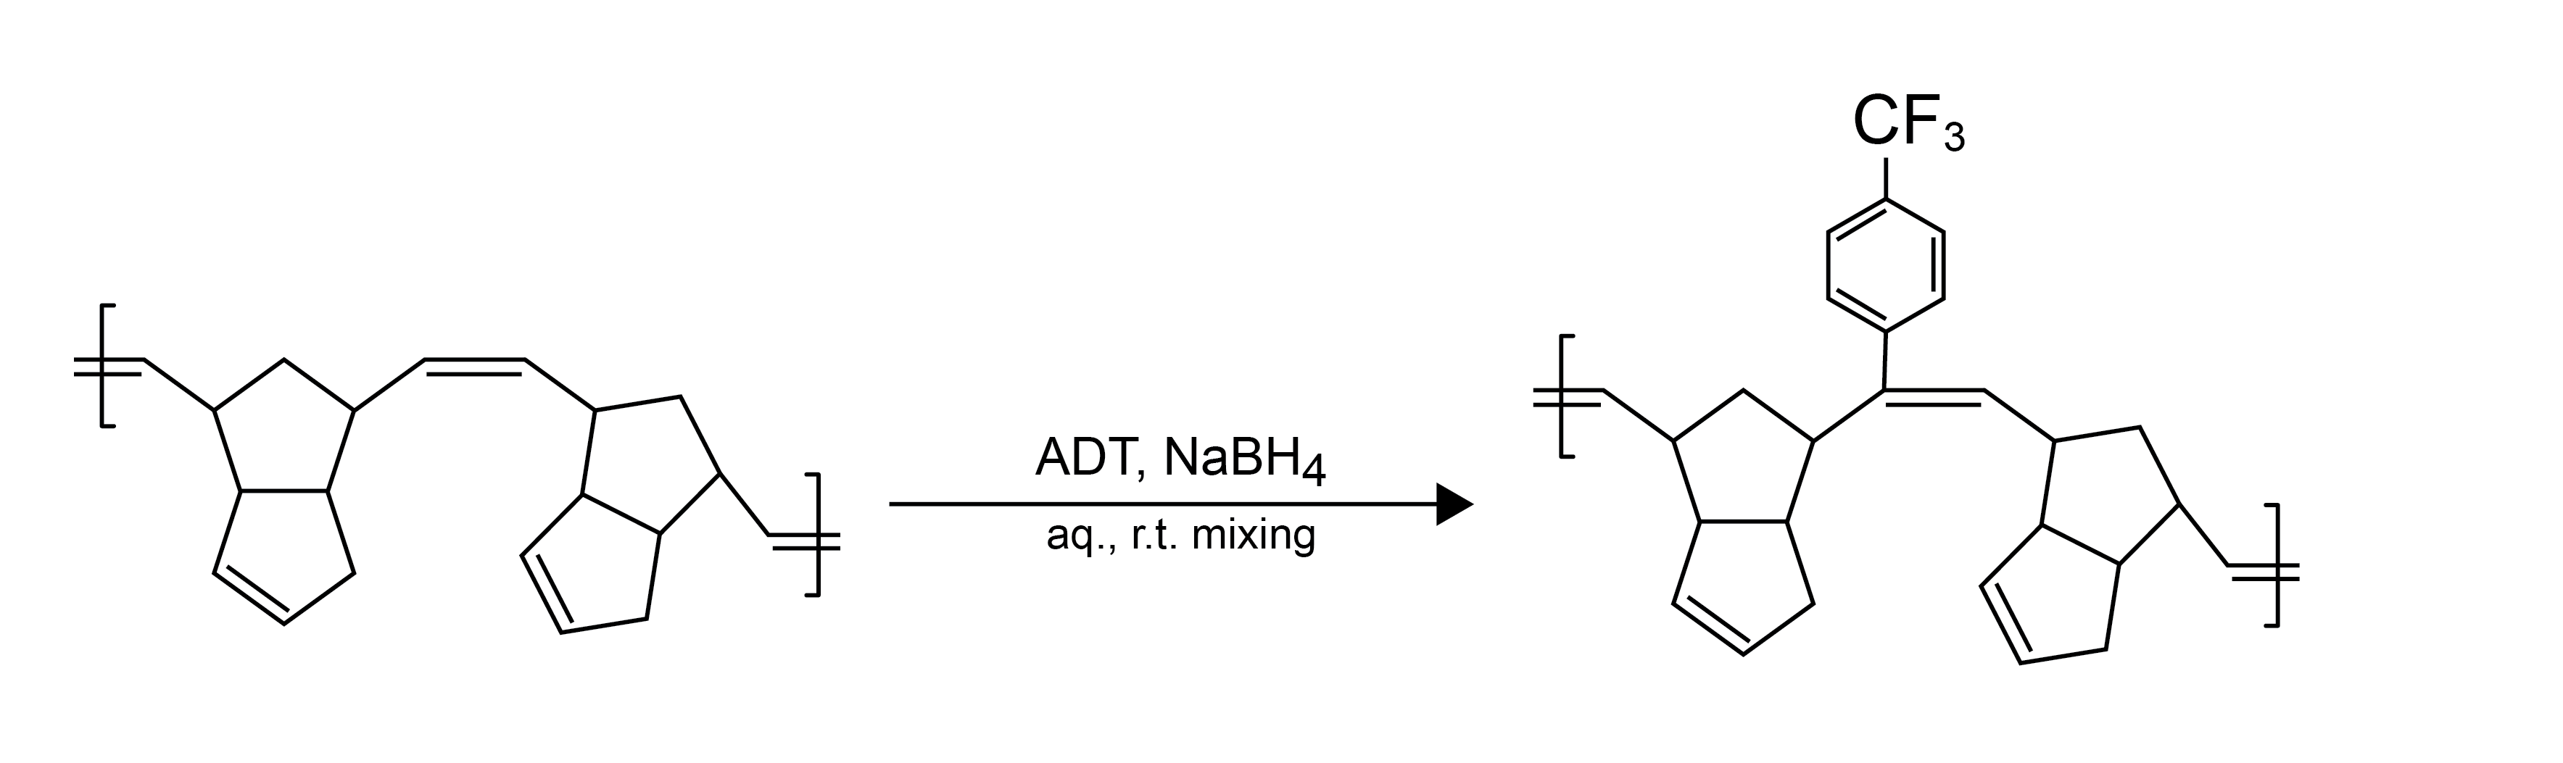
Picture 1. Surface modification using 4-(trifluoromethyl)benzoldiazonium tosylate.

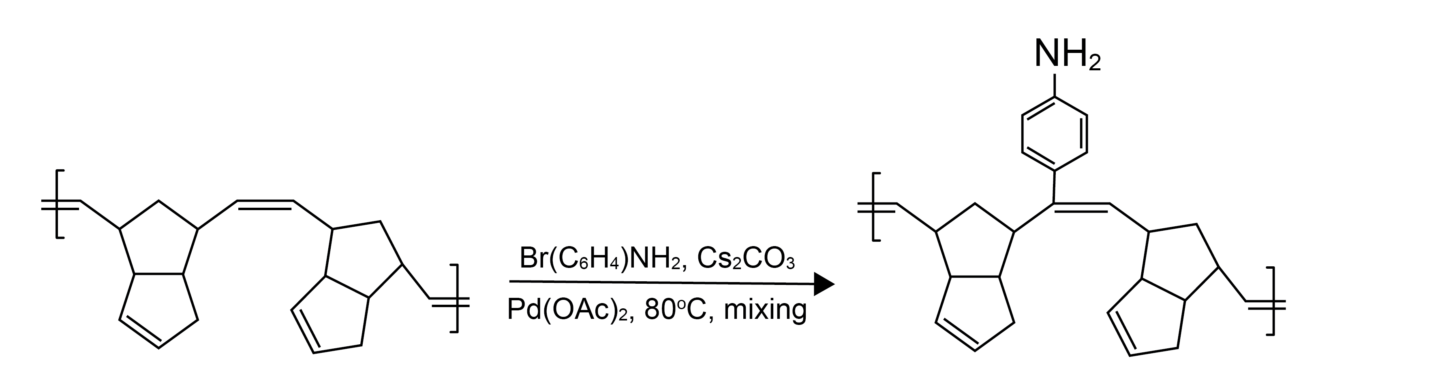
Picture 2. Surface modification by Heck Reaction.

2.3 Characterization

2.3.1. Characterisation of the pore structure:

The morphology of the porous polymers was investigated by scanning electron microscopy (SEM, JEOL JCM-6000, JEOL LTD, Japan). Each sample was fixed to a sample holder using a carbon sticker and gold coated (JEOL JFC-1200 fine coater (JEOL LTD, Japan)) in argon atmosphere. Characteristic SEM images are shown in Figure 3.

x50 x300 x1000

Picture 3. SEM pictures of the poly(DCPD)HIPE (internal phase content of the HIPE template = 80 vol.%)

2.3.2. Characterisation of the wetting behaviour of porous PCPD

After surface modification, the contact angle was measured using a Drop Shape Analyzer. Water droplets were placed onto the surface of pure poly(DCPD)HIPEs and fluorinated and aminated poly(DCPD)HIPEs (Figure 4a, 4b, 4c respectively) contact angles were measured as function of time.


a) b) c)

Picture 4. Contact Angle measurement a) pure PolyHIPE DCPD, b) with CF₃-group, c) after Heck Reaction

3. Results and discussion

The aim of current study was to investigate the effect of surface modifications by diazonium salts and Heck Reaction on the physical properties of macroporous poly(DCPD)HIPEs. The polyHIPE with a porosity of 80% were chosen for SEM and wettability analysis. It was observed that all samples have a homogeneous interconnected pore structure with average pore sizes of 20 ÷ 12.8 μm and pore throat diameter of 4.3 ÷ 0.8 μm (Fig. 3). The pore structure was not affected by the surface modifications.
After polymer modification by diazonium salts and Heck Reaction, the wettability of the macroporous polymer changed dramatically. Water imbibed immediately into pure poly(DCPD)HIPEs. The introduction of CF₃-functional groups contact angle resulted as expected in very hydrophobic surfaces with a contact angle of 130◦. Surprisingly, even after amination of poly(DCPD)HIPEs using the Heck Reaction the contact angle remained high at 135◦ (Fig. 4 a,b,c). This indirectly confirms the possibility to stabilise maroporous polyDCPD by surface modification.

4. Conclusion

A simple method to produce mechanically robust macroporous polyDCPD was presented. Besides stabilizing porous poly(DCPD) against oxidation, it was shown that surface modification by of poly(DCPD)HIPEs allows to control the wetting behavior of poly(DCPD) rendering the porous material, which was initially hydrophilic, hydrophobic.

References

- M. Talha Gokmen, Filip E. Du Prez. Porous polymer particles-A comprehensive guide to synthesis, characterization, functionalization and applications.// Progress in Polymer Science 37 (2012) 365-405
- Neil R. Cameron, Peter Krajnc, Michael S. Silverstein. Colloidal templating.// Porous Polymers. New York: John Wiley & Sons; 2011. p. 119-172.
- K. J. Lissant. The Geometry of High-Internal-Phase-Ratio Emulsions.// Journal Of Colloid And Interface Science 22, 462-468 (1966)
- Michael S. Silverstein. PolyHIPEs: Recent advances in emulsion-templatedporous polymers.// Progress in Polymer Science 39 (2014) 199- 234.
- Michael S. Silverstein. Emulsion-templated porous polymers: A retrospective perspective.// Polymer 55 (2014) 304-320.
- N. R. Cameron, D. C. Sherrington. High internal phase emulsions (HIPEs) - Structure, properties and use in polymer preparation.// Advances in Polymer Science pp 163-214, Volume 126.
- Michael S. Silverstein, Neil R. Cameron. PolyHIPEs - Porous Polymers from High Internal Phase Emulsions.// J. Colloid and Interface Science, Vol. 42, No. 1, January 1973
- Ruckenstein E. Concentrated Emulsion Polymerization.// Adv Polym Sci 1997;127:1-58.
- Neil R. Cameron. High internal phase emulsion templating as a route to well-defined porous polymers.// Polymer, Vol. 46, Is. 5, Feb. 2005, P. 1439-1449;
- Zhang, H., Cooper, A.I. Synthesis and applications of emulsion-templated porous materials.// The Royal Society of Chemistry Vol. 1, Is. 2, 14 July 2005, P. 107-113
- Sebastijan Kovacic, Peter Krajnca and Christian Slugovc. Inherently reactive polyHIPE material from dicyclopentadiene.// Chem. Commun., 2010, 46, 7504-7506.
- Vervacke D. An introduction to PDCPD. Waarschoot: Product Rescue. 2008. P. 129.
- Zhen Yao, Li-wu Zhou, Bin-bin Dai, Kun Cao. Ring-Opening Metathesis Copolymerization of Dicyclopentadiene and Cyclopentene Through Reaction Injection Molding Process.// Journal of Applied Polymer Science 2012. P. 2489-2493.
- Chenard J.-Y., Commereuc D., Chauvin Y. Complexes du cyanoformiate d'éthyle avec les dérivés carbonyles des métaux de transition.// C.R. Acad. Sc. Paris série Chimie. - 1971. - T. 273. - P. 1469-1472.
- Sebastijan Kovacic, Florian Preishuber-Pflugl, Christian Slugovc “Macroporous Polyolefin Membranes from Dicyclopentadiene High Internal Phase Emulsions Preparation and Morphology Tuning”, Macromol. Mater. Eng. 2014, 299, 843–850
- Ligandless Heck Coupling between a Halogenated Aniline and Acrylonitrile
Catalyzed by Pd/C: Development and Optimization of an Industrial-Scale Heck Process for the Production of a Pharmaceutical Intermediate.// Org. Process Res. Dev. 12, 3, 530-536

