EuroSun2026
IMPACT OF WEATHER DATASET SELECTION AND SOLAR IRRADIANCE REPRESENTATION ON BUILDING ENERGY SIMULATION IN CANADIAN CLIMATES
Caroline Hachem-Vermette¹, Ayoyimika Edun², Erin Tonita³, Lucio Mesquita³
¹ Concordia University, Montreal; caroline.hachemvermette@concordia.ca
² University of Calgary
³ Natural Resources Canada (NRCan), Ottawa
Summary
Weather data are a primary boundary condition in building energy simulation and can materially affect annual loads and peak demand. This study evaluates weather-product selection, direct-solar sensitivity, and weather-year construction across four Canadian climates (Halifax, Regina, Toronto, and Vancouver) and three archetypes: a detached house, a multi-unit residential building (MURB), and a medium office. Using a Grasshopper–Honeybee/EnergyPlus parametric workflow, the analyses compare historical products (CWEEDS, PSM4, ERA5), a controlled ±10 % Direct Normal Irradiance (DNI) sensitivity with Diffuse Horizontal Irradiance (DHI) held constant, and typical (TMY) and extreme (XMY) meteorological year methods against the 2005–2022 historical record. Heating is generally less sensitive than cooling to weather-product selection: most residential heating differences are within about 5 % of CWEEDS, whereas cooling differences reach reductions of about 65–70 % with ERA5 and increases exceeding 100 % with PSM4 in some MURB cases. Under the controlled DNI test, cooling changes reach about ±7 % for the detached house and ±13–14 % for the MURB, while remaining below 1 % for the office. Relative to the historical maximum peak, conventional TMY peak cooling is approximately 11–45 % lower for the residential archetypes and 20–30 % lower for the office. XMY methods reduce this gap in several cases but do not reproduce historical maxima uniformly, supporting the use of multi-year and extreme-weather references for cooling assessment, system sizing, and resilience.
Keywords: building energy simulation, weather datasets, solar radiation, TMY, XMY, Canadian climate
1. Introduction
Weather data constitute one of the most important inputs in building energy modelling (BEM). Outdoor temperature, solar radiation, humidity, and wind conditions directly influence building heating and cooling demand as well as the performance of renewable energy technologies such as photovoltaic systems. In Canada, where climates range from temperate coastal to severe cold regions, simulation outputs are particularly sensitive to how weather datasets are selected, constructed, and applied. Weather data choice is therefore not merely a technical input, but a fundamental modelling decision that can significantly affect conclusions regarding energy performance, system sizing, and resilience.
Building simulations commonly rely on Typical Meteorological Year (TMY) datasets derived from long-term historical observations, such as the Canadian Weather Year for Energy Calculation (CWEC), which condense multi-decadal records into a representative synthetic year using statistical techniques such as the Finkelstein–Schafer method (Hall et al., 1978; Finkelstein and Schafer, 1971). While well suited for annual benchmarking and code compliance, TMY datasets intentionally exclude extreme events and smooth interannual variability (Herrera et al., 2017), which can result in underestimation of peak heating or cooling loads, misrepresentation of solar gains, and inaccurate sizing of HVAC and renewable systems (Kočí et al., 2019; Yuan et al., 2022).
These limitations are particularly consequential in Canadian contexts. Robert and Kummert (2012) showed that a Canadian net-zero energy home designed on historical typical weather misses its net-zero target for most future years when re-simulated with climate-change-morphed weather, concluding that climate-sensitive buildings should be designed using multi-year, climate-aware weather rather than repeated typical years. Comparing typical against actual weather years for Winnipeg, Moradi et al. (2023) found that typical years systematically underpredict heating and overpredict cooling relative to the ten-year median, with the cooling bias reaching as much as 75 % for a detached house. Moradi et al. additionallyreported that CWEC captured long-term trends better than TMYx formulations, demonstrating that both the choice of typical-year dataset and its variable weighting materially affect outcomes.
Building typology strongly mediates this sensitivity. Berardi and Jafarpur (2020) reported that projected heating demand in Toronto falls by roughly 18–33 % under future climate scenarios while cooling rises, with larger, internally dominated buildings (e.g. large offices) proving less climate-sensitive than envelope-driven typologies, and with the downscaling method itself influencing the predicted change. Regarding the adequacy of typical years, Hosseini et al. (2021) found CWEC agreed with long-term data within about 5 % annually for Montreal and Vancouver offices, yet underestimated heating peaks in 60–80 % of Montreal cases, with the largest deviations for solar-sensitive designs (higher SHGC and thermal mass). Data-driven TMY construction (Bigtashi et al., 2024) can improve monthly fidelity but does not resolve the omission of extremes.
Beyond temperature, solar irradiance representation, specifically GHI and DNI, plays a central role in both thermal performance and photovoltaic yield, and differences in solar weighting within weather-file generation can alter cooling load and renewable generation estimates (Pernigotto et al., 2020; Huld et al., 2018). To capture variability and extremes, recent work has expanded toward Extreme Meteorological Years (XMY), reanalysis data (e.g. ERA5), high-resolution solar datasets (e.g. the National Solar Radiation Database Physical Solar Model v4, PSM4), and bias-corrected climate projections (Nik, 2016; Gaur and Lacasse, 2022). Resilience-focused studies further stress that worst-case demand and lowest-generation sequences, not annual averages, govern performance during outages and compound events, so single representative years are structurally limited for resilience assessment (Yan et al., 2025; Perera et al., 2020; Siu et al., 2023).
Despite these advances, there remains limited systematic assessment of how different weather datasets and generation methods influence building energy performance across multiple archetypes and climates within a single, consistent modelling framework (Crawley and Lawrie, 2015). In particular, the relative influence of solar irradiance representation, the robustness of TMY datasets, and the role of extreme weather in shaping both annual loads and peak demands are not yet fully resolved.
The objective of this study is to investigate how different weather datasets, solar irradiance assumptions, and weather-file generation methods influence building energy simulation outcomes across several Canadian climates. The analysis is structured around three components: (1) a comparison of historical weather datasets (CWEEDS, PSM4, and ERA5), (2) a sensitivity analysis to variations in solar irradiance (DNI), and (3) a comparison of typical and extreme weather-file generation methods (TMY and XMY), evaluated consistently across three building archetypes.
2. Methodology
2.1. Building archetypes
Building energy simulations were performed using a parametric workflow in which building geometry and simulation settings were defined in the Grasshopper–Honeybee environment and the energy calculations were carried out by the EnergyPlus engine for three representative building archetypes: a detached house, a multi-unit residential building (MURB) consisting of 16 units arranged over four storeys, and a medium office building (Fig. 1). These archetypes were selected to span a range of building scales, envelope-to-internal-gain ratios, and operational profiles: the detached house represents a low-internal-gain, envelope-driven residential typology; the MURB represents a compact multi-family form with a higher surface-to-volume complexity; and the medium office represents a commercial typology dominated by internal gains from lighting, equipment, and occupancy. This spread allows the influence of weather data to be examined across buildings with contrasting sensitivities to solar and temperature inputs.
Each archetype was modelled with representative Canadian construction and occupancy assumptions and simulated for four cities spanning distinct ASHRAE climate zones: Halifax (Zone 6A), Toronto (Zone 5A), Regina (Zone 7), and Vancouver (Zone 4C). These locations were chosen to represent the range of Canadian conditions relevant to the study, from the cold, dry continental climate of Regina to the milder marine climate of Vancouver. Envelope properties, internal gains, schedules, and system assumptions were held constant across locations for each archetype, so that all differences in simulated performance could be attributed to the weather inputs rather than to changes in building design or operation.
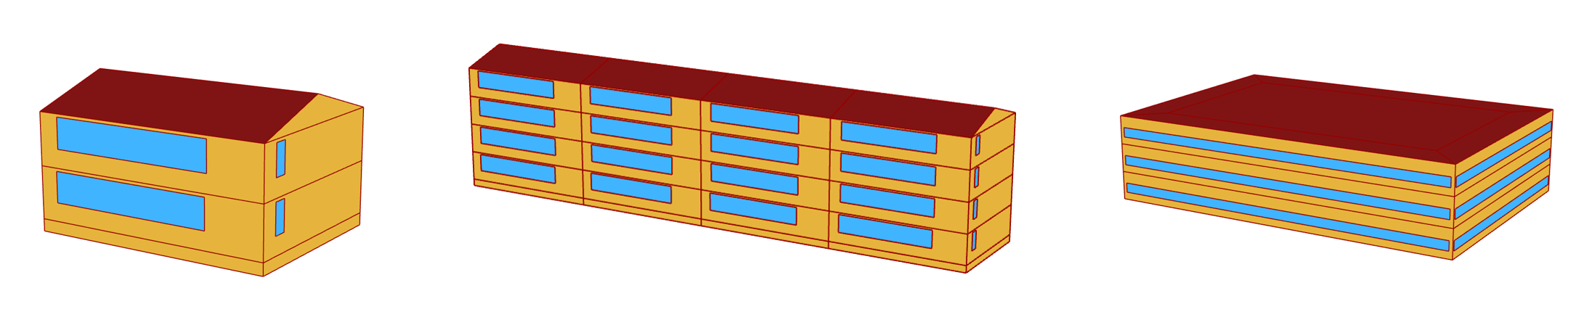
Fig. 1: Modelled building archetypes: a) detached house; b) multi-unit residential building (MURB); c) medium office building.
Key operational parameters are summarized in Table 1, while the location-specific envelope characteristics for the detached house and medium office are given in Tables 2 and 3. Internal gains were kept constant within each archetype, and the envelope assumptions for each city were held fixed across all weather comparisons.
Table 1: Summary of operational parameters for the three building archetypes.
Parameter | Detached House | MURB | Medium Office
Infiltration (m³/s·m²) | 0.001024 | 0.001024 | 0.000302
Heating setpoint (°C) | 22 | 21.7 | 21
Cooling setpoint (°C) | 24.4 | 24.4 | 24
Occupancy (ppl/m²) | 0.028 | 0.028 | 0.057
Lighting (W/m²) | 14.4 | 14.4 | 11.84
Equipment (W/m²) | 6.7 | 6.7 | 10.33
Table 2: Detached house envelope characteristics (ASHRAE 2004-based); U in W/m²K, R in (h·ft²·°F/Btu).
Location | Zone | Wall U (R) | Roof U (R) | Ground U (R) | Window U (SHGC)
Halifax | 6A | 0.463 (11.33) | 0.148 (37.56) | 2.11 (1.76) | 0.895 (0.41)
Regina | 7 | 0.463 (11.33) | 0.148 (37.56) | 2.11 (1.76) | 0.895 (0.48)
Toronto | 5A | 0.463 (11.33) | 0.186 (29.56) | 2.11 (1.76) | 0.9 (0.41)
Vancouver | 4C | 0.463 (11.33) | 0.186 (29.56) | 2.11 (1.76) | 0.9 (0.41)
Table 3: Medium office envelope characteristics; U in W/m²K, R in (h·ft²·°F/Btu).
Location | Zone | Wall U (R) | Roof U (R) | Ground U (R) | Window U (SHGC)
Halifax | 6A | 0.428 (12.33) | 0.329 (16.33) | 2.11 (1.76) | 0.9 (0.41)
Regina | 7 | 0.329 (16.33) | 0.329 (16.33) | 2.11 (1.76) | 0.895 (0.48)
Toronto | 5A | 0.428 (12.33) | 0.329 (16.33) | 2.11 (1.76) | 0.9 (0.41)
Vancouver | 4C | 0.613 (8.33) | 0.329 (16.33) | 2.11 (1.76) | 0.9 (0.41)
Envelope constructions for the MURB follow location-specific assumptions consistent with residential construction practices.
2.2. Weather data
Three categories of weather data were used:
- Historical datasets: CWEEDS, PSM4, and ERA5, representing measured or reconstructed multi-year conditions. The Canadian Weather Energy and Engineering Datasets (CWEEDS) provide long-term hourly records of temperature, humidity, wind, and solar radiation for Canadian stations and serve here as the reference historical source (Environment and Climate Change Canada and NRCan, 2020). The Physical Solar Model version 4 (PSM4) is a high-resolution, satellite-derived, gridded solar radiation dataset with hourly and half-hourly irradiance records extending back to 1998 (Sengupta et al., 2018). ERA5 is the fifth-generation atmospheric reanalysis produced by ECMWF, which assimilates observations into a physically consistent global model (Hersbach et al., 2020). Annual heating and cooling loads, peak demands, and solar quantities were evaluated for each year from 2005 to 2022.
- Typical Meteorological Year (TMY): CWEC, ISO 15927, TMY3, and the TMY-NO method, providing statistically representative years. These methods differ mainly in how candidate months are selected and how climatic variables are weighted: CWEC is the standard Canadian formulation, ISO 15927 follows the international standard weighting, TMY3 uses the U.S. Sandia weighting scheme, and TMY-NO is a proposed seasonal weighting method for northern locations (Thiis et al., 2025). Because each approach weights temperature and solar radiation differently, the resulting representative years can diverge, particularly for solar-driven quantities (Hall et al., 1978; Herrera et al., 2017).
- Extreme weather datasets (XMY): Two extreme-weather constructions were proposed and evaluated in this study: TMY+ and seasonal XMY. TMY+ augments a typical year with additional extreme weeks, while seasonal XMY selects the most extreme months of the historical record to represent severe seasonal conditions and retain peak-load and resilience-relevant sequences that conventional typical years smooth out (Nik, 2016; Pernigotto et al., 2020).
2.3. Simulation approach
Simulations were conducted using a parametric workflow based on the Grasshopper–Honeybee interface coupled with EnergyPlus, allowing each archetype-location model to be run across the alternative weather files while holding geometry, envelope, internal gains, schedules, and system assumptions fixed. For the historical comparison, annual heating and cooling loads, annual peak heating and cooling demands, incident solar radiation, and solar gains were calculated for each year from 2005 to 2022 and then summarized over the historical period. For the historical-reference comparisons, “Historical Avg” denotes the mean of the annual simulation results from 2005 to 2022; for peak demand, it is the mean of the annual peak values. “Historical Max” denotes the maximum annual value over the same period; for peak demand, it is the largest annual peak.
To ensure comparability, all weather files were standardized to 8760 hours, with 29 February removed where present. The three analyses were then applied consistently to each archetype and location. First, CWEEDS, PSM4, and ERA5 were compared directly. Because the complete weather product changes in this comparison, temperature, humidity, wind, and solar-radiation variables may all contribute to differences in simulated performance; this analysis therefore does not isolate a single meteorological variable. Second, a controlled direct-solar sensitivity analysis was performed using CWEC TMY files, with DNI perturbed by ±10 % and DHI held constant. Third, typical (CWEC, ISO 15927, TMY3, and TMY-NO) and extreme (TMY+ and seasonal XMY) weather-file generation methods were compared with the long-term historical references to assess their representation of average and extreme performance.
The reported outputs, evaluated consistently for each analysis, comprise the solar quantities (incident radiation and solar gains) and the resulting space-conditioning metrics. Across all analyses, results were reported in terms of annual heating and cooling loads, peak heating and cooling demands, and solar gains, allowing the influence of weather data to be traced consistently from the radiation inputs through to the resulting space-conditioning demands.
3. Results and Discussion
This section presents the historical weather-product comparison (Section 3.1), the controlled DNI sensitivity analysis (Section 3.2), and the comparison of typical and extreme weather-file generation methods (Section 3.3). Annual heating and cooling loads, peak demands, and solar gains are examined across the three archetypes and four climates. Results are reported relative to the CWEEDS historical baseline unless otherwise stated.
3.1. Historical weather-product comparison
The historical products yield smaller differences in heating than in cooling. For the detached house and MURB, most annual heating loads remain within approximately 5 % of the CWEEDS baseline, with larger cases including an ~11 % reduction with PSM4 in Regina and ERA5 deviations of about 10–14 % in Halifax and Vancouver. The office shows a wider spread, with PSM4 generally lower and ERA5 higher than CWEEDS, reaching about +30 % in Vancouver. Thus, heating is comparatively less sensitive than cooling, although weather-product selection still produces material differences in some cases (Fig. 2).
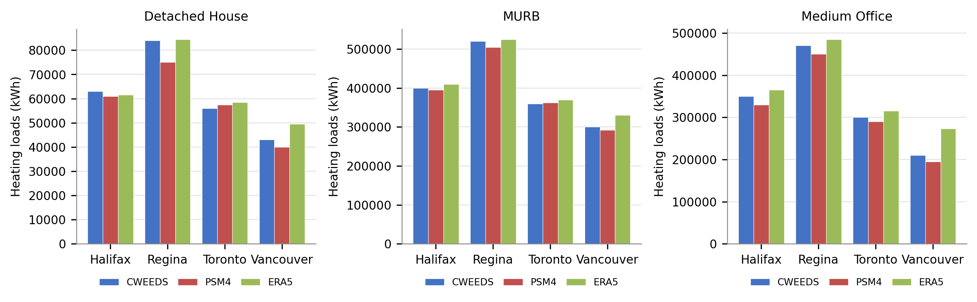
Fig. 2: Annual heating loads by location for historical weather products — detached house, MURB, and medium office.
Cooling loads show substantially greater variability. ERA5 consistently produces the lowest cooling loads and PSM4 the highest. For the detached house, PSM4 differs from CWEEDS by approximately 30–43 % in some locations, while ERA5 is up to about 65 % lower in Vancouver. The spread is larger in the MURB, where PSM4 deviations exceed 100 % and ERA5 reductions reach about 70 % as compared to CWEEDS. These differences are shown in Fig. 3. The office has larger absolute cooling loads but smaller relative variation (PSM4 up to ~20 % higher; ERA5 up to ~25 % lower). Because the historical products differ in temperature, humidity, wind, and solar variables, these differences cannot be attributed to solar radiation alone. However, the direction of the cooling differences is consistent with PSM4’s higher direct irradiance and ERA5’s lower surface solar radiation. The residential archetypes show larger percentage changes because their cooling loads are smaller and more solar-sensitive, whereas the office is buffered by substantial internal gains from lighting, equipment, and occupancy (Berardi and Jafarpur, 2020).
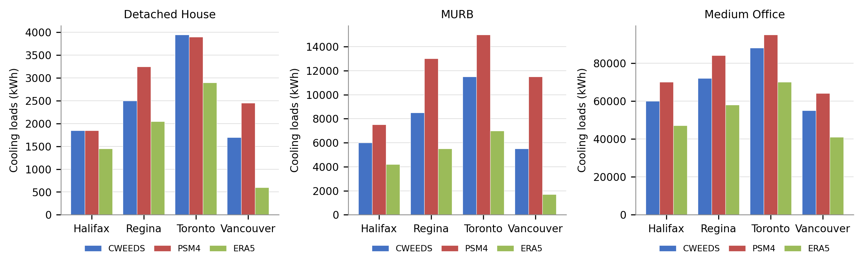
Fig. 3: Annual cooling loads by location for historical weather products — detached house, MURB, and medium office.
Solar gains follow the irradiance differences between products. PSM4 generally remains within ±10 % of CWEEDS for direct irradiance, whereas ERA5 is substantially lower, with differences reaching about 55 % in Vancouver. ERA5 solar gains are correspondingly lower, by up to about 70 % in some cases (Fig. 4). Together with the controlled DNI analysis, these results support solar-radiation representation as an important contributor to cooling variability while recognizing the concurrent effects of the other meteorological variables.
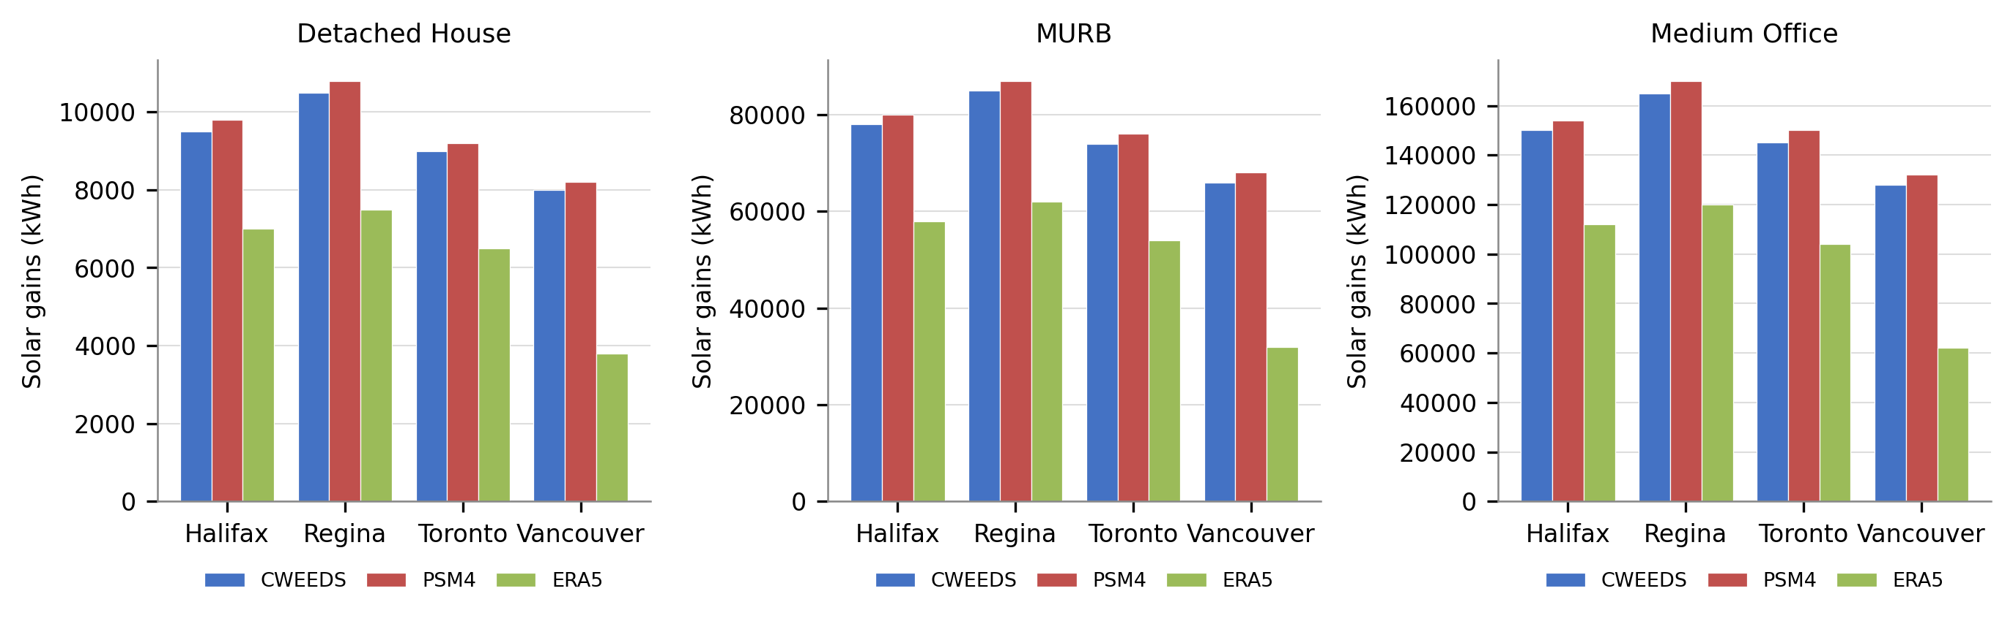
Fig. 4: Internal solar gains by location for historical weather products - detached house, MURB, and medium office.
Figures 5–7 compare peak heating and cooling demand across the historical products for all three archetypes. Peak heating follows the annual-heating pattern, with most residential differences within about 5–8 % of CWEEDS. Peak cooling varies more strongly: PSM4 often produces the highest peaks, while ERA5 tends to reduce them, particularly in Vancouver. For the office, dataset rankings are less significant, reflecting stronger interaction among weather inputs, internal gains, and operating schedules.
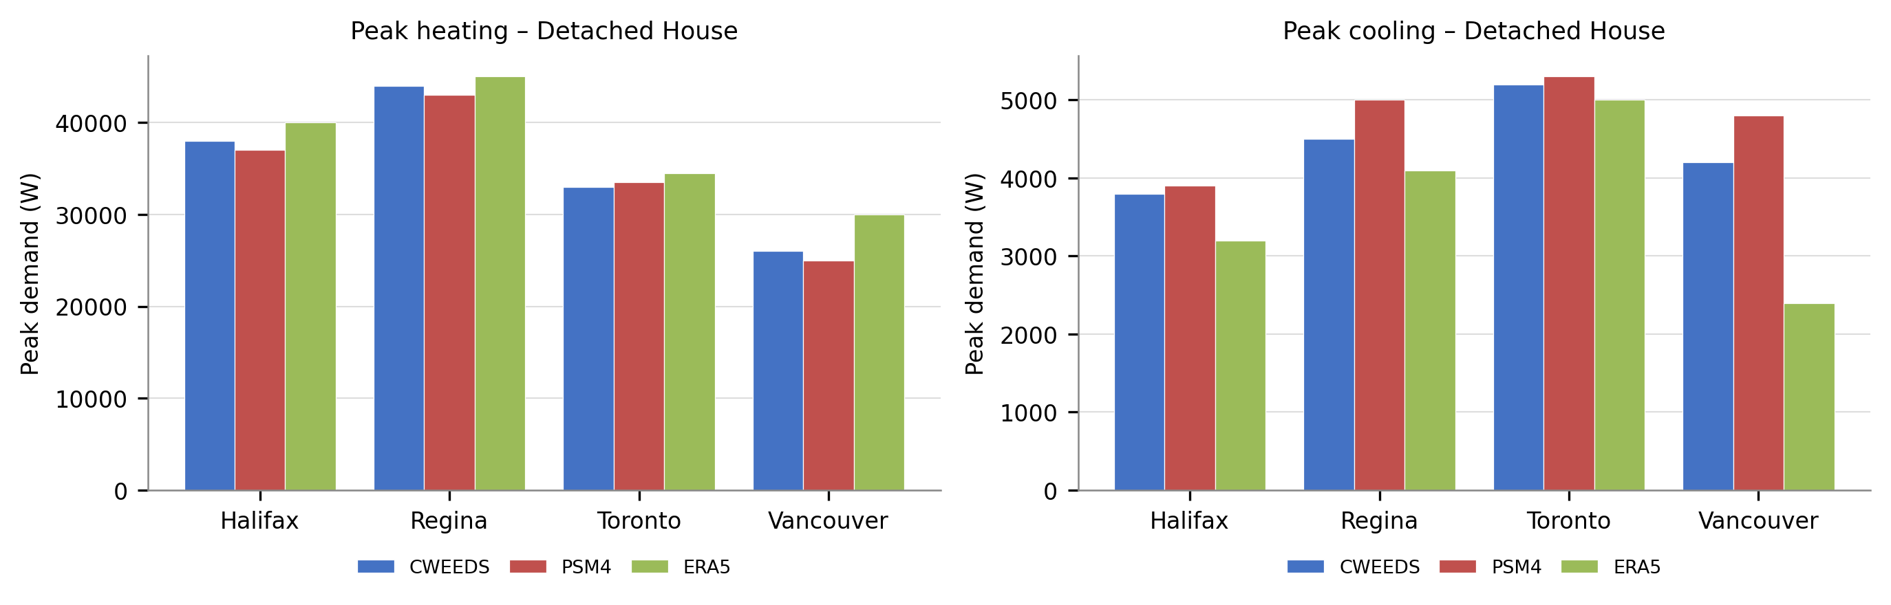
Fig. 5: Peak heating and cooling demand for the detached house under historical weather products.
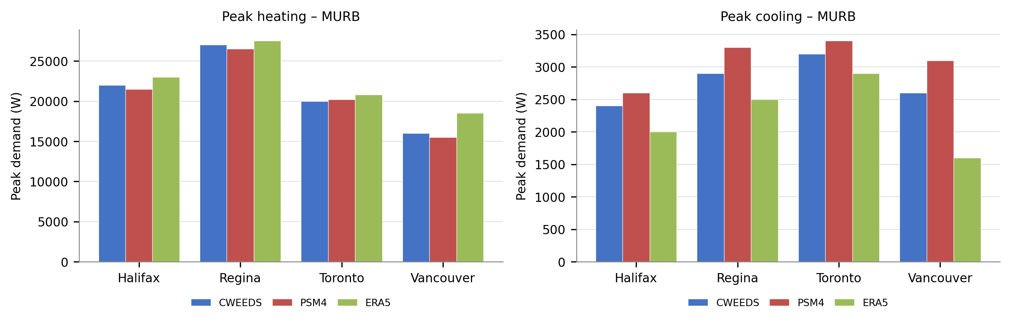
Fig. 6: Peak heating and cooling demand for the MURB under historical weather products.
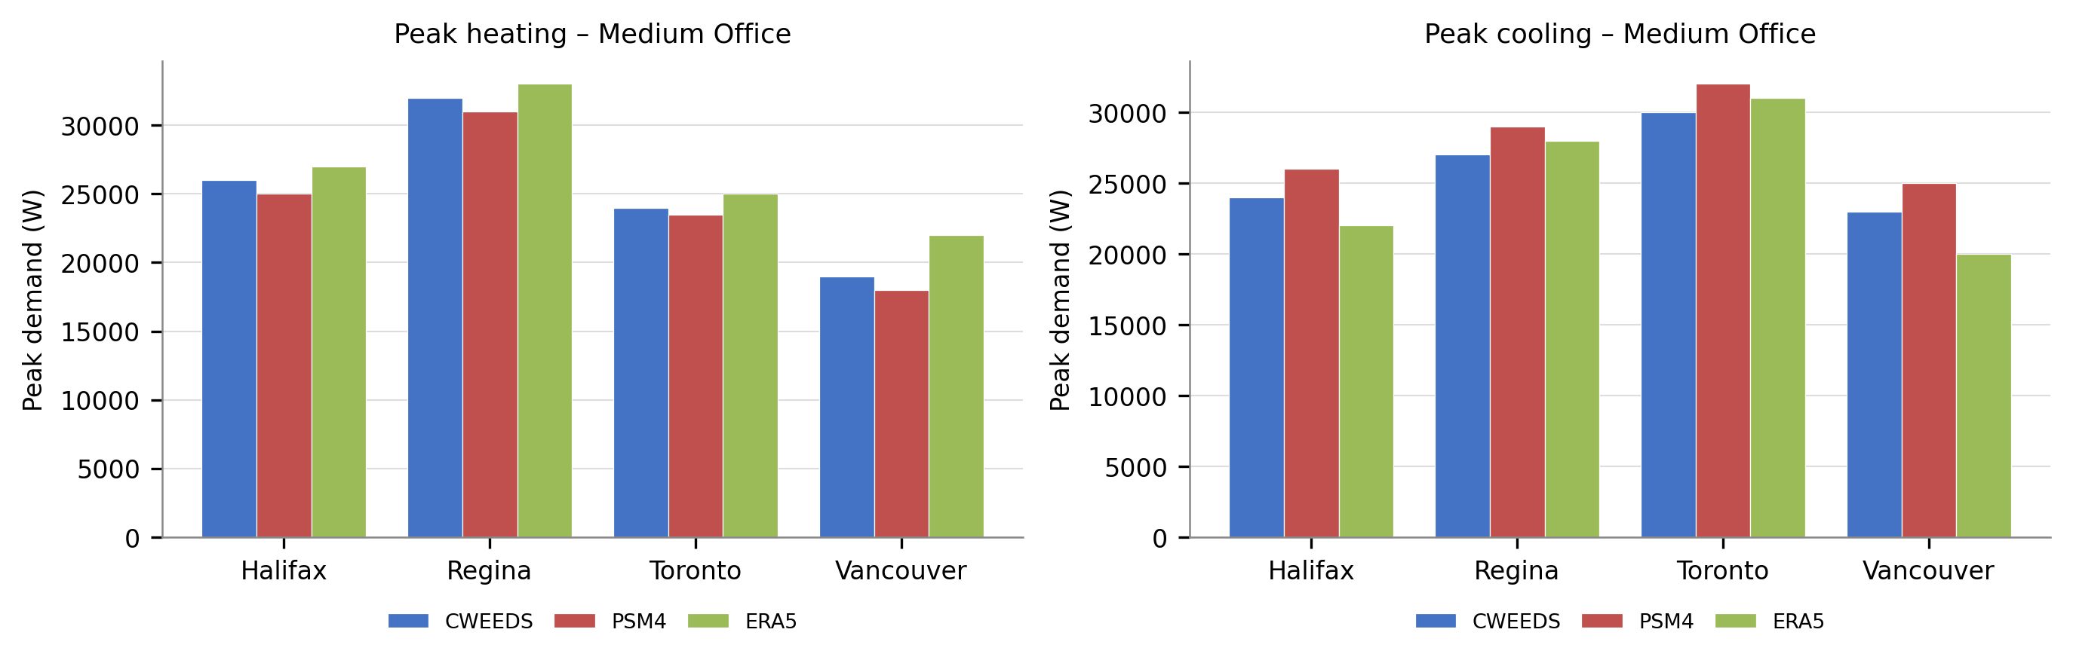
Fig. 7: Peak heating and cooling demand for the medium office under historical weather products.
3.2. DNI sensitivity
The controlled DNI sensitivity analysis shows that annual heating is only weakly affected by moderate changes in direct solar irradiance. A ±10 % change in DNI changes annual heating loads by only about 1–2 % across the archetypes (Fig. 8). Heating remains governed primarily by outdoor temperature, transmission, and infiltration losses, with solar gains providing a secondary offset. DHI was held constant and was not independently tested

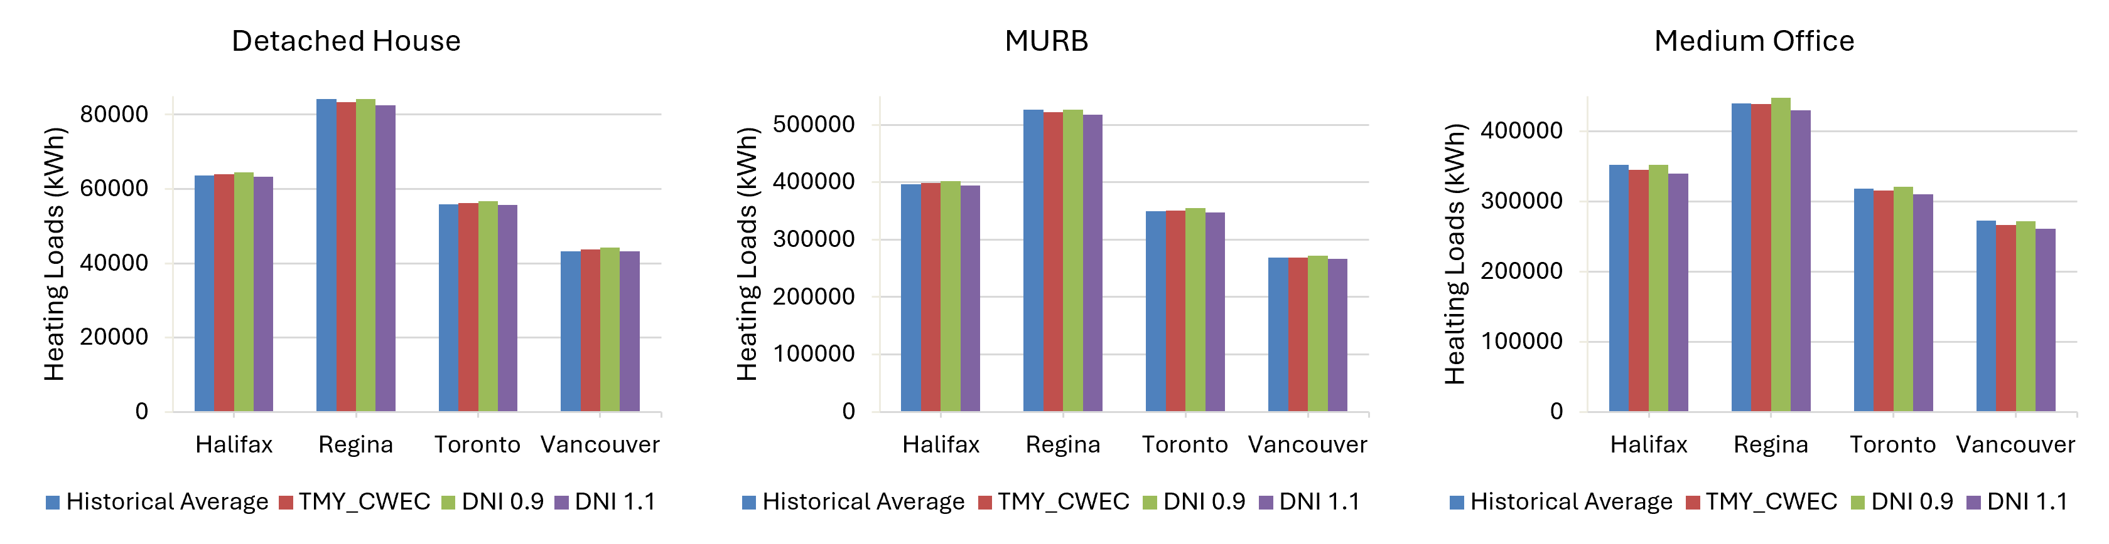
Fig. 8: Annual heating loads under DNI sensitivity (±10 %) — three archetypes.
Cooling loads exhibit greater sensitivity to solar radiation variations, with the magnitude depending on building type. For the detached house, deviations remain within approximately ±7 % (largest in Vancouver); in the MURB the range increases to ±13–14 % in Vancouver; the office building shows very limited sensitivity (typically below 1 %), reflecting the dominant role of internal gains (Fig. 9). A ±10 % change in DNI produces approximately a ±7 % change in total incident radiation, while diffuse radiation remains unchanged.
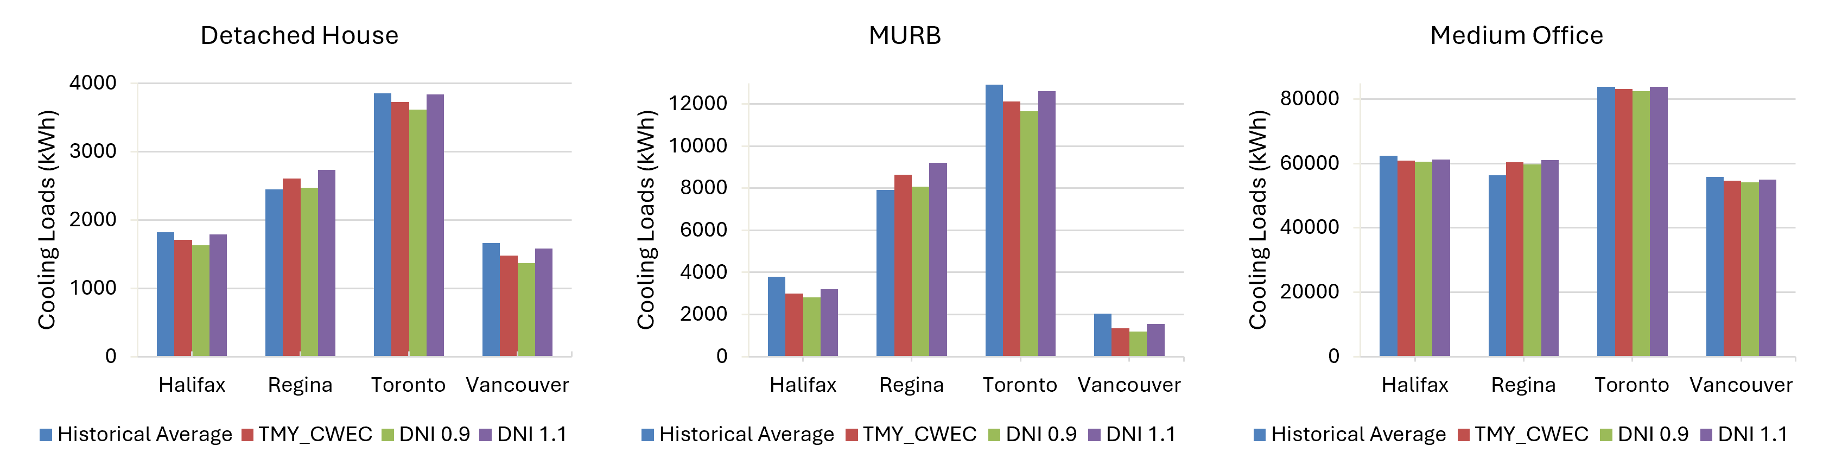
Fig. 9: Annual cooling loads under DNI sensitivity (±10 %) — three archetypes.

Peak heating is largely unaffected by DNI variation, with changes below approximately 1 %, while peak cooling shows a somewhat greater but still modest response, generally within about 2–4 % (Fig. 10).
Figure 10 shows that relative to historical averages, TMY peak heating of the detached houses differs by up to approximately 9–13 % in some locations, while TMY peak cooling differences are approximately 2–12 %. The same qualitative pattern is observed for the MURB and office.
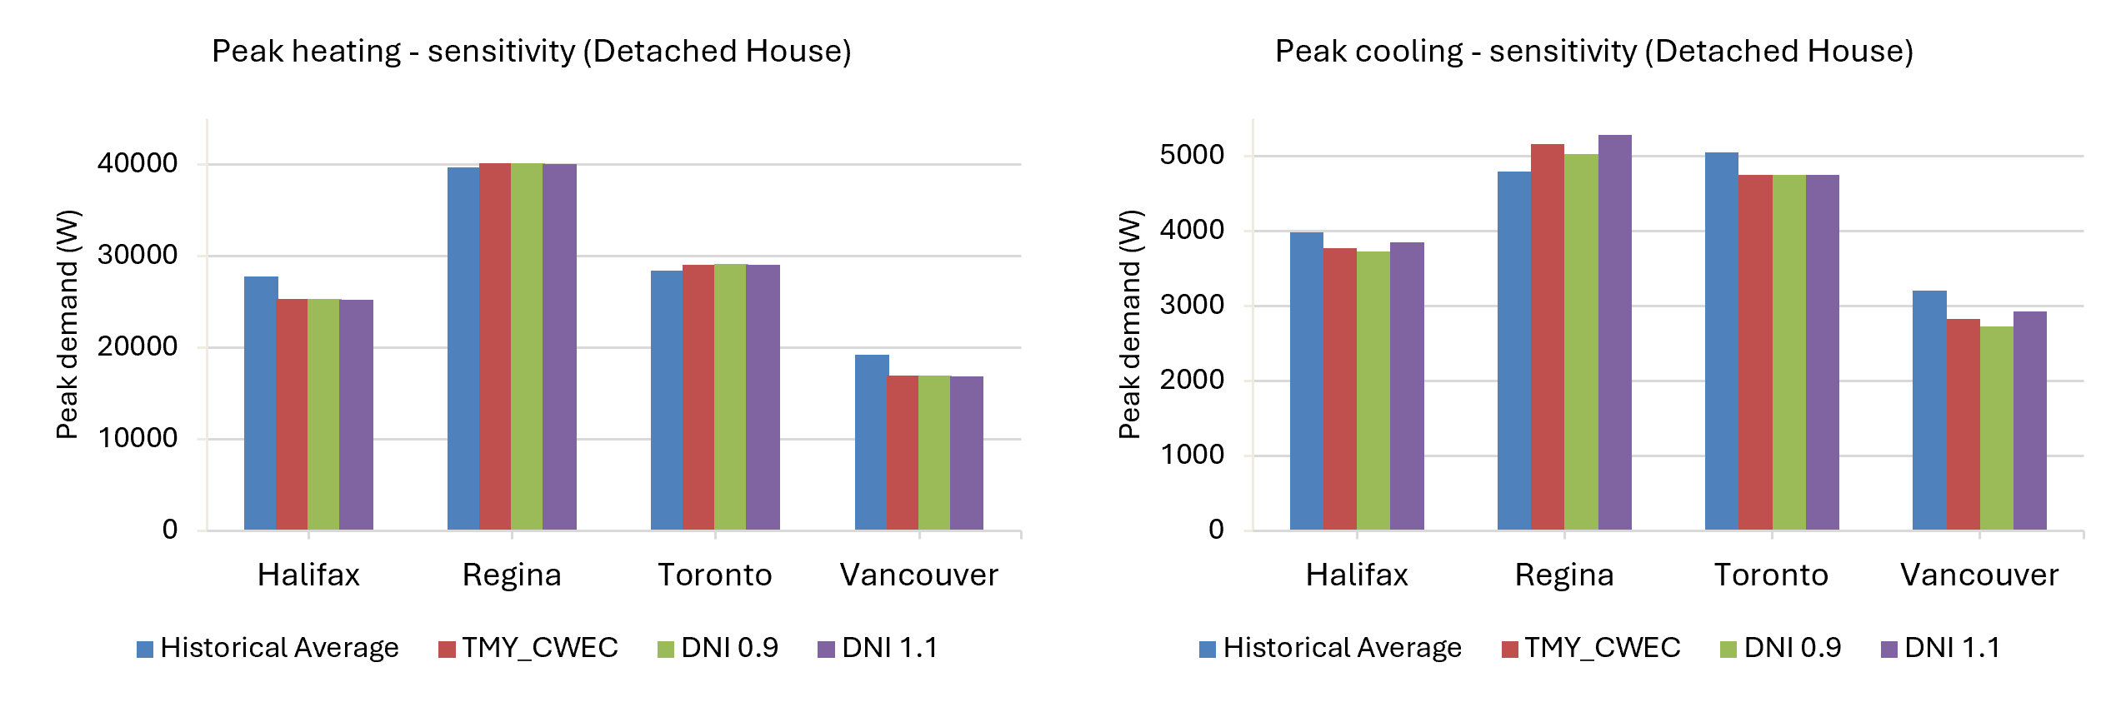
Fig. 10: Peak heating and cooling demand under DNI sensitivity (±10 %) — detached house.
3.3. Weather-file generation methods
The comparison of weather-file generation approaches shows that TMY methods produce relatively consistent annual heating loads across all cities, generally within approximately 2 % of historical averages for residential buildings and about 5 % for the office. Seasonal XMY introduces larger deviations, increasing heating loads by up to 20 % in colder climates (Fig. 11). This consistency is expected: TMY methods are constructed to reproduce long-term average monthly conditions, so for a temperature-driven quantity such as annual heating they converge closely to the historical mean regardless of the specific weighting scheme used (Herrera et al., 2017; Hosseini et al., 2021). The seasonal XMY, by contrast, deliberately selects the most extreme months of the record; in cold climates this concentrates colder-than-average periods into the file, raising the seasonal heating-degree total and hence the annual heating load. The larger relative deviation for heating in colder climates is therefore a direct consequence of the extreme-month selection rather than of any change in the building model (Nik, 2016). The seasonal XMY dataset represents a “worst-case scenario” heating load.
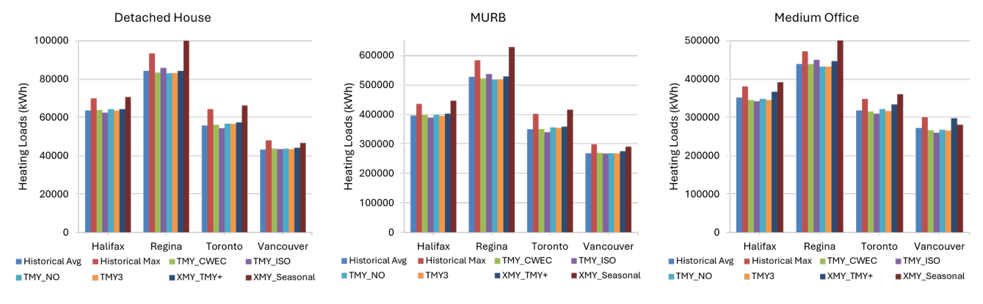
Fig. 11: Annual heating loads under TMY and XMY generation methods with historical average and maximum annual references — three archetypes.
Whereas Section 3.1 quantified how cooling loads differ between historical data sources, this comparison isolates the effect of the file-construction method itself. Cooling loads show substantially greater sensitivity to weather-file construction. For the detached house, seasonal XMY increases cooling loads by approximately 50–85 % relative to historical averages, while TMY+ produces more moderate increases. These effects are amplified in the MURB, where seasonal XMY results are at least double the historical averages in several locations. The office building shows smaller relative changes (seasonal XMY ~18–40 %, TMY+ generally below 10 %). These two XMY file constructions are made to better capture extreme cooling scenarios that may occur over the long-term operation of a building. TMY+ generally produces an intermediate response between conventional TMY and seasonal XMY, particularly for cooling, because limited extreme periods are introduced into an otherwise typical year rather than constructing the year entirely from seasonal extremes. Relative to Historical Max, seasonal XMY approaches or exceeds the maximum historical annual cooling load in several cases, particularly for the residential archetypes, while TMY+ generally remains intermediate between conventional TMY and seasonal XMY.
In contrast, across all archetypes, TMY methods remain within approximately 5 % of historical average values (Fig. 12), however, they cannot capture the effects of extreme weather events. Across TMY files, the much stronger response of the residential archetypes reflects the same mechanism identified in the heating load section: their cooling loads are small and solar-driven, so concentrating extreme warm and high-irradiance periods in the XMY file produces a large proportional increase, whereas the internally dominated office is buffered by its high baseline gains (Pernigotto et al., 2020).
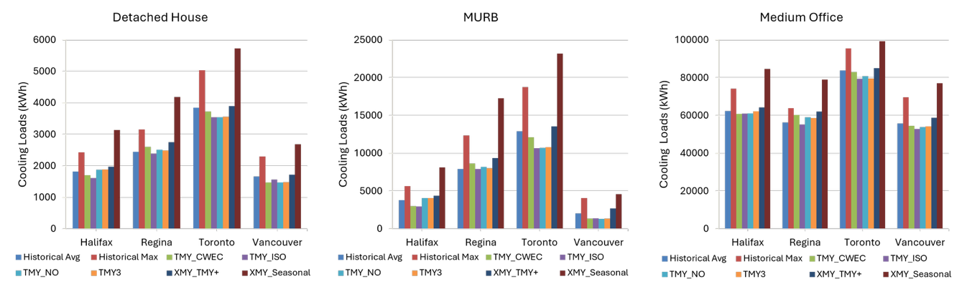
Fig. 12: Annual cooling loads under TMY and XMY generation methods with historical average and maximum annual references — three archetypes.
Peak demand provides the clearest distinction between typical and extreme weather-year constructions (Fig. 13). Conventional TMY methods generally remain close to Historical Average but can fall substantially below Historical Max, particularly for cooling. Extreme-year methods reduce this gap, although not uniformly.
For detached-house peak heating, TMY+ is within about 0–7% of Historical Max and is essentially coincident with it in Halifax, Toronto and Vancouver; seasonal XMY is within about 0–4% in Halifax, Regina and Toronto but remains about 21% below the maximum in Vancouver. For office peak heating, TMY+ performs particularly well, remaining within about 1% of Historical Max across all four climates. For cooling, the improvement is more variable: TMY+ remains approximately 0–20% below Historical Max for the detached house and 13–28% below for the office, whereas seasonal XMY ranges from slightly exceeding Historical Max in some cases to remaining about 11–23% below it. These results show that extreme-year methods generally shift peak predictions from typical historical conditions toward the observed upper bound, but their effectiveness remains climate- and archetype-dependent (Hosseini et al., 2021; Siu et al., 2023).

Fig. 13: Peak heating and cooling demand under TMY and XMY generation methods compared with historical average and maximum peak references (2005–2022) — detached house, MURB, and medium office.
Across the synthetic weather files, solar gains vary less than cooling loads. Conventional TMY methods remain close to Historical Avg, while seasonal XMY generally produces the highest synthetic-year gains and shifts results toward the upper historical envelope. However, seasonal XMY generally remains below Historical Max, showing that the extreme-year construction does not uniformly reproduce the largest historical annual solar-gain value (Fig. 14).
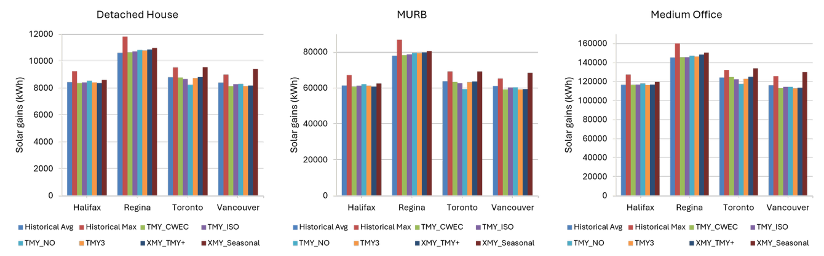
Fig. 14: Internal solar gains under TMY and XMY generation methods with historical average and maximum annual references -- three archetypes.
4. Conclusions
This study evaluated the influence of weather dataset selection, solar irradiance assumptions, and weather-file generation methods on building energy simulation outcomes in four Canadian climates across three representative archetypes - a detached house, a MURB, and a medium office. The study shows that weather-product selection affects both heating and cooling predictions, but the effect is substantially greater for cooling. For the detached house and MURB, most annual heating differences are within about ±5 % of CWEEDS, with isolated deviations of approximately 10–14 %; the office reaches about +30 % in Vancouver. Cooling is much more sensitive: ERA5 reductions reach about 65 % for the Vancouver detached house and about 70 % in the MURB, while PSM4 increases exceed 100 % in some MURB cases. Because each historical product replaces the complete meteorological record, these differences cannot be attributed to solar radiation alone; however, their correspondence with solar-radiation contrasts, together with the controlled DNI analysis, identifies solar representation as an important contributor to cooling variability.
The controlled sensitivity analysis confirms a clear response to DNI. A ±10 % DNI perturbation changes annual cooling by up to about ±7 % in the detached house and ±13–14 % in the MURB, while the office remains below about 1 %; annual heating changes are only about 1–2 %. The magnitude of the response is therefore strongly archetype-dependent, with the MURB showing the greatest amplification and the internally dominated office the least.
Typical meteorological years remain close to historical averages for annual loads, but they do not reproduce the full range of extremes. Relative to Historical Max, conventional TMY peak cooling is approximately 11–45 % lower for the residential archetypes and 20–30 % lower for the office. XMY methods reduce this gap in many cases, but no single formulation reproduces all historical maxima across climates and archetypes. TMY is therefore suitable for average annual benchmarking, whereas peak-load sizing and resilience assessment should combine extreme-weather files with multi-year historical maxima rather than rely on a typical year alone.
The study holds the location-specific building assumptions fixed across weather comparisons to isolate weather effects. Window-to-wall ratio, glazing type, solar heat gain coefficient, shading, thermal mass, façade orientation, airtightness, and broader envelope-performance variations were not tested. Future work should examine these variables across additional climates and future weather scenarios, including morphed and bias-corrected projections, and extend the framework to photovoltaic and storage modelling.
Recommendations for weather data selection
The appropriate weather dataset depends on the performance question being asked; matching the weather representation to the objective is more important than defaulting to a single source.
- For annual energy benchmarking and code compliance, a well-constructed TMY dataset (e.g., CWEC) remains appropriate because annual loads stay close to long-term historical averages across the tested TMY methods.
- For cooling-load estimation and solar-sensitive design, the quality and consistency of Direct Normal Irradiance (DNI) and Diffuse Horizontal Irradiance (DHI) should be checked. This study quantifies DNI sensitivity; across the four locations, PSM4 generally produces higher direct irradiance and ERA5 lower solar values than CWEEDS.
- For peak-load and equipment sizing, TMY datasets should not be used alone. Extreme meteorological years or actual multi-year records should be used alongside the historical maximum peak to evaluate whether a weather-year construction adequately represents short-duration extremes.
- For resilience and passive-survivability assessment, weather inputs should represent prolonged low-irradiance and high-demand periods; extreme or continuous multi-year sequences are more appropriate than a single representative year.
- Because weather sensitivity is typology-dependent, envelope-driven residential buildings, especially the MURB in this study, require particularly careful treatment of solar and extreme inputs, whereas the internally dominated office is comparatively less sensitive.
More broadly, reporting results against more than one weather representation makes weather-input uncertainty explicit. For cooling, peak-load, or resilience studies, combining a typical year with an extreme or multi-year historical reference provides a broader and more decision-relevant range of performance than a single deterministic weather file.
References
Berardi, U., Jafarpur, P., 2020. Assessing the impact of climate change on building heating and cooling energy demand in Canada. Renewable and Sustainable Energy Reviews 121, 109681.
Bigtashi, A., et al., 2024. Defining generation parameters with an adaptable data-driven approach to construct typical meteorological year weather files. Energy and Buildings 303, 113781.
Crawley, D.B., Lawrie, L.K., 2015. Rethinking the TMY: is the “typical” meteorological year best for building performance simulation? In: Proceedings of Building Simulation 2015 (IBPSA), Hyderabad, India.
Environment and Climate Change Canada and Natural Resources Canada, 2020. Canadian Weather Energy and Engineering Datasets (CWEEDS). Government of Canada, Ottawa.
Finkelstein, J.M., Schafer, R.E., 1971. Improved goodness-of-fit tests. Biometrika 58(3), 641–645.
Gaur, A., Lacasse, M.A., 2022. Climate data to support the adaptation of buildings to climate change in Canada. Data 7(4), 42.
Hall, I.J., Prairie, R.R., Anderson, H.E., Boes, E.C., 1978. Generation of a Typical Meteorological Year (TMY). Sandia National Laboratories Report SAND78-1601, U.S. Department of Energy.
Herrera, M., Natarajan, S., Coley, D.A., 2017. A review of current and future weather data for building simulation. Building Services Engineering Research and Technology 38(5), 602–627.
Hersbach, H., et al., 2020. The ERA5 global reanalysis. Quarterly Journal of the Royal Meteorological Society 146(730), 1999–2049.
Hosseini, M., et al., 2021. Evaluating the applicability of typical meteorological year under different building designs and climate conditions. Urban Climate 38, 100870.
Huld, T., Müller, R., Gambardella, A., 2012. A new solar radiation database for estimating PV performance in Europe and Africa. Solar Energy 86(6), 1803–1815.
Kočí, J., Kočí, V., Maděra, J., Černý, R., 2019. Effect of applied weather data sets in simulation of building energy demands: comparison of design years with recent weather data. Renewable and Sustainable Energy Reviews 100, 22–32.
Moradi, A., et al., 2023. Impact of typical and actual weather years on the energy simulation of buildings with different construction features and under different climates. Energy 270, 126875.
Nik, V.M., 2016. Making energy simulation easier for future climate — synthesizing typical and extreme weather data sets out of regional climate models (RCMs). Applied Energy 177, 204–226.
Perera, A.T.D., Nik, V.M., Chen, D., 2020. Quantifying the impacts of climate change and extreme climate events on energy systems. Nature Energy 5(2), 150–159.
Pernigotto, G., Prada, A., Gasparella, A., 2020. Extreme reference years for building energy performance simulation. Journal of Building Performance Simulation 13(2), 152–166.
Robert, A., Kummert, M., 2012. Designing net-zero energy buildings for the future climate, not for the past. Building and Environment 55, 150–158.
Sengupta, M., Xie, Y., Lopez, A., Habte, A., Maclaurin, G., Shelby, J., 2018. The National Solar Radiation Data Base (NSRDB). Renewable and Sustainable Energy Reviews 89, 51–60.
Siu, C.Y., O’Brien, W., Touchie, M., Armstrong, M., Laouadi, A., Gaur, A., Jandaghian, Z., Macdonald, I., 2023. Evaluating thermal resilience of building designs using building performance simulation – A review of existing practices. Building and Environment 234, 110124.
Thiis, T.K., Petersen, A.J., Fuglestvedt, H.F., Hygen, H.O., 2025. Typical meteorological years tailored for high latitudes based on high-resolution reanalysis data. Journal of Building Performance Simulation, 1–17.
Yan, D., Wu, Y., Malik, J., Hong, T., 2025. Ten questions on future and extreme weather data for building simulation and analysis in a changing climate. Building and Environment 269, 112461.
Yuan, J., Huang, P., Chai, J., 2022. Development of a calibrated typical meteorological year weather file in system design of zero-energy building. Energy 259, 125031.

