EuroSun2026
SYSTEM-COP AND OPERATION STRATEGIES FOR
LARGE-SCALE SOLAR THERMAL & HEAT PUMP COMBINATIONS

Daniel Trier
PlanEnergi
dt@planenergi.dk
Summary
The ideal operation mode for the combination of solar thermal systems and heat pumps depends on a number of case-specific parameters as well as external factors such as electricity prices and weather conditions. Where the focus is often intuitively on maximising the solar yield per m² of solar collector and the COP of the heat pump, this analysis evaluates the overall system performance to minimise the electricity consumption and need for auxiliary energy. The term “system-COP” is applied as an indicator for the COP of a certain operation choice – not the COP of one unit. In this context it represents the correlation between extra heat output and the electricity consumption to enable this. The system-COP is used to show how unconditional operation using solar heat as heat source for the heat pump can lead to an increased primary energy demand, whereas sufficient evaluation of options in a “level playing field comparison” can reveal options to both energetic and financial improvements compared to standard operation of solar thermal systems and heat pumps. The basis for the calculations is the application involving large-scale solar thermal systems combined with similarly large-scale heat pumps for district heating.
Keywords: Solar district heating, heat pumps, system-COP
Field of application for the findings: Large-scale systems, district heating, design and operation optimisation
Addressed audience: System designers, decision makers, operation managers, system simulation researchers
- Introduction
While solar thermal systems are well-known and, in some countries, widely used, large-scale heat pumps are becoming an increasingly important component for district heating. Optimising operation in the combination of both technologies – possibly using the solar thermal system as heat source for the heat pump – involves a potential for energetic and economic improvements but at the same time risk of a hidden unnecessary electricity demand if the control strategy is oversimplified.
Recommendations for the operation strategy of large-scale solar heating systems in combination with heat pumps are described, and the concept of system-COP is introduced. The system-COP calculation represents the extra heat output when using the solar thermal production as heat source for the heat pump, divided by the extra electricity consumption needed for that process. This becomes a useful tool to identify the real value of such “cold solar operation” taking into account the electricity cost enabling the extra solar yield.
The results can benefit companies investing in and/or operating the combination of solar thermal systems and heat pumps – especially in systems involving multiple choices to define the most suitable control strategy.
- System-COP
2.1 Solar yield improvement by reducing collector temperature
It can be shown that if the solar collector temperature is reduced, the solar heat production increases by an absolute amount independent of the solar radiation. This becomes relevant to determine the value of reducing the collector operating temperature.
In a given situation (e.g. traditional operation mode referred to as situation I with index number "I" below), the specific solar heating output q_{s,I} (in W per m² solar collector) is calculated using the simplified solar collector efficiency expression as follows:
Regular operation (I):
$q_{s,I}=η_{0}K_{θ}G-a_{1}\left(T_{m,I}-T_{a}\right)-{a_{2}\left(T_{m,I}-T_{a}\right)}^{2}$ (eq. 1)
where is the solar heat output, η₀ is the maximum solar collector efficiency, K_{θ} is the angle of incidence correction factor [-], G is the solar irradiance on the collector plane [W m⁻²], T_{m} is the average temperature of the solar collector fluid [°C], T_{a} is the ambient (air) temperature [°C], while a₁ [W m⁻² K⁻¹] and a₂ [W m⁻² K⁻²] are solar collector heat loss coefficients.
In an almost similar situation "II" where the only change is a lower temperature in the solar collectors enabled by previous cooling of the buffer storage tank (and thus lower temperature T_{m} of the solar collector fluid), the formula is similar as follows:
Lower temperature in the solar collectors (II):
$q_{s,II}=η_{0}K_{θ}G-a_{1}\left(T_{m,II}-T_{a}\right)-{a_{2}\left(T_{m,II}-T_{a}\right)}^{2}$ (eq. 2)
The impact on the solar collector performance is found as the difference between the two calculated solar collector performances q_{s}. In the expression of this difference ∆q_{s} [W m⁻²] = q_{s,II} – q_{s,I} the η₀K_{θ}G equals out (which represents the absorbed solar heat) hence, the extra output from the solar collectors is independent of the solar radiation as shown in eq. 3. In any given situation (with a given ambient temperature T_{a}) the additional Δq_{s} for a given solar collector thus depends solely on the change in T_{m}. It should be noted that the expression does not take into account that the efficiency expression can be negative. Hence, the expression can only show extra yield compared to no solar yield for q_{s,I} ≥ 0.
$$∆q_{s}=q_{s,II}-q_{s,I} \\ =η_{0}K_{θ}G-a_{1}\left(T_{m,II}-T_{a}\right)-{a_{2}\left(T_{m,II}-T_{a}\right)}^{2}-\left(η_{0}K_{θ}G-a_{1}\left(T_{m,I}-T_{a}\right)-{a_{2}\left(T_{m,I}-T_{a}\right)}^{2}\right) \\ =a_{1}\left(T_{m,I}-T_{a}\right)+{a_{2}\left(T_{m,I}-T_{a}\right)}^{2}-a_{1}\left(T_{m,II}-T_{a}\right)-{a_{2}\left(T_{m,II}-T_{a}\right)}^{2} \\ =-2a_{2}\left(T_{m,I}-T_{m,II}\right)T_{a}+a_{1}\left(T_{m,I}-T_{m,II}\right)+a_{2}\left({T_{m,I}}^{2}-{T_{m,II}}^{2}\right)$$ (eq. 3)
Eq. 3 shows that the extra solar yield, Δq_{s} is inversely proportional to the ambient temperature for any given temperature T_{m,I} changed to a lower given temperature T_{m,II}. The inclination is equal to –2a₂(T_{m,I} – T_{m,II}). The negative inclination follows the logic that the improvement by reduced collector operating temperature is more pronounced at lower ambient temperatures where the heat losses are highest.
When a heat pump is used to cool the solar collector fluid, this way reducing the collector operating temperature, the extra solar yield gained from the increased collector efficiency is thus independent of the solar radiation, while the electricity required is not. With increasing solar radiation levels, more solar heat is produced which must be cooled using the heat pump, thus requiring more electricity than when solar radiation levels are low. Hence, a given extra solar yield requires more electricity at high solar radiation levels compared to low solar radiation.

2.2 System-COP definition
The correlation between extra heat output by reducing the collector mean temperature and the electricity consumption to enable this (by cooling the solar collector loop) can be considered a COP for the whole system process – a “system-COP”. As explained by From and Bobach (2013) system-COP (also referred to as COP_{system}) can be defined as
$${COP}_{system}=\frac{{\dot{Q}}_{Extra output}}{{\dot{Q}}_{Extra consumption}}=\frac{{\dot{Q}}_{Extra solar yield}+{\dot{Q}}_{Extra elctricity}}{{\dot{Q}}_{Extra electricity}}$$

Where _{Extra output} is the additional heat flow rate delivered when applying the solar loop cooling, _{Extra consumption} is the extra energy demand to enable such additional heat flow rate, _{Extra solar yield} is the additional produced solar heat flow rate, and _{Extra electricity} is the extra electric power demand to enable the solar loop cooling.

2.3 Example calculations of system-COP
Figure 1 below shows an example of a system-COP. For comparison, a typical level of a heat pump's COP is shown in normal operation ("Standard COP"). While the exact values are both case-specific and depend on weather conditions, there is a trend represented by the light orange shaded area on the figure defined by a typical operation range of 5-20 °C ambient air temperature. The example is based on a solar collector typically used for large-scale systems and an air-source heat pump used for district heating. However, it could also represent other heat sources than air.
The assumptions in the following calculations are based on table 1.
Tab. 1: Assumptions applied in example calculations.
Parameter | Value | Unit
Network supply temperature | 80 | °C
Network return temperature | 45 | °C
Heat exchanger temperature difference | 3 | K
Solar loop cooling supply temperature | 35 | °C
Solar loop cooling return temperature | 25 | °C
Heat pump COP air cooling | 3.0 | -
Heat pump COP solar loop cooling | 5.0 | -
Ambient air temperature | 20 | °C
Maximum solar collector efficiency (η₀) | 0.773 | -
First order solar collector heat loss coefficient (a₁) | 2.270 | W m⁻² K⁻¹
Second order solar collector heat loss coefficient (a₂) | 0.018 | W m⁻² K⁻²

Since the system-COP is a calculation comparing two states (i.e. possible operation modes), the value depends on the relevant alternative operation. In winter and shoulder seasons when the total heat demand is relatively high, standard solar thermal systems can benefit from delivering an intermediate temperature since the solar heat can be mixed with a higher temperature from a heat pump or boiler to achieve the desired resulting district heating supply temperature. In the example in figure 1, this period of the year is represented by the ambient air temperature (Ta) of 5 °C indicated in dark purple colours. Using the solar heat as heat source for the heat pump should in winter months be compared primarily with an alternative representing solar heat at intermediate temperature (indicated with a fully drawn dark purple line). Similarly, the ambient temperature is typically higher in summer (represented by Ta = 20 °C in figure 1) when the solar thermal system often covers a relatively large share of the heat demand. In this case it may not be possible to mix a relatively large share of district heating water flow at intermediate temperature with sufficient flow at higher temperature to reach the targeted supply temperature. Hence, the relevant alternative to solar loop cooling is standard operation delivering solar heat at the district heating network supply temperature level. This is represented by the fully drawn light purple line in figure 1. Hence, though the orange shaded area representing other temperature combinations are possible, the fully drawn lines represent the most relevant trends for the system-COP in the example.
It is seen how the system-COP is low when the irradiance is high and vice-versa. This indicates that operation using solar heat as a heat source for the heat pump is mainly relevant at low irradiation levels. However, the relevance also depends on what other heat sources are involved in the overall supply mix, and the costs associated with displacing these.
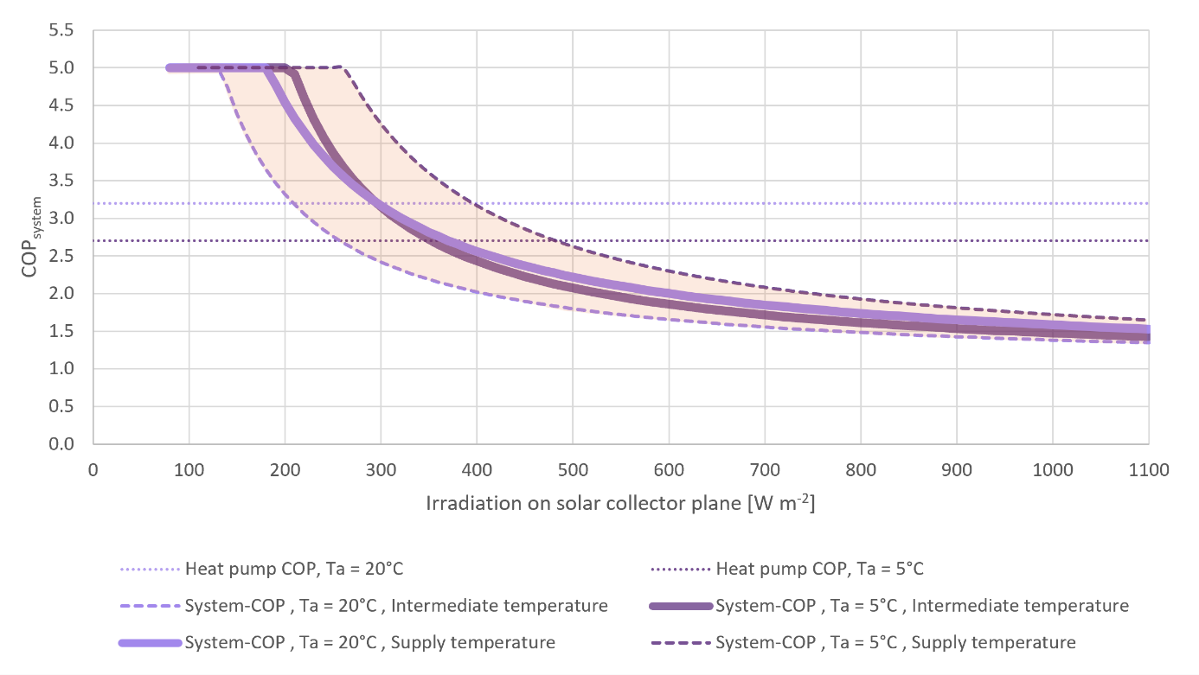
Fig. 1: System-COP related to irradiation on solar collector plane depending on the reference condition of either solar thermal production at intermediate temperature level or district heating supply temperature level. The range of possible system-COP values in this example is indicated with shaded orange. COP for normal heat pump operation is indicated between dotted lines for comparison.
In many cases, the higher temperature of the heat source when using the solar collector loop (indirectly by cooling of storage water) compared to the regular heat source (e.g. ambient air) will result in an increased heat capacity of the heat pump. When additional heat is needed beyond what the heat pumps and solar collectors can deliver, even a low system-COP (e.g. of 2.0) may still be relevant, e.g. if the alternative is an electric boiler for peak load (corresponding to a COP of 1.0). On the other hand, if there is an overcapacity of the solar heat in the storage/from the solar collectors and the regular heat pump operation combined, then solar heat used as a heat pump heat source will simply displace the regular heat pump operation (e.g. ambient air heat). If the system-COP is lower than the COP of regular heat pump operation, the result is increased electricity demand even if both the solar yield and directly measured COP of the heat pump are increased.
An example of such increase in electricity consumption though the solar yield is increased, is seen in figure 2 below for an irradiation level of 500 W m⁻² whereas for low irradiation levels, the total electricity consumption can be reduced. This indicates that the operation strategy needs to take a comparison of multiple options into account. The energetic distribution incl. total electricity consumption for the example of an irradiation level of 500 W m⁻² is summarized in table 2. Electricity for solar collector fluid pumps is neglected.
Tab. 2: Example comparison of 10 MW heat supply distribution at solar radiation of 500 W m⁻².
Energy source | Standard operation thermal power supply [MW] | Solar loop cooling included in thermal power supply [MW] | Difference compared to Standard operation [MW]
Solar heat | 2.2 | 3.2 | + 1.0
Ambient air | 5.2 | 4.0 | – 1.2
Electricity (air cooling) | 2.6 | 2.0 | – 0.6
Electricity (solar loop cooling) | 0 | 0.8 | + 0.8
Electricity total | 2.6 | 2.8 | + 0.2
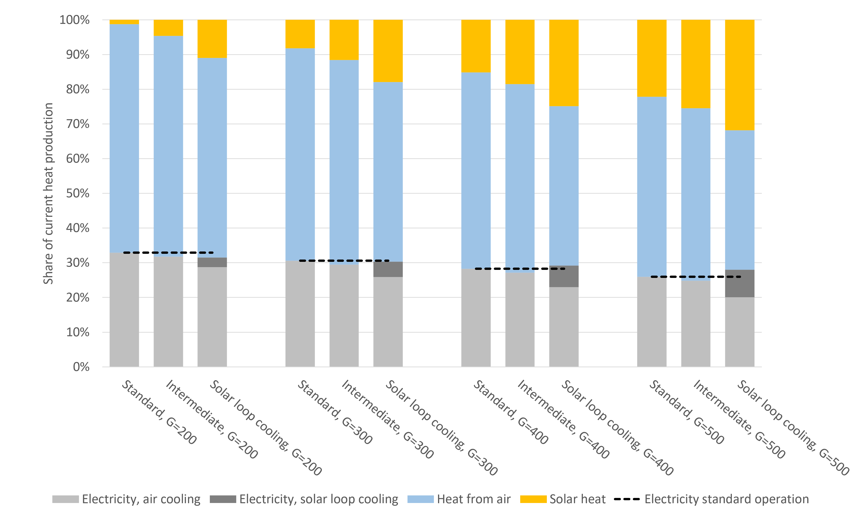
Fig. 2: Example calculation of the distribution of heat production in a situation with irradiation (G) of 200, 300, 400 and 500 W m⁻², respectively, where the solar collectors must supply the flow temperature in the district heating network ("Standard"), an intermediate temperature ("Intermediate", i.e. a temperature between the return and flow of the district heating network) or where the solar collectors are cooled by the heat pump and deliver a low temperature ("Solar loop cooling").
- Simulation results
3.1 Energetic performance simulations for one year
By applying the data from Løgumkloster District Heating (Denmark) as the case using ambient air temperature, irradiation and district heating demand data, the production mix is calculated on an hourly basis over one year. The sum of the district heating demand is approx. 32.6 GWh, the total annual irradiation on the collector plane is approx. 1,200 kWh m⁻² and the average ambient temperature is 10.0 °C. Solar collectors typically used in large-scale solar district heating (cf. table 1) is applied assuming a collector area of 9,000 m² while a heat pump capacity of 3,000 kW_{heating} is included. Calculating the system-COP of solar loop cooling hourly over a year shows how the values follow the trend in figure 1 above. The system-COP calculations of the simulation are shown in figure 3.
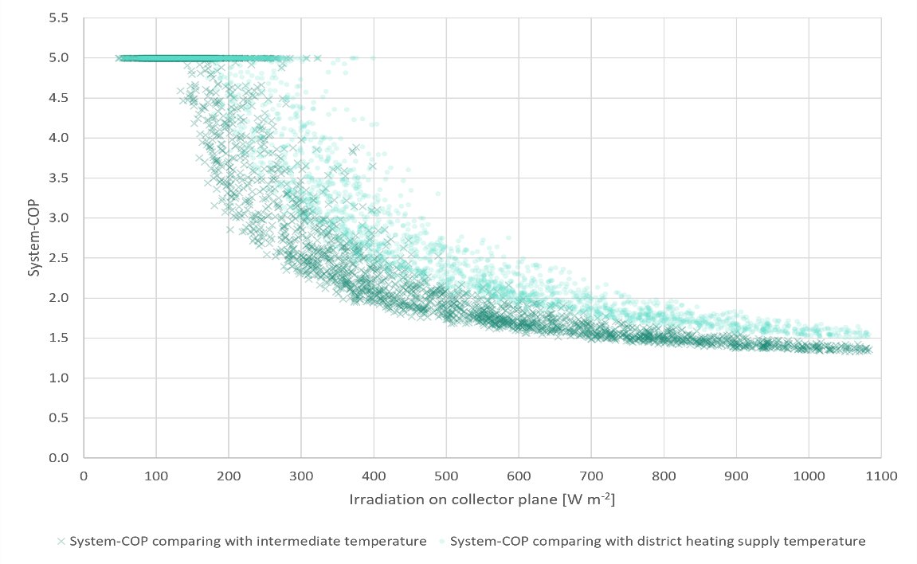
Fig. 3: System-COP of solar loop cooling calculated every hour of one year using two different reference operation modes (either district heating supply temperature or an intermediate collector temperature) related to irradiation on the solar collector plane.
3.2 Sensitivity analysis
By varying several key parameters, it is confirmed how the given circumstances significantly affect the business case of the solar loop cooling option. The electricity price and the cost of auxiliary heat have a relatively heavy impact on the feasibility of solar loop cooling operation. Especially the value of displaced energy affects the results.
Another key parameter is the capacity of the heat pump, since this affects the number of hours where the combination of solar heat and heat pump at normal operation mode is sufficient to cover the demand. A larger heat pump capacity reduces the number of hours where any extra solar yield is displacing auxiliary heat (as described in section 2.3) thus making solar loop cooling less feasible though still relevant in some periods. Similarly, a changed solar collector area is affecting the relevance of solar loop cooling. If the solar collector area is reduced, any extra solar yield from solar loop cooling is more often useful thus increasing the hours where such operation makes sense. However, the economic benefit is reduced in absolute numbers since the capacity of improvement is reduced by the lower collector area.
A main assumption is that using solar heat as the heat source of the heat pump will increase the heat pump capacity. If this is not the case, the economic value of solar loop cooling is in the calculations practically eliminated. However, in real cases where the combination of solar thermal systems and heat pumps are implemented in large scale, thermal capacity improvements have been seen, thus supporting the assumption of increased heat pump performance. The calculations assume additional 500 kW_{heating} but a sensitivity analysis with half of this extra capacity shows that the majority of the financial benefit is enabled even with relatively little extra heat pump capacity.
The assumptions of the COP for normal heat pump operation and the solar loop cooling operation are less significant for the annual operation costs thus indicating that the conclusions hold even if COP levels are not exactly as assumed.

3.3 Summary of case-specific analysis
The simulations show that if solar loop cooling is activated at times when it is feasible (with the chosen assumptions), about 7-11% higher solar thermal output is achieved compared to a reference situation without solar loop cooling. However, this requires extra electricity consumption for the heat pump, resulting in total energetic annual savings of around 2%.
The calculations show a potential for financial savings by optimising the combined operation of the solar thermal and heat pump systems – including cooling the solar collectors with the heat pump under certain conditions. This may apply even if such an opportunity requires an additional investment. However, the total economic value depends on the assumptions where especially the price of the auxiliary heat production displaced by increased solar heat production is key. The simulations showed economic savings around 1% of total annual operation costs. Hence, a financial benefit exists but given the uncertainties involved in the prediction and decision making when selecting the operation mode continuously, there is also a risk of missing the actual optimum and targeted financial benefits thus resulting in no financial benefit or even a negative result compared to the reference. Hence, care should be taken if such optimisation is applied. However, especially in large systems, even relatively small performance improvements may in absolute numbers enable benefits worth pursuing.
- Conclusions
The various possible operation modes should be taken into account and compared properly to identify the optimum operation strategy of the combined system. This introduces more complexity but also enables potential improvements.
By calculating the system-COP a better understanding of the actual benefit of solar loop cooling can be identified. This can help the decision making both in terms of investments and operation.
It is typically not recommendable to apply solar loop cooling at high irradiance levels, and it is also least relevant if there is already sufficient thermal capacity from the solar thermal system and the heat pump combined. In that case any extra solar heat production will displace the heat pump's normal heat source. The fact that the majority of the annual solar irradiation is found at high irradiance levels limits the technical potential for optimisation via solar loop cooling.
Optimisation is complex especially when multiple operation modes are possible, and in an attempt to optimise operations, there is a risk of making decisions, which can be more expensive and/or less efficient. Many parameters play a role in the choice of the optimal mode of operation, and some operation modes may seem intuitively attractive but may turn out to be more expensive and inefficient than alternatives. However, with the proper comparison of operation mode options to identify the most feasible choices, both energetic and financial benefits are possible in combined solar thermal and heat pump systems.
- Acknowledgements
The analysis was carried out in course of the project “Solvarme og varmepumper” funded by the Danish District Heating Association. This paper has been prepared based on funding from the Danish Energy Technology Development and Demonstration Programme, EUDP.
- References
From, N., Bobach, M.V., 2013. Combining solar thermal plants with heat pumps. Solar District Heating Conference 2013 proceedings. https://www.solar-district-heating.eu/wp-content/uploads/2018/06/SDH-Conference-2013-Book-of-papers.pdf accessed 27-07-2026.
Trier, D. 2026. Solvarme & varmepumper – Evaluering af muligheder for samdrift. https://danskfjernvarme.dk/media/paffctde/solvarmevarmepumper.pdf accessed 27-07-2026.

