FLUTTER ANALYSIS OF AGARD COMPOSITE WING

S. Kilimtzidis¹, D.E. Mazarakos ¹ and V. Kostopoulos^{1*}

¹ Applied Mechanics Laboratory, Department of Mechanical Engineering and Aeronautics, University of Patras, Patras University Campus, GR-26500 Patras, Greece
*corresponding author: kostopoulos@upatras.gr

Keywords: Aeroelasticity, composite materials, optimization, numerical analysis, Doublet Lattice Method

Abstract
In this survey, a numerical subsonic and transonic flutter study was developed in order to investigate the reliability of flutter data measured in the Langley transonic dynamics tunnel for the AGARD 445.6 wing structure. The AGARD wing is an experimental structure that promotes the evaluation of existing and emerging unsteady codes-methods for application to aeroelastic problems, especially for the transonic range. The original AGARD wing is a limited aerodynamic configuration and its experimental dynamic response data are designated as standard for comparisons. The AGARD is a tapered, high swept back and low aspect ratio wing, made of mahogany anisotropic wood. This baseline structure was used for the development of a Composite AGARD wing. Using the experimental data from the original wing (Wind tunnel tests AGARD Report No. 765), the MSc FlightLoads Aeroelastic analysis was verified. The results are in good agreement at all Mach numbers. The verified methodology was further proposed for the modification of the original AGARD wing using Composite Materials. Both the original and composite wing were modeled with Doublet Lattice panels for the aerodynamic calculations and two different element types were selected (shell elements and solid elements) for the structural components. The dynamic aeroelasticity was investigated for both configurations using MSC FlightLoads. The aerodynamic panels and the structural mesh were coupled using the rigid/flexible spline method for both configurations, verifying the numerical method’s accuracy. The flutter response of the composite wing was compared to the flutter point of the original configuration. The loads, flutter results as well as the mass reduction are further discussed for both cases. The proposed AGARD wing, made of composite materials, could be used as wind tunnel testing model for the verification of numerical codes at higher Mach speeds.

1. Introduction

The calculation of the aeroelastic response in aircraft structures is mainly performed via either Computational Fluid Dynamics (CFD) or the Doublet Lattice Method (DLM). The first method solves the Euler or Reynolds Averaged Navier-Stokes equations while the second one is based on linearized aerodynamic potential theory. In order to verify each solver, the AGARD 445.6 wing is widely selected in the literature as a baseline. This wing structure, developed in the NASA Langley Wind Tunnel, [1] serves as a baseline for further studies due to the plethora of available data obtained through several wind tunnel tests. Lee-Rausch et al [2] studied the flutter characteristics of the AGARD 445.5 using Euler and Navier-Stokes algorithms. A linear stability analysis and a time-marching aeroelastic analysis were used to determine the flutter characteristics of the wing. The numerical results are in a good agreement with the experimental ones. Liu et al [3] developed a parallel integrated CFD-CSD (Computational Solid Dynamics) code for the simulation and prediction of flutter speed. The coupled code predicted well the flutter velocity and frequency of the wing at subsonic and transonic velocities, but overpredicts them at supersonic velocities. Goud et al [4] performed a Fluid-Structure Interaction analysis at Mach=0.9 taking into consideration the pressure, kinetic energy and temperature over the wing. The calculated flutter velocity is in good agreement with the experimental results. Beaubien et al [5] compared time marching simulations using Euler and Reynolds Averaged Navier-Stokes equations to a frequency domain solution provided be the Doublet-Lattice Method for the AGARD wing in the transonic region. The time marching simulations show good agreement compared to the experimental results, whether DLM unaltered aerodynamics produced unreliable transonic flutter boundaries.
The purpose of this study is initially to verify the flutter boundaries of the reference AGARD wing making use of the DLM Code implemented in the commercial software MSC FlightLoads and then to propose a composite wing made of CFRP layers and a damage tolerant foam following the criteria: reduced weight and increased flutter velocity.

2. Geometry and Testing

The wing geometry and the airfoil profile of the AGARD 445.6 wing are presented in Figure 1.The span of the wing is 0.762 m, with a quarter-chord sweep angle of 45⁰ and a taper ratio of 0.658. The chord of the wing is 0.559 m at the root and 0.368 m at the tip and follows the NACA 65a004 airfoil coordinates throughout the span.

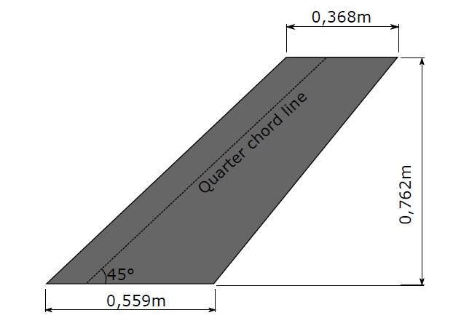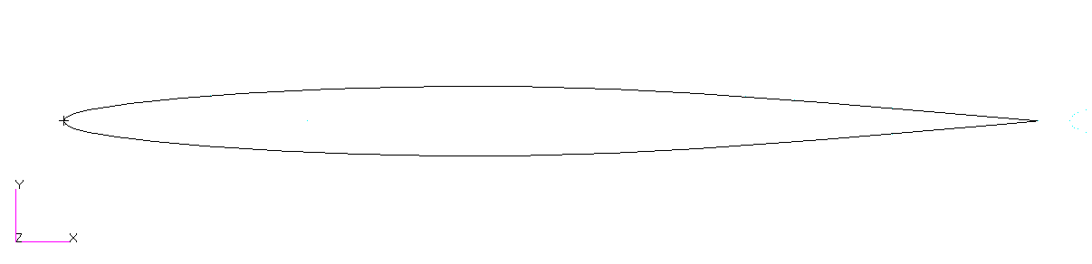

Figure 1. Wing dimensions and airfoil profile

For the current work, the weakened model 3, referenced in [1] was selected. It is made of laminated mahogany with drilled holes and filled with foam in order to obtain the flutter conditions at low velocity. The material properties of this configuration are summarized in Table 1:

Table 1. Laminated mahogany material properties

Material Property | Weakened Model
E₁₁ | 3.1511 GPa
E₂₂ | 0.41621 GPa
E₃₃ | 0.41621 GPa
v₁₂ | 0.31
v₁₃ | 0.31
v₂₃ | 0.31
G₁₂ | 0.4392 GPa
G₂₃ | 0.4392 GPa
G₁₃ | 0.4392 GPa
ρ | 381.98 kg/m³

The natural frequencies of the test model as well as its mass are also reported:

Table 2. Test model natural frequencies and mass

Frequency | Value
f₁ | 9.5992 Hz
f₂ | 38.1650 Hz
f₃ | 48.3482 Hz
f₄ | 91.5448 Hz
f₅ | 118.1132 Hz
Half-Model Mass | 1.673 kg

The test conditions as well as the resulting flutter velocities are summarized below:

Table 3. Weakened model 3 flutter testing results [1]

Structure | Model | M | ρ(kg/m³) | μ | ω_{α}(rad/s) |  | ω(rad/s) | V(m/s) | q(Pa) | Flutter index
Weakened | 3 | .499 | .42776 | 33.465 |  | 239.3 | 128.1 | 172.45 | 6372.8 | .4459
 | 3 | .901 | .09947 | 143.92 |  | 239.3 | 101.1 | 296.69 | 4275.7 | .3700
 | 3 | 1.141 | .07833 | 182.74 |  | 239.3 | 109.9 | 364.33 | 5041.8 | .4031

3. Verification of FE Model

Two scenarios using Finite Element models have been taken into consideration. The first case is based on solid elements modeling with 10-noded elements TET10 (Figure 2). The second case is based on shell elements QUAD4 and high order QUAD8, both with thickness variation along the span (Figure 3). At the second case, the different formulation of shell element was also investigated for the most accurate result. Τhe h-method for QUAD4 elements was applied using 6 chordwise and 11 spanwise 4-noded (QUAD4) elements (coarse). The mesh is then refined by doubling the number of elements (fine). For the p- method, 8-noded quadrilateral elements are used in order to reduce the elements number .
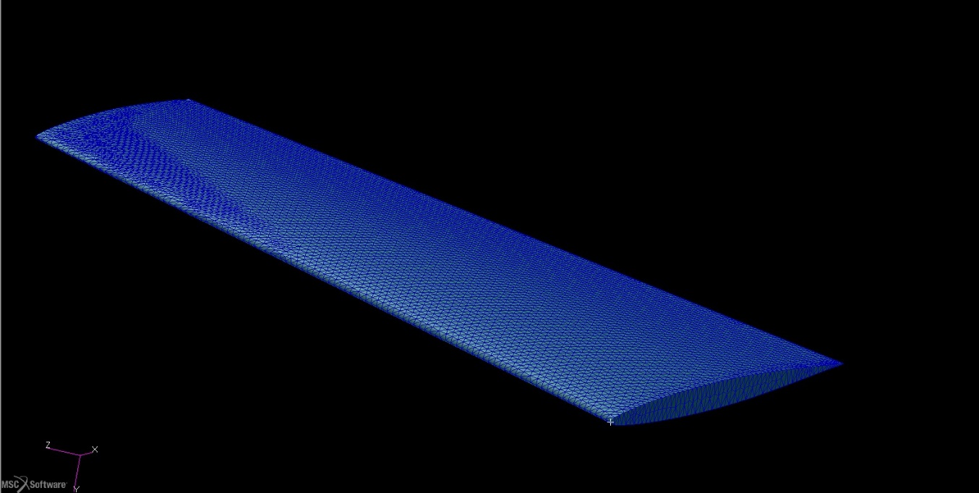

Figure 2. TET mesh of the wing

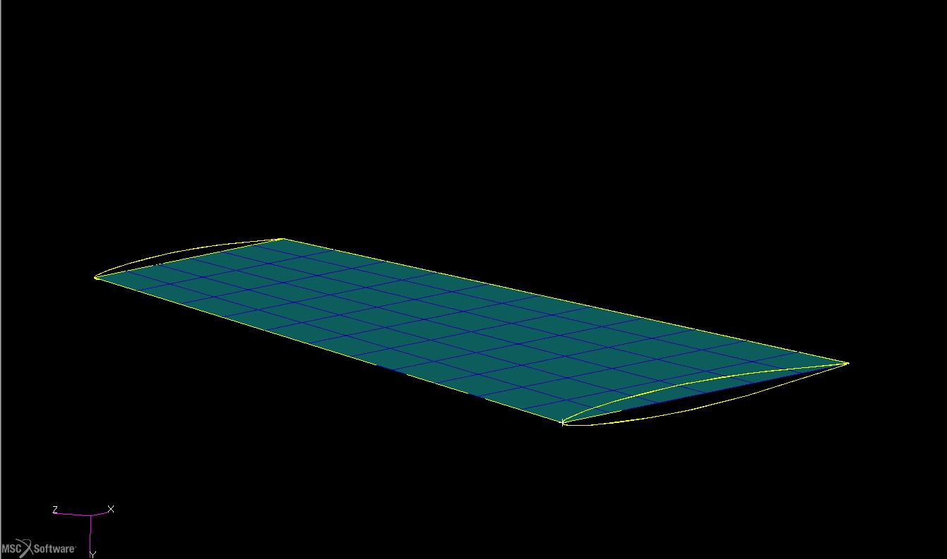
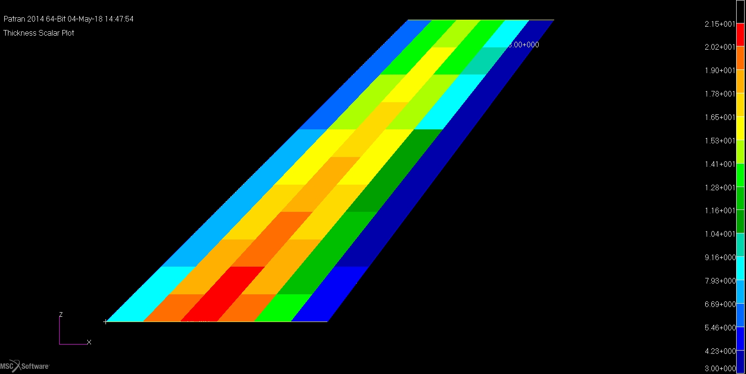

Figure 3. Quad mesh of the wing and nodal thickness variation

The natural frequencies of the experimental test model along with its mass, as reported in Table 2, were set for comparison and validation of the numerical results. The error between experimental and numerical results is also discussed.The results are reported below:

Table 4. Natural frequencies analysis summary

Frequency(Hz) | QUAD4(Coarse Mesh) | QUAD4(Fine Mesh) | QUAD8 | TET Mesh
f₁ | 9.77 | 10.05 | 9.89 | 10.76Hz
f₂ | 37.79 | 40.79 | 38.44 | 44.64Hz
f₃ | 47.48 | 50.49 | 49.15 | 55.22Hz
f₄ | 84.63 | 97.44 | 90.26 | 91.5448 Hz
f₅ | 103.41 | 122.63 | 114.98 | 106.175Hz
Half-Model Mass(kg) | 1.63 | 1.698 | 1.667 | 1.851 kg
Average Error (%) | 4.91 | 5.27 | 1.9 | 14.89

The higher order elements succeed lower average error in the calculation of the eigenfrequencies and mass. For this reason, QUAD8 elements were used for the Flutter analysis and Composite wing design and simulation process.

4. Flutter Analysis using MSC FlightLoads

The flutter analysis is a dynamic instability due to the coupled aerodynamic and inertial forces. It is based on the eigenfrequencies of the wing and the aerodynamic loads. The aerodynamic model was generated in MSC FlightLoads, using 657 aero elements (15 chordwise and 65 spanwise), that follows the mesh criteria as defined in [6] (Figure 4). The aerodynamic and structural models are connected via a finite plate spline (FPS)[6] The aeroelastic analyses are carried out at Mach numbers : M=0.5, M=0.9 and M=1.14 in order to to compare the test results with numerical results in a long velocity range.
At MSc FlightLoads, the reduced frequencies has to be defined in order to perform the flutter analysis [6]. The necessary input data are summarized in Table 5.

Table 5. Input Data for flutter analysis (QUAD 8 structural mesh)

 | M=0.5 | M=0.9 | M=1.14
Minimum frequency(Hz) | 7 | 7 | 7
Maximum Velocity (m/s) | 100 | 250 | 350
Maximum frequency(Hz) | 120 | 120 | 120
Minimum Velocity(m/s) | 200 | 350 | 550

The flutter point can be estimated by velocity-damping (V-g) and velocity-frequency (V-f) for each mode. For Mach=0.5, the V-g and V-f diagrams are presented and the flutter velocity and frequency are marked in red and green dots respectively.

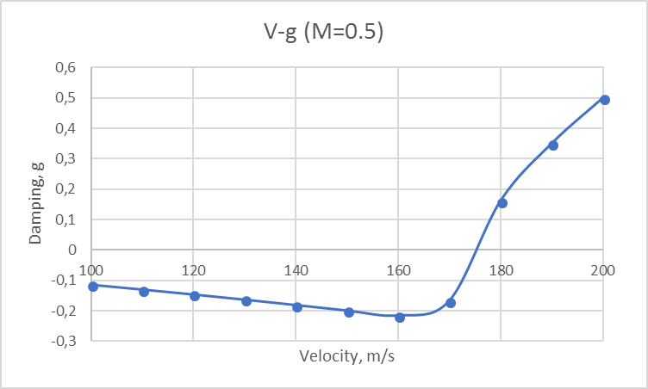
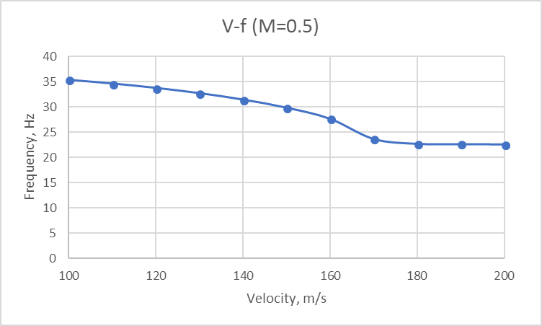

Figure 4. V-g, V-g plots for M=0.5
The flutter numerical results for the range 0.5<Ma<1.141 are presented in Table 8 in comparison with experimental data from windtunnel analysis. It is obvious that for all the Mach range the QUAD8 structural mesh coupled with 2D aero mesh by Finite Spline method lead to very accurate (low error) results.

Table 6. Flutter velocity and frequency comparison

 | M=0.5 | M=0.9 | M=1.141
Numerical flutter velocity, m/s | 174.1 | 271.3 | 384.31
Experimental flutter velocity | 172.45 | 296.69 | 364.33
Numerical flutter frequency, Hz | 22.98 | 16.96 | 19.7
Experimental flutter frequency, Hz | 20.39 | 16.1 | 17.5

5. Composite AGARD Configuration for high supersonic speeds

A composite AGARD configuration is proposed in this section for high supersonic speeds. As the mahogany AGARD wing has low flutter speed an advanced solution for higher speeds is necessary. Based on the reference geometry, a reinforced sandwich structure is investigated. The core material is a lightweight AIREX R63 foam [7], reinforced with 8 CFRP unidirectional layers [8].The initial ply thickness is 0.175 mm with a symmetric lay-up [0/±45/90]_{S}. The lay-up thickness was set for further optimization in order to minimize the wing mass while the flutter speed is maximized.The properties of the materials as well as the proposed lay-up of the airfoil are presented below:

Table 7. CFRP and Foam material properties

 | Material Property | Value
UD-CFRP | E₁₁ | 180.72 GPa
UD-CFRP | E₂₂ | 8.68 GPa
UD-CFRP | v₁₂ | 0.35
UD-CFRP | G₁₂ | 4.385 GPa
UD-CFRP | G₂₃ | 3 GPa
UD-CFRP | G₁₃ | 4.385 GPa
UD-CFRP | ρ | 1622 kg/m³
AIREX R63 | E | 50 GPa
AIREX R63 | G | 21 GPa
AIREX R63 | ρ | 90 kg/m³

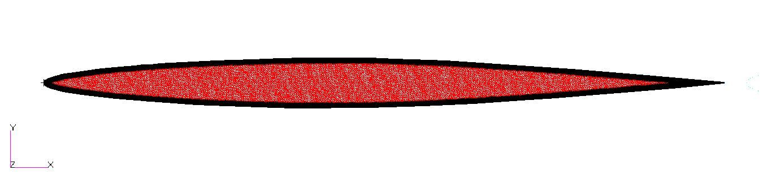
FOAM
CFRP Layers

Figure 5. Composite lay-up of the airfoil including the foam

In order to retain the aerodynamic shape of the wing, at each element of the structural composite lay-up is defined. Given the averaged thickness of each element and the thickness of the CFRP layers, the thickness of the foam is calculated. The criteria for maximum mass of 1.673 kg and increased eigenfrequencies relative to Mahagony AGARD wing were set as priorities. An optimization routine was developed in MATLAB taking into consideration :

m_{composite}< m_{mahogany} , V_{flutter,comp}>V_{flutter, mahogany}, f_{comp}>f_{mahogany}

The analysis is performed in the ESTECO modeFRONTIER software. The algorithm starts with the definition of the design variables, i.e. the thickness of the plies, that range from 0.05 to 0.25 mm, taking into consideration manufacturing aspects [8]. A DoE with 20 entries is generated based on a SOBOL sequence, in order to sufficiently cover the domain of the problem and avoid the risk of correlated sampling. SOBOL is also suitable for a low number of variables, usually less than 10 [9]. A Multi-Objective Genetic Algorithm (MOGA-II) has been chosen for the optimization phase, with 100 generations, probability of directional cross-over equal to 0.5, probability of selection and mutation 0.05 and 0.1 respectively. The number of individual entries in the DoE table are used as the problem's initial population. After the initialization stage, a flutter analysis is performed, and data collected from the analyses are further processed via a MATLAB routine, where the flutter velocity and mass are reported. The objectives for the problem, as stated earlier, are the minimization of the mass and the maximization of the flutter velocity.
The results of the optimization process are presented in Figure 6 where the mass and flutter velocity values are plotted together. Due to large amount of solutions,the following are chosen to be analyzed:

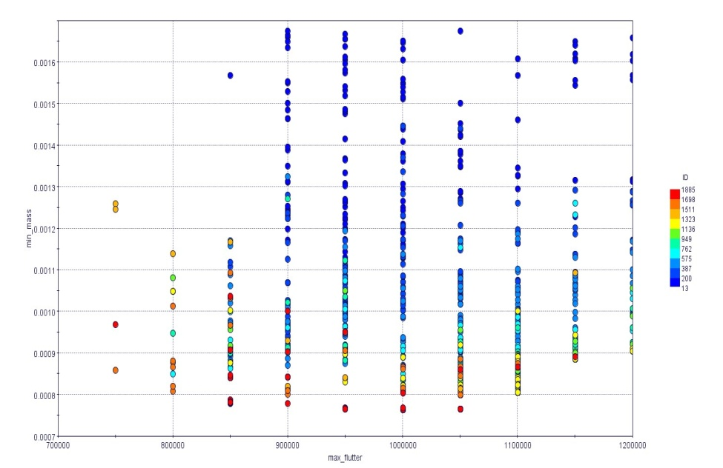

Figure 6. Mass-flutter velocity plot for each design ID
Regarding the results, the wing’s minimum mass with flutter velocity within the range of 750-850 m/s were selected for the AGARD composite wing layout. The designs 1681, 1539 and 1739 were the most appropriate and the results for the wing mass, the flutter velocity and the optimized average CFRP thicknesses at the root and tip chords are summarized in Table 8:

Table 8. Design variables and objective values for designs of interest

 | Design 1681 | Design 1539 | Design 1739
Root CFRP Total Thickness (mm) | 0.8 | 0.8 | 0.826
Tip CFRP Total Thickness (mm) | 1.498 | 1.152 | 0.874
Half-Model Mass (kg) | 0.858 | 0.808 | 0.778
Flutter Velocity(m/s) | 750 | 800 | 850

To conclude, it was proved that the Monohogany AGARD wing could be replaced from a composite wing made of AIREX damage tolerant foam and CFRP skins. This new version is lighter than the wooden wing and the flutter velocity is close to 800 m/s . This layout could be used in supersonic wind tunnels in order to investigate the wing’s response in dynamic conditions for speeds up to Mach=2.2 .

6. Conclusions

An upgraded version of the AGARD 445.6 wing , made of composite materials has been proposed. At early stages the natural frequencies and flutter velocities at different Mach numbers have been verified for the original mahogany configuration using MSC FlightLoads software. As far as the natural frequencies and mass of the model concerned, the QUAD8 elements calculate the behavior of the wing better than any other case. The solid elements produce larger errors mainly due to the misalignment of the element coordinate system with the material coordinate system. For the flutter analyses, the results are in a good agreement for Mach numbers 0.5-1.114. However, near the transonic boundary, errors are observed and corrections to the DLM could be applied. Afterwards, taking into account the same thickness variation across the elements, a composite wing model has been created, consisting of a damage tolerant foam and CFRP layers.The analyses indicate a significant increase in the natural frequencies as well as in the flutter velocity with a decrease in the mass. The optimization algorithm proved that the wing mass could be minimized while the flutter speed was increased. A reduction of 53% in mass can be achieved while maintaining the flutter boundary much higher than the original value. Manufacturing issues may rise due to the thickness variation of the composite structure. For future work, the optimization process can further be expanded to hypersonic speeds if additional thermal effects could be included. This process can lead to optimized windtunnel testing models in order to investigate dynamic effects at higher speeds.

References

[1] E. Yates, N. S. Land, J. Foughner, AGARD Standard Aeroelastic Configurations for Dynamic Response, AGARD Report 765, North Atlantic Trinity Organization, Group for Aerospace Research and Development, Vol10, 1963

[2] Lee-Rausch, E. & Batina, J. T., Wing flutter computations using an aerodynamic model based on the Navier-Stokes equations, Journal of Aircraft pp. 33,6,1139–1147, 1996

[3] Liu F, Cai J and Zhu Y, Calculation of wing flutter by a coupled Fluid Structure Method, Journal of aircraft, Vol. 38, 2001

[4] Goud, T. S. K., Sai Kumar, A. & Prasad, S. S., Analysis of fluid-structure interaction on an aircraft wing, Analysis 3(9), 2014

[5] Beaubien R. J., Nitzsche F., Feszty D., Time and frequency domain flutter solutions for the AGARD 445.6 wing, 2005

[6] MSC FlightLoads User’s Manual, 2014

[7] AIREX R63 Data Sheet, https://www.airexbaltekbanova.com/

[8] R&G Composites, https://www.r-g.de/en/home.html

[9] ModeFrontier user manual. ESTECO S.p.A; 2014.

[10] Raymond L. Bisplinghoff, Holt Ashley, Robert L. Halfman, Aeroelasticity, Dover Science Books

[11] T.H.G Megson, Aicraft Structures for Engineering Students, 4th Edition, Elsevier Aerospace Engineering Series

[12] J.R. Wright, J.E. Cooper, Introduction to Aeroelasticity and Aircraft Loads, Wiley

[13] B.Emsile, Flutter Calculations for a model wing using the MSC Nastran Structural Analysis Program, Aircraft Structures Technical Memorandum 495

[14] A. Kratochvil, S. Slavik, Aeroelasticity analysis of wing UL-39

