EuroSun2026
SIMULATION-BASED HEAT PUMP SYSTEM PERFORMANCE OPTIMISATION OF LARGE APARTMENT BUILDINGS AND DISTRICTS
Fabian Ochs 1 (corresponding author), Elisa Venturi 1, Samuel Breuss 1
University of Innsbruck
fabian.ochs@uibk.ac.at, elisa.venturi@uibk.ac.at, samuel.breuss@uibk.ac.at
Summary
A systemic simulation-based planning approach for district energy systems includes the total heat demand, network length and layout, heat line density, local heat source availability, climate conditions, and renewable energy potential. Cost-optimal solutions need to be identified considering highly efficient thermal envelopes, very efficient heat pump (HP)-based heat generation combined with low-temperature heat distribution systems as well as maximized photovoltaic yield. Decentralized or semi-centralized HP system concept with reduced distribution losses enable higher seasonal performance. Cold district heating or medium-temperature semi-central systems that combine central heat pumps with decentralized booster units for domestic hot water (DHW) preparation can be a promising alternative to classical high temperature district heating system. HP system topology is a key determinant of system efficiency. Simulation models and methods are required that are able to simulated large buildings and districts with the required level of detail and allowing high simulation performance. This contribution focuses on modelling aspects of DHW distribution systems of large buildings using one building of the “Campagne” district with 50 flats as an example.

Keywords: Positive Energy District, Efficiency, Heat Pump System, Monitoring, Simulation
Field of application for the findings: Transition to Renewable and CO₂-Free Energy System
Addressed audience: Science, Planner, Decision Maker
- Introduction
In order to foster the transition of the European building stock, the concept of positive energy districts (PED) has been defined and energy-efficiency, on-site renewable energy generation and energy-flexibility on urban scale shall be demonstrated (Lindholm et al. 2021). PEDs are defined as groups of interconnected buildings that have no net greenhouse gas emissions and actively manage an annual local or regional surplus of renewable energy (Hedman et al. 2021). Besides the high-quality thermal envelope of the buildings, prerequisite for achieving a positive energy balance is a very efficient heating (and cooling) system. The heat pump (HP) system topology is one of the main drivers for system efficiency (Ochs et al. 2026).
While heat pumps (HPs) are increasingly replacing fossil fuel-based heating systems, their application in multi-apartment buildings (MAB) remains limited (Lämmle et al. 2023). The performance and efficiency of HP systems are strongly influenced by system topology (Kropp et al. 2025), control strategies, and operating boundary conditions. In particular, domestic hot water (DHW) preparation remains a major challenge. In spite of the increasing relevance of DHW (Pomianowski et al. 202), only few studies concentrate on efficient HP-based DHW preparation systems. Consequently, electric boilers (E-boilers) or flow-type post heaters (FTPHs) are frequently used instead of HPs (Jähnig et al. 2025), resulting in higher electricity consumption, increased operating costs for tenants, and additional load on the electrical grid. A range of different central, semi-central, decentralized, and hybrid heat pump (HP)-based heating systems have been implemented in recent years in MAB (Ochs et al. 2022). The most common concepts are either centralized, including 4-pipe circulation systems, 2+2-pipe fresh water stations (FWS), 2-pipe heat transfer stations (HTS), and 2-pipe systems with decentralized DHW storage, or decentralized systems employing electric boilers or flow-type post heaters (FTPH). More recently, semi-centralized concepts with decentralized booster heat pumps have attracted increasing attention due to their potential to improve overall system performance in MABs (Ochs et al. 2026, Ochs et al. 2026a). Two principal configurations can be distinguished. The first combines decentralized DHW booster heat pumps (also referred to as return flow heat pumps) with low-temperature space heating distribution systems. The second employs decentralized booster heat pumps for both space heating (SH) and DHW preparation, enabling their application even with conventional high-temperature heat emission systems. Dedicated decentralized heat pumps for DHW preparation (so-called boiler heat pumps) are commercially available but are rarely applied in multi-apartment buildings because of installation space limitations and the challenges associated with providing a suitable heat source. Although a limited number of decentralized split-type air-to-water heat pumps for DHW preparation are available, they currently remain a niche solution.
This monitoring and simulation study focuses on the heat distribution from the buffer in the technical room to the flats for different configurations in terms of building and distribution system using Campagne district as an example. The (cost-)optimal HP integration options in MAB mainly depend on the distribution system, number and size of buffer storage and the useful energy (SH + DHW). The system performance depends on both, the distribution losses and the flow and return temperatures. The accurate prediction of the distribution losses and return temperature requires simulation models and tapping profiles on flat level (Venturi et al. 2026). They depend on the size and geometry of the building as well as location of or distance between the buildings, respectively (i.e., length and thermal quality of the distribution pipes).
This contribution proposes methods for modelling and simulation of heat distribution systems in large MAB and small districts starting from few flats up to few hundreds of flats with a focus on very efficient buildings and “towards” PEDs. In contrast to previous studies physical based approaches are developed with the aim to predict accurately the thermal distribution losses and the return temperature depending on the DHW consumption and DHW tapping profiles. Realistic profiles derived from monitoring are uses and simulations are performed for lumped profiles and individual profiles and considering different time steps.
- Method
2.1 Towards PED Innsbruck Campagne
The case study is the housing project “Innsbruck Campagne” consisting of four blocks of each four buildings (Venturi et al. 2024). The first block, comprising four apartment buildings following the Passive House standard with a total of 307 apartments and 2 500 m² of commercial space has been realized, see Fig. 1, and has been monitored since 2023. A ground-water HP supplies low temperature heat to the floor heating system and the local district heating system supplies heat to the decentral flat-wise fresh water stations (FWS). The buildings have a heating demand (HD) close to 15 kWh m⁻² a⁻¹) and a very low heating load (HL) below 15 W m⁻², see Tab. 1.

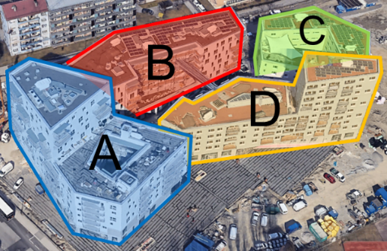 | 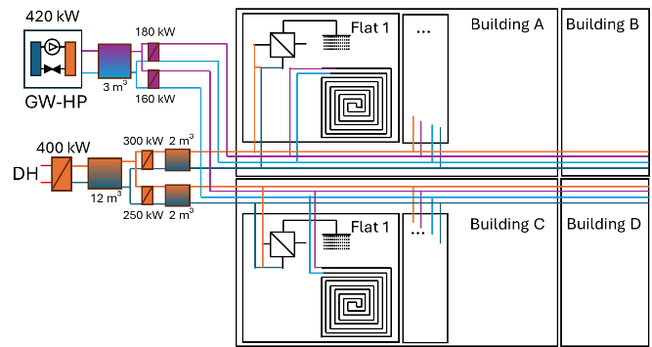
Fig. 1: Block 1 of Campagne areal with the four buildings A, B, C, D in Innsbruck (left, google earth) and heating system (right) with ground water (GW) HP for SH and district heating (DH) for DHW (Ochs et al. 2025).
Table 1: Treated area (A_{T}), heating demand (HD), heating load (HL) and DHW for the 4 buildings: A, B, C, D (Ochs et al. 2026)
Building (Treated Area / m²) | A (6686) | B (6525) | C (3587) | D (5479)
HD / [kWh/(m² a)] | 15.3 | 15.0 | 20.0 | 16.0
HL / [W/m²] | 11.9 | 11.5 | 15.1 | 12.8
DHW / [kWh/(m² a)] | 15 | 15 | 15 | 15
2.2 Monitoring
DHW demand is monitored in detail in each of the 52 flats of building C (on the primary side of the FWS). Load patterns are analyzed and distribution losses can be determined as a difference between the heat meter in the heating central, in each building and in building C the sum of all flats. The simultaneity factor is used to determine the required sizing of components in the capacity of the HP and other equipment such as volume of the buffer and size of heat exchanger.
2.3 Simulation
Simulation Model
The simulation model implemented in Matlab/Simulink is modular and consists of four main parts.
- Flat level: tapping profile - useful energy (thermal)
- Building level: distribution – thermal losses
- Technical room: Storage and DHW Heat Exchanger
- Heat pump and generation (A/W or B/W heat pump) – delivered energy (thermal and electric)
The concept of the simulation model with the main components is schematically shown in Fig. 2. Different number of flats per staircase and different number of parallel staircases can be considered. Currently up to 50 flats with individual tapping cycles were implemented.
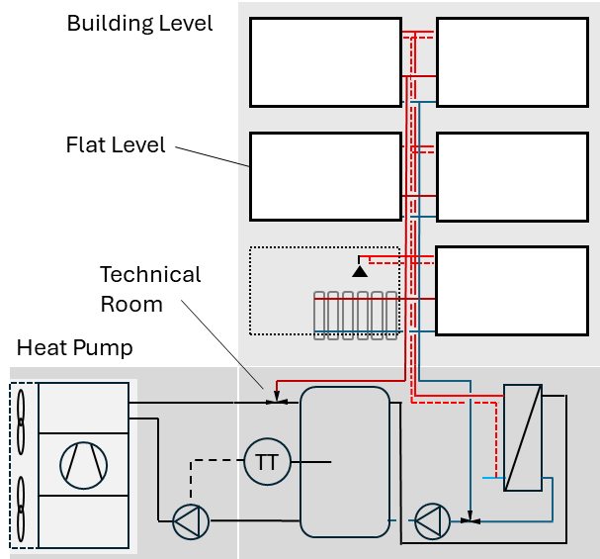  A/W-HP System  B/W-HP System | 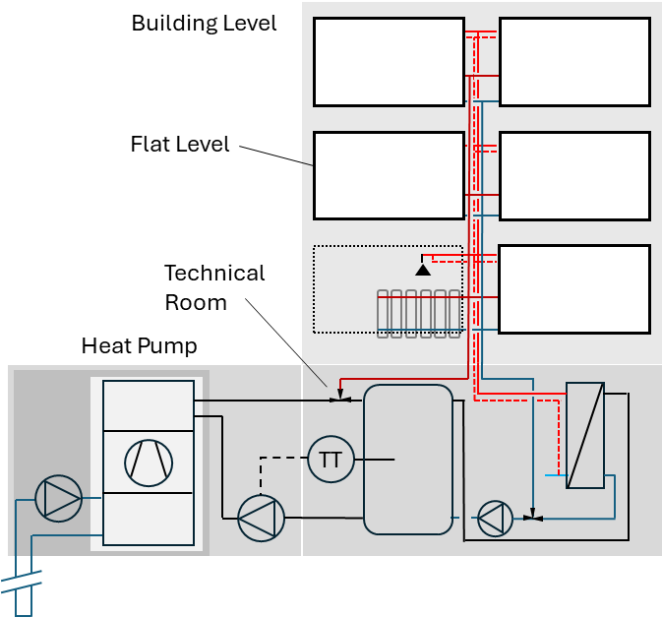
Fig. 2: Concept of the simulation model with the main components: flat-level (tapping), building level (distribution) and technical room with storage and A/W or B/W heat pump; example of 4-pipe circulation (circulation pump not depicted)
Building and Flat Level - Tapping Profiles and Simultaneity
The dynamic behavior of DHW demand has a significant influence on the performance evaluation of HP systems. Each flat is assumed to have a standard DHW consumption based on realistic DHW tapping profiles derived from stochastic occupant models. Two principal approaches are commonly used to generate DHW tapping events for simulation studies: stochastic profile generators such as DHWcalc (Jordan et al. 2005) and standardized tapping profiles, e.g., according to EN 16147.
DHWcalc generates stochastic tapping events based on statistical user behavior, thereby reproducing the temporal variability and simultaneity observed in real buildings. This approach is particularly suitable for annual performance assessments, investigations of peak loads, storage sizing, and control strategy development. However, simulation results depend on the random realization, requiring multiple runs or long simulation periods to obtain statistically robust results. In addition, comparisons between different system configurations may be influenced by different tapping sequences unless identical profiles are used.
In contrast, standardized tapping profiles according to EN 16147 define deterministic draw-off sequences with fixed tapping times, flow rates, and energy demand. They provide a highly reproducible basis for comparing different system concepts under identical boundary conditions and are therefore widely used for product testing and benchmarking. The representation of occupant behavior is limited, as they neither capture stochastic variations nor simultaneity effects occurring in real multi-apartment buildings. EN 16147 tapping profiles have to be adapted in terms of energy use to account for the number of persons per flat and in terms of peak power, to account for the simultaneity depending on the number of flats. Acc. to VDI 2072 the simultaneity factor is a function of the number of flats (eq. 1):
$φ_{VDI} =0.03+0.5∙N_{flat}^{-0.5}+\frac{0.47}{N_{flat}}$ (eq. 1)
In order to consider a deterministic, reproducible but also in terms of peak loads realistic user behavior, the concept of the simultaneity according to VDI 2072 (Fig. 3) is applied and standard tapping profiles are adapted in terms of daily energy demand and time-shifted to match the simultaneity, accordingly. Two different variants, “M/2” and “M 2P” are generated for up to N = 200 flats, see Fig. 7. “M/2” is based on the standard profile M of EN 16147 but with an energy demand scaled from 4 to 2 persons. “M 2P” is also based on profile M but it contains fewer tapping events, in particular no shower in the morning and corresponds also to the average energy demand of 2 persons. Both of the two variants contain each 3 subvariants concerning the time shift to match the simultaneity acc. to VDI 2072 (eq. 1). In variant 0, all profiles are shifted withing one hour (0 s to 3600 s), in variant 1 each odd flat is shifted within one hour (0 s to 3600 s) and each even flat is shifted by one further hour (3600 s to 7200 s), while in subvariant 2 each third flat is shifted backwards in time by 1 h (- 3600 s to 0 s).
 | “M/2” | “M 2P”
var 0 | 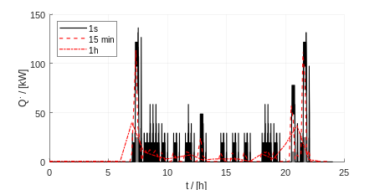 | 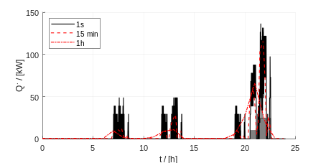
var 1 | 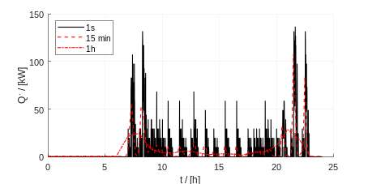 | 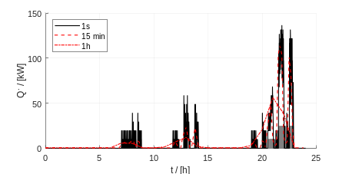
var 2 | 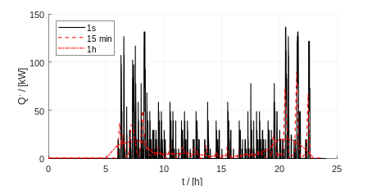 | 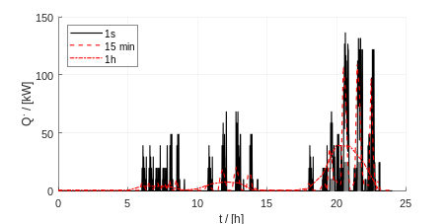
Fig. 3: Profile “M/2” (scaled) and profile “M 2P” (adapted) to match a household with 2 persons and N_{flat} = 50 (corresponding to building C) and with variants 0, 1, 2 with 15 min and 1 h time average; simultaneity φ = 0.11 (acc. to eq. 1)
Energy-Based Implementation of EN 16147 DHW Tapping Events
EN 16147 defines each water draw-off not only by a prescribed flow rate and duration, but also by a required useful energy content delivered above the specified service temperature. To reproduce this evaluation procedure, the present implementation controls the completion of each tapping based on the accumulated useful energy rather than solely on the nominal tapping duration. To capture precisely the tapping events, simulations are performed with a sub-second time step. Results are evaluated on a time step of 1 s and then average to 1 min, 15 min or 1 h.
Building and System Level - System Topology
Figure 4 provides a schematic overview of five common central DHW system concepts using a staircase with five flats as an example.
4-pipe system with Circulation (C): The system consists of separate SH and DHW distribution circuits and may include a hydraulic separator or an SH buffer and alternatively to the internal, an external fresh water heat exchanger. SH is provided by a conventional two-pipe distribution system with optional weather-compensated flow temperature control (heating curve). Space cooling can also be realized with a cooling-compatible emission system, requiring a buffer bypass. DHW is prepared centrally with a circulation loop, which generally requires storage temperatures of at least 60 °C to comply with hygiene requirements (Legionella prevention). The system allows independent temperature levels for SH and DHW while providing continuous DHW availability with short waiting times.
2+2-pipe system with Fresh Water Station (FWS): The system consists of separate SH and DHW distribution circuits and may include an SH buffer or a combined storage tank. SH is provided by a conventional two-pipe distribution system with optional weather-compensated flow temperature control (heating curve). Space cooling is possible with a cooling-compatible emission system, typically requiring a buffer bypass. DHW is prepared in each apartment using a fresh water station (decentral DHW plate heat exchanger), typically supplied with temperatures above 52 °C. This configuration enables independent temperature levels for SH and DHW, provides continuous DHW availability with short waiting times, and improves overall heat pump system efficiency by allowing lower central DHW supply temperatures compared to conventional circulation systems.
3p-system with FWS: The system consists of separate SH and DHW supply pipes with a common return line, reducing the overall distribution effort compared to a 2+2-pipe system. SH is operated with optional weather-compensated flow temperature control (heating curve). Space cooling is partly possible with a cooling-compatible emission system, requiring a buffer bypass. DHW is prepared in each apartment using decentral FWS, i.e. with flat-wise DHW plate heat exchangers, typically supplied with temperatures above 52 °C. The shared return line reduces piping requirements while maintaining separate temperature control of SH and DHW supply.
2-pipe system with Heat Transfer Station (HTS): The system uses a shared distribution circuit for SH and DHW preparation with a central SH buffer. Since the same supply temperature is used for both SH and DHW preparation, the required flow temperature is determined by the DHW demand, which limits the application of weather-compensated flow temperature control (heating curve) for SH. Space cooling is generally not possible with this configuration. DHW is prepared in each apartment using decentral DHW heat exchangers in so-called HTS, typically supplied with temperatures above 52 °C. The reduced number of distribution pipes lowers installation effort compared to 4-pipe, 2+2-pipe, and 3-pipe systems, but at the expense of reduced temperature flexibility and system performance.
2-pipe system with HTS and Flow Type Post Heater (FTPH): The system uses a shared distribution circuit for SH and DHW preparation with a central SH buffer and flat-wise DHW-HX and post-heating by FTPH. The SH flow temperature is partly independent of DHW temperature needs depending on the power of the FTPH, allowing ambient temperature compensation (heating curve). Space cooling is not possible. DHW is prepared in each apartment using decentralized, flat-wise HXs in HTS combined with a FTPH unit. This configuration allows the primary supply temperature to be significantly reduced based on the heating curve and enables tenants to set individual DHW set points, though it results in higher electricity demand and electrical peaks during DHW preparation.
2-pipe system with decentral DHW buffer and so-called charging windows: The system uses a shared distribution circuit for SH and DHW preparation with a central SH buffer and flat-wise DHW buffers. Outside the DHW charging windows, SH flow temperature is independent of DHW preparation, allowing ambient temperature compensation via a heating curve. Provided the system is equipped with cooling-compatible emission units, space cooling is possible but limited, and depending on the volume of the DHW buffers and the corresponding length of the charging window. DHW is prepared in each apartment using a decentralized, flat-wise DHW buffer tank (typically 120 l to 150 l) that is charged to 60 °C during designated DHW charging windows (typically 2 to 3 times per day). While this configuration enables heating curve optimization outside of charging windows and supports hybrid configurations with electric heating elements in the buffer, it demands adequate DHW storage sizing to ensure comfort.
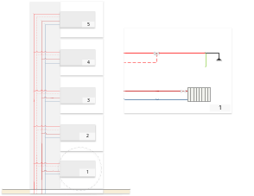 | 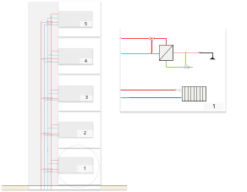 | 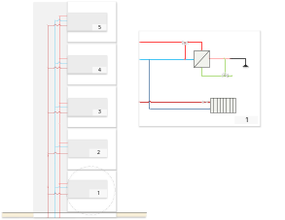 | 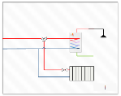  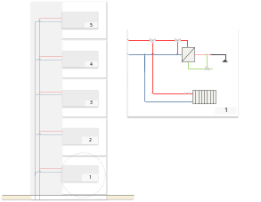
4-pipe system with circulation (C) | 2+2-pipe system with fresh water station (FWS) | 3-pipe system with fresh water station (FWS) | 2-pipe system with heat transfer station (HTS), optionally with FTPH or alternatively with decentral buffer
Fig. 4: Schematic overview of common central DHW system concepts for the example of a staircase with five flats
Fig. 5 shows exemplarily for the case of the 2+2-p system different configurations: 3, 4, 5 and 6 flats per staircase and 3 staircases x 5 flats with the corresponding simultaneity factor acc. to eq. 1 and the peak power based on 25 kW per flat. The configuration influences the thermal distribution losses and the return temperature. The simulation performance (i.e. simulation time) is additionally compared for the cases of different number of staircases in parallel: 1x5, 2x5, 3x5, 4x5, 6x5, 8x5, 10x5.
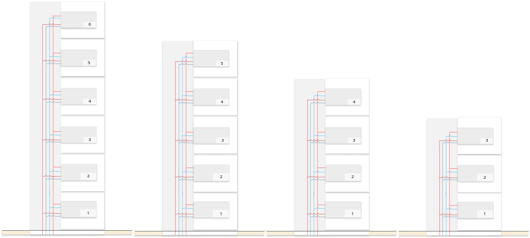 |  |  |  | 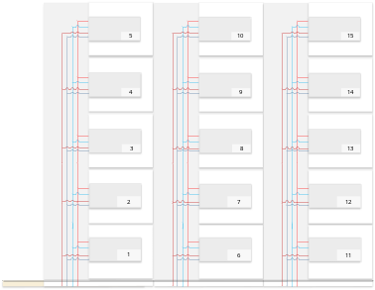
1 x 6: φ = 0.31  $$\dot{Q}=46.9 kW$$ | 1 x 5: φ = 0.35  $$\dot{Q}=43.5 kW$$ | 1 x 4: φ = 0.40  $$\dot{Q}=39.8 kW$$ | 1 x 3: φ = 0.48  $$\dot{Q}=35.7 kW$$ | 3 x 5: φ = 0.19  $$\dot{Q}=71.4 kW$$
Fig. 5: Different piping configurations and simultaneity φ acc. to eq. 1 and resulting peak power for DHW preparation assuming 25 kW peak power per flat.
In addition, three different types of decentral DHW systems as well as a semi-central system with booster-HP are compared and shown in Fig. 5.
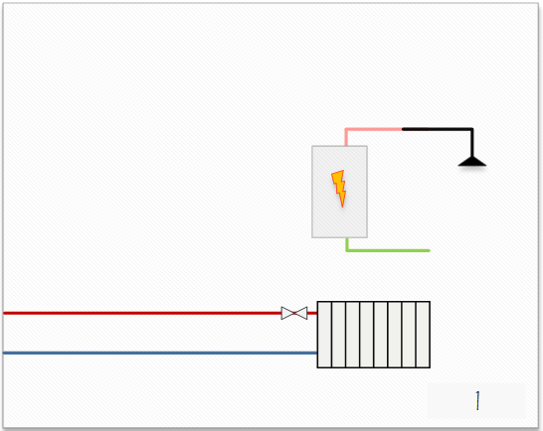 | 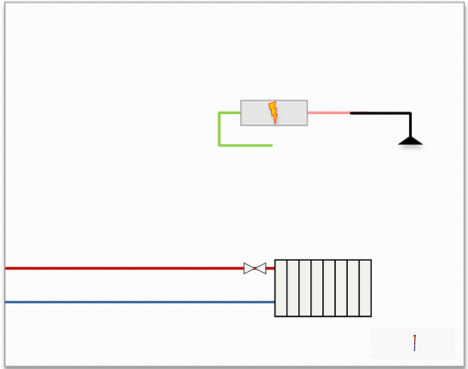 | 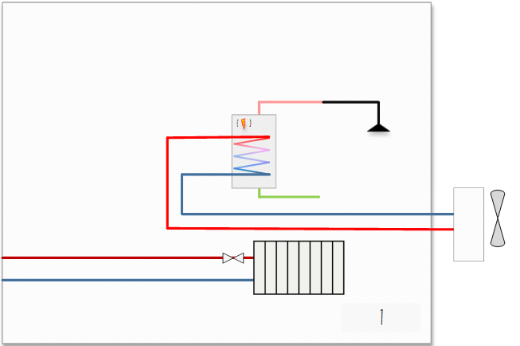 | 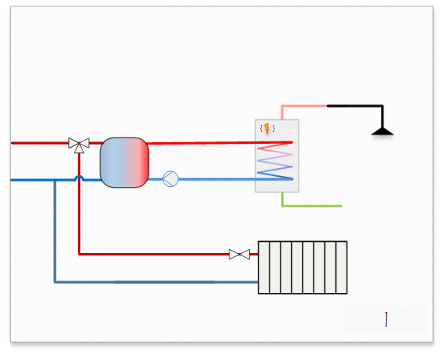
E-Boiler (typ. 3 kW_{el}, up to 6 kW_{el}) | FTPH (> 25 kW_{el}) | Decentral DHW-HP (< 1 KW_{el}) | Semi-central Booster-HP (< 1 KW_{el})
Fig. 6: Schematic overview of three different decentral DHW concepts: E-boiler, flow type post heater, decentral DHW HP and a flat-wise booster-HP
2.4 KPIs
Key performance indicators include useful (thermal) energy (UE), delivered (thermal) energy) DE, thermal distribution (and storage) losses, total electricity demand as well as seasonal performance factor for the HP (SPFHP) and the system (SPFsys). In terms of design and peak power considerations, the simultaneity factor with respect the UE and DE is evaluated. Furthermore, grid-related metrics such as peak electrical demand and the electric simultaneity factor are evaluated.
- Results
3.1 Monitoring
DHW tapping patterns from the detailed monitoring of 52 flats of building C and of the delivered energy measured in the heating central (for all four buildings) are shown in Fig. 7. A peak between ca. 16:00 h and 22:00 h can be observed with a shift of 1 h in summer resulting from winter/summer time. It can be also observed, that the peak in the evening is much more pronounced than the one in the morning (staring around 05:00 h). In addition, a relative strong seasonal effect can be observed in case of the delivered energy (all buildings) with pronounced energy delivery in the winter months.
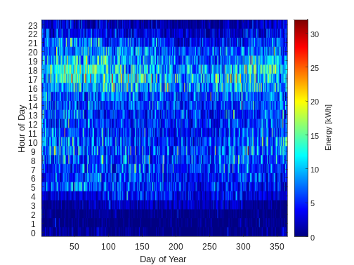 | 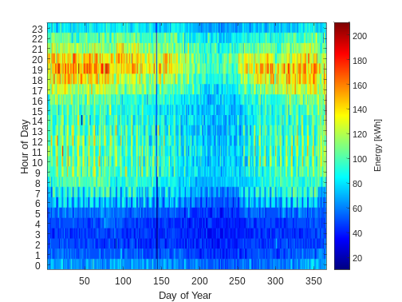
Building C | Main (Buildings A+B+C+D)
Fig. 7: Carpet plot of the DHW tapping measured in the flats in 2024; left: sum of 50 flats of building C, and right: delivered energy in the heating central for all for buildings
The average DHW demand per flat and day is with ca. 2.56 kWh relatively low compared to typical planning assumptions of e.g. 25 l per person and day at 60 °C energy equivalent, e.g. 5.8 kWh per day for a four-person household. A deeper analysis shows that out of the 52 flats only 32 have a regular DHW demand at all in the considered period (i.e. average daily demand > 1 kWh/day). A relevant number of flats had long absence periods and in those without extensive absence periods the average is 21 days. Out of these 32 flats when disregarding these absence periods, roughly five groups can be identified where 3 flats have high daily DHW demand > 8 kWh, 4 have a demand corresponding to 4-person household, 8 to a 3-person household, 6 to a 2-person household and 5 to a 1-person household.
3.2 Simulation
Tapping profiles
The resulting profiles with the 15 min and 1 h average are also shown in Fig. 8. The peak power of all profiles is with ca. 150 kW equal but the density of tapping events is different as can be seen best with the hourly average.
 | “M/2” | “M 2P”
var 0 | 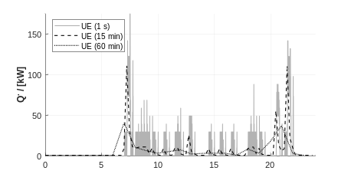 | 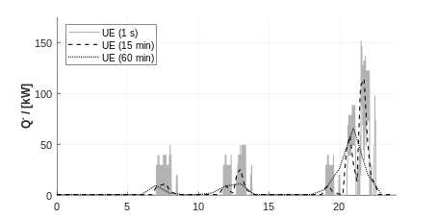
var 1 | 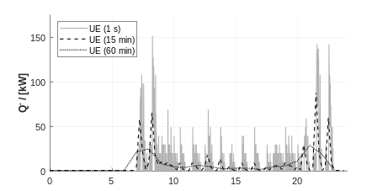 | 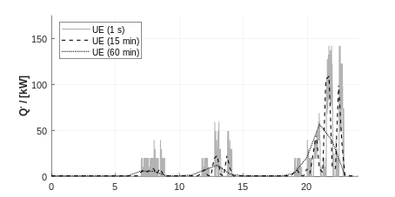
var 2 | 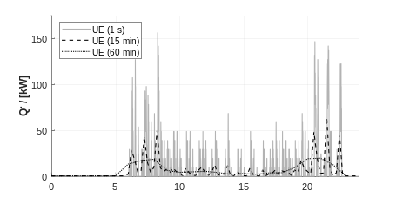 | 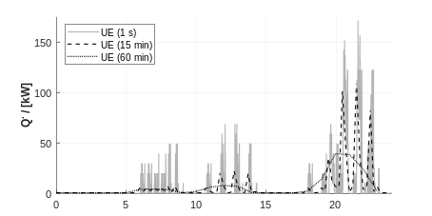
Fig. 8: Heating power related to the Useful Energy (UE) for different variants of the DHW tapping profile “M/2” var 0,1,2 and “M 2P” var 0,1,2 for N_{flat} = 50 with φ = 0.11
Delivered Energy and Return Temperature
Fig. 9 shows simulation results of the required heating power for the decentral DHW preparation with FWS (measured at the buffer outlet) and Fig. 10 the resulting central return temperature for the example of 10 parallel staircases with each 5 flats. As above, the six different tapping profile cases are compared and the peak power and corresponding simultaneity factor measured at the central distribution (main) are shown. It is remarkable that in all cases, the 50 individual tapping profiles correspond to a simultaneity of φ = 0.11 but due to the implemented DHW energy control the resulting simultaneity is higher (here between 0.113 and 0.145). This is depends on the heating and distribution system as well as on the system configuration and the control (in particular set point temperatures, which is 57.5 °C in this example).
 | “M/2” | “M 2P”
var 0 | 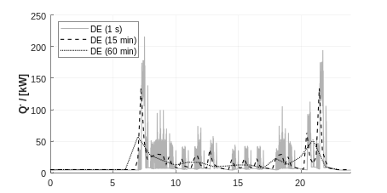 | 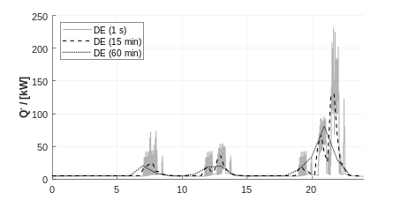
var 1 | 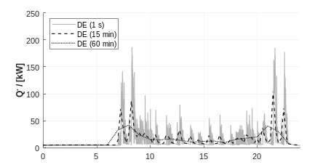 | 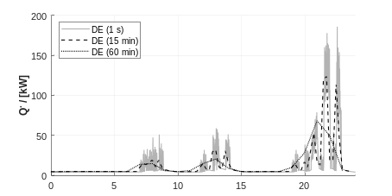
var 2 | 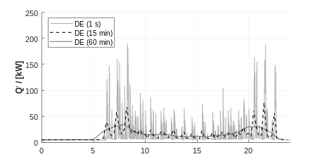 | 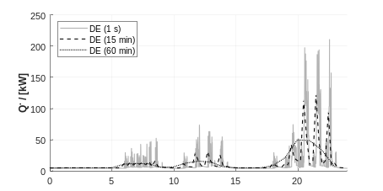
Fig. 9: Heating power related to the Delivered Energy (DE) for different variants of the DHW tapping profile “M/2” and “M 2P” each with var 0,1,2 for N_{flat} = 50 (10 x 5); max. simulation time step = 1 s
 | “M/2” | “M 2P”
var 0 | 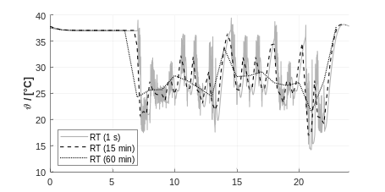 | 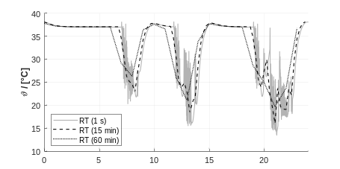
var 1 | 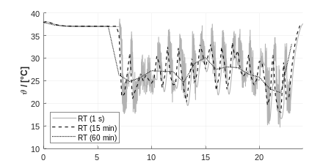 | 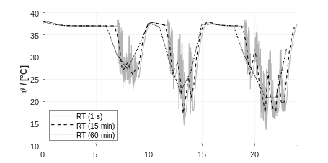
var 2 | 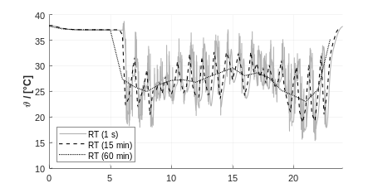 | 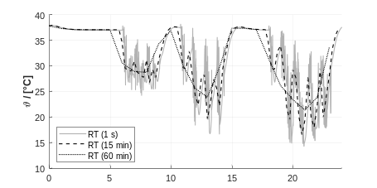
Fig. 9: Resulting return temperature (RT) for different variants of the DHW tapping profile “M/2” and “M 2P” each with var 0,1,2 for N_{flat} = 50 (10 x 5); max. simulation time step = 1 s
Tab. 2 summarizes the heating power related to the UE, the DE as well as the simultaneity factor for the useful energy and the delivered energy. In spite of the same UE between the subvariants the DE slightly deviates but in particular the simultaneity factor is influenced by the choice of the subvariant and varies between 0.135 and 1.64 which corresponds to a difference on peak power of ca. 36 kW.

The simultaneity factor as a function of the number of flats is shown in Fig. 10. The resulting simultaneity factor for the UE and DE is following a power law trend (with some outliers) and is significantly higher for the useful and delivered energy and depends on the tapping profile variant.
“M/2” | “M 2P”
Fig. 10: Simultaneity acc. to VDI, for the useful energy (UE) and the delivered energy (DE) for left profile “M/2” and right “M 2P” each for var 0.
Number of flats and simulation time
In Fig. 11 the simulation time for 2 days (where the first day is for initialisation) is compared for the two different tapping profiles “M/2” and “M 2P”, each with the three different subvariants (var: 0,1,2), see Fig. 8, above. Simulations have been repeated 5 times and results are reproducible with a minor deviation between the runs. A significant increase of the simulation time can be observed with increasing number of flats. The simulation time is relevantly higher (up to a factor 2) for the profile “M/2” compared to “M 2P” due to two main tapping events (shower in the morning and evening compared to only shower in the evening). There are “outliers” in case of a max. time step of 1s and also some numerical deviations. With reduced max. time step of 0.1 s the outliers and the numerical errors can be significantly reduced but on cost of significantly higher simulation times.
“M/2” 1s | “M 2P” 1s
“M/2” 0.1s | “M 2P” 0.1s
Fig. 11: Simulation performance for different number of flats (1x5 to 10 x5) and different tapping profiles “M/2” and “M 2P” with the different subvariants; 2nd order polynomial trends (Intel(R) Core(TM) Ultra 7 265U 64 BG LPDDR5, max. simulation time step = 1 s and 0.1 s)
Lumped profile vs. time averaged
A time average profile can significantly speed-up simulations compared to the lumped profile approach, however, the accurate consideration of the thermal peak power requires a time step depending on the chosen profile, as shown in Fig. 8. In case of the profile M/2 the 15 min average profile matches at N_{flat} = 50 the lumped profile with simultaneity acc. to VDI 2072, however in case of the profile M 2P there is a match at 10 flats and for 50 flats the 15 min overestimates the power, while for 200 flats the 1 h av. profile matches the peak power of the lumped profile.
“M/2” | “M 2P”
Fig. 8: Peak thermal power of lumped profile (VDI) vs. time averaged profile (15 min and 1 h) for N_{flat} = 5, 10, 50 and 200 flats for left “M/2” and right “M 2P”
Delivered Energy and Electric Peak Power
Exemplarily, for the example of one staircase with 6 flats the seven different DHW HP system concepts (see Fig. 4 and 6) are compared in terms of delivered electricity and electric peak power. The comparison includes the case of profile M (4 persons) and the scaled profile “M/2” (left) as well as the modified profile (“M 2P”), in order to show the influence of the profile and useful energy on both the electricity demand and peak power. Fig. 11. Shows the resulting electric power profiles and Fig. 12 shows the peak power vs. the electricity demand. The electric peak power profile differs significantly with the different HP system concepts, see also Tab. 2.
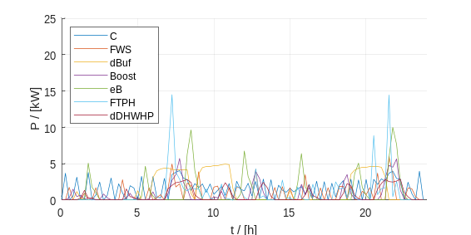 | 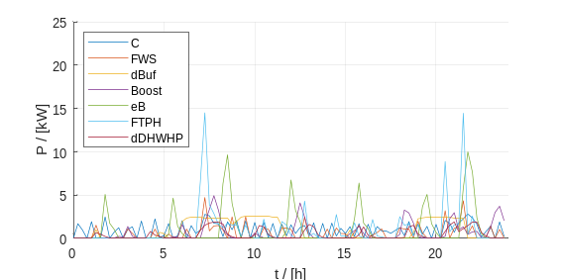
A/W-HP “M/2” | B/W-HP “M/2”
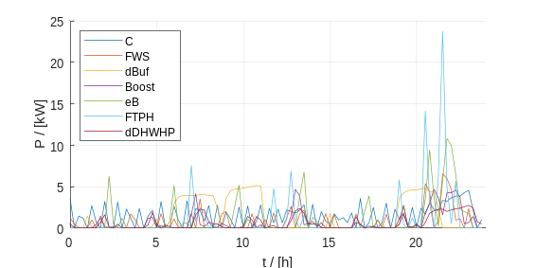 | 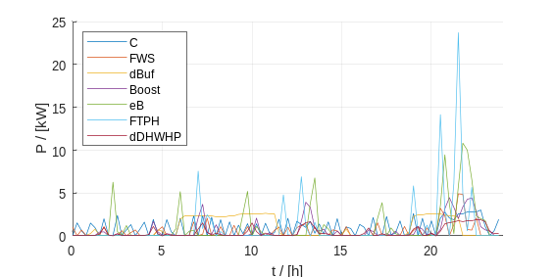
A/W-HP “M 2P” | B/W-HP “M 2P”
Fig. 11: Electric power profile (15 min av.) for the case of 6 flats and seven different heating system configurations (see Figs. 4 and 6) for the scaled profile “M/2” with 2 persons and the adapted profile “M 2P”. Example of A/W-HP with 0 °C source temperature and a B/W-HP with 5 °C source temperature
Table 2: Summary of thermal and electric peak power for the seven investigated systems for the tapping profile “M 2P” var 0 and “M/2” var 0 for A/W-HP (0 °C) as well as and B/W-HP (5 °C) (1 min average)
 | “M/2” A/W-HP |  | “M 2P” A/W-HP |  | “M/2” B/W-HP |  | “M 2P” B/W-HP
 | $\dot{Q}$ / [kW] | $P$/ [kW] | $\dot{Q}$ / [kW] | $P$/ [kW] | $\dot{Q}$ / [kW] | $P$/ [kW] | $\dot{Q}$ / [kW] | $P$/ [kW]
4-p C | 26.1 | 4.7 | 26.0 | 4.7 | 26.2 | 3.1 | 26.0 | 3.1
(2+)2-p FWS | 29.5 | 7.5 | 38.7 | 7.5 | 29.6 | 5.4 | 38.8 | 5.4
2-p dec Buffer | 14.1 | 5.2 | 20.1 | 5.2 | 13.8 | 2.6 | 19.6 | 2.6
2-p Booster-HP | 6.7 | 5.9 | 7.4 | 5.4 | 7.0 | 6.3 | 7.6 | 5.8
2-p E-Boiler | 26.2 | 12.0 | 26.0 | 12.0 | 26.2 | 12.0 | 26.0 | 12.0
2-p FTPH | 25.8 | 29.2 | 26.8 | 28.3 | 25.8 | 29.2 | 26.8 | 28.3
2-p dDHW-HP | 26.2 | 3.1 | 26.2 | 2.9 | 26.2 | 2.0 | 26.2 | 2.0
The E-boiler and FTPH have a comparable electricity demand with a slight advantage of the FTPH, but on cost of a significantly higher peak power (on 1 s time step: 75 kW instead of 12 kW). All HP-based systems perform better than the direct electric systems. The best performance has the decentral DHW-HP followed by the 2+2-p (or 3-p) FWS and the DHW booster-HP. The 4-p C system performs worst among the central systems in particular in case of smaller DHW demand due to the increased influence of the high circulation losses. The 2-p decentral buffer has only an advantage in terms of peak power. As expected, all systems with B/W-HP perform better but not only in terms of electric energy demand but also in terms of peak power.
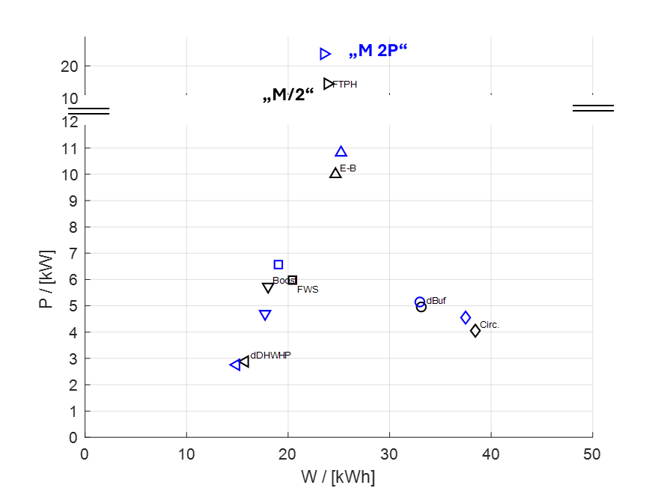 | 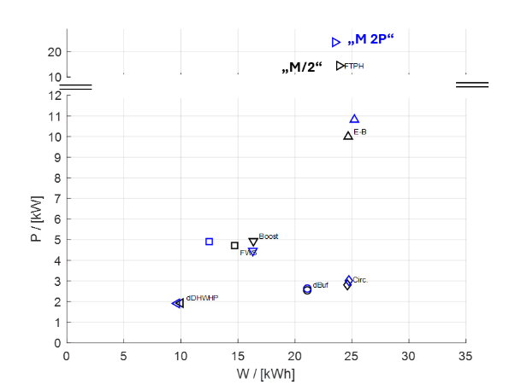
A/W-HP (0 °C) | B/W-HP (5°C)
Fig. 12: Heating power vs. heating load for the case of 6 flats and seven different heating system configurations (see Figs. 4 and 6) for the A/W-HP (left) and the B/W-HP (right) for the scaled profile “M/2” and the scaled profile (“M/ 2P”), each var 0
- Conclusions and Outlook
The paper presents simulation methods and results for large multi-apartment buildings and small districts based on monitoring results from the “towards” PED Innsbruck Campagne. The accurate prediction of the heating load (for SH and DHW) as well as of the required flow and resulting return temperature is the basis for simulation-based optimization of positive energy buildings and positive energy districts. The HP system topology with the corresponding temperature levels has a significant influence on both sizing and the performance. Different concepts are introduced and compared with focus on DHW preparation, which dominates the energy demand in very efficient buildings.
The performance of a HP-based DHW system is influenced by a wide range of interacting parameters. These include the characteristics of the building, such as its size, the number of flats and occupants, as well as the resulting DHW demand (e.g., showers versus baths). User behaviour also plays a significant role, with stochastic variations in tapping times, durations, flow rates, and daily consumption patterns affecting system operation. Furthermore, the overall system configuration – including centralized or decentralized DHW generation, storage concepts, circulation systems, and control strategies – has a considerable impact on efficiency. Realistic operating conditions must also account for comfort and hygiene requirements, such as minimum outlet temperatures, draw-off delay times, and Legionella prevention measures. The sizing of key components, including the HP, heat exchangers, buffer and DHW storage tanks, directly influences system performance and operational flexibility.
In this work, standardized tapping profiles are preferred over stochastic profiles because they ensure identical load conditions for all investigated system topologies, allowing a fair comparison of their energetic performance. The tapping profile “M” represents with a daily demand of 5.845 kWh a 4 persons household with a peak power of 25 kW corresponding to a typical shower. In order to consider different number of persons per flat in terms of useful energy demand, the profile has to be scaled or adapted. Furthermore, profiles have to be either time averaged or time-shifted in order to maintain a realistic heating power profile in terms of peak power for a different number of flats. Different options for adapted and time shifted DHW tapping profiles to match the simultaneity factor according to VDI 2072 are implemented, compared and evaluated in terms of delivered energy and resulting return temperature.
Even with the same simultaneity factor, i.e., the same instantaneous sum of all tapping events, the thermal peak load at the buffer outlet (main supply) can differ relevantly depending on the chosen DHW tapping profile (sub-) variant. This is in particular important for component sizing (buffer, heat exchanger, HP) and control optimisation. Furthermore, different HP heating system configurations perform differently in terms of electric energy demand, but also in terms of electric peak load, which is relevant in particular in planning the electric connection for large buildings and small districts.
Physics-based models are required to capture the dynamic behaviour correctly. However, for large buildings and districts with some hundred flats, this is a challenge and computational effort is very high: simulation time grows superlinear trend with increasing number of flats. Reduced order models are required. These ROM can be derived from the detailed models. Nevertheless, stochastic profiles generated with DHWcalc remain valuable for assessing the robustness of system concepts under realistic operating conditions and should complement standardized profiles in future investigations.
- Acknowledgements
Project 101166831 - LIFE23-CET-KnowHowHP, Co-funded by the European Union. Views and opinions expressed are however those of the authors only and do not necessarily reflect those of the European Union or CINEA. Neither the European Union nor CINEA can be held responsible for them.
- References
Hedman Å.; Rehman HU.; Gabaldon A.; Bisello A.; Albert-Seifried V.; Zhang X.; et al.; 2021. IEA EBC Annex 83 Positive energy districts. Buildings 2021,11(3), 130.
Jordan U.; Vajen K.; DHWcalc; Proceedings of the 2005 ISES Solar World Congress, 2005.
Lämmle M.; Metz J.; Kropp M.; Wapler J; Oltersdorf T.; Günter D.; Herkel S..; Bongs C.; Heat Pump Systems in Existing Multifamily Buildings: A Meta-Analysis of Field Measurement Data Focusing on the Relationship of Temperature and Performance of Heat Pump Systems, Energy Technology, 2023, doi: 10.1002/ente.202300379.
Kropp M.; Lämmle M.; Herkel S.; Henning H. M.; Velte-Schäfer A.; Enhancing heat pump performance for domestic hot water preparation: A comparative analysis in existing multi-family houses, Energy and Buildings, 2025, doi: 10.1016/j.enbuild.2024.115155.
Jähnig D.; Male M.; Ochs F.; Sanierung mit Wärmepumpen in Mehrfamilienhäusern – eine Simulationsstudie, Intelligente Energie- und Klimastrategien Energie-Gebäude-Umwelt, Pinkafeld: Hochschule Burgenland, 2025, p. 350.
Lindholm, O.; Rehman, H.U.; Reda, F.; 2021. Positioning positive energy districts in Euro-pean cities. Buildings 2021, 11(1), 19; https://doi.org/10.3390/buildings11010019
Ochs, F.; Tosatto, A.; Venturi, E.; Breuss, S.; Magni, M.; Dermentzis, G.; Wemhöner, C.; 2024. Characteristic Load Curves of Positive Energy Districts, Solar Energy Advances, Elsevier; https://doi.org/10.1016/j.seja.2024.100081
Ochs, F.; Magni., M; Dermentzis, G.; 2022. Integration of heat pumps in buildings and district heating systems-Evaluation on a building and energy system level; Energies 15 (11), 3889; https://doi.org/10.3390/en15113889
Ochs F.; Venturi, E.; Breuss, S.; Bockelmann, F.; Wemhoener, C.; 2025; Towards Positive Energy Districts Heat Pump System Topology Design Guidelines, ISEC 2026, Graz.
Ochs F.; Venturi E.; Magni M.; Breuss S.; Monteleone W.; Dermentzis G.; Simulation-based heat pump system design and optimization for multi-apartment buildings, in 15th IEA Heat Pump Conference, Vienna, 2026.
Ochs F.; Venturi, E.; Breuss, S.; Monteleone. W., Simulation-based optimization of Centralized and Decentralized Heat Pump Systems for Domestic Hot Water Preparation in Multi-Apartment Buildings, NSB 2026. Tampere.
Pomianowski, M.Z.; Johra, H.; Marszal-Pomianowska, A. Zhang, C.; Sustainable and energy-efficient domestic hot water systems: A review, Renewable and Sustainable Energy Reviews, 2020. https://doi.org/10.1016/j.rser.2020.109900.
Venturi, E.; Ochs, F.; Magni, M.; Dermentzis, G.; 2024. EuroSun 2024, Evaluation of positive energy districts with district heating and heat pumps. ISES and IEA SHC Int. Conference on Sustainable and Solar Energy for Buildings and Industry.
Venturi, E.; Ochs, F.; Magni, M.; Dermentzis, G.; Complex Hydronic Systems in Multi-Apartment Buildings: Modelling Approaches and Dynamic Simulations, Journal of Building Performance Simulation, 2026. https://doi.org/10.1080/19401493.2026.262815

