EuroSun2026
Germany’s district heating systems as a demand-side flexibility resource
Panitz, Felix; Stute, Judith; Ragwitz, Mario
Fraunhofer Research Institution for Energy Infrastructures and Geotechnologies IEG, Germany felix.panitz@ieg.fraunhofer.de
Summary
The currently identified electric boiler and thermal storage capacities in German district heating systems are documented and quantified, and their potential contribution to short- and long-duration flexibility in the electricity system is discussed. The analysis also reconstructs the development of thermal storage deployment in German district heating systems and compares installed capacities and annual additions with those of battery and pumped hydro storage systems. Although the energy carriers and system services are not directly equivalent, the comparison highlights the substantial and growing role of thermal storage as an energy storage option.
Realizing this potential requires policy and market designs that adequately value long-duration flexibility and provide predictable revenue streams, enabling investment and sector coupling.
Keywords: district heating, flexibility, power-to-heat, thermal energy storage
Field of application for the findings: district heating networks, energy transition policy, grid integration
Addressed audience: district heating system stakeholder, DSO, TSO, policymakers
- Necessity of Electric Flexibility in the District Heating Sector
The rapid growth of renewable electricity sources (RES) capacity across Europe increases generation volatility. In Germany, the following consequences can be observed:
- Persistent price volatility in the energy market, with negative prices driven by PV feed-in peaks (Day-Ahead: 301 h in 2023, 459 h in 2024, 575 h in 2025 with a peak of -250 €/MWh on 11 May). In extreme cases, PV surplus can prevent market clearing and jeopardize system balancing.
- Due to limited grid capacity, grid congestion management is necessary. In Germany in 2024, grid operations faced a congestion management volume of 30.3 TWh (mainly wind curtailment and mainly caused by congestions in the transmission system) and roughly €2.8 billion in redispatch costs (SMARD, 2025). In the near future, PV is expected to face a significant share of grid congestion, which could also be located in distribution systems.
This challenge makes electricity storage, along with demand- and generation-side flexibility and cross-border transmission, essential for grid stability, security of supply, and a reliable energy transition.
- Storage expansion is currently dominated by batteries, but grid connection capacity limits deployment. Moreover, these storage systems are typically short-term, which makes it economically necessary to achieve more than 100 full-load cycles per year due to their relatively high specific costs.
- RES generation flexibility is valuable, but without on-site storage or flexible demand leads to curtailment and higher specific production costs of energy.
- Cross-border exchange can provide limited relief when neighboring countries face simultaneous renewable surpluses and interconnector capacities are limited.
Against this background, this paper examines the demand-side flexibility potential of Germany’s district heating sector. It provides a source-based inventory of electric boilers and thermal storage facilities, reconstructs the historical development of thermal storage capacity, and derives illustrative deployment scenarios for 2045. Particular attention is given to the ability of district heating systems to provide both short-duration and long-duration flexibility and to the regulatory and economic barriers that currently limit its utilization.
- Electricity supply for power-to-heat units
As part of the transformation of heating networks, substantial portions of heat production –often the main share–will be delivered as power-to-heat (PtH) via heat pumps or electric boilers. Actual shares of electrical heat delivery are low. The identified 73 operating large-scale heat pumps (with a minimum thermal capacity of 500 kW), listed in Fraunhofer IEG et al (2025) have an aggregated nominal thermal power of 179 MW. Assuming a coefficient of performance of 2.5, this corresponds to approximately 72 MW electrical power. Taking into account both operational heat pumps and those under construction, the total thermal power will be 467 MW (i.e., 186 MW electrical power). The electrical flexibility potential will increase as many large-scale heat pumps are still under construction or in planning. Under the assumptions of Panitz et al. (2024), approximately 1,800 full-load hours are required for competitiveness against electric boilers. They are often planned for even much more operation to be economically feasible for heat supply. This limits their flexibility potential. Therefore, here, the focus should be on electric boilers.

Tab. 1: Electric boilers above 200 kW in district heating systems in Germany
Federal state | Locations | Cumulated power (MW)
Baden-Württemberg | 4 | 170
Bayern | 11 | 124
Berlin | 3 | 135
Brandenburg | 5 | 58
Bremen | 1 | 20
Hamburg | 4 | 156
Hessen | 4 | 98
Mecklenburg-Vorpommern | 5 | 100
Niedersachsen | 5 | 108
Nordrhein-Westfalen | 6 | 119
Rheinland-Pfalz | 2 | 20
Saarland | 2 | 30
Sachsen | 4 | 70
Sachsen-Anhalt | 5 | 81
Schleswig-Holstein | 12 | 143
Thüringen | 1 | 4
Germany | 74 | 1,435

A systematic analysis of installed electric boilers in DH systems does not exist for Germany. Therefore, the installed capacity was analyzed by desk research. Following the two-source principle, using Välila et al. 2020 and a multitude of company press releases, local and national press articles, an amount of 74 sites were identified with an overall installed capacity of 1.435 GW_{el} (Table 1).
Figure 1 shows the spatial distribution of the installed plants in Germany. The biggest individual plant sites are in Berlin (120 MW) and Hamburg (80 MW).

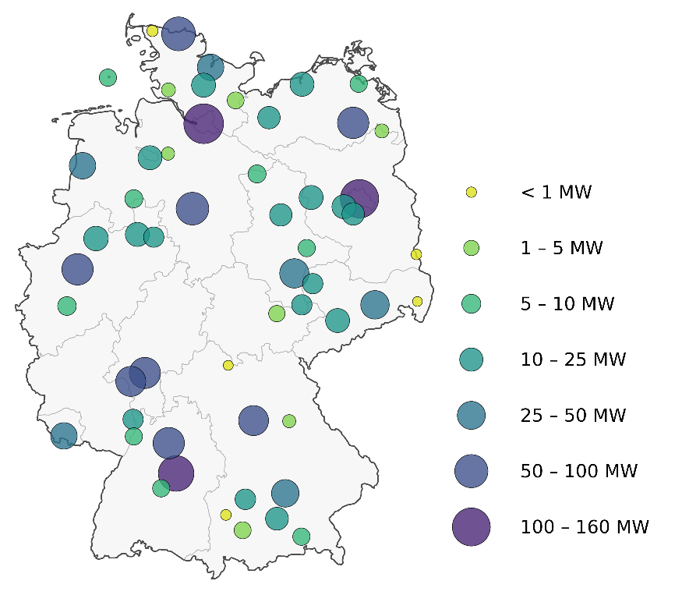
Fig. 1: Electric boilers above 200 kW in district heating systems in Germany; circles show cumulated nominal power in 15 km radius
Including unrecorded units, the actual installed capacity is likely to exceed 1.5 GW. Under the assumptions of Panitz et al. (2024), electric boilers require approximately 600 hours of strongly negative electricity prices to compete with fossil heat generation. Grid charges, particularly the power charge, dominate the levelized cost of heat and undermine competitiveness, even during surplus/ negative price periods. Consequently, a substantial share of the installed PtH capacity is not utilized in electricity markets. This also highlights the contrast with grid-connected battery storage systems. Under certain conditions, in § 118(6) of the German Energy Industry Act (EnWG, 2026), grid-connected battery storage systems are exempt from grid charges for 20 years following commissioning and can therefore exploit low- and negative-price periods without facing the same barriers.
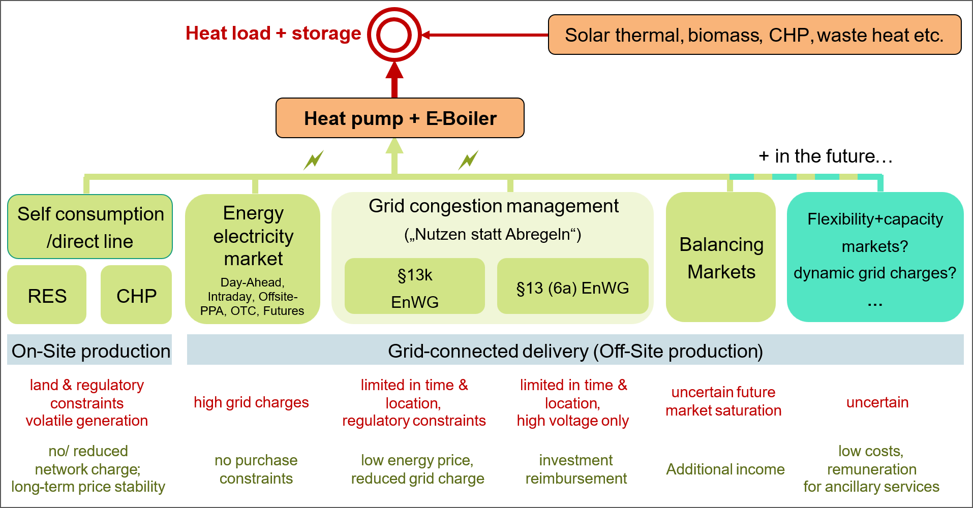
Fig. 2: Electricity procurement for electrified heat supply in district heating systems; current options in Germany. Disadvantages/barriers are shown in red below, advantages in green below.
In Figure 2, relevant electricity procurement options for PtH plants under German regulation are depicted. On-site production represents a favorable option. Particularly from renewables, heat systems can strengthen generation-side flexibility without curtailment, though near-site potential is often limited by the urban location of DH networks. Small DH systems utilizing self-consumption from local photovoltaic or wind plants exist. Since CHP units respond sluggishly to load changes and should not be subjected to frequent on-off cycling, systems with CHP units often use power-to-heat systems to avoid grid feed-in during periods of negative spot prices. To the right, in Figure 2, all grid-based electricity sources are shown. The most common form of electricity procurement via energy markets enables price-guided operation of heat pumps and electric boilers; however, as noted above, procurement is not economical at low full-load hours despite negative prices. Very attractive options arise from grid-congestion-management procurement, but regulatory constraints exist to avoid cross-subsidy-driven distortions and participation options are regionally limited. Reduced grid charges through atypical grid usage pursuant to § 19(2) StromNEV (2023) are, in principle, also of interest; however, to the authors’ knowledge, there are currently no known cases in which this provision has been applied in DH sector. Balancing markets are used for electric boilers but market saturation is expected in the future. To unlock the flexibility potential of power-to-heat systems, dynamic network tariffs and market mechanisms are needed that reward flexible electricity consumption, value long-duration flexibility, and provide predictable long-term revenue streams, including capacity equivalent remuneration of flexible demand.
- Flexibility potential of District Heating
The heat demand of DH systems in Germany is about 123 TWh (AGFW, 2025) and expected to grow to between 161.1 and 183.5 TWh by 2045 (50Hertz et al., 2026).
With limited potential for shifting end-user heat demand, electricity demand-side flexibility can mainly be realized through two approaches:
(a) “fuel-switch” options enabled by a diversified plant portfolio (PtH, CHP, fuel-based boilers, biomass boilers and waste incineration);
(b) use of thermal storages, allowing electric heat generation to be decoupled from the demand load profile.
In both approaches, district heating offers clear advantages over decentralized heating. For (a), decentralized building energy systems typically operate with mono- or bi-valent heat generation and limited oversizing for cost reasons, whereas DH networks exploit scale effects to deploy a variety of different heat sources and enable financially viable oversizing of the total capacity. Grid connections at the medium- and high-voltage level enable considerably higher connection capacities and significantly reduce grid charges per kWh of electricity. Grid connection capacities originally built for combined heat and power (CHP) units can be co-used.
For (b), district heating enables very large storage units impractical at the individual-building level. Larger storages reduce heat losses, improve performance (e.g., temperature stratification), and lower specific investment costs. A practical example is the DH network in the German village of Bracht, which integrates a pit thermal energy storage of 26,600 m³ (Lang et al., 2024) for the supply of mainly single and multi-family houses. Taking the number of connected buildings into account, the storage corresponds to approximately 8 MWh per connected building, equivalent to roughly 140 m³ of tank storage per building. Such a scale would be infeasible if each building had to provide its own storage.
Furthermore, both approaches enable short-term and long-duration flexibility. Actual projects of batteries show 1-8 h nominal discharge durations, while the average discharge time of big battery storages is only 1.7 h for the installed 7.34 GWh large-scale storages in Germany (Figgener et al., 2023; Battery-Charts, 2026). In contrast, DH systems could offer – beside high cyclic flexibility – long-term flexibility of several hundred hours up to more than 1,000 hours of continuous operation — i.e., upward or downward demand flexibility far beyond the typical high-cyclic charge and discharge time spans.
- The potential of heat storages
The average summer heat load of German DH networks is predominantly determined by domestic hot water demand. Based on the hourly load profile of an exemplary medium-sized German DH system with an annual heat demand of 47 GWh, overall heat load during a representative summer week was estimated at approximately 4–5 GW_{th} when scaled to the total annual DH demand in Germany.
For approach (a) without thermal storage, this represents the approximate upper limit for simultaneously increasing electricity demand through power-to-heat units. Compared with the currently identified electric boiler capacity of approximately 1.5 GW_{el}, additional flexible capacity could therefore still be integrated. However, this potential is limited in relation to the expected increase in photovoltaic capacity from 118 GW in 2026 to 215 GW by 2030 and 400 GW by 2040.
Using approach (b), the same load profile was used to assess the effect of a daily short-term thermal storage. The simplified scenario assumes a four-hour charging period from 10:00 to 14:00 and a 20-hour discharge period from 14:00 to 10:00 on the following day. The results are scaled to Germany’s total annual DH demand. The scenario results in a daily storage capacity of approximately 90 GWh and a thermal heat-generation capacity of approximately 20–25 GW , indicating substantial potential for additional flexible power-to-heat operation. This illustrative estimate shows how thermal storage can decouple power-to-heat operation from instantaneous summer heat demand and thereby substantially increases the potential use of surplus photovoltaic electricity.
However, a systematic registration or analysis of installed thermal storages in DH systems does not exist for Germany. Therefore, the installed capacity was analyzed by desk research. Following the two-source principle, mainly based on scientific literature and industry reports, a multitude of company press releases, local and national press articles 79 sites were identified. If the heat storage capacity was not explicitly stated, it was estimated based on the volume and temperature spread. An overall installed thermal storage capacity of 59 GWh_{th} in German DH systems in 2025 could be identified (see Table 2).
Tab. 2: Installed heat storage capacity in district heating systems in Germany until end of 2025
Federal state | Locations | Cumulated capacity (MWh)
Baden-Württemberg | 8 | 4780
Bayern | 10 | 5140
Berlin | 4 | 5060
Brandenburg | 4 | 1850
Bremen | 1 | 230
Hamburg | 5 | 3630
Hessen | 3 | 680
Mecklenburg-Vorpommern | 8 | 16200
Niedersachsen | 2 | 630
Nordrhein-Westfalen | 11 | 5630
Rheinland-Pfalz | 1 | 750
Saarland | 3 | 1530
Sachsen | 7 | 3210
Sachsen-Anhalt | 3 | 2880
Schleswig-Holstein | 6 | 5050
Thüringen | 3 | 1730
Germany | 79 | 58,980

The spatial distribution of heat storages is visualized in Figure 3. Largest single storage facilities are an aquifer thermal energy storage (ATES) in Neubrandenburg, Mecklenburg-Vorpommern (12 GWh), and tank thermal energy storages (TTES) in Berlin (56,000 m³) and München (57,000 m³).
AGFW (2025) reports a storage capacity of 35.2 GWh for year 2023 across 372 companies. In contrast, this study identified a total of 49.1 GWh for 2023, despite being limited to 79 identified locations. Unfortunately, the discrepancy could not be investigated because the methodology used by AGFW (2025) was not publicly available. One possible explanation is that the aquifer thermal energy storage facility in Neubrandenburg, with a storage capacity of 12 GWh (Holstenkamp et al., 2017), was not included in AGFW (2025), which would explain part of the difference.
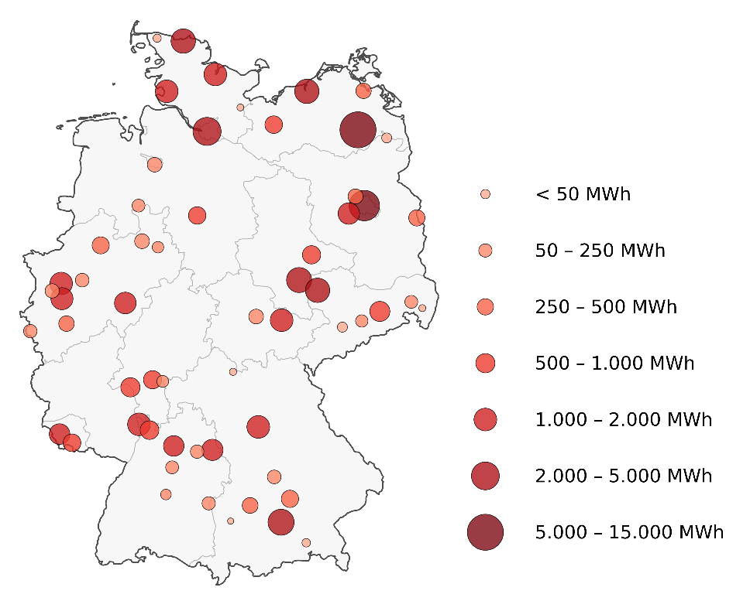
Fig. 3: Heat storage capacity in district heating systems in Germany; circles show cumulated capacity in 15 km radius
In Figure 4, the development of cumulative heat storage capacities in German DH networks are shown, and a steady growth is evident. In comparison with electrical storage (while keeping in mind that the different forms of energy are only partially comparable), the capacity of battery storage is clearly smaller but is known to be growing strongly, while pumped hydro storage capacity remains nearly constant due to limited expansion potential. Among the thermal storage options, a wide variety of short- to long-duration storage types are present. With only two projects, the share of pit thermal energy storages (PTES) remains small, but a strong increase is possible in future. The average annual capacity addition between 2022 and 2025 is 5.2 GWh per year for thermal storage, only slightly lower than the 6.4 GWh for overall battery storage (from small to large-scale). 79 % of the capacity addition between 2022 and 2025 were from TTES installations, and 18% originated from the two PTES installations.
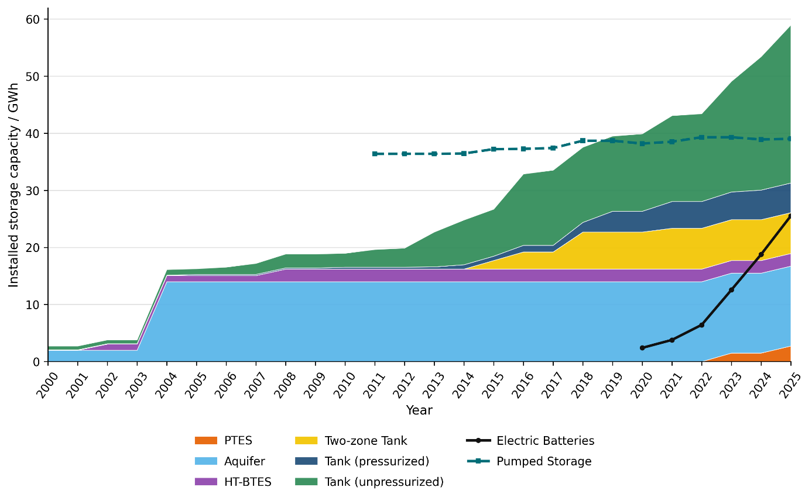
Fig. 4: Installed storage capacity in district heating sector in GWh_{th} & electricity sector in Germany in GWh_{el} until 2025 (end of year values), desk research following two-source-principle). Abbreviations: PTES - pit-thermal energy storage; HT-BTES - high temperature borehole thermal energy storage.
In this context the storage-to-demand ratio $r_{store}$ defined as the ratio of nominal heat storage capacity $Q_{storage,nom}$ compared to the annual feed-in heat demand $Q_{demand,a}$ of the DH systems can be very helpful.
$$r_{store}=\frac{Q_{store,nom}}{Q_{demand,a}}$$ | (eq. 1)
The cumulated storage-to-demand ratio of Germany’s DH systems in 2025 can be identified to $r_{stor, 2025}=$ 0.05 %.
If all DH systems in 2024 were equipped with just daily heat storages sized for summer operation (according to the approach above), they would collectively provide around 90 GWh of thermal storage capacity, i.e. roughly 1.5 times the currently identified capacity and more than two times that of the electric storage capacity of pumped hydro storage plants. This would be a storage-to-demand ratio of 0.073 %.
Ten hypothetical realizations of a PTES of 500,000 m³, as currently discussed in some German DH networks, would activate a cumulated capacity of about 300 GWh which would increase the storage-to-demand ratio by 0.24 %.
In this discussion, it is also interesting to compare the mean storage-to-demand ratio of Germany with values of single DH systems.
In Table 3 storage-to-demand ratios are given for different DH systems where large storages are installed. German village Bracht has the highest storage-to-demand ratio in Germany of 38 %. Since the PTES of Bracht is used for seasonal storage of solar thermal energy and a solar fraction of at least 70 % is targeted, its storage-to-demand-ratio generally sets a rough techno-economic upper limit for DH systems. But also other DH systems show storage-to-demand ratios far beyond the aggregated storage-to-demand ratio of Germany’s DH systems. However, none of these DH systems is known to store large quantities of heat produced using electricity purchased from the grid; instead, their storage facilities are used for solar thermal energy (Bracht, Vojens), biomass (Fuchstal), CHP (Neubrandenburg) or on-site photovoltaic (Bundorf) or on-site wind (Bosbüll).
Tab. 3: Selected district heating systems with high storage-to-demand ratio. (Due to the partly estimated operating temperature spread of the storages and only rough numbers published for heat demand, the storage-to-demand ratio is a rough estimation)
DH system | annual heat demand | storage | storage-to-demand ratio
Bracht (Germany) | 4 GWh | 26,600 m³ PTES | 38 %
Vojens (Denmark) | 56.4 GWh | 200,000 m³ PTES | 20 %
Neubrandenburg (Germany) | 312 GWh | 12 GWh ATES | 4 %
Fuchstal (Germany) | 6 GWh | 5,000 m³ TTES | 3 %
Bosbüll (Germany) | 1 GWh | 2x84 m³ TTES | 0.9 %
Bundorf (Germany) | 0.9 GWh | 75 m³ TTES | 0.4 %
Germany (aggregated) | 123 TWh | 58.98 GWh | 0.05 %

Schauß et al. (2026) investigates in a sector-coupled least-cost optimization of the German and European energy system the use of PTES for a simplified spatial resolution of German DH systems for 2045. Assuming an annual DH demand of about 177 TWh, they calculate an optimal storage-to-demand ratio of between 0.8% and 3.4%. The results depend strongly on the investment costs of large-scale storage systems. However, the list of implemented projects (Table 3) demonstrates that high storage-to-demand ratios are achievable.
Estimating plausible scenarios for heat storage deployment is difficult, as the local feasibility of different storage types and sizes—and, consequently, the associated storage costs—may depend heavily on site-specific conditions. On the other hand, resilience may become increasingly important for DH operators in the future. Heat storage can help ensure an independent heat supply, particularly during global price crises or national or regional supply crises, such as blackouts. This could lead to the deployment of thermal energy storage systems that are substantially larger than those identified by optimization approaches based solely on electricity price forecasts. Furthermore, independence from market prices and a high degree of supply autonomy were key considerations in the design of the system in Bracht, which has a high storage-to-demand ratio.
As Schauß et al. (2026) is the only known study to have assessed the potential of large-scale heat storage in Germany’s energy system, while some individual systems already exhibit much higher storage-to-demand ratios, aggregated storage-to-demand ratios of 0.5% and 5% are used to define low and high scenarios representing a plausible range of potential future development. This range also reflects the fact that actual deployment will depend heavily on a variety of local, market-related, and regulatory conditions, as well as on technological learning curves. Based on a range of DH demand between 161.1 TWh and 183.5 TWh by 2045 (50Hertz et al., 2026), these scenarios are intended to illustrate the potential of heat storage deployment rather than to represent precise forecasts. Table 4 illustrates the thermal storage deployment alongside battery and pumped hydro storage scenarios.
Tab. 4: Illustrative heat storage capacity deployment scenarios compared to scenarios of batteries and pump storage
 | 2025 | 2045
 |  | Scenario | storage-to-demand-ratio
Thermal storages in DH systems | 59 GWh | Low | 0.5 % | 800 GWh
Thermal storages in DH systems |  | High | 5% | 9,200 GWh
Battery storage¹⁾ | 25.5 GWh | NEP-A/C | - | 206 … 390 GWh
Pump storage¹⁾ | 39 GWh | NEP A/C | - | 47 GWh
1) For 2045 NEP-A and NEP-C from 50Hertz et al. (2026)

The low scenario would require average annual additions of 37 GWh (457 GWh per year in the high scenario). This corresponds to increases by factor of 7 (87 in the high scenario), respectively, compared with the average annual additions between 2022 and 2025. However, deployment during this period was dominated primarily by TTES. Significantly larger individual TTES units than the one in Berlin (56,000 m³, ~2.6 GWh) are unlikely to be built in the future. Nevertheless, technologies such as PTES, ATES, and BTES are available that are not only considerably more cost-effective but can also be implemented as much larger individual systems.
A single PTES system with a storage volume of 1 million m³ could provide approximately 60 GWh of storage capacity—roughly the same order of magnitude as Germany’s current total installed heat storage capacity. Comparable scales can also be achieved with individual BTES or ATES systems. Therefore, a significantly higher level of deployment appears technically feasible in the future.
Beyond electricity-system flexibility, thermal storage supports renewable heat integration, CHP optimization, waste-heat utilization, and security of supply. Its system value therefore extends beyond electricity-price arbitrage and should be reflected in investment and market frameworks.
Economic barriers relate mainly to high upfront capital costs and long project lead times, which create uncertainty for investors. While larger thermal storages are often more cost-effective, their scale requires substantial single investments, which contrasts with investors’ preference for risk diversification. This leads to hesitation in committing to large, efficient projects.
- Conclusions
A source-based inventory of electric boilers and thermal storage facilities in German district heating systems could be provided. At least 74 electric boiler sites with an aggregated nominal capacity of 1.435 GW_{el} and 79 thermal storage sites with an aggregated estimated capacity of approximately 59 GWh were identified for 2025. These figures should be interpreted as a documented minimum rather than a complete census.
However, the currently installed flexibility is only used to a limited extent (Panitz et al., 2024). In particular, electricity network charges and insufficiently predictable revenue streams weaken the economic incentives for flexible operation.
Illustrative scenarios indicate that thermal storage capacity in German district heating systems could reach approximately 0.8–9.2 TWh_{th} by 2045, corresponding to storage-to-demand ratios of 0.5–5%. These values are not forecasts; they illustrate a technically plausible range whose realization depends on local conditions, investment costs, market design and regulation. High upfront investment costs and uncertain revenue streams currently limit utilization and deployment. To unlock this potential, electricity market design, congestion-management mechanisms, and network charges need to reward flexible electricity consumption and provide long-term planning certainty for large-scale investments, thereby creating an attractive business case for combining power-to-heat with thermal storage.
- References
AGFW, 2025. AGFW-Hauptbericht 2024. AGFW. Der Energieeffizienzverband für Wärme, Kälte und KWK e.V. December 2025.
Battery-Charts, 2026. Battery-Charts: Battery Data & Insights for Germany. Accessed 2026-09-04. https://battery-charts.de/
EEG, 2023. Renewable Energy Sources Act. Erneuerbare-Energien-Gesetz -- EEG, § 4 Ausbaupfad. German Federal Government 2023. https://www.gesetze-im-internet.de/eeg_2014/
EnWG, 2026. German Energy Industry Act. Energiewirtschaftsgesetz (EnWG). German Federal Government. https://www.gesetze-im-internet.de/enwg_2005 .
Figgener, J., Hecht, C., Haberschusz, D., Bors, J., Spreuer, K.G., Kairies, K.-P., Stenzel, P., Sauer, D.U., 2023. The development of battery storage systems in Germany: A market review (status 2023). DOI: 10.48550/arXiv.2203.06762.
Fraunhofer IEG and LEA Hessen (2025): Infoportal für Großwärmepumpen. www.grosswaermepumpen-info.de (accessed September 10, 2026).
Fraunhofer ISE (Institute for Solar Energy Systems), 2026. Energy-Charts: Electricity generation, energy data and market data. Accessed 2026-09-04. https://www.energy-charts.info/
Holstenkamp, L.; Meisel, M.; Neidig, P.; Opel, O.; Steffahn, J.; Strodel, N.; Lauer, J. J.; Vogel, M.; Degenhart, H.; Michalzik, D.; Schomerus, T.; Schönebeck, J.; Növig, T., 2017. Interdisciplinary Review of Medium-deep Aquifer Thermal Energy Storage in North Germany. Energy Procedia, 135, 327–336. https://doi.org/10.1016/j.egypro.2017.09.524
Lang, S.; Panitz, F.; Nikolov, A.; Drechsler, B.; Ahrendts, F.; Meier, N., 2024. Erneuerbar, effizient, regional – Potenziale von Großwärmepumpen in Brandenburg und Sachsen. Rosa-Luxemburg-Stiftung.
Panitz, F.; Scholz, D.; Ragwitz, M.; Schneider, C., 2024. Neue große Lasten – wer kann kurzfristig und flexibel mehr verbrauchen? Ausführlicher Ergebnisbericht. In Warmer Lichtsturm (pp. 52–65). 50Hertz Transmission.
Schauß, C., Schledorn, A., Kähler, T., Schumacher, K., Ammon, M., Brown, T., 2026. Mind the Temperature Gap: The Role of Pit Thermal Energy Storage in a Sector-Coupled Energy System with High-Temperature District Heating. DOI: 10.48550/arXiv.2601.07647.
SMARD, 2025. Grid congestion and redispatch costs. Available at: https://www.smard.de (accessed 15 December 2025).
StromNEV, 2023. German Electricity Grid Charges Ordinance. Stromnetzentgeltverordnung (StromNEV), Atypische Netznutzung. German Federal Government. https://www.gesetze-im-internet.de/stromnev/
Välilä, K., Laing-Nepustil, D., & Nepustil, U., 2020. Power-to-Heat – Wo könnte es hingehen? Zeitschrift für Energiewirtschaft, 44(4), 247-259. https://doi.org/10.1007/s12398-020-00288-4
50Hertz Transmission GmbH, Amprion GmbH, TenneT TSO GmbH und TransnetBW GmbH (2026). Netzentwicklungsplan Strom 2025: Zweiter Entwurf der Übertragungsnetzbetreiber.

