EuroSun2026
Calculation method for collector performance
and available usable temperature
in feasibility studies

Sheikh Hussain, Tobias Wolf, Jan Albers (corresponding author)
Fraunhofer Institution for Energy Infrastructures and Geotechnologies IEG, Gulbener Straße 23, 03046 Cottbus
jan.albers@ieg.fraunhofer.de
Summary
Solar thermal potential in district heating feasibility studies is often estimated using fixed collector inlet and outlet temperatures, although the achievable outlet temperature depends strongly on irradiance and flow rate. This work presents an explicit calculation method for determining collector heat output and achievable outlet temperature from known inlet conditions and heat-capacity flow rate. The method uses mean-temperature-based collector coefficients directly and avoids iteration of the unknown outlet temperature. It is further extended to account for a counterflow heat exchanger. For the investigated single-collector cases, deviations from a detailed reference model remain below 1% in heat output and 1 K in outlet temperature. The method is applied to a 516 m² flat-plate collector field in Graz using hourly weather data and operating constraints derived from measured plant behaviour. For a 50 °C inlet and a required 70 °C outlet temperature, collector yields of 580, 595 and 667 kWh/(m²·a) are obtained for an annually optimized fixed-flow, irradiance-proportional and temperature-controlled operation, respectively. These values indicate that the annual collector performance of 730 kWh/(m²·a) calculated with fixed temperatures in the quadratic efficiency curve might overestimate the collector yield by 8.7% to 20.5%. For the investigated boundary conditions, insufficient outlet temperature is the dominant cause of yield reduction, demonstrating the importance of considering both heat quantity and temperature availability in solar thermal feasibility studies.
Keywords: Collector efficiency, district heating, variable flow rate, feed-in temperature
1. Introduction
For determining solar useful energy yields in feasibility studies for the climate-neutral transformation of district and local heating networks, three methodological approaches can be found: On the one hand, detailed calculation programs with dynamic collector simulation are already used in this early planning phase (e.g., Polysun, TRNSYS, etc.). On the other hand, specific annual collector yields are applied, given as 350 – 550 kWh/(m²·a) IEA-TASK45 (2018), AGFW (2021), BSW (2025), for which, however, the system specific consideration of the temperature level is imprecise or uncertain. An intermediate approach involves applying the collector efficiency curve (Berberich et al. (2017), SolarKeymark (2019), Möller et al. (2024)). According to EN 12975 this curve is described by $η_{Col}=a_{0}-{a_{1}}/{q_{gt}}⋅\left(t_{col}-t_{amb}\right)-{a_{2}}/{q_{gt}}⋅{\left(t_{col}-t_{amb}\right)}^{2}$. However, to determine the mean collector temperature $t_{col}={\left(t_{col,in}+t_{col,out}\right)}/2$, fixed values for the inlet and outlet temperatures $t_{col,in}$ and $t_{col,out}$ are often specified (although they depend on the current operating conditions and are therefore usually unknown). In addition, the collector parameters $a_{N}$ (with $N$ = 0…2) are not constant but depend on flow rate.
For example, Razika et al. (2014) derived a linear dependency of the collector efficiency from their measurements of a horizontally oriented flat plate collector with specific flow rates between 19 and 78 L/(m²·h) (Fig. 1, left). In addition, Chen et al. (2012) compared two flat plate collectors (one with an ETFE foil between absorber and cover glass and the other one without, see solid and dotted lines in Fig. 1, right). They derived performance curves for three different flow rates of 24, 48 and 119 L/(m²·h). In combination with collector simulations, they provided a nonlinear (i.e. cubic) efficiency curve as function of flow rate.
From a theoretical point of view the flow rate dependency of $a_{0}$, $a_{1}$ and $a_{2}$ is described already by Beckman et al. (1977), Duffie and Beckman (2020) with correction of the heat removal factor $F_{R}$ and the collector efficiency factor $F’$ (both will be introduced in more detail in the next section). The simulation model equations are originally formulated with the inlet temperature $t_{col,in}$ instead of the mean temperature, $t_{col}$, which corresponds to American test procedures. Thus, for their application a transformation of the Keymark-Coefficients is necessary, which can be done exactly, but only if $a_{2}$ is zero, i.e. if the collector is characterized by a linear efficiency curve (cf. Duffie and Beckman (2020), equation (6.19)). For a quadratic efficiency curve (where $a_{2}≠0$) an iteration is necessary, which includes the unknown outlet temperature (see e.g. Type 1 in TRNSYS-17 (2009)).
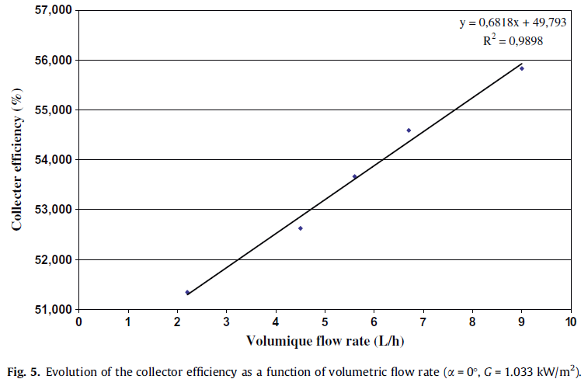 | 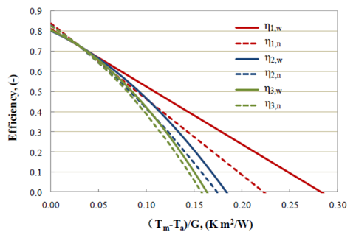
Fig. 1: Left: Collector efficiency as function of flow rate, adopted from Razika et al. (2014)
Right: Collector efficiency of two different collectors (index w and n)
for three flow rates (index 1, 2, 3) adopted from Chen et al. (2012)
This contribution focuses on an explicit calculation method for the achievable feed-in temperature, which makes solar heat available for district heating networks, and it investigates how strongly the performance of a collector field degrades when this feed-in temperature is not reached. For this purpose, not only the collector efficiency curve but also the characteristics of the solar heat exchanger under variable mass flow rates are examined.
2. Method
2.1 Available collector outlet temperature
In feasibility studies, the solar heat from a collector area $A_{col}$ is typically determined using the following equation
$${\dot{Q}}_{col}= A_{col}⋅ {\dot{q}}_{gt}⋅ η_{col}$$ | (1)
with global irradiance on the tilted collector surface, ${\dot{q}}_{gt}$, and the collector efficiency, $η_{col}$, which is calculated according to EN 12975 as follows:
$$η_{Col}=a_{0}-a_{1}⋅\frac{\left(t_{col}-t_{amb}\right)}{{\dot{q}}_{gt}}-a_{2}⋅\frac{{\left(t_{col}-t_{amb}\right)}^{2}}{{\dot{q}}_{gt}}$$ | (2)
With the collector efficiency $η_{Col}$ and the parameters contained therein, $a_{N}$ (with $N$ = 0…2), equation (1) describes the energy conversion of solar radiation into thermal energy as well as the transport of the thermal energy to the heat-transfer medium in a simplified way. In DIN EN ISO 9806 (2024) a more detailed model for the collector yield, ${\dot{Q}}_{col}$ is performed, where additional coefficients $a_{3…8}$ are used to describe e.g. the influence of the surrounding air velocity, the long-wave irradiance and the effective heat capacity. Nevertheless, equation (1) can be understood as the heat transfer equation of the collector. The reduced parameter set $a_{0…2}$ used in most simulation and potential studies is published in collector data sheets and in the Solar Keymark database0F0F0F0F.
According to equations (1) and (2) the useful heat output, ${\dot{Q}}_{col}$ of a collector can be derived from a quadratic function of the temperature difference, $Δt_{m}$.
$${\dot{Q}}_{col}= A_{col}⋅\left[a_{0}⋅{\dot{q}}_{gt}-a_{1}⋅Δt_{m}- a_{2}⋅{\left(Δt_{m}\right)}^{2}\right]$$ | (3)
This temperature difference is calculated from the arithmetic mean of the fluid inlet and outlet temperatures of the collector and the ambient air temperature.
$$Δt_{m}=t_{col}-t_{amb}=\frac{\left(t_{col,in}+t_{col,out}\right)}{2}-t_{amb}$$ | (4)
To determine the mean collector temperature $t_{col}$, fixed or estimated values for the inlet and outlet temperatures are often assumed (although they depend on operating conditions and are thus usually unknown). This is problematic, because by fixing $t_{col,in}$ and $t_{col,out}$, the collector thermal power ${\dot{Q}}_{col}$ is effectively over-determined because simultaneously to the heat transfer equation (1) the energy balance must apply,
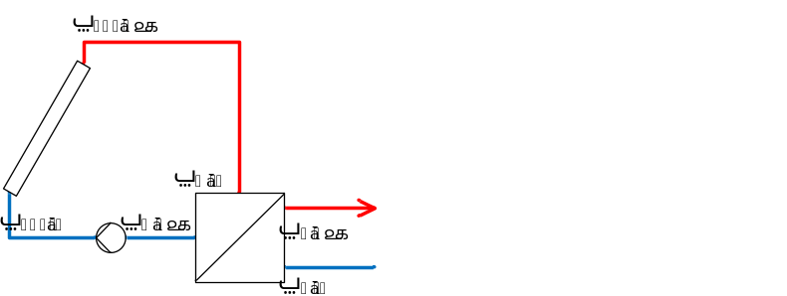  Fig. 2: Nomenclature in collector circuit. | ${\dot{Q}}_{col}={\dot{W}}_{col}⋅\left(t_{col,out}-t_{col,in}\right)$ (5)  where the heat capacity flow rate ${\dot{W}}_{col}={\dot{V}}_{col}⋅c_{p,col}⋅ρ_{col}$ must match the value used during the collector test to determine the values of $a_{0}$, $a_{1}$ and $a_{2}$ for applying equation (2). However, with ${\dot{W}}_{col}$ the unknown outlet temperature in the mean temperature $t_{col}$ of equation (2) can be replaced, since $t_{col,out}=t_{col,in}+{{\dot{Q}}_{col}}/{{\dot{W}}_{col}}$.  By inserting $t_{col,out}$ into eq. (4) and using the resulting mean temperature difference  $Δt_{m}=\frac{{\dot{Q}}_{col}}{2⋅{\dot{W}}_{col}}+t_{col,in}-t_{amb}=\frac{{\dot{Q}}_{col}}{2⋅{\dot{W}}_{col}}+Δt_{i}$ (6)
in eq. (3) a quadratic equation for the collector thermal power is derived as function of $Δt_{i}=t_{col,in}-t_{amb}$. After solving for ${\dot{Q}}_{col}$, it turns out that only the positive square root produces technically meaningful results.
$${\dot{Q}}_{col}=-\frac{p_{i}}{2}+\sqrt{\frac{p_{i}^{2}}{4}-q_{i}}$$ | (7)
With
$$p_{i}={\left(2⋅{\dot{W}}_{col}\right)}^{2}⋅\frac{1000 W/kW}{A_{col}⋅a_{2}}+2⋅{\dot{W}}_{col}⋅\left(2⋅Δt_{i}+\frac{a_{1}}{a_{2}}\right)$$ | (8)
$$q_{i}={\left(2⋅{\dot{W}}_{col}\right)}^{2}⋅\left(Δt_{i}^{2}+\frac{a_{1}}{a_{2}}⋅Δt_{i}-{\dot{q}}_{gt}⋅\frac{a_{0}}{a_{2}}\right)$$ | (9)
and the same technical parameters of the collector (i.e., $a_{0}$, $a_{1}$, $a_{2}$, and the corresponding heat capacity flow rate ${\dot{W}}_{col}={\dot{W}}_{col}^{test}$ under test conditions), eq. (7) provides the same collector power, ${\dot{Q}}_{col}$ as described by eq. (1) and (3). However, ${\dot{Q}}_{col}$ can be calculated solely from the operating conditions at the collector inlet, without assuming an outlet temperature, because instead of $Δt_{m}$, the known temperature difference $Δt_{i}=t_{col,in}-t_{amb}$ is used1F1F1F1F. Moreover, no parameter transformation is necessary, although the inlet temperature is used in eq. (7) (via eq. (8) and (9)). The used parameter set $a_{N}$ (with $N$ = 0…2) is the one from Solar Keymark database with reference to $Δt_{m}$.
From the collector thermal power, ${\dot{Q}}_{col}$ of eq. (7) and the capacity flow rate, ${\dot{W}}_{col}$, the available collector outlet temperature can be determined:
$$t_{col,out}=t_{col,in}+{{\dot{Q}}_{col}}/{{\dot{W}}_{col}}$$ | (10)
2.2 Variable mass flow and collectors in series
Although the actual capacity flow rate, ${\dot{W}}_{col}$ under current operating conditions is used in eq. (7) to (10) the collector parameters $a_{N}$ (with $N$ = 0…2) are used independent of ${\dot{W}}_{col}$ – despite their real variability. In the following the resulting deviations are determined in comparison to the TRNSYS-simulation model for flat plate collectors (Type 1, TRNSYS-17 (2009)). The model equations of Type 1 for the collector thermal power are based on a linear form provided by Duffie and Beckman (2020).
$${\dot{Q}}_{col}^{D\&B}= A_{col}⋅\left(a_{0,i}⋅{\dot{q}}_{gt}-F_{R}⋅U_{L}⋅Δt_{i}\right)$$ | (11)
Since the overall loss coefficient, $U_{L}$ is defined with respect to the temperature difference $Δt_{def}=t_{pm}-t_{amb}$ between mean absorber plate temperature, $t_{pm}$, and ambient temperature, $t_{amb}$, the heat removal factor, $F_{R}$ accounts for the difference between $Δt_{def}$ and the practically used temperature difference, $Δt_{i}$. The product of heat removal factor and overall loss coefficient provides the first order loss parameter $a_{1,i}=F_{R}⋅U_{L}$. Since the overall heat loss coefficient $U_{L}$ is not constant but increases with the temperature difference between absorber and ambient, mainly due to the growing contribution of thermal radiation and convection, the loss term is expanded by a linear temperature dependence (cf. Cooper and Dunkle (1981)), and the modified product becomes:
$$F_{R}{⋅U}_{L}^{'}=a_{1i}+a_{2i}⋅Δt_{i}$$ | (12)
Applying this modified product in eq. (11) yields a quadratic equation for the collector thermal power equivalent to eq. (3) but with coefficients $a_{N,i}$ related to $Δt_{i}$ instead of $Δt_{m}$.
$${\dot{Q}}_{col}^{D\&B}= A_{col}⋅\left(a_{0,i}⋅{\dot{q}}_{gt}-a_{1,i}⋅Δt_{i}- a_{2,i}⋅{\left(Δt_{i}\right)}^{2}\right)$$ | (13)
To account for off-rated heat capacity flow rates a correction factor $r_{1}$ is provided by Duffie and Beckman (2020), eq. (6.20.2)
$$r_{1}=\frac{{\dot{W}}_{col}⋅\left[1-exp\left(-\frac{A_{c}⋅F^{'}⋅U_{L} }{{\dot{W}}_{col}}\right)\right]}{{\dot{W}}_{col}^{test}⋅\left[1-exp\left(-\frac{A_{c}⋅F^{'}⋅U_{L}}{{\dot{W}}_{col}^{test}}\right)\right]}$$ | (14)
where the product $F^{'}⋅U_{L}$ can be determined from test conditions (i.e. with $F_{R}{⋅U}_{L}^{'}$ from eq. (12))
$$F^{'}⋅U_{L} =-\frac{{\dot{W}}_{col}^{test}}{A_{c}}⋅\ln\left(1-\frac{A_{c}⋅F_{R}{⋅U}_{L}^{'}}{{\dot{W}}_{col}^{test}}\right)$$ | (15)
According to Oonk et al. (1979) the correction factor to account for $N_{S}$ identical collectors in series is (cf. Duffie and Beckman (2020), eq. (10.5.11)):
$$r_{2}=\frac{1-{\left(1-r_{1}⋅\frac{A_{c}⋅F_{R}{⋅U}_{L}^{'}}{{\dot{W}}_{col}}\right)}^{N_{S}}}{N_{S}⋅r_{1}⋅\frac{A_{c}⋅F_{R}{⋅U}_{L}^{'}}{{\dot{W}}_{col}}}$$ | (16)
In summary the collector power can be calculated in a straightforward way if the coefficients $a_{N,i}$ are available
$${\dot{Q}}_{col}^{D\&B}=r_{1}⋅r_{2}⋅A_{col}⋅\left(a_{0,i}⋅{\dot{q}}_{gt}-a_{1,i}⋅Δt_{i}- a_{2,i}⋅{\left(Δt_{i}\right)}^{2}\right)$$ | (17)
and the outlet temperature follows analog to eq. (10):
$$t_{col,out}^{D\&B}=t_{col,in}+{{\dot{Q}}_{col}^{D\&B}}/{{\dot{W}}_{col}}$$ | (18)
Computational effort increases when the coefficients $a_{N,i}$ have to be derived from $a_{N}$ by a conversion factor $r_{i}$,
$$a_{N,i}=r_{i}⋅ a_{N}$$ | (19)
i.e. if the results of ${\dot{Q}}_{col}$ from eq. (7) shall be compared to ${\dot{Q}}_{col}^{D\&B}$ from eq. (17) for the same collector under the same operating conditions (e.g. where ${\dot{W}}_{col}≠ {\dot{W}}_{col}^{test}$ and/or $N_{S}$ > 1). According to eq. (6.19.2a) in Duffie and Beckman (2020) there is a conversion factor
$$r_{i}={\left(1+\frac{{A_{c}⋅F}_{R,m}⋅U_{L}^{'}}{2⋅{\dot{W}}_{col}}\right)}^{-1}$$ | (20)
which can be calculated explicitly only, if $a_{N>1}=0$ (i.e. linear relationship). In case of a quadratic collector curve the modified product of heat removal factor and overall loss coefficient $F_{R,m}{⋅U}_{L}^{'}$ has to be used instead of $F_{R,m}⋅U_{L}$.
$$F_{R,m}{⋅U}_{L}^{'}=a_{1}+a_{2}⋅\left(\frac{t_{col,in}+t_{col,out}^{D\&B}}{2}-t_{amb}\right)$$ | (21)

Since $t_{col,out}^{D\&B}$ is unknown an iteration process is necessary, i.e. we assume a value for $t_{col,out}^{D\&B}$ first and then repeat
- Determine $F_{R,m}{⋅U}_{L}^{'}$ from eq. (21) with $t_{col,out}$ from initial or last iteration step
- Calculate $r_{i}$ to convert $a_{N}$ (based on $Δt_{m}$, European standard) to $a_{N,i}$ (based on $Δt_{i}$, American standard)
- Calculate $r_{1}$ to account for different flow rates compared to test conditions (i.e. ${\dot{W}}_{col}≠ {\dot{W}}_{col}^{test}$)
- Calculate $r_{2}$ to account for $N_{S}$ collectors in series
- Determine ${\dot{Q}}_{col}^{D\&B}$ from eq. (17) and a new value for $t_{col,out}^{D\&B}$ from eq. (18)
until the change in $t_{col,out}$ is lower than a stop criterion. In contrast, ${\dot{Q}}_{col}$ from eq. (7) and $t_{col,out}$ from eq. (10) can be calculated explicitly.
The relative difference $ϵ= {\left({\dot{Q}}_{col}-{\dot{Q}}_{col}^{D\&B}\right)}/{{\dot{Q}}_{col}^{D\&B}}$ between the calculated collector power of eq. (7) with respect to the detailed model of eq. (17) is depicted in Fig. 3 for six variations (thick lines) together with the corresponding difference in outlet temperature (thin lines). For all variations the inlet temperature was set to $t_{col,in}$ = 40 °C and a global irradiance on the tilted collector plane of ${\dot{q}}_{gt}$ = 500 W m⁻² was used together with an ambient temperature of $t_{amb}$ = 20 °C. If not varied, the parameters for the 6 identical collectors are as follows: $A_{col}$ 3 m², $a_{0}$ = 0.84, $a_{1}$ = 2.5 W m⁻² K⁻¹, $a_{2}$ = 0.02 W m⁻² K⁻², $c_{p}$ = 4.2 kJ kg⁻¹ K. The specific mass flow rate under test conditions was assumed to be $G_{col}^{test}$ = 72 kg m⁻² h⁻¹, which corresponds to a heat capacity flow rate of ${\dot{W}}_{col}^{test}$ = 0.25 kW K⁻¹.
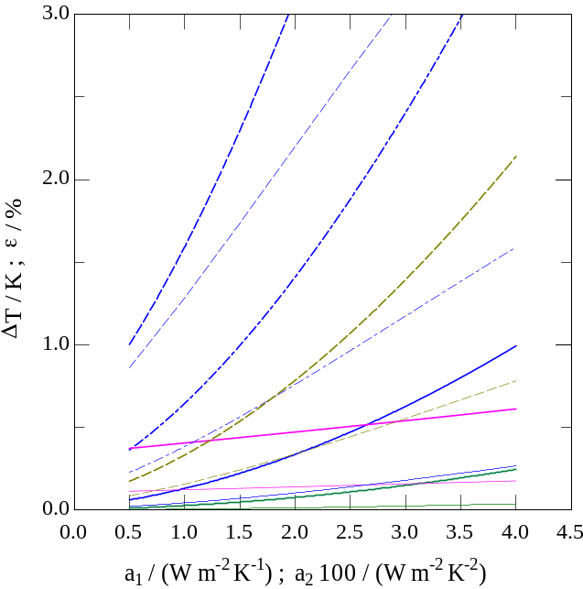  $$ΔT_{6}$$  $$ϵ_{3}$$  $$ΔT_{3}$$  $$ϵ_{2}$$  $$ΔT_{2}$$  $$ϵ_{1}$$  $$ΔT_{1}$$  $$ϵ_{6}$$  $$ΔT_{4}$$  $$ϵ_{4}$$  $$ΔT_{5}$$  $$ϵ_{5}$$ | No. | $$a_{1}$$W m⁻² K⁻¹ | $$a_{2}$$W m⁻² K⁻² | $$G_{col}$$kg m⁻² h⁻¹ | $$N_{S}$$
 | 1 | 0.5 – 4.0 | 0.02 | 20 | 1
 | 2 | 2.5 | 0.005 – 0.04 | 10 | 1
 | 3 | 0.5 – 4.0 | 0.02 | 10 | 1
 | 4 | 0.5 – 4.0 | 0.02 | 10 | 2
 | 5 | 0.5 – 4.0 | 0.02 | 10 | 3
 | 6 | 0.5 – 4.0 | 0.02 | 20 | 3
 | Fig. 3: Comparison of presented approach with results from detailed collector simulation
For a single-collector cases (solid lines for cases 1–3 in Fig. 3) the deviations $ϵ$ for all variations are below 1 % and the outlet temperature differs by less than 1 K. Large deviations occur only for (very) low specific mass flow rates (i.e. $G_{col}$ < 10 kg m⁻² h⁻¹) and/or in combination with a high number of collectors in series with low efficiency (i.e. $a_{1}$ > 3.0 W m⁻² K⁻¹). In case 5 the collector outlet temperatures $t_{col,out}$ are in the range of approx. 85 to 115 °C. These outlet temperatures indicate that the low-flow configuration is unsuitable for operation at higher irradiance. At a higher specific flow rate, e.g., $G_{col}$ = 20 kg m⁻² h⁻¹ (case 6), these high temperatures are only reached for ${\dot{q}}_{gt}$ > 900 W m⁻². For an irradiance of 500 W m⁻² shown in Fig. 3, the deviations $ϵ$ and temperature differences $ΔT$ then lie (at least for sufficiently efficient collectors, i.e. $a_{1}$ < 2.5 W m⁻² K⁻¹), again below approx. 1 % and 1 K compared to the detailed simulation model.
2.3 Solar heat exchanger
Often the collector circuit is hydraulically separated from the useful heat circuit by a heat exchanger (cf. Fig. 2). Therefore, the collector inlet temperature, $t_{col,in}$ depends on: $t_{c,in}$, the (known) inlet temperature into the heat exchanger on the cold side, ${\dot{Q}}_{HX}$, the transferred heat flow (which is equal to ${\dot{Q}}_{col}$ when thermal losses from piping are neglected) and the thermal size of the heat exchanger. The latter is described by the heat transfer capability $Y=U⋅A$. For a counterflow heat exchanger, the transferred heat flow can be calculated from:
$${\dot{Q}}_{HX}=Y⋅ΔT_{log}=Y⋅\frac{Δt_{h}-Δt_{c}}{ln\left(Δt_{h}\right)-ln\left(Δt_{c}\right)}={\dot{W}}_{col}⋅P_{h}⋅ΔT_{max}$$ | (22)
Instead of the logarithmic mean value of the temperature differences $Δt_{h}=t_{h,i}-t_{c,o}=t_{col,out}-t_{c,o}$ and $Δt_{c}=t_{h,o}-t_{c,i}=t_{col,in}-t_{c,i}$ at the hot and cold end of the heat exchanger also the maximum temperature difference $ΔT_{max}=t_{col,out}-t_{c,in}$ in combination with the dimensionless temperature glide $P_{h}$ for the hot fluid side can be used (i.e. right-hand side of eq. (22)). The dimensionless temperature glide $P_{h}$ can be derived from its well-known correlation with heat transfer capability $Y=U⋅A$ and the heat capacity flow rates on the cold and hot fluid side, i.e. ${\dot{W}}_{c}$ and ${\dot{W}}_{h}={\dot{W}}_{col}$, respectively.
$$P_{h}=\frac{1-exp\left(\left(\frac{{\dot{W}}_{col}}{{\dot{W}}_{c}}-1\right)⋅\frac{Y}{{\dot{W}}_{col}}\right)}{1-\frac{{\dot{W}}_{col}}{{\dot{W}}_{c}}⋅exp\left(\left(\frac{{\dot{W}}_{col}}{{\dot{W}}_{c}}-1\right)⋅\frac{Y}{{\dot{W}}_{col}}\right)}$$ | (23)
Dimensionless temperature glide $P_{h}$ and maximum temperature difference $ΔT_{max}$ can also be used to find an expression for the temperature difference at the heat exchangers’ cold end (cf. Appendix C in (Albers, 2019)).
$$Δt_{c}=\left(1-P_{h}\right)⋅ΔT_{max}=t_{col,in}-t_{c,in}$$ | (24)
By neglecting any thermal gains (e.g. from the pump) and losses (e.g. from the piping to environment) there is only one heat flow of interest (i.e. ${\dot{Q}}_{HX}={\dot{Q}}_{col}$). Thus, combining eq. (24) with the righthand side of the heat transfer equation (22) leads to
$$t_{col,in}=t_{c,in}+{\dot{Q}}_{col}⋅\frac{1-P_{h}}{{\dot{W}}_{col}⋅P_{h}}$$ | (25)
By substituting $t_{col,in}$ from equation (25) into the temperature difference $Δt_{i}=t_{col,in}-t_{amb}$ in equations (8) and (9) and then using the resulting expressions for the coefficients $p$ and $q$ in eq. (7), again a quadratic equation for the collector thermal power is obtained. The only technically meaningful solution of which can also be expressed via the positive root of the p-q-formula.
$${\dot{Q}}_{col}=-\frac{p_{c}}{2}+\sqrt{\frac{p_{c}^{2}}{4}-q_{c}}$$ | (26)
The numerical values of the coefficients occurring therein are identical to equation (7) i.e. $p_{c}=p_{i}$ and $q_{c}=q_{i}$, but can now be calculated very easily from the known operating conditions, since the difference $Δt_{c}^{*}=t_{c,in}-t_{amb}$ between the inlet temperature on the cold side of the heat exchanger, $t_{c,in}$ and the ambient temperature, $t_{amb}$ is used instead of $Δt_{m}$ or $Δt_{i}$.
$$p_{c}= {\left(\frac{{\dot{W}}_{col}⋅P_{h}}{1-{P_{h}}/2}\right)}^{2}⋅\frac{1000 W/kW}{A_{col}⋅a_{2}}+\frac{{\dot{W}}_{col}⋅P_{h}}{1-{P_{h}}/2}⋅\left(2⋅Δt_{c}^{*} +\frac{a_{1}}{a_{2}}\right)$$ | (27)
$$q_{c}={\left(\frac{{\dot{W}}_{col}⋅P_{h}}{1-{P_{h}}/2}\right)}^{2}⋅\left(Δ{t_{c}^{*}}^{2}+\frac{a_{1}}{a_{2}}⋅Δt_{c}^{*}-{\dot{q}}_{gt}⋅\frac{a_{0}}{a_{2}}\right)$$ | (28)
Finally, the usable outlet temperature on the cold side of the heat exchanger, $t_{c,out}$, which can be used in potential analysis as feed-in temperature for a distribution network or seasonal storage or as source temperature for a heat pump etc., can be calculated.
$$t_{c,out}=t_{c,in}+\frac{{\dot{Q}}_{col}}{{\dot{W}}_{c}}$$ | (29)

3. Application
3.1 Determination of the collector operating point
Section 2 provides a calculation approach that no longer needs an assumed outlet temperature. What it needs instead is the heat capacity flow rate, which is not a constant of the collector field but a decision of its operator. This section states how that decision is made in real plants, how the resulting heat is counted as usable, and on which field the calculations of section 4 are carried out.
In a real solar-thermal plant the collector is not operated at a single design flow rate. It is a time-varying thermo-hydraulic state that results from three conditions being satisfied simultaneously: a thermal requirement, the hydraulic characteristic of field and pump, and a set of operational constraints (Gölles and Unterberger, 2021). In district heating applications, the required delivery temperature is often the dominant constraint. The field does not have to collect the maximum instantaneous heat; it must deliver heat at a temperature the network accepts. Current practice for large flat-plate fields therefore inverts the energy balance of eq. (5): a feed-forward model computes the mass flow needed to reach a desired outlet temperature from the measured return temperature, irradiance and ambient temperature; afterwards a slow integrating feedback corrects the model error, and an inner flow controller tracks the resulting setpoint (Gölles and Unterberger, 2021). The requested flow is then clipped to a range whose lower bound follows from hydraulic stability, i.e. avoiding laminar flow regime in the absorber tubes, boiling margin and frost protection, and whose upper bound follows mainly from pump capacity (Bava et al., 2016).
For this paper, the operating constraints are derived from measurements of the 516 m² ‘Arcon South’ array at the Graz district-heating plant. One full operational year (2017) is available at one-minute resolution (FHW Dataset), with volume flow, inlet and row-wise outlet temperatures, global tilted and horizontal irradiance, weather data and propagated measurement uncertainties (Tschopp et al., 2023). Fig. 4 shows three summer days from this dataset. The collector field remains largely inactive below approximately 250 W/m². Above approximately 250 W/m², the pump starts at its lowest observed specific mass-flow rate of about 7 kg/(m²·h). The mass-flow rate then increases with irradiance and approaches approximately 16.8 kg/(m²·h) at 600–700 W/m².
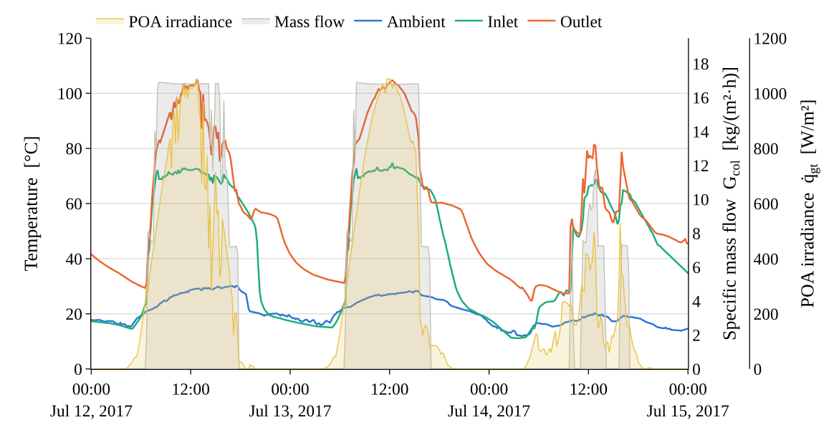
Fig. 4: Measured operating conditions of the collector array at district heating plant Graz,
aggregated to hourly values for three days in 2017 (Tschopp et al., 2023).
Three operating strategies are carried out through the rest of the paper as scenarios. They differ only in what the pump is allowed to do: collector type and field, irradiance, the 50 °C inlet and the 70 °C desired outlet temperature are identical in all three cases.
- Scenario 1 fixes one flow rate for the whole year. The flow is found by a search over the whole year so that the usable heat supplied to the heating network is maximised, while simultaneously remaining under the maximum allowed operating temperature below 110°C. The resulting collector thermal power is labelled ${\dot{Q}}_{col}^{fix,opt}$. It represents a hindsight-optimised fixed-flow benchmark rather than a causal control strategy.
- Scenario 2 assumes an irradiance-based plant operation from the FHW Dataset (see Fig. 4). We assume a radiation proportional flow-rate control between 250 W/m² and 800 W/m² without any hysteresis, i.e. below 250 W/m² the pump is off and above 800 W/m² it is limited by the mass flow range of 7 - 16.8 kg m⁻² h⁻¹ and maximum operating collector temperature of 110°C. The 800 W/m² saturation point is a modelling assumption. The resulting thermal power is labelled ${\dot{Q}}_{col}^{prop}$. This scenario is supposed to represent a simplified real operation of a collector plant.
- Scenario 3 treats the flow as the control variable. At each hour the same quadratic equation (i.e. eq. (7) to (9)), is solved for the heat capacity flow rate ${\dot{W}}_{col}$ at which the collector outlet reaches the desired outlet temperature exactly, and the resulting specific mass-flow rate is bounded to 7-16.8 kg m⁻² h⁻¹. This scenario is understood as an upper bound of what an hourly resolution control can recover. The collector thermal power here is labelled ${\dot{Q}}_{col}^{var,opt}$.
All three are compared against the base case, the established calculation of eq. (3) with the inlet and outlet temperature fixed at 50 and 70 °C and Δt_{m} taken from eq. (4). The base case does not prescribe a flow rate explicitly. Instead, the fixed 50/70 °C temperature pair and the energy balance in eq. (5) imply an hourly heat-capacity flow rate that varies with collector heat output. Because this implied flow is not constrained to the adopted operating range, the base case serves as an unconstrained calculation reference rather than a physically enforceable operating strategy. This case also represents the oemof flat plate collector model (Möller et al., 2024); hence the collector thermal power of the base case is labelled ${\dot{Q}}_{col}^{oemof}$.
A collector field that feeds a heat network is not credited with the heat it can generate but with the heat the network accepts, and the difference between the two is the available useable temperature, $t_{c,out}$, not an energy. Under the direct-feed assumption used here, collector heat is counted as usable only when the outlet temperature, $t_{c,out}$ reaches the required feed-in temperature, e.g. $t_{c,out}$ > 67 °C. However, for simplicity all calculations in section 4 do not consider the heat exchanger. They are performed with fixed collector inlet and desired outlet, i.e. the collector inlet is held at t_{col,in} = 50 °C, and the desired collector outlet temperature is t_{col,out} = 70 °C. Accordingly, heat produced at $t_{col,out}$ < 70 °C is assigned zero usable yield in the present analysis.
3.2 Modelling a real-life collector field
The collector of the modelled field is the Arcon-Sunmark HTHEATstore 35/10, a double-glazed flat-plate collector of 13.57 m² gross area, and its parameters are those of the Solar Keymark certificate SP SC0843-14 (SP Technical Research Institute of Sweden, 2016): a₀ = 0.7372, a₁ = 2.067 W/(m²·K) and a₂ = 0.009 W/(m²·K²). Coefficients, module area and test flow rate are all referenced to the gross area. With 38 collectors the field gross area is 516 m².
The certificate states its test point at a mass flow of water $G_{col}^{test}$ = 0.061 kg/(s·m²), i.e. a specific heat capacity flow rate of Ẇ_{col}/A_{col} = 0.255 kW/(K·m²). The field circulates 43.5 % propylene glycol with ρ·c_{p} = 3,921 kJ/(m³·K), tabulated at 55 °C and is assumed constant over the whole temperature range. The pump range starts from 7 kg/(m²·h) because the measured field data indicate this lower operating bound, which is adopted as a plant-specific model constraint. Minimum-flow limits are generally required to maintain suitable hydraulic and thermal operating conditions (Bava et al., 2016).
The field is set up and simulated in the Enable software suite (Fraunhofer IEG, 2026). Site geometry, weather and collector field are held in the Enable-Odeon data model, the field layout — module count, tilt and row spacing on the given footprint — is produced by Enable-Prospect. The base case is evaluated with the flat-plate collector model of oemof (Möller et al., 2024), which is the EN 12975 curve of eq. (2) at the fixed mean collector temperature implied by the 50/70 °C temperature pair, i.e. with mean temperature t_{col} = 60 °C in every hour of the year. The three scenarios are evaluated with eqs. (7) to (10) of section 2, implemented directly.
The weather data is taken from the FHW-Dataset for the year 2017 (Tschopp et al., 2023). Since the dataset contains missing data for 30 days of the year, the ambient temperature and solar irradiance data for these days are taken from the closest weather station (Station ID: 16413 "Graz Strassgang", 2.0 km from the plant) (GeoSphere Austria, 2024). The completed weather year has a global horizontal irradiation of 1,250 kWh/(m²·a) and an annual mean ambient temperature of 10.9 °C. For a south-facing collector plane with a 30° tilt, the corresponding annual plane-of-array irradiation is 1,470 kWh/(m²·a). The calculation is quasi-steady and hourly. The effective heat capacity of the collector (a₅ = 7.313 kJ/(m²·K) in the certificate) and the transport delay of the field piping are not modelled, so morning warm-up and cloud transients enter only through the hourly mean irradiance; piping heat losses and pump electricity are not included; and the collector inlet temperature is a constant rather than a measured network return.
4. Results
4.1 Daily impact of operating strategy
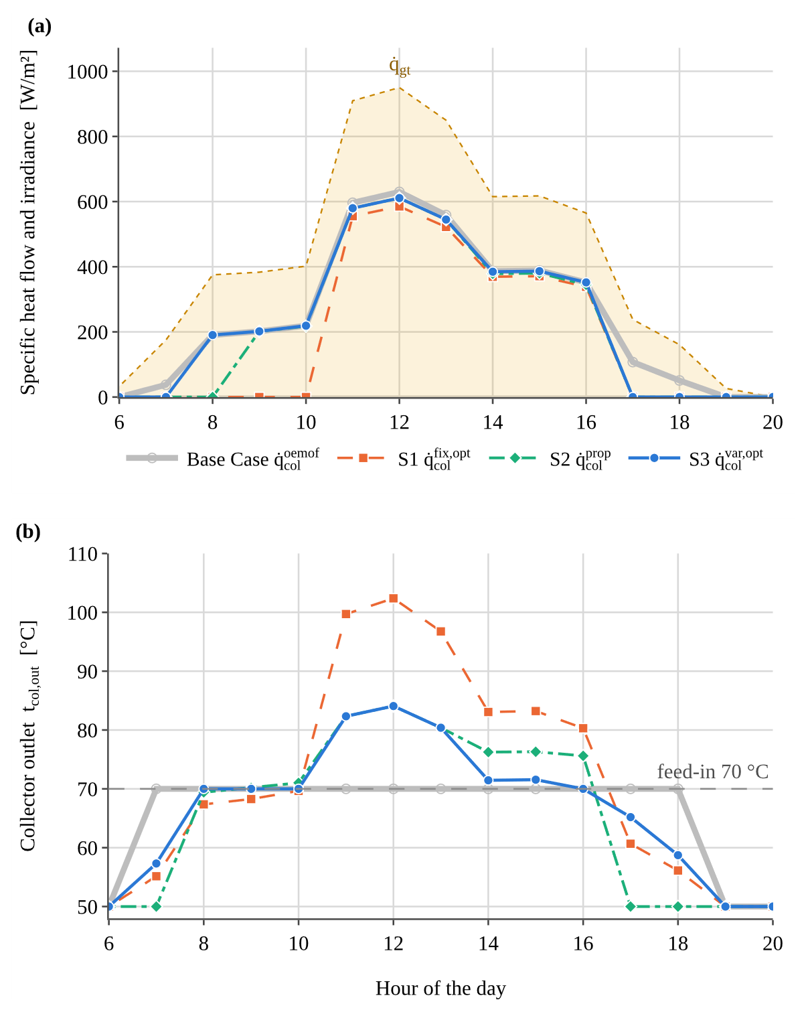
Fig. 5 illustrates the effect of the operating strategy on usable collector output and outlet temperature on 5 Aug. 2017. The base case prescribes an outlet temperature of 70 °C whenever positive heat output is calculated. In the flow-constrained scenarios, this temperature must instead be attained under the prevailing irradiance and ambient conditions. Consequently, positive collector heat production does not necessarily imply usable heat at the required temperature.
At the annually optimised fixed flow of approx. 10.5 kg/(m²·h), Scenario 1 fails to reach 70 °C during periods of lower irradiance but reaches 102.4 °C near midday. Because outlet temperatures above the 70 °C requirement provide no additional benefit under the adopted usability criterion, the higher mean collector temperature in Scenario 1 increases thermal losses during these hours. Irradiance-proportional control of flow rate in Scenario 2 reduces the midday temperature to 84.1 °C and extends usable operation. Scenario 3 maintains 70 °C whenever the required flow lies within the permitted range. At high irradiance, the maximum flow becomes binding and the outlet temperature rises above the setpoint, reaching the same maximum as Scenario 2. At low irradiance, the minimum flow prevents attainment of 70 °C. The daily usable yields are 3.72, 2.74, 3.26 and 3.47 kWh/m² for the base case and Scenarios 1 – 3, respectively, corresponding to 12, 6, 8 and 9 operating hours.
Fig. 5: Effect of the operating strategy on collector heat output and outlet temperature for 5 August 2017. (a) Plane-of-array irradiance ${\dot{g}}_{gt}$ and specific collector output of the base case and of Scenarios 1 to 3; (b) the corresponding collector outlet temperature $t_{col,out}$. Heat generated below the desired collector outlet temperature is counted as zero in (a).

4.2 Annual impact of operating strategy
Fig. 6 shows the annual usable-yield reduction $R_{s}$, calculated for each scenario using eq. (30), and separates it into three contributions, each expressed relative to the annual base-case yield $q_{col}^{oemof}$ of 730 kWh/m²a. The purple segment represents the contribution to the annual heat reduction predicted by the base case during hours when the scenario’s pump is switched off. It occurs only in Scenario 2, where circulation starts at a plane-of-array irradiance of 250 W/m² due to the assumed ramp control. The orange segment represents the contribution from hours in which the pump operates but the calculated outlet temperature remains below 70 °C. These hours contribute to no usable heat in the corresponding scenario. The blue segment represents the net difference between base-case and scenario output during hours when usable heat is produced. This difference reflects increased thermal losses when the collector operates above the required temperature of 70 °C ($t_{req}$ in eq. (30)).
$$R_{SN}\left(t_{req}\right)=\frac{q_{col}^{oemof}(t_{req})-q_{col,N}^{usable}\left(t_{req}\right)}{q_{col}^{oemof}(t_{req})}, N ∈ \{1,2,3\}$$ | (30)
Insufficient outlet temperature accounts for the largest contribution in all three scenarios. With the fixed flow of Scenario 1, low-irradiance periods remain below the temperature requirement, while high-irradiance periods produce temperatures substantially above it. This combination explains both the large orange segment and the comparatively large blue segment. Irradiance-proportional control in Scenario 2 reduces both contributions, although the pump-start threshold introduces an additional shortfall. The total reduction therefore decreases only moderately, from 20.5 % to 18.4 %.
Scenario 3 reduces the shortfall to 8.7 % by adjusting the flow to maintain 70 °C whenever possible. Its remaining orange segment arises when the minimum permitted flow is still too high to achieve the required temperature. Conversely, the blue segment arises when the maximum permitted flow is insufficient to maintain the setpoint, forcing operation at higher temperatures. Between these limits, Scenario 3 reproduces the base-case results. The remaining shortfall therefore illustrates the effect of the assumed flow limits, even under ideal hourly control.
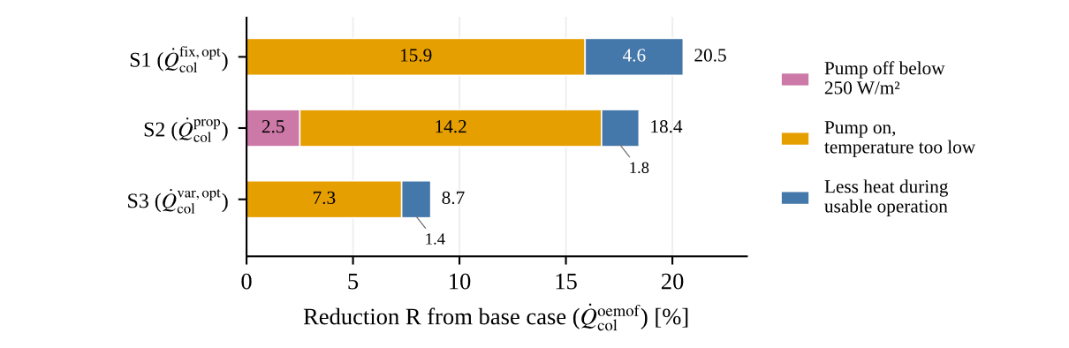
Fig. 6: Reduction in annual usable heat relative to the base case for Scenarios 1–3, decomposed by cause.
Table 1 summarises the annual usable yields and operating conditions of the four calculation cases. The base case gives 730 kWh/(m²·a), but its prescribed temperatures imply a variable flow that is not restricted to the adopted operating range. It therefore serves as an unconstrained reference. The annually optimised fixed flow in Scenario 1 yields 580 kWh/(m²·a), with a maximum outlet temperature at the 110 °C operating limit. Scenario 2 increases usable yield to 595 kWh/(m²·a), an improvement of 2.6 %, while reducing the maximum outlet temperature to approximately 89 °C. This improvement occurs despite slightly fewer usable hours, 1,407 compared with 1,421, showing that operating duration alone does not determine annual yield.
Scenario 3 achieves the highest usable yield among the constrained cases, 667 kWh/(m²·a), and extends usable operation to 1,759 h/a. Relative to Scenario 2, this represents 12.0 % more usable heat and 352 additional usable hours. Its maximum outlet temperature remains approximately 89 °C because the same upper flow limit applies. The residual deviation of 8.7 % from the base case shows that, even with hourly outlet-temperature control, the prescribed flow limits prevent the target temperature from being reached at low irradiance and cause temperature overshoot at high irradiance. Under the adopted operating constraints, the fixed-temperature calculation therefore overestimates the usable collector yield.
Table 1: Comparison of the four calculation cases for the modelled collector field.
Case | Symbol | What is fixed | $$G_{col}$$  [kg/(m²·h)] | $q_{col}^{usable}$  [kWh/(m²a)] | Max outlet [°C] | Usable hours [h] | vs. base case [%]
Base case | $$q_{col}^{oemof}$$ | $t_{col,in}$ and $t_{col,out}$  (${\dot{W}}_{col}$ implied) | Implied  (median 11.9) | 730 | 70 | – | –
Scenario 1 | $$q_{col}^{fix,opt}$$ | $t_{col,in}$ and one fixed flow for the whole year | 10.5  (fixed, optimal) | 580 | 110 | 1421 | −20.5
Scenario 2 | $$q_{col}^{prop}$$ | $t_{col,in}$ and a proportional ramp control | 7.0 – 16.8  (median 13.1) | 595 | 89 | 1407 | −18.4
Scenario 3 | $$q_{col}^{var,opt}$$ | $t_{col,in}$ and the $t_{col,out}$  (${\dot{W}}_{col}$ solved) | 7.0 – 16.8  (median 10.5) | 667 | 89 | 1759 | −8.7

5. Conclusion
An explicit calculation method has been presented for determining collector heat output and achievable outlet temperature from inlet conditions and heat-capacity flow rate. The quadratic formulation uses the mean-temperature-based collector coefficients directly and avoids iteration on the unknown outlet temperature. Its extension to a counterflow heat exchanger also permits calculation of the usable-side outlet temperature. For the single-collector cases examined in Section 2.2, differences from the detailed comparison model remained below 1 % in heat output and 1 K in outlet temperature; these bounds should not be generalised to arbitrary flow rates or series configurations.
The annual application demonstrates the importance of evaluating heat output together with its temperature. For the modelled Graz collector field, a 50 °C inlet and a 70 °C outlet requirement give usable yields of 580, 595 and 667 kWh/(m²·a) under optimised fixed-flow, irradiance-proportional and hourly outlet-temperature control within the prescribed flow limits, respectively. These more realistic values are 20.5 %, 18.4 % and 8.7 % below the unconstrained fixed-temperature reference, where the yield of 730 kWh/(m²·a) is only possible due to capacity flow rates outside technical boundaries. For the investigated 50/70 °C boundary temperatures and adopted flow limits, insufficient outlet temperature accounts for the largest contribution to the yield shortfall in all three scenarios.
The method thus supports feasibility studies that explicitly relate solar heat availability to temperature requirements and operating constraints. The annual results describe hourly, quasi-steady collector operation with prescribed inlet temperature; they do not establish delivered network heat or validate actual plant performance. Further work should examine measured control behaviour, hydraulic flow limits, transient effects and heat-exchanger integration under varying network conditions.
- References
AGFW, 2021. Praxisleitfaden Solarthermie, Frankfurt am Main. https://www.agfw.de/praxisleitfaeden. Accessed 17 May 2024.
Albers, J., 2019. Enhancement of a calculation method for the control of absorption chillers. PhD-Thesis in German. Fakultät III Prozesswissenschaften, TU Berlin, Germany. DOI: 10.14279/depositonce-8708.
Bava, F., Nielsen, J.E., Knabl, S., Brunger, A., Furbo, S., Fink, C., 2016. Results of IEA SHC Task 45: Large Scale Solar Heating and Cooling Systems. Subtask A: “Collectors and Collector Loop”. Energy Procedia 91, 546–556.
Beckman, W.A., Klein, S.A., Duffie, J.A., 1977. Solar heating design, by the f-chart method. NASA STI/Recon Technical Report A 78, 31071.
Berberich, M., Deschaintre, L., Schmidt, T., 2017. ScenoCalc Fernwärme Version 2.0. Handbuch. Steinbeis Forschungsinstitut für solare und zukunftsfähige thermische Energiesysteme, Stuttgart. https://www.scfw.de/. Accessed 4 September 2026.
BSW, 2025. Solarthermie für Wärmenetze. Hilfen für die kommunale Wärmeplanung. BSW — Bundesverband Solarwirtschaft e. V. https://www.solarwirtschaft.de/datawall/uploads/2025/09/BSW_Waermeplanung_mit_Solarthermie.pdf. Accessed 28 August 2026.
Chen, Z., Furbo, S., Perers, B., Fan, J., Andersen, E., 2012. Efficiencies of Flat Plate Solar Collectors at Different Flow Rates. Energy Procedia 30, 65–72.
Cooper, P.I., Dunkle, R.V., 1981. A non-linear flat-plate collector model. Solar Energy 26 (2), 133–140.
DIN EN ISO 9806, 2024. Solarenergie –Thermische Sonnenkollektoren –Prüfverfahren (ISO/DIS 9806:2024); Deutsche und Englische Fassung prEN ISO 9806:2024. DIN-Normenausschuss Heiz- und Raumlufttechnik sowie deren Sicherheit (NHRS).
Duffie, J.A., Beckman, W.A., 2020. Solar engineering of thermal processes, photovoltaics and wind. Wiley, Hoboken, New Jersey, 905 pp.
Fraunhofer IEG, 2026. Enable. Die modulare und flexible Toolbox für Energiesystemplanung. https://www.ieg.fraunhofer.de/de/projekte/enable.html. Accessed 4 September 2026.
GeoSphere Austria, 2024. Qualitätsgeprüfte Stationsdaten für Österreich in stündlicher Auflösung (v2). Accessed 10 September 2026. DOI: 10.60669/9bdm-yq93.
Gölles, M., Unterberger, V., 2021. IEA SHC, Task 55. B-D3.1: Control-of-Large-scale-solar-thermal-plants. http://task55.iea-shc.org/fact-sheets. Accessed 4 September 2026.
IEA-TASK45, 2018. IEA SHC, Task 45 Large Scale Solar Heating and Cooling Systems. Databases for Large Solar Heating and Cooling Systems. https://task45.iea-shc.org/publications. Accessed 31 August 2026.
Möller, C., Pleißner, F., Gering, M.-C., Launer, J., Schönfeldt, P., Rasti, S.J., Krien, U., Haas, S., Kaldemeyer, C., Günther, S., 2024. oemof/oemof-thermal: v0.0.8. Zenodo.
Oonk, R.L., Jones, D.E., Cole-Appel, B.E., 1979. Calculation of performance of N collectors in series from test data on a single collector. Solar Energy 23 (6), 535–536.
Razika, I., Nabila, I., Madani, B., Zohra, H.F., 2014. The effects of volumetric flow rate and inclination angle on the performance of a solar thermal collector. Energy Conversion and Management 78, 931–937.
SolarKeymark, 2019. Description of ScenoCalc (Solar Collector Energy Output Calculator). https://solarkeymark.eu/wp-content/uploads/2021/10/Description-of-ScenoCalc-v6.1.pdf. Accessed 13 June 2026.
SP Technical Research Institute of Sweden, 2016. Solar Keymark Certificate SP SC0843-14: HTHEATstore 35/10.
TRNSYS-17, 2009. TRNSYS 17 a TRaNsient SYstem Simulation program. Volume 4 Mathematical Reference. https://web.mit.edu/parmstr/Public/TRNSYS/04-MathematicalReference.pdf. Accessed 4 September 2026.
Tschopp, D., Ohnewein, P., Stelzer, R., Feierl, L., Hamilton-Jones, M., Moser, M., Holter, C., 2023. [Dataset] One year of high-precision operational data including measurement uncertainties from a large-scale solar thermal collector array with flat plate collectors, located in Graz, Austria. DOI: 10.5281/zenodo.7741083.
- Nomenclature

Table 3: Symbols.
Quantity | Symbol | Unit
Area | A | m²
Collector coefficient | a | coefficient-dependent
Specific heat capacity | c | J kg⁻¹ K⁻¹
Collector performance factor | F | –
Specific mass-flow rate | G | kg m⁻² h⁻¹
Number / count | N | –
Dimensionless temperature glide | P | –
Auxiliary p-coefficient of the p-q formulation | p | kW
Auxiliary q-coefficient of the p-q formulation | q | kW²
Irradiance / heat-flux density | $$\dot{q}$$ | W m⁻²
Specific annual collector yield | q | kWh m⁻² a⁻¹
Heat-flow rate | $$\dot{Q}$$ | W (or kW)
Correction factor | r | –
Reduction factor | R | –
Temperature | t | °C
Temperature difference | ΔT | K
Overall heat-transfer coefficient | U | W m⁻² K⁻¹
Volume-flow rate | V̇ | m³ s⁻¹
Heat-capacity flow rate | Ẇ | kW K⁻¹
Heat-transfer capability | Y | kW K⁻¹
Efficiency | η | –
Density | ρ | kg m⁻³
Relative difference | ε | –
Table 4: Subscripts and superscripts.
Quantity | Symbol
Ambient | _{amb}
Cold side of the heat exchanger | _{c}
Collector / collector circuit / collector field | _{col}
definition | _{def}
Global horizontal irradiance | _{gh}
Global irradiance on tilted collector plane | _{gt}
Hot side of the heat exchanger | _{h}
Heat exchanger | _{HX}
Inlet-temperature-based | _{i}
Inlet | _{in}
Loss | _{L}
Logarithmic mean | _{log}
Arithmetic mean | _{m}
Maximum | _{max}
Generic coefficient index | _{N}
Outlet | _{out}
Property at constant-pressure | _{p}
Mean absorber plate | _{pm}
Reduction Factor | _{R}
Collectors in series | _{S}
Duffie & Beckman formulation | ^{D&B}
Collector test conditions | ^{test}
Base-case / oemof calculation | ^{oemof}
Fixed-flow, annually optimised case (Scenario 1) | ^{fix,opt}
Proportional control (Scenario 2) | ^{prop}
Variable-flow optimised case (Scenario 3) | ^{var,opt}
modified parameter, coefficient etc. | ′

https://solarkeymark.eu/database/
The factor $1000 W/kW$ in eq. (8) allows the use of convenient units, i.e. $\left[a_{2}\right]=Wm^{-2}K^{-2}$ and ${[\dot{W}}_{col}]=kW K^{-1}$.

