EuroSun2026
ADAPTIVE STRATIFIER LANCE: COMPARING NOVEL METHODS AND CONTROL STRATEGIES FOR STRATIFIED THERMAL ENERGY STORAGES TO IMPROVE SYSTEM EFFICIENCY

Leroy Tomás (corresponding author), Jonas Hauser, Sascha Rißmann, Jens Pfaferott, Manuel Lämmle
Offenburg University of Applied Sciences (Hochschule Offenburg), Offenburg, Germany
leroy.tomas@hs-offenburg.de; jhauser2@stud.hs-offenburg.de ; sascha.rissmann@hs-offenburg.de; jens.pfafferott@hs-offenburg.de; manuel.laemmle@hs-offenburg.de
Summary
This paper presents an experimental study of a vertically actuated stratifier lance for managing thermal stratification in a hot thermal energy storage (HTES) that drives an adsorption chiller (ADC) in a laboratory-scale CCHP system. Two control strategies for the lance are developed and compared: a PID setpoint-strategy and a phase-optimal strategy, evaluated alongside a mixed and a fixed-discharge stratified TES as baselines, across four operating modes. Both lance-controlled strategies are evaluated under static single-cycle discharge tests and realistic dynamic 24-hour tests with automated charging and discharging. In the static tests, both strategies increase usable heat and delivered cooling energy over the two baselines; in the dynamic tests, the phase-optimal strategy does the same, while the PID setpoint-strategy instead best preserves thermal stratification and achieves the longest ADC operating time. An additional exergetic analysis shows that the phase-optimal strategy achieves higher values on all three exergy-based indicators, the exergetic COP of the ADC, the exergy utilization ratio of the HTES, and the overall well-to-cold system efficiency. indicating that stratification preservation and thermodynamic conversion quality are distinct objectives. The choice between the two strategies should therefore be guided by the intended use of the extracted heat, and the underlying lance concept is discussed as a potentially transferable principle for other thermally driven systems relying on stratified storage.
thermal energy storage, stratification management, actuated stratifier lance, adsorption chiller, CCHP system, exergy efficiency, PID control
Field of application for the findings: Thermally driven cooling systems (e.g. adsorption/absorption chillers) and other applications relying on stratified thermal energy storage, such as solar thermal systems.
Addressed audience: Researchers and engineers working on thermal energy storage and thermally driven cooling systems.
- Introduction
Managing the thermal energy storage (TES) is a key factor in improving the performance of advanced energy systems integrating technologies such as heat pumps, solar thermal collectors or adsorption chillers. TES buffers temporal mismatches between variable renewable generation and heat or cooling demand (Abdur Rehman et al. 2021). The preservation of thermal stratification in TES represents a major advantage, as it has been shown to improve the overall efficiency of thermally driven systems (Sifnaios et al. 2019; Gütle et al. 2025), and must therefore be actively maintained to avoid efficiency losses caused by mixing.
To exploit this potential, a TES management concept with a vertically actuated stratifier lance was designed, allowing targeted discharge of heat at a freely definable temperature level within the stratified storage. This concept was implemented in a combined cooling, heating and power (CCHP) laboratory system with a heat pump and a cogeneration unit driving an adsorption chiller. The underlying idea is to enable flexible adjustment of the desorption temperature (Wittstadt 2018). By operating at a lower desorption temperature during the initial phase of the cycle, a reduced energy efficiency ratio (EER) of the chiller is accepted in favor of improved overall system efficiency and increased utilization of the stored thermal energy.
Two lance control strategies were developed and compared in this study: a phase-optimal strategy that positions the discharge point at the temperature level considered ideal for the current phase of the adsorption cycle, and a PID controller that instead tracks one fixed, exact setpoint temperature at the lance. Both strategies are evaluated under two complementary test conditions: static single-cycle discharge tests – in which the HTES is charged once and the adsorption chiller is simply left running until it shuts down by itself, without any further recharging – and realistic, dynamic 24-hour operation with automated charging and discharging of the storage, mimicking real system dynamics. Comparing the two control strategies under both test conditions allows a direct assessment of their respective system performance in practice.
This raises the central research question of how the two lance control strategies affect system performance under static and realistic dynamic operating conditions and whether the underlying principle of an actuated stratifier lance can be transferred to other thermally driven energy systems.
- Methodology
2.1 Experimental setup
Experiments were conducted on a laboratory-scale CCHP system in which hot water from a 1.5 m³ hot thermal energy storage (HTES) drives a 4.8 kW silica-gel adsorption chiller (ADC) that cools a 1.45 m³ cold thermal energy storage (CTES). In conventional operation, hot water is extracted exclusively from the top of the HTES. To enable flexible, temperature-controlled extraction, a vertically actuated stratifier lance was integrated into the HTES. A control program receives a target temperature as input and dynamically adjusts the vertical position of the movable discharge lance. For the dynamic tests a thermostat draws chilled water from the CTES to emulate the building-side cooling load. A mixing valve upstream of the thermostat is set to a fixed supply temperature of 20 °C (see Fig. 1). The operating modes described below are investigated in two complementary test campaigns: static single-cycle discharge tests and dynamic 24 h tests. Each test campaign compares four operating modes, as detailed in Section 2.3. In both campaigns the ADC is operated with a constant cooling setpoint temperature of 11 °C. To ensure comparability between the investigated operating modes, identical boundary conditions in the HTES and CTES were applied in all experiments.
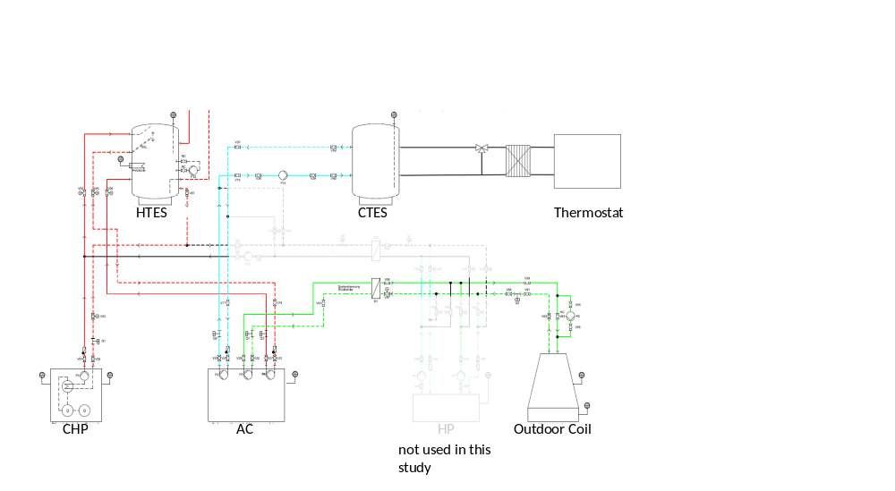
Fig. 1: Flow diagram of the CCHP laboratory system, comprising the hot and cold thermal energy storages (HTES, CTES) with the actuated stratifier lance, the ADC, the combined heat and power unit (CHP), the outdoor coil and the room thermostat emulating the building-side cooling load (Load); the reversible heat pump (HP) is not used in this study.
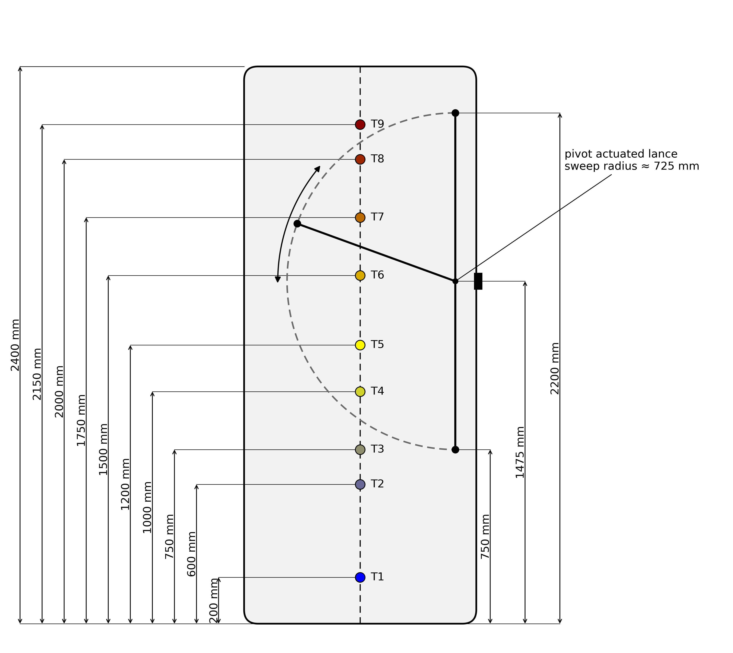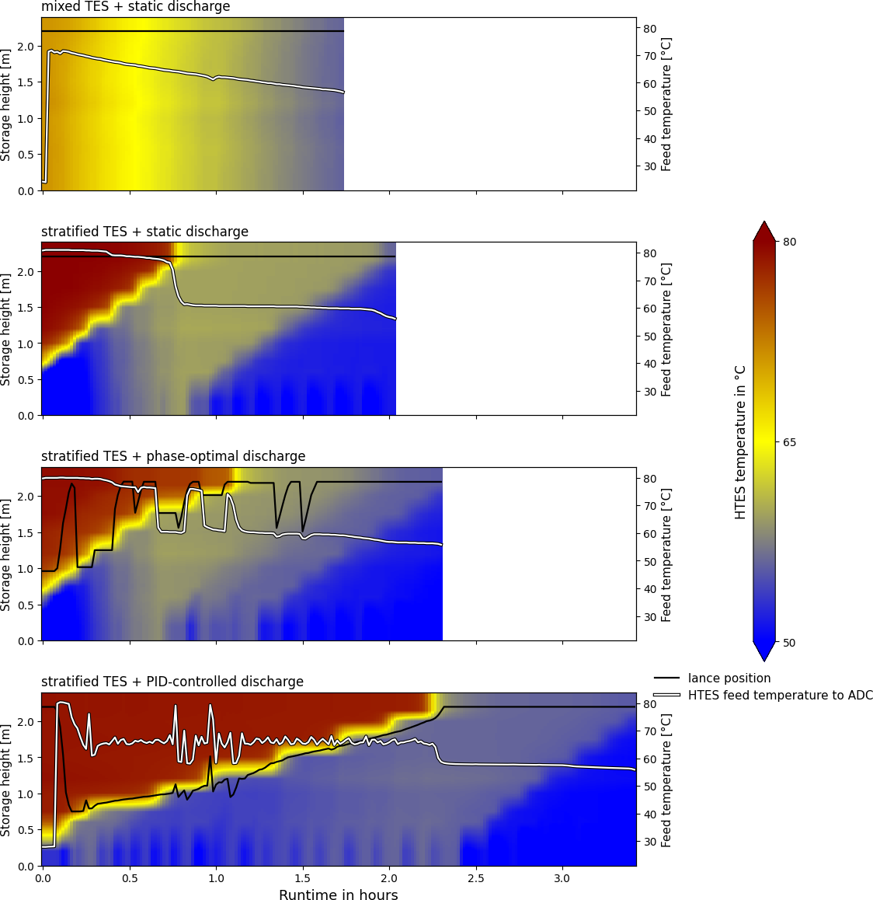
Fig. 2: Left: Schematic cross-section of the HTES, showing the vertical positions of the nine temperature sensors (T1–T9) and the pivoting stroke of the actuated stratifier lance between its lower and upper end positions. Right: Photograph of the actuated stratifier lance installed in the HTES.
As shown in Fig. 2, the HTES is equipped with nine temperature sensors (T1–T9) distributed vertically along its height, which are used to characterize the thermal stratification inside the storage. The stratifier lance can be positioned continuously between a lower end position near the bottom of the HTES and an upper end position near its top, allowing hot water to be withdrawn from any height within this range. The CTES is equipped in the same way with four temperature sensors, distributed vertically along its height. Tab. 1 lists the main technical specifications of the CCHP laboratory system components.
Tab. 1: Technical specifications of the CCHP laboratory system components
Parameter | Value | Unit
Hot thermal energy storage (HTES) volume | 1.5 | m³
Hot thermal energy storage (HTES) height | 2400 | mm
Number of temperature sensors (HTES) | 9 | –
Cold thermal energy storage (CTES) volume | 1.45 | m³
Cold thermal energy storage (CTES) height | 2200 | mm
Number of temperature sensors (CTES) | 4 | -
Adsorption chiller (ADC) type | Silica gel adsorption chiller | –
Adsorption chiller (ADC) nominal cooling capacity | 4.8 | kW_{th}
Adsorption chiller (ADC) cooling setpoint temperature | 11 | °C
Combined heat and power (CHP) unit thermal capacity | 12.5 | kW_{th}
Combined heat and power (CHP) unit electrical capacity | 5.5 | kW_{el}
Outdoor coil capacity | 40.0 | kW_{th}
2.2 Control strategies
Phase-optimal strategy:
Based on a predefined setpoint temperature of 65 °C, this open-loop control algorithm positions the lance at the beginning of each adsorption cycle at the vertical location within the HTES that provides the desired temperature level, within a tolerance of 5 K. During operation, the ideal extraction temperature continues to evolve with the current phase of the adsorption cycle, and the lance is moved upward accordingly to track this changing target while following the evolving temperature stratification of the HTES, reaching the top of the storage exactly at the end of the adsorption cycle. Afterwards the process repeats for the next cycle. The underlying idea is to accept a lower, less efficient extraction temperature during the initial phase of the cycle in exchange for an improved ADC efficiency and a greater utilization of the stored thermal energy.
PID setpoint-strategy:
Instead of tracking a phase-dependent ideal temperature, a closed-loop PID controller was developed that positions the lance to extract heat at one fixed, exact setpoint temperature of 65 °C. This strategy is used in the dynamic 24h tests described in Section 2.3.
The controlled variable is the water temperature measured at the lance’s extraction point, and the actuating variable is the duration of the lance movement within each control step. The controller was tuned to P = 4, I = 17 min and D = 0 min (P is a dimensionless gain; I and D denote the integral and derivative time constants in minutes, per the controller implementation’s convention, independent of the underlying control-loop period; since D = 0, this is effectively a PI-type controller); its output is normalized and mapped to a lance movement duration of 0 to 2 seconds, with the movement direction (upward or downward) determined by the sign of the PID output.
The PID parameters were determined empirically: with the integral and derivative terms initially set to zero, the proportional gain was increased stepwise from P = 1 until the lance extraction temperature oscillated reasonably evenly around the setpoint, which occurred at P = 8; this value was then halved to P = 4 to reduce overshoot. The oscillation period of these temperature oscillations, approximately 17 minutes, was subsequently adopted as the integral time I. The derivative term was kept at D = 0, as the high thermal inertia of the system makes derivative action generally inadvisable for such slow-responding processes.
2.3 Test campaigns
Two types of test campaigns were carried out. Static discharge tests compare four operating modes for identical initial temperature conditions of the HTES: a mixed HTES continuously homogenized with a recirculation pump, a stratified HTES with fixed discharge at the top, a stratified HTES with the PID setpoint-strategy and a stratified HTES with phase-optimal lance control. For the mixed-HTES test, the HTES is charged to the same temperature level as in the other tests and is then fully homogenized with the recirculation pump, which is left running for the entire duration of the test to continuously mix the storage. In each case, the HTES is charged once and the ADC is left running until it shuts down by itself, without further recharging; each experiment ends once the HTES feed temperature to the ADC drops below 55 °C, the ADC’s minimum feed temperature.
Dynamic 24h tests instead combine automated charging and discharging of the HTES and CTES to mimic realistic system dynamics. At the start of each test, the HTES is charged to its maximum temperature until the CHP return temperature reaches 70 °C, its protective shutdown threshold. The CTES is cooled to an average temperature of 15 °C. The ADC, the CHP unit and a thermostat are then switched on together: the thermostat draws chilled water from the CTES and heats it back up to 23 °C, while the CHP and the ADC switch on and off at fixed temperature thresholds in the HTES and CTES, respectively. Four tests of this kind were carried out: a mixed HTES with fixed discharge, a stratified HTES with fixed discharge, a stratified HTES with the PID setpoint-strategy, and a stratified HTES with the phase-optimal strategy.
2.4 Evaluation and KPIs
For the static discharge tests, each dataset is subset to begin at the start of ADC operation and end once the HTES feed temperature drops to 55 °C, at which point the ADC switches off automatically, and evaluated in terms of exergy efficiency, EER of the ADC, total runtime, utilization of the initially stored thermal energy in the HTES, and useful cooling energy delivered to the CTES.
For the dynamic 24h tests, each dataset instead spans the full 24 h test duration and is cut off at that point rather than at a fixed feed temperature. The same core quantities are complemented by the mean thermal and cooling power over the ADC operating time, and by the mean stratification number and mean MIX number during ADC operation, as a measure of how well thermal stratification in the HTES is preserved.
The MIX number (Andersen et al. 2011) quantifies the degree of mixing in a thermal storage by comparing the measured vertical energy distribution to two reference cases: an ideally stratified and a fully mixed storage with the same total energy content. It is defined as
$$MIX = \frac{M_{str} - M_{exp}}{M_{str} - M_{mix}}$$ | (eq.1)
where $M_{exp}$is the measured energy content of the storage, and $M_{str}$and $M_{mix}$ are the energy contents of the ideally stratified and fully mixed reference cases, respectively. It ranges from 0 (ideally stratified) to 1 (fully mixed). In this study, it is evaluated at each time step from the nine HTES temperature sensors, weighted by their installation height, and averaged over ADC operating time. The ADC downtime windows observed in three of the four dynamic tests are therefore excluded from the mean cooling power, mean stratification number, and mean MIX number averages, which are evaluated over ADC operating time only. Only the mean HTES temperature (Tab. 3) is evaluated over the full 24 h test duration, including these downtime windows.
Unless noted otherwise, all heating and cooling energies reported in this study (Tab. 2, Tab. 3, Fig. 6, Tab. 4) are obtained by numerically integrating the corresponding thermal power at the HT and LT circuits of the ADC over time, using only those time steps during which the associated water flow is actually measured; time steps without flow are excluded from the integration.

- Results
3.1 Static TES test campaign
Fig. 3 shows the thermal stratification profile of the HTES during each of the four static discharge tests, based on the nine HTES temperature sensors (bottom to top), together with the lance position, overlaid as a solid line. The mixed TES shows a largely uniform temperature distribution throughout the discharge, whereas the stratified TES and the two lance-controlled tests show a distinct thermocline separating the hot upper region from the cooler lower region of the storage.
Tab. 2 summarizes the corresponding ADC performance indicators. Compared to the mixed TES, the stratified TES increases the ADC runtime by 16 %, while the phase-optimal lance control extends it by 32 %. The mixed TES results in the lowest EER, while the PID setpoint-strategy achieves the highest. The stratified TES and the phase-optimal strategy show comparable, intermediate EER values. The mean MIX number, quantifying the degree of mixing in the HTES during ADC operation, is highest for the mixed TES (0.753) and lowest for the PID setpoint-strategy (0.103), with the stratified TES (0.137) and the phase-optimal strategy (0.204) in between; these low MIX numbers indicate that a high degree of thermal stratification is preserved by the lance-controlled strategies during ADC operation. Within the lance-controlled tests, the PID setpoint-strategy keeps the extraction point “surfing” on the desired temperature layer at a fixed height, whereas the phase-optimal strategy exploits the entire storage volume above the target temperature layer as the extraction point moves upward over the course of the cycle.
Tab. 2: Comparison of adsorption chiller and storage performance metrics across the four static discharge tests
Metric | Unit | Mixed TES + static discharge | Stratified TES + static discharge | Stratified TES +  PID setpoint-strategy | Stratified TES +  phase-optimal lance
Operation time of one discharge cycle | min | 105 | 122 | 206 | 139
EER of ADC | - | 0.28 | 0.35 | 0.39 | 0.33
Produced cooling energy in CTES | kWh | 7.7 | 10.6 | 15.8 | 11.0
Consumed heating energy in HTES | kWh | 27.3 | 30.0 | 40.6 | 33.2
Mean cooling power (ADC operation) | kW | 5.1 | 5.5 | 4.8 | 5.0
Mean temperature of HTES | °C | 62.7 | 59.3 | 61.6 | 59.0
Mean HTES feed temperature to the ADC | °C | 62.8 | 68.1 | 63.6 | 66.1
Mean MIX number (HTES) | - | 0.753 | 0.137 | 0.103 | 0.204

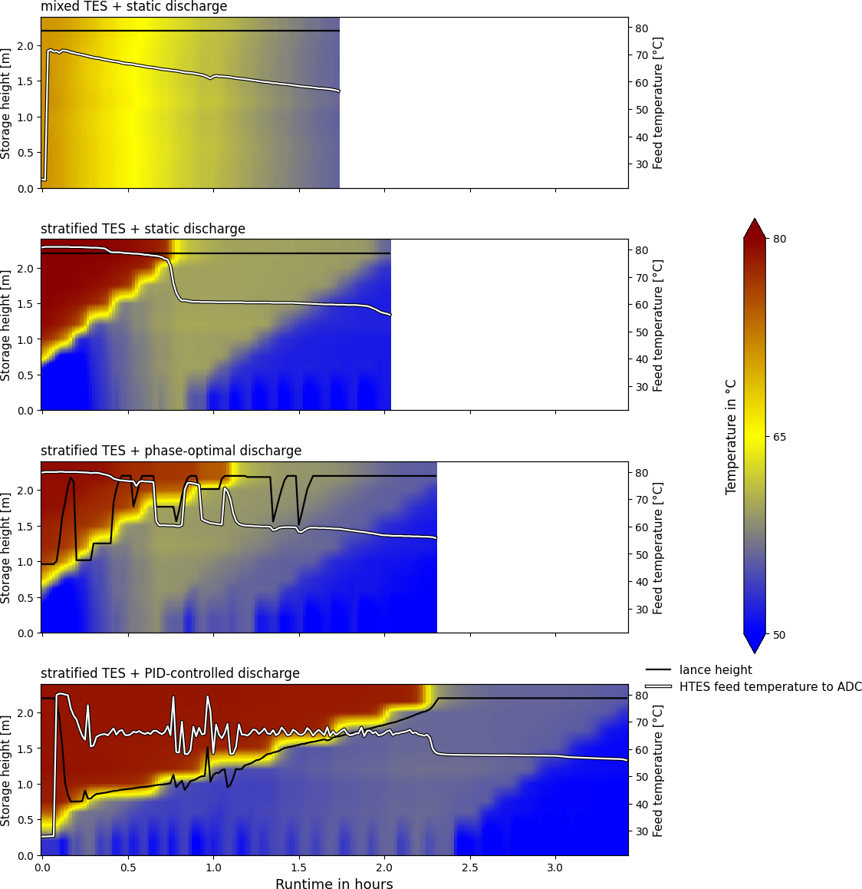
Fig. 3: Thermal stratification of the HTES during the four static discharge tests (colour scale, 9 sensors bottom to top), with the lance position, or fixed extraction height, overlaid as a solid black line, and the HTES feed temperature to the ADC overlaid as a white line (right axis)
Fig. 4 shows the energy balance of the four static discharge test modes for identical initial conditions of the HTES. Although the boundary conditions are the same, the amount of heat that can be extracted from the HTES until the cutoff temperature of 55 °C is reached varies significantly. Compared to the mixed TES, the stratified TES increases the utilizable heat by 10 %, the phase-optimal lance control by 22 %, and the PID setpoint-strategy by 49 %; the latter is also driven by its considerably longer discharge cycle (206 min, compared to 105–139 min for the other three modes). This superior performance results from the lance's ability to continuously discharge fluid at the precise temperature level required by the process: by dynamically adjusting its vertical position, the lance prevents turbulent mixing and maintains a sharp thermocline, maximizing the utilization of the storage capacity. As a consequence, 38 % more cooling energy is generated with the stratified storage, 43 % with the phase-optimal lance, and 105 % with the PID setpoint-strategy, compared to the mixed TES.
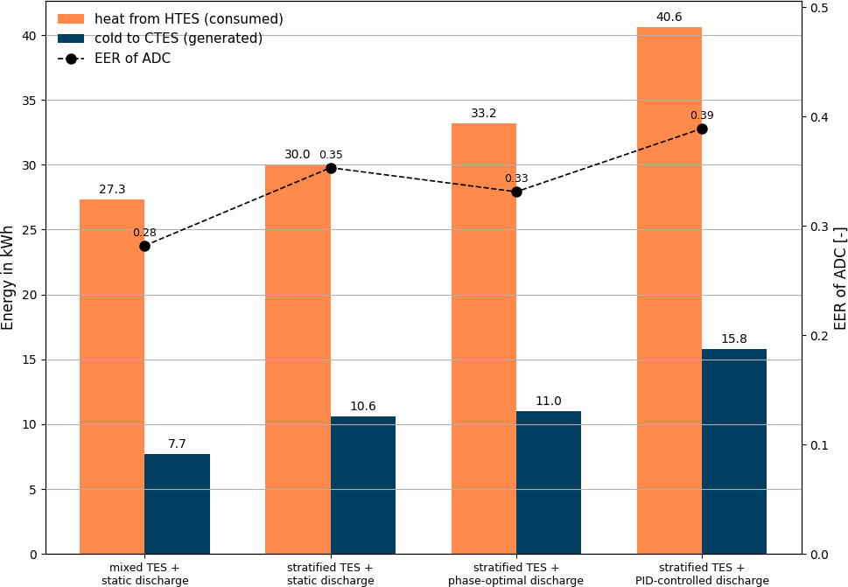
Fig. 4: Energy balance of the four static discharge test modes: heating energy consumed from the HTES and cooling energy produced in the CTES per discharge cycle, with the resulting EER of the ADC (right axis)
3.2 Dynamic 24h test campaign
Tab. 3 summarizes the key ADC and thermal energy storage performance indicators for the four dynamic 24h tests completed to date: a mixed HTES, a stratified HTES with fixed discharge, a stratified HTES with the PID setpoint-strategy, and a stratified HTES with the phase-optimal strategy.
Tab. 3: Comparison of adsorption chiller and storage performance metrics across the four dynamic 24h tests
Metric | Unit | Mixed TES | Stratified TES | Stratified TES +  PID setpoint-strategy | Stratified TES +  phase-optimal strategy
ADC operating time | h | 19.6 | 20.7 | 23.9 | 18.2
Consumed heating energy in HTES | kWh | 166.6 | 195.1 | 179.7 | 197.0
Energy supplied to HTES (CHP) | kWh | 195.7 | 221.1 | 218.2 | 217.9
Produced cooling energy in CTES | kWh | 57.2 | 71.6 | 61.8 | 77.3
Energy withdrawn from CTES (thermostat) | kWh | 40.2 | 52.3 | 46.7 | 60.1
Mean temperature of HTES over the 24h test | °C | 66.5 | 66.3 | 71.0 | 68.5
Mean HTES feed temperature to the ADC | °C | 70.3 | 71.9 | 67.2 | 71.6
EER of ADC | – | 0.34 | 0.37 | 0.34 | 0.39
Mean MIX number (HTES) | – | 0.355 | 0.262 | 0.034 | 0.181
Tab. 3 shows that the ADC operating time ranges from 18.2 h (phase-optimal strategy) to 23.9 h (PID setpoint-strategy) across the four dynamic tests. The heating energy consumed from the HTES ranges from 166.6 kWh (mixed TES) to 197.0 kWh (phase-optimal strategy), and the cooling energy produced in the CTES ranges from 57.2 kWh (mixed TES) to 77.3 kWh (phase-optimal strategy), resulting in EER values between 0.34 (mixed TES and PID setpoint-strategy) and 0.39 (phase-optimal strategy). The mean MIX number is lowest for the PID setpoint-strategy (0.034) and highest for the mixed TES (0.355), with the stratified TES (0.262) and the phase-optimal strategy (0.181) in between.
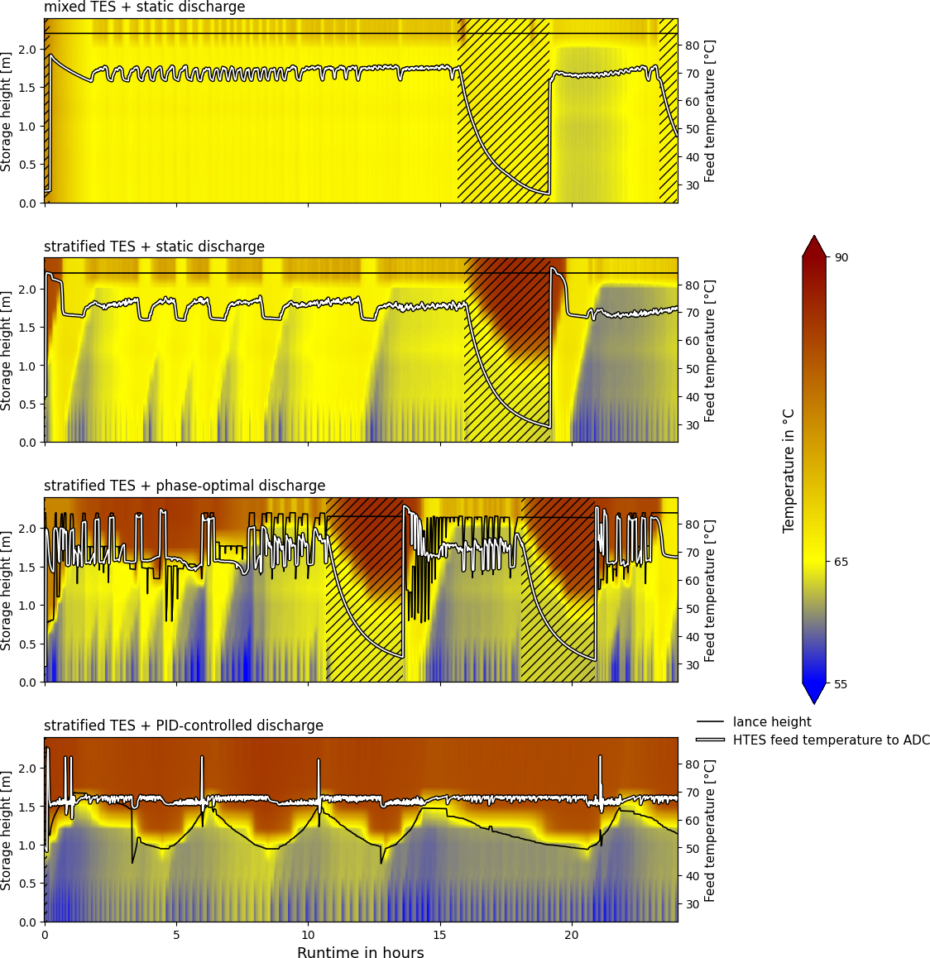
Fig. 5: Thermal stratification of the HTES over the course of the four dynamic 24h tests (colour scale, 9 sensors bottom to top), with the lance position, or fixed extraction height, overlaid as a solid black line, and the HTES feed temperature to the ADC overlaid as a white line (right axis); hatched areas indicate periods when the ADC is off
Fig. 5 shows the thermal stratification profile of the HTES over the full 24 h duration of each dynamic test, based on the nine HTES temperature sensors (bottom to top), together with the lance position, or the fixed extraction height, overlaid as a solid line; hatched areas mark the ADC downtime windows observed during three of the four tests. The mixed TES shows a largely uniform temperature distribution throughout the test, whereas the stratified TES and the two lance-controlled tests show a cold zone at the bottom of the storage that grows and shrinks with each charge/discharge cycle over the 24 h period.
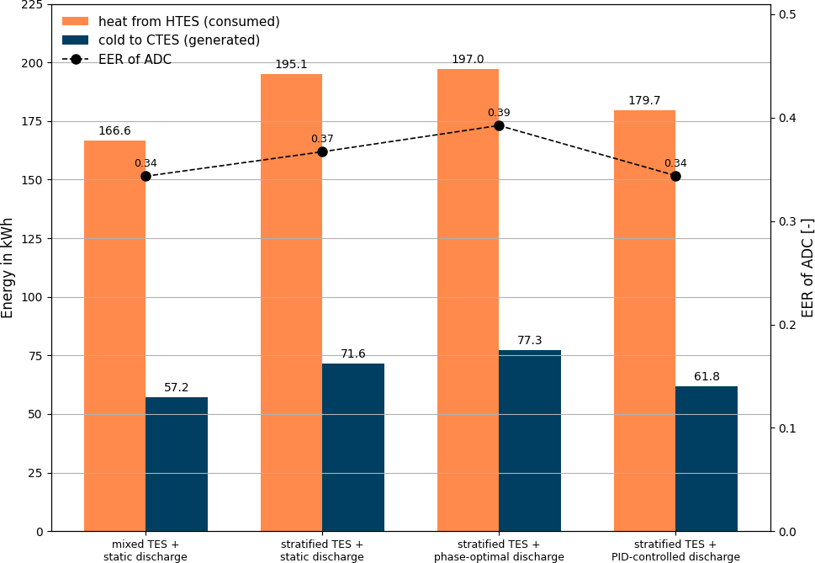
Fig. 6: Energy balance of the four dynamic 24h tests: heating energy consumed from the HTES and cooling energy produced in the CTES, together with the resulting EER of the ADC (right axis)
Fig. 6 shows, for each of the four dynamic tests, the heating energy consumed from the HTES and the cooling energy produced in the CTES as bars, together with the resulting EER of the ADC as a line on the secondary axis. The mixed TES shows the lowest values for both heating energy (166.6 kWh) and cooling energy (57.2 kWh), while the phase-optimal strategy shows the highest values for both (197.0 kWh and 77.3 kWh, respectively); the stratified TES and the PID setpoint-strategy fall in between, at 195.1 kWh / 71.6 kWh and 179.7 kWh / 61.8 kWh, respectively.
3.3 Exergetic analysis of the dynamic 24h tests
While Section 3.2 evaluates the four dynamic 24h tests on a purely energetic basis, energy quantities alone do not reflect that heat at different temperature levels carries different thermodynamic potential. To assess how effectively each strategy converts this potential into useful cooling, the dynamic tests are additionally evaluated using three exergy-based KPIs, referenced to an assumed ambient temperature of T₀ = 20 °C.
The exergetic COP of the ADC, COP_{ex}, compares the exergy gained by the cold stream to the exergy given up by the driving-heat stream across the ADC:
$${COP}_{ex} = \frac{{Ex}_{cool}}{{Ex}_{heat}}$$ | (eq.2)
where Ex_{cool} is the exergy gained by the cold (LT) stream and Ex_{heat} is the exergy given up by the driving-heat (HT) stream, both integrated over each test’s ADC operating time.
The exergy utilization ratio of the HTES, η_{ex,HTES}, compares the exergy delivered from the HTES to the ADC to the exergy charged to the HTES by the CHP, computed layer-wise across the nine HTES sensors to correctly capture the additional exergy content of a stratified store:
$$η_{ex,HTES} = \frac{{Ex}_{ADC}}{{Ex}_{CHP}}$$ | (eq.3)
where Ex_{ADC} is the exergy delivered to the ADC and Ex_{CHP} is the exergy charged to the HTES by the CHP.
The overall system efficiency, η_{system}, is an energy-based (not exergy-based) well-to-cold indicator, evaluated as the useful cooling delivered to the load divided by an estimated primary fuel energy input, based on the CHP’s documented nominal gas consumption of 2.4 m³/h during its runtime:
$$η_{system} = \frac{Q_{cold,load}}{E_{fuel}}$$ | (eq.4)
where Q_{cold,load} is the useful cooling energy delivered to the load and E_{fuel} is the estimated primary fuel energy input.
Tab. 4: Exergy-based performance indicators of the ADC and the HTES for the four dynamic 24h tests, together with the overall (energy-based) system efficiency
Metric | Unit | Mixed TES | Stratified TES | Stratified TES +  PID setpoint-strategy | Stratified TES +  phase-optimal strategy
Exergetic COP of ADC | - | 0.026 | 0.039 | 0.027 | 0.045
Exergy utilization ratio of HTES | - | 0.710 | 0.758 | 0.687 | 0.796
Overall system efficiency (well-to-cold) | - | 0.115 | 0.130 | 0.119 | 0.143
Tab. 4 shows that the phase-optimal strategy achieves the highest value in all three indicators (COP_{ex} = 0.045, η_{ex,HTES} = 0.796, η_{system} = 0.143), ahead of the stratified TES with fixed discharge. The PID setpoint-strategy performs only marginally better than the mixed TES baseline on the exergetic COP and the overall system efficiency, and even falls slightly behind it on the HTES exergy utilization ratio.
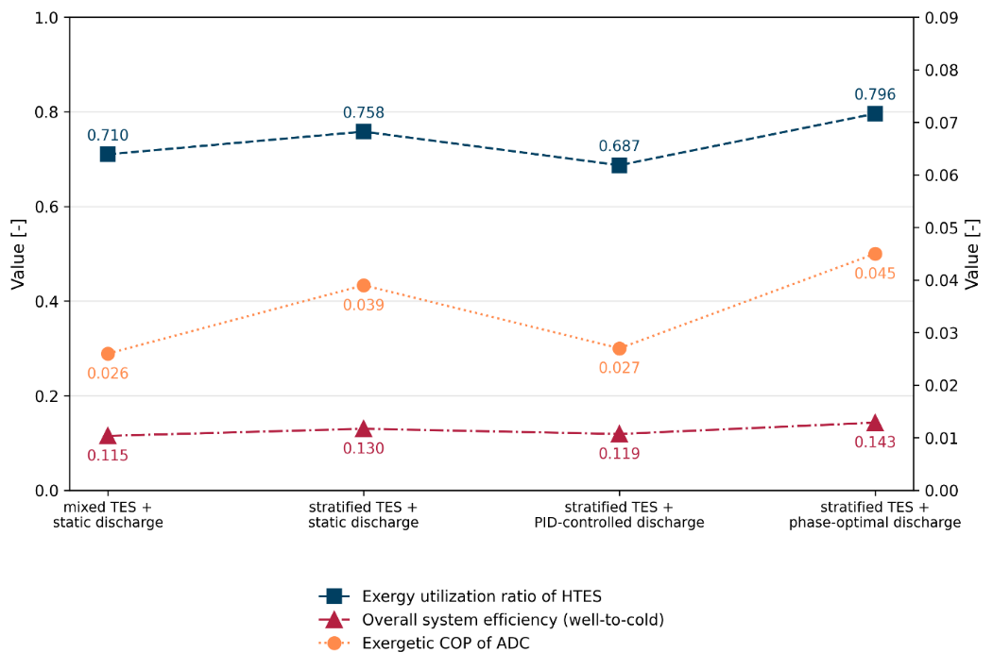
Fig. 7: Exergy utilization ratio of the HTES and overall system efficiency (well-to-cold) on the primary axis, and exergetic COP of the ADC on the secondary axis, for the four dynamic 24h tests
Fig. 7 shows a notable contrast to the stratification-quality result in Section 3.2, where the PID setpoint-strategy showed the better stratification preservation of the two lance-controlled strategies (lower MIX number). Preserving stratification and converting the stored thermal potential into useful cooling exergy therefore do not appear to be the same thing: the phase-optimal strategy’s ability to draw from higher storage layers over the discharge cycle appears to outweigh its comparatively weaker stratification-preservation performance when it comes to the thermodynamic quality of the energy conversion chain as a whole.

- Conclusion
This study set out to examine how the two lance control strategies affect system performance under static and realistic dynamic operating conditions, and whether the underlying principle of an actuated stratifier lance can be transferred to other thermally driven energy systems. The following synthesizes the static (Section 3.1), dynamic (Section 3.2) and exergetic (Section 3.3) results from both test campaigns to address these questions.
Across both test campaigns, the two lance-controlled strategies distinguish themselves along different performance axes rather than one strategy leading uniformly. In the dynamic 24h tests, the PID setpoint-strategy preserves thermal stratification in the HTES markedly better than the phase-optimal strategy, reflected in a mean MIX number of 0.034 compared to 0.181 (Tab. 3). The phase-optimal strategy, in turn, delivers more cooling energy (77.3 kWh vs. 61.8 kWh) at a higher EER (0.39 vs. 0.34) within a shorter ADC operating time (18.2 h vs. 23.9 h). The exergetic analysis in Section 3.3 extends this comparison to the thermodynamic quality of the energy conversion chain: here, the phase-optimal strategy achieves the higher value on all three exergy-based indicators considered, with an exergetic COP of the ADC of 0.045 vs. 0.027, an exergy utilization ratio of the HTES of 0.796 vs. 0.687, and an overall well-to-cold system efficiency of 0.143 vs. 0.119 for the PID setpoint-strategy.
At first glance, the better-preserved stratification achieved by the PID setpoint-strategy might be expected to also yield the better energetic and exergetic outcome, since an intact temperature profile keeps hotter water available to the ADC for longer. Section 3.3 already noted that this is not the case. The underlying mechanism, visible in the operating-time and cooling-power figures in Tab. 3, follows from the difference in extraction logic described in Section 3.1: the PID setpoint-strategy “surfs” a fixed, comparatively narrow temperature layer, which preserves the shape of the stratification but limits how much of the storage’s usable thermal capacity is drawn on per test. This is reflected in its long operating time of 23.9 h at a low mean cooling power of 2.6 kW. The phase-optimal strategy instead moves the extraction point upward through the full usable storage volume above the target temperature over the course of the discharge, disturbing the temperature profile more but accessing a larger share of the stored thermal energy within a shorter operating time of 18.2 h at a markedly higher mean cooling power of 4.2 kW. Preserving stratification and extracting the largest possible share of the stored thermal energy are therefore two distinct objectives, each favoring a different one of the two control strategies.
Neither strategy therefore outperforms the other on every criterion considered in this study. On each of the efficiency-type indicators computed (EER, exergetic COP of the ADC, exergy utilization ratio of the HTES, and well-to-cold system efficiency) the phase-optimal strategy matches or exceeds the PID setpoint-strategy. The PID setpoint-strategy’s distinguishing strength is the stratification quality it maintains in the HTES, a property not captured by any of these energy- or exergy-based indicators but that carries its own practical value, discussed below.
Overall, the choice between the two control strategies should be guided by the intended use of the extracted heat rather than by a single efficiency ranking. The PID setpoint-strategy’s ability to hold a stable extraction temperature while preserving stratification appears particularly well suited to applications with a temporally constant target temperature, such as the extraction of domestic hot water from a thermal storage tank. The phase-optimal strategy, by contrast, was developed and optimized specifically for the phase-dependent operating logic of an ADC and is not intended to generalize directly to loads without an equivalent notion of “phase”. More broadly, the underlying principle of adapting the extraction height to the current process demand is not inherently tied to ADC-driven cooling and could in principle be applied to other thermally driven energy systems relying on stratified storage, such as solar thermal systems or other sorption-based processes. Confirming this would require dedicated future work. Beyond controlling the discharge, a similar lance-based approach could also be applied to the charging process, guiding where hot water is injected into the HTES in order to preserve or actively shape its stratification rather than only extracting from it in a stratification-preserving way. Finally, a combination of both discharge strategies could exploit the strengths of each: a phase-optimal extraction that follows a temperature profile, adjusting its setpoint temperature depending on the current phase of the ADC cycle.
Several boundary conditions of this study limit the extent to which the above findings can be generalized. The well-to-cold system efficiency relies on an approximation of the primary fuel energy input based on the CHP’s nominal gas consumption rather than a direct flow measurement (Section 2.4), and the exergy-based indicators are sensitive to the assumed reference temperature. The initial states of charge of the HTES and CTES could only be reproduced approximately between tests, even though they were kept comparably close. Ambient temperature, which was not controlled, is known to affect ADC performance and therefore introduces additional variability between tests conducted on different days. Finally, the on/off logic governing the CHP and the ADC resulted in markedly different ADC operating times across the four dynamic tests (18.2 h to 23.9 h, Tab. 3), which should be kept in mind when comparing absolute energy quantities between strategies.
Future work could extend the dynamic testing to longer, multi-day or seasonal operating periods to assess whether the trends observed here persist under more variable ambient and load conditions; explore model-based or optimized control approaches beyond the two strategies compared here; and investigate the transfer of the actuated stratifier lance concept to other thermally driven systems and storage types.
- References
Abdur Rehman, O., Palomba, V., Frazzica, A., Cabeza, L.F., 2021. Enabling Technologies for Sector Coupling: A Review on the Role of Heat Pumps and Thermal Energy Storage. Energies 14(24), 8195.
Andersen, E., Furbo, S., Chen, Z., 2011. Thermal stratification in hot water storage tanks with fabric stratification inlet pipes. Proceedings of ISES Solar World Congress 2011, Kassel, Germany.
Gütle, V., Haberl, R., Haller, M., 2025. Domestic Hot Water Preparation With Heat Pumps in MFH: Single-Pass vs. Multi-Pass Charging. Solarthermie-Symposium Proceedings 2. https://doi.org/10.52825/st-symposium.v2i.2758
Sifnaios, I., Fan, J., Olsen, L., Madsen, C., Furbo, S., 2019. Optimization of the coefficient of performance of a heat pump with an integrated storage tank – A computational fluid dynamics study. Applied Thermal Engineering 160, 114014.
Wittstadt, U., 2018. Experimentelle und modellgestützte Charakterisierung von Adsorptionswärmeübertragern. Ph.D. thesis, Technische Universität Berlin. https://doi.org/10.14279/depositonce-7354

