The influence of core materials upon the selected strength properties of a sandwich composite

Robert Szczepaniak¹, Tomasz Cioć², Andrzej Komorek³, Piotr Kasprzak⁴, Paweł Przybyłek⁵, Aneta Krzyżak⁶

¹Faculty of Aviation, Polish Air Force Academy, 08-521 Dęblin, Dywizjonu 303 Street No. 35
Email: r.szczepaniak@wsosp.pl
²Faculty of Aviation, Polish Air Force Academy, 08-521 Dęblin, Dywizjonu 303 Street No. 35
Email: tomaszcioc@gmail.com
³Faculty of Aviation, Polish Air Force Academy, 08-521 Dęblin, Dywizjonu 303 Street No. 35
Email: a.komorek@wsosp.pl
⁴Faculty of Aviation, Polish Air Force Academy, 08-521 Dęblin, Dywizjonu 303 Street No. 35
Email: p.kasprzak2815@wsosp.edu.pl
⁵Faculty of Aviation, Polish Air Force Academy, 08-521 Dęblin, Dywizjonu 303 Street No. 35
Email: p.przybylek@wsosp.pl
⁶Faculty of Aviation, Polish Air Force Academy, 08-521 Dęblin, Dywizjonu 303 Street No. 35
Email: a.krzyzak@wsosp.pl

Keywords: sandwich-type composite, herex core, strength properties

Abstract
The paper presents findings of selected strength tests of sandwich-type composite materials with herex filling - expanded poly(vinyl chloride), and honeycomb. For the sake of the investigation, three sets of composite sandwich-type samples, of different densities, were prepared. Herex is characterized by high resistance to vibration, impact and tear, at the same time possessing a very low specific weight. The investigations aimed at proving how different density herex fabric core affects the strength properties of composite materials, containing it. The investigation covered a static tensile test and an impact strength test performed by means of the Charpy method. The article discusses the composition of composite materials, their manufacture process and the preparation manner of preparing the samples, in compliance with the norm for strength testing. The article describes the course of the measurements. The findings have been depicted in tables, and the research findings are depicted in the illustrations. As a result of the conducted investigations, it was found that the density of the herex-type layer affects the strength of the composite material with a core of this type. The impact is not the same for all the examined parameters.

1. Introduction

Sandwich-type composites are usually made with two types of materials. The outer layers carry the load and determine the strength. They are made of materials with good mechanical properties [1, 2]. The inner layer, called the core, is made of a material of lesser strength, stiffness and density in relation to the outer layers [3]. The middle layer separates the two covers (mostly in thin-walled structures) in order to increase the stiffness of the entire structure with a slight increase in weight.
The outer layers are commonly plates composed of polymer matrix composites, with glass, aramid or carbon reinforcement [4]. The core is generally composed of homogeneous materials (e.g. balsa), mesh (e.g. plastic honeycomb structure) and heterogeneous materials (e.g. PVC foams, polyurethane foams) [5]. The structures made up of core materials are characterized by much greater flexural strength in relation to materials made only with a solid material. The stresses caused by the bending moment are smaller in sandwich-type structures. The longitudinal forces and the bending moments are transferred through an outer material, whereas the shear forces - through the core of the material [6].
The disadvantage of sandwich structures is the fact that they are more exposed to mechanical damage. There are the following forms of mechanical damage, characteristic of this type of structures [6]:
- global buckling of the structure,
- delamination,
- core shear,
- local buckling of a single cell (in the case of honeycomb-type core).
Due to a favourable weight ratio of the selected strength parameters, the core materials are used, among others, in the production of: roofing, building walls, sports equipment (skis, surfboards - high buoyant force and stiffness), boat hulls, sports canoes and above all in the airline industry as a building material for fuselages, beams, wing ribs, stabilizers and in the production of unmanned aerial vehicles [7].
For the investigations evaluating the selected strength properties of sandwich composites, the author selected a static tensile test, which is one of the basic methods of examining strength and measurement of impact strength by Charpy method.

2. Tested materials

For testing, the authors prepared three control “sandwich-type" laminate boards of different herex material density, which constituted the core of the composite. The external layer of each composite consisted of one layer of a carbon fabric 160 in weight and one layer of glass fabric 250 in weight, while the core was herex foam of the following densities: 55 kg/m³, 75 kg/m³ and 90 kg/m³ (Fig. 1). The matrix of the examined composites was epoxy resin LH385, with the hardener HG385.

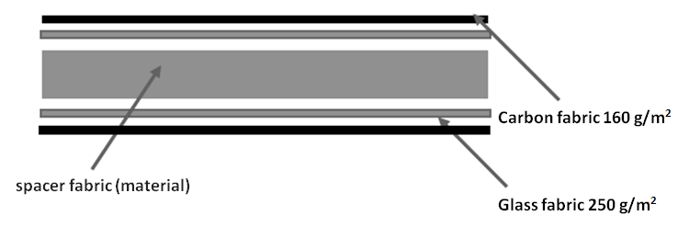

Figure 1. Structure of the sandwich composite used in research

The composite sheets were prepared by the contact method of manual lamination, using compression on both sides with glass plates at standard pressure. The fabrics in the layers were laid out with fibres parallel to one another. 24 hours after the completion of laminating, the prepared composites were separated from the glass surfaces. They were later cut down into samples in accordance with the ISO 527-1:2012 [7] standard for a static tensile test and the standard ISO 179-1:2010 [8] for the investigation of impact strength.

3. Experimental studies and discussion of the results

3.1. Static tensile test

The static tensile test allows determining strength properties and material properties. The tests were conducted on the ZWICK ROELL Z100 test machine.
The anisotropy of the material makes it necessary to determine the direction of the performed test. The samples were cut down in such a way that the stretching was made along the direction of the reinforcement fibers.
After the evaluation of the technical condition of the cut specimens, 29 samples made up of the herex material, 55 kg/m³ in density, 30 samples with the herex material, 75 kg/m³ in density, and also 26 samples made up of the herex core material, 90 kg/m³ in density, were selected for the testing.

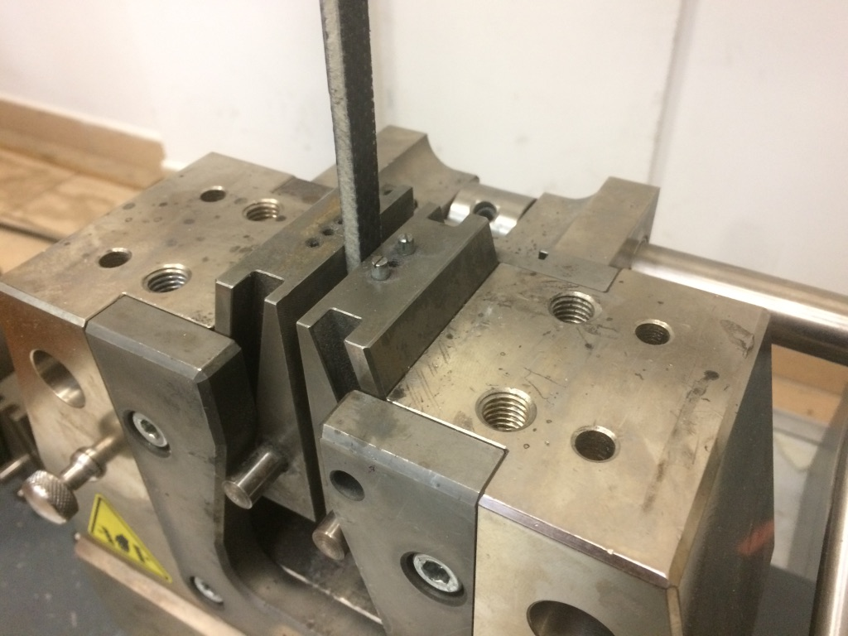

Figure 2. The sample was fixed in the hands of the machine Zwick Roell Z100.

The graphs of samples stretching, where the core was composed of different density herex foam, are shown in Figures 3, 4, 5.

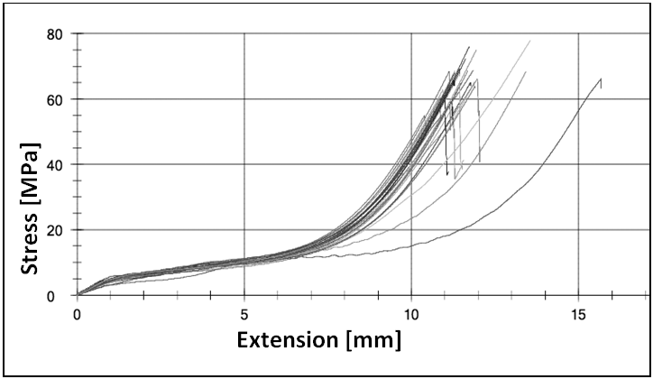

Figure 3. Line graph of composites stretching with the herex core, with a density of 55 kg/m³.

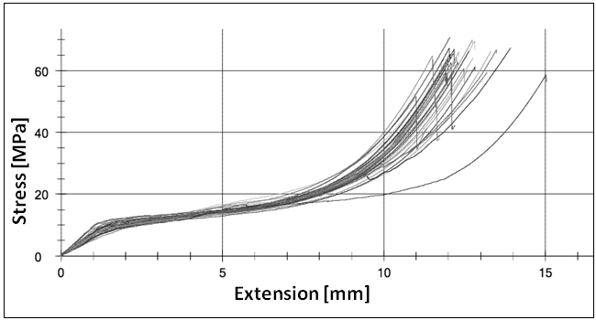

Figure 4. Line graph of composites stretching with herex core, with a density of 75kg/m³.

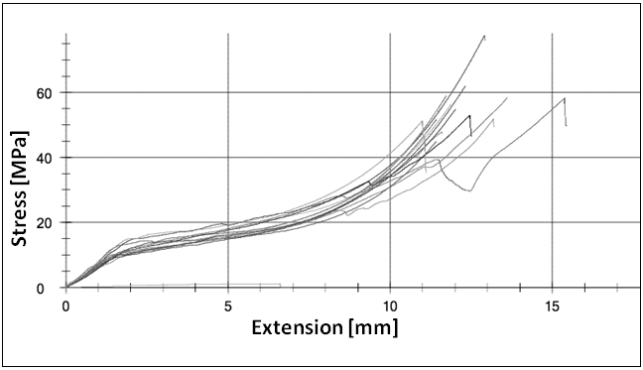

Figure 5. Line graph of composites stretching with herex core, with a density of 90 kg/m³.

Based on the graphs illustrating tensile tests, it is possible to conclude that the course of trials was similar, which may point to the proper homogeneous structure of the prepared samples. Furthermore, one may observe that despite a different density of the core material, the nature of the course, for all samples, is similar and the differences in the values are tiny, especially at elongation, which is caused both by the sample elongation and the values of elongation obtained during the crushing of the sample in the test machine hand.
Having conducted the examination of the selected samples, the author performed statistical calculations in the Statistica software.
Figure 6 shows the average values of the Young’s modulus, obtained as a result of the tensile test. These results may only be considered as the quality ones, taking into account the trend in changes of the modulus of elasticity (the E modulus rises along with an increase in the density of the core). However, in this configuration it is not possible to analyze detailed values.

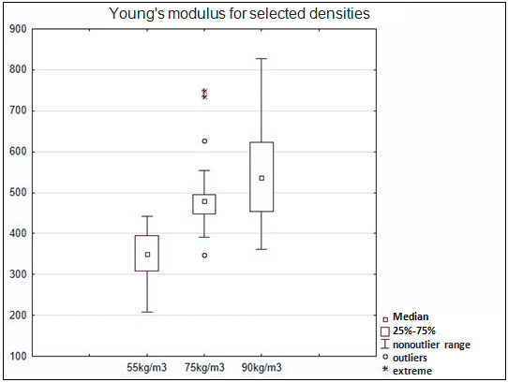

Figure 6. Young's modulus of the examined materials at different densities of the core herex material.

The analysis of the chart shown in Figure 6 points to a very large dispersion of results. Therefore, the possibility of comparing them becomes debatable.

Table 1. The findings of the Young’s modulus values for different densities of the herex fabric.

variable | N valid | average | median | minimum | maxim | variance | stand. deviation
55kg/m³ | 29 | 350.44 | 350 | 209 | 443 | 3591.9 | 59.93
75kg/m³ | 33 | 489.73 | 480 | 347 | 749 | 6999.95 | 83.67
90kg/m³ | 26 | 566.31 | 536 | 361 | 828 | 16733 | 129.36

The obtained results of the tensile strength are illustrated in a box plot (Fig. 7) and a table (Table 2). The analysis of the graph leads to a conclusion that the average value of the fracture strain, for each of the samples, decreases almost linearly while increasing the density of the core material.

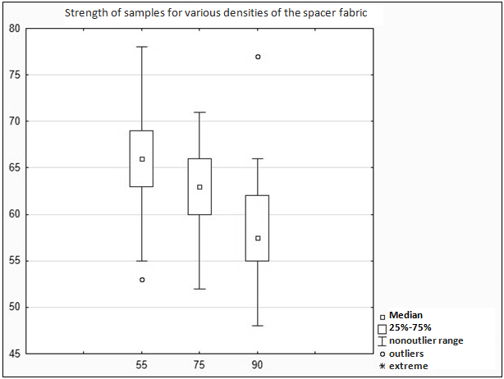

Figure 7. The strength of the composite to stretching for different densities of the herex fabric

Table 2. Findings of tensile strength of composites for different densities of the herex fabric.

variable | N valid | average | median | minimum | maxim | variance | stand. deviation
55kg/m³ | 29 | 65.59 | 66 | 53 | 78 | 34.18 | 5.85
75kg/m³ | 33 | 63.15 | 63 | 52 | 71 | 17.57 | 4.19
90kg/m³ | 26 | 58.46 | 57.5 | 48 | 77 | 36.81 | 6.07

3.1. Impact strength test

The examination of impact strength is a test, which allows determining the ability of a material to carry dynamic loads. The test consists in breaking the sample supported at both ends by the dropping hammer. It was performed on a total of 90 samples sized 10x80mm. Each of the 30 samples was made with a different density of the core herex material. The investigation was made in accordance with the standard ISO 179-1. The determination of impact strength by means of Charpy method was performed on the pendulum hammer Galdabini Impact 25. The temperature in the laboratory during the test equalled 20°C. The load was applied to the surface of the samples (Fig. 8).

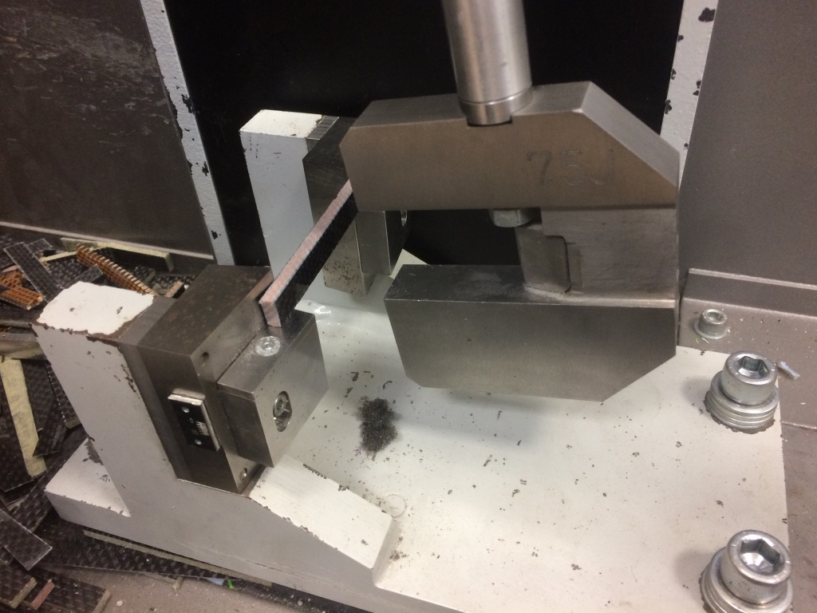

Figure 8. View of the laboratory stand for the determination of impact strength.

The results of impact strength were subjected to a statistical analysis and presented in the form of a graph (Fig. 9) and a table (Table 3).
The software integrated with the test machine allows determining the impact strength, after entering the initial dimensions of the cross-section of the sample. The results were subjected to a statistical analysis and presented in the form of a graph.
The analysis of the graph demonstrates that the density of the core material considerably affects the resistance of the material to cracking under dynamic load. The outliers observed during the tests of the material with a herex of 55 kg/m³ and 90 kg/m³, as well as a wide range of nonoutliers at the density of 90 kg/m³ are due to the shortcomings in the technology of contact manufacturing of composites, using external pressure.

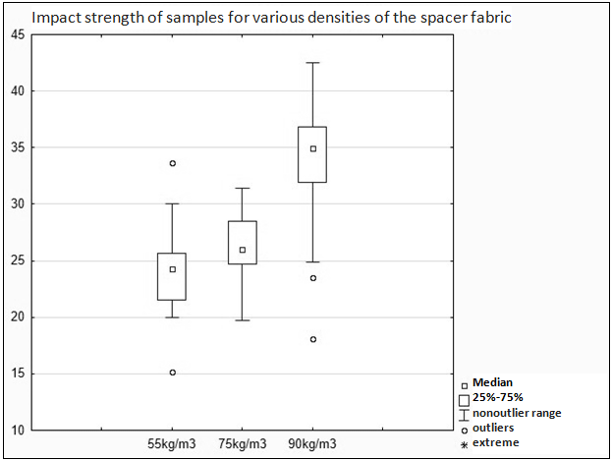

Figure 9. Impact strength of examined composites for different density of the herex material.

Table 3. Impact strength values of examined composites for a different density of the core fabric.

variable | N valid | average | median | minimum | maxim | variance | stand. deviation
55kg/m³ | 30 | 24.19 | 24.3 | 15.15 | 33.69 | 11.83 | 3.44
75kg/m³ | 30 | 26.38 | 25.97 | 19.7 | 31.44 | 7.31 | 2.7
90kg/m³ | 30 | 34.04 | 34.93 | 18.08 | 42.52 | 25.92 | 5.09

4. Conclusions

The conducted investigations have shown that the density of the herex core fabric has a significant impact on strength properties determined during a static tensile test and also on researching impact strength by means of Charpy method. A detailed analysis of each of the examined parameters allows drawing a conclusion that the values of almost all parameters change with the use of the core fabric of higher density. It was demonstrated that the density of the core fabric affects such parameters as: Young’s modulus, tensile strength and fracture strain. The authors observed a significant increase in impact strength of the composite with herex fabric of 90 kg/m³ in density. Young's modulus of the examined materials increases with a rise in density of the exploited core fabric. On the other hand, tensile strength of the examined composites decreases along with a rise in the density of the core. The wide interquartile range of the analyzed parameters is due to the imperfections of the manufacture technology of the samples by contact lamination, without the possibility of a precise impregnation of carbon fibers and glass fibers with epoxy resin. Smaller discrepancies may be caused by a nonideal sample distribution, with fibers parallel to the vector of the tensile force, which in the case of an anisotropic material such as glass fabrics exerts an impact on the obtained findings of the investigation. It is expected that the manufacture of samples with the technology of resin film infusion might ensure regular and accurate impregnation of the matrix reinforcement in a composite. It needs to be noted that the conducted investigations aimed at testing the samples which were made in a significantly cheaper technology, which is widely available, without the need of specialised equipment.

References

[1] Dyląg Z., Jakubowicz A., Orłoś Z. Wytrzymałość Materiałów, Wydawnictwa Naukowo-Techniczne, Warszawa 2003.
[2] Falkowski J. Wytrzymałość Materiałów, Wydawnictwo Uczelniane Politechniki Koszalińskiej, Koszalin 2014.
[3] Meunier M., Shenoi R. A. Forced response of FPR sandwich panels with viscoelastic materials. Journal of Sound and Vibration, Volume 263(1):131-151, 2003.
[3] Surowska B. Functional and hybrid materials in air transport. Eksploatacja i Niezawodność, 3:30-40, 2008.
[4] Romanów F. Wytrzymałość konstrukcji warstwowych, Wydawnictwo Wyższej Szkoły Inżynierskiej w Zielonej Górze, 1995.
[5] Muc A., Nogowczyk R. Formy zniszczenia konstrukcji sandwiczowych z okładzinami wykonanymi z kompozytów, Kompozyty, 4:31–35, 2005.
[6] Mieloszyk J., Tarnowski A. Mass, time and cost reduction in MAV manufacturing. Prace Instytutu Lotnictwa, 1(238):22-34, 2015.

[7] Standard ISO 527-1:2012, Plastics - Determination of tensile properties - Part 1: General principles, 2012.
[8] Standard ISO 179-1:2010, Plastics - Determination of Charpy impact properties - Part 1: Non-instrumented impact test, 2010.

