ASSESSMENT OF EXISTING LS-DYNA MATERIAL MODELS FOR REPRODUCTION OF EXPERIMENTAL QUASI-STATIC RESPONSE OF CYCOM 977-2 MATERIAL: EXPERIMENTS AND SIMULATION

Efthimios Giannaros, Athanasios Kotzakolios, George Sotiriadis, Vassilis Kostopoulos*

Applied Mechanics & Vibrations Laboratory, Department of Mechanical Engineering and Aeronautics, University of Patras, Patras University Campus, GR-26500, Greece
*kostopoulos@mech.upatras.gr

Keywords: Quasi-static loading, material characterization tests, composite material, numerical analysis

Abstract
The present study investigates the numerical reproduction of quasi-static response of CYCOM 977-2 composite material. The aim is to assess the applicability and to find-out the limitations of existing orthotropic materials models of commercial code LS-DYNA for the prediction of CYCOM 977-2 composite material behavior in different quasi-static loadings. The basic material characterization tests (Tensile and Compressive test in both fiber and matrix direction, In-plane shear test and delamination tests in Mode I and Mode II) are experimentally executed and numerically simulated. For the determination of material model's parameters, the numerical force-stain curves were correlated to experimental ones. Finally, the points of convergence and divergence of numerical and experimental results are remarked.

1. Introduction

The constant requirement of the aerospace industry to enhance the structural efficiency for reasons of weight reduction, aircraft fuel efficiency and NOx/CO₂ emissions reduction is driving to the usage of high performance composite materials. Composite materials, due to their high specific stiffness and strength, are attractive to aviation applications. Nevertheless, the vulnerability of composite structures to sudden, localized and dynamic loads may result unpredictable complex damage, which can significantly degrade their post-impact residual strength. For the aforementioned reason and the continuing effort to save the cost of experimental campaigns and certification, advanced reliable simulation techniques are sought. Although, a large number of published papers are available on numerical simulation of composite materials to impact loading, the modeling of composite material behavior to quasi-static loading capturing its complex damage mechanisms is first priority target and it constitutes the base for further investigation to high-strain rate loading.

The current work is focused on the numerical reproduction of quasi-static behavior of CYCOM 977-2 [1] commercial carbon fiber reinforced polymer material (CFRP) suitable for aerospace applications, under different loadings. Firstly, the basic material characterization tests, tension and compression in fiber direction, tension and compression in matrix direction, in-plane shear test as well as fracture tests in Mode I and Mode II were executed according to the corresponding standard procedure. Secondly, ply-based finite element model was created for each experimental case using orthotropic material model for lamina behavior modeling and cohesive zone method (CZM) for prediction of interlaminar failure. Mesh sensitivity analysis and correlation of numerical results to experimental ones was carried-out for the verification of numerical model.

2. Material

For the purposes of present work, Cytec's CYCOM 977-2-34-24KIMS-194 material [1] was examined. It is a toughened epoxy unidirectional prepreg, widely used in various applications including aircraft primary and secondary structures. Five plates of various thicknesses and laminations were manufactured. Regarding to manufacturing procedure, the manipulation and cutting of prepregs and other consumables, as well as the lamination procedure, were carried-out in a controlled environment of 21ºC and 70% relative humidity (R.H). Every eight plies, a 15min of de-bulking & de-airing cycle was realized. At the final ply, final vacuum bagging arrangement was completed and the tool was placed in the Autoclave. The curing profile that was followed for all plates was involving 2ºC/min heating rate, 3 hours at 177ºC, and 3ºC/min cooling rate. Pressure was set to 6 bars throughout the curing, until the system reached at 60ºC, where decompression was realized.

3. Experiments

The basic material characterizations tests of CYCOM 977-2 composite material were performed using two servo-hydraulic testing machines, INSTRON 8872 and 8802, having load capacities ±25 kN and ±250 kN respectively. More specifically, plain tensile tests were performed in both 0º and 90º of unidirectional laminates, according to ASTM D3039 standard [2]. This test method is suitable for the definition of in-plane tensile properties of polymer matrix composites. The tensile modulus of elasticity, tensile strength and ultimate strain were calculated. For the measurement of strain, both contact and non-contact extensometers were used in order to maximize the resolution for modulus and strain to failure measurements. For the case of plain compression tests in both directions, the ASTM D3410 standard [3] was adopted. Introducing the compressive force into the specimen through shear at grip interface, four specimens for each direction were tested in order to be defined the compressive modulus, the compressive strength as well as the ultimate strain. Whereas, for the determination of the in-plane shear properties of CYCOM material, a tensile test of a ±45º laminate was performed according to ASTM D3518 standard test method [4]. In order to measure the strain in both the longitudinal and the transverse direction, two independent strain gages were adhered onto each specimen, as per D3518. Shear modulus and maximum shear stress at 5% shear strain were stemmed testing four specimens. The derived intrinsic mechanical properties of CYCOM 977-2 composite are presented in Table 1, whereas all recorded data are plotted in the experimental force-strain curves given below.

G_{IC} and G_{IIC} interlaminar fracture toughness energy were determined by performing Mode I and Mode II tests according to Airbus test methods AITM 1.0005 [5] and 1.0006 [6] respectively. Four double cantilever beam (DCB) specimens with initial dimensions 280(L) x 25.3(W) x 2.81mm(T) were cut from the appropriate plate, and subsequently were marked for crack position identification (initial crack 25mm). In case of Mode II, a total of 4 end-notch flexure (ENF) specimens were also cut from a 16 layer unidirectional CFRP plate. The specimen dimensions were kept constant at 110(L) x 25.2(W) x2.82mm(T) with a initial crack of 35mm and 100mm span length.

Table 1. Mechanical properties of CYCOM 977-2 composite material.

Mechanical Property | Values | Mean value | Units | Standard test
Tensile Modulus 0º | 176.9-182.6 | 180.72 | GPa | ASTM D3039
Tensile Strength 0º | 3011-3325 | 3172.10 | MPa | ASTM D3039
Ultimate strain 0º | 1.59-1.81 | 1.72 | % | ASTM D3039
Tensile Modulus 90º | 8.19-9.67 | 8.68 | GPa | ASTM D3039
Tensile Strength 90º | 60.4-70.8 | 66.47 | MPa | ASTM D3039
Ultimate strain 90º | 0.67-0.86 | 0.78 | % | ASTM D3039
Compressive Modulus 0º | 115.2-130 | 124.5 | GPa | ASTM D3410
Tensile Strength 0º | 850-970.9 | 911.15 | MPa | ASTM D3410
Ultimate strain 0º | 0.68-0.83 | 0.74 | % | ASTM D3410
Compressive Modulus 90º | 8.3-9.1 | 8.73 | GPa | ASTM D3410
Tensile Strength 90º | 164.3-180.7 | 170.27 | MPa | ASTM D3410
Ultimate strain 90º | 2.19-2.42 | 2.26 | % | ASTM D3410
Shear Modulus | 4.32-4.44 | 4.385 | GPa | ASTM D3518
Shear Strength | 77.6-79.4 | 78.55 | MPa | ASTM D3518
Fracture toughness G_{IC} | 317.9-376.1 | 352.5 | J/m² | AITM 1.0005
Fracture toughness G_{IIC} | 569.4-599.5 | 586.7 | J/m² | AITM 1.0006

4. Finite element modeling approach

The finite element modeling of basic material characterization tests was performed utilizing the LS-DYNA implicit code [7]. In general, ply-based methodology using solid elements was adopted for modeling of lamina behavior in cases of in-plane tension, compression and shear tests. Whereas, in case of fracture tests, homogenization approach was implemented for adherents modeling and cohesive zone methodology (CZM) was applied at their interface for modeling of crack initiation and propagation.

4.1. FE models' geometry and meshing

On the occasion of tension test, three different meshing cases with 1, 2 and 5 mm element length and thickness equal to corresponding CPT were studied (Fig.1). In case of compression, the cases of 0.5 and 1mm element length were investigated for convergence reasons (Fig.2).

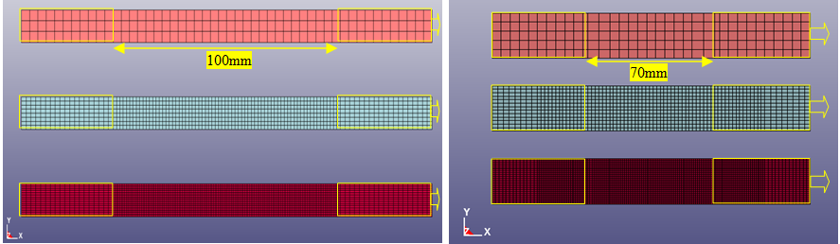

Figure 1. Tensile 0º & 90 º FE models with solid element formulation.

During the simulation of in-plane shear test, 1 and 2mm element size meshing approaches were examined (Fig.3). Whereas, in fracture tests simulation, the analysis started from a element size 0.125mm, which is 3 times smaller than the cohesive zone [8]. It continued with 1mm element length and finished with 2mm. Regarding to boundary conditions of DCB and ENF models, Fig.4 and Fig.5 present the position and the kind of applied restrictions.

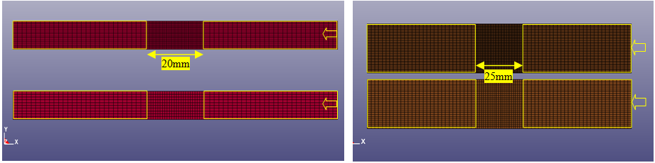

Figure 2. Compression 0º & 90 º FE models with solid element formulation.

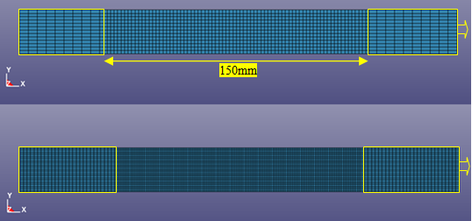

Figure 3. In-plane shear FE model with solid element formulation.

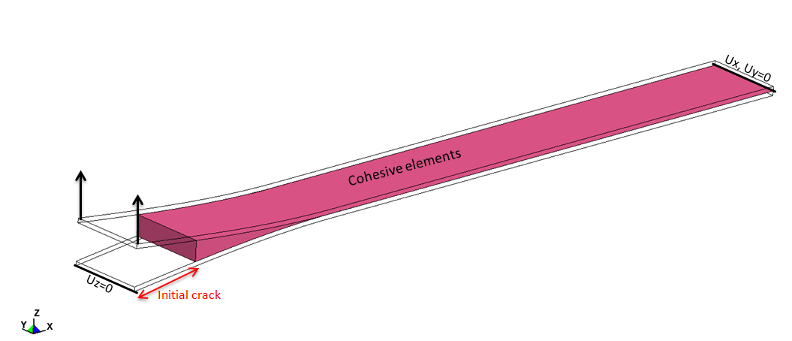

Figure 4. Double cantilever beam (DCB) model.

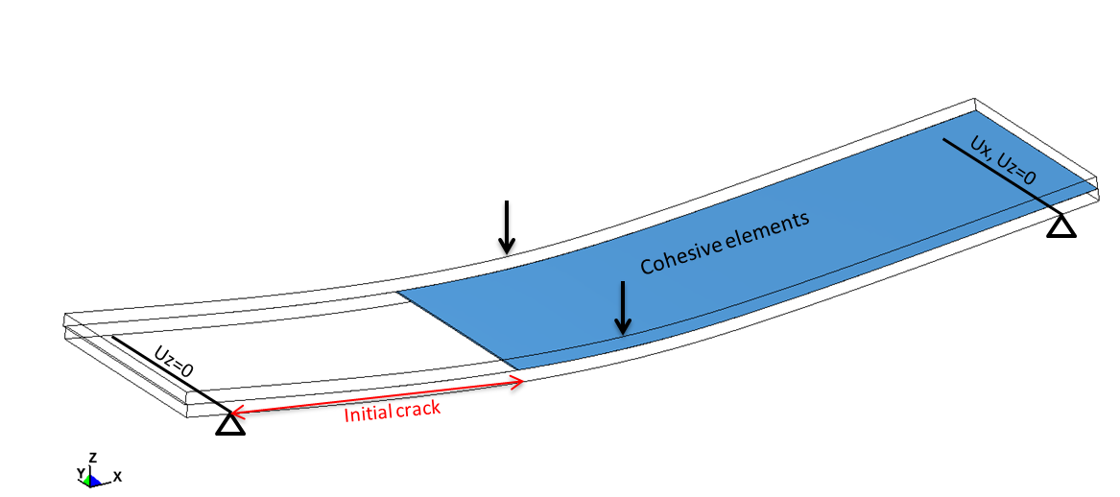

Figure 5. End-notch flexure (ENF) model.

4.2. Material models

The determination of material model as well as the input parameters play important role in the efficiency of model's results. Consequently, an investigation was executed to the available LS-DYNA material models for composites materials and fracture mechanism. According to LS-DYNA manual [7], the laws of interest which include failure criteria, damage effects as well as they are capable of incorporating strain rate effects are the Enhanced_Composite_Damage (called MAT_54-55), the Laminated_Composite_Fabric (MAT_58), the Rate_Sensitive_Composite_Fabric (MAT_158) and the Composite_MSC_DMG (MAT_ 161,162) [7], [9]. From aforementioned models, only the MAT_54-55 and MAT_161 are compatible with 3-dimensional elements. In the framework of current study, the Enhanced_Composite_Damage material model (MAT_54-55) is investigated. Its provides orthotropic material definition capable of modeling the progressive failure of the composite material, and, also includes four failure modes 1) Tensile fiber mode, 2) Compressive fiber, 3) Tensile matrix and 4) Compressive matrix. Whereas, two failure criterion exist in current model: 1) Chang/Chang (MAT_54) and 2) Tsai-Wu (MAT_55). Adopting the MAT_54 (Chang/Chang), the below equations followed:

for the tensile fiber mode,
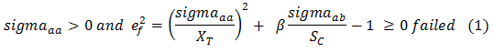
for the compressive fiber mode,
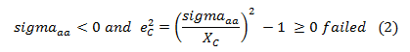
for the tensile matrix mode,
for the compressive matrix mode,
where, sigma_{aa}=normal stress in longitudinal direction (fiber), sigma_{bb}=normal stress in transverse direction (matrix), sigma _{ab}=in plane shear stress, β = parameter for failure criterion determination, X_{T} longitudinal tensile strength (fiber), Xc longitudinal compression strength (fiber), Yc transverse compressive strength (matrix),Y_{T} transverse tensile strength (matrix), Sc shear strength in plane. According to LS-DYNA user's manual [7], the Chang-Chang criterion has two formulations. The first formulation is the original Hashin criterion which is activated using the β factor equal to 1, whereas the second one, that was used in this study, is the known maximum stress criterion. The maximum stress criterion does not combine tensile and shear stresses for the prediction of fiber tensile failure and relies on comparing the acting tensile stress with the strength value of material. The other three modes of maximum stress criterion do not differ with the Hashin failure modes.

As far as the cohesive material models are concerned, Cohesive_Mixed_Mode (MAT_138), Cohesive_Elastic (MAT_184), Cohesive_TH (MAT_185), Cohesive_General (MAT_186) and Mixed_Mode_Elastoplastic_Rate (MAT_240) are provided in LS-DYNA [7]. The first model includes a bilinear traction-separation law using both power law and Benzeggangh-Kenane (B-K) law for ultimate mixed-mode displacement and constitutes a simplification of Mat_Cohesive_General restricted to linear softening. MAT_184 is elastic cohesive model without fracture criterion, whereas MAT_185 provides tri-linear traction-separation law. On the other hand, MAT_240 is a rate-dependent, elastic ideally plastic zone model with tri-linear traction-separation law. Finally, the MAT_186 is generic model which includes both power and B-K law for mixed mode fracture applying arbitrary normalized traction-separation law given as input. The current paper is focused on MAT_186 since no restriction on traction-separation law formulation exists, normal and shear stiffness are not needed to define as input variables and, finally, it is appropriate for modeling delamination in pure mode I and mode II in relation to the rest of models. Linear loading and exponential unloading curve constitute the adopted traction-separation law. The mean fracture toughness G_{IC} and G_{IIC} derived by experiments were used as input parameters in material model.

4. Results and Discussion

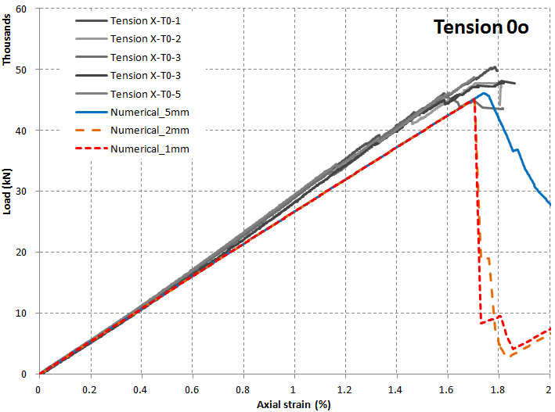 | 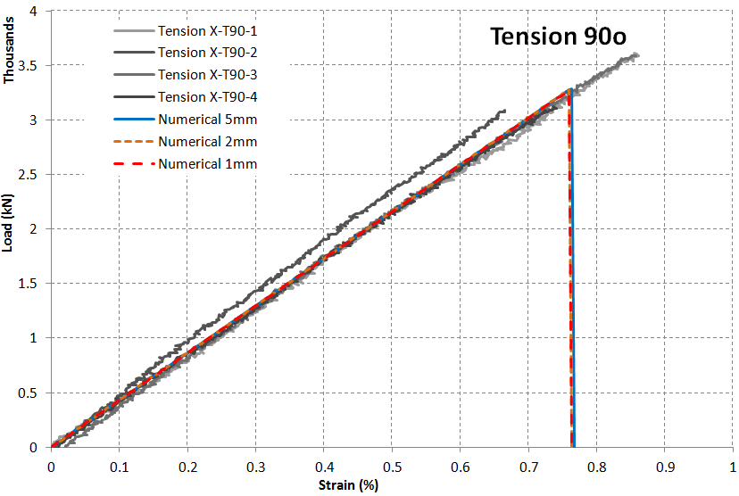
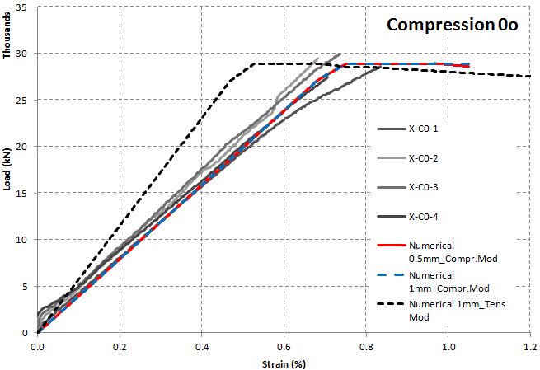 | 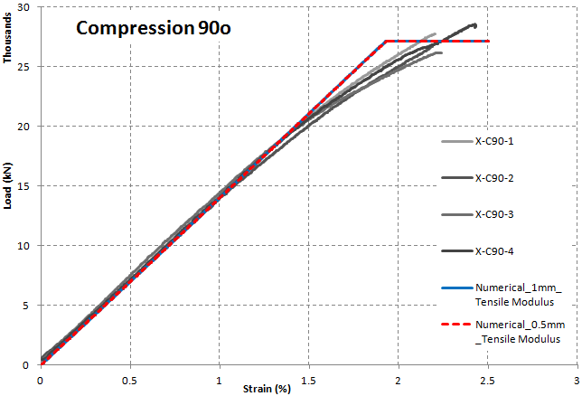

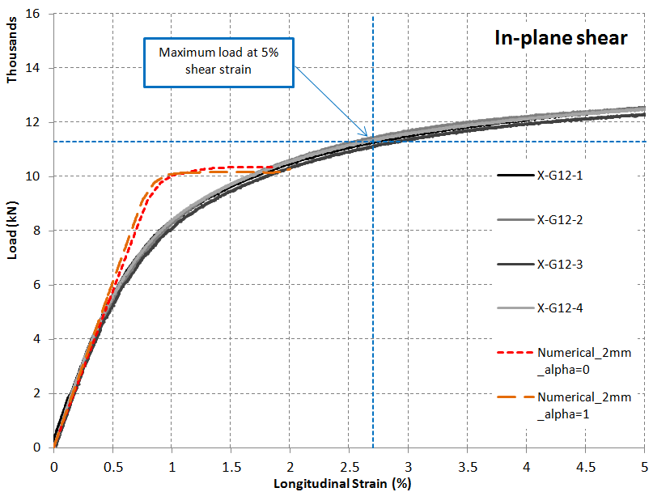

Figure 6. Comparison of numerical and experimental force-strain curves.

Observing the Fig.6, the most numerical force-strain curves are in a good agreement with experimental one. In particular, taking account the mean elastic tensile modulus and strength derived by experimental tests in fiber direction into material model, the slope of numerical curve (Tension 0º, Fig.6) and experimental one do not present significant discrepancy. The maximum numerical load differs 6.6% from the experimental one, where the numerical strain is very close to experimental one (<1% difference). Concerning the tension case in matrix direction, the slope of numerical and experimental curves are fully consistent independently the mesh size. Simultaneously, both numerical maximum load and the ultimate strain are in full agreement with experimental ones. Examining the case of compression in fiber direction, two cases were studied. In first one, the experimentally derived mean tensile modulus was adopted into material model and it is obvious that numerical model overestimates the stiffness of material. In contrary, in second case, where mean compressive modulus is used, the error between experiments and model is negligible (0.2% difference in stiffness and 1.35% for strength). Therefore, MAT_54 is not capable of predicting material stiffness to compressive loading in fiber direction, since it does not provide the capability for definition of a different modulus in case of compression. Moreover, excellent stiffness and peak load prediction for compression in 90⁰ was observed, although the model cannot approach the non-linear behaviour of CYCOM 977-2 before maximum load. The same conclusion is highlighted to in-plane shear loading since no convergence between numerical and experimental response is observed after 0.5% longitudinal strain.

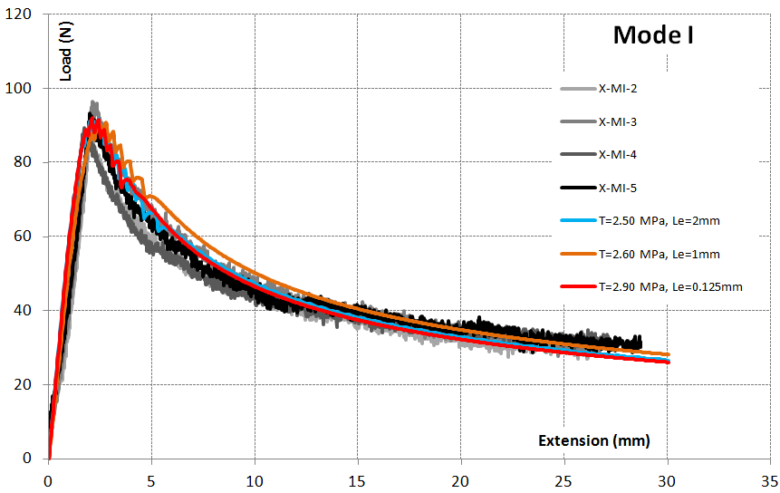 | 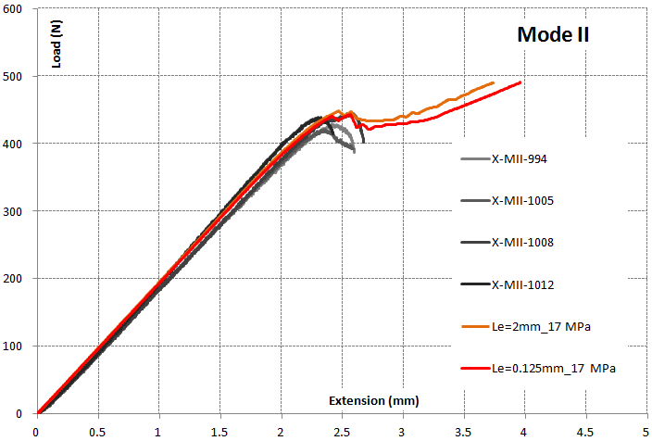

Figure 7. Force-extension curves for fracture tests Mode I & II

From fracture testing point of view, excellent convergence between experimental and models' results is remarked for all meshing case studies (Fig.7). The initial stiffness, the peak load as well as the non linear segment of force-extension curve after crack initiation are excellently predicted. Consequently, the MAT_186 is proved to be a suitable material model for predicting of delamination failure mode in quasi-static level.

5. Conclusions

In present work, the capability of existing compatible LS-DYNA material models to approximate the experimental response of CYCOM 977-2 composite material was investigated. Initially, the basic material characterization tests were carried-out and corresponding 3-D finite element models were created to represent the experimental response. Examining different meshing cases and comparing the experimental and numerical force-strain curves, it was proved that MAT_54 combined with MAT_186 are capable of simulating the quasi-static mechanical behavior of 977-2 composite material from the view of both stiffness and peak load apart from the cases of compression in fiber direction and in-plane shear.

For the improvement of numerical results, a new user-defined material model, which will be capable of capturing the nonlinear behavior of composite materials under shear loading and handling differently the tensile and compressive behavior, is required to develop. Finally, an automated calibration procedure, which will match the numerical curve with experimental one, is essential for determination of the optimum combination of new material model's parameters.

Acknowledgments

This work has been supported by EU, H2020 Smart, Green and Integrated Transport, Aviation program under the acronym EXTREME (EXTREME Dynamic Loading - Pushing the Boundaries of aerospace Composite Material Structures).

References

[1] Cytec Engineering Materials. Technical data sheet CYCOM 977-2 epoxy resin system. Rev:01,2012.
[2] D3039/D3039-95a. Standard test method for tensile properties of polymer matrix composite materials. ASTM International, 1995.
[3] D3410/D3410M-03. Standard test method for compressive properties of polymer matrix composite materials with unsupported gage section by shear loading. ASTM International, 2003.
[4] D3518/D3518M-94. Standard test method for In-Plane shear response of polymer matrix composite materials by tensile test of a ±45ºlaminate. ASTM International, 1994.
[5] AITM 1.0005. Determination of interlaminar fracture toughness energy Mode I. Airbus Industry, 1994.
[6] AITM 1.0006. Determination of interlaminar fracture toughness energy Mode II. Airbus Industry, 1994.
[7] LS-DYNA Theory manual R7.0. Livermore Software Technology Corporation.
[8] P. Camanho, C. Lopes, A.Turon and D.Trias. Delamination Assessment Tool. European Space Agency, Contract report,2011.
[9] A progressive composite damage model for unidirectional and woven fabric composites. Materials Sciences Corporation & University of Delaware Center for Composite Materials, 2013.

