**Crack Propagation Suppression in Composite T-joint using Fiber-reinforcement-based Crack Arrester**

Shinsaku Hisada, Shu Minakuchi and Nobuo Takeda

The University of Tokyo

One of the difficulties in composite structural application is joining components. Composite T-joint is one of the important elements in aircraft structures that transfers load between vertical and horizontal panels. T-joint is composed of two L-shaped parts, skin laminate, and deltoid. It is known that cracks occur in the deltoid under rather low loading condition and easily propagate along the interface between the flange and the skin [1]. Therefore, crack arrest feature is necessary to improve the damage tolerance of composite T-joints. Previous works evaluated the effectiveness of crack arrest feature such as Z-pinning and stitching [1, 2]. Although they can reinforce the flange/skin interface, the cost increases and initial failure strength decreases because of the through-thickness ply penetration by metallic or fibrous rods. The authors have been proposing a fiber-reinforcement-based disbond arrester feature that introduces continuous fibers in bond lines and suppresses the crack propagation using massive fiber bridging [3]. Figure 1 shows the schematic of one of the proposed arresters. The arrester is composed of 0° and 90° composite layers and 90° layer is inserted between the crossed 0° layers. When the crack from the deltoid passes through the crossing part, one 0° layer bridges and suppresses the crack opening (Fig. 1 A). In addition, the other 0° layer restrains the 90° layer and prevents the bridged 0° layer from peeling off (Fig. 1 B). Therefore, fiber failure in the 0° or 90° layers is necessary for further crack propagation, which leads to high crack growth resistance. In this current study, this crack arrester concept was

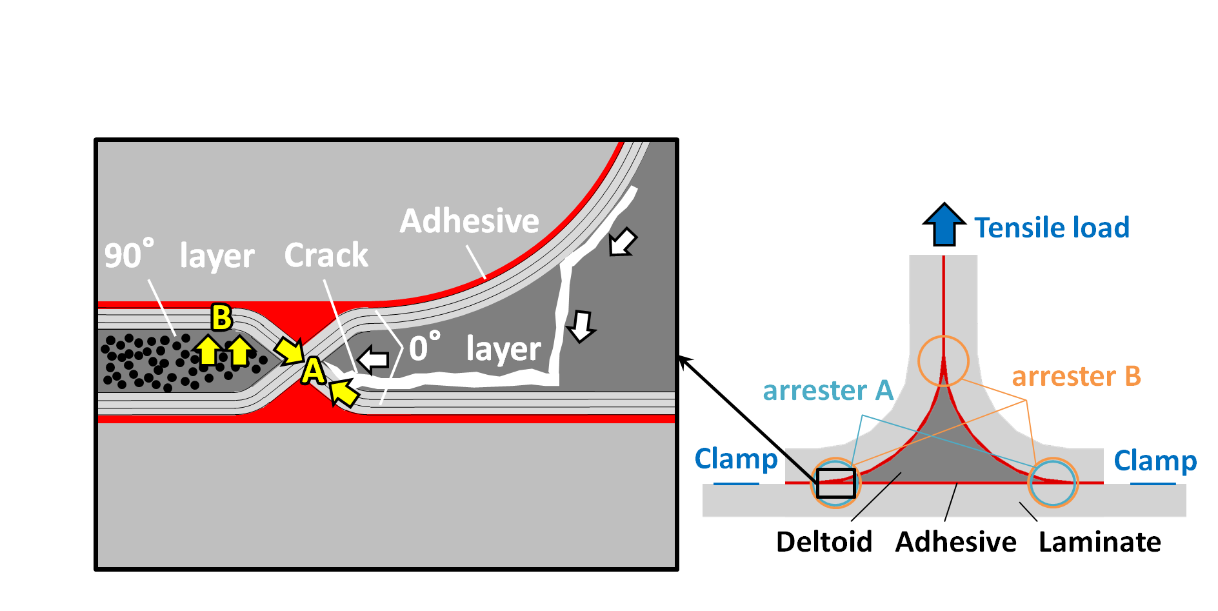

Fig. 1 Schematic of fiber-reinforcement-based crack arrester and deployment of arresters in the specimen.

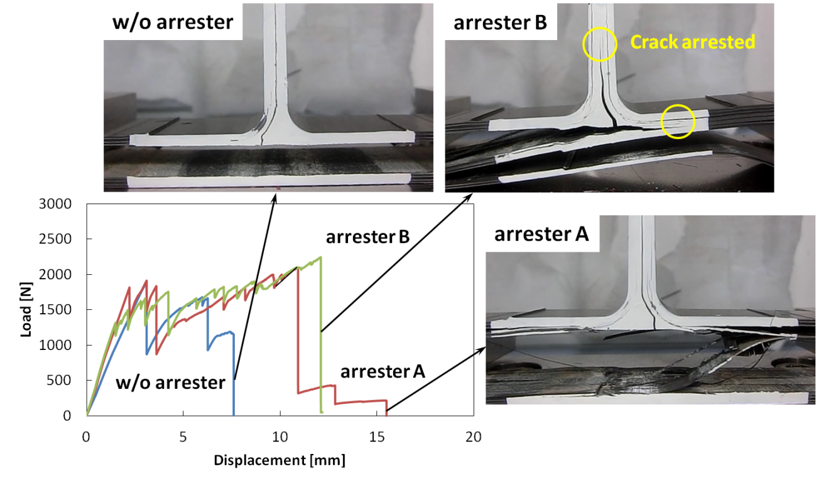

Fig. 2 Comparison of representative load-displacement curves and pictures of specimens after final failure.

applied to T-joint and its effectiveness was evaluated through tensile tests and cross-sectional observation. Three types of specimens were used; specimens without the arrester, specimens with the arresters in two places (Fig. 1, arrester A), and specimens with the arresters in three places (Fig. 1, arrester B). Figure 2 shows the representative load-displacement curves in each specimen and pictures of specimens after final failure. In the specimens with the arresters, peeling off of skin and flange is prevented and many small cracks occurred. As a result, load increased even after the deltoid interface failure and much higher energy was absorbed compared to the specimens without the arrester. From these results, it was shown that proposed arrester can improve damage tolerance of composite T-joint without initial failure strength reduction.

**Reference**

[1] T. M. Koh et al., “ Experimental determination of the structural properties and strengthening mechanisms of z-pinned composite T-joints,” Compos. Struct., vol. 93, pp. 2222-30, 2011.

[2] P. B. Stickler et al., “Investigation of mechanical behavior of transverse stitched T-joints with PR 520 resin in flexure and tension,” Compos. Struct., vol. 52, pp. 307-14, 2001.

[3] S. Minakuchi, “Fiber-reinforcement-based crack arrester for composite bonded joints,” Proceedings of ICCM20, 2118-4, Copenhagen, Denmark, 2015.