EuroSun2026
EXPERIMENTAL AND NUMERICAL STUDY OF A SHELL-AND-MULTITUBE LATENT THERMAL ENERGY STORAGE WITH A PERFORATED PLATE FOR SOLAR THERMAL APPLICATIONS
Summary
Latent thermal energy storage (LTES) is an effective option for mitigating the mismatch between solar heat supply and heat demand, but its practical performance depends strongly on the uniform utilization of phase change material (PCM). This study experimentally and numerically investigates the phase change and temperature uniformity of a shell-and-multitube LTES equipped with a perforated plate. A validated three-dimensional computational fluid dynamics (CFD) model is used to clarify the thermal behavior during both charging and discharging. The results show a clear difference between inter-tube and intra-tube performance. Melting, solidification, and temperature evolution are highly consistent among the parallel PCM tubes, indicating good inter-tube uniformity during both processes. In contrast, pronounced nonuniformity develops along the height of individual tubes, resulting in uneven PCM utilization and limiting effective heat transfer. The perforated plate further improves inter-tube phase change uniformity compared with the configuration without the plate. Therefore, the present design provides effective flow distribution among parallel tubes, while future optimization should primarily focus on improving vertical phase change and temperature uniformity within individual PCM tubes.
Latent heat storage, perforated plate, experiment, CFD, phase change uniformity
Field of application for the findings: Solar thermal applications
Addressed audience: Researchers, thermal system designers, LTES developers, solar heating engineers
1. Introduction
Solar thermal systems can provide low carbon heat for domestic hot water and space heating, but solar availability and heat demand do not generally coincide in time. Latent thermal energy storage (LTES) can mitigate this mismatch by storing surplus heat in phase change materials (PCMs) and releasing it when heat demand occurs. Studies of solar domestic hot water systems have shown that PCM storage can improve the utilization of available solar heat and support heat delivery (Chopra et al., 2022). However, at the component level, the effective storage capacity and thermal power depend not only on the nominal PCM inventory but also on how rapidly and uniformly the PCM is charged and discharged.
Shell-and-multitube configurations are attractive because parallel PCM tubes provide a large heat transfer area, and experimental studies have demonstrated improved phase change performance compared with single tube arrangements (Joybari et al., 2019). For configurations with the heat transfer fluid (HTF) on the shell side and PCM inside the tubes, Wang et al. (2021) experimentally demonstrated the feasibility of the concept. Subsequent validated CFD analysis, however, identified pronounced short circuiting of the shell side flow that caused unequal heating and liquid fraction evolution among the PCM tubes (Wang et al., 2022). Perforated plates and related flow distribution structures have therefore been proposed to mitigate this problem, but reported numerical results are not fully consistent regarding their effectiveness (Abdellatif et al., 2024; Pytlik et al., 2022). Experimental evidence and quantitative assessment of both inter-tube and intra-tube uniformity are therefore still needed.
To address this gap, the present study experimentally and numerically investigates a shell-and-multitube LTES with a perforated plate under charging and intermittent discharging conditions relevant to solar heating. A full three-dimensional CFD model is validated against measured outlet temperature and transferred heat. The validated model is then used to quantify phase change and temperature field uniformity from inter-tube and vertical intra-tube perspectives, identify the dominant source of nonuniformity, and evaluate the influence of the perforated plate on transient inter-tube phase change uniformity. The results provide a concise basis for targeted optimization of the LTES for solar thermal applications.
2. Experimental and numerical methods
2.1. LTES prototype and experimental procedure
The storage unit is a vertical cylindrical tank with a height of 1.16 m and an outer diameter of 0.345 m, as shown in Fig. 1 (Frazzica et al., 2019). Twenty vertical PCM tubes are installed in parallel. Each tube contains a commercial salt hydrate PCM (PCM S58) and is manufactured from high-density polyethylene (HDPE) to provide macroencapsulation and prevent leakage. The immersed tube bundle contains 60.2 kg of PCM and provides approximately 2.95 m² of external heat transfer area. Water is used as the HTF. A stainless steel upper tube sheet locates the tubes, whereas a lower perforated plate contains the tube pass openings and 153 additional pores, each 7 mm in diameter, to redistribute the inlet flow. The principal prototype and PCM parameters are summarized in Tab. 1.
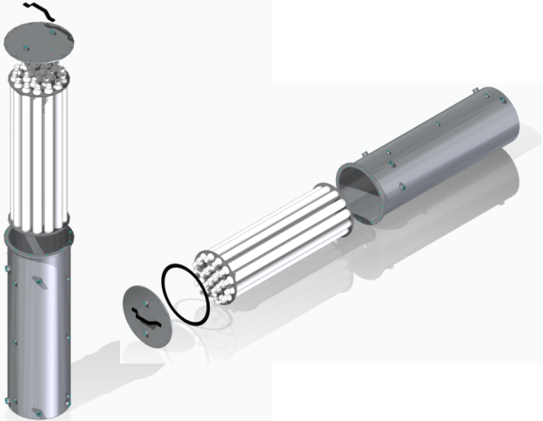
Fig. 1: LTES prototype
Tab. 1: Main parameters of the LTES prototype and PCM.
Item | Parameter | Value
Tank | Height / outer diameter | 1.16 m / 0.345 m
PCM tube bundle | Number / tube length / inner diameter | 20 / 0.94 m / 0.045 m
PCM inventory | PCM mass / immersed external area | 60.2 kg / 2.95 m²
PCM S58 | Phase change range / latent heat | 50.5-59.5 °C / 145 kJ kg⁻¹
PCM S58 | Density / thermal conductivity | 1505 kg m⁻³ / 0.69 W m⁻¹ K⁻¹
Perforated plate | Additional pores / pore diameter / porosity | 153 / 7 mm / 0.11
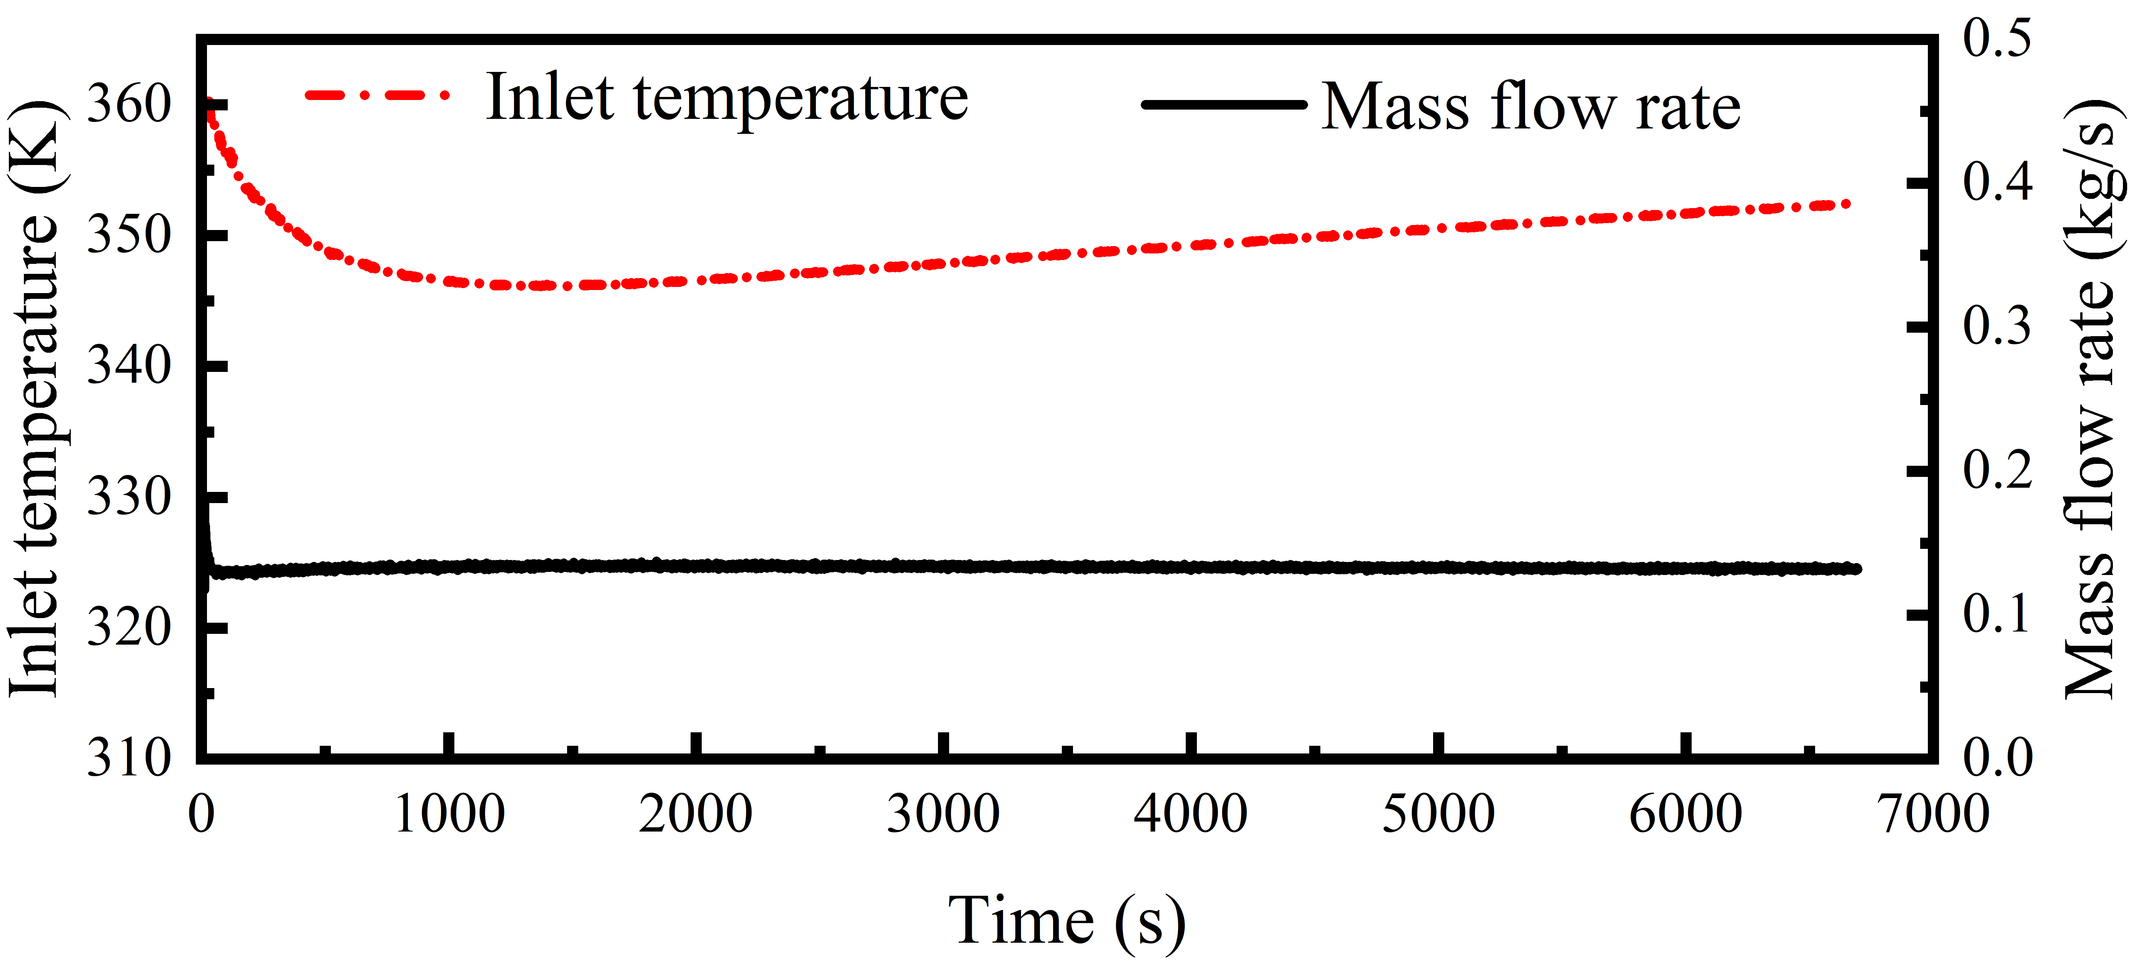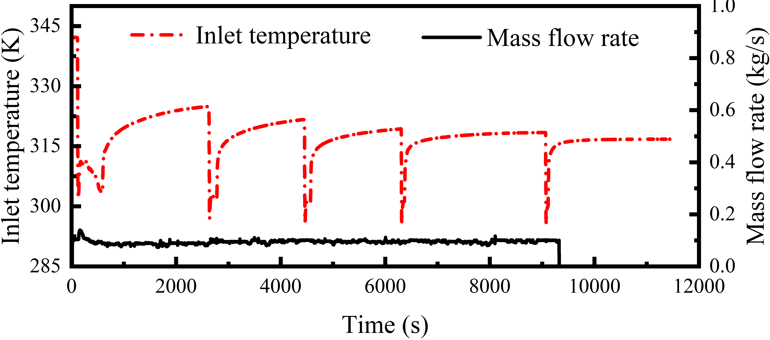
(a) (b)
Fig. 2: Experimental inlet temperature and mass-flow-rate profiles during (a) charging and (b) discharging.
Fig. 2(a) and (b) show the experimental inlet temperature and mass flow rate profiles during charging and discharging, respectively. During charging, the inlet temperature decreases rapidly at the beginning and then varies gradually, while the mass flow rate remains nearly constant, providing a relatively stable charging boundary. In contrast, the discharging process is characterized by repeated sharp drops and recoveries in inlet temperature, representing the transient boundary conditions associated with intermittent DHW demand. These experimentally measured profiles were directly applied as boundary conditions in the CFD model, providing a representative and demanding case for model validation.
Charging continued until the average internal temperature of the LTES remained stable for 10 min. During discharging, heat extraction was continued while the system could deliver water at or above 40 °C. Temperatures were measured using Type-T thermocouples with an uncertainty of ±0.5 °C, and the flow rate was measured using an ultrasonic flow meter with an uncertainty of 1%.
2.2. Three-dimensional CFD model
A half-domain model is constructed using the geometric symmetry of the storage. The computational domain contains the shell side water, HDPE tube walls, PCM regions and the lower perforated plate. The final structured hexahedral mesh contains 3,528,883 cells with refined layers around the tube walls to resolve conjugate heat transfer. Phase change of the PCM is represented by the enthalpy-porosity method. Natural convection during melting is included with the Boussinesq approximation. These modeling choices allow the complete shell side flow distribution and the thermal interaction among parallel PCM tubes to be resolved.
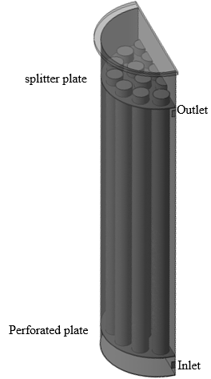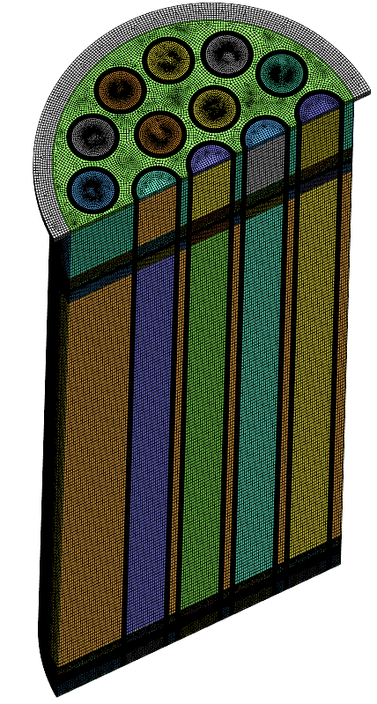
Fig. 3: CFD model and mesh: (a) half-domain geometry and (b) structured mesh.
The experimentally measured inlet temperature and mass flow rate shown in Fig. 2 are imposed directly at the CFD inlet. The top, side and bottom heat-loss coefficients are 2.86, 2.38 and 2.63 W m⁻² K⁻¹, respectively. The initial storage temperatures are 44.4 °C for charging and 71.5 °C for discharging. Simulations are performed in ANSYS Fluent 2024 R2 using PISO coupling of pressure and velocity; convergence is required to reduce all governing equation residuals below 10⁻⁶. The model is validated against the measured outlet temperature and the heat charged and released before it is used to examine internal phase change behavior. A fixed time step of 0.2 s was used for the transient simulations, with second order upwind discretization for the momentum and energy equations.
2.3. Uniformity evaluation indicators
To quantify phase change and temperature field uniformity, nonuniformity indices are defined as the standard deviation of liquid fraction or temperature among selected PCM regions. For a variable x (x = β for liquid fraction and x = T for temperature), the transient nonuniformity index is defined as:
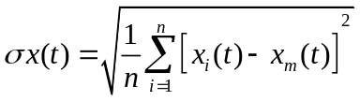 (1)
Here, xᵢ(t) is the mass averaged value for an individual PCM tube or the facet averaged value for a selected plane/zone, xₘ(t) is the corresponding mean over all selected regions, n is the number of regions. A smaller index indicates better uniformity.
Uniformity is evaluated from three complementary spatial perspectives so that tube-to-tube maldistribution can be distinguished from vertical nonuniformity within the PCM tubes. TP quantifies inter-tube uniformity by treating each PCM tube as one region and evaluating the dispersion of its mass averaged liquid fraction or temperature relative to the mean of all tubes. RD-HML characterizes vertical nonuniformity using three horizontal cross sections located 223 mm (low), 549 mm (middle), and 875 mm (high) above the tube bottom; the facet averaged values on these planes are compared at each time step. AD-HML provides an additional vertical assessment using vertical planes divided into three equal height zones (low, middle, and high), for which the corresponding facet averaged values are compared. The suffix M denotes melting during charging and S denotes solidification during discharging. Accordingly, TP-M, RD-HML-M, and AD-HML-M are used for charging, while TP-S, RD-HML-S, and AD-HML-S are used for discharging. The same definitions are applied to both liquid fraction and temperature. Thus, TP reflects inter-tube uniformity, whereas RD-HML and AD-HML quantify intra-tube vertical nonuniformity from two complementary spatial descriptions.
3. Results and discussion
3.1. Experimental validation of the CFD model
Fig. 4 compares the measured and simulated outlet temperature and heat transfer response. During charging, the model reproduces both the rapid initial transient and the subsequent gradual temperature evolution. Except for the first approximately 300 s, the outlet temperature deviation is below 1.5 K, while the deviation in heat charged is below 3%. The remaining early discrepancy is attributed to experimental thermal mixing near the outlet and to the development of the perforated plate flow field in the numerical model.
The intermittent discharge test is more challenging because the inlet temperature changes abruptly. The numerical model follows the measured sawtooth outlet temperature response and the repeated heat release peaks. For most of the discharge period, the outlet temperature deviation remains below 2 K and the deviation in released heat is below 5%. The agreement in both charging and discharging therefore supports use of the CFD model to analyze the internal HTF distribution and PCM phase state.
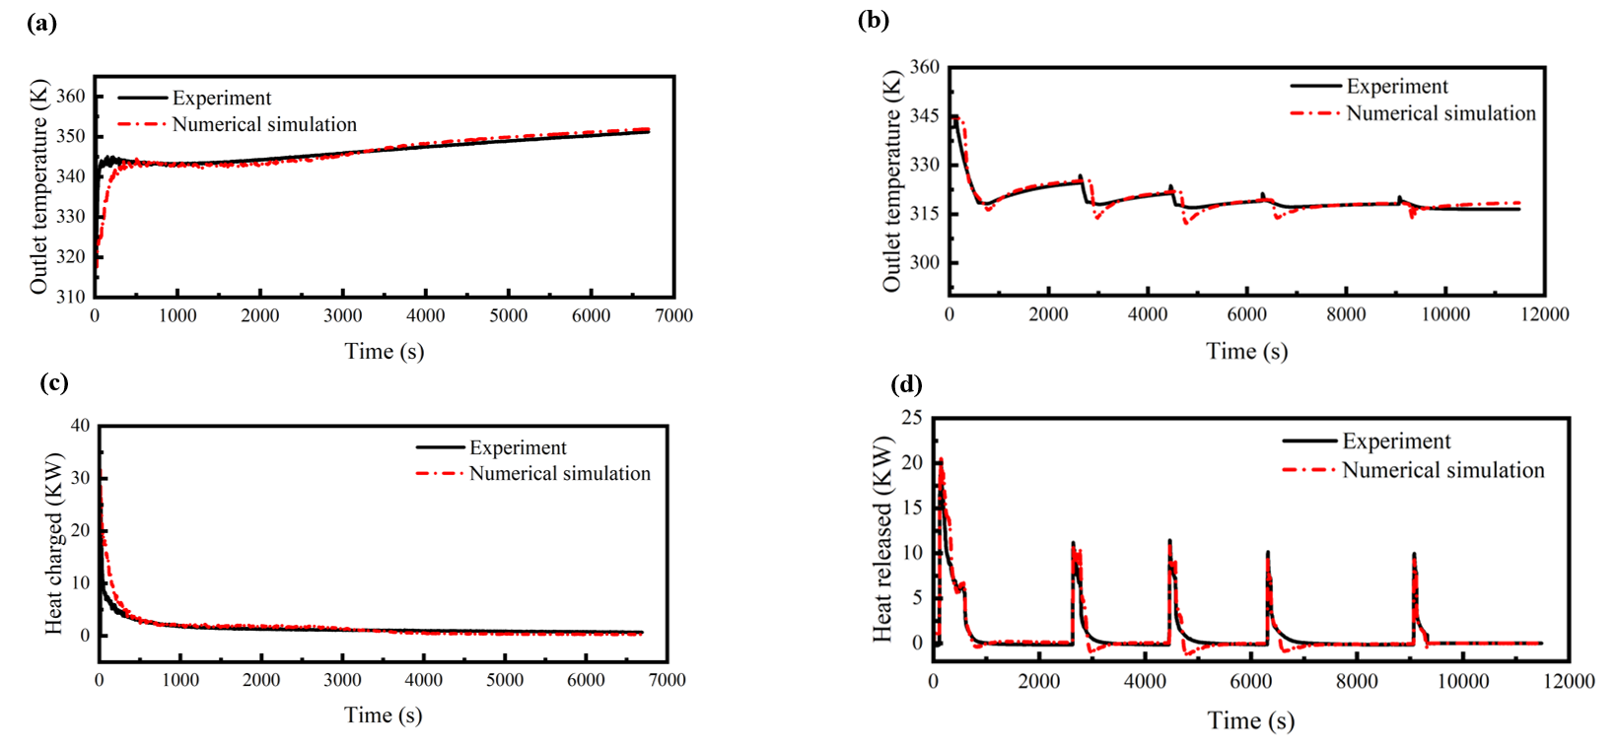
Fig. 4: CFD validation against experiment: (a) charging outlet temperature, (b) charging heat transfer, (c) discharging outlet temperature, and (d) discharging heat release.
3.2. Inter-tube and intra-tube phase change and temperature field uniformity
Fig. 5 presents the transient liquid fraction evolution and melting nonuniformity during charging using the three spatial evaluations defined in Section 2.3. Both vertical evaluations reveal pronounced nonuniformity along the tube height: the peak RD-HML-M and AD-HML-M indices are approximately 0.18 and 0.20, respectively. The upper region melts earlier than the middle and lower regions once sufficient liquid PCM has formed, because buoyancy-driven natural convection intensifies heat transfer in the upper part of the tubes. In contrast, the liquid fraction histories of the individual PCM tubes nearly overlap, and the maximum inter-tube index TP-M is only about 0.02. Charging is therefore well balanced among the parallel tubes, while the dominant phase change nonuniformity develops vertically within individual tubes.
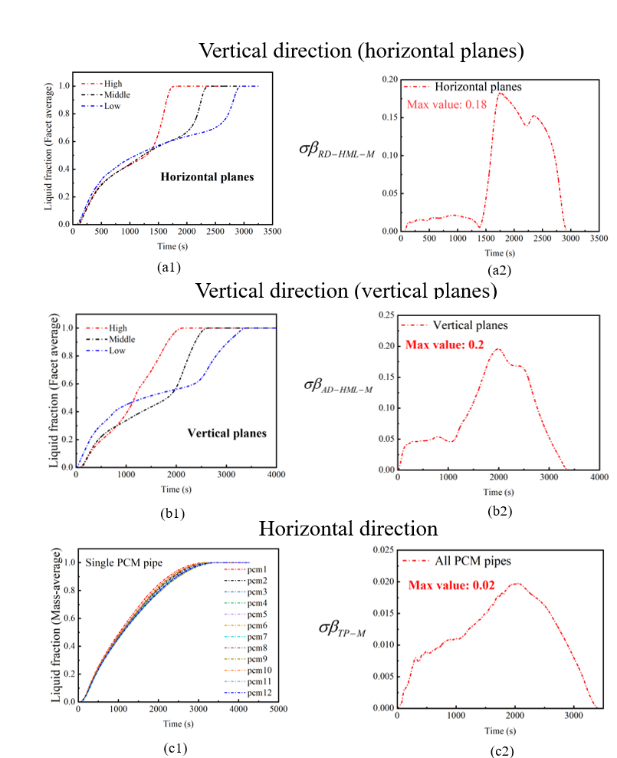
Fig. 5: Transient liquid fraction evolution and melting nonuniformity during charging: (a1–a2) vertical variation evaluated using horizontal planes, (b1–b2) vertical variation evaluated using vertical-plane zones, and (c1–c2) inter-tube variation among PCM tubes.
Fig. 6 presents the transient PCM temperature evolution and temperature field nonuniformity during charging. The RD-HML-M and AD-HML-M evaluations show pronounced vertical temperature differences, with maximum indices of approximately 5.1 K and 5.3 K, respectively. These differences become most evident during the intermediate stage of charging, when buoyancy-driven natural convection produces thermal stratification along the tube height. By comparison, the temperature histories of the individual PCM tubes remain highly consistent, and the maximum inter-tube temperature nonuniformity TP-M is only 0.68 K. The temperature results therefore confirm the same pattern as the liquid fraction analysis: behavior among the tubes is highly uniform, whereas the principal nonuniformity occurs vertically within the tubes.
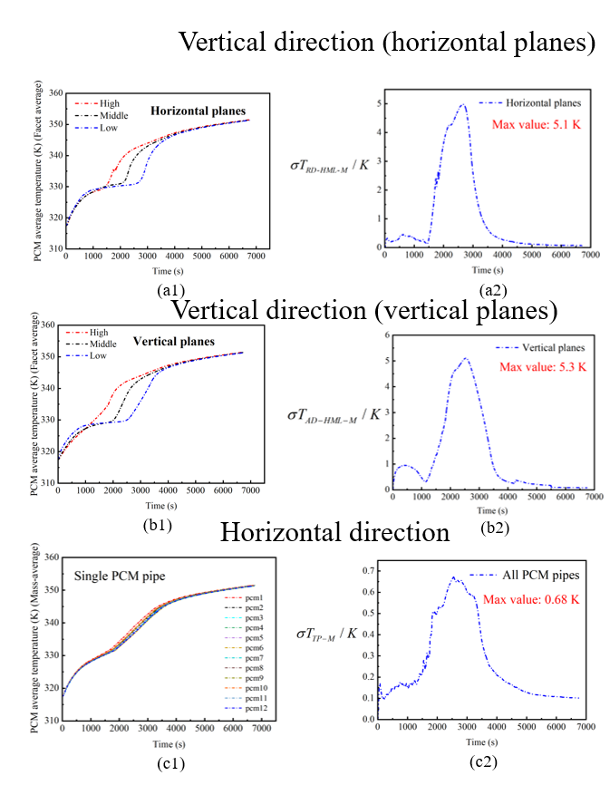
Fig. 6: Transient PCM temperature evolution and temperature field nonuniformity during charging: (a1–a2) vertical variation evaluated using horizontal planes, (b1–b2) vertical variation evaluated using vertical-plane zones, and (c1–c2) inter-tube variation among PCM tubes.
Fig. 7 presents the transient liquid fraction evolution and solidification nonuniformity during discharging. Clear vertical differences are observed in both the RD-HML-S and AD-HML-S evaluations, with maximum indices of approximately 0.13 and 0.18, respectively. Because cold water enters from the bottom, the lower region solidifies first, followed by the middle and upper regions. The intermittent discharge operation also causes temporary changes in the vertical nonuniformity as the inlet condition repeatedly varies. In contrast, the liquid fraction histories of the individual PCM tubes nearly overlap, and the maximum inter-tube solidification index TP-S is only 0.0034. Thus, solidification remains highly consistent among the parallel tubes, while the dominant phase change nonuniformity again develops along the tube height.
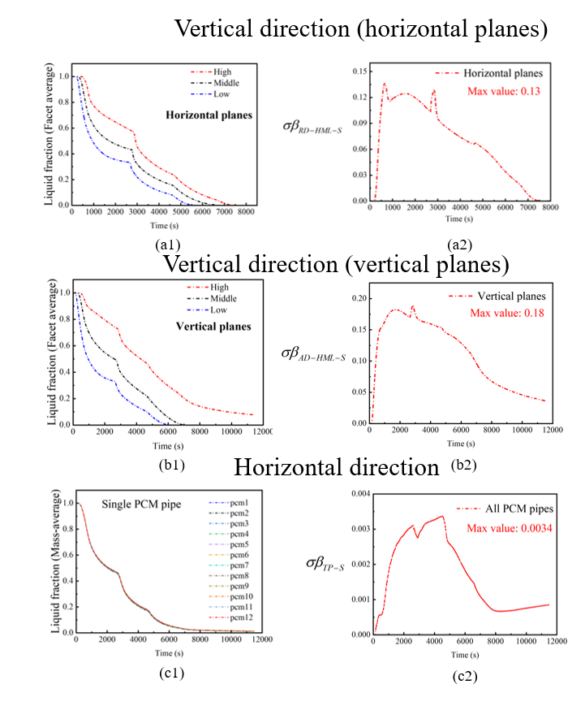
Fig. 7: Transient liquid fraction evolution and solidification nonuniformity during discharging: (a1–a2) vertical variation evaluated using horizontal planes, (b1–b2) vertical variation evaluated using vertical-plane zones, and (c1–c2) inter-tube variation among PCM tubes.
Fig. 8 presents the transient PCM temperature evolution and temperature field nonuniformity during discharging. The vertical RD-HML-S and AD-HML-S indices reach approximately 4.1 K and 4.6 K, respectively, reflecting the sequential cooling of the lower, middle, and upper regions as cold water enters from the bottom. Their characteristic sawtooth variations are associated with the intermittent discharge boundary condition. In contrast, the temperature histories of the individual PCM tubes remain highly consistent, and the maximum inter-tube temperature nonuniformity TP-S is only 0.18 K. The discharging results therefore reinforce the charging results: the tube bundle is thermally well balanced in the horizontal direction, while vertical intra-tube nonuniformity remains the dominant limitation.
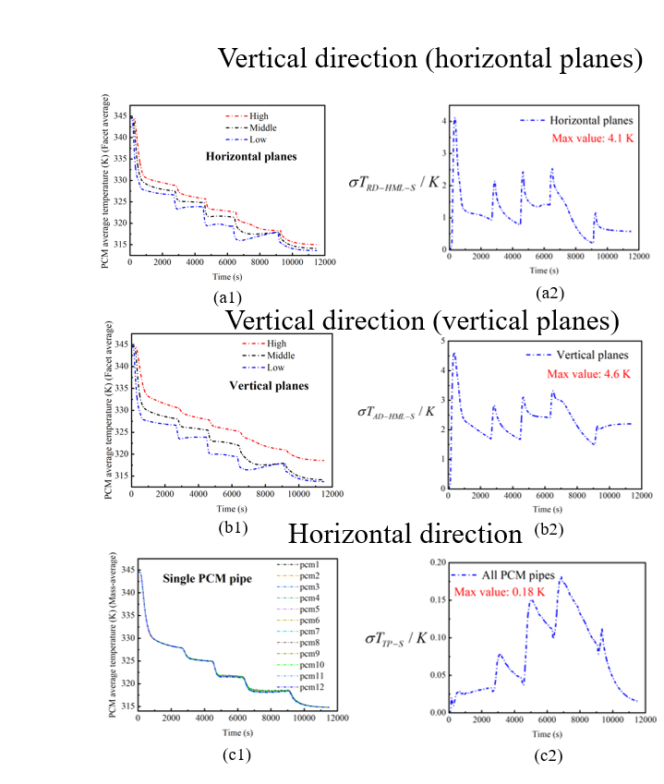
Fig. 8: Transient PCM temperature evolution and temperature field nonuniformity during discharging: (a1–a2) vertical variation evaluated using horizontal planes, (b1–b2) vertical variation evaluated using vertical-plane zones, and (c1–c2) inter-tube variation among PCM tubes.
Taken together, the charging and discharging results show a consistent directional contrast: the PCM tubes behave similarly to one another, but substantial gradients develop within each tube along its height. This distinction indicates that the present tube bundle already achieves good inter-tube utilization, whereas vertical intra-tube heat transfer remains the principal source of nonuniform phase change and temperature distribution.
3.3. Influence of the perforated plate
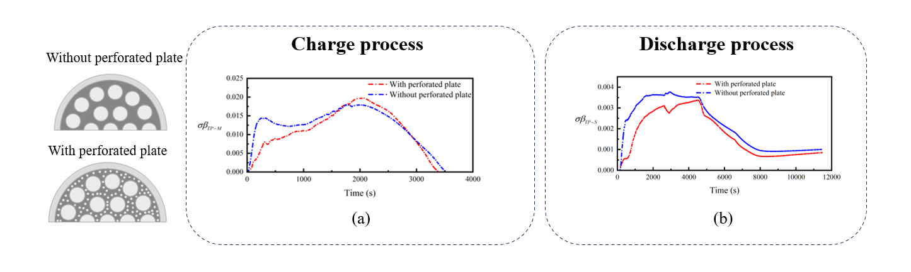
Fig. 9: Effect of the perforated plate on transient inter-tube phase change nonuniformity during (a) charging and (b) discharging.
Fig. 9 compares the influence of the perforated plate on transient inter-tube phase change nonuniformity during charging and discharging. In both processes, the configuration with the perforated plate generally exhibits lower inter-tube nonuniformity over most of the phase change period. The consistent reduction in transient nonuniformity indicates that the perforated plate improves the uniformity of phase change evolution among the parallel PCM tubes.
4. Conclusions
A perforated plate assisted shell-and-multitube LTES was investigated experimentally and numerically to clarify its phase change and temperature field uniformity during charging and discharging. The validated 3D CFD model shows that the parallel PCM tubes exhibit good inter-tube uniformity, whereas pronounced nonuniformity develops vertically within individual tubes. During charging, the maximum inter-tube liquid fraction and temperature field nonuniformity indices are only about 0.02 and 0.68 K, respectively, compared with vertical maxima of 0.18–0.20 and 5.1–5.3 K. During discharging, the corresponding inter-tube maxima are only 0.0034 and 0.18 K, compared with vertical maxima of 0.13–0.18 and 4.1–4.6 K. The perforated plate further reduces the transient inter-tube phase change nonuniformity during both processes, indicating more consistent phase change evolution among the parallel PCM tubes. Overall, vertical intra-tube nonuniformity remains the main limitation of the present design. Future optimization should therefore focus primarily on improving vertical heat transfer and phase change uniformity within individual PCM tubes.
References
Abdellatif, H.E., Belaadi, A., Arshad, A., Bourchak, M., Ghernaout, D., 2024. Enhanced solar energy utilization of thermal energy storage tanks with phase change material and baffle incorporating holes. Thermal Science and Engineering Progress 52, 102674.
Chopra, K., Tyagi, V.V., Pandey, A.K., Popli, S., Singh, G., Sharma, R.K., Sari, A., 2022. Effect of simultaneous & consecutive melting/solidification of phase change material on domestic solar water heating system. Renewable Energy 188, 329-348.
Frazzica, A., Palomba, V., Brancato, V., La Rosa, D., Freni, A., Manzan, M., 2019. Numerical simulation and experimental analysis of a latent thermal energy storage for naval applications. In: Proceedings of the Eurotherm Seminar 112 - Advances in Thermal Energy Storage, Lleida, Spain, 15-17 May 2019.
Joybari, M.M., Seddegh, S., Wang, X., Haghighat, F., 2019. Experimental investigation of multiple tube heat transfer enhancement in a vertical cylindrical latent heat thermal energy storage system. Renewable Energy 140, 234-244.
Pytlik, B., Smykowski, D., Szulc, P., 2022. The impact of baffle geometry in the PCM heat storage unit on the charging process with high and low water streams. Energies 15(24), 9349.
Wang, G., Dannemand, M., Xu, C., Englmair, G., Furbo, S., Fan, J., 2021. Thermal characteristics of a long-term heat storage unit with sodium acetate trihydrate. Applied Thermal Engineering 187, 116563.
Wang, G., Xu, C., Englmair, G., Kong, W., Fan, J., Furbo, S., Wei, G., 2022. Experimental and numerical study of a latent heat storage using sodium acetate trihydrate for short and long term applications. Journal of Energy Storage 47, 103588.

