INTEGRATED INVESTIGATION OF
THE ROLE OF 3D ARCHITECTURE
IN THE MECHANICAL BEHAVIOR OF KNITTED TEXTILES
Emine Tekerek¹, Dani Liu¹, Brian Wisner¹, Melvin Matthew¹
David Breen² and Antonios Kontsos^{1,*}

¹Theoretical & Applied Mechanics Group, Department of Mechanical Engineering & Mechanics,

Drexel University, Philadelphia, PA

²Department of Computer Science, Drexel University

*Corresponding Author*: antonios.kontsos@drexel.edu | t: +1 215 895 2297

Abstract
The mechanical behavior of 3D architectured knitted textiles is investigated experimentally and computationally. In this aspect, different imaging methods including microscopy and digital image correlation (DIC) are used to investigate the multiscale behavior of such structures. Local and global kinematics are observed in-situ as displacement is applied providing a link between behavior at the two scales. Additionally, Finite Element Analysis (FEA) is used to simulate the geometrical details of the entangled yarns in the 3D models developed. Parallelized Direct Numerical Simulations (DNS) conducted in high performance computing clusters and are shown to be capable of investigating the influence of local architecture at the yarn level on the global response. The effect of local contact evolution on kinematic behavior of knitted textiles is also investigated. The results obtained both computationally and experimentally were found to be in good agreement.

- Introduction
Advanced manufacturing [1] is distinguished from traditional manufacturing techniques by its capability to produce complex geometric structures typically consisting of internal architectures. A common example of such materials are lattice structures that have been heavily investigated at multiple scales [1]. AM-produced 3D architectured materials are built from a digital model which can be adjusted and controlled in order to produce multiscale modifications. Such lattice materials can be defined as a combination of base materials and a periodic array of spaces [2] which are used in various applications [3-4].
Knitted textiles can be classified as advanced manufactured 3D architecture lattice materials. Modern knitting machines can be programed through a digital model to achieve a range of knitting patterns using a number of different input materials [5]. Knitted textiles have found use in a range of applications including medical devices [6], aerospace industry [7], and wearable sensors [8], among others. Although, AM is accepted as a new industrial revolution [9] due to its promising technology for design [9], it does rely on a mixture of material, structural and behavior effects which are challenging to be quantified experimentally or computationally. In the context of the investigation presented in this article, there is currently a need to define a link between microstructure and mechanical behavior of knitted textiles [10].
The work presented here focuses on a combined experimental and computational approach for a monofilament knitted textile with the goal to investigate and understand their mechanical behavior. In this aspect, a series of tensile tests were conducted by loading single jersey knitted specimens in two different orientations (wale & course). The tests were coupled with digital microscopy and stereo Digital Image Correlation (DIC) [11] to examine both local yarn motions and the global behavior. The same mechanisms were investigated computationally using a Finite Element Analysis (FEA) framework based on Direct Numerical Simulations (DNS). The simulations presented are shown to capture yarn-to-yarn interactions allowing for a direct investigation of the influence of local information on the global textile behavior. The experimental results were compared with the computational investigations revealing good agreement which validates the integrated approach adopted.
- Experimental Approach

  - Sample Specifications
Knitted textile specimens with monofilament polypropylene single jersey architectures are used in this investigation. Figure 1 depicts the three parameters including D (diameter), W (wale spacing) and C (course spacing), which are required to create a unit cell that denotes the fundamental repeating loop structure that the textile consists of. These parameters are not directly controllable during the manufacturing process, but are tunable by adjusting the yarn diameter and stitch number along with the stitch spacing resulting in relatively consistent loop parameters similar to that used in computational modelling.
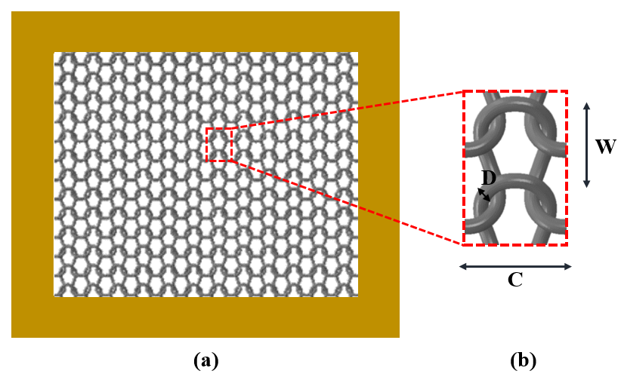
Figure 1: a) Schematic of single jersey knitted fabrics, and (b) characterizing parameters of the loop geometry in single jersey knitted structures
The design parameters used in this work are given in Table 1. The specimens are comprised of a border and an interior region. The border region is a result of manufacturing constraints and was created using cotton blended polypropylene required to support the interior, “testing zone”. The final specimens are prone to a curling behavior as a result of the relaxation in the fibers when the specimens are removed from the knitting machine. Consequently, a controlled experimental method was needed to account for this behavior.

Table 1. Specimen material, physical and geometrical details
Polypropylene  Yarn | Diameter (mm) | Linear Density (g/9000m)
Polypropylene  Yarn | 0.1 | 143.1
Loop | Course Spacing | Wale Spacing
Loop | 2.1 | 1.2
Coupon | Overall Dimension | Number of Stitches
Coupon | 84x51 | 40x40

  - Specimen Preparation and Tensile Test
Aluminum tabs (2.37 mm thickness) were attached to the specimens using high strength hot melt glue to allow for specimen alignment while also eliminating slipping at the grips that was observed during loading when tabs were not used. The deformation of the material was monitored using a 5MP stereo DIC system manufactured by GOM. To allow for tracking, a multiscale speckle pattern was applied on the specimens. Black spray paint was used to provide random small dots (approx. 1mm) in size for local yarn-yarn interactions, while large blots were placed in a grid pattern to track the global textile behavior, as shown in Figure 2(a) and 2(b). To increase contrast and improve image registration a white background was used behind the specimen.
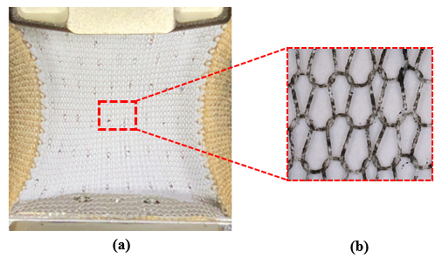
Figure 2. a) Smaller randomly spread speckle pattern alongside larger dots in a grid pattern b) Speckle pattern under a digital microscope used to study yarn-to-yarn interaction
Uniaxial tensile tests were conducted using a desktop load frame (Mark-10 ESM 301) equipped with a 2.5kN load cell. The specimens were loaded monotonically at a rate of 0.5 mm/min with the specimens oriented first in the wale and subsequently in the course direction. DIC was used to observe global textile behavior while a digital microscope (Bodelin ProScope EDU) was used to resolve finer detail for local yarn-yarn interactions. It is important to note that the border material of the coupons affects the behavior of the textile over a region of the testing zone. DIC results from the global field of view (FOV) are used to identify the region of the material that is not effected by the boundary conditions for local investigations.
  - Results
Figure 3a shows the global load displacement response of two specimens manufactured using the same parameters which were loaded in the wale and course directions. Figure 3b shows the loop geometry at the final displacement (30mm) for the two orientations. For the specimen loading in the wale direction uniformly aligned loops were observed, while the course-wise loaded specimen results in a disordered loop geometry. As a result of the different loop deformations, the load follows a more direct path through the material in the wale-wise case leading to a larger apparent stiffness for textiles loaded in this orientation than those loaded in the course-wise manner.
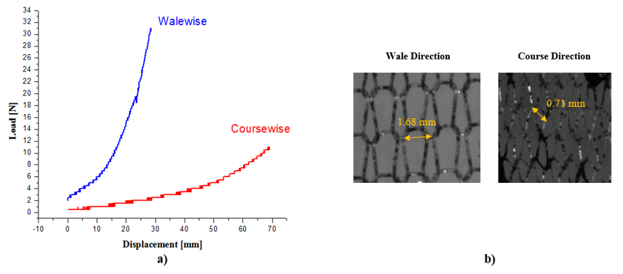
Figure 3. a) Load-displacement curves for single jersey knitted textiles loading parallel to the wale and course directions, respectively; b) digital microscope images of the loop shapes at the final stage of tensile loading
In addition to the differing loop geometry, the changes of the length and orientation in a single loop are tracked during tensile loading in the manner shown in Figure 4a where L is defined as the length of the loop and θ is the angle of the loop measured with respect to the vertical axis. Prior to loading, the loop is in a relaxed state with a large angle, θ, in one side and a smaller value in the other. As the specimens are stretched, the angles reduce which is coupled with almost no increase in loading. The lack of load increase while the structure reorganizes itself is attributed to the sliding and friction between yarns. As the load increases, the angle changes and the loops begin to stabilize. Additionally, the fluctuations in the loading value are linked to the locking and unlocking behavior of the yarns as a result of intermittent sliding and friction effects which ere validated by examining the fluctuations produced directly by the load cell when no load is applied as compared to the fluctuations observed during loading.
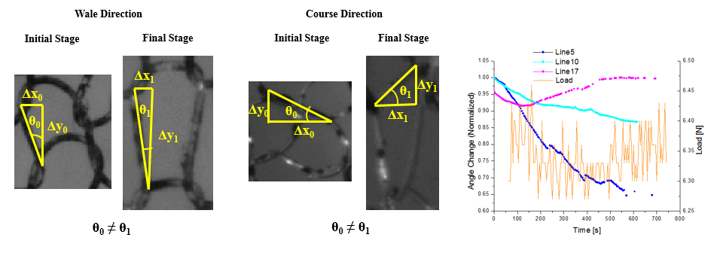
Figure 4. a) Demonstration of angle change in a unit cell in wale and course directions; b) Sliding and stretching along several lines defined based on the loop architecture confirming the effects of sliding and friction between yarns,
In addition, as knitted textiles deform contact areas among yarns create out-of-plane displacements similar to buckling [10, 12]. This feature was also measured by stereo DIC using the large grid of dots to observe the out-of-plan motion relative to an initial state [5]. Figure 5 shows such a result where the z-displacement at the center of the specimen (which is expected to be free of boundary effects) is plotted as a function of the applied displacement. The early motion observed in the curve of Figure 5 is attributed to the realignment of the yarns from sliding and friction as discussed previously, while the subsequent gradual increase is attributed to local yarn effects including yarn rotation that occurs as a result of the yarn bending around a contact area. This effect was explored computationally as shown in the following section.
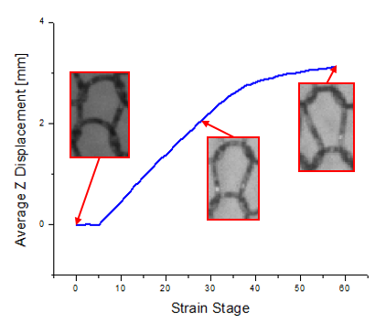
Figure 5. Out of plane displacements in wale direction

- Computational Approach

  - Simulation Methodology
Plain knitted loop geometry could be characterized by the three different fundamental parameters including the wale spacing (W), course spacing (C) and diameter (D) as shown in Figure 1. Piecewise cubic Bezier curves are used to construct the centerline of the yarn. Visualization of the 3D yarn model which are rendered with a circular cross-section was achieved in a publicly open software (TexGen) [10]. To eliminate the yarn interpenetration and obtain a more physically natural configuration, an energy minimization-based optimization approach was performed on the original model. Then the optimized 3D knit model was imported into a commercial FEA code (ABAQUS 6.13/Standard) and boundary value problems were set up to study the in-plane mechanical behavior of knitted textiles. In this investigation, geometry nonlinearity and contact-friction between yarns were considered [5].
  - Results
Similar to experimental investigations, uniaxial tensile tests along both course and wale directions were considered in simulations. The global reaction force versus strain curves are shown in Figure 6, demonstrating the strong anisotropic behavior of the knitted textiles which was also observed in experiments. The fact that flexural motion of the curved loops contributes greatly to the deformation mechanism along course direction while the yarn stretch is predominant in the wale direction which further demonstrates the significant influence of architecture on the mechanical behavior of the knitted textiles.
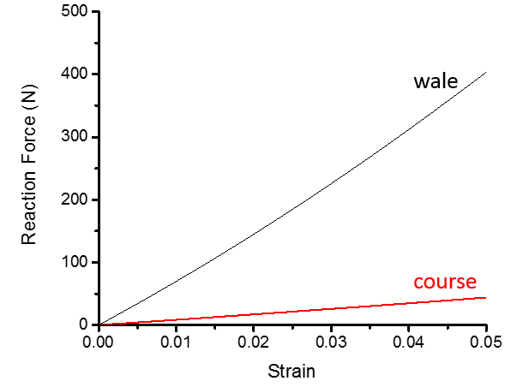
Figure 6. Simulations of reaction forces vs applied strain computed along the course and wale directions
Furthermore, the local yarn motion combined with the contact area evolution are demonstrated in Figure 6. During the course tensile loading, any row of loops inside the material could be analyzed in a free-body diagram as shown in Figure 6(a), where the contact/friction forces resulting from the yarn interactions could be considered as the external forces exerted on that particular loop of yarn. Consequently, the yarn tends to behave as a cantilever beam subjected to rotation, compression and spinning around yarn centerlines from as shown in Figure 7.
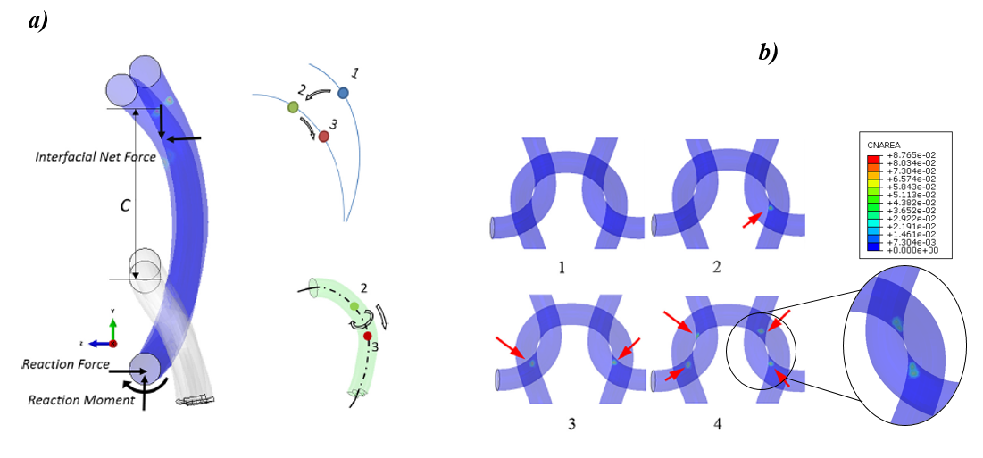
Figure 7. a) Local set of forces exerted in each yarn; deformation path observed for each yarn including, rotation, contraction, and spin about the yarn’s centerline. b) contact area distribution in one unit cell of a 3x3 knit
Additionally, local contact area changes was computed as shown in Figure 7(b). Specifically, the unit cell in Figure 7(b) is found to contain no contact areas in state 1 where no loading is applied. With load increasing, the number of contact areas gradually increased to 4 in the final state 4 in Figure 7(b). Hence, both the local yarn motion and contact area evolution play an important role in the global response of knitted textiles, contributing greatly to the observed nonlinear mechanical behavior. In fact, the out of plane motion mentioned in the experiments was observed in the simulations as well. Figure 8 shows the maximum out of plane versus applied displacement on the course direction in a 3by3 knit model. As described above, the out of plane motion results mainly from the yarn bending behavior which is essentially the consequence of the yarn entanglement.

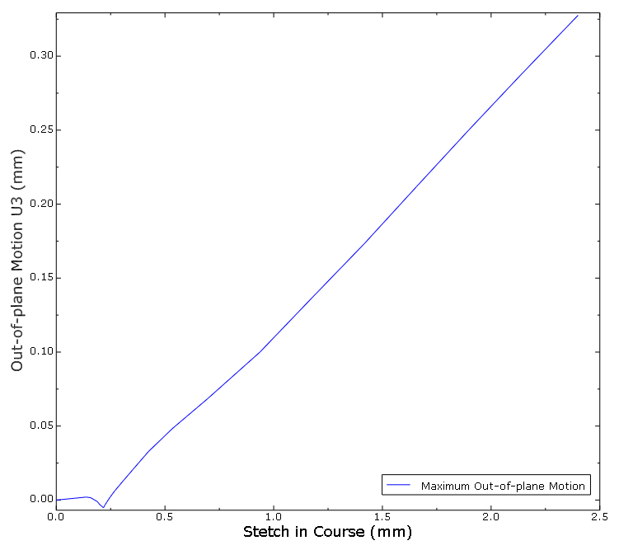
Figure 8. Out of plane motion predicted by simulating a 3by3 model under course tension

- Concluding remarks
Experimental and computational results related to the mechanical behavior of knitted textiles were presented. Specifically, tensile properties of knitted textiles were found to vary according to direction of loading. This mechanical behavior anisotropy was captured both experimentally and numerically. Sliding, contact and friction at the yarn level were found to affect the overall behavior. In addition, a pronounced buckling-type effect resulting in a pronounced out-of-plane motion was validated both experimentally and computationally.
Acknowledge
The authors acknowledge the financial support received by the National Science Foundation (CMMI #1537720). They also thank Professor Genevieve Dion and her team from Shima Seiki Haute Tech Lab at Drexel University.
References
[1] J. Xiong et al., “Advanced Micro-Lattice Materials,” Adv. Eng. Mater., vol. 17, no. 9, pp. 1253–1264, 2015.
[2] C. I. Hammetter, R. G. Rinaldi, and F. W. Zok, “Pyramidal Lattice Structures for High Strength and Energy Absorption,” J. Appl. Mech., vol. 80, no. 4, p. 41015, 2013.
[3] Z. Hu, V. K. Gadipudi, and D. R. Salem, “Topology Optimization of Lightweight Lattice Structural Composites Inspired by Cuttlefish Bone,” Appl. Compos. Mater., pp. 1–13, 2018.
[4] V. V. Vasiliev and A. F. Razin, “Anisogrid composite lattice structures for spacecraft and aircraft applications,” Compos. Struct., vol. 76, no. 1–2, pp. 182–189, 2006.
[5] D. Liu, B. Shakibajahromi, G. DIon, D. Breen, and A. Kontsos, “A Computational Approach to Model Interfacial Effects on the Mechanical Behavior of Knitted Textiles,” J. Appl. Mech. Trans. ASME, vol. 85, no. 4, pp. 1–12, 2018.
[6] M. Ciocchetti et al., “Smart Textile Based on Fiber Bragg Grating Sensors for Respiratory Monitoring: Design and Preliminary Trials,” Biosensors, vol. 5, no. 3, p. 602, 2015.
[7] A. D. Kelkar, J. S. Tate, and R. Bolick, “Structural integrity of aerospace textile composites under fatigue loading,” Mater. Sci. Eng. B Solid-State Mater. Adv. Technol., vol. 132, no. 1–2, pp. 79–84, 2006.
[8] A. Grassi, F. Cecchi, M. Maselli, M. Roling, C. Laschi, and M. Cianchetti, “Warp-Knitted Textile as a Strain Sensor: Characterization Procedure and Application in a Comfortable Wearable Goniometer,” IEEE Sens. J., vol. 17, no. 18, pp. 5927–5936, 2017.
[9] Y. Zhai, D. A. Lados, and J. L. Lagoy, “Additive Manufacturing: Making imagination the major Limitation,” Jom, vol. 66, no. 5, pp. 808–816, 2014.
[10] D. Liu et al., “On the role of material architecture in the mechanical behavior of knitted textiles,” Int. J. Solids Struct., vol. 109, pp. 101–111, 2017.
[11] M. K. Imrith, R. Unmar, and S. Rosunee, “Determination of Knitted Fabric Porosity Using Digital Imaging Techniques,” vol. 2016, no. 1, 2016.
[12] A. A. A. Jeddi, H. Dabiryan, and S. Kalani, “An explanation of warp knitted fabric deformation under uni-axial tension by a novel index as shape ratio,” J. Text. Inst., vol. 108, no. 4, pp. 500–506, 2017.

